Comparison - Minimum Spanning Tree
Project Overview
This project implements and compares several Minimum Spanning Tree algorithms, focusing on their time and space complexity across various graph configurations. The study includes both classical algorithms and advanced randomized approaches, with parallel implementations for performance analysis.
Authors
- Orynbassar Abylaikhan - xorynba00
- Balseit Yeldana – xbalsey00
- Note: This documentation was written by the authors with language polishing assistance from AI tools.
Implemented Algorithms
- Kruskal’s Algorithm
Time complexity: O(E log V)
Space complexity: O(E + V)
Principle: A greedy algorithm that sorts all edges and adds them to the MST of they don’t form cycles.
Pseudocode:
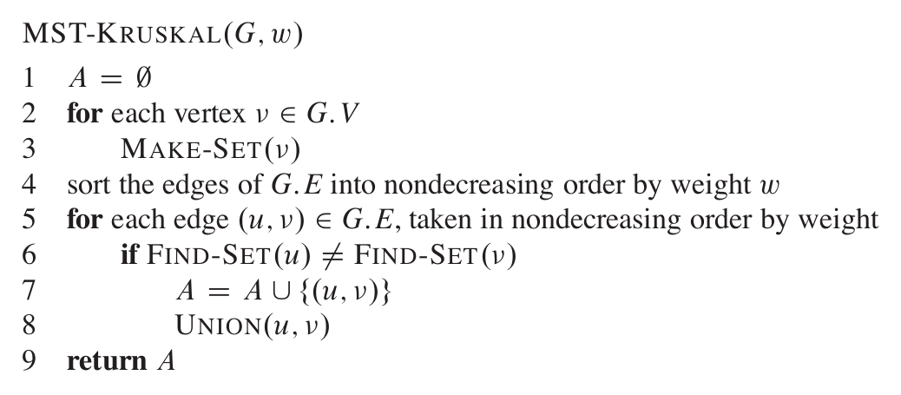
(Source: Thomas H. Cormen, Charles E. Leiserson, Ronald L. Rivest, Clifford Stein. Introduction to Algorithms, 3rd ed., MIT Press, 2009)
Implementation details: Union-Find with path compression and union by rank for efficient cycle detection was used as data structures.

- Prim’s Algorithm with Binary Heap
Time complexity: O(E log V)
Space complexity: O(E + V)
Principle: A greedy algorithm that grows the MST from an arbitrary vertex, always adding the cheapest connecting edge.
Pseudocode:
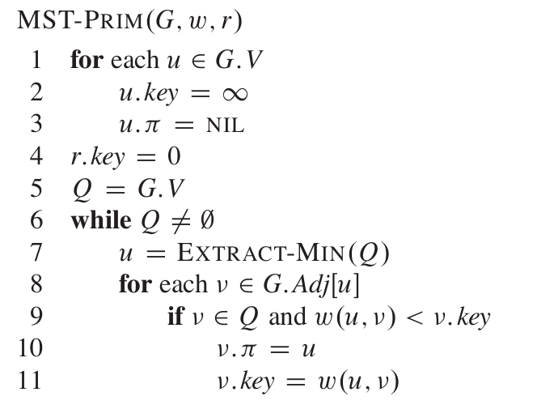
(Source: Thomas H. Cormen, Charles E. Leiserson, Ronald L. Rivest, Clifford Stein. Introduction to Algorithms, 3rd ed., MIT Press, 2009)
Implementation details: std::priority_queue was used as a binary heap for efficient minimum extraction.

- Parallel Prim’s Algorithm
Time complexity: O(E log V) with parallel speedup
Principle: Multi-threaded version of Prim’s algorithm where multiple threads process vertices concurrently.
Implementation challenges: Required careful synchronization with mutex locks to prevent race conditions while maintaining performance benefits.

- Karger-Klein-Tarjan Randomized Algorithm
Time complexity: O(E) expected
Principle: An algorithm follows a three-step recursive approach that combines graph contraction via Borůvka steps with randomized edge sampling and heavy-edge elimination.
Pseudocode:
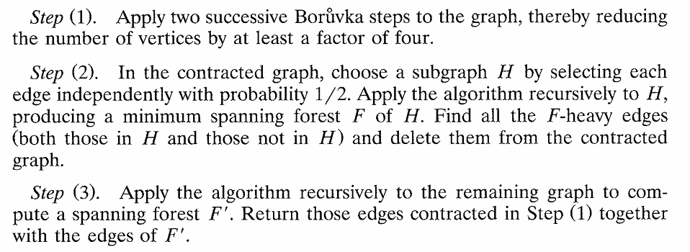
(Source: Karger, D. R., Klein, P., Tarjan, R. E. A Randomized Linear-Time Algorithm to Find Minimum Spanning Trees. Journal of the ACM, Vol. 42, No. 2, 1995.)
Implementation details: Two successive Borůvka steps contract the graph, followed by random edge sampling with probability 1/2 to compute a candidate MST, which is then used to identify and eliminate heavy edges before final recursion on the reduced graph.
Experimental Design
Graph Generation
We generated comprehensive test suites with the following characteristics:
Graph types:
- Sparse graphs: Density 0.01-0.5 (trees with few additional edges)
- Medium density: Density 0.5-2.0
- Dense graphs: Density 2.0-20.0 (approaching complete graphs)
- Grid graphs: Structured 2D grids
Graph sizes:
- Small: 100-1,000 vertices
- Medium: 1,000-10,000 vertices
- Large: 10,000-50,000 vertices
- Very Large: 50,000-100,000 vertices (sparse only due to memory constraints)
Total test suite: 30+ distinct graph configurations covering various sizes and densities.
Measurement Methodology
- Time Measurement: High-resolution chrono timers with millisecond precision
- Memory Usage: Cross-platform memory monitoring (Windows: GetProcessMemoryInfo)
- Statistical Approach:
  - Deterministic algorithms (Borůvka, Kruskal, Prim): Single runs per configuration due to consistent outputs
  - Randomized algorithm (KKT): Multiple runs (typically 5-10) with different random seeds to account for variance, reporting average performance metrics
- Error Handling: Comprehensive exception handling with graceful degradation

Testing Environment
- Machine: 12th Gen Intel(R) Core(TM) i5-1240P, 16GB RAM
- Compiler: g++ with C++17 standard, -O3 optimization
- Operating System: Windows
Building the Project
git clone https://github.com/yeldanabb/mst-comparison-project
cd mst-comparison-project
make all # Build all components
# Or build specific targets
make tests # Build and run unit tests
make simple # Build simple experiments (12 graphs)
make large # Build large-scale experiments (20 graphs)
make comprehensive # Build comprehensive experiments (30+ graphs)

Running Experiments
./bin/run_tests # Run unit tests to verify implementation
./bin/simple_experiments # Run simple experiments (quick verification)
./bin/comprehensive_experiments # Run comprehensive experiments (full analysis)
./bin/large_scale_experiments # Run large-scale experiments (asymptotic analysis)

Analyzing results
python experiments/results.py # Basic analysis for simple/large experiments
python experiments/analysis.py # Comprehensive analysis with visualizations

