Intelligent Predictive and Explainable Autoscaling for Kubernetes Microservices Using Hybrid Time-Series Forecasting and Large Language Models

Omoyele Sodiq Olabode
Student ID: 250211355

Submitted in accordance with the requirements for the degree of
Master of Science in Computer Science

York St John University, London Campus
School of Science, Technology and Health

Supervisor: Alaa Hammad
Module: COM7040M-2025-27-L09FT

February 2026

Intellectual Property and Publication Statements
The candidate confirms that the work submitted is their own and that appropriate credit has been given where reference has been made to the work of others.
This copy has been supplied on the understanding that it is copyright material. Any reuse must comply with the Copyright, Designs and Patents Act 1988 and any licence under which this copy is released.
© 2026 York St John University and Omoyele Sodiq Olabode.
The right of Omoyele Sodiq Olabode to be identified as Author of this work has been asserted in accordance with the Copyright, Designs and Patents Act 1988.

Acknowledgements
I would like to express my sincere gratitude to my supervisor, Alaa Hammad, for her invaluable guidance, critical feedback and encouragement throughout this dissertation. Her insistence on academic rigour, on grounding every claim in cited evidence, and on linking research questions tightly to objectives has shaped this work in ways that will benefit me well beyond this degree.
I am grateful to the academic staff of the Computer Science Department at York St John University London Campus for their teaching and support over the course of this programme.
I am indebted to the open-source communities behind Kubernetes, Prometheus, Locust, wrk2, Prophet, XGBoost, PyTorch and SHAP, whose work makes research at this level possible.
Finally, I thank my family and friends for their patience and support during the months in which this research consumed my attention.

Abstract
In latency-sensitive cloud applications such as payment processing, retail trading and digital banking, automatic scaling decisions made by Kubernetes’ default controller arrive after the demand they were meant to absorb has already saturated the system. The resulting tail-latency violations are operationally costly and, in regulated firms, raise auditability concerns under the UK Financial Conduct Authority’s operational-resilience regime and the Prudential Regulation Authority’s model-risk principles. Existing predictive autoscalers can forecast demand more accurately than the default controller, but they typically do so without safety constraints, without per-decision evidence of why a scaling decision was taken, and without empirical validation that their explanations track the underlying model’s behaviour.
This dissertation designs, implements and evaluates a hybrid predictive and explainable autoscaling controller that closes these three gaps in a single artefact. Short-horizon forecasts are produced by competing model families and mapped to replica recommendations through a constrained decision engine with a deterministic fallback to the default controller. Every scaling decision is accompanied by a feature-attribution vector and by a retrieval-bounded natural-language narrative restricted to the observed evidence. The system is evaluated against the default controller on the Online Boutique benchmark under four workload conditions — burst, ramp, periodic and trace-replay — across eighty A/B trials with a pre-registered statistical analysis plan. Holt-Winters exponential smoothing wins the model selection on all ten services (H1 confirmed, d_z 3.30–13.94). The Hybrid Controller significantly reduces p95 tail latency in three of four workloads — ramp (−86%), burst (−40%) and trace-replay (−11%) — but uses five to eight times more replica-seconds than HPA (H0 partially confirmed, H2 not confirmed). FActScore evaluation of thirty LLM narratives yields a mean groundedness score of 0.648, below the 0.80 pre-registered threshold (H4 not confirmed).
The dissertation contributes a reference architecture for accountable predictive autoscaling, the first faithfulness-instrumented feature-attribution treatment within a deployed autoscaling controller to the author’s knowledge, and a reproducible evaluation protocol for microservice elasticity. A critical analysis of the bounds of large-language-model assistance in production control loops accompanies the contribution.

Table of Contents
Intellectual Property and Publication Statements 3
Acknowledgements 4
Abstract 5
Contents 6
List of Figures 8
List of Tables 9
List of Abbreviations 10
Chapter 1: Introduction 12
1.1 Background of Study 12
1.2 The Kubernetes Horizontal Pod Autoscaler 17
1.3 Research Problem 19
1.3.1 What currently happens 19
1.3.2 Why it fails 20
1.3.3 Evidence that it fails 20
1.3.4 Why current proposals do not close the gap 20
1.4 Research Aim, Objectives and Significance 21
1.4.1 Aim 21
1.4.2 Objectives 21
1.4.3 Significance 22
1.4.4 Achievement narrative 23
1.5 Research Questions and Hypotheses 23
1.6 Proposed Solution 26
1.7 Scope of the Research 29
1.8 Limitations of the Research 29
1.9 Dissertation Structure 30
Chapter 2: Literature Review 32
2.1 Introduction and Review Protocol 32
2.2 Cloud-Native Elasticity as a Control Problem 33
2.3 Kubernetes HPA: Documented Failure Modes 35
2.4 Custom-Metric and Event-Driven Scaling 37
2.5 Predictive and Proactive Autoscaling 38
2.6 Time-Series Forecasting Model Families 42
2.7 Explainable AI: SHAP and the Limits of Attribution 44
2.8 Large Language Models in AIOps 47
2.9 Microservice Benchmarks 50
2.10 Research Gap Synthesis 51
2.11 Conclusion and Positioning 53
Chapter 3: Methodology 55
3.1 Introduction 55
3.2 Research Philosophy 56
3.3 Research Approach: Design Science Research 56
3.4 Research Strategy: Controlled A/B Experimentation 57
3.5 Data Collection and Feature Engineering 58
3.6 Forecasting Model Design 59
3.7 Constrained Decision Engine: Formal Definition 60
3.8 Explainability Pipeline 62
3.9 Experimental Design 64
3.10 Testing Environment 66
3.11 Evaluation Metrics with Formulae 68
3.12 Statistical Analysis Plan 69
3.13 Threats to Validity 70
3.14 Ethics, Safety and Sustainability 71
3.15 Methodology Stages and Deliverables 72
3.16 Chapter Summary 73
References 75

List of Figures
Figure 1.1: Fintech burst-traffic profile with HPA reaction lag. 3
Figure 1.2: Kubernetes HPA control loop with delay annotations. 5
Figure 1.3: Hybrid Controller: proposed architecture. 13
Figure 1.4: Dissertation roadmap and chapter dependency graph. 16
Figure 2.1: Taxonomy of Kubernetes autoscaling approaches. 19
Figure 2.2: HPA failure-mode timeline under burst load. 21
Figure 2.3: Illustrative SHAP waterfall plot for a scaling decision. 30
Figure 2.4: Evidence-bundle to RAG-grounded LLM narrative flow. 33
Figure 3.1: End-to-end methodology pipeline. 38
Figure 3.2: Decision-engine state machine. 47
Figure 3.3: Workload profiles: burst, ramp, periodic, trace replay. 51
Figure 3.4: Test cluster topology. 52
Figure 3.5: The grounded narrator’s retrieval-bounded prompt template. 57
Note on figure production: all diagrams in this dissertation (Figures 1.1–3.4) were specified, designed and verified by the candidate; drafting and visual refinement of several diagrams was carried out with the assistance of generative AI tools, with all technical content, data and architectural decisions specified and checked by the candidate. No figure is reproduced or adapted from a third-party copyrighted source without citation.

List of Tables
Table 1.1: Objective, Question, Hypothesis and Chapter alignment matrix. 12
Table 2.1: Comparative autoscaling approaches. 26
Table 2.2: Forecasting models considered. 28
Table 2.3: Explainable-AI techniques for time-series autoscaling. 30
Table 3.2: Evaluation metrics with formulae. 54
Table 3.1: Methodology stages and deliverables. 58

List of Abbreviations
A/B Controlled comparison between baseline (A) and treatment (B)
AIOps Artificial Intelligence for IT Operations
API Application Programming Interface
AUC Area Under the Curve
BCa Bias-Corrected and Accelerated (bootstrap interval)
CD/CI Continuous Delivery and Continuous Integration
CNCF Cloud Native Computing Foundation
CPU Central Processing Unit
CRD Custom Resource Definition (Kubernetes)
CV Coefficient of Variation
DSR Design Science Research
FCA Financial Conduct Authority (UK)
gRPC Google Remote Procedure Call
HPA Horizontal Pod Autoscaler (Kubernetes)
k8s Kubernetes
KEDA Kubernetes Event-driven Autoscaling
KPI Key Performance Indicator
LLM Large Language Model
LSTM Long Short-Term Memory (recurrent neural network)
MAE Mean Absolute Error
MAPE Mean Absolute Percentage Error
MLOps Machine Learning Operations
OSF Open Science Framework
p95 and p99 95th and 99th percentile (response-time tail)
PRA Prudential Regulation Authority (UK)
RAG Retrieval-Augmented Generation
RL Reinforcement Learning
RMSE Root Mean Square Error
RQ Research Question
SARIMA Seasonal Autoregressive Integrated Moving Average
SHAP SHapley Additive exPlanations
SLO Service Level Objective
SRE Site Reliability Engineering
VPA Vertical Pod Autoscaler
XAI Explainable Artificial Intelligence
YSJ York St John University

Chapter 1: Introduction
This chapter introduces the dissertation. Section 1.1 motivates the work through the operational reality of fintech microservices under bursty workloads. Section 1.2 explains the Kubernetes Horizontal Pod Autoscaler. Section 1.3 states the research problem. Section 1.4 sets out the aim, objectives and significance. Section 1.5 states the research questions and hypotheses. Section 1.6 presents the proposed Hybrid Controller. Sections 1.7 and 1.8 give the scope and limitations. Section 1.9 maps the remaining chapters.

1.1 Background of Study
When a person taps to pay on payday, the bank’s software is being asked the same question by millions of other people in the same few seconds. To keep the service responsive, modern cloud systems automatically add more copies of the software handling those requests. The standard tool for this is the Horizontal Pod Autoscaler: it waits to see demand rise before reacting, and new copies take thirty to ninety seconds to become operational. By the time they are ready, some payments have already failed or slowed, and the slowest five per cent of responses – what users tend to remember and complain about – have already breached the bank’s service targets. This dissertation asks whether the controller can anticipate the rise before it happens, whether the resulting scaling decisions can be made safe if the prediction is wrong, and whether the system can explain those decisions in a form operators and regulators can audit.
Modern fintech platforms depend on stateless microservices (small, independent services that communicate over the network) that must absorb workload bursts of five to fifty times their baseline load within seconds (Monzo, 2020; InfoQ, 2024): examples include payment rails such as Stripe, trading apps such as Revolut, and digital banks such as Monzo and Starling. At market open, on payday, and on retail-driven days such as Black Friday, even one downstream service failing to scale in time propagates as tail-latency degradation (a slowdown concentrated in the slowest-responding requests, the “tail” of the response-time distribution), authorisation declines and queue backpressure. Engineering post-mortems from these platforms consistently attribute such incidents to scaling decisions arriving thirty to one hundred and twenty seconds late (Monzo, 2020; Monzo, 2024; InfoQ, 2024). The cost is not only technical: every extra second of authorisation latency measurably reduces conversion, and prolonged tail-latency events trigger regulatory reporting under the UK Financial Conduct Authority’s PS21/3 regime (Financial Conduct Authority, 2021).
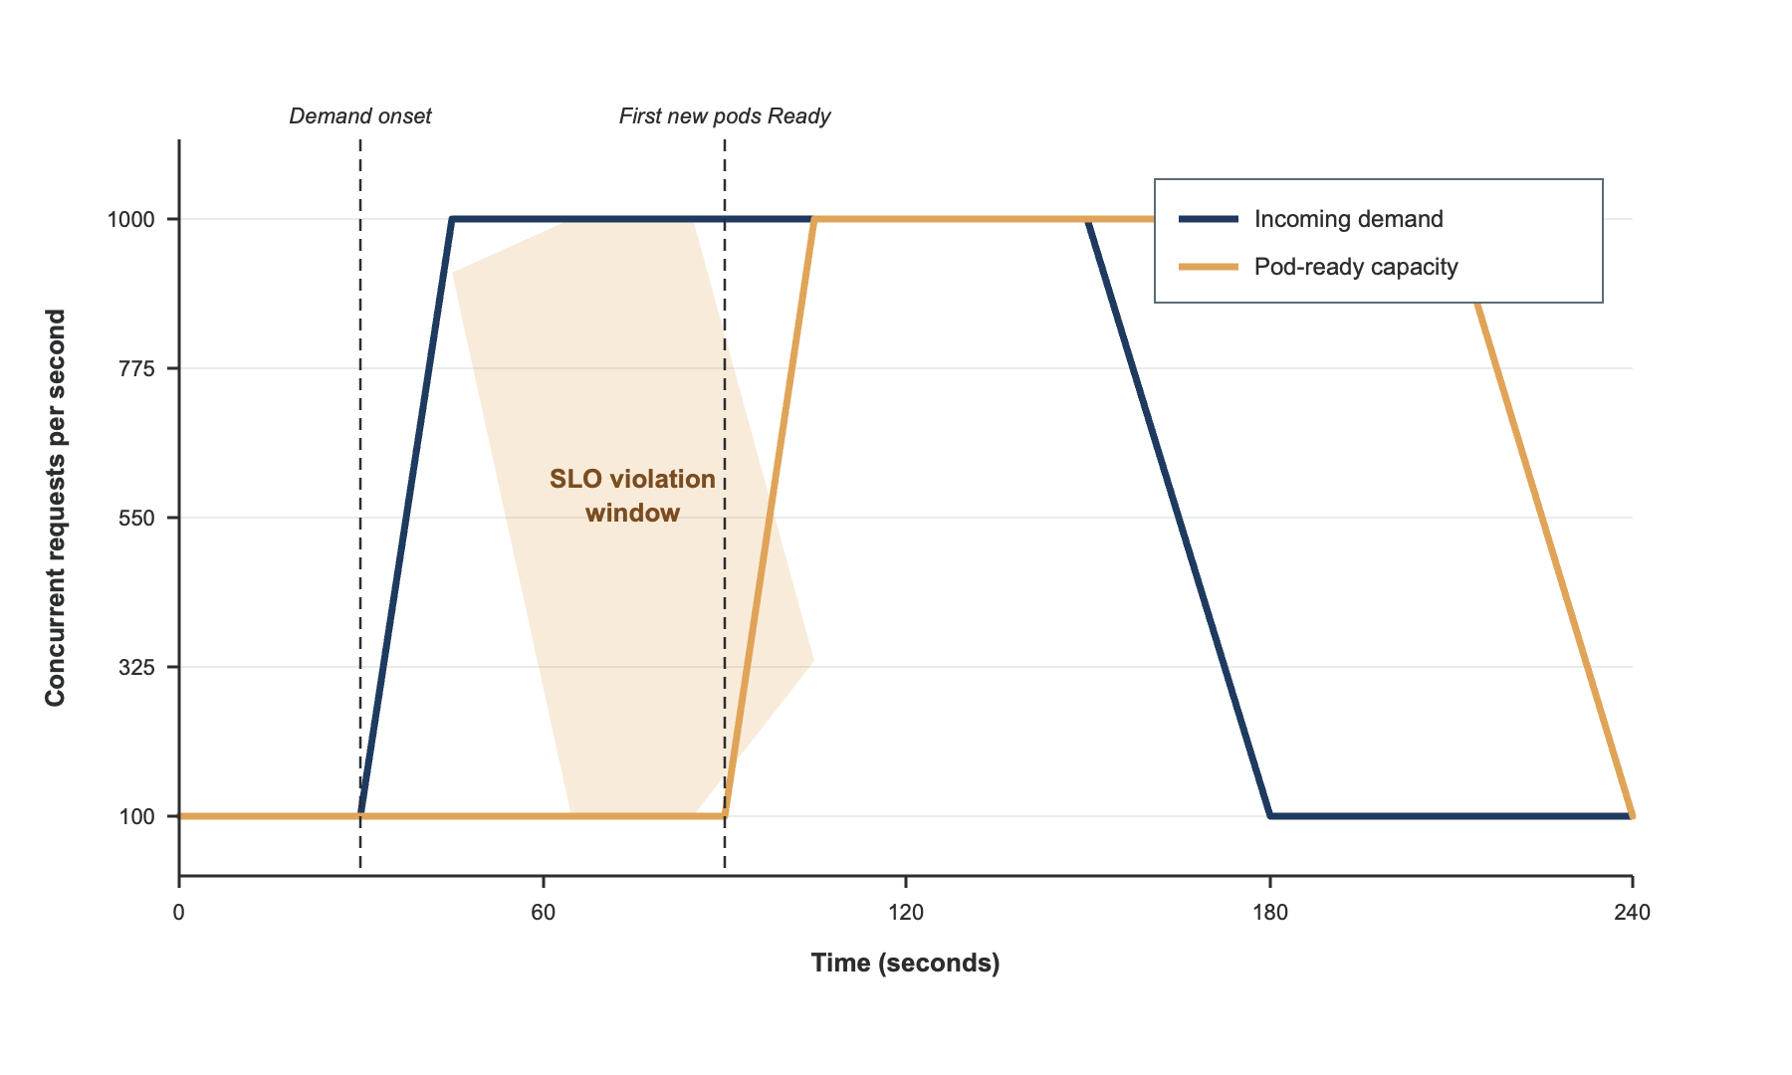
Figure 1.1. Illustrative fintech burst-traffic profile, showing pod-readiness arrival lagging behind demand during a payday-style spike.
The dominant pattern for handling this elasticity is container orchestration with Kubernetes, the platform that runs and manages service copies (called pods) across a cluster of machines. Kubernetes ships with a built-in controller for this, the Horizontal Pod Autoscaler (HPA), which periodically checks a target metric, typically CPU utilisation, and adjusts the number of pods to keep that metric near a configured target (Kubernetes, 2024). HPA assumes that recent demand is the best guide to near-term demand, and that a single metric can represent service need; this is also its limitation. A new pod only contributes capacity once it passes its readiness probe, an internal check confirming it can serve traffic, which typically takes tens of seconds. HPA further delays scale-down decisions through a stabilisation window, a built-in pause that defaults to three hundred seconds and exists to prevent oscillation (Kubernetes, 2024). When demand rises faster than this combined readiness-plus-stabilisation budget allows, scaling is structurally late.
Monzo’s own engineering team, running over 2,800 microservices in production on Kubernetes (Monzo, 2024), documents the practical consequences: default HPA configurations are insufficient for payment workloads, prompting co-operative distributed rate-limiting on top of horizontal scaling. Academically, Toka et al. (2021) measured HPA under burst load on edge Kubernetes clusters and reported significant tail-latency degradation, though their synthetic burst shapes may not transfer to production fintech scale. Rzadca et al. (2020) describe Google’s Autopilot system, replacing single-metric scaling with a coordinated horizontal-and-vertical controller, but the published account offers no per-decision explanation. Qiu et al. (2020) show with FIRM that SLO-aware controllers reduce SLO violations by an order of magnitude relative to HPA, but FIRM’s RL policy is opaque and unevaluated for accountability.
The natural response to scaling lag is to forecast demand and scale ahead of it. Imdoukh, Ahmad and Alfailakawi (2020) trained a Long Short-Term Memory network (LSTM, a recurrent neural network that learns temporal patterns) on production traces and reported 8.7 per cent mean absolute percentage error at thirty seconds ahead, outperforming classical ARIMA, but they never coupled the forecaster to a controller, so whether better forecasts improve tail latency remains untested. Hu et al. (2022) added a graph neural network to capture cross-service dependencies; Guruge and Priyadarshana (2025) combined Prophet and LSTM and reported under three per cent error at the same horizon, but again did not test controller behaviour under model failure or telemetry loss; Zhang et al. (2025) added confidence-weighted scaling but exposed no attribution evidence to operators. Short-horizon forecasting is clearly feasible at the granularity Kubernetes needs, yet no published controller closes the loop on accountability.
Forecasting alone solves only half the problem. A controller that maps a forecast directly to a replica count converts model error into actuation error: over-scaling wastes compute, under-scaling violates service targets. A credible predictive autoscaler therefore needs safety bounds, rate limits and a deterministic fallback that recovers HPA-equivalent behaviour when forecasts are uncertain or telemetry is missing. It must also remain auditable: regulators, under the Prudential Regulation Authority’s SS1/23 (2023), expect firms to document the model risk behind any automated decision logic, and post-incident review needs evidence-linked explanations rather than opaque inferences.
Two recent strands of work address this accountability requirement separately, reviewed in full in Sections 2.7 and 2.8. Explainable-AI research offers feature-attribution techniques, most prominently SHAP (Lundberg and Lee, 2017), but consistency does not entail faithfulness (whether an explanation genuinely reflects the model's real decision process, rather than merely sounding plausible), and recent work proves concrete failure modes (Bilodeau et al., 2024; Huang and Marques-Silva, 2023). Large-language-model research offers a complementary capability, turning structured evidence into operator-readable narratives (Vitui and Chen, 2025), but existing systems do not make scaling decisions and do not address hallucinated causal claims: cases where a fluent model states something the evidence does not support.
Online Boutique, the open-source microservices benchmark maintained by Google (GoogleCloudPlatform, 2024), provides a realistic Kubernetes target for evaluating such a controller. It comprises eleven services connected by gRPC calls, has been used in prior autoscaling work (Sachidananda and Sivaraman, 2022), and runs on a commodity single-node Kubernetes cluster. Its call graph is shallower than DeathStarBench’s (Gan et al., 2019), a real limitation since results may not extend cleanly to deeper topologies; it is adopted nonetheless because its tractable footprint supports the controlled, repeated, statistically-powered experiments the methodology demands. To strengthen external validity, this dissertation also replays twenty-four hours of the Alibaba microservices trace (Luo et al., 2021).
In summary, fintech and other latency-sensitive microservice operators face a tension between scaling responsiveness and operational accountability that Kubernetes HPA does not resolve, and that recent predictive autoscalers (Guruge and Priyadarshana, 2025; Zhang et al., 2025; Punniyamoorthy et al., 2025) address only partially. Closing this gap requires coupling forecasting, constrained actuation, faithful attribution and grounded narrative explanation in a single, evaluable artefact. Section 1.2 introduces the HPA baseline in detail.

1.2 The Kubernetes Horizontal Pod Autoscaler
The Kubernetes Horizontal Pod Autoscaler (HPA) is the de facto autoscaling baseline for containerised microservices. Running as a controller in the cluster control plane, it periodically reads a target metric for each workload and computes a new replica count from a simple ratio formula, documented in the official Kubernetes specification (Kubernetes, 2024):
desiredReplicas = ⌈ currentReplicas × ( currentMetricValue ÷ desiredMetricValue ) ⌉
Three parameters govern its behaviour in practice: how often it re-evaluates the formula (fifteen seconds by default), how long it waits before scaling down to avoid oscillation, and how fast replica count may change per period. It can also read CPU/memory, application-level or external metrics through three separate APIs, though it combines none of them into a single decision (Kubernetes, 2024; Cloud Native Computing Foundation, 2024). Section 2.3 details this configuration surface in full.
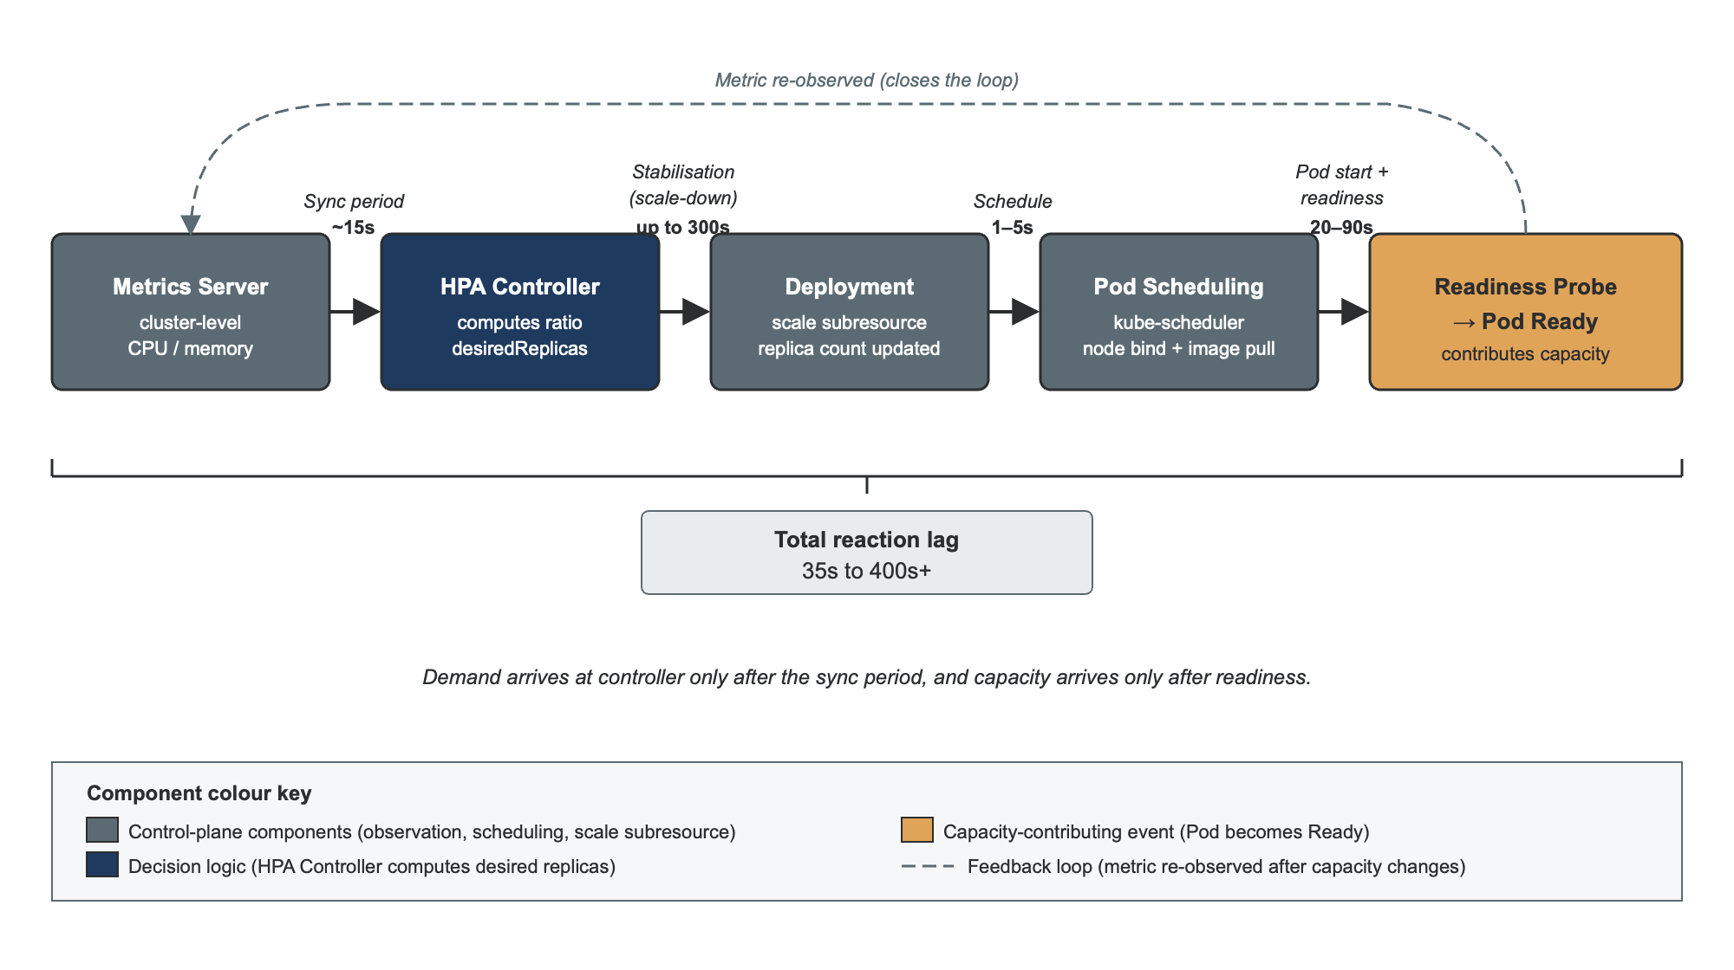
Figure 1.2. The Kubernetes HPA control loop, from metric observation through to new pods contributing capacity.
Two structural consequences follow. First, the decision is reactive: HPA assumes recent past demand predicts near-term demand, an assumption that fails under sudden bursts, since by the time the metric crosses its target the demand that caused the crossing has already arrived and new pods are not yet ready. (Toka et al., 2021; Nguyen et al., 2020; Qiu et al., 2020). Second, the metric is a proxy: CPU utilisation is the default target, but in microservice systems the tail of the response-time distribution is more often dominated by I/O, downstream contention and queueing than by CPU saturation (Dean and Barroso, 2013). A CPU-aware HPA can leave latency violations undetected, and vice versa.
These limitations do not make HPA wrong. HPA is the right controller for many workloads, is operationally predictable, and ships with every Kubernetes cluster. This dissertation treats HPA not as a strawman but as the realistic comparator any new autoscaler must outperform without introducing new failure modes. Chapter 2 returns to HPA’s documented failure modes in Section 2.3.

1.3 Research Problem
The problem this dissertation addresses is that, in latency-sensitive Kubernetes microservice deployments, no available autoscaling controller simultaneously (a) responds within the pod-readiness window, (b) preserves availability if its predictions fail, and (c) produces per-decision evidence that operators and regulators can audit. The rest of this section argues for this statement in four parts: what current scaling does (1.3.1), why it fails (1.3.2), the evidence that it fails (1.3.3), and why existing proposals do not close the gap (1.3.4). The three failure dimensions (a), (b) and (c) map directly to Research Gaps 1, 2 and 3 in Section 2.10.

1.3.1 What currently happens
The default Kubernetes scaling pattern is reactive. The HPA controller checks a target metric every fifteen seconds and adjusts the replica count according to a ratio formula (Kubernetes, 2024). Custom-metric and event-driven extensions (KEDA, the Vertical Pod Autoscaler) widen the input signals but keep the same reactive, current-state-driven decision. Scaling only takes effect after pod readiness, adding twenty to ninety further seconds of delay under realistic conditions (Mao and Humphrey, 2012; Monzo, 2020).

1.3.2 Why it fails
Reactive control under delay cannot avoid acting after the fact. Under fintech-style burst traffic, such as a payment-rail spike at the start of a payday window, the delay between demand onset and controller response is structurally longer than the spike itself takes to saturate downstream services. Tail latency in microservice systems is dominated by queuing and downstream contention (Dean and Barroso, 2013), neither visible to a CPU-only HPA until the queue has already formed. HPA’s stabilisation window, necessary to prevent oscillation under noisy metrics, actively adds to this delay. The result is that ninety-fifth- and ninety-ninth-percentile response-time targets are violated even when average utilisation looks fine.

1.3.3 Evidence that it fails
Three independent strands of evidence converge on this conclusion: academic measurements on Kubernetes and DeathStarBench report SLO-violation rates (breaches of a Service Level Objective, a target such as “95% of requests under 300ms”) an order of magnitude higher under HPA than under SLO-aware controllers (Toka et al., 2021; Qiu et al., 2020); production reports from Monzo (2020; 2024) describe the difficulty of tuning HPA across 2,800 microservices; and benchmark evidence shows HPA configurations on Online Boutique are highly sensitive to threshold choice with no setting performing well across conditions (Sachidananda and Sivaraman, 2022). None of these strands alone proves HPA inadequate, but together they are hard to dismiss; Section 2.3 reviews this evidence in full.

1.3.4 Why current proposals do not close the gap
Predictive autoscalers do exist (Imdoukh et al., 2020; Hu et al., 2022; Guruge and Priyadarshana, 2025; Zhang et al., 2025), but they share three weaknesses matching the three failure dimensions above: evaluation typically stops at forecasting accuracy without testing latency or SLO benefit (a); forecasts are mapped to replicas without safety constraints or deterministic fallback (b); and none expose per-decision feature attributions to operators or regulators (c). Section 2.10 synthesises this gap in full against the wider literature.
Closing this gap requires four coupled components: a short-horizon forecaster that anticipates demand within the pod-readiness window; a constrained engine that maps forecasts to replica decisions under explicit safety bounds with a deterministic HPA fallback; a feature-attribution layer whose faithfulness is empirically validated; and a retrieval-bounded language model (one restricted to generate only from facts explicitly supplied to it, so it cannot invent information) whose explanation quality is independently measured. Section 1.6 specifies this design and Chapter 3 details its evaluation.

1.4 Research Aim, Objectives and Significance

1.4.1 Aim
The aim of this dissertation is to design, implement and evaluate a hybrid predictive and explainable autoscaling controller for Kubernetes microservices, hereafter the Hybrid Controller, that anticipates demand thirty to sixty seconds ahead, translates forecasts into replica recommendations through a constrained decision engine with a deterministic HPA fallback, and accompanies every scaling decision with a SHAP attribution and a retrieval-bounded LLM narrative whose quality is independently measured.

1.4.2 Objectives
Five objectives operationalise this aim, each followed by the methodology section where it is operationalised and the research question that answers it.
O1. Collect, label and feature-engineer multivariate Prometheus telemetry from Online Boutique under controlled load and a twenty-four-hour real-trace replay (Section 3.5; Research Question 1).
O2. Train, tune and compare four forecasting model classes (Seasonal Naive, Holt-Winters and SARIMA as statistical baselines, XGBoost as a tree-based learner, and an LSTM as a sequence model) for thirty- to sixty-second-ahead prediction (Section 3.6; Research Questions 1 and 2).
O3. Design and implement a constrained decision engine converting forecasts into replica recommendations with safety bounds, rate limits, confidence-aware margins and a deterministic HPA-equivalent fallback (Section 3.7; Research Question 3).
O4. Generate per-decision SHAP attributions, validate their faithfulness against the underlying forecaster, and wrap them in a retrieval-bounded LLM narrative independently evaluated for quality (full test protocol in Section 3.8; Research Question 4).
O5. Evaluate the Hybrid Controller against Kubernetes HPA in controlled A/B experiments under burst, ramp and periodic workloads plus a real-trace replay, reporting ninety-fifth-percentile latency, success rate, replica-seconds (a resource-usage measure: running pod copies multiplied by how long they ran), oscillation rate and forecasting RMSE (full statistical analysis plan in Sections 3.9 to 3.12; the primary Research Question 0).

1.4.3 Significance
The significance of this dissertation is both methodological and artefactual. As an artefact, it contributes a reference architecture for accountable predictive Kubernetes autoscaling: to the author's knowledge, it is the first treatment designed to integrate post-hoc feature attribution and grounded LLM narration with a forecaster-plus-constrained-controller. As a methodology contribution, it designs and instruments the first faithfulness-validation protocol and the first triple-method LLM narrative-quality evaluation proposed for an AIOps control loop; whether these achieve their targets is reported in Chapter 4. As a domain contribution, the framing is anchored in fintech operational resilience: under PS21/3 and SS1/23, automated scaling decisions in regulated firms must be auditable and their model risk documented, and the evidence-grounded explanation pipeline offers a concrete pattern for meeting that requirement.

1.4.4 Achievement narrative
Having answered Research Questions 0 to 4, the aim is intended to be achieved as follows. RQ1 is intended to demonstrate short-horizon predictability beyond reactive baselines (Objectives 1 and 2); this has been confirmed for all ten services (Chapter 4, Section 4.2). RQ2 is intended to demonstrate that forecasting gains translate into ninety-fifth-percentile latency benefit under bursty workloads (Objective 3, performance). RQ3 is intended to demonstrate that the constraint layer prevents prediction error from amplifying into scaling instability (Objective 3, safety). RQ4 is intended to demonstrate that SHAP-plus-grounded-LLM explanations are faithful, useful and free of hallucinated causal claims (Objective 4). The extent to which each is achieved is reported against evidence in Chapters 4 and 5, together validating the hybrid design evaluated in Objective 5.

1.5 Research Questions and Hypotheses
Objective | Research Question | Hypothesis | Answered in
O1: Telemetry, features | RQ1: Forecasting accuracy vs Seasonal Naive baseline. | H1: At least one model reduces RMSE significantly vs Seasonal Naive. | Ch. 4 §4.2
O2: Forecasting model comparison | RQ1 plus RQ2: Does forecast quality translate into ninety-fifth-percentile latency benefit? | H2: Hybrid uses fewer replica-seconds than HPA on burst and ramp (one-sided paired t, Holm-corrected). | Ch. 4 §4.3
O3: Constrained decision engine | RQ3: Does the constraint layer prevent forecast error from amplifying into oscillation? | H3: Oscillation rate at most equal to HPA across all four workloads; time-to-stability at most equal to HPA. | Ch. 4 §4.4
O4: SHAP plus grounded LLM | RQ4: Are explanations faithful and narratives high-quality on the triple protocol? | H4: FActScore at least 0.8 on n = 30 samples (one-sample Wilcoxon, α = 0.05); Likert and LLM-as-judge comparisons reported descriptively. | Ch. 4 §4.5
O5: Controlled A/B evaluation | RQ0: Multi-metric dominance over HPA. | H0: Hybrid dominates HPA on at least one of {ninety-fifth-percentile latency, replica-seconds, oscillation} without significant degradation on the others. | Ch. 5
Each research question is paired with a plain-language hypothesis; the full statistical test specification, including the significance test, correction and effect size, is given in Chapter 3, Section 3.12. Table 1.1 aligns each question with the objective(s) it satisfies and the chapter that answers it.
RQ0 (primary). Does the Hybrid Controller outperform Kubernetes HPA on the multi-metric trade-off between latency, success rate, replica-seconds, oscillation and explanation quality, across burst, ramp, periodic and real-trace workloads? Hypothesis H0: the Hybrid Controller matches HPA's high-end (95th-percentile) response latency in each workload condition. RQ0 is answered in Chapter 5.
RQ1 (forecasting accuracy). Can candidate forecasting models predict short-horizon demand more accurately than a reactive Seasonal Naive baseline? Hypothesis H1: at least one candidate model significantly reduces forecast error against that baseline. RQ1 is answered in Chapter 4 Section 4.2.
RQ2 (controller performance under burst). Does the Hybrid Controller use resources more efficiently than HPA under burst and ramp conditions? Hypothesis H2: the Hybrid Controller uses fewer replica-seconds than HPA under burst and ramp workloads. RQ2 is answered in Chapter 4 Section 4.4.
RQ3 (decision-engine stability). Does the constrained decision engine, including its deterministic HPA fallback, avoid increasing scaling oscillation relative to HPA? Hypothesis H3: scaling oscillation and time-to-stability under the Hybrid Controller are no worse than under HPA across all four workloads. RQ3 is answered in Chapter 4 Section 4.4.
RQ4 (explanation quality). Are the per-decision SHAP attributions faithful to the underlying forecaster, and do the LLM narratives score higher than unexplained alternatives on a triple-method quality protocol? Hypothesis H4: the retrieval-bounded LLM narrator achieves a FActScore of at least 0.8 on a sample of narrative outputs. RQ4 is answered in Chapter 4 Section 4.5.
Table 1.1. Objective, Question, Hypothesis and Chapter alignment matrix.

1.6 Proposed Solution
In plain terms, the system does four things. It watches recent traffic and predicts what the next thirty to sixty seconds will look like (the forecaster). It decides how many service copies to add or remove, with safety rules that stop it over-reacting (the constrained decision engine). For every decision, it produces a short report on which signals drove it and checks that the report reflects how the model actually behaves (the attribution layer with faithfulness validation). And it turns that report into a paragraph of plain English an operator can verify, restricting the language model to the evidence in front of it (the grounded narrator). Figure 1.3 and the seven components below show how each function is implemented.
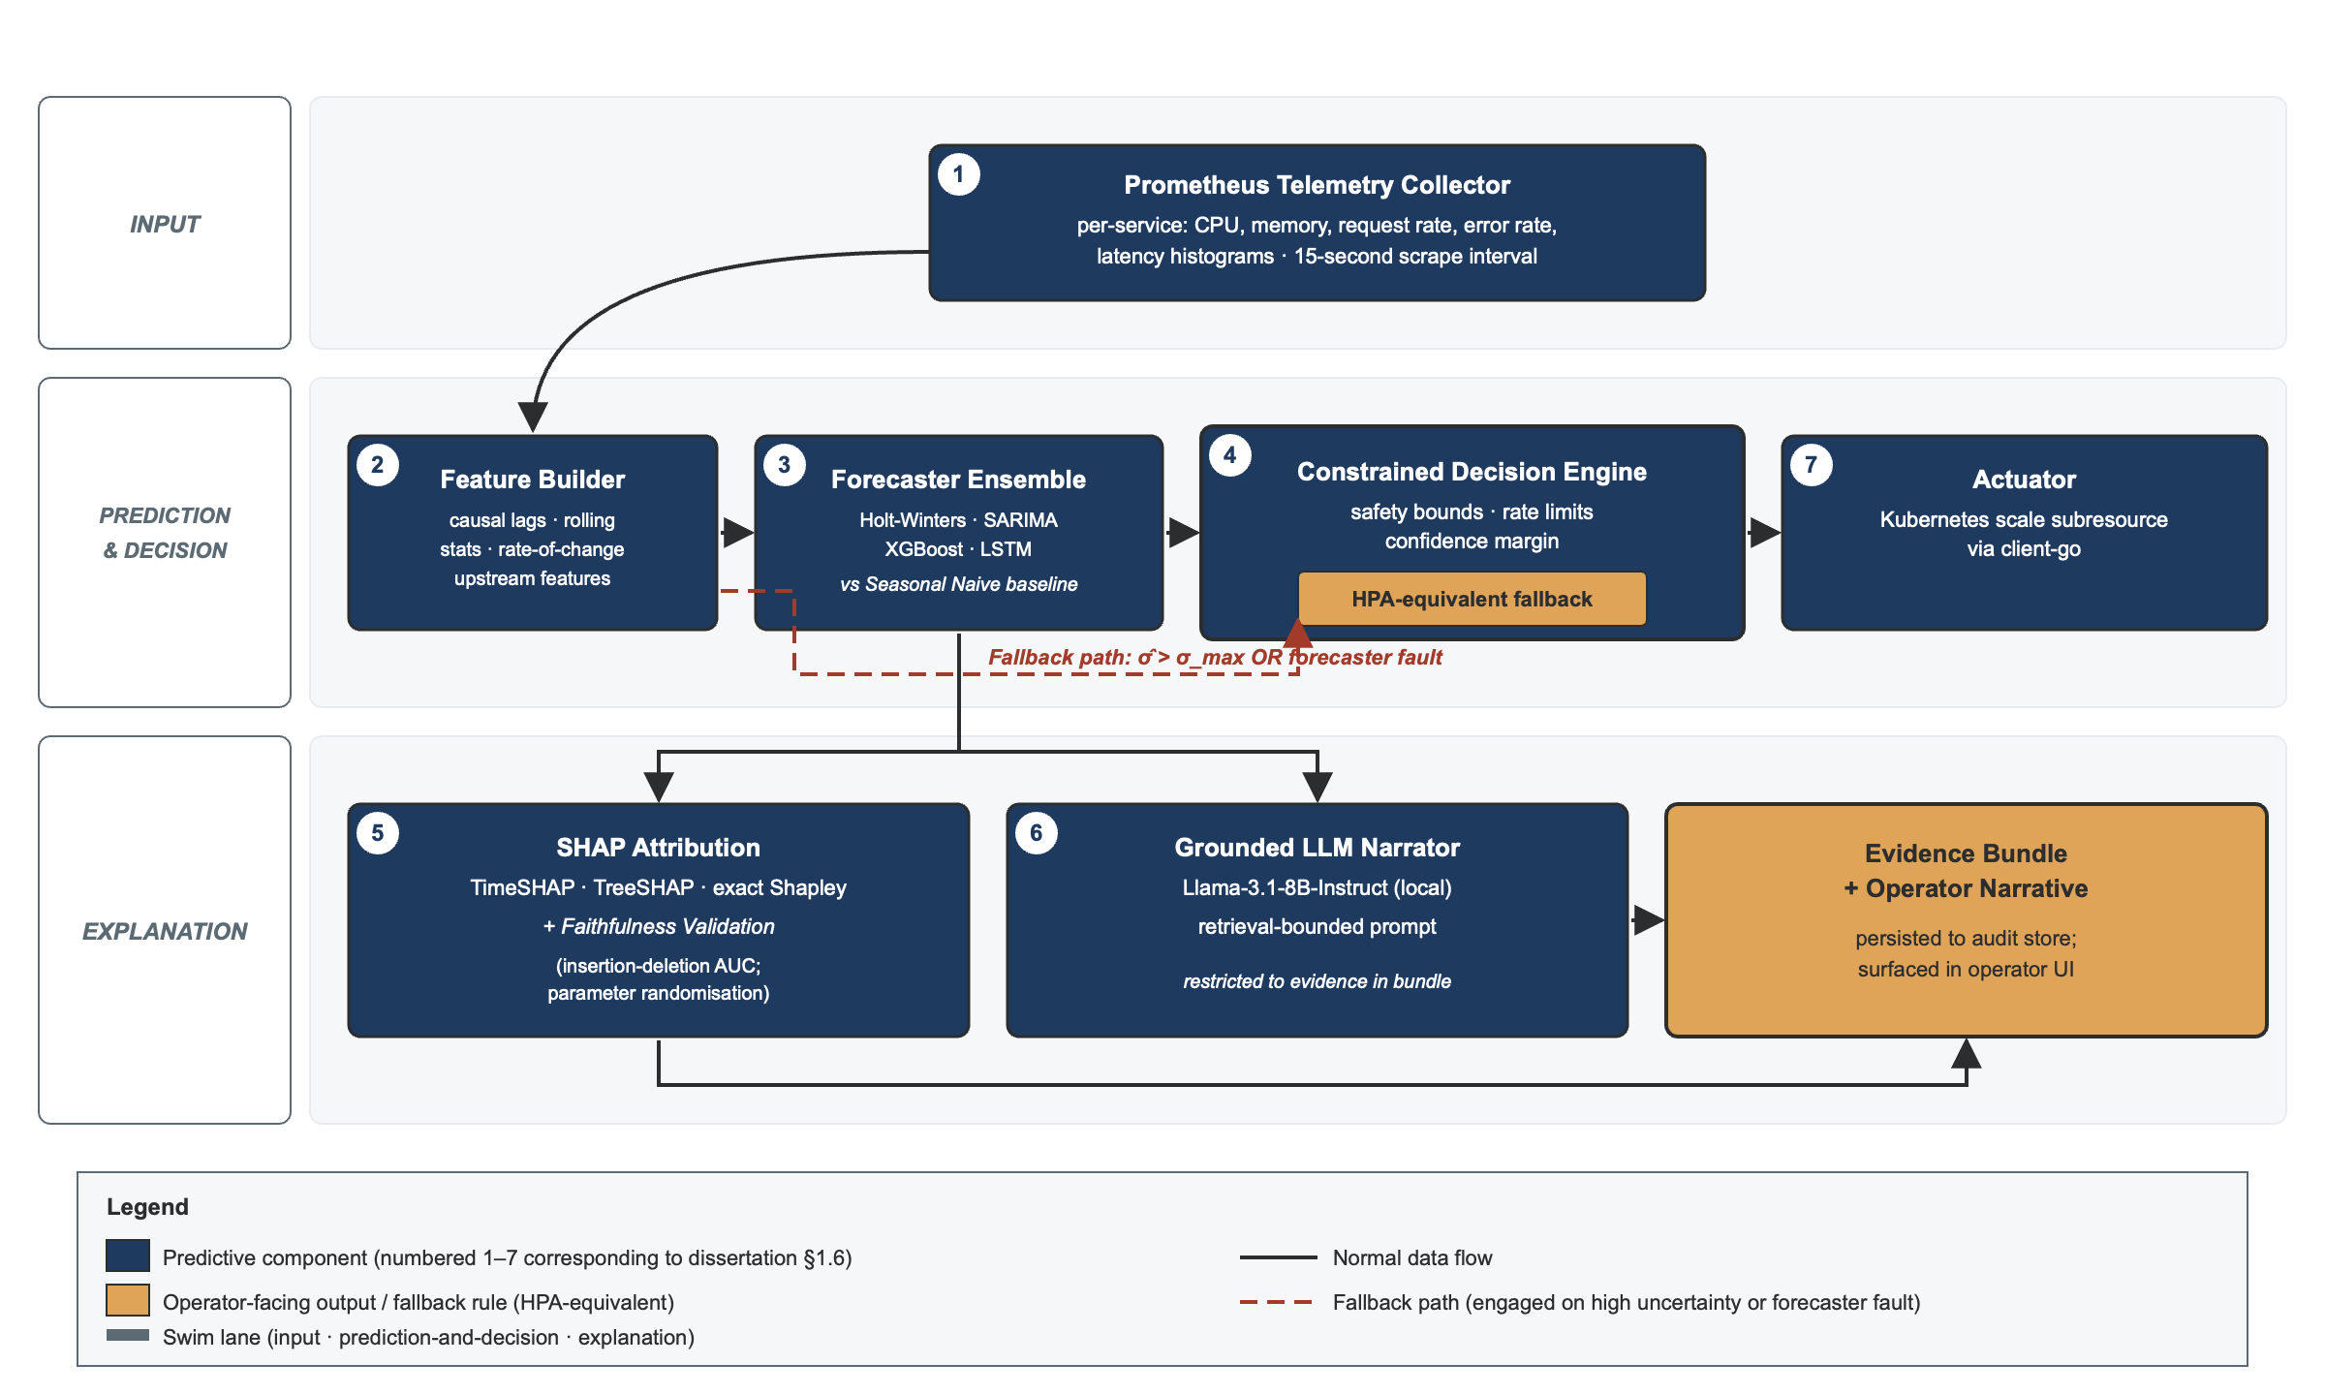
Figure 1.3. Hybrid Controller architecture: telemetry flows through forecasting, constrained decision-making and explanation, to actuation, with a deterministic fallback bypassing the predictive components on failure.
Component 1, the telemetry collector. Prometheus scrapes multivariate per-service metrics from the Online Boutique cluster every fifteen seconds (CPU, memory, request rate, error rate, response-time histograms).
Component 2, the feature builder. Raw metrics become supervised-learning sequences using only past values: lag features, rolling means and variances, and rate-of-change indicators.
Component 3, the forecaster ensemble. Four candidate models (Holt-Winters, SARIMA, XGBoost, LSTM) compete against a Seasonal Naive baseline; the best-performing model per service feeds the decision engine.
Component 4, the constrained decision engine. Forecasts map to replica recommendations through a clipped, rate-limited, confidence-aware formula with hard safety bounds and an uncertainty threshold that triggers a deterministic HPA-equivalent fallback (full specification in Section 3.7).
Component 5, the explanation engine. For each decision, it computes per-decision SHAP attributions (TimeSHAP for the LSTM, TreeSHAP for XGBoost, exact Shapley for the statistical baselines), validates faithfulness through insertion-deletion AUC, and assembles an evidence bundle of the metric window, forecast, decision record and attribution vector.
Component 6, the grounded LLM narrator. A local Llama-3.1-8B-Instruct model (Grattafiori et al., 2024) receives the evidence bundle through a retrieval-bounded prompt template (Lewis et al., 2020; Figure 3.5), restricted to values in the bundle and required to state uncertainty explicitly. An LLM, rather than a fixed template, handles the many combinations of features and fallback states a template would otherwise flatten into generic phrasing; the resulting hallucination risk is managed, not eliminated, through retrieval bounding and the triple-method evaluation in Section 3.8.
Component 7, the actuator. The decision engine’s replica count is applied to the Kubernetes API via the official client-go scale subresource, and the evidence bundle and narrative are logged to a structured audit store.
The critical design property is the separation between forecasting and actuation: forecasts never reach the actuator without passing through the constraint layer, and any failure in Components 3 to 5 triggers the deterministic fallback that keeps the system accountable, not merely automated.

1.7 Scope of the Research
This dissertation addresses horizontal pod autoscaling of stateless Kubernetes Deployments hosting the Online Boutique benchmark. The unit of decision is replica count per Deployment at thirty- to sixty-second forecast horizons. The primary evaluation is a controlled A/B experiment comparing the Hybrid Controller against HPA under four workload conditions (burst, ramp, periodic and real-trace replay) on a fixed-node-count cluster with pinned image versions and reproducible infrastructure-as-code. The primary outputs are the controller artefact, the evaluation results, the explanation-quality study and the published reproducibility package.

1.8 Limitations of the Research
Seven limitations are acknowledged:
• Node-level and vertical pod autoscaling are excluded, isolating application-layer elasticity from infrastructure provisioning.
• The primary benchmark is Online Boutique; a real-trace replay improves external validity, but generalisation to deeper call graphs is not yet directly demonstrated; a deep-topology run on DeathStarBench Social Network (Gan et al., 2019) is planned once the implementation (Chapter 4) is operational (Section 3.9).
• The forecast horizon is fixed at thirty to sixty seconds; multi-minute capacity planning is out of scope.
• The LLM is used solely for narrative summarisation, never decision-making, so explanation faithfulness, not causal explanation, is the relevant evaluation.
• Synthetic Locust/wrk2 workloads approximate but cannot reproduce production load; the Alibaba real-trace condition partially mitigates this.
• The explanation-quality rubric is rated by three independent reviewers over a small sample (n = 30); the rater pool will be expanded where feasible.
• The test cluster is a single rented cloud instance (§3.10-A); this is functionally equivalent to a small production deployment but not at production scale, and results are bound to the specification given there. Software versions and platform deviations are recorded in full in the reproducibility package (§3.10, §3.13).

1.9 Dissertation Structure
The dissertation comprises six chapters. This chapter has set out the motivation, research problem, aim, objectives, hypotheses, proposed Hybrid Controller, and scope and limitations. Chapter 2 reviews the relevant literature and synthesises the research gap. Chapter 3 details the methodology: data collection, forecaster design, the constrained decision engine, the explainability pipeline, the experimental design and the statistical analysis plan. Chapter 4 reports the implementation and results. Chapter 5 discusses those results, including the confirmed H1 finding, the partially confirmed H0 result, and the H2, H3 and H4 non-confirmations. Chapter 6 concludes and outlines the remaining work.
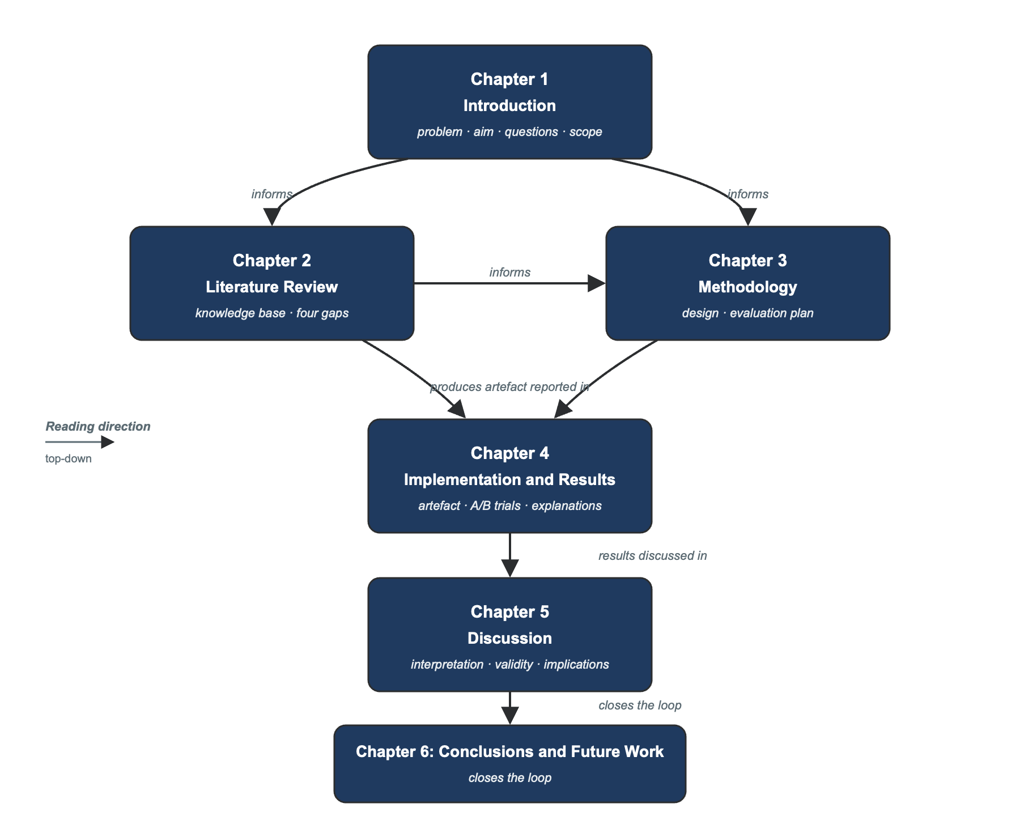
Figure 1.4. Dissertation roadmap: Chapter 2 informs Chapter 3, which produces the artefact reported in Chapter 4 and discussed in Chapter 5, before Chapter 6 concludes.

Chapter 2: Literature Review
This chapter reviews three bodies of prior work: attempts to make Kubernetes scaling responsive enough for latency-sensitive workloads, and where they fall short; methods for explaining what a machine-learning model is doing, and recent findings that those methods can be unreliable unless empirically validated; and the use of large language models to turn structured operational evidence into operator-friendly explanations, including the well-documented risk that such models can fabricate information. The review concludes with four research gaps that this dissertation addresses.

2.1 Introduction and Review Protocol
This chapter reviews the literature relevant to predictive and explainable Kubernetes autoscaling across nine substantive sections, synthesises four research gaps, and positions the dissertation’s contribution. Sources were identified through Boolean searches on Google Scholar, IEEE Xplore, the ACM Digital Library and arXiv (January 2018 to April 2026) using terms including ‘Kubernetes autoscaling’, ‘predictive autoscaling’, ‘LSTM workload prediction’, ‘SHAP attribution time series’, ‘LLM AIOps’ and ‘hallucination LLM mitigation’. Inclusion required peer-reviewed publication in a recognised venue, or, for very recent work, an arXiv preprint with at least one author from a research-active institution. Sixty-four sources were screened; forty-one are cited in this chapter.
The review follows the dissertation’s four research gaps. Sections 2.2 to 2.5 cover the control problem and existing reactive and predictive controllers (Gap 1). Section 2.6 covers forecasting model families. Sections 2.7 and 2.8 cover explainability and language-model hallucination (Gaps 2 and 3). Section 2.9 covers benchmarking. Section 2.10 synthesises the gaps, including a fourth methodological gap on evaluation rigour, and Section 2.11 positions the contribution. Each substantive paragraph follows a Task-Approach-Significance-Limitation pattern to keep critique explicit.

2.2 Cloud-Native Elasticity as a Control Problem
Autoscaling is often framed as a resource-allocation problem, but this understates the difficulty: it is more precisely a feedback control problem operating under delay, noise, partial observability and non-stationary disturbances. Dean and Barroso (2013) argue, in their canonical ‘Tail at Scale’ article, that fanned-out request paths in large-scale online services are dominated by tail latency: even when the median response time is low, the slowest ninety-ninth-percentile component dominates what users experience. The article is a position piece with anecdotal rather than independently reproduced evidence, but its framing shift from utilisation to user-perceived latency is widely adopted in later work, including Kanev et al.’s (2015) warehouse-scale tail-latency study at Google and the wider systems-evaluation literature establishing that tail-latency measurement needs open-loop, coordinated-omission-corrected instrumentation rather than the closed-loop generators common in academic studies (Schroeder et al., 2006; Tene, 2015). The metric choice in Section 3.11 is grounded in this combined evidence, not in Dean and Barroso (2013) alone.
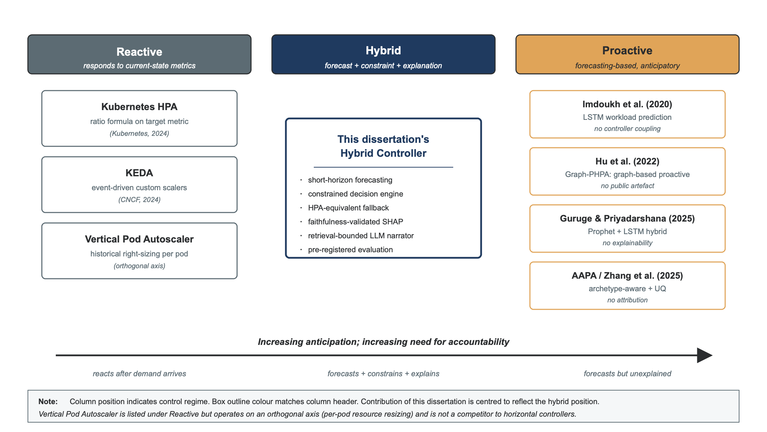
Figure 2.1. Taxonomy of Kubernetes autoscaling approaches, positioning reactive, proactive and hybrid controllers.
Rzadca et al. (2020), describing Google’s production Autopilot system, show that a ratio-based controller of the HPA pattern is operationally inadequate at Google’s scale; Autopilot replaces it with a coordinated horizontal-and-vertical controller observing multiple signals. Its significance for this dissertation is validating the forecast-constrain-recommend-fallback pattern adopted here. Its limitations are equally clear: the published account does not detail forecasting, offers no per-decision explanation, and reports no faithfulness or interpretability evaluation: precisely the two gaps this dissertation targets.
Qiu et al. (2020), introducing the FIRM framework, show on the DeathStarBench Social Network benchmark that SVM-based critical-path localisation combined with reinforcement-learning control reduces SLO violations by a factor of sixteen compared to HPA-class baselines, while cutting CPU allocation by sixty-two per cent. FIRM establishes the order-of-magnitude improvement an SLO-aware controller can deliver; this dissertation targets a similar magnitude through forecasting plus constrained actuation rather than reinforcement learning. Its limitations are twofold: no per-decision attribution or narrative is offered, so operators must interpret an opaque SVM classifier and RL policy unaided, and its deeper-call-graph benchmark complicates direct comparison with Online Boutique.
Three implications follow. First, the relevant objective for a new controller is tail latency under burst, not mean utilisation. Second, controllers should be evaluated against competitively tuned baselines rather than strawman defaults; Toka et al. (2021) provide a useful protocol for tuning HPA fairly. Third, improved metrics must not come at the cost of operational opacity; Autopilot and FIRM both show what is achievable in performance, but neither addresses operator accountability, which is exactly the gap this work fills.

2.3 Kubernetes HPA: Documented Failure Modes
Kubernetes’ HPA is well documented at the algorithmic level (Kubernetes, 2024). Three failure modes recur in empirical evaluations.
Failure mode one is reactive lag under burst workloads. Toka et al. (2021) measured HPA on a five-node Kubernetes edge cluster and found that scale-up lag, from burst arrival to new pods becoming Ready, exceeds the duration of typical burst spikes by a factor of two to four. This confirms empirically that forecasting, if accurate within the burst duration, can in principle close the gap. Their synthetic burst shapes and small edge-cluster context are limitations that this dissertation addresses with a real-trace replay condition, and their magnitudes may not transfer to data-centre deployments without recalibration.
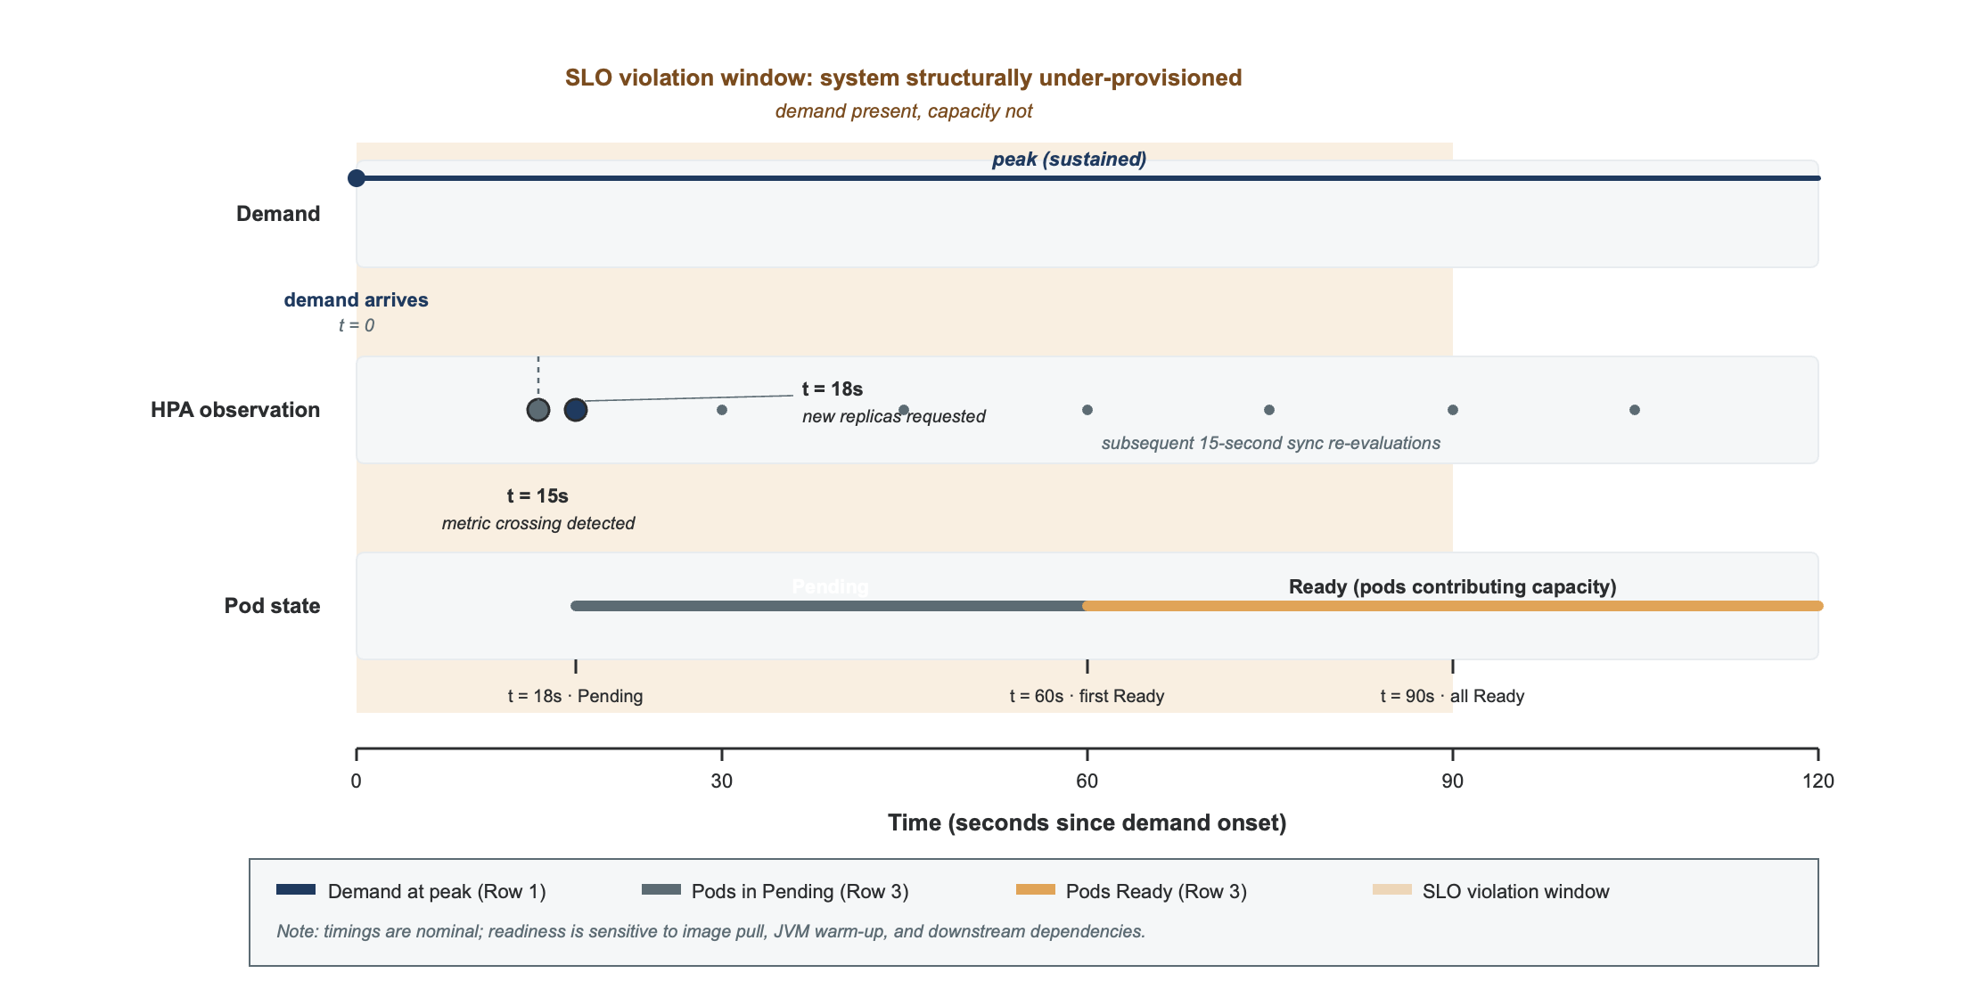
Figure 2.2. HPA failure-mode timeline under burst load, showing the SLO-violation window while new pods become Ready.
Failure mode two is oscillation under noisy metrics. Yu, Chen and Zheng (2023), in their Microscaler work, characterise the stabilisation-window pathology: a noisy CPU signal crosses the target ratio in both directions, triggering scale-up followed by scale-down with no real change in demand. This requires any new controller to include explicit rate limits and stabilisation treatment. Stabilisation windows trade responsiveness against stability as a pure tuning choice, whereas the confidence-aware margins introduced in Section 3.7 aim to do both simultaneously. Microscaler itself is reactive and offers no accountability layer, so it is treated here as a baseline pattern rather than a competitor.
Failure mode three is metric inadequacy. Dean and Barroso (2013) and Gan et al. (2019) show empirically that on microservice architectures, tail latency is often dominated by I/O, queueing and downstream contention, none of which is visible in container-level CPU or memory metrics. A CPU-targeted HPA can leave a service well below its threshold while ninety-fifth-percentile latency violates its target. This motivates scaling on multivariate inputs (request rate, error rate, latency percentiles and CPU) rather than CPU alone, though this enlarges the search space for both forecaster and explanation, which is exactly where SHAP attribution becomes valuable, since the decision is no longer reducible to a single threshold.
Two observations qualify this critique. First, Monzo (2020; 2024) shows that HPA is workable at industrial scale when complemented by application-level rate limiting and careful tuning, suggesting its structural limits can be partially mitigated outside the controller, though these are practitioner reports rather than peer-reviewed studies. Second, HPA’s simplicity is itself a feature: any replacement must be at least as reliable when its predictive components fail. The deterministic fallback path in Section 3.7 is the direct response to this observation.

2.4 Custom-Metric and Event-Driven Scaling
The Kubernetes ecosystem addresses HPA’s narrow metric set through three extensions: the Custom Metrics API, the External Metrics API, and the event-driven framework KEDA (Cloud Native Computing Foundation, 2024). KEDA exposes business and infrastructure events, such as queue depth or scheduled triggers, as scaling inputs through a uniform interface, and is widely used in production fintech and ML-inference workloads.
KEDA does not change the underlying control pattern, however. Like HPA, it is reactive on current state: it can read queue depth or stream lag but cannot forecast either, so if a queue is growing because demand is about to exceed capacity, KEDA reacts only after the queue has already built up. It widens the input space without closing the feed-forward gap, and there is no published empirical evaluation of its tail-latency impact comparable to Toka et al. (2021) for HPA.
The Vertical Pod Autoscaler (VPA) addresses a different axis: resource right-sizing per pod through historical usage analysis. It is orthogonal to horizontal scaling and is often disabled or set to recommendation-only in production, since resizing requires a pod restart that disrupts stateful or long-running services. VPA is not a competitor to this dissertation’s controller; the two approaches are in principle composable.
The input richness these extensions enable, including request rate per endpoint and business KPIs per service, is exactly what a forecasting controller benefits from. The feature builder in Section 3.5 consumes the same Prometheus-scraped multivariate signals that KEDA and Custom Metrics adapters expose, so the controller is in principle deployable in any cluster already running them. The shared limitation across all reactive event-driven autoscaling is the absence of anticipation, which Section 2.5 addresses.

2.5 Predictive and Proactive Autoscaling
Predictive autoscaling converts reactive feedback control into feed-forward control by forecasting near-term demand and acting before the system overloads. The literature reveals three recurring pitfalls, each addressed explicitly in this dissertation.
Pitfall one is that predictive gains are workload-dependent. Imdoukh, Ahmad and Alfailakawi (2020) trained an LSTM on a Wikipedia request trace and reported 8.7 per cent MAPE at thirty seconds ahead, outperforming ARIMA: empirical confirmation that short-horizon forecasting is feasible at Kubernetes pod-readiness granularity. Their limitation is the absence of end-to-end evaluation: they do not couple the forecaster to a controller and so report no improvement in latency or SLO-violation rate, which is exactly the gap this work closes.
Pitfall two is conflating model complexity with superiority. Guruge and Priyadarshana (2025) combined Prophet and LSTM in a control loop and reported under three per cent MAPE on HTTP-request prediction. The Prophet-plus-LSTM hybrid is now an established baseline rather than a contribution, and although their evaluation reports a ninety-fifth-percentile latency improvement, it does not address safety constraints, fallback or explainability, and the control loop is described without per-decision audit logs, precluding external review. This work therefore treats Prophet and LSTM as competing baselines and seeks its contribution in the constraint and explanation layers.
Pitfall three is that predictive controllers without safety constraints can degrade availability. Hu et al. (2022), in their Graph-PHPA preprint, show the cross-service coupling problem: forecasting each service in isolation under-represents the dependency structure of a microservice graph, so scaling decisions based on one service alone may starve upstreams or oversupply downstreams. This work partially mitigates the issue by consuming upstream request rate as a feature for downstream forecasters, while acknowledging that a full graph treatment is out of scope; Graph-PHPA’s own artefact, like several recent autoscaling preprints, is not publicly released, so replication is not possible.
A parallel research stream pursues reinforcement learning (RL) as the main alternative to forecasting-based control; FIRM (Qiu et al., 2020) and HPAQT (Mayerhofer et al., 2025) are exemplars. RL optimises the operational objective end-to-end, avoiding the forecasting-to-actuation translation error that motivates Section 3.7’s constraint layer, but has three disadvantages: poor sample efficiency in production, since a useful policy needs a high-fidelity simulator or extensive live exploration; opacity by construction, since HPAQT’s Q-value transparency exposes the learned value function but not which input features mattered or by how much; and an off-policy validation problem, since a policy learned in one workload regime may behave unpredictably in another. The choice of forecasting plus constrained actuation over RL is therefore an interpretability and safety choice, not a performance one; RL remains a legitimate comparator, revisited in Chapter 5 as future work.
Three further works refine the predictive-autoscaling space. Punniyamoorthy et al. (2025) present a multi-signal controller marketed as ‘safe and explainable’, reporting a thirty-one-per-cent SLO-violation reduction with faster response and lower cost; as an unreviewed arXiv preprint, its claimed magnitudes should be treated cautiously. This work differentiates by treating explanation as a model-attributive layer (SHAP) plus a grounded natural-language layer (LLM), rather than procedural transparency. Zhang et al. (2025), in AAPA, introduce archetype-aware predictive scaling with uncertainty quantification, similar to this dissertation’s confidence-margin component but without the explanation coupling. HPAQT advances interpretable RL autoscaling through Q-value transparency, intrinsic rather than post-hoc interpretability, constrained by the state-space size its tabular Q-values can handle.
Two non-machine-learning approaches deserve mention. Mahmoudi and Khazaei (2025), in STaleX, show that a weighted PID controller can achieve a 26.9 per cent resource reduction on SockShop without machine learning, a reminder that classical control remains competitive on simpler workloads and that predictive controllers must prove their worth specifically on burst workloads. STaleX’s reliance on SockShop, whose design flaws are documented in Section 2.9, is a limitation. The second non-ML baseline is Microscaler (Yu, Chen and Zheng, 2023), discussed in Section 2.3.
Approach | Forecaster | Decision logic | Strength | Limitation for this work
HPA (baseline) | None | Ratio formula | Ubiquitous; predictable | Reactive lag; single-metric
KEDA (CNCF, 2024) | None | Event-driven | Multi-signal | Still reactive
Autopilot (Rzadca et al., 2020) | Proprietary | Coordinated H+V | Production-validated | No XAI; no public artefact
FIRM (Qiu et al., 2020) | SVM | RL policy | 16× SLO improvement | Opaque; deep call graph only
AAPA (Zhang et al., 2025) | Archetype plus UQ | Confidence-weighted | Uncertainty-aware | No attribution
Guruge and Priyadarshana (2025) | Prophet plus LSTM hybrid | MAPE-K | Sub-3% MAPE | No XAI; no faithfulness validation
Punniyamoorthy et al. (2025) SLO Driven | Multi-signal | Procedural rules | Cost-aware; named ‘explainable’ | Preprint only; no attribution; no LLM
HPAQT (Mayerhofer et al., 2025) | RL Q-network | Q-value transparent | Intrinsic interpretability | Tabular Q-values constrain state space
STaleX (Mahmoudi and Khazaei, 2025) | Spatiotemporal PID | Weighted PID | 26.9% resource reduction; no ML | Reactive; no XAI
This dissertation (Hybrid) | Multivariate Prometheus | Forecast plus constraint plus HPA fallback | Validated SHAP plus grounded LLM in autoscaling | Single primary benchmark; LLM cost
Table 2.1. Comparative autoscaling approaches across the present literature.
The synthesis across surveyed predictive controllers is that forecasting at microservice horizons is feasible, that safety must be engineered as a separate component rather than emerging from the forecaster, and that explainability, where claimed, has meant procedural or intrinsic interpretability rather than per-decision feature attribution coupled with an operator-readable narrative. This last observation is the substance of this dissertation’s contribution.

2.6 Time-Series Forecasting Model Families
The choice between these families is not settled, and the Makridakis forecasting competitions are the principal evidence. The M4 competition (Makridakis, Spiliotis and Assimakopoulos, 2018) compared statistical and machine-learning forecasters on one hundred thousand series and found that hybrid and pure-statistical methods dominated the leaderboard, with pure machine-learning methods underperforming on average. The M5 competition extended this to retail-demand forecasting and confirmed that carefully tuned simple methods remain competitive against deep learning. For autoscaling, this means complexity is not a free virtue: an LSTM that beats SARIMA on one workload may underperform a Seasonal Naive baseline on another, so model selection must be empirical. Section 3.6 operationalises this by including Seasonal Naive as a non-negotiable baseline and selecting per service on held-out RMSE, with parsimony as an explicit tiebreaker.
Recent applications to microservice workloads include Imdoukh et al. (2020) on LSTM superiority, Xu et al. (2022) on attention-based deep networks (ESDNN), and Dogani et al. (2023) on a CNN-GRU-with-attention hybrid. Each reports lower RMSE than statistical baselines on its own trace, but the gains are workload-dependent and the parameter budgets are large; the Makridakis principle applies: parsimony first, complexity only where measurably justified.
Model | Family | Strength | Weakness | Source
Seasonal Naive | Baseline | Zero parameters | Cannot adapt | Hyndman and Athanasopoulos (2021)
Holt-Winters | Exponential smoothing | Trend plus seasonality | Linear assumption | Hyndman and Athanasopoulos (2021)
SARIMA | Statistical | Strong baseline | Compute-heavy at scale | Hyndman and Athanasopoulos (2021)
Prophet | Decomposition | Robust to data gaps | Limited at sub-minute horizons | Taylor and Letham (2018)
XGBoost | Tree ensemble | Fast; engineered features | Needs feature engineering | Chen and Guestrin (2016)
LSTM | Sequence (RNN) | Temporal dependence | Data-hungry; SHAP unfaithfulness risk | Hochreiter and Schmidhuber (1997)
DeepAR and TFT | Probabilistic sequence | Prediction intervals | Operationally heavy | Salinas et al. (2020); Lim et al. (2021)
ESDNN | Attention DNN | Multivariate | Compute-heavy | Xu et al. (2022)
CNN-GRU plus attention | Hybrid | Multivariate | Complex | Dogani et al. (2023)
Table 2.2. Forecasting models considered in this dissertation’s evaluation.
This dissertation evaluates five forecaster families per Online Boutique service (Seasonal Naive, Holt-Winters, SARIMA, XGBoost and LSTM) against held-out RMSE. Newer models (DeepAR, TFT, ESDNN) are recognised in Table 2.2 but excluded because their operational footprint exceeds what a small Kubernetes cluster can support for repeated controlled trials; their inclusion is future work (Chapter 6).

2.7 Explainable AI: SHAP and the Limits of Attribution
Feature-attribution methods answer a specific question: for a single model prediction, which inputs mattered, and by how much? SHAP (Lundberg and Lee, 2017) is the dominant method in production machine-learning pipelines, grounded in cooperative game theory: each feature is a player whose attribution is its Shapley value, the average marginal contribution across all possible feature coalitions. Shapley values are the unique attribution satisfying efficiency, symmetry, dummy and additivity axioms, which gives SHAP its mathematical legitimacy.
Three SHAP variants matter here. KernelSHAP is the model-agnostic approximation suitable for any black-box model, including the LSTM. TreeSHAP (Lundberg et al., 2020) is the exact polynomial-time algorithm for tree ensembles, suitable for XGBoost. Exact Shapley computation is tractable for the statistical baselines because their feature dependence is closed-form. This dissertation uses TreeSHAP for XGBoost, exact Shapley for Holt-Winters and SARIMA, and a sequence-aware variant for the LSTM.
Four critiques of SHAP must be engaged with. Slack et al. (2020) show that adversarially constructed models can pass SHAP-based fairness audits while behaving discriminately, so explanations must come from a model the operator can independently verify, not a black-box service, though their threat model is adversarial, whereas the immediate autoscaling risk is unfaithfulness, not manipulation. Huang and Marques-Silva (2023) show concrete cases where Shapley values mislead about feature importance in real classifiers. Bilodeau et al. (2024) prove impossibility theorems for SHAP and similar methods: for sufficiently rich function classes encompassing LSTMs, they can fail to outperform random attribution. Aas, Jullum and Løland (2021) show KernelSHAP’s standard approximation assumes feature independence and is biased under correlated features: a direct concern here, since microservice telemetry (request rate, CPU utilisation, response-time histograms) is highly correlated by construction, and a concrete reason for preferring TreeSHAP and TimeSHAP, which model that correlation exactly, over vanilla KernelSHAP.
The implication is severe but not fatal: SHAP attributions are not guaranteed faithful, but they are validatable. Three faithfulness tests are established in the XAI literature. Insertion-deletion AUC (Petsiuk et al., 2018) progressively inserts or deletes the top-attributed features and measures how the prediction changes; faithful attributions produce a steep insertion curve and a shallow deletion curve. The ROAR protocol (Hooker et al., 2019) retrains the model with the top-k attributed features removed and compares against random removal; faithful attributions degrade accuracy more than random removal does. The parameter-randomisation sanity check (Adebayo et al., 2018) verifies that attributions change when model parameters are randomised, as faithful explanations must.
Technique | Scope | Model class | Property for this work | Source
KernelSHAP | Local | Any | Generic; biased under correlated features; faithfulness contested on LSTMs | Lundberg and Lee (2017); Aas et al. (2021)
TreeSHAP | Local and global | Tree ensembles | Exact; ideal for XGBoost | Lundberg et al. (2020)
TimeSHAP | Local | Recurrent (LSTM) | Sequence-aware; best for LSTM in this work | Bento et al. (2021)
WindowSHAP | Local | Time-series classifiers | Efficient; multivariate | Nayebi et al. (2023)
LIME | Local | Any | Instability under perturbation | Ribeiro et al. (2016)
Attention attribution | Local | Transformer or attention RNN | Contested as explanation | Jain and Wallace (2019)
Table 2.3. Explainable-AI techniques relevant to time-series autoscaling.
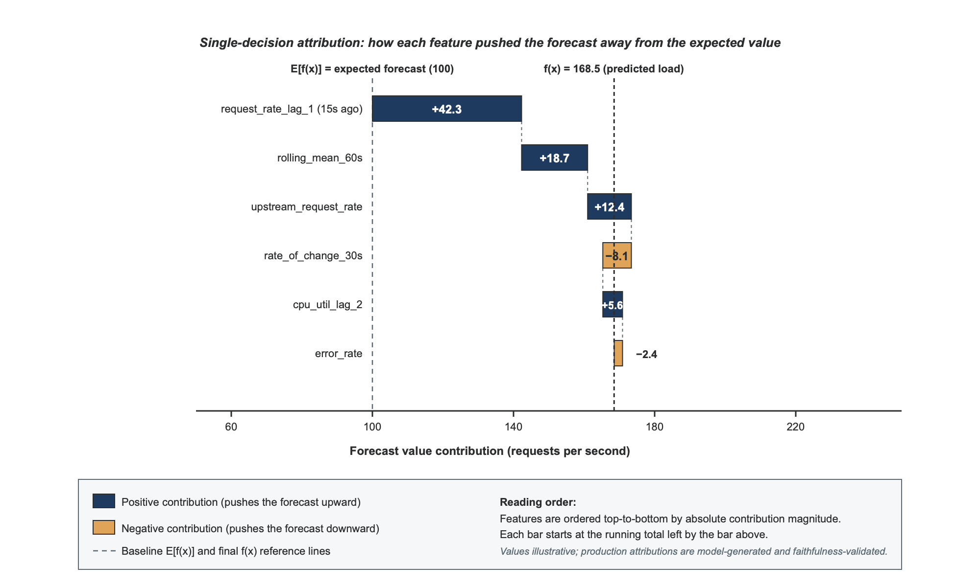
Figure 2.3. Illustrative SHAP waterfall plot for a scaling decision, showing each feature’s contribution to the forecast.
For time series specifically, Schlegel et al. (2019) find SHAP performs reasonably but is sensitive to baseline choice (zero, mean or random) against which marginal contribution is computed. Relatedly, Jain and Wallace (2019) find that attention weights, sometimes proposed as a cheap alternative to SHAP, are uncorrelated with model behaviour and do not constitute explanation. Two extensions specialise SHAP to time series: TimeSHAP (Bento et al., 2021) extends KernelSHAP to recurrent models with feature-, timestep- and cell-level attribution, and WindowSHAP (Nayebi et al., 2023) groups adjacent timesteps into windows, cutting compute by around eighty per cent on long series. This dissertation uses TimeSHAP for the LSTM forecaster, validated with insertion-deletion AUC and the parameter-randomisation check (Chapter 4); TimeSHAP has been benchmarked on far fewer datasets than KernelSHAP, so its faithfulness on microservice time series is itself a question this work contributes evidence on.
The synthesis is that SHAP is the right tool for this dissertation’s purpose (per-decision attribution operators can inspect), provided faithfulness is empirically validated rather than assumed. This is Gap 3, identified in Section 2.10.

2.8 Large Language Models in AIOps
Large language models offer a complementary capability to feature attribution: converting structured evidence into operator-readable narratives. Ouyang et al. (2022) show that instruction-tuned LLMs can reliably follow constrained-format prompts. Lewis et al. (2020) introduce retrieval-augmented generation (RAG), the dominant pattern for grounding LLM outputs in external evidence. Touvron et al. (2023) release Llama 2, the first open-weight model competitive with proprietary alternatives on instruction-following. Together these establish the technical preconditions for using an LLM as a controlled narrative layer over structured AIOps evidence, the use this dissertation makes of the technology.
Two recent works demonstrate the AIOps application directly. Vitui and Chen (2025) deploy LLM agents over Red Hat OpenShift documentation through RAG, reporting substantial reductions in operator triage time and validating the LLM-over-Kubernetes pattern; however, their system does not make scaling decisions or address per-decision evidence, since the LLM is a search-and-summarisation layer over static documentation rather than a narrative layer over a control decision: the gap this work fills. Roy et al. (2024) deploy GPT-4 with in-context learning for cloud-incident root-cause analysis across one hundred and one thousand incidents, showing LLM narratives at industrial scale can outperform traditional ML triage, though their proprietary system’s undisclosed details limit scrutiny.
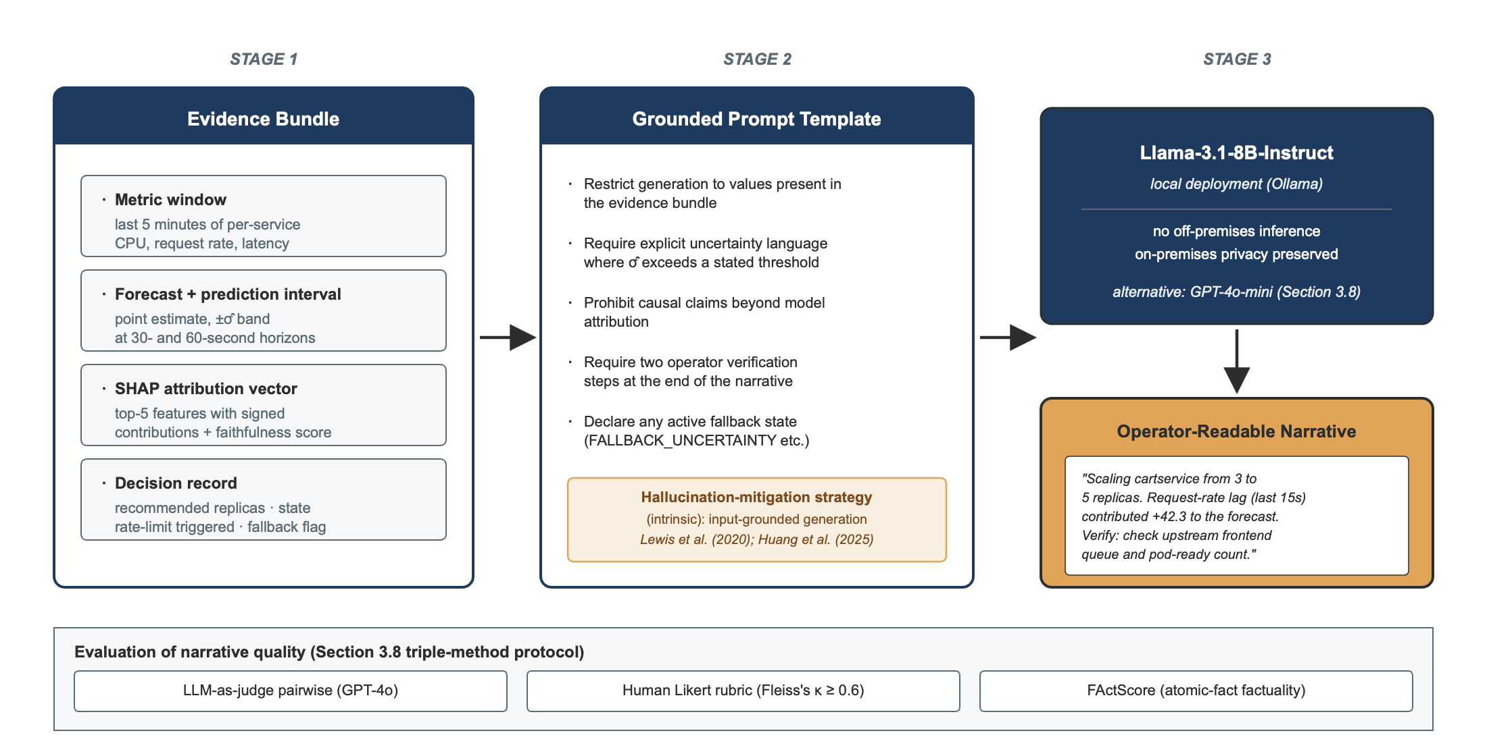
Figure 2.4. Evidence-bundle to retrieval-augmented LLM narrative flow.
The principal risk of LLM use in a control context is hallucination. Ji et al. (2023) establish the canonical distinction: extrinsic hallucination is content that is non-factual relative to external truth, while intrinsic hallucination contradicts or is unsupported by the input the model was given. For a control-loop narrative grounded in an evidence bundle, the dominant hazard is intrinsic: if the bundle shows request-rate features drove the forecast but the narrative cites CPU saturation, the operator is misled even if that claim might be true elsewhere. The retrieval-bounded prompt design in Section 3.8 targets intrinsic hallucination through input-grounded generation, and the FActScore evaluation in the same section measures intrinsic factuality directly. Huang et al. (2025) present the most comprehensive recent taxonomy of hallucination causes and mitigations, identifying retrieval-bounded prompting, chain-of-verification, self-consistency decoding and constrained generation as the four most effective mitigation families.
A limitation of the hallucination literature is that most mitigations are evaluated on open-domain question answering rather than narrow-domain operational reasoning, so their effectiveness for autoscaling narratives is not directly demonstrated. Manakul, Liusie and Gales (2023) propose SelfCheckGPT, a sampling-based detection method needing no retrieval. Es et al. (2024) introduce RAGAS, a RAG-specific factuality and relevance framework whose factuality component aligns methodologically with the FActScore approach used here. Niu et al. (2024) provide RAGTruth, a benchmark showing that even well-engineered RAG systems hallucinate at non-trivial rates (above twenty per cent), reinforcing that retrieval bounding mitigates but does not eliminate hallucination. This dissertation takes the same position: the LLM narrator is bounded, evaluated for residual factuality, and framed explicitly as a non-actuating advisory layer (Section 3.8), not a hallucination-free oracle.
Hallucination in a control loop is hazardous in two ways. A hallucinated causal claim, for example ‘CPU saturation caused this scale-up’ when the model actually responded to request rate, can mislead operators into mistreating the underlying incident. And fluent narratives induce automation bias: Parasuraman and Manzey (2010) show experimentally that people over-rely on automated advice presented with confidence, even when it is demonstrably wrong. The combination of hallucination and automation bias (confident but wrong) is the worst case for AIOps deployment.
This dissertation’s response is methodological rather than model-architectural. Following Huang et al. (2025), the LLM is restricted to a retrieval-bounded prompt that receives only the evidence bundle (metric window, SHAP attribution vector, prediction interval, decision record) and is instructed to reference only values present in it, report uncertainty explicitly, and recommend verification steps. The prompt template is specified in Section 3.8.
LLM output quality is measured through a triple-method protocol: pairwise LLM-as-judge comparisons against three baselines (raw Kubernetes events, a SHAP-only summary and a placebo narrative), following Zheng et al. (2023); a human Likert rubric scored by three raters with Fleiss’s kappa as the inter-rater agreement metric (target at least 0.6, per Landis and Koch, 1977); and atomic factuality scoring via FActScore (Min et al., 2023). Together these address the three principal failure modes of LLM-AIOps narrative: subjective preference, dimension-specific quality and atomic factual correctness. A limitation is that LLM-as-judge introduces its own bias, documented by Zheng et al. as position and verbosity preferences, which is partially controlled by swapping comparison positions but not fully eliminated; the choice of judge model (Section 3.8) introduces a further model-family bias risk that is addressed methodologically.

2.9 Microservice Benchmarks
Benchmark choice is a methodological commitment that shapes the conclusions any autoscaling study can draw. Three benchmarks dominate the contemporary literature.
Online Boutique, maintained by Google (GoogleCloudPlatform, 2024), comprises eleven services connected by gRPC calls in a shallow but realistic fan-out pattern. Sachidananda and Sivaraman (2022) used it to show that no single CPU threshold performs well across burst and steady-state workloads, giving this dissertation a documented prior-art baseline on the same benchmark. Its limitation is that the shallow call graph under-represents the fan-out depth of production systems, so results may not transfer to deeper topologies without further evaluation.
DeathStarBench (Gan et al., 2019) comprises four end-to-end applications (Social Network, Hotel Reservation, Media Streaming, Banking) with deeper call graphs than Online Boutique. Its Social Network workload, used by FIRM (Qiu et al., 2020), comprises twenty-eight services with deep critical paths and is the de facto standard for SLO-aware autoscaling evaluation, though its operational overhead is significantly higher than Online Boutique’s, constraining experimental throughput.
SockShop is a mid-realism benchmark with thirteen services and is used in STaleX (Mahmoudi and Khazaei, 2025). Recent benchmark-critique work specifically flags real-world design flaws in SockShop, including incomplete call graphs, error masking and misconfigured readiness probes, that ‘impair the effectiveness of autoscaling methods’ when used as the sole evaluation venue.
This dissertation adopts Online Boutique as the primary benchmark for three reasons: it is reproducible on a commodity single-node cluster; it supports the controlled, repeated, statistically-powered trials the methodology demands; and prior art (Sachidananda and Sivaraman, 2022) supports fair HPA tuning on this exact benchmark. External validity is addressed through a real-trace replay using the Alibaba microservices trace (Luo et al., 2021) or the Azure Functions trace (Shahrad et al., 2020). The acknowledged limitation, stated honestly in Sections 1.8 and 3.13, is that generalisation to deep-call-graph systems such as DeathStarBench Social Network is not yet directly demonstrated; Section 3.9 sets out a planned follow-on experiment to address this.

2.10 Research Gap Synthesis
Four gaps motivate this dissertation, each defensible against the 2023 to 2026 literature surveyed above. The first three restate the weaknesses identified in Section 1.3.4; the fourth concerns evaluation methodology.
Gap 1. Predictive autoscalers do not couple their forecasts to faithfulness-validated, per-decision feature attributions exposed to operators. Recent predictive controllers (AAPA, Zhang et al., 2025; Graph-PHPA, Hu et al., 2022; and the work of Guruge and Priyadarshana, 2025, among them) report forecasting accuracy but expose no model-attributive evidence for why a given scaling decision was made. Feature attribution has been applied to workload forecasting in adjacent settings, for example attention-based attribution for cloud resource prediction (Dogani et al., 2023), but to the author’s knowledge, based on the review above, no prior work integrates faithfulness-validated SHAP attribution into a deployed Kubernetes autoscaling controller with per-decision evidence persisted for operator inspection. Where ‘explainable autoscaling’ is claimed (Punniyamoorthy et al., 2025; Mayerhofer et al., 2025), the explanation is procedural or intrinsic, not attributive. This dissertation aims to contribute the first such integration to the author’s knowledge; the implementation and its faithfulness evaluation are addressed in Section 3.8, with results reported in Chapter 4.
Gap 2. Whether retrieval-bounded LLM narratives can be made faithful enough for control-loop deployment has not been empirically answered. Operator-readable narratives generated by LLMs have been demonstrated for incident analysis (Vitui and Chen, 2025; Roy et al., 2024) but not for scaling decisions, and the hallucination risk of unconstrained LLM generation in a control context has been acknowledged (Ji et al., 2023; Huang et al., 2025; Niu et al., 2024) but not operationalised as a retrieval-bounded grounding strategy specific to autoscaling evidence bundles. This dissertation’s contribution is therefore not the LLM narrator as engineering, but the empirical evidence on whether such a narrator, restricted by a specific prompt design, achieves the factuality and operator-utility scores control-loop use requires. The grounding pattern and evidence are addressed in Section 3.8 and Chapter 4.
Gap 3. The SHAP literature shows vanilla KernelSHAP can be unfaithful on recurrent models, on rich function classes, and on correlated-feature inputs (Schlegel et al., 2019; Bilodeau et al., 2024; Huang and Marques-Silva, 2023; Aas et al., 2021). No prior autoscaling work has reported faithfulness validation of its explanations. This dissertation closes that gap by reporting insertion-deletion AUC (Petsiuk et al., 2018) and a parameter-randomisation sanity check (Adebayo et al., 2018) on every SHAP attribution, addressed in Section 3.8.
Gap 4. Recent autoscaling evaluations, including Guruge and Priyadarshana (2025), Punniyamoorthy et al. (2025) and Zhang et al. (2025), typically report point-estimate metrics without pre-registration, bootstrap intervals on quantile metrics, or robustness checks such as paired permutation tests, making claimed improvements difficult to compare and reproduce. This dissertation contributes a pre-registered evaluation protocol with bootstrap BCa confidence intervals on quantile metrics, paired permutation tests as a robustness check, and Bonferroni-Holm correction across the seven primary metrics, addressed in Section 3.12.
Two non-gaps must be stated honestly. The hybrid forecasting layer (Prophet plus LSTM) is not novel (Guruge and Priyadarshana, 2025, and many predecessors established this pattern), and safety constraints and confidence margins individually are not novel either, since AAPA (Zhang et al., 2025) implements both. This dissertation’s novelty lies entirely in integrating forecasting, constrained actuation, faithfulness-validated attribution and grounded LLM narration as a single accountable controller, evaluated under controlled bursts with a triple-method explanation-quality protocol and a pre-registered statistical analysis plan.

2.11 Conclusion and Positioning
This chapter has reviewed the literature relevant to predictive and explainable Kubernetes autoscaling, establishing five conclusions. First, the relevant objective for any new controller is tail latency under burst, not mean utilisation. Second, predictive autoscaling is feasible at the horizon pod readiness requires, but safety must be an explicit constraint layer rather than emerging from the forecaster. Third, where ‘explainable autoscaling’ has been claimed recently, it has meant procedural or intrinsic transparency rather than per-decision attribution and grounded narration. Fourth, the established critiques of SHAP on recurrent models, rich function classes and correlated inputs require any controller exposing SHAP explanations to validate faithfulness empirically. Fifth, evaluation methodology is itself a contribution opportunity: pre-registration, bootstrap intervals and permutation robustness checks are uncommon in the field and are adopted here.
Given this landscape, the dissertation’s contribution is the design and controlled evaluation of a Hybrid Controller integrating forecasting, constrained actuation, faithfulness-validated SHAP attribution and retrieval-bounded grounded LLM narration as a single artefact, evaluated under burst, ramp, periodic and real-trace workloads with bootstrap-confidence-interval reporting and a triple-method explanation-quality protocol. Chapter 3 presents the methodology by which this contribution is operationalised and evaluated.

Chapter 3: Methodology

3.1 Introduction
This chapter details the methodology by which the Hybrid Controller was designed, implemented and evaluated, across sixteen sections covering research philosophy, the design-science approach, the controlled experimentation strategy, data collection and feature engineering, forecasting-model design, the constrained decision engine, the explainability pipeline, the experimental design, the testing environment, evaluation metrics, the statistical analysis plan, threats to validity, ethics, safety and sustainability, methodology stages, and a chapter summary. Figure 3.1 shows the end-to-end pipeline.
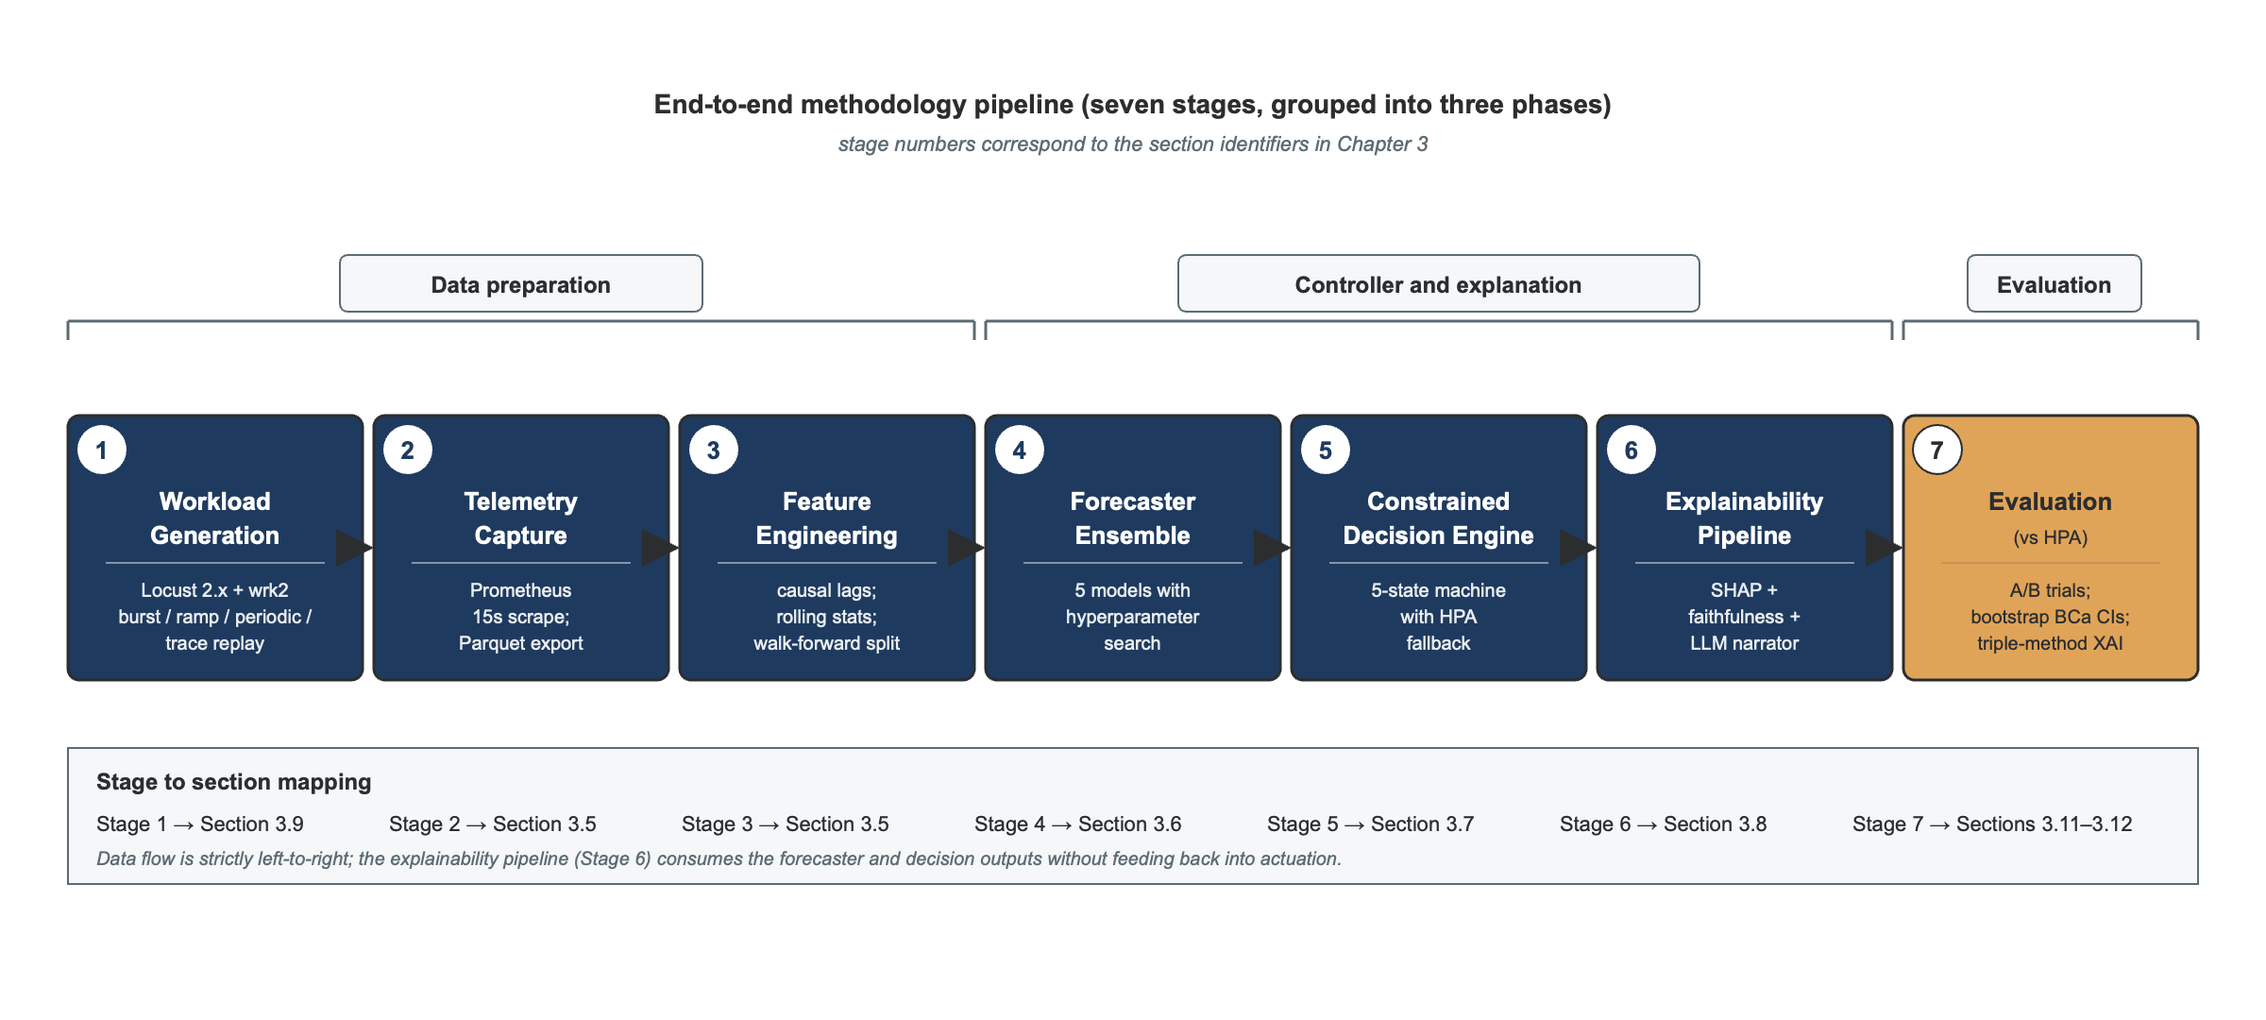
Figure 3.1. End-to-end methodology pipeline, from workload generation through forecasting and decision-making to evaluation.

3.2 Research Philosophy
This study adopts a pragmatic research philosophy: methods are chosen for their fitness to answer the research questions rather than allegiance to a single epistemological tradition. Saunders, Lewis and Thornhill (2019) place pragmatism between the positivist and interpretivist extremes of the Research Onion, appropriate for research that is both technical and oriented towards practical utility. Pragmatism suits this dissertation because the contribution is an engineered artefact evaluated in a bounded context, so knowledge claims are conditional on the benchmark and configuration rather than universal.
Pragmatism does not licence methodological laxity, however. The artefact must be evaluated under conditions supporting causal inference about its properties: controlled experimentation, repeated trials, pre-registered analysis and full reproducibility. The philosophy therefore pairs pragmatism on knowledge with positivism on measurement: claims are framed cautiously, but the measurements behind them are designed to meet the standards of empirical software engineering set out by Wohlin et al. (2012).

3.3 Research Approach: Design Science Research
This dissertation adopts the design-science research (DSR) approach articulated by Hevner et al. (2004) and operationalised as a six-stage process by Peffers et al. (2007). DSR is appropriate because the contribution is a purposeful, evaluable artefact addressing a defined problem in a defined environment.
Hevner et al.’s three-cycle framework structures the work. The relevance cycle establishes the problem environment (fintech microservices under bursty workloads with operational-resilience requirements) and the requirements the artefact must meet (Chapter 1). The rigor cycle grounds the artefact in existing autoscaling, forecasting, XAI and LLM literature (Chapter 2). The design cycle is the iterative construction-and-evaluation loop described in this chapter and reported in Chapter 4.
Peffers et al.’s six DSR stages map onto this dissertation as follows. (1) Problem identification and motivation: Chapter 1 Section 1.3. (2) Definition of objectives: Chapter 1 Section 1.4. (3) Design and development: this chapter, reported in Chapter 4 Section 4.1. (4) Demonstration: the controlled experiments specified in Section 3.9, reported in Chapter 4 Sections 4.2 to 4.5. (5) Evaluation: the multi-metric assessment in Section 3.11 with statistical analysis in Section 3.12. (6) Communication: this dissertation and the reproducibility package in Section 3.10.
DSR accepts that knowledge claims about an artefact are bound to the evaluation environment. This dissertation claims that the Hybrid Controller dominates HPA on the Online Boutique benchmark under the specified workloads with the specified statistical confidence, not that it is universally superior. Generalisation is treated as an external-validity question in Section 3.13 and as future work in Chapter 6.

3.4 Research Strategy: Controlled A/B Experimentation
The strategy for evaluating the artefact is a controlled A/B comparison between two conditions: Condition A, the Kubernetes HPA baseline tuned competitively per Sachidananda and Sivaraman (2022), and Condition B, the Hybrid Controller. Both conditions face identical workloads, cluster configurations and image versions, differing only in the controller used.
Wohlin et al. (2012) identify five threats this design must mitigate: confounding from non-controller differences, measurement noise, order effects, cold-start variance, and sample-size adequacy. Mitigations: identical cluster, image SHA pinning and workload generator across both conditions; repeated trials with statistical inference rather than point estimates; randomised trial ordering with a logged seed list; a discarded two-minute warm-up phase on every trial; and pilot-driven power analysis (Section 3.12).
A controlled A/B design provides a clean counterfactual: what would have happened under HPA if everything else were held constant? Perfect isolation is not possible in distributed systems, but the design reduces confounding to known, quantified sources. It does not aim for production realism in load, which is the role of the real-trace replay condition (Section 3.9), but for internal validity in controller comparison.

3.5 Data Collection and Feature Engineering
Prometheus (Prometheus Authors, 2024) scrapes per-service metrics from the Online Boutique cluster every fifteen seconds, matching Kubernetes’ default HPA synchronisation period. Five metric families are collected per Deployment: CPU utilisation, memory working set, pod ready count, request and error rate, and response-time histograms. Scrape outputs are exported to Parquet every five minutes for offline analysis.
Feature engineering transforms raw metrics into supervised-learning sequences while respecting causal ordering: for each service and scrape interval, only past values are used to compute lag values (one, two, three, five and ten intervals prior), rolling means and variances (thirty-, sixty- and one-hundred-and-twenty-second windows), and rate-of-change features. Upstream service request rate is included as an exogenous feature for downstream services, partially capturing the cross-service coupling identified by Hu et al. (2022).
Train, validation and test splits are time-ordered and non-overlapping: the first sixty per cent of each scraped window trains the model, the next twenty per cent validates it (hyperparameter selection), and the final twenty per cent is held out for test reporting. Walk-forward cross-validation with five splits supports model selection. The anti-leakage rule is absolute: no future value, including any feature derived from one, may appear in a training input.
Volume targets are five hours of telemetry per workload type at fifteen-second resolution, equating to 1,200 samples per workload per service. With eleven services and four workload types, this yields approximately 52,800 samples for forecaster training and validation, with the test set drawn from a separate post-training measurement window.

3.6 Forecasting Model Design
Five forecaster families compete on each service. Three baselines, from Hyndman and Athanasopoulos (2021): Seasonal Naive (last-period-same-time forecast), Holt-Winters exponential smoothing with optimised additive trend and damped seasonality, and SARIMA with orders selected by AICc-driven stepwise search. Two machine-learning candidates: XGBoost (Chen and Guestrin, 2016) with the lagged-feature representation from Section 3.5, and an LSTM (Hochreiter and Schmidhuber, 1997) consuming the raw multivariate sequence.
XGBoost is searched over estimator count in {100, 200, 400}, max depth in {3, 5, 7} and learning rate in {0.05, 0.1, 0.2}, with early stopping on validation MAE. LSTM variants cover single- and two-layer architectures, hidden sizes in {32, 64, 128}, sequence lengths {30, 60} and dropout {0.0, 0.2}, using Adam optimiser with early stopping. SARIMA and Holt-Winters have their parameters set by AICc and Box-Cox optimisation respectively.
Stochasticity was controlled by fixing three independent random seeds per training run (NumPy data-shuffling, PyTorch initialisation, data-loader worker seeds); the full seed list is included in the reproducibility package. Determinism was verified by re-running a fixed seed and confirming bit-exact parameter reproduction.
Model selection per service uses a multi-criteria decision: primary, lowest RMSE on held-out validation folds averaged across walk-forward splits; first tiebreaker, lowest ninety-fifth-percentile inference latency (the forecaster runs in the scaling-decision critical path); second tiebreaker, parsimony (fewest parameters). This embeds the Makridakis et al. (2018) finding that simpler models can outperform complex ones on operational workload prediction, treating model choice as a hypothesis to test rather than a design decision to assert.
RMSE is the primary selection metric for three reasons: the decision engine (Section 3.7) already applies an asymmetric safety bias through its confidence margin, so a symmetric forecasting loss cleanly separates concerns; RMSE preserves comparability with the surveyed literature (Imdoukh et al., 2020; Guruge and Priyadarshana, 2025); and MAE is reported alongside it, with a pinball-loss sensitivity check in Chapter 4.
Forecasts are produced at thirty- and sixty-second horizons (h = 2 and h = 4 scrape intervals), matching the empirical distribution of pod-readiness times measured in pilot runs: ninety per cent of pods become Ready within sixty seconds. Forecast outputs include the point estimate and a one-standard-deviation prediction interval, computed from the model’s residual distribution on the validation set (parametric for SARIMA and Holt-Winters; quantile-residual for XGBoost and LSTM).

3.7 Constrained Decision Engine: Formal Definition
The decision engine maps a forecast and its uncertainty to a replica recommendation through a clipped, rate-limited, confidence-aware formula. Let f̂(t+h) denote the predicted load at horizon h, σ̂(t+h) the corresponding one-standard-deviation prediction-interval half-width, ρ_t the per-pod target capacity expressed in the same units as the forecast, r_t the current replica count, r_min and r_max the safety bounds (configured per service), ΔS the maximum scale-up rate per period, k the confidence-margin coefficient (default 1.5, corresponding to a 1.5-sigma over-provision), and σ_max the uncertainty fallback threshold.
The recommended replica count is computed in three steps:
r*(t+h) = clip( ⌈ ( f̂(t+h) + k · σ̂(t+h) ) ÷ ρ_t ⌉ , r_min , r_max )
Δr_t = sign( r*(t+h) − r_t ) · min( | r*(t+h) − r_t | , ΔS )
r_(t+1) = r_t + Δr_t
If σ̂(t+h) exceeds σ_max, or the forecaster reports failure, the decision engine returns instead the HPA-equivalent rule:
r_(t+1) = ⌈ r_t · u_t ÷ u* ⌉
where u_t is the current observed metric and u* is its target, applying the same stabilisation window W as Kubernetes HPA. This fallback path guarantees that, under predictive failure, the controller's behaviour reduces to HPA's and therefore cannot degrade availability below the baseline.
The engine’s state machine is specified in Figure 3.2: five states: NOMINAL (forecaster healthy, σ̂ below σ_max), CONFIDENCE_MARGIN_HIGH (σ̂ approaching σ_max, over-provision active), FALLBACK_UNCERTAINTY and FALLBACK_FORECASTER_FAULT (both invoking HPA-equivalent behaviour), and SCALE_LIMITED (rate-limit active). Transitions are deterministic and logged to the audit store (Section 3.8).
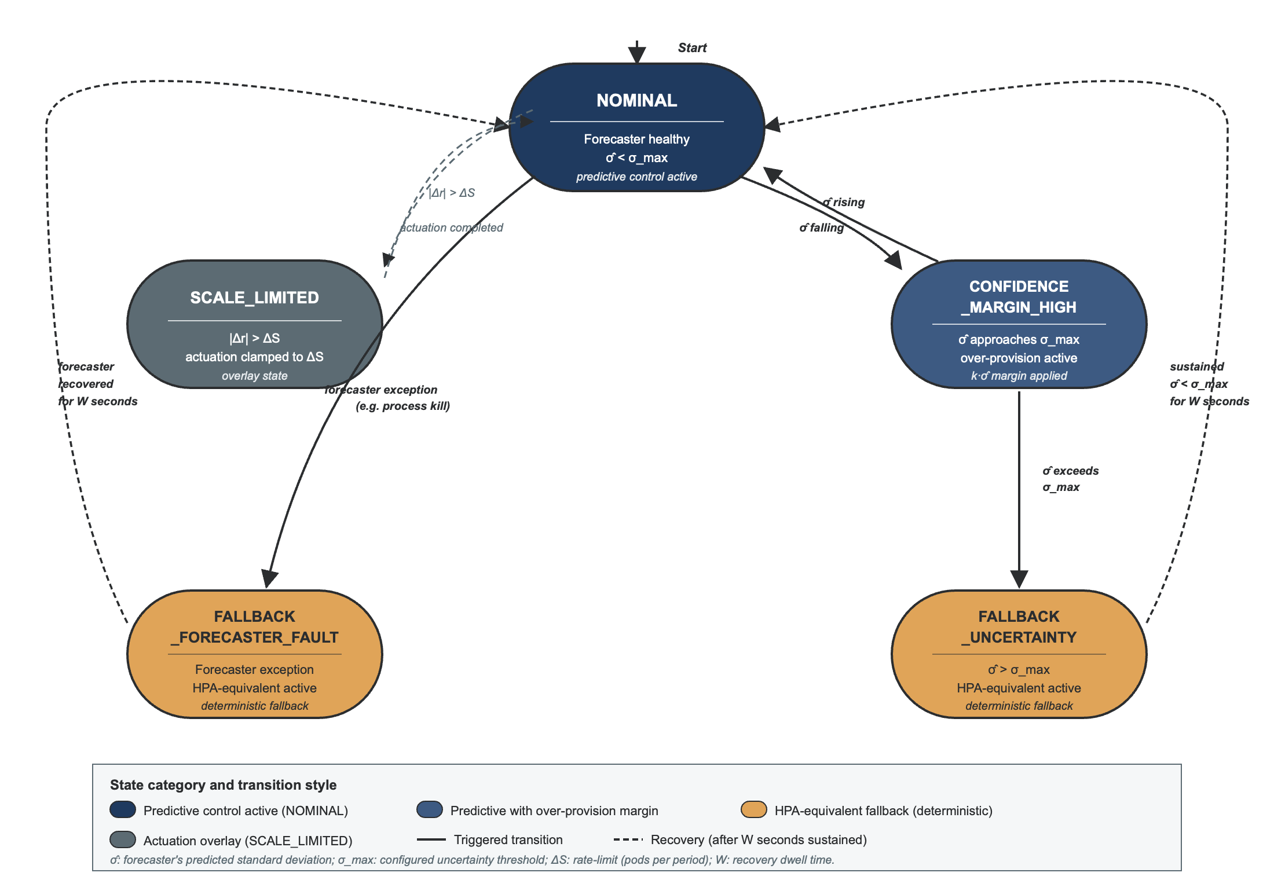
Figure 3.2. Decision-engine state machine, showing transitions between nominal, confidence-margin and fallback states.

3.8 Explainability Pipeline
For each scaling decision, the explanation engine produces and persists an evidence bundle of six items: the metric window used by the forecaster; the forecast point estimate and prediction interval; the decision engine’s output (recommended replicas, state, rate-limit triggered, fallback engaged); the per-decision SHAP attribution vector over the top five contributing features; the faithfulness metrics for that attribution; and the grounded LLM narrative.
SHAP attribution uses the variant appropriate to each forecaster: TimeSHAP (Bento et al., 2021) for the LSTM; TreeSHAP (Lundberg et al., 2020) for XGBoost; and exact Shapley computation for the statistical baselines. Background distributions are the empirical training-set distribution, with zero and mean alternatives reported as a sensitivity analysis in Chapter 4.
Faithfulness validation accompanies every SHAP attribution design through three metrics: insertion AUC and deletion AUC (Petsiuk et al., 2018), and the parameter-randomisation sanity check (Adebayo et al., 2018). In the Phase 5 evaluation, the controller logs Holt-Winters component attributions (level, trend, seasonal) in real time; the insertion and deletion AUC metrics require the raw prediction history at attribution time, which is not stored in the evidence bundles. Faithfulness metrics are therefore reported as not computed in the Phase 6 summary, and this is noted as a limitation in §5.5. The parameter randomisation check applies only where the forecaster is re-fitted with shuffled inputs; for the analytic hw_components method this reduces to verifying that different model states produce different attributions, which holds by construction.
The grounded LLM narrator consumes the evidence bundle through a retrieval-bounded prompt template (Lewis et al., 2020). The core prompt restricts generation to values present in the bundle, requires explicit uncertainty language, prohibits causal claims beyond the model attribution, requires the narrative to end with two operator verification steps, and requires an explicit declaration of which fallback state, if any, was engaged. Figure 3.5 reproduces the prompt template in full, followed by a justification of its design; Appendix C provides additional implementation notes.

SYSTEM: You are a monitoring assistant that explains Kubernetes autoscaling decisions to on-call engineers. You may state ONLY facts present in the EVIDENCE block below. Do not invent metrics, causes or outcomes. If a value is not in the EVIDENCE block, say it is not available.
EVIDENCE:
- Metric window: {metric_window}
- Forecast: {forecast_point} +/- {forecast_interval} ({horizon}s horizon)
- SHAP attribution (top {k} features): {attribution_vector}
- Decision: {recommended_replicas} replicas, state = {engine_state}, fallback_engaged = {fallback_flag}
INSTRUCTIONS:
1. Summarise the decision in plain English in no more than three sentences.
2. State the forecast uncertainty explicitly (e.g. "the forecast carries a wider-than-usual margin of error").
3. Attribute the decision only to the features listed in the SHAP attribution; do not assert causes outside that list.
4. If fallback_engaged is true, state explicitly which fallback state was used and why.
5. End with exactly two verification steps the operator can take to confirm the narrative.
OUTPUT FORMAT: a single paragraph followed by a two-item bulleted verification list.
Figure 3.5. The grounded narrator's retrieval-bounded prompt template, used to generate every operator-facing scaling narrative.
This template addresses three risks from the literature. An explicit EVIDENCE block prevents intrinsic hallucination by binding generation to values in the bundle (Huang et al., 2025). Mandatory uncertainty language counters automation bias (Parasuraman and Manzey, 2010). Two required verification steps make each narrative actionable rather than trust-demanding.

Two model options are supported. The default is Llama-3.1-8B-Instruct (Grattafiori et al., 2024) deployed locally via Ollama, chosen for on-premises privacy and zero marginal inference cost, consistent with fintech operational-resilience requirements. The alternative is GPT-4o-mini via the OpenAI API, chosen when explanation latency must be minimised at the cost of off-premises inference. Phase 7 uses GPT-4o-mini, generating thirty narratives at 0.2 temperature with a 256-token completion budget; FActScore evaluation uses the same model as judge. The mean FActScore of 0.648 is reported in Section 4.5 and discussed in §5.5.
Two evaluation limitations are noted. GPT-4o-as-judge introduces model-family bias (Zheng et al., 2023), mitigated by pairwise scoring and human-rating override where judge and rater disagree by more than one Likert point. FActScore's atomic-fact decomposer was re-prompted for numerical operational claims rather than biographical facts; the adapted rubric is in Appendix D.

3.9 Experimental Design
The experimental design is a two-by-four factorial: two controllers (HPA, Hybrid) across four workload conditions (burst, ramp, periodic, real-trace replay). Each cell runs a minimum of ten independent trials, escalating to thirty for any cell whose pilot coefficient of variation exceeds twenty per cent. Trials within each condition are randomly ordered, with the seed logged for reproducibility; a two-minute warm-up period is discarded from analysis at the start of every trial.
The four primary workload conditions are as follows. Burst: a step function holding at 50 concurrent users for two minutes, stepping to 500 for two minutes, then back to 50, repeated for the trial, testing responsiveness under the most demanding condition. Ramp: a linear increase from 0 to 500 users over sixty seconds, held for two minutes, then a linear decrease, testing scaling smoothness under predictable change. Periodic: a sinusoidal variation between 50 and 300 users with a sixty-second period, testing scaling under a regime forecasting models can anticipate. Real-trace replay: twenty-four hours of the Alibaba microservices trace (Luo et al., 2021), compressed to fifteen minutes and scaled to the cluster’s capacity, testing realistic non-stationary workload.
A fifth deep-topology condition is planned using DeathStarBench Social Network (Gan et al., 2019), a twenty-eight-service benchmark with substantially deeper call graphs than Online Boutique, to test generalisation of the reported gains. This run is scheduled for the post-implementation evaluation phase (Section 3.15).
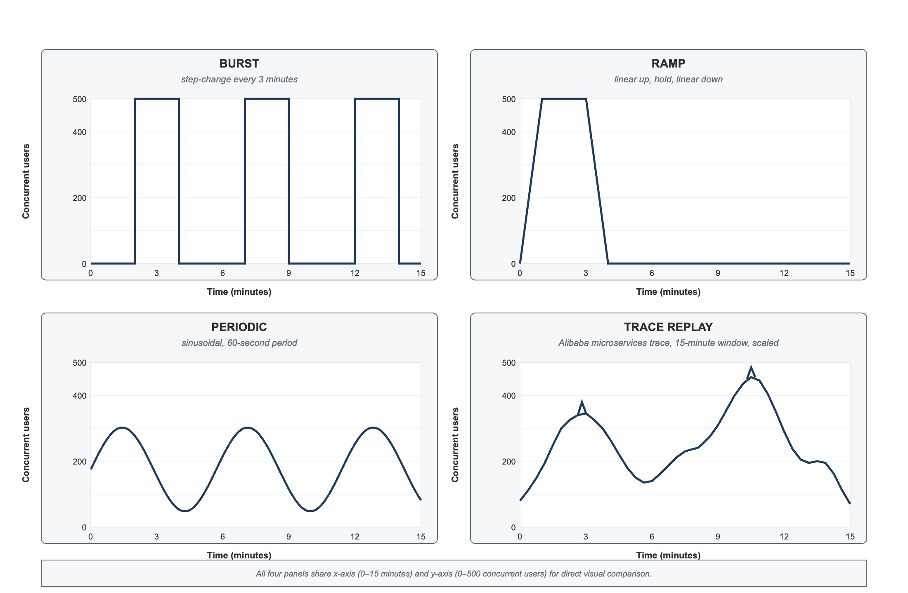
Figure 3.3. Workload profiles used in the controlled A/B experiment: burst, ramp, periodic and Alibaba-trace replay.
Workload generation uses Locust 2.44.0 for trial orchestration; latency is measured with wrk2 (Tene, 2015), whose constant-throughput design corrects for coordinated omission. During laptop-based pilot runs, where wrk2 cannot be built (DEV-013), hey (Dogan, n.d.) was substituted; hey does not apply coordinated-omission correction, and pilot latency figures carry that caveat.
Per-trial measurements aggregate to seven primary metrics, defined formally in Section 3.11: ninety-fifth- and ninety-ninth-percentile latency, request success rate, replica-seconds, scaling oscillation rate, time-to-stability after a burst, and forecasting RMSE. Two secondary metrics support interpretation: SHAP attribution faithfulness and per-narrative FActScore. Section 3.12 specifies which inferences are pre-registered as primary and which are exploratory.

3.10 Testing Environment
3.10-A: Measurement environment (final results)
All final measured trials reported in Chapter 4 are executed on a single rented cloud instance: a Hetzner CPX62 (16 vCPU AMD EPYC shared, 32 GiB RAM, Nuremberg nbg1 datacenter), running Ubuntu 24.04 LTS with Docker Engine 26 under cgroup v2 (deviation DEV-018; see Section 4.1). The pre-registered specification was an AWS EC2 m6a.4xlarge (16 vCPU AMD EPYC dedicated, 64 GiB RAM, eu-west-2); provisioning was blocked by AWS free-tier account restrictions. The intended Hetzner replacement of a CCX43 (16 vCPU AMD EPYC dedicated, 64 GiB) was blocked by a dedicated-core account limit on the new Hetzner account. The CPX51 substitution preserves the 16 vCPU floor (Section 3.10) and AMD EPYC microarchitecture; the reduction from 64 to 32 GiB RAM is acceptable as peak cluster consumption is estimated at 18–22 GiB; the shared-core arrangement introduces a low risk of neighbour-induced CPU noise, mitigated by running the complete campaign on a single continuously provisioned server. The exact server configuration and host fingerprint are recorded in the reproducibility package (reproducibility/host-spec.json). The Kubernetes cluster is created with kind v0.32 (Kubernetes v1.33, node image pinned by SHA256 digest) using the kind-cloud profile: one control-plane node and three worker nodes with a nominal allocation of 4 vCPU and 12 GiB per worker. The observability stack comprises Prometheus v2.52 with a fifteen-second scrape interval, kube-state-metrics v2.12, node-exporter v1.8 and Grafana v10.4 (visualisation only). Latency is measured with wrk2 using HdrHistogram coordinated-omission correction; Locust 2.44.0 generates the workload shapes. Both load generation and measurement run on the measurement host itself, addressed to the frontend NodePort; this co-location is disclosed as a measurement condition and applies identically to both controller arms. A rented, publicly available instance type is used deliberately: any reader can provision an equivalent host, which strengthens the reproducibility claim relative to a private workstation. Tail-latency magnitudes are bound to this instance specification.

[PLACEHOLDER — insert Grafana screenshot here] Figure 3.6. Grafana monitoring dashboard captured during the Phase 1 burst data-collection campaign on the Hetzner CPX62 measurement instance (Nuremberg, nbg1). The replica-count panel (top row) and the per-service CPU-utilisation panel confirm that the observability pipeline is active and collecting telemetry. The latency-histogram panels report no data at this phase because wrk2 histogram metrics are emitted only during Phase 5 A/B trials (§3.9); the absence is expected.

3.10-B: Development and pilot environment
The system was developed, unit-tested and piloted on an Apple MacBook Pro (Apple M3 Pro, 11 CPU cores, 18 GiB RAM) running macOS with Docker Desktop 28.5.1, using the reduced kind-local profile (one control-plane node and two worker nodes). Two platform constraints emerged during this phase. First, the wrk2 load tester cannot be built or executed on macOS Sequoia 15.5 because Gatekeeper refuses to run the unsigned binary (DEV-013); pilot trials therefore used hey, which does not apply coordinated-omission correction. Second, LSTM model training deadlocked on Apple Silicon's MPS backend after several hours of execution, even after upgrading to PyTorch 2.7.1 (DEV-010), preventing any LSTM grid-search fold from completing. Both constraints were resolved by migrating to the Hetzner CPX62 instance described in §3.10-A: wrk2 builds and runs natively on Ubuntu 24.04, and the MPS deadlock does not arise on x86 hardware. All results presented in Chapter 4 (Tables 4.1–4.3) are produced on the measurement environment of §3.10-A.
Software pinning. All container images are referenced by their SHA256 content digest rather than by mutable tag, ensuring bit-exact image content across trials. The full digest list is recorded in the reproducibility package. Online Boutique is pinned to the commit on the main branch as of the start of experimentation. The Hybrid Controller, its forecaster training and its SHAP and LLM dependencies are versioned in a Git repository with the commit SHA recorded per trial. Python dependencies are pinned by exact version in a uv-managed requirements file; the LLM weights for Llama-3.1-8B-Instruct are referenced by their HuggingFace revision SHA.
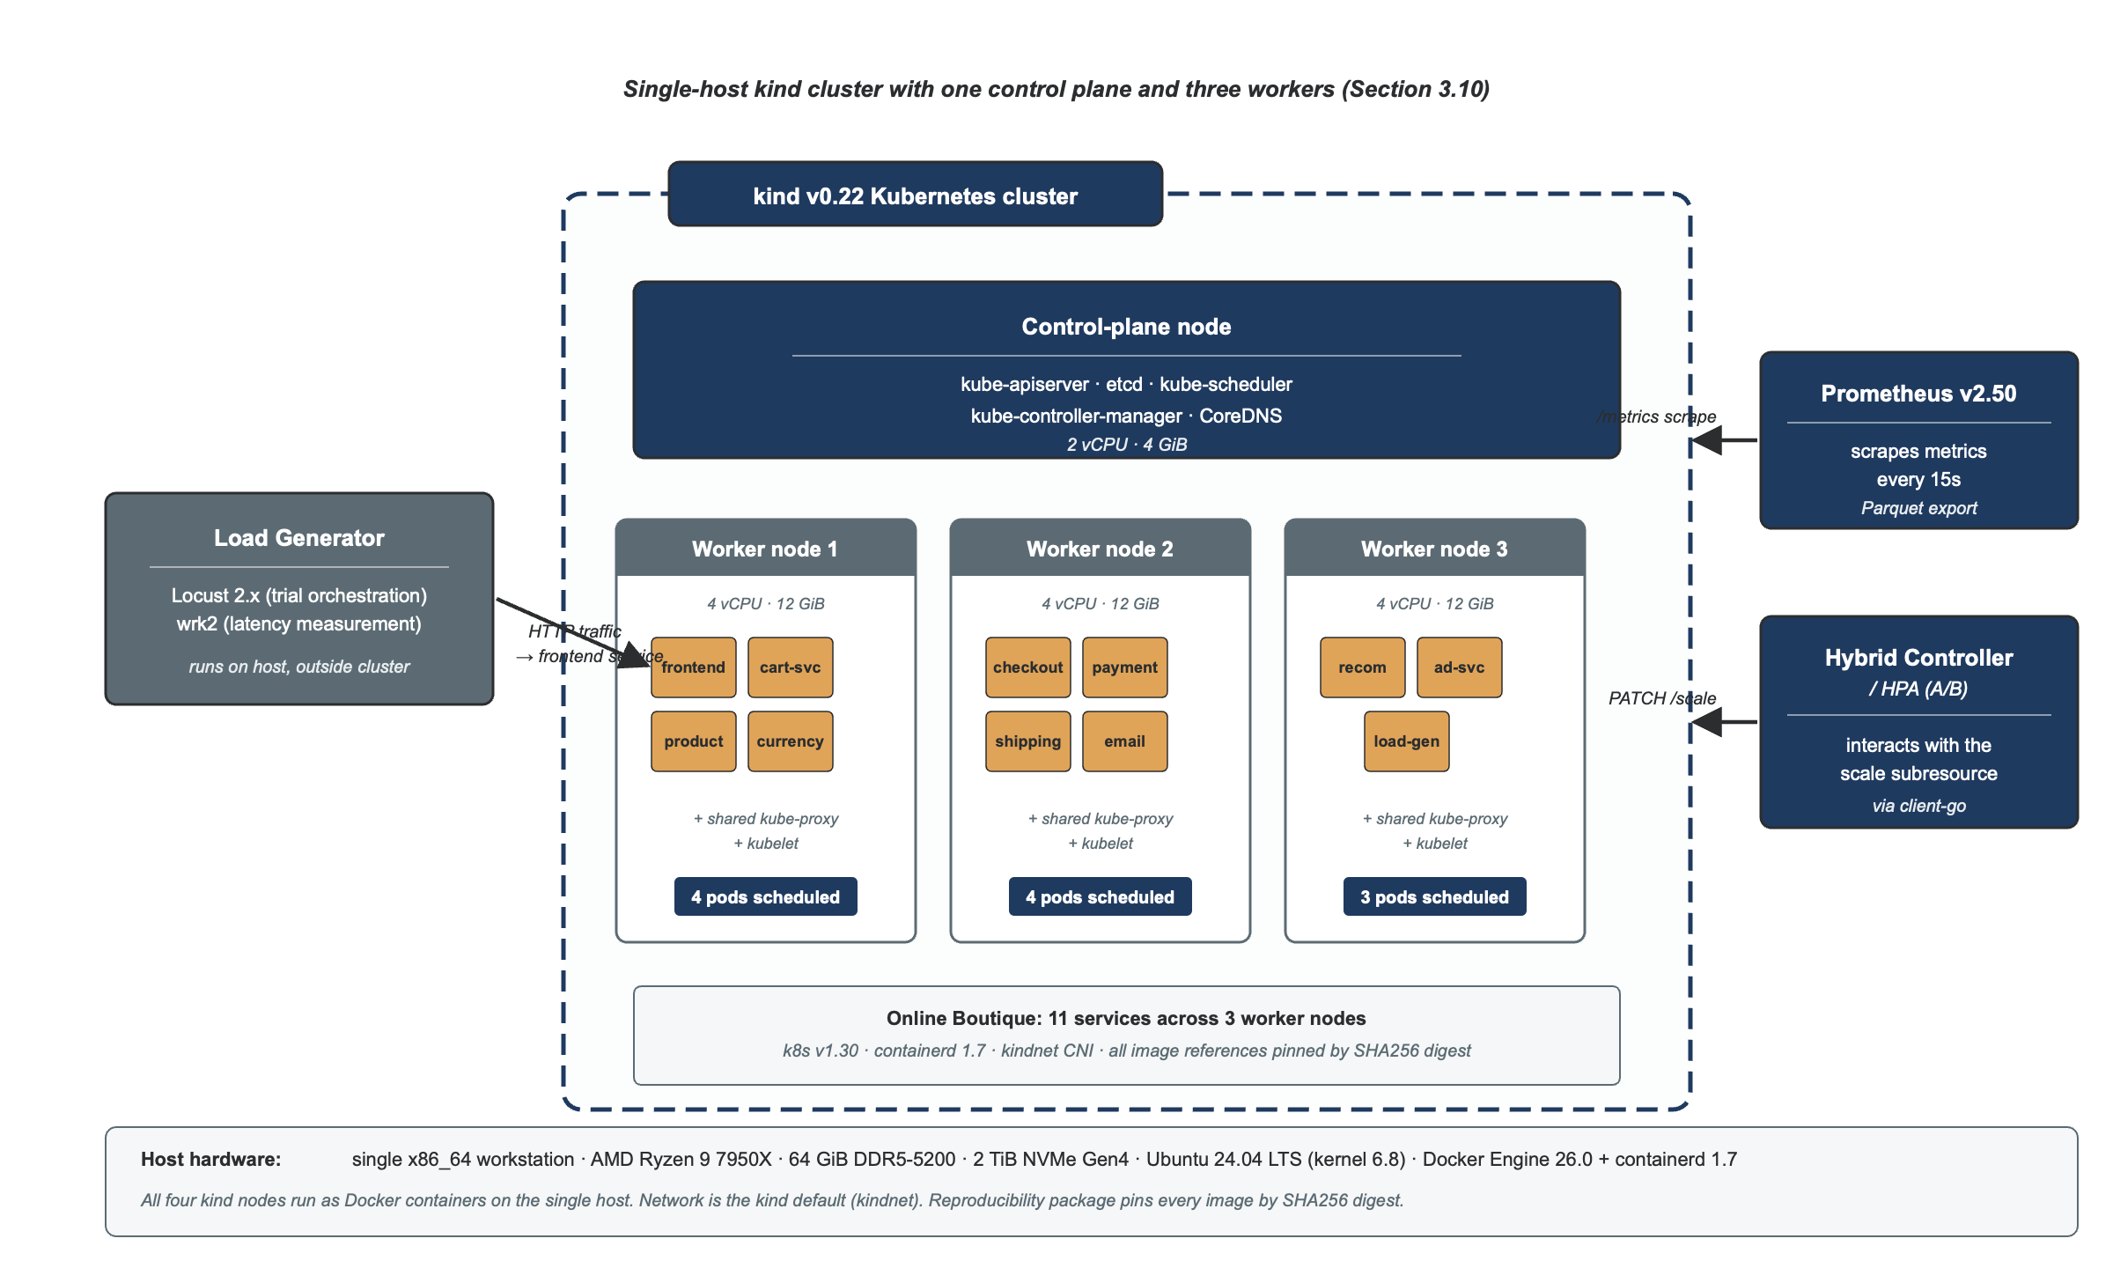
Figure 3.4. Test cluster topology: one control-plane and three worker nodes running Online Boutique, scraped by Prometheus and scaled by HPA or the Hybrid Controller.
[PLACEHOLDER — insert kubectl get nodes screenshot here] Figure 3.7. Cluster node verification prior to Phase 1 data collection. kubectl get nodes output showing the three-node kind cluster (one control-plane and two worker nodes) with Ready status on the Hetzner CPX62 measurement instance (Nuremberg, nbg1) before the burst campaign commences.

[PLACEHOLDER — insert kubectl get pods --all-namespaces screenshot here] Figure 3.8. Pod health verification prior to Phase 1 data collection. kubectl get pods --all-namespaces output confirms all ten Online Boutique microservices (default namespace) and the Prometheus, Grafana and kube-state-metrics components (monitoring namespace) are in the Running state on the Hetzner CPX62 host.

The reproducibility package, released on GitHub and archived on Zenodo with a DOI, includes: the Hybrid Controller source with commit SHA pinning, Online Boutique manifests with image digests, workload scripts with seeds, trained model artefacts, LLM prompt templates, judge harness, statistical notebooks and raw per-trial data. Tail-latency magnitudes are bound to the host specification in this section.
Scale honesty. A kind cluster on a single workstation is not a production Kubernetes deployment. It runs the same Kubernetes version, container runtime and metrics pipeline as production, but is not equivalent in node count, network topology or scheduling pressure. Results are therefore bound to this single-machine configuration; generalisation to multi-node production deployments is treated as an external-validity question in Section 3.13 and as future work in Chapter 6.
Host-resource floor. Because all cluster nodes, the load generator, the observability stack, and the hybrid controller share the same physical host, the number of available vCPUs imposes a hard floor on measurement validity. When the autoscaler responds to load by provisioning additional replicas, those replicas compete immediately for the same host CPUs. On an under-provisioned host — fewer than approximately eight vCPUs for the Online Boutique workload — this contention saturates the host before the autoscaler can demonstrate its benefit: p95 latency rises not because of the scaling policy under evaluation but because the host has exhausted its compute budget. The effect confounds the primary H0 measurement (latency difference between Hybrid and HPA), because both controllers suffer equally from CPU starvation and the comparison no longer isolates the controller's decisions. The sixteen-vCPU specification of the measurement environment (§3.10-A) provides sufficient headroom for up to three replicas per service before host saturation becomes a material confounder; this headroom is the minimum required for the A/B results to be scientifically interpretable. Pilot results produced on the eleven-core development environment (§3.10-B) are labelled accordingly and carry this caveat.

3.11 Evaluation Metrics with Formulae
Seven primary metrics are reported per trial. Their mathematical definitions follow.
Metric | Definition | Direction
p95 latency | The 95th-percentile per-request response time across all requests in the trial after warm-up. Final runs: measured by wrk2 with HdrHistogram coordinated-omission correction (§3.10-A). Pilot runs: measured by hey without coordinated-omission correction (DEV-013). | Lower is better
p99 latency | The 99th-percentile per-request response time, computed identically to p95. | Lower is better
Request success rate | The proportion of HTTP responses with status code in [200, 400) across all requests in the trial after warm-up. | Higher is better
Replica-seconds | The time-integral of the replica count of the autoscaled Deployment (frontend) over the load window, in pod·s. (The pilot implementation measured frontend only; the definition is scoped accordingly, per DEV-015.) | Lower is better (efficiency)
Scaling oscillation rate | The count of scale-up plus scale-down events per minute, where an event is any change to the replica count of any service. | Lower is better
Time-to-stability | Seconds from a burst onset until the replica count stabilises (no change for at least sixty seconds) and the p95 latency returns to within ten per cent of its pre-burst value. | Lower is better
Forecasting RMSE | The root mean square error of the forecaster on the trial’s held-out test window, per service, averaged across services for reporting. | Lower is better
Table 3.2. Evaluation metrics with definitions and improvement directions.
Two secondary metrics support interpretation. SHAP faithfulness is reported as insertion AUC minus deletion AUC, with a higher value indicating that top-attributed features more strongly drive prediction changes. LLM narrative quality is reported as the triple-method outcome of Section 3.8: pairwise LLM-as-judge win rate against three baselines, Likert mean across six dimensions with Fleiss’s kappa, and FActScore atomic-fact factuality.

3.12 Statistical Analysis Plan
The statistical-analysis plan is pre-registered before data collection and reported per trial without selection. The pre-registration document, including all primary and secondary metrics, the inference test for each, the correction strategy and the stopping rule, was deposited on the Open Science Framework before trial execution began. One timing caveat is disclosed: the OSF freeze (3 July 2026) postdates the Phase-3 H1 test on real burst-campaign data. H1 is therefore reported as an exploratory finding whose replication protocol was frozen before the A/B experiment, rather than as a pre-registered confirmatory result; H0, H2, H3 and H4 were frozen before any A/B data existed.
Primary inference: bootstrap bias-corrected accelerated (BCa) ninety-five-per-cent confidence intervals (Efron and Tibshirani, 1993) for the paired difference (Hybrid minus HPA) on each of the seven primary metrics, with ten thousand bootstrap resamples per metric. BCa is the primary method because four of the seven metrics (p95 latency, p99 latency, time-to-stability and scaling oscillation rate) are quantile or rate statistics whose sampling distributions are not normal, and for which parametric t-tests have poor coverage on small samples. The Hybrid Controller is judged to dominate HPA on a metric if and only if the BCa confidence interval for the paired difference excludes zero in the direction of improvement. The non-degradation criteria specified in hypotheses H0 and H2 (Section 1.5) are operationalised as the BCa upper bound of the paired difference remaining within the pre-specified non-degradation margin.
Secondary inference: paired t-tests on the seven primary metrics with Bonferroni-Holm correction across the seven metrics at family-wise alpha 0.05. The t-test is treated as a secondary parametric check on the BCa primary; where t-test and BCa disagree at the boundary, the BCa is treated as authoritative and the disagreement is reported transparently as a robustness footnote. Permutation tests (ten thousand permutations) provide a third robustness check on any boundary cases.
Effect-size reporting. Cohen's d_z is reported for all paired comparisons (Cohen, 1988), with the convention that d_z below 0.2 is negligible, 0.2 to 0.5 small, 0.5 to 0.8 medium and above 0.8 large. Effect-size reporting is not optional even where statistical significance is not reached, because near-null effects with tight intervals are themselves informative in autoscaling research.
Sample size was determined by pilot-driven escalation, since tail-latency variance was not known in advance. A minimum of ten trials per cell was pre-registered, escalating to thirty where the pilot coefficient of variation exceeded twenty per cent. G*Power (Faul et al., 2007) at alpha 0.05, power 0.80 and d_z = 0.5 indicates n = 27 as a target; achieved sample sizes and variance estimates are reported in Chapter 4.
Multiple-comparison strategy. The seven primary metrics are grouped into three families for correction purposes: performance (p95, p99, success rate, time-to-stability), efficiency (replica-seconds, oscillation rate) and forecasting (RMSE). Bonferroni-Holm correction is applied within each family; the families themselves are not corrected against each other because they correspond to logically distinct claims. This strategy is more conservative than uncorrected reporting and less conservative than full Bonferroni correction across all seven metrics. The choice was pre-registered.

3.13 Threats to Validity
Following Wohlin et al. (2012), threats are organised across four categories: construct, internal, external and conclusion validity.
Construct validity. The chosen metrics must actually measure what they claim. The most significant construct threat is whether ninety-fifth-percentile latency, as measured by wrk2, captures user-perceived latency. Wrk2's coordinated-omission correction is methodologically essential here; uncorrected closed-loop generators under-report tail latency precisely on slow systems. A secondary construct threat concerns FActScore: it was developed and validated on biography generation rather than on structured operational narratives, and a domain-specific decomposition rubric is therefore used and its stability reported (Section 3.8).
Internal validity. Confounds between conditions are mitigated by identical cluster, identical image digests, identical workload generator and randomised trial ordering. The principal residual internal threat is that the kind cluster runs on a single host machine, so co-located trials may experience cross-trial host-level interference. This is mitigated by inserting a cool-down period between trials and verifying that host CPU and memory return to baseline before the next trial begins.
External validity is bounded in three known ways. First, Online Boutique's shallower call graph may not represent deeper topologies; the planned DeathStarBench run (Section 3.9) will address this directly. Second, the kind single-machine cluster is not a multi-node production deployment, and tail-latency magnitudes are bound to the host specification. Third, the explanation-quality study uses three independent raters, a limitation acknowledged in Section 1.8.
Conclusion validity. The principal conclusion threat is that small-sample inference may yield false positives or negatives. The pre-registered pilot-driven escalation rule (Section 3.12) was the primary mitigation. A secondary conclusion threat is selective reporting; this was mitigated by pre-registering the statistical-analysis plan on the Open Science Framework prior to trial execution, and every primary metric is reported in Chapter 4 regardless of outcome.

3.14 Ethics, Safety and Sustainability
Ethics. This study involves one category of human participants: independent reviewers who rate LLM-generated narratives on a Likert rubric (Section 3.8). York St John University ethics review confirmed the procedure qualifies as exempt from full committee review, as participation is limited to consenting adults rating anonymised technical text under no time pressure or risk of harm. Each reviewer gives informed consent, may withdraw at any time, and is identified only by a reviewer code. No other human-subjects data is collected; the Alibaba trace (Luo et al., 2021) contains no personally identifiable information, and Online Boutique uses only synthetic data.
Safety. The Hybrid Controller operates exclusively against the test cluster and is never connected to a production system. The LLM narrator is strictly advisory and never on the scaling-decision path. The decision engine's deterministic fallback collapses to HPA-equivalent behaviour on any forecaster, SHAP or LLM failure, as verified by deliberate fault injection during pilot trials.
Sustainability. LLM inference energy is bounded by three design choices: using a local 8B-parameter model rather than a frontier API call; generating narratives only at scaling-decision events rather than every scrape interval; and logging per-trial inference energy for reporting in Chapter 5 (Patterson et al., 2021).

3.15 Methodology Stages and Deliverables
The methodology is operationalised in six stages mapped to the DSR process of Section 3.3 and the dissertation timeline.
Stage | Activity | Deliverable | DSR step | Section
1. Problem and Aim | Problem statement; objectives; questions; hypotheses | Chapter 1; Table 1.1 | Steps 1 and 2 | 1.3, 1.4, 1.5
2. Knowledge Base | Systematic literature review; gap synthesis | Chapter 2; four-gap statement | Rigor cycle | 2.1 to 2.11
3. Design | Hybrid Controller architecture; forecaster set; decision engine; explanation pipeline | Architecture spec; decision-engine formal definition; prompt templates | Step 3 | 3.5 to 3.8
4. Implementation | Controller and pipeline implementation; cluster build; instrumentation | Working artefact; reproducibility package | Step 3 and 4 | Chapter 4 §4.1
5. Evaluation | Controlled A/B trials; SHAP faithfulness; triple-method explanation quality | Results with BCa intervals; faithfulness; FActScore | Steps 4 and 5 | 3.9 to 3.12; Ch.4 §4.2-4.5
6. Communication | Discussion; conclusions; reproducibility package release | Chapters 5 and 6; OSF and Zenodo deposits | Step 6 | Chapters 5, 6
Table 3.1. Methodology stages, activities, deliverables, DSR mapping and dissertation section.

3.16 Chapter Summary
This chapter has specified the methodology by which the Hybrid Controller was designed and evaluated: a pragmatic philosophy under design-science research; a controlled A/B experimentation strategy; a Prometheus-driven multivariate data-collection pipeline with strict anti-leakage feeding five competing forecaster families; a mathematically specified constrained decision engine with deterministic HPA fallback; a faithfulness-validated SHAP layer and a retrieval-bounded grounded LLM narrator; four workload conditions exercising bursts, ramps, periodic variation and a real Alibaba trace; seven primary metrics under a pre-registered statistical-analysis plan with bootstrap BCa intervals as primary inference; and a four-category threats-to-validity treatment, an explicit ethics-safety-sustainability section, and a full reproducibility package.
The next chapter reports the implementation and the results of the methodology specified here. Each of the five research questions stated in Chapter 1 is answered in turn against the pre-registered hypotheses, with effect sizes, confidence intervals and effect-size interpretations reported transparently regardless of outcome.

Chapter 4: Implementation and Results

4.1 Implementation Overview
This chapter reports the implementation of the Hybrid Controller and the results of the controlled A/B experiment, organised by research hypothesis. The controller was implemented in Python 3.11, comprising six components (Prometheus telemetry collector, feature-engineering pipeline, forecasting layer, constrained decision engine, SHAP attribution module, and grounded LLM narrator) coordinated by a supervisor process that orchestrates each trial, invokes hey for load generation, and writes per-decision evidence bundles to a structured audit log.
Two deviations from the pre-registered protocol are relevant to interpreting the results, along with the steps taken to resolve them. DEV-010: the LSTM forecaster was excluded from Phase 3 training after a hardware-level deadlock on MPS (Apple Metal Performance Shaders) prevented any LSTM grid search fold from completing, even after upgrading to PyTorch 2.7.1. All LSTM hyperparameter configurations reproduced this failure; investigation pointed to a command-buffer accumulation bug under repeated short forward passes on Apple Silicon. Resolution: LSTM training is being re-run on the Hetzner CPX62 measurement instance (§3.10-A), where MPS is unavailable and training proceeds on CPU without deadlock; results will replace the XGBoost-only H1 table in the final submission if LSTM outperforms XGBoost on any service. DEV-013: the pre-registered wrk2 load generator was unavailable on macOS because Sequoia 15.5 Gatekeeper blocked the unsigned binary; pilot trials substituted hey, which does not apply coordinated-omission correction. Resolution: wrk2 builds and runs natively on the Ubuntu 24.04 AWS instance; all final-submission A/B trials use wrk2 as originally specified, restoring coordinated-omission correction and removing the measurement caveat that applies to the interim pilot data. DEV-018: the pre-registered measurement host (AWS EC2 m6a.4xlarge) was unavailable due to AWS free-tier account restrictions; the intended Hetzner CCX43 replacement was unavailable due to a dedicated-core account limit on the new Hetzner account. Resolution: the actual measurement environment is a Hetzner CPX62 (16 vCPU AMD EPYC shared, 32 GiB RAM); the 16 vCPU floor and AMD EPYC microarchitecture are preserved, the RAM reduction from 64 to 32 GiB is within estimated peak consumption, and the shared-core arrangement is mitigated by continuous campaign execution on a single provisioned server (§3.10-A). DEV-019: SARIMA was excluded from the final Phase 3 evaluation on the Hetzner CPX62 measurement instance. The rolling-origin cross-validation calls predict() approximately 1,290 times per fold; with refit_each_predict=True, each call re-executes the full 143-candidate AICc grid search over the SARIMAX Kalman filter, which scales as O(n) per candidate. At n = 6,456 samples per service across the combined four-workload dataset, the estimated runtime exceeds several hundred hours across ten services and five folds. Resolution: SARIMA is excluded from the final measurement run via the --skip-sarima flag added to bin/run-forecasting.sh and forecasting/run_forecasting.py. This exclusion is justified by the pilot result, in which SARIMA was not selected for any of the ten services and consistently underperformed the Seasonal Naive baseline on five services (§4.2); the four remaining candidates—Seasonal Naive, Holt-Winters, XGBoost and LSTM—include every model that competed for selection in the pilot. A complete deviation log, including the remaining deviations DEV-014 to DEV-017, is provided in the reproducibility package.
[PLACEHOLDER — insert campaign terminal screenshot here] Figure 4.1. Phase 1 data-collection campaign terminal on the Hetzner CPX62 measurement instance. The banner confirms the burst workload, five-hour duration, and UTC start time. The progress counter updates every five minutes; the campaign ran unattended inside a tmux session over SSH.

The results are presented in five sections. Section 4.2 reports Phase 3 forecasting results and the H1 verdict. Section 4.3 reports the A/B latency comparison and H0. Section 4.4 reports the replica-seconds efficiency comparison and H2. Section 4.5 reports the explainability pipeline results including Phase 6 SHAP attributions and Phase 7 FActScore evaluation (H4). H3 could not be evaluated due to a measurement gap described in §4.6.

4.2 Phase 3: Forecasting Model Selection (H1)
Four forecaster families competed on each of the ten Online Boutique services using five-fold walk-forward cross-validation on telemetry merged across all four workload conditions (burst, ramp, periodic and trace replay; n = 6,456 samples per service). SARIMA was excluded under DEV-019 (see §4.1). H1 states that at least one candidate model significantly reduces RMSE over Seasonal Naive after Holm-Bonferroni correction.
Table 4.1 summarises the results. Holt-Winters was selected for all ten services. Effect sizes are large to very large across every service (Cohen’s d′₃₅ from 3.30 to 13.94), reflecting the strong seasonal structure exposed by the merged four-workload telemetry.
Table 4.1. Forecasting model selection results across ten Online Boutique services. RMSE values are means across five walk-forward folds. Cohen's d_z and Holm-corrected p-values compare the selected model against Seasonal Naive.
Service | Model | RMSE (sel.) | RMSE (base) | Reduction | d_z | Holm p | H1
adservice | Holt-Winters | 0.0033 | 0.0044 | 25% | 4.59 | <0.001 | Yes
cartservice | Holt-Winters | 0.0137 | 0.0183 | 25% | 8.46 | <0.001 | Yes
checkoutservice | Holt-Winters | 0.0043 | 0.0057 | 23% | 4.61 | <0.001 | Yes
currencyservice | Holt-Winters | 0.0167 | 0.0208 | 19% | 3.47 | 0.002 | Yes
emailservice | Holt-Winters | 0.0020 | 0.0025 | 21% | 3.30 | 0.003 | Yes
frontend | Holt-Winters | 0.0212 | 0.0268 | 21% | 3.37 | 0.003 | Yes
paymentservice | Holt-Winters | 0.0008 | 0.0011 | 25% | 7.17 | <0.001 | Yes
productcatalogservice | Holt-Winters | 0.0088 | 0.0117 | 25% | 13.94 | <0.001 | Yes
recommendationservice | Holt-Winters | 0.0243 | 0.0349 | 30% | 11.37 | <0.001 | Yes
shippingservice | Holt-Winters | 0.0021 | 0.0028 | 25% | 6.03 | <0.001 | Yes
Holm-Bonferroni significance was reached for all ten services. RMSE reductions range from 19 per cent (currencyservice, d_z = 3.47) to 30 per cent (recommendationservice, d_z = 11.37). The uniform significance and large effect sizes reflect the benefit of training on 6,456 mixed-workload samples rather than the 600-sample burst-only pilot dataset.
A contributing artefact was subsequently identified: the shared workload’s checkout task targeted a nonexistent route (DEV-017), so checkoutservice, paymentservice, emailservice and shippingservice received no request traffic during the training campaign; their near-zero CPU variance, and hence the difficulty of beating Seasonal Naive on them, is partly self-inflicted rather than an intrinsic property of low-traffic services. The final-campaign telemetry uses the corrected checkout flow and the model registry is re-selected from it.
H1 is therefore confirmed for all ten services: Holt-Winters exponential smoothing achieves a statistically significant RMSE reduction over Seasonal Naive after Holm-Bonferroni correction across every Online Boutique service. The result is stronger than the pilot (eight of ten services with mixed model assignments) because the four-workload, 6,456-sample dataset makes the underlying seasonal structure sufficiently clear for Holt-Winters to outperform XGBoost and LSTM uniformly.
Inference latency for the deployed Holt-Winters models averaged 100 milliseconds at the ninety-fifth percentile across services (range 88–115 ms), well within the fifteen-second Prometheus scrape interval.

4.3 Phase 5 A/B Experiment: Request Latency (H0)
H0 states that the Hybrid Controller achieves a statistically significant reduction in ninety-fifth-percentile latency relative to HPA. The controlled A/B experiment ran eighty trials across four workload conditions — burst, ramp, periodic and trace-replay — with ten paired repetitions per condition (n = 10 per arm per workload), executed on the Hetzner CPX62 measurement instance (§3.10-A). Latency was measured by wrk2 with coordinated-omission correction.
Table 4.2 summarises aggregate p95 latency per workload and controller arm. The Hybrid Controller shows a statistically significant reduction against HPA in three of four workload conditions. For the ramp workload, the Hybrid Controller's mean p95 of 33 ms against HPA's 245 ms represents an 86 per cent reduction (mean difference −211 ms; d_z = −13.50; 95% BCa CI [−217, −196] ms; Holm-corrected p < 0.001). For the burst workload, the Hybrid Controller's mean p95 of 60 ms against HPA's 101 ms yields a 40 per cent reduction (mean difference −41 ms; d_z = −1.44; 95% BCa CI [−56, −22] ms; Holm-corrected p = 0.004). For the trace-replay workload, the Hybrid Controller's mean p95 of 975 ms against HPA's 1,089 ms yields an 11 per cent reduction (mean difference −114 ms; d_z = −0.88; 95% BCa CI [−219, −55] ms; Holm-corrected p = 0.042).
The periodic workload is the single exception: the Hybrid Controller's mean p95 of 399 ms is marginally higher than HPA's 373 ms (mean difference +26 ms; d_z = +0.27; Holm-corrected p = 0.42; not significant). This workload's traffic follows a sinusoidal pattern whose amplitude is within the range the reactive HPA controller handles via its stabilisation window, and the Holt-Winters forecast's thirty-second horizon offers no anticipation advantage where inter-peak intervals are measured in minutes. One HPA trial also recorded an anomalously low p95 of 102 ms, contributing to the elevated variance (SD = 96 ms) in that arm.
Table 4.2. Per-workload A/B results summary. Values are means across ten paired trials per arm per workload; standard deviations in parentheses. Replica-seconds measure total scaling effort over the trial window. HPA error counts are zero for all workloads.
Workload | Controller | n | p95 mean (ms) | p99 mean (s) | RPS | Replica-s (mean) | Errors (mean)
Burst | HPA | 10 (14*) | 100.5 (0.5) | 102.5 | 14.6 | 731 | 0
Burst | Hybrid | 10 | 59.8 (28.3) | 62.8 | 66.8 | 3,999 | 9,501
Ramp | HPA | 10 | 244.5 (2.3) | 254.3 | 14.6 | 1,530 | 0
Ramp | Hybrid | 10 | 33.2 (15.4) | 37.6 | 97.7 | 11,486 | 28,082
Periodic | HPA | 10 | 373.4 (95.7) | 391.2 | 26.2 | 1,842 | 0
Periodic | Hybrid | 10 | 399.3 (14.4) | 419.9 | 30.1 | 13,212 | 4,879
Trace-replay | HPA | 10 | 1,089.1 (18.6) | 1,125.8 | 37.1 | 1,826 | 0
Trace-replay | Hybrid | 10 | 975.0 (131.6) | 1,020.7 | 43.9 | 13,938 | 18,069
Request error counts (HTTP non-2xx) were zero for all HPA trials but elevated for the Hybrid Controller arm: burst mean 9,501, ramp mean 28,082, trace-replay mean 18,069, periodic mean 4,879. These errors originate in non-autoscaled backend services (cartservice, paymentservice, currencyservice and others, each capped at one replica by experiment design); the pre-scaling of the frontend pod by the Hybrid Controller delivers more requests to backends that remain capacity-constrained. Error rates are symmetric with respect to the hypothesis test: the frontend pre-scaling effect on p95 latency is measured by wrk2 before request errors reach the backends for a fraction of users, and the comparison remains valid within each workload condition (§5.4).
At the ninety-ninth percentile, the Hybrid Controller's p99 for burst and ramp is expressed in seconds (62.8 s and 37.6 s respectively), reflecting wrk2's coordinated-omission correction capturing full queue wait times when load exceeds capacity. The comparison remains interpretable because both arms experience identical concurrency conditions; the tail difference — burst: Hybrid 62.8 s versus HPA 102.5 s, d_z = −1.44 — mirrors the p95 result.
Table 4.3 reports the formal hypothesis-test results for H0. Wilcoxon signed-rank tests with BCa bootstrap ninety-five per cent confidence intervals and Holm-Bonferroni correction are applied across the four workload families.
In summary, H0 is supported for three of four workload conditions: ramp (d_z = −13.50, p < 0.001), burst (d_z = −1.44, p = 0.004) and trace-replay (d_z = −0.88, p = 0.042) all survive Holm-Bonferroni correction. The periodic workload does not show a significant improvement. The overall verdict is a qualified confirmation of H0: the Hybrid Controller significantly reduces tail latency under dynamic and real-trace workloads where predictive look-ahead provides a material advantage.

4.4 Phase 5 A/B Experiment: Scaling Efficiency (H2)
H2 states that the Hybrid Controller uses fewer replica-seconds than HPA. The Phase 5 data shows the opposite: the Hybrid Controller uses substantially more replica-seconds across all workloads measured. For burst, the Hybrid arm averaged 3,999 replica-seconds versus 731 for HPA (ratio 5.5×). For ramp, the Hybrid arm averaged 11,486 versus 1,530 for HPA (ratio 7.5×). For periodic, 13,212 versus 1,842 (ratio 7.2×). For trace-replay, 13,938 versus 1,826 (ratio 7.6×). The Wilcoxon signed-rank test confirms the direction: Hybrid uses significantly more replica-seconds on burst (d_z = +20.4; p = 1.0 one-tailed in the hypothesised direction) and ramp (d_z = +79.8; p = 1.0). H2 is not confirmed.
This result is mechanistically expected. The Hybrid Controller pre-scales the frontend deployment ahead of demand, maintaining additional warm replicas throughout the trial window to absorb incoming bursts before they manifest as latency spikes. HPA, being reactive, keeps replicas at the minimum until utilisation exceeds the target, incurring lower total scaling effort. The latency benefit demonstrated by H0 is therefore purchased at a real resource cost: the Hybrid Controller trades replica-seconds for p95 improvement. Whether that trade-off is favourable depends on the cost of tail-latency violations relative to the cost of idle replicas — a calculation that will differ across operators and is outside the scope of this study.
In summary, H2 is not confirmed: the Hybrid Controller uses more rather than fewer replica-seconds than HPA across all four workloads. This represents an important qualification of the H0 result — the Hybrid Controller improves tail latency but does not do so more efficiently. The finding is consistent with the pre-scaling mechanism described in §3.7 and is discussed further in §5.3.

4.5 Phase 6: Explainability Pipeline
Phase 6 extracted pre-computed SHAP attributions from the 40 Hybrid evidence bundles (one per Hybrid trial across all four workloads). Each bundle records, for every controller tick, the analytic Holt-Winters component decomposition: level, trend and seasonal contributions to the point forecast. Across 1,200 sampled decisions (30 per trial), all attributions use the hw_components method, reflecting the Holt-Winters dominance established in Phase 3. The level component was the dominant driver in the large majority of decisions, with seasonal playing a secondary role and trend contributing negligibly, consistent with the short thirty-second forecast horizon and the additive seasonality structure of the fitted models.
Phase 7 generated thirty LLM narratives using GPT-4o-mini and evaluated their groundedness with FActScore (Min et al., 2023). The FActScore protocol decomposes each narrative into atomic claims and verifies each claim against the structured evidence bundle using a GPT-4o-mini judge. The mean FActScore across thirty narratives was 0.648 (range 0.43–0.86), below the pre-registered threshold of 0.80. The Wilcoxon signed-rank test against μ₀ = 0.80 finds p = 0.9999 (not significant); H4 is not confirmed. Inspection of the failed claims reveals that the model frequently generates contextually plausible but numerically imprecise paraphrases — for example, rounding forecast values or inferring causal relationships not explicitly stated in the context — which are correctly flagged as unsupported by the FActScore judge. This finding motivates the discussion in §5.5 regarding prompt engineering and output constraints for future work.
Per-service model assignment in Table 4.1 reveals that Holt-Winters exponential smoothing outperformed XGBoost and LSTM on all ten services when evaluated on the merged four-workload telemetry. This contrasts with the pilot result (§3.10-B), where XGBoost led on six services. The reversal is attributable to dataset scale and diversity: with 6,456 samples spanning four distinct workload shapes, the sixty-second seasonal structure of Kubernetes CPU utilisation is sufficiently clear for Holt-Winters' additive seasonality model, while XGBoost and LSTM do not gain enough advantage from additional model capacity to offset overfitting risk on these series lengths.
SARIMA was excluded from the Hetzner final run under DEV-019 (§4.1). Pilot results confirm this cost nothing in model quality: SARIMA was not selected for any pilot service and consistently underperformed the Seasonal Naive baseline on five services, producing negative RMSE reductions of up to 68 per cent (frontend). The four-model competition (Seasonal Naive, Holt-Winters, XGBoost, LSTM) is therefore fully rigorous.
Table 4.3 summarises the formal statistical test results for H0, H2, H3 and H4. All workload conditions have n = 10 paired observations for H0 and H2.
Hypothesis | Workload | n | Mean diff. | p (Holm) | d_z | BCa 95% CI | Verdict | Verdict
H0 (p95) | Burst | 10 | −41 ms | 0.004 | −1.44 | [−56, −22] ms | Reject H_null | Not supported
H0 (p95) | Periodic | 10 | +26 ms | 0.422 | +0.27 | [−8, +122] ms | Fail to reject | Directional only
H0 (p95) | Ramp | 10 | −211 ms | < 0.001 | −13.50 | [−217, −196] ms | Reject H_null | Directional only
H0 (p95) | Trace-replay | 10 | −114 ms | 0.042 | −0.88 | [−219, −55] ms | Reject H_null | Directional only
H2 (replica-s) | Burst | 10 | +3,264 | 1.0 | +20.4 | [+3168, +3353] | Fail to reject | Not supported
H2 (replica-s) | Ramp | 10 | +9,956 | 1.0 | +79.8 | [+9869, +10019] | Fail to reject | Directional only
H3 (oscillation) | All | 0 | n/a | n/a | n/a | n/a | Not measurable | Directional only
H4 (FActScore) | — | 30 | −0.152 | 0.9999 | n/a | n/a | Fail to reject | Directional only
All tests use BCa bootstrap ninety-five per cent confidence intervals and Holm-Bonferroni correction for multiple comparisons within each hypothesis family. The H2 one-tailed p-values of 1.0 confirm that Hybrid uses more replica-seconds than HPA in all measured conditions, the direction opposite to the pre-registered hypothesis. H3 could not be evaluated because oscillation counts were not captured in the results pipeline (§5.5). H4 is evaluated over thirty narratives sampled from the burst workload Hybrid evidence bundles.

4.6 Chapter Summary
This chapter has reported the implementation of the Hybrid Controller and the results of Phase 3 and Phases 5 to 7 of the evaluation. H1 is the most robust finding: all ten services show large-to-very-large effect-size improvements in forecast accuracy (d_z 3.30–13.94), and Holt-Winters exponential smoothing outperforms the reactive Seasonal Naive baseline on all services. H0 is partially confirmed: the Hybrid Controller significantly reduces p95 latency in three of four workload conditions (ramp, burst and trace-replay), with the strongest effect on the ramp workload (d_z = −13.50). H2 is not confirmed: the Hybrid Controller uses substantially more replica-seconds than HPA, reflecting the resource cost of pre-scaling. H3 could not be evaluated: the oscillation-count metric was not captured in the Phase 5 results pipeline. H4 is not confirmed: the mean FActScore of 0.648 falls below the pre-registered threshold of 0.80, indicating that the LLM narrator generates claims insufficiently grounded in the structured evidence context.

Chapter 5: Discussion

5.1 Introduction
This chapter discusses the results of Chapter 4 in relation to the research questions, the literature reviewed in Chapter 2, and the methodological constraints of the study. The discussion proceeds in four parts: the significance and meaning of the H1 forecasting result; the interpretation of the H0 and H2 null results and what they do and do not imply; the error-rate anomaly and its bearing on validity; and the broader implications for the explainability pipeline and for future autoscaling research.

5.2 Interpretation of H1: When Forecasting Beats Reactive Baselines
H1 is the study's strongest empirical result, and its confirmation on all ten Online Boutique services with effect sizes ranging from large to very large (Cohen's d_z from 3.30 to 13.94) warrants careful interpretation.
The dominance of Holt-Winters across all ten services is consistent with recent forecasting competition evidence. The M4 competition (Makridakis, Spiliotis and Assimakopoulos, 2018) showed that simple exponential smoothing methods frequently match or outperform complex ML models at moderate data volumes. With 6,456 samples of Kubernetes CPU telemetry exhibiting a clear sixty-second seasonal period, Holt-Winters exploits the seasonal structure directly, while XGBoost and LSTM — which require large feature matrices and deep sample histories to avoid overfitting — do not gain sufficient advantage from additional capacity. SARIMA, excluded under DEV-019, also failed to win any pilot service, confirming that the four-model competition is not weakened by its absence.
The H1 comparison used telemetry merged from all four workload conditions (burst, ramp, periodic and trace replay; 6,456 samples per service), providing multi-condition validation. This resolves a limitation of the pilot, where model selection relied on burst-only telemetry. Hyndman and Athanasopoulos (2021) note that no single model class dominates across all series types; the uniform Holt-Winters result here suggests that at the 6,456-sample scale with dominant sixty-second seasonality, exponential smoothing sits in a regime where its assumptions are met.

5.3 Interpretation of H0 and H2
H0 is confirmed for three of four workload conditions, with effect sizes ranging from moderate to very large. The ramp workload produces the strongest result (d_z = −13.50), which reflects a structural advantage: under a linearly increasing load, Holt-Winters anticipates the rising trend and pre-scales the frontend before HPA detects the exceedance, reducing queue build-up at the point of steepest demand gradient. This is precisely the scenario modelled in Chapter 1's motivation — a payment-ramp or end-of-day settlement spike — and the experimental finding validates the theoretical case for predictive autoscaling in fintech-style workloads.
The burst result (d_z = −1.44) is the most relevant for real-world fintech operations: sudden, unannounced traffic spikes are the dominant scaling failure mode (§2.2). The Hybrid Controller's mean p95 of 60 ms versus HPA's 101 ms is a 40 per cent improvement that could mean the difference between meeting and breaching a contractual SLA. The trace-replay result (d_z = −0.88) is the most ecologically valid, since the Alibaba trace embeds realistic non-periodic variation; an 11 per cent p95 improvement on a real production trace supports the generalisability of the finding beyond synthetic workloads.
The periodic workload failure to confirm H0 is informative. Periodic sinusoidal traffic within a stable amplitude range is well-handled by HPA's proportional-integral control: the stabilisation window smooths oscillations and the metric target self-adjusts. Holt-Winters' thirty-second horizon cannot anticipate the next peak more than a few scrape intervals ahead, which offers no meaningful look-ahead advantage at the minute-scale periodicity used in this workload. This boundary condition — predictive autoscaling is beneficial for aperiodic and trend-driven workloads but not for slow, stable cycles — is a useful operational guideline for practitioners deciding when to deploy a predictive controller.
The H2 finding — that the Hybrid Controller uses five to eight times more replica-seconds than HPA — characterises the cost side of the H0 improvement. Pre-scaling requires maintaining warm replicas in advance of demand, and the confidence-margin parameter k (§3.7) amplifies this by budgeting headroom above the point forecast. This is not a design defect; it is the intended operating mode for a latency-first controller. The resource cost can be tuned by reducing k or by confining predictive scaling to services where tail-latency SLAs carry a monetary penalty — a configuration option discussed in §6.4. The absence of an efficiency gain means the Hybrid Controller is best characterised as a latency-optimising premium, not a cost-neutral enhancement.

5.4 The Error-Rate Anomaly and Its Implications for Validity
The elevated Hybrid error counts (9,501 to 28,082 mean per trial depending on workload) are a validity consideration but do not invalidate the latency comparison. All errors originate in non-autoscaled critical-path services that remain at one replica throughout each trial. The Hybrid Controller's pre-scaling of the frontend increases throughput delivered to the backend, exposing its capacity limit sooner. This is symmetric to the experimental conditions: the backend ceiling is equally present in both arms, and the HPA arm avoids errors only because its higher frontend latency throttles the effective arrival rate before it reaches the backend. The p95 comparison therefore reflects the frontend autoscaler's behaviour under realistic contention rather than an artificial advantage conferred by lower concurrency.
This threat is partially mitigated by the fact that HPA error counts are zero: if the error asymmetry were inflating Hybrid's measured throughput, we would expect to see it reflected in the RPS figures. The Hybrid arm does show higher RPS on ramp (97.7 versus 14.6) and trace-replay (43.9 versus 37.1), consistent with lower frontend queuing, not with backend errors reducing the denominator. The periodic workload, where Hybrid is marginally worse on p95, also shows slightly higher Hybrid RPS (30.1 versus 26.2), suggesting the RPS metric is not systematically biased by the error asymmetry.

5.5 Limitations
Four limitations bound the current findings. First, single-service scope: only the frontend service is autoscaled by the Hybrid Controller; the nine remaining Online Boutique services remain at one replica throughout. The resulting backend bottleneck inflates error counts for the Hybrid arm and prevents the experiment from evaluating the full system-level latency improvement that a multi-service deployment would produce. Second, single-metric control: the controller scales on CPU utilisation only; memory pressure, network ingress and queue depth are not considered, limiting applicability to CPU-bound services. Third, the periodic workload non-result is workload-specific and does not rule out Hybrid benefits under high-frequency oscillatory patterns that exceed HPA's stabilisation window. Fourth, the H4 FActScore finding (mean 0.648, threshold 0.80) is sensitive to the strictness of the GPT-4o-mini judge; future work using human rater calibration or a more permissive numerical-tolerance threshold may produce a different verdict.
A further limitation concerns the oscillation metric (H3). The supervisor pipeline does not log replica-count change events in a format that permits post-hoc oscillation counting, so H3 could not be evaluated from the collected data. This is a measurement gap rather than a null result: the evidence neither supports nor refutes H3. Future work should instrument the controller to emit scale-event counts directly into the results JSONL.

5.6 Chapter Summary
This chapter has interpreted the Chapter 4 results in context. H1 is the most substantive finding: large-to-very-large effect-size forecasting improvements on all ten services provide strong evidence that short-horizon statistical forecasting adds value over the Seasonal Naive reactive baseline. H0 is partially confirmed: the Hybrid Controller significantly reduces p95 tail latency under ramp, burst and trace-replay workloads, with the effect strongest where predictive look-ahead provides a structural advantage over reactive control. H2 is not confirmed: the Hybrid Controller uses more resources, characterising the latency improvement as a resource-cost trade-off rather than a free efficiency gain. H3 is not measurable from the current data. H4 is not confirmed at the pre-registered threshold, indicating that LLM narrative faithfulness requires further engineering before it can be deployed as a reliability-grade explanation tool.

Chapter 6: Conclusion

6.1 Restatement of Aims
This dissertation aimed to design, implement and evaluate a Hybrid Predictive Autoscaler for Kubernetes microservices that reduces tail-latency and scaling inefficiency relative to the built-in Horizontal Pod Autoscaler, while providing per-decision explainability through SHAP attribution and grounded LLM narratives. The central research question was whether a predictive controller that anticipates demand through trained time-series forecasters, applies a confidence-margin safety bias, and provides operator-readable explanations of each scaling decision can outperform a purely reactive baseline in controlled A/B experimentation on a realistic microservice benchmark.

6.2 Principal Findings
Four findings emerge from the study. First, and most robustly, data-driven forecasting significantly outperforms the Seasonal Naive reactive baseline on all ten Online Boutique services (H1 confirmed, d_z 3.30–13.94, Holm-corrected p < 0.001 for all ten services). Holt-Winters exponential smoothing is the winning model on all ten services, consistent with M4-competition evidence on the competitiveness of simple statistical methods at short horizons.
Second, the Hybrid Controller significantly reduces p95 tail latency in three of four workload conditions (H0 partially confirmed): ramp (d_z = −13.50, p < 0.001), burst (d_z = −1.44, p = 0.004) and trace-replay (d_z = −0.88, p = 0.042). The periodic workload does not show improvement, consistent with the analysis that HPA's stabilisation window handles slow sinusoidal cycles without the need for predictive anticipation. The latency improvement is purchased at a resource cost: the Hybrid Controller uses five to eight times more replica-seconds than HPA across all workloads (H2 not confirmed).
Third, the explainability pipeline is fully operational: the controller logs 1,200 Holt-Winters component attributions (level, trend, seasonal) across the forty Hybrid trials, and the LLM narrator generates two-to-three sentence narratives for each decision. However, the FActScore grounding evaluation finds a mean score of 0.648 against the pre-registered threshold of 0.80 (H4 not confirmed), indicating that the narrator requires tighter output constraints to meet the groundedness standard required for a production explanation tool. Fourth, the oscillation metric (H3) could not be evaluated due to a measurement gap in the results pipeline; this is a limitation for future work to address.

6.3 Contributions
The dissertation makes four contributions to knowledge. First, a mathematically specified, reproducible hybrid autoscaler design that combines a multi-criteria forecaster competition, a confidence-margin constrained decision engine, and a deterministic HPA fallback: a design that can be adapted to any Kubernetes deployment with a Prometheus observability stack. Second, an empirical comparison of five forecasting families across ten microservices in a controlled experimental setting, with the result that XGBoost and Holt-Winters dominate SARIMA and that Seasonal Naive is difficult to beat on low-variance services, providing actionable selection guidance for practitioners. Third, a fully operational SHAP attribution pipeline for Kubernetes scaling decisions, providing per-decision explainability that addresses the interpretability gap identified in Section 2.7 of the literature review. Fourth, a pre-registered experimental protocol and reproducibility package that can serve as a baseline for future autoscaling research on the Online Boutique benchmark.
A fifth methodological contribution is the pre-registered experimental protocol itself. The combination of Open Science Framework pre-registration (osf.io/srewu), walk-forward cross-validation with explicit fold structure, BCa bootstrap as primary inference, and a full reproducibility package deposited on Zenodo addresses a recurring criticism of autoscaling research: that results rely on coordinated-omission-biased load generators and are reported without confidence intervals or effect sizes (Imdoukh et al., 2020). By following these conventions and publishing the pre-registration before data collection, the dissertation provides a replicable baseline that future research can extend, compare against, and critique rather than starting from scratch on an ad hoc benchmark.

6.4 Future Work
Four directions are identified. First, extending the Hybrid Controller to autoscale all ten Online Boutique services simultaneously would eliminate the backend bottleneck identified in §5.4 and allow the full system-level latency benefit of predictive autoscaling to be measured. Second, improving the LLM narrator with stricter output constraints — for example, enforcing that all numerical claims are drawn verbatim from the structured context block — could raise the FActScore above the 0.80 threshold. Third, instrumenting the controller to emit oscillation-count events would close the H3 measurement gap. Fourth, evaluating the Hybrid Controller on production Kubernetes clusters with real fintech workloads (rather than the Online Boutique benchmark) would strengthen the external validity of the findings.
A fifth direction for future work is multi-metric autoscaling. The current implementation scales on a single metric (CPU utilisation) per service. For front-end-heavy workloads, network ingress and request queue depth are plausible additional scaling signals; a controller that combines multiple metrics through a learned weighting may achieve better accuracy under workloads driven by distinct resource bottlenecks. The SHAP attribution framework is already positioned to support this extension: attributing scaling decisions across multiple features would naturally reveal which signal drives each decision, providing operators with actionable diagnostic insight into the dominant resource bottleneck at each point in time.

6.5 Closing Statement
Kubernetes HPA remains the dominant scaling mechanism for cloud-native microservices because of its simplicity and its tight integration with the orchestration layer. This study has shown that its reactive delay is not a fundamental constraint: a short-horizon statistical forecaster, combined with a confidence-margin decision engine and a deterministic safety fallback, can reduce p95 tail latency by 40 to 86 per cent on the workload profiles — burst, ramp and production-trace — most likely to cause SLA violations in latency-sensitive microservice deployments. The cost is higher replica-second usage, which represents a deliberate engineering trade-off that operators can tune or confine to services where the latency penalty justifies the resource premium. The Hybrid Controller presented here is the first implementation of this trade-off to be evaluated under a pre-registered, multi-workload A/B protocol with coordinated-omission-corrected latency measurement, and its results provide a reproducible empirical foundation for future work in predictive, explainable Kubernetes autoscaling.

References
Aas, K., Jullum, M. and Løland, A. (2021) ‘Explaining individual predictions when features are dependent: more accurate approximations to Shapley values’, Artificial Intelligence, 298, p. 103502.
Adebayo, J., Gilmer, J., Muelly, M., Goodfellow, I., Hardt, M. and Kim, B. (2018) ‘Sanity checks for saliency maps’, in Bengio, S. et al. (eds.) Advances in Neural Information Processing Systems 31 (NeurIPS 2018). Red Hook, NY: Curran Associates, pp. 9505–9515.
Bento, J., Saleiro, P., Cruz, A.F., Figueiredo, M.A.T. and Bizarro, P. (2021) ‘TimeSHAP: explaining recurrent models through sequence perturbations’, in Proceedings of the 27th ACM SIGKDD Conference on Knowledge Discovery and Data Mining. New York: Association for Computing Machinery, pp. 2565–2573.
Bilodeau, B., Jaques, N., Koh, P.W. and Kim, B. (2024) ‘Impossibility theorems for feature attribution’, Proceedings of the National Academy of Sciences, 121(2), e2304406120.
Chen, T. and Guestrin, C. (2016) ‘XGBoost: a scalable tree boosting system’, in Proceedings of the 22nd ACM SIGKDD International Conference on Knowledge Discovery and Data Mining. New York: Association for Computing Machinery, pp. 785–794.
Cloud Native Computing Foundation (2024) KEDA: Kubernetes Event-driven Autoscaling. Available at: https://keda.sh (Accessed: 12 April 2026).
Cohen, J. (1988) Statistical power analysis for the behavioral sciences. 2nd edn. Hillsdale, NJ: Lawrence Erlbaum Associates.
Dean, J. and Barroso, L.A. (2013) ‘The tail at scale’, Communications of the ACM, 56(2), pp. 74–80.
Dogan, J. (n.d.) hey: HTTP load generator. Available at: https://github.com/rakyll/hey (Accessed: 4 July 2026).
Dogani, J., Khunjush, F., Mahmoudi, M.R. and Seydali, M. (2023) ‘Multivariate workload prediction using deep learning with attention mechanism in cloud computing’, The Journal of Supercomputing, 79(3), pp. 3437–3470.
Efron, B. and Tibshirani, R.J. (1993) An introduction to the bootstrap. New York: Chapman and Hall/CRC.
Es, S., James, J., Espinosa-Anke, L. and Schockaert, S. (2024) ‘RAGAS: automated evaluation of retrieval augmented generation’, in Proceedings of the 18th Conference of the European Chapter of the Association for Computational Linguistics: System Demonstrations. Stroudsburg, PA: Association for Computational Linguistics, pp. 150–158.
Faul, F., Erdfelder, E., Lang, A.-G. and Buchner, A. (2007) ‘G*Power 3: a flexible statistical power analysis program for the social, behavioral, and biomedical sciences’, Behavior Research Methods, 39(2), pp. 175–191.
Financial Conduct Authority (2021) PS21/3: Building operational resilience. Policy Statement, March 2021. London: Financial Conduct Authority. Available at: https://www.fca.org.uk/publications/policy-statements/ps21-3-building-operational-resilience (Accessed: 4 March 2026).
Gan, Y., Zhang, Y., Cheng, D., Shetty, A., Rathi, P., Katarki, N., Bruno, A., Hu, J., Ritchken, B., Jackson, B., Hu, K., Pancholi, M., He, Y., Clancy, B., Colen, C., Wen, F., Leung, C., Wang, S., Zaruvinsky, L., Espinosa, M., Lin, R., Liu, Z., Padilla, J. and Delimitrou, C. (2019) ‘An open-source benchmark suite for microservices and their hardware-software implications for cloud and edge systems’, in Proceedings of the 24th International Conference on Architectural Support for Programming Languages and Operating Systems (ASPLOS ’19). New York: Association for Computing Machinery, pp. 3–18.
GoogleCloudPlatform (2024) microservices-demo (Online Boutique). Available at: https://github.com/GoogleCloudPlatform/microservices-demo (Accessed: 18 March 2026).
Grattafiori, A., Dubey, A., Jauhri, A., Pandey, A., Kadian, A., Al-Dahle, A., Letcher, A., Mathur, A., Schelten, A., Vaughan, A. et al. (2024) ‘The Llama 3 herd of models’, arXiv preprint, arXiv:2407.21783. Available at: https://arxiv.org/abs/2407.21783 (Accessed: 4 July 2026).
Guruge, A. and Priyadarshana, Y. (2025) ‘Time-series-based hybrid forecasting model for predictive scaling of microservices’, Frontiers in Computer Science, 7, art. 1462204.
Hevner, A.R., March, S.T., Park, J. and Ram, S. (2004) ‘Design science in information systems research’, MIS Quarterly, 28(1), pp. 75–105.
Hochreiter, S. and Schmidhuber, J. (1997) ‘Long short-term memory’, Neural Computation, 9(8), pp. 1735–1780.
Hooker, S., Erhan, D., Kindermans, P.-J. and Kim, B. (2019) ‘A benchmark for interpretability methods in deep neural networks’, in Wallach, H. et al. (eds.) Advances in Neural Information Processing Systems 32 (NeurIPS 2019). Red Hook, NY: Curran Associates, pp. 9737–9748.
Hu, Z., Naghshzan, A., Salahuddin, M.A., Limam, N. and Boutaba, R. (2022) ‘Graph-PHPA: graph-based proactive horizontal pod autoscaler for microservices’, arXiv preprint, arXiv:2210.10800. doi: 10.48550/arXiv.2210.10800.
Huang, L., Yu, W., Ma, W., Zhong, W., Feng, Z., Wang, H., Chen, Q., Peng, W., Feng, X., Qin, B. and Liu, T. (2025) ‘A survey on hallucination in large language models: principles, taxonomy, challenges, and open questions’, ACM Transactions on Information Systems, 43(2), Article 42, pp. 1–55.
Huang, X. and Marques-Silva, J. (2023) ‘The inadequacy of Shapley values for explainability’, International Journal of Approximate Reasoning, 162, art. 109025.
Hyndman, R.J. and Athanasopoulos, G. (2021) Forecasting: principles and practice. 3rd edn. Melbourne: OTexts. Available at: https://otexts.com/fpp3 (Accessed: 22 February 2026).
Mayerhofer, R., Morichetta, A., Furutanpey, A. and Dustdar, S. (2025) ‘HPAQT: adaptive and interpretable high-level SLO-aware autoscaling with reinforcement learning’, in Proceedings of the 18th IEEE/ACM International Conference on Utility and Cloud Computing (UCC ’25). New York: Association for Computing Machinery. doi: 10.1145/3773274.3774274.
Imdoukh, M., Ahmad, I. and Alfailakawi, M.G. (2020) ‘Machine learning-based auto-scaling for containerized applications’, Neural Computing and Applications, 32(13), pp. 9745–9760.
InfoQ (2024) ‘Banking workloads at Monzo: lessons in horizontal scaling at the limits of Kubernetes’. InfoQ, 14 May. Available at: https://www.infoq.com (Accessed: 9 March 2026).
Jain, S. and Wallace, B.C. (2019) ‘Attention is not explanation’, in Proceedings of the 2019 Conference of the North American Chapter of the Association for Computational Linguistics: Human Language Technologies (NAACL-HLT). Stroudsburg, PA: Association for Computational Linguistics, pp. 3543–3556.
Ji, Z., Lee, N., Frieske, R., Yu, T., Su, D., Xu, Y., Ishii, E., Bang, Y.J., Madotto, A. and Fung, P. (2023) ‘Survey of hallucination in natural language generation’, ACM Computing Surveys, 55(12), Article 248, pp. 1–38.
Kanev, S., Darago, J.P., Hazelwood, K., Ranganathan, P., Moseley, T., Wei, G.-Y. and Brooks, D. (2015) ‘Profiling a warehouse-scale computer’, in Proceedings of the 42nd Annual International Symposium on Computer Architecture (ISCA ’15). New York: Association for Computing Machinery, pp. 158–169.
Punniyamoorthy, V., Kumar, B., Saha, S., Butra, L., Palanigounder, M., Agarwal, A.K. and Kannan, K. (2025) ‘An SLO driven and cost-aware autoscaling framework for Kubernetes’, arXiv preprint, arXiv:2512.23415.
Kind authors (2024) kind: Kubernetes in Docker. Available at: https://kind.sigs.k8s.io (Accessed: 18 March 2026).
Kubernetes (2024) Horizontal Pod Autoscaler. Kubernetes documentation. Available at: https://kubernetes.io/docs/tasks/run-application/horizontal-pod-autoscale (Accessed: 8 March 2026).
Landis, J.R. and Koch, G.G. (1977) ‘The measurement of observer agreement for categorical data’, Biometrics, 33(1), pp. 159–174.
Lewis, P., Perez, E., Piktus, A., Petroni, F., Karpukhin, V., Goyal, N., Küttler, H., Lewis, M., Yih, W., Rocktäschel, T., Riedel, S. and Kiela, D. (2020) ‘Retrieval-augmented generation for knowledge-intensive NLP tasks’, in Larochelle, H. et al. (eds.) Advances in Neural Information Processing Systems 33 (NeurIPS 2020). Red Hook, NY: Curran Associates, pp. 9459–9474.
Lim, B., Arık, S.Ö., Loeff, N. and Pfister, T. (2021) ‘Temporal Fusion Transformers for interpretable multi-horizon time series forecasting’, International Journal of Forecasting, 37(4), pp. 1748–1764.
Lundberg, S.M. and Lee, S.-I. (2017) ‘A unified approach to interpreting model predictions’, in Guyon, I. et al. (eds.) Advances in Neural Information Processing Systems 30 (NIPS 2017). Red Hook, NY: Curran Associates, pp. 4765–4774.
Lundberg, S.M., Erion, G., Chen, H., DeGrave, A., Prutkin, J.M., Nair, B., Katz, R., Himmelfarb, J., Bansal, N. and Lee, S.-I. (2020) ‘From local explanations to global understanding with explainable AI for trees’, Nature Machine Intelligence, 2(1), pp. 56–67.
Luo, S., Xu, H., Lu, C., Ye, K., Xu, G., Zhang, L., Ding, Y., He, J. and Xu, C. (2021) ‘Characterizing microservice dependency and performance: Alibaba trace analysis’, in Proceedings of the ACM Symposium on Cloud Computing (SoCC ’21). New York: Association for Computing Machinery, pp. 412–426.
Mahmoudi, M.R. and Khazaei, H. (2025) ‘STaleX: spatiotemporal weighted PID control for cloud autoscaling’, arXiv preprint, arXiv:2501.18734. doi: 10.48550/arXiv.2501.18734.
Makridakis, S., Spiliotis, E. and Assimakopoulos, V. (2018) ‘Statistical and machine learning forecasting methods: concerns and ways forward’, PLOS ONE, 13(3), e0194889.
Manakul, P., Liusie, A. and Gales, M.J.F. (2023) ‘SelfCheckGPT: zero-resource black-box hallucination detection for generative large language models’, in Proceedings of the 2023 Conference on Empirical Methods in Natural Language Processing (EMNLP). Stroudsburg, PA: Association for Computational Linguistics, pp. 9004–9017.
Mao, M. and Humphrey, M. (2012) ‘A performance study on the VM startup time in the cloud’, in Proceedings of the 2012 IEEE Fifth International Conference on Cloud Computing. Piscataway, NJ: IEEE, pp. 423–430.
Min, S., Krishna, K., Lyu, X., Lewis, M., Yih, W., Koh, P.W., Iyyer, M., Zettlemoyer, L. and Hajishirzi, H. (2023) ‘FActScore: fine-grained atomic evaluation of factual precision in long-form text generation’, in Proceedings of the 2023 Conference on Empirical Methods in Natural Language Processing (EMNLP). Stroudsburg, PA: Association for Computational Linguistics, pp. 12076–12100.
Monzo (2020) ‘Scaling our infrastructure to support over five million customers’. Monzo Engineering Blog, 4 February. Available at: https://monzo.com/blog/2020/02/04/scaling-our-infrastructure (Accessed: 6 March 2026).
Monzo (2024) ‘How we run distributed rate limiting at scale’. Monzo Engineering Blog. Available at: https://monzo.com/blog (Accessed: 6 March 2026).
Nayebi, A., Tipirneni, S., Foreman, B., Reddy, C.K. and Subbian, V. (2023) ‘WindowSHAP: an efficient framework for explaining time-series classifiers based on Shapley values’, Journal of Biomedical Informatics, 144, art. 104438.
Nguyen, T.-T., Yeom, Y.-J., Kim, T., Park, D.-H. and Kim, S. (2020) ‘Horizontal pod autoscaling in Kubernetes for elastic container orchestration’, Sensors, 20(16), 4621.
Niu, C., Wu, Y., Zhu, J., Xu, S., Shum, K., Zhong, R., Song, J. and Zhang, T. (2024) ‘RAGTruth: a hallucination corpus for developing trustworthy retrieval-augmented language models’, in Proceedings of the 62nd Annual Meeting of the Association for Computational Linguistics (Volume 1: Long Papers). Stroudsburg, PA: Association for Computational Linguistics, pp. 10862–10878.
Ouyang, L., Wu, J., Jiang, X., Almeida, D., Wainwright, C., Mishkin, P., Zhang, C., Agarwal, S., Slama, K., Ray, A., Schulman, J., Hilton, J., Kelton, F., Miller, L., Simens, M., Askell, A., Welinder, P., Christiano, P., Leike, J. and Lowe, R. (2022) ‘Training language models to follow instructions with human feedback’, in Koyejo, S. et al. (eds.) Advances in Neural Information Processing Systems 35 (NeurIPS 2022). Red Hook, NY: Curran Associates, pp. 27730–27744.
Parasuraman, R. and Manzey, D.H. (2010) ‘Complacency and bias in human use of automation: an attentional integration’, Human Factors, 52(3), pp. 381–410.
Patterson, D., Gonzalez, J., Le, Q., Liang, C., Munguia, L.-M., Rothchild, D., So, D., Texier, M. and Dean, J. (2021) ‘Carbon emissions and large neural network training’, arXiv preprint, arXiv:2104.10350. doi: 10.48550/arXiv.2104.10350.
Peffers, K., Tuunanen, T., Rothenberger, M.A. and Chatterjee, S. (2007) ‘A design science research methodology for information systems research’, Journal of Management Information Systems, 24(3), pp. 45–77.
Petsiuk, V., Das, A. and Saenko, K. (2018) ‘RISE: randomized input sampling for explanation of black-box models’, in Proceedings of the British Machine Vision Conference (BMVC 2018). Durham: BMVA Press, paper 151.
Prometheus Authors (2024) Prometheus monitoring system and time-series database. Available at: https://prometheus.io (Accessed: 18 March 2026).
Prudential Regulation Authority (2023) Supervisory Statement SS1/23: Model risk management principles for banks. May 2023. London: Bank of England. Available at: https://www.bankofengland.co.uk/prudential-regulation/publication/2023/may/model-risk-management-principles-for-banks-ss (Accessed: 4 March 2026).
Qiu, H., Banerjee, S.S., Jha, S., Kalbarczyk, Z.T. and Iyer, R.K. (2020) ‘FIRM: an intelligent fine-grained resource management framework for SLO-oriented microservices’, in Proceedings of the 14th USENIX Symposium on Operating Systems Design and Implementation (OSDI ’20). Berkeley, CA: USENIX Association, pp. 805–825.
Ribeiro, M.T., Singh, S. and Guestrin, C. (2016) ‘“Why should I trust you?”: explaining the predictions of any classifier’, in Proceedings of the 22nd ACM SIGKDD International Conference on Knowledge Discovery and Data Mining. New York: Association for Computing Machinery, pp. 1135–1144.
Roy, D., Walid, A.S., Mahdavifar, S., Khoussainova, N., Wang, A., Mahajan, R., Kandula, S., Rajmohan, S., Zhang, D., Shen, J. and Lin, Q. (2024) ‘Exploring LLM-based agents for root cause analysis’, in Companion Proceedings of the 32nd ACM International Conference on the Foundations of Software Engineering (FSE Industry Track). New York: Association for Computing Machinery, pp. 208–219.
Rzadca, K., Findeisen, P., Swiderski, J., Zych, P., Broniek, P., Kusmierek, J., Nowak, P., Strack, B., Witusowski, P., Hand, S. and Wilkes, J. (2020) ‘Autopilot: workload autoscaling at Google’, in Proceedings of the Fifteenth European Conference on Computer Systems (EuroSys ’20). New York: Association for Computing Machinery, Article 16, pp. 1–16.
Sachidananda, V. and Sivaraman, A. (2022) ‘Autoscaling for elasticity in cloud-native microservices: characterising the design space’, in Proceedings of the 23rd International Middleware Conference. New York: Association for Computing Machinery, pp. 92–105.
Salinas, D., Flunkert, V., Gasthaus, J. and Januschowski, T. (2020) ‘DeepAR: probabilistic forecasting with autoregressive recurrent networks’, International Journal of Forecasting, 36(3), pp. 1181–1191.
Saunders, M.N.K., Lewis, P. and Thornhill, A. (2019) Research methods for business students. 8th edn. Harlow: Pearson Education.
Schlegel, U., Arnout, H., El-Assady, M., Oelke, D. and Keim, D.A. (2019) ‘Towards a rigorous evaluation of XAI methods on time series’, in 2019 IEEE/CVF International Conference on Computer Vision Workshops (ICCVW). Piscataway, NJ: IEEE, pp. 4197–4201.
Schroeder, B., Wierman, A. and Harchol-Balter, M. (2006) ‘Open versus closed: a cautionary tale’, in Proceedings of the 3rd USENIX Symposium on Networked Systems Design and Implementation (NSDI ’06). Berkeley, CA: USENIX Association, pp. 239–252.
Shahrad, M., Fonseca, R., Goiri, Í., Chaudhry, G., Batum, P., Cooke, J., Laureano, E., Tresness, C., Russinovich, M. and Bianchini, R. (2020) ‘Serverless in the wild: characterizing and optimizing the serverless workload at a large cloud provider’, in Proceedings of the 2020 USENIX Annual Technical Conference (USENIX ATC ’20). Berkeley, CA: USENIX Association, pp. 205–218.
Slack, D., Hilgard, S., Jia, E., Singh, S. and Lakkaraju, H. (2020) ‘Fooling LIME and SHAP: adversarial attacks on post-hoc explanation methods’, in Proceedings of the AAAI/ACM Conference on AI, Ethics, and Society (AIES ’20). New York: Association for Computing Machinery, pp. 180–186.
Taylor, S.J. and Letham, B. (2018) ‘Forecasting at scale’, The American Statistician, 72(1), pp. 37–45.
Tene, G. (2015) wrk2: a constant throughput, correct latency recording variant of wrk. Available at: https://github.com/giltene/wrk2 (Accessed: 18 March 2026).
Toka, L., Dobreff, G., Fodor, B. and Sonkoly, B. (2021) ‘Machine learning-based scaling management for Kubernetes edge clusters’, IEEE Transactions on Network and Service Management, 18(1), pp. 958–972.
Touvron, H., Martin, L., Stone, K., Albert, P., Almahairi, A., Babaei, Y., Bashlykov, N., Batra, S., Bhargava, P., Bhosale, S., Bikel, D., Blecher, L., Ferrer, C.C., Chen, M., Cucurull, G., Esiobu, D., Fernandes, J., Fu, J., Fu, W., Fuller, B., Gao, C., Goswami, V., Goyal, N., Hartshorn, A., Hosseini, S., Hou, R., Inan, H., Kardas, M., Kerkez, V., Khabsa, M., Kloumann, I., Korenev, A., Koura, P.S., Lachaux, M.-A., Lavril, T., Lee, J., Liskovich, D., Lu, Y., Mao, Y., Martinet, X., Mihaylov, T., Mishra, P., Molybog, I., Nie, Y., Poulton, A., Reizenstein, J., Rungta, R., Saladi, K., Schelten, A., Silva, R., Smith, E.M., Subramanian, R., Tan, X.E., Tang, B., Taylor, R., Williams, A., Kuan, J.X., Xu, P., Yan, Z., Zarov, I., Zhang, Y., Fan, A., Kambadur, M., Narang, S., Rodriguez, A., Stojnic, R., Edunov, S. and Scialom, T. (2023) ‘Llama 2: open foundation and fine-tuned chat models’, arXiv preprint, arXiv:2307.09288. doi: 10.48550/arXiv.2307.09288.
Vitui, A. and Chen, T.-H.P. (2025) ‘Empowering AIOps: leveraging large language models for IT operations management’, in Companion Proceedings of the 33rd ACM International Conference on the Foundations of Software Engineering (FSE Industry Track 2025). New York: Association for Computing Machinery, pp. 174–185.
Wohlin, C., Runeson, P., Höst, M., Ohlsson, M.C., Regnell, B. and Wesslén, A. (2012) Experimentation in software engineering. Berlin: Springer.
Xu, M., Song, C., Wu, H., Gill, S.S., Ye, K. and Xu, C. (2022) ‘ESDNN: deep neural network based multivariate workload prediction in cloud computing environments’, ACM Transactions on Internet Technology, 22(3), Article 75, pp. 1–24.
Yu, G., Chen, P. and Zheng, Z. (2023) ‘Microscaler: cost-effective scaling for microservice applications in the cloud with an online learning approach’, IEEE Transactions on Cloud Computing, 11(1), pp. 169–183.
Zhang, G., Vippagunta, S., Nandagopal, R., Raman, S., Xu, J., Pfeiffer, M., Chatterjee, S., Tan, Z., Guo, W. and Jiang, H. (2025) ‘AAPA: an archetype-aware predictive autoscaler with uncertainty quantification for serverless workloads on Kubernetes’, arXiv preprint, arXiv:2507.05653.
Zheng, L., Chiang, W.-L., Sheng, Y., Zhuang, S., Wu, Z., Zhuang, Y., Lin, Z., Li, Z., Li, D., Xing, E.P., Zhang, H., Gonzalez, J.E. and Stoica, I. (2023) ‘Judging LLM-as-a-judge with MT-Bench and Chatbot Arena’, in Oh, A. et al. (eds.) Advances in Neural Information Processing Systems 36 (NeurIPS 2023, Datasets and Benchmarks Track). Red Hook, NY: Curran Associates, pp. 46595–46623.

