手机抓包发现的几个接口：

(1) 查询支持送货上门的地理位置API接口：

GET <http://mobile.walmartmobile.cn/MobileHD-0.0.1/cities/all?v=1496212650684>

Host: mobile.walmartmobile.cn

Connection: keep-alive

Upgrade-Insecure-Requests: 1

User-Agent: Mozilla/5.0 (Windows NT 10.0; Win64; x64) AppleWebKit/537.36 (KHTML, like Gecko) Chrome/60.0.3112.113 Safari/537.36

Accept: text/html,application/xhtml+xml,application/xml;q=0.9,image/webp,image/apng,*/*;q=0.8

Accept-Encoding: gzip, deflate

Accept-Language: zh-CN,zh;q=0.8

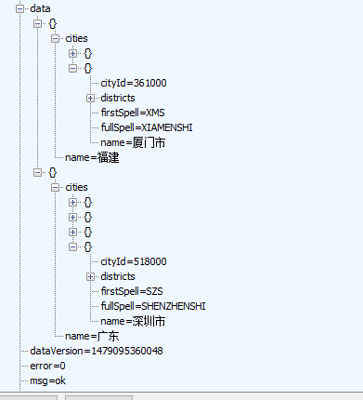

地理位置API返回数据

（2）所以商品简介？(带商品id)

POST

<http://mobile.walmartmobile.cn/MobileHD-0.0.1/globalpromotion/data/versionv3?gpDataStoreId=1059&versionId=1505243064248>

Accept: text/plain, */*

Accept-Encoding: gzip

Content-Type: application/x-www-form-urlencoded;charset=UTF-8

Content-Length: 349

Host: mobile.walmartmobile.cn

Connection: Keep-Alive

User-Agent: Apache-HttpClient/UNAVAILABLE (java 1.4)

storeId=1059&orderStoreId=1059&dagId=&clientInfo={"OsVersion":"4.4.2","appVersion":"1.5.1","buildVersion":"1.5.1","cn":"CN","deviceId":"860719010282717","ln":"zh","model":"ANDROID","name":"M636","nt":"wifi","op":"CMCC","screenSize":"1280x720x1.5","systemName":"ANDROID OS","ts":"1505271120318","tz":"Asia/Shanghai","tz_name":"GMT+08:00"}&data=%7B%7D



(3) 商品详情

POST <http://mobile.walmartmobile.cn/MobileHD-0.0.1/items/detail/v5/1691135201870>

Accept: text/plain, */*

Accept-Encoding: gzip

Content-Type: application/x-www-form-urlencoded;charset=UTF-8

Content-Length: 349

Host: mobile.walmartmobile.cn

Connection: Keep-Alive

User-Agent: Apache-HttpClient/UNAVAILABLE (java 1.4)

storeId=1059&orderStoreId=1059&dagId=&clientInfo={"OsVersion":"4.4.2","appVersion":"1.5.1","buildVersion":"1.5.1","cn":"CN","deviceId":"860719010282717","ln":"zh","model":"ANDROID","name":"M636","nt":"wifi","op":"CMCC","screenSize":"1280x720x1.5","systemName":"ANDROID OS","ts":"1505281648389","tz":"Asia/Shanghai","tz_name":"GMT+08:00"}&data=%7B%7D



（4）列表商品

POST <http://search.walmartmobile.cn/mobile/search?pageSize=20&categoryId=133635&keyword&storeId=1059&orderStoreId=1059&v=1.4>

Accept: text/plain, */*

Accept-Encoding: gzip

Content-Type: application/x-www-form-urlencoded;charset=UTF-8

Content-Length: 349

Host: search.walmartmobile.cn

Connection: Keep-Alive

User-Agent: Apache-HttpClient/UNAVAILABLE (java 1.4)

storeId=1059&orderStoreId=1059&dagId=&clientInfo={"OsVersion":"4.4.2","appVersion":"1.5.1","buildVersion":"1.5.1","cn":"CN","deviceId":"860719010282717","ln":"zh","model":"ANDROID","name":"M636","nt":"wifi","op":"CMCC","screenSize":"1280x720x1.5","systemName":"ANDROID OS","ts":"1505281648389","tz":"Asia/Shanghai","tz_name":"GMT+08:00"}&data=%7B%7D



几个列表商品api

|  |  |  |  |
| --- | --- | --- | --- |
| ID | url | 分类 | 说明 |
| 1 | http://search.walmartmobile.cn/mobile/search?pageSize=20&categoryId=560&keyword&storeId=1059&orderStoreId=1059&v=1.4 | 精选月饼 |  |
| 2 | <http://search.walmartmobile.cn/mobile/search?pageSize=20&categoryId=461057&keyword&storeId=1059&orderStoreId=1059&v=1.4> | 粮油副食-干货-枣类 |  |
| 3 | <http://search.walmartmobile.cn/mobile/search?pageSize=20&categoryId=8961&keyword&storeId=1059&orderStoreId=1059&v=1.4> | 粮油副食-直接进口商品 |  |
| 4 | <http://search.walmartmobile.cn/mobile/search?pageSize=20&categoryId=395779&keyword&storeId=1059&orderStoreId=1059&v=1.4> | 母婴之家-母婴产品-进口奶粉 |  |
| 5 | http://mobile.walmartmobile.cn/MobileHD-0.0.1/items/groupId/184869 | 主题特惠-酸奶，牛奶大作战 |  |

翻页：

POST <http://mobile.walmartmobile.cn/MobileHD-0.0.1/items/v6>

Accept: text/plain, */*

Accept-Encoding: gzip

Content-Type: application/x-www-form-urlencoded;charset=UTF-8

Content-Length: 607

Host: mobile.walmartmobile.cn

Connection: Keep-Alive

User-Agent: Apache-HttpClient/UNAVAILABLE (java 1.4)

storeId=1059&orderStoreId=1059&dagId=&clientInfo={"OsVersion":"4.4.2","appVersion":"1.5.1","buildVersion":"1.5.1","cn":"CN","deviceId":"860719010282717","ln":"zh","model":"ANDROID","name":"M636","nt":"wifi","op":"CMCC","screenSize":"1280x720x1.5","systemName":"ANDROID OS","ts":"1505281648389","tz":"Asia/Shanghai","tz_name":"GMT+08:00"}&data=%5B%7B%22storeId%22%3A1059%2C%22productId%22%3A%5B1692799258938%2C1692312062087%2C1692301892026%2C1692190990110%2C1692190990125%2C1692799259044%2C1885207118101%2C1694819584075%2C1885207119101%2C1693747312080%2C1693747310112%2C1692138558945%2C1693747312223%5D%7D%5D

data=%5B%7B%22storeId%22%3A1059%2C%22productId%22%3A%5B1692799258938%2C1692312062087%2C1692301892026%2C1692190990110%2C1692190990125%2C1692799259044%2C1885207118101%2C1694819584075%2C1885207119101%2C1693747312080%2C1693747310112%2C1692138558945%2C1693747312223%5D%7D%5D

以下为翻页参数，暂不知如何生成

data=[{"storeId":1059,"productId":[1692799258938,1692312062087,1692301892026,1692190990110,1692190990125,1692799259044,1885207118101,1694819584075,1885207119101,1693747312080,1693747310112,1692138558945,1693747312223]}]

data数据的生成：

1. 打开类别时加载所有的快照信息，和需要显示的前二十个商品信息。

Items为所有的快照信息，包含商品id信息

detailedItems: 为需要显示前二十个商品基本信息

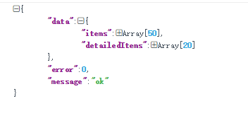

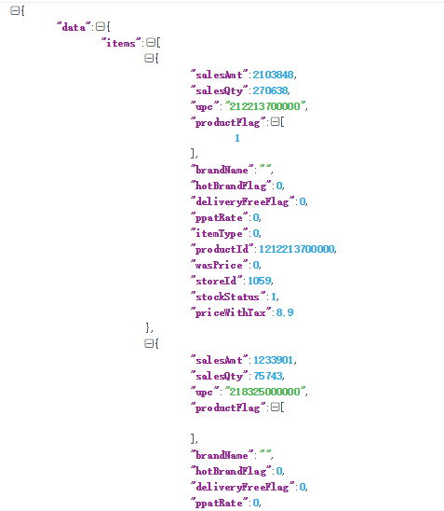

2、下拉到第二页时加载第21到第40个商品，通过id获取商品信息，data中拼接商品productId为21到第40个商品的id ,storeId：为类别id