Avenue JOAILLERIE ERP — Full Flow Documentation
This guide walks through the complete shop + manufacturing workflow, with screenshots from a live session at http://localhost:3000.
Start the app: run START.bat (or npm run dev), then open the browser URL shown.

1. System overview
Avenue JOAILLERIE ERP covers stock, manufacturing, sales, purchasing, and double-entry accounting in one place.
mermaid
flowchart LR
A[Settings & Rates] --> B[Purchases]
B --> C[Raw Materials]
B --> D[Finished Stock]
C --> E[Manufacturing]
E --> D
D --> F[Sales / POS]
F --> G[Accounting]
B --> G
F --> H[AI Analytics]
G --> H
Area | What it does
Dashboard | Today/month revenue, metal rates, recent sales, low stock
AI Analytics | Best collections, staff, slow stock, repeat buyers
Finished Stock | Sellable jewellery (gold / diamond filters)
Raw Materials | Bullion, stones, findings
Manufacturing | Job cards → issue metal to karigars → finished pieces
Sales / POS | Retail, gold, and diamond sales + returns
Purchases | Raw and finished stock POs
Accounting | Journals, P&L, balance sheet, ledgers
Settings | Company name, logo, currency, tax ID
Expenses | Salary, Rent, Utilities, Marketing, Transport and others

2. Dashboard
Path: /
Central live view of revenue, stock count, open jobs, metal rates, recent invoices, and low-stock alerts.
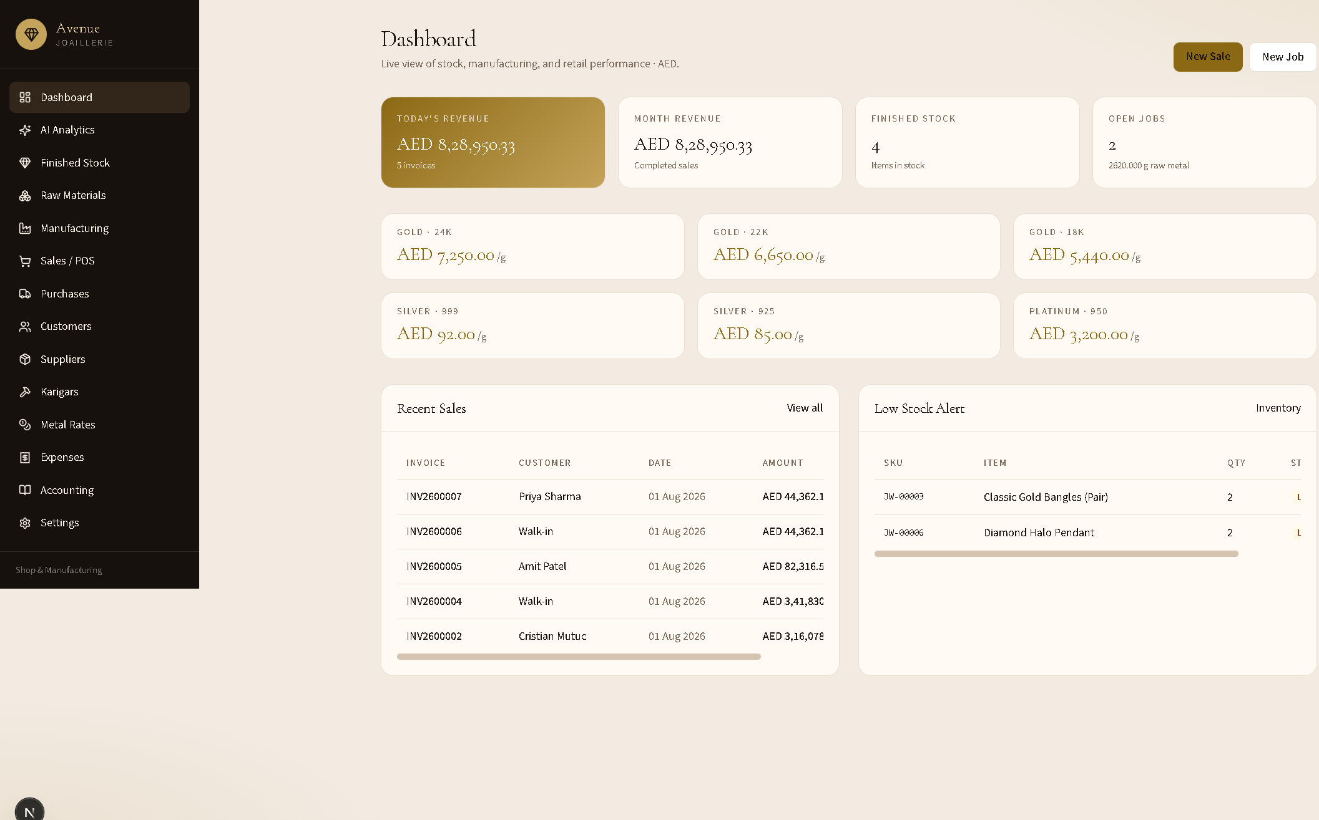
Typical actions
- Check Today’s Revenue and Month Revenue.
- Confirm metal rates before selling.
- Click New Sale or New Job, or open a recent invoice.

3. Company settings (do this first)
Path: /settings
Set shop identity used on invoices and printed reports: name, address, email, phone, tax number, currency, logo, default making % and wastage %.
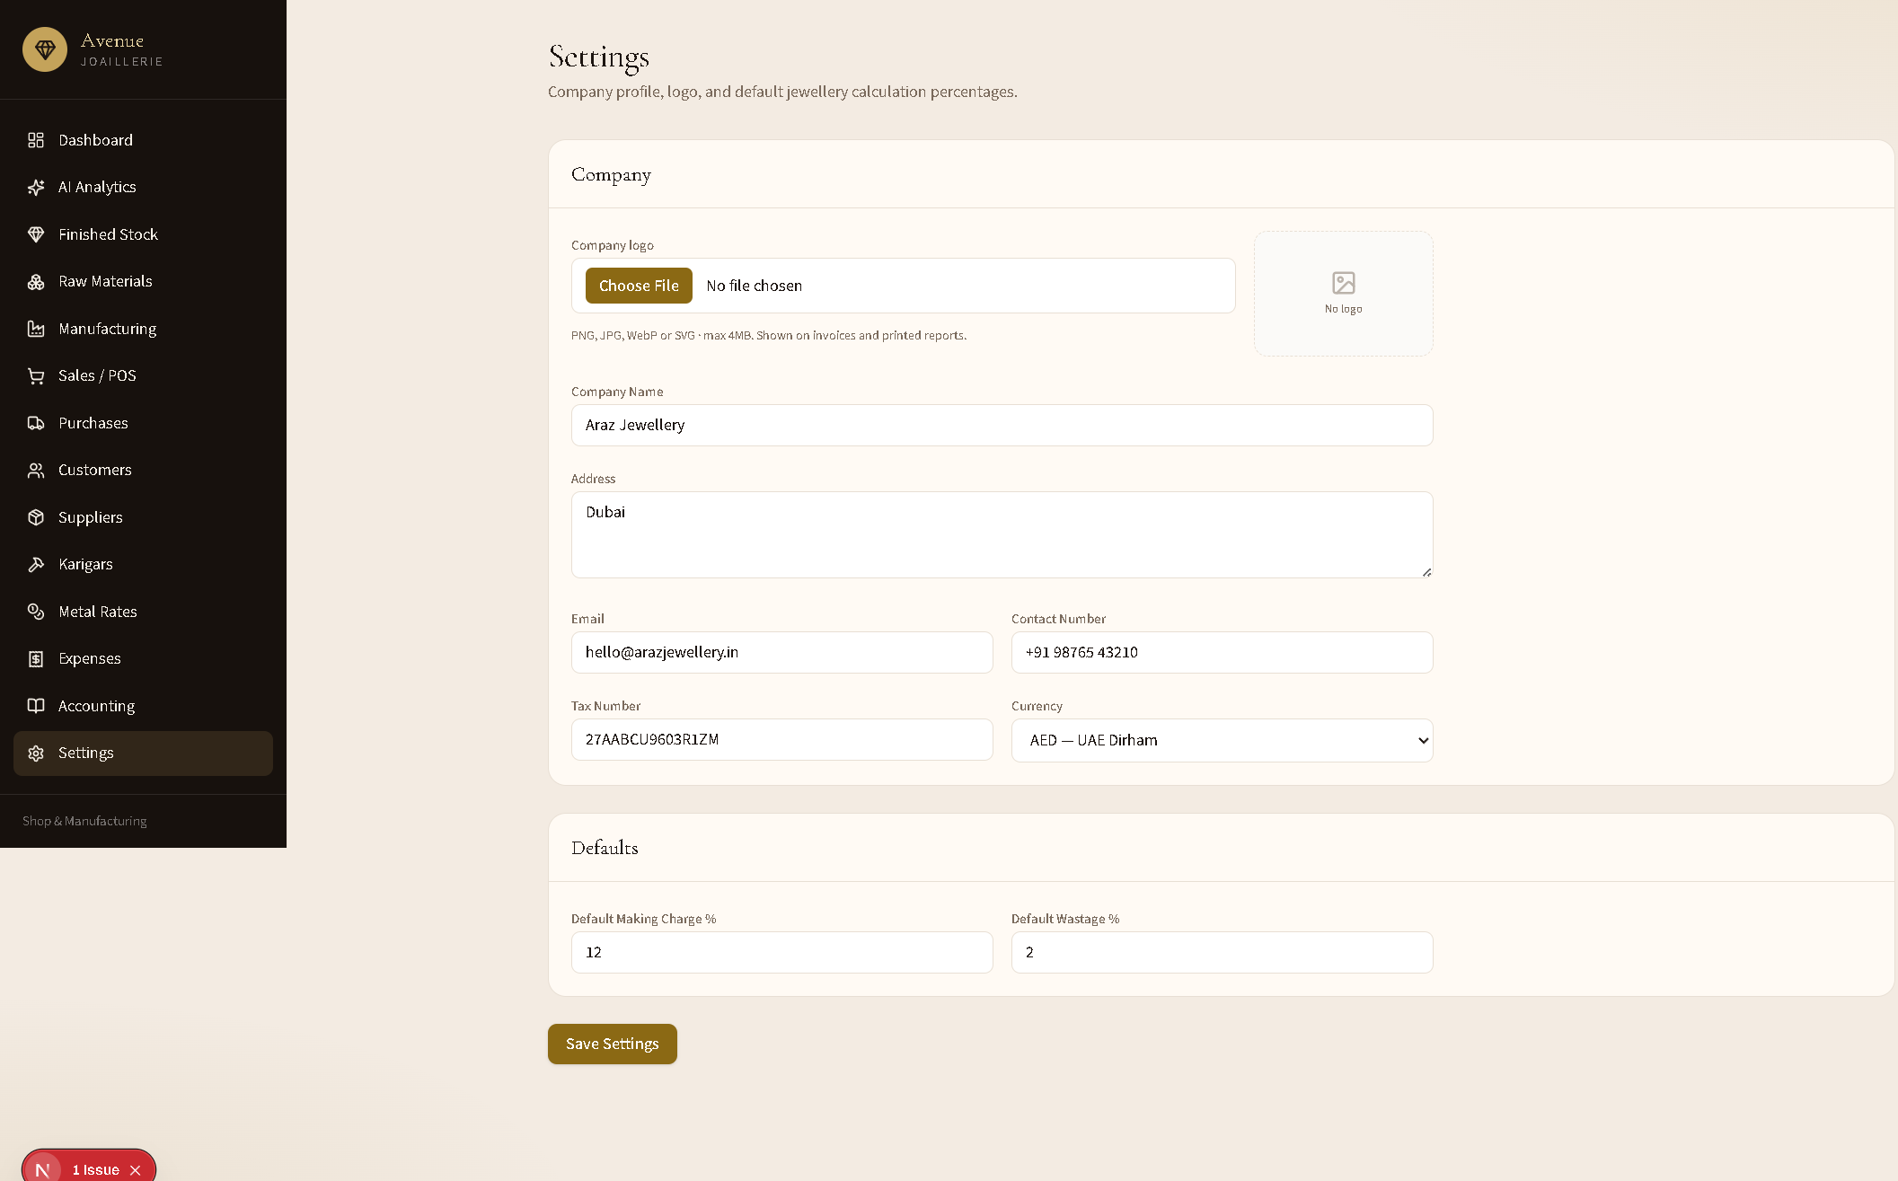
Recommended setup
- Set Company Name to Avenue JOAILLERIE.
- Choose Currency (e.g. AED).
- Upload a Company logo (shown on invoices).
- Click Save Settings.
If invoices still show an old name, update and save Settings — the database value overrides code defaults.

4. Stock flows

4.1 Finished stock
Path: /inventory
Sellable pieces with diamond / gold / all filters, search, edit, and delete.
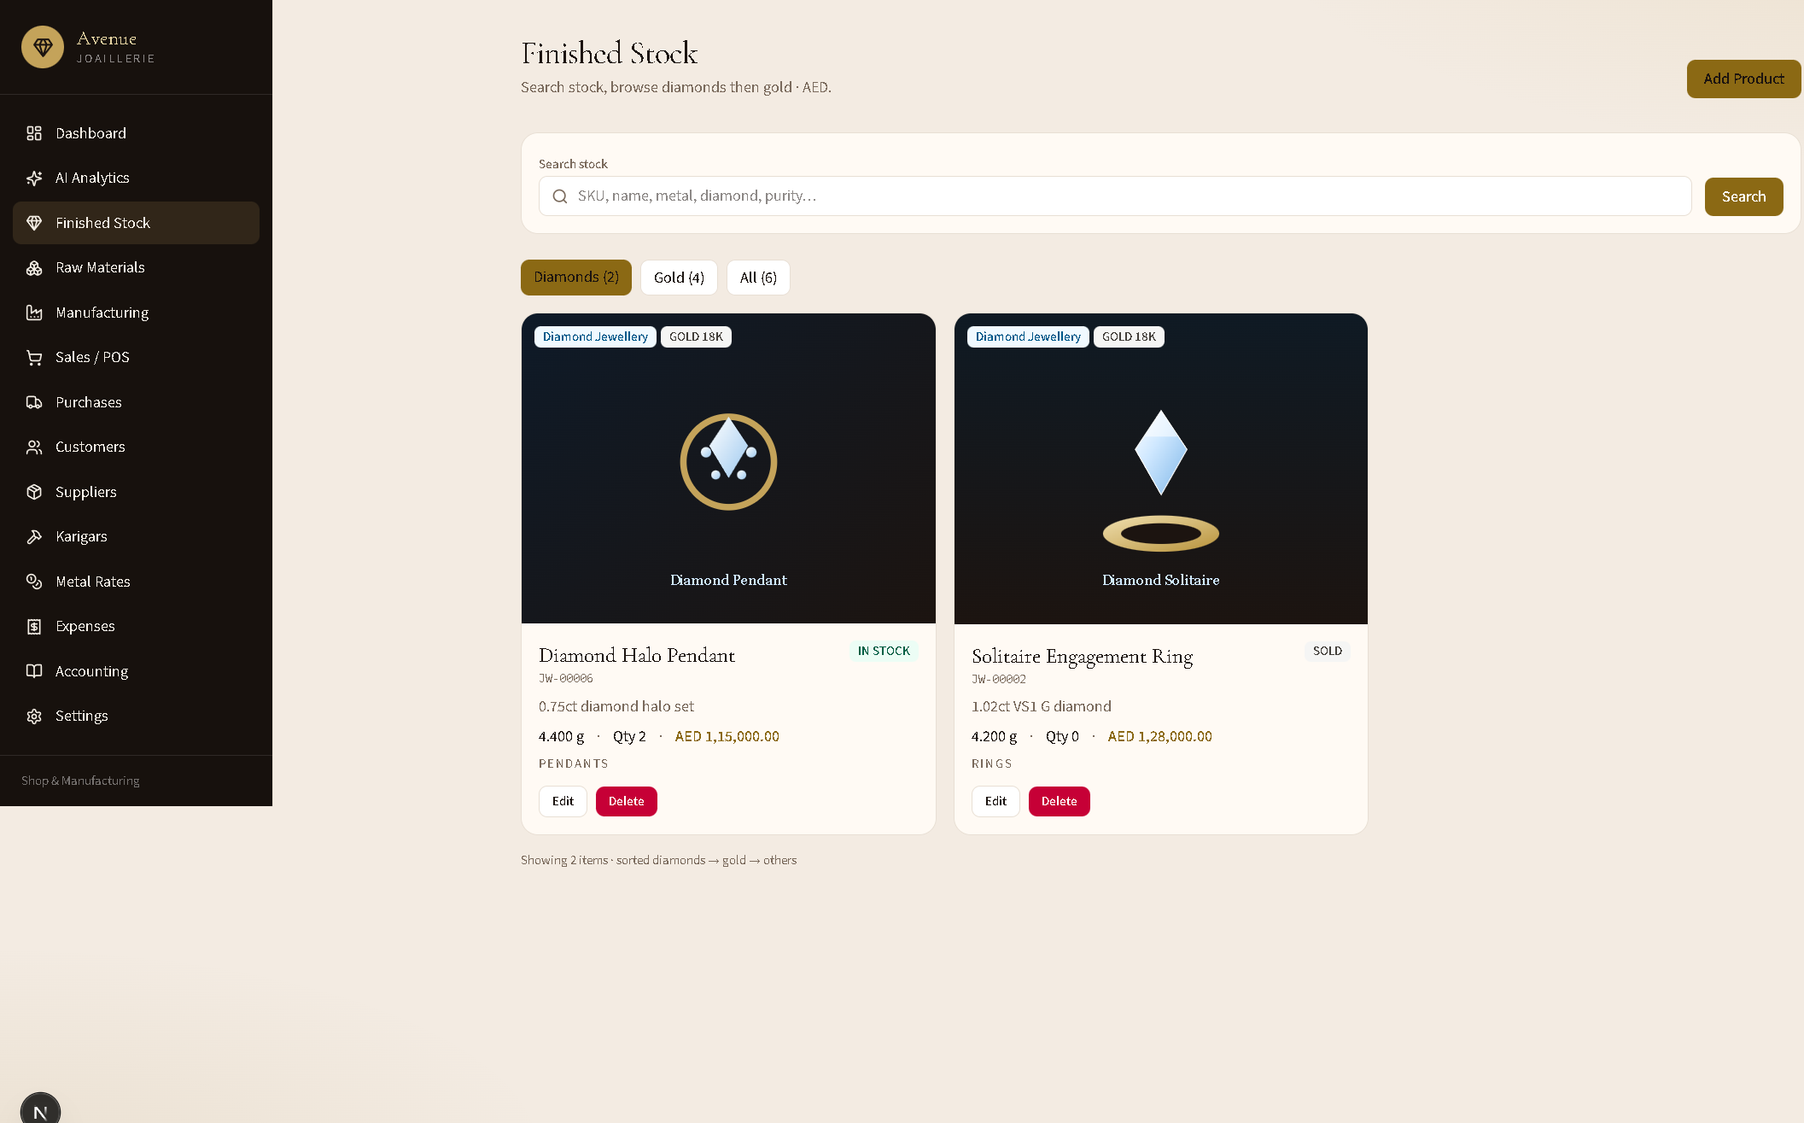
Add a product
- Click Add Product.
- Choose jewellery category (Gold or Diamond).
- Enter SKU details, weights, making, prices, photo.
- Save — item appears in Finished Stock and can be sold or purchased into.

4.2 Raw materials
Path: /materials
Bullion, stones, and findings used by manufacturing and raw purchases.
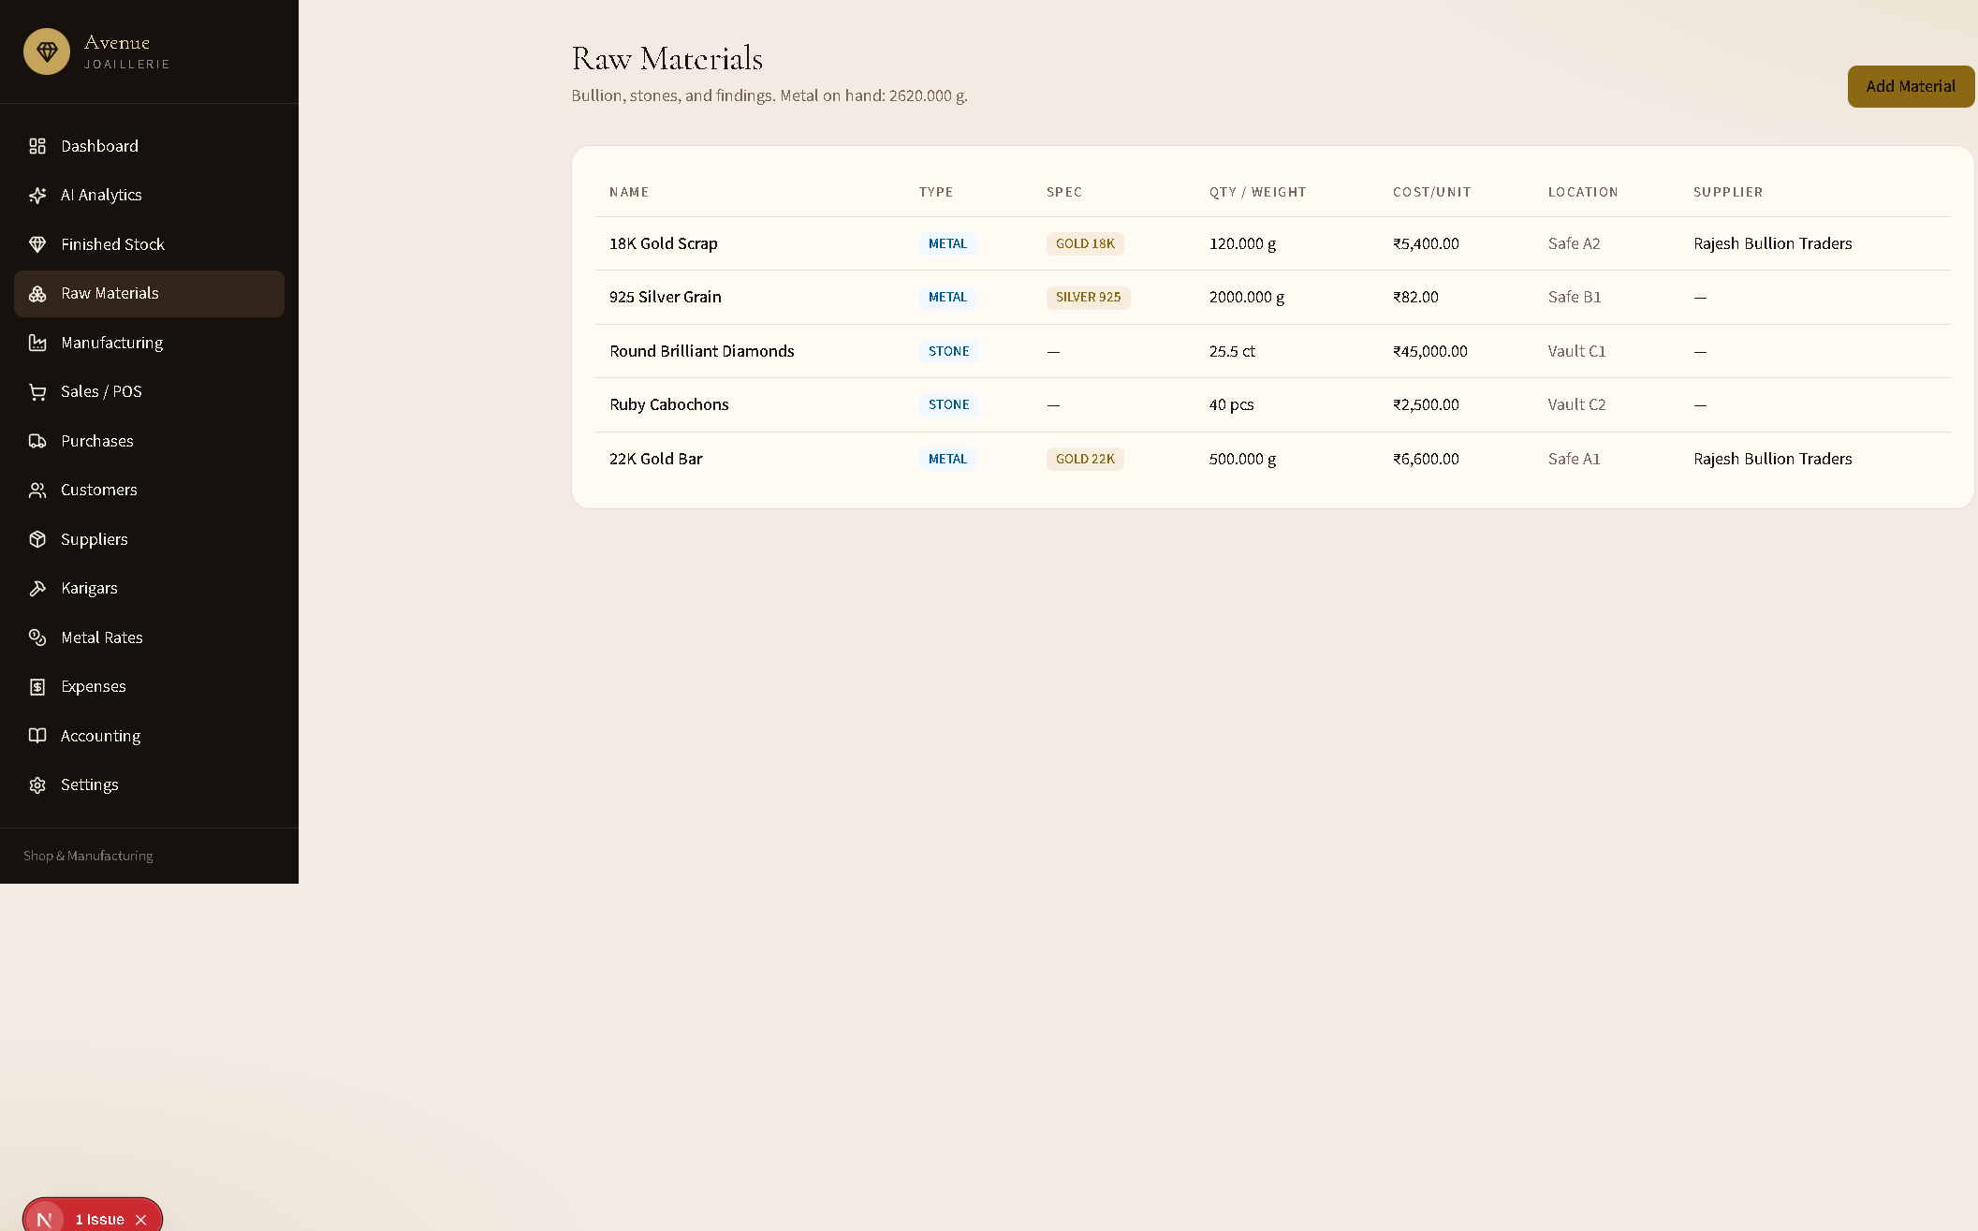

5. Purchase flow
Path: /purchases → New Purchase
Buy raw metal/materials or finished stock. Receiving finished stock increases inventory quantity.
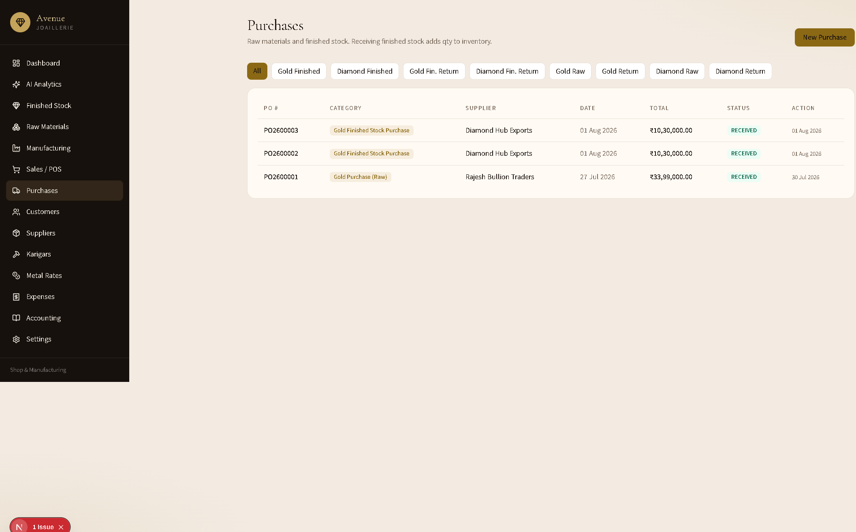
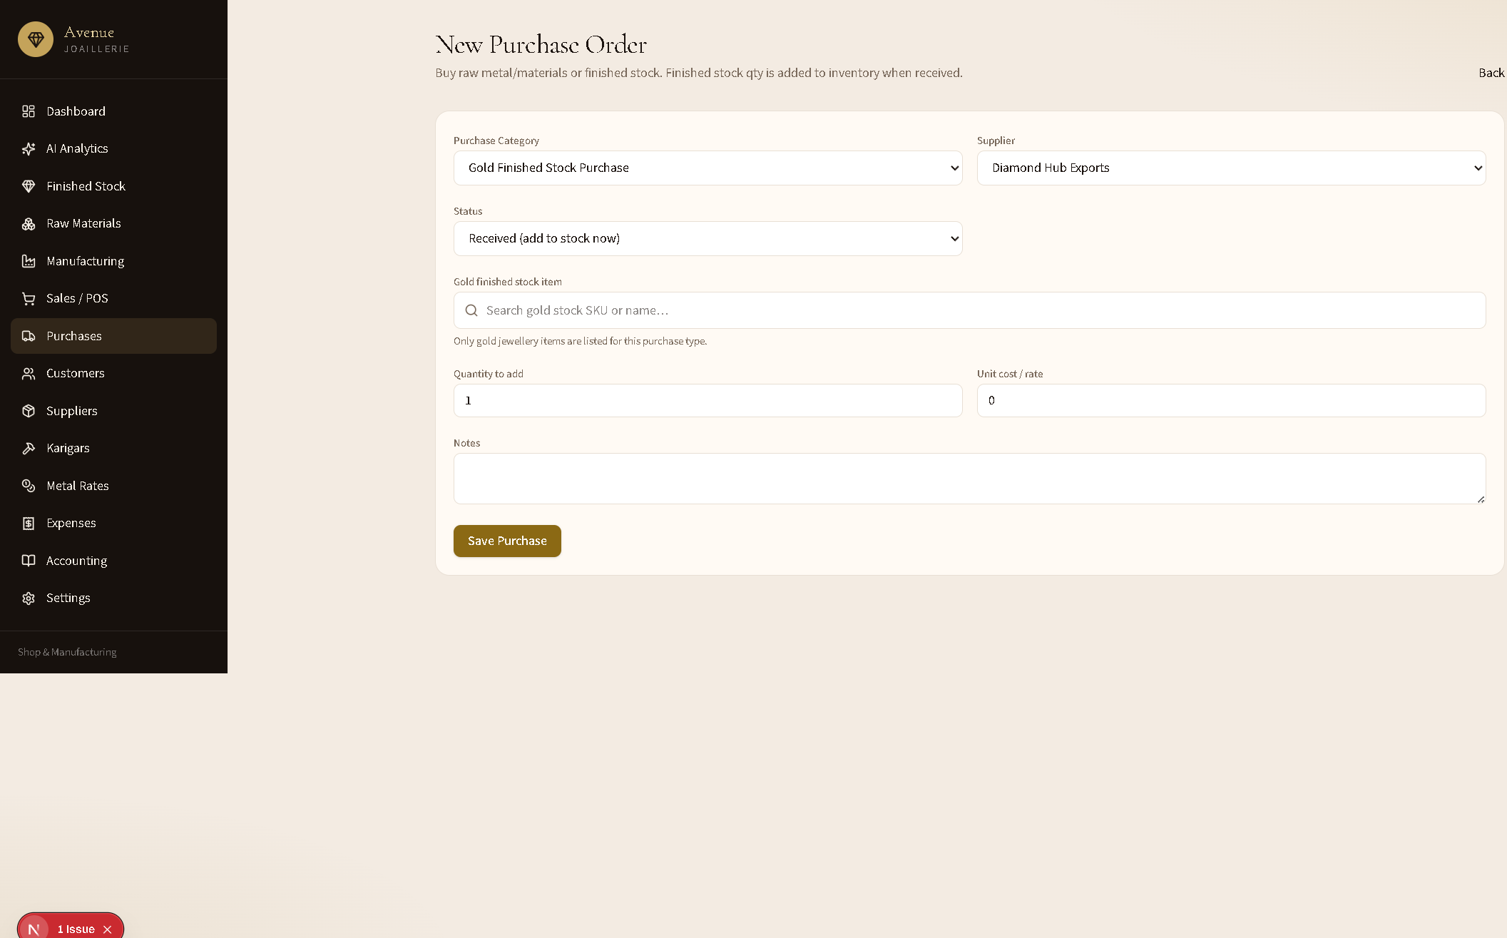
mermaid
flowchart TD
A[New Purchase] --> B{Category}
B -->|Raw Gold/Diamond| C[Enter description, metal, weight, rate]
B -->|Finished Gold| D[Pick gold stock item only]
B -->|Finished Diamond| E[Pick diamond stock item only]
C --> F[Status: Ordered / Received]
D --> F
E --> F
F -->|Received| G[Stock + accounting journal]
Steps
- Open Purchases → New Purchase.
- Choose Purchase Category:
  - Gold / Diamond Purchase (Raw) — materials ledger.
  - Gold / Diamond Finished Stock Purchase — product picker filtered to that jewellery type.
- Select supplier and status (Received adds stock immediately).
- For finished stock: search and select the product, qty, and unit cost.
- Save Purchase → PO created; if received, qty and journal post automatically.

6. Manufacturing flow
Path: /manufacturing
Issue metal to karigars, track labour, and receive finished pieces into stock.
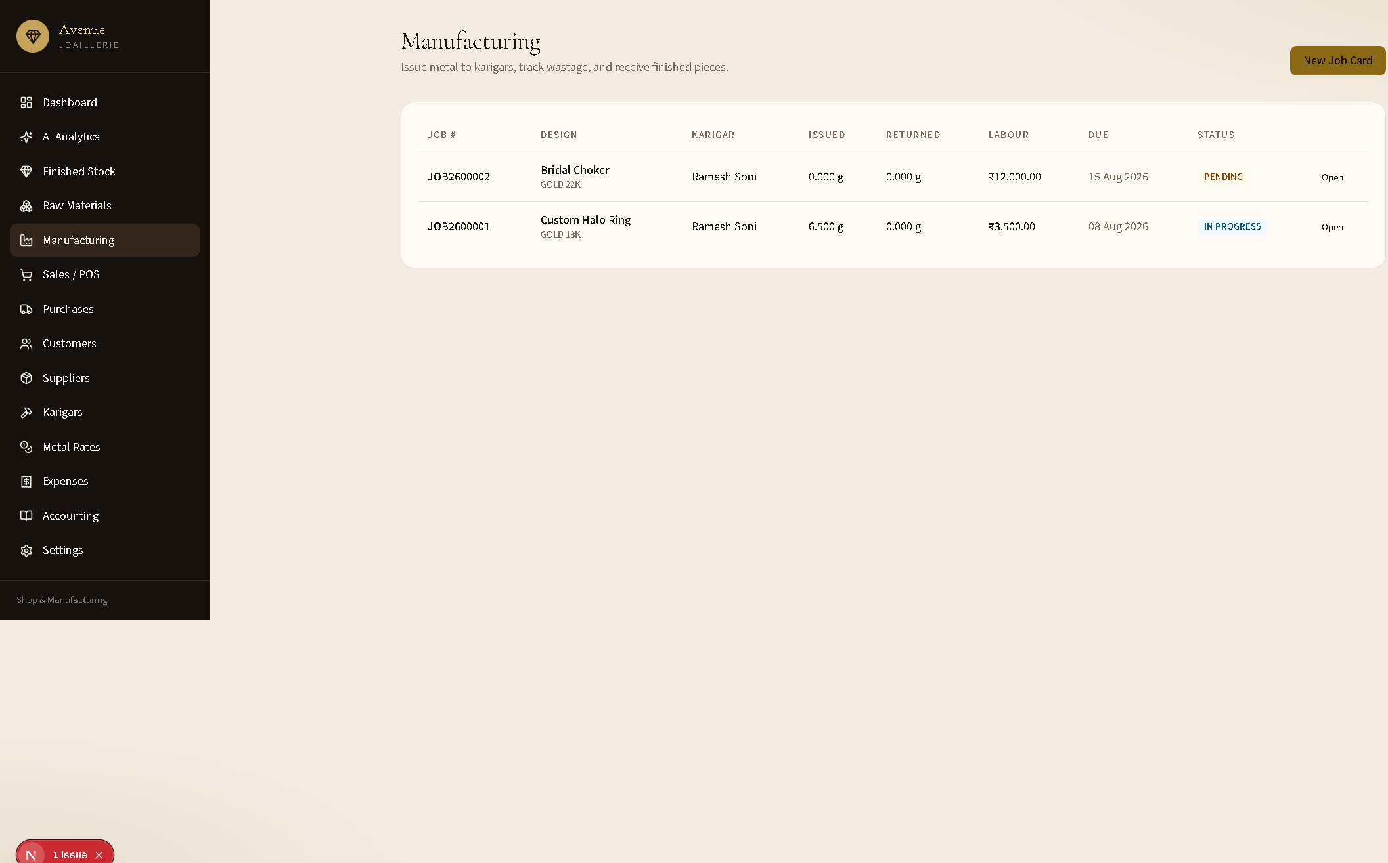
Steps
- Click New Job Card.
- Describe the design, metal, karigar, due date, labour.
- Issue raw metal weight from materials.
- When complete, receive the finished piece (creates / updates finished stock).

7. Sales / POS flow
Path: /sales → New Sale → invoice detail

7.1 Sales list
Filter by Retail, Gold, Diamond (and returns). Edit or delete invoices; stock and journals reverse on delete/edit.
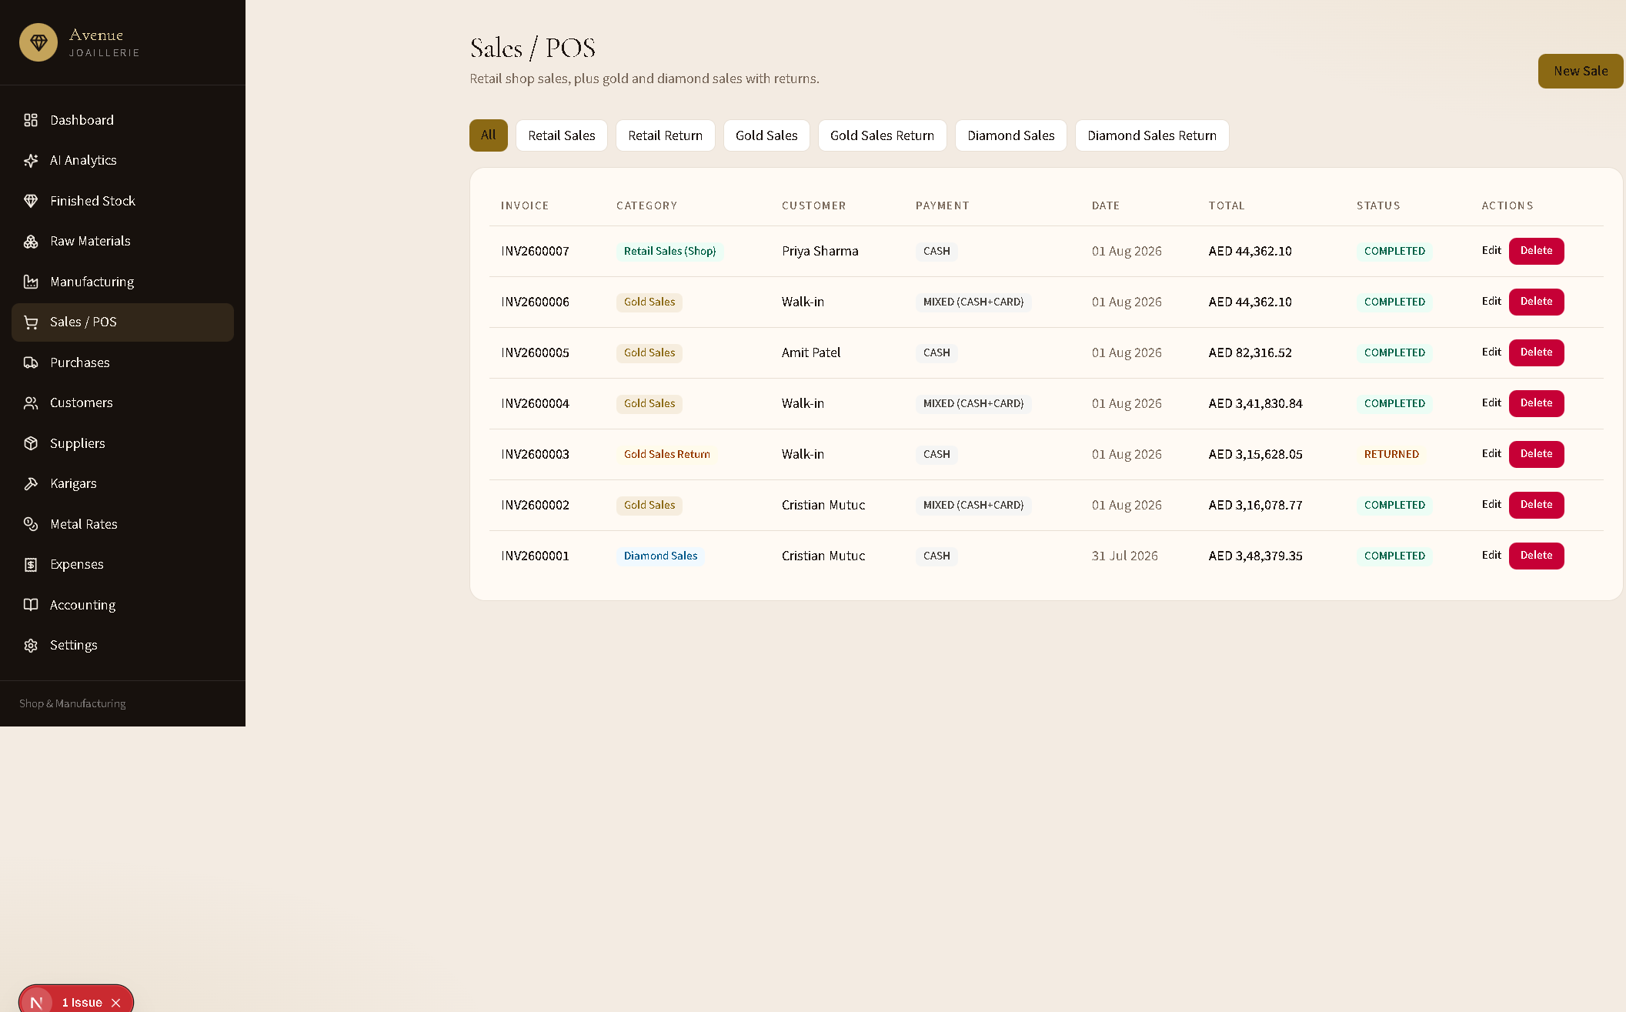

7.2 Create a sale
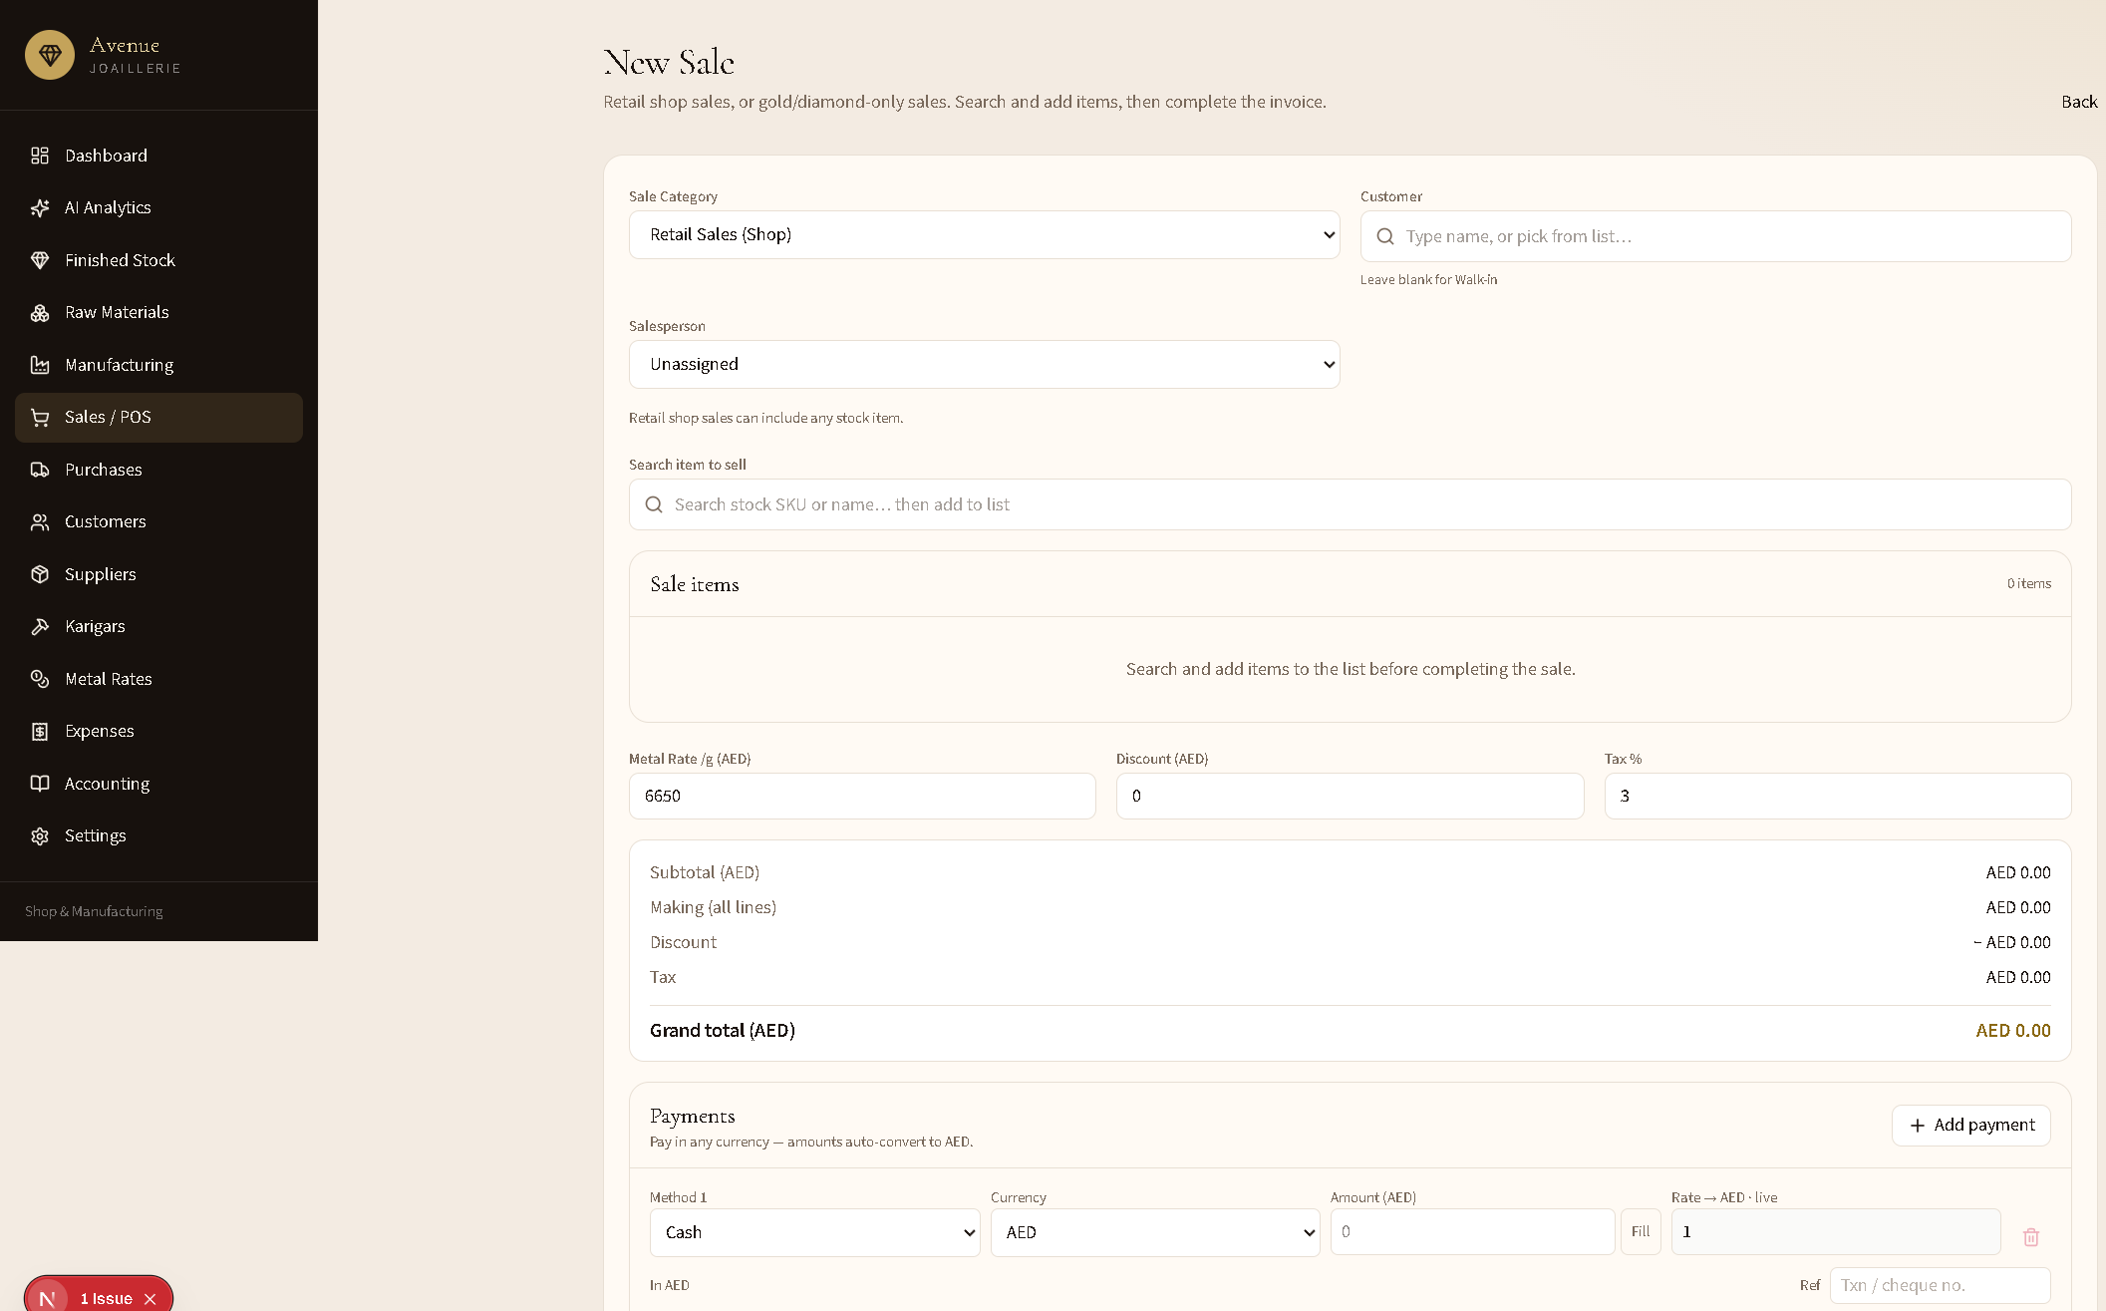
mermaid
flowchart TD
A[New Sale] --> B[Pick Sale Category]
B -->|Retail| C[Any stock item]
B -->|Gold| D[Gold items only]
B -->|Diamond| E[Diamond items only]
C --> F[Add lines to cart]
D --> F
E --> F
F --> G[Metal rate, discount, tax]
G --> H[Split payments any currency]
H --> I[Complete Sale]
I --> J[Stock down + sale journal]
I --> K[Tax Invoice printable]
Steps
- Choose Sale Category:
  - Retail Sales (Shop) — any stock (default).
  - Gold Sales — gold jewellery only.
  - Diamond Sales — diamond jewellery only.
- Customer: type a name or pick from the list (blank = Walk-in).
- Assign a Salesperson (powers AI staff ranking).
- Search SKU/name → add one or more lines; adjust weight, making, stone, qty.
- Set metal rate /g, discount, tax %.
- Enter Payments (cash/card/UPI/bank; multi-currency converts to shop currency).
- Complete Sale → invoice created, stock reduced, accounting posted.

7.3 Tax invoice
Printable invoice with company header, line items, payments, and salesperson.
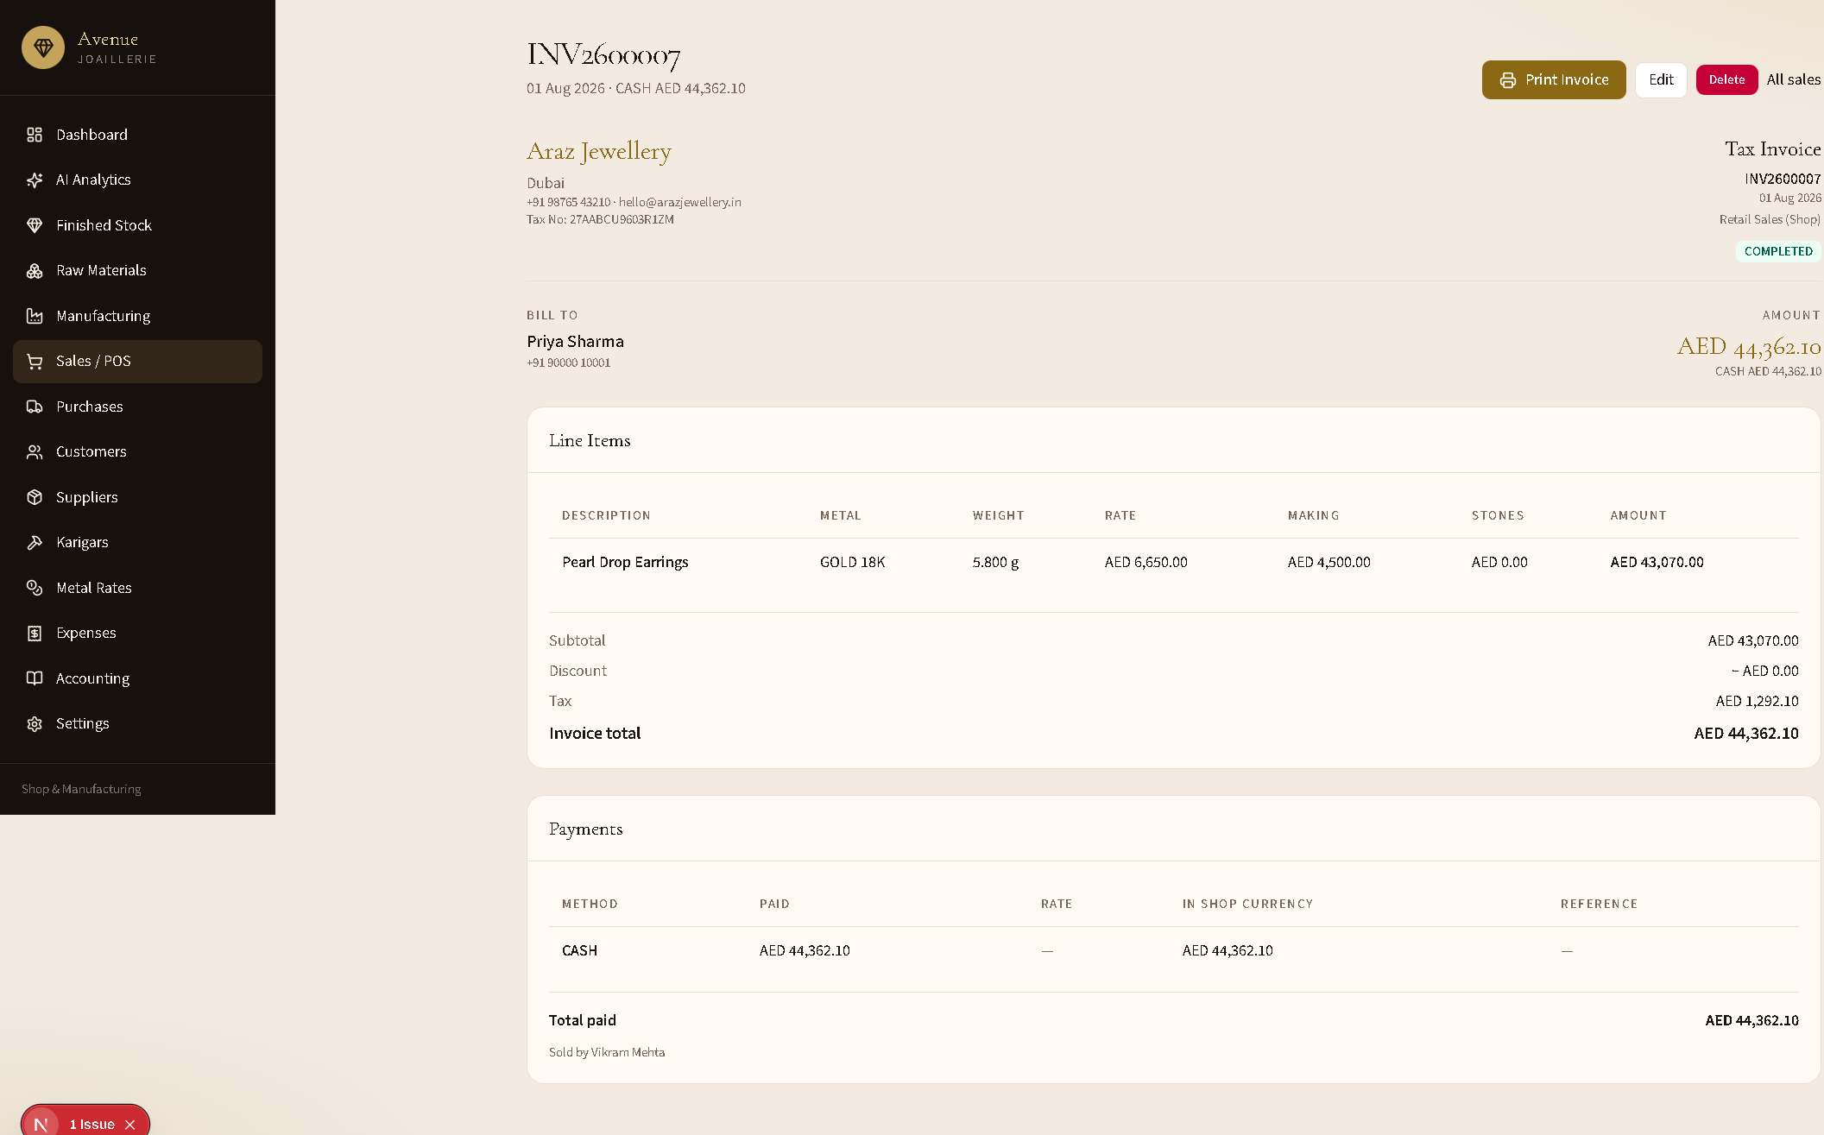
Use Print Invoice, Edit, or Delete from this page.

8. Accounting flow
Path: /accounting
Books sync from sales, purchases, and expenses. Hub shows P&L snapshot, trial balance status, assets/liabilities, and links to reports.
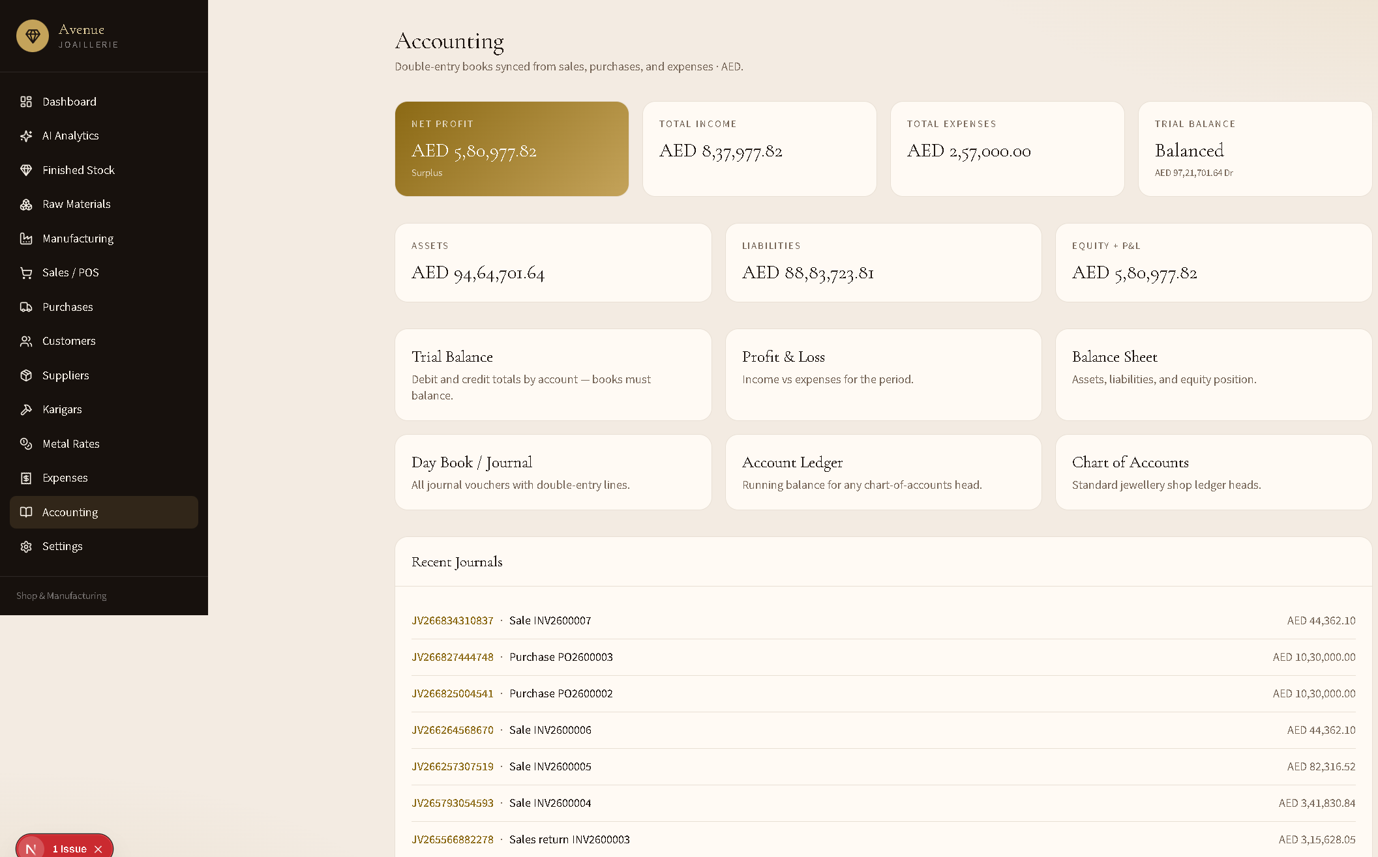
Report | Purpose
Trial Balance | Debits = credits check
Profit & Loss | Income vs expenses
Balance Sheet | Assets, liabilities, equity
Day Book / Journal | All vouchers
Account Ledger | Running balance per head
Chart of Accounts | Standard jewellery ledger codes
Sales post to finished-goods / income / cash-bank / GST as applicable; finished purchases hit finished inventory (INV_FG), raw purchases hit raw materials (INV_RM).

9. AI Sales Analytics
Path: /analytics
Answers the four business questions with date-filtered data and narrative insights.
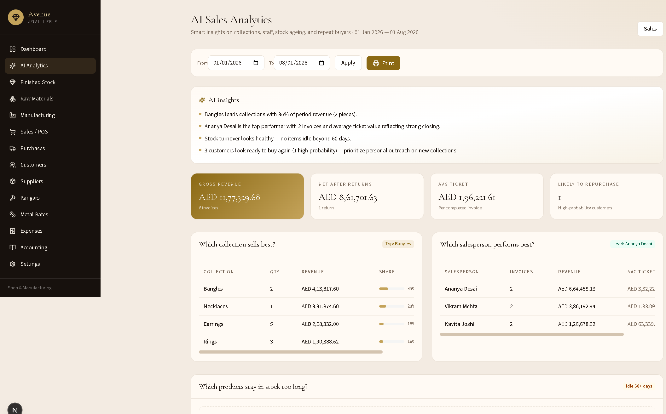
Question | What you see
Which collection sells best? | Revenue, qty, and share by category (e.g. Bangles, Rings)
Which salesperson performs best? | Invoices, revenue, average ticket
Which products stay in stock too long? | Idle 60+ days, risk high/medium, tied value
Which customers are likely to buy again? | RFM-style score (high / medium) + win-back list
- Set From / To → Apply.
- Read AI insights at the top.
- Use tables for outreach, markdowns, or staff coaching.
- Optional Print for a period pack.

10. End-to-end “happy path”
- Settings — company name Avenue JOAILLERIE, currency, logo.
- Metal Rates — set today’s gold/silver/platinum rates.
- Suppliers / Customers / Karigars — master data.
- Purchase finished or raw stock → receive.
- Optional Manufacturing job → finished piece in stock.
- New Sale (Retail / Gold / Diamond) → multi-item cart → payments → complete.
- Print invoice for the customer.
- Accounting — confirm journals / P&L.
- AI Analytics — review collections, staff, ageing stock, repeat buyers.

11. Screenshot index
File | Screen
screenshots/01-dashboard.png | Dashboard
screenshots/02-analytics.png | AI Sales Analytics
screenshots/03-inventory.png | Finished Stock
screenshots/04-sales.png | Sales list
screenshots/05-new-sale.png | New Sale
screenshots/06-purchases.png | Purchases list
screenshots/07-new-purchase.png | New Purchase
screenshots/08-manufacturing.png | Manufacturing
screenshots/09-accounting.png | Accounting hub
screenshots/10-settings.png | Settings
screenshots/11-materials.png | Raw Materials
screenshots/12-invoice.png | Tax Invoice
All images live under docs/screenshots/.

12. Quick reference — sale & purchase categories
Sales: RETAIL_SALE / RETAIL_RETURN · GOLD_SALE / GOLD_RETURN · DIAMOND_SALE / DIAMOND_RETURN
Purchases: raw gold/diamond · finished gold/diamond purchase & return
Item pickers always match the selected jewellery type (retail sales show all stock).

