Report on Data Architecture for Gaming Platform

Made by:
Youssef Elkiki
Sherif Osama
Kareem Baher

1. Introduction
The purpose of this report is to provide an overview of the data architecture implemented for The Gaming Platform. This project involves the development of a gaming platform that encompasses various features such as player profiles, real-time game updates, social interactions, player statistics, and game analytics. The data architecture plays a crucial role in ensuring the efficient storage, retrieval, and management of application data to support these functionalities.

2. Database Selection
For the data storage requirements of the project, two databases were selected: Cassandra and Redis.

Cassandra: Chosen for its scalability and high availability. Cassandra's distributed architecture allows for seamless scaling to handle large amounts of data and high throughput. It is well-suited for storing structured data with flexible schemas, making it ideal for player profiles, game data, and analytics.

Redis: Selected for its fast read and write operations, as well as its support for real-time data processing. Redis provides various data structures suitable for different use cases, such as lists, sets, and hashes, making it suitable for storing real-time game updates, leaderboards, social features, and player statistics.

3. Data Modeling

Cassandra:

Player Profiles: Modeled using a single table with the username as the primary key. This denormalized structure allows for fast retrieval of player data by username.
Game Data: Organized into separate tables based on the type of data, such as game information and object details. Each table uses appropriate primary keys and clustering columns to optimize query performance.
Game Analytics: Modeled using tables to track player behavior and game events. This allows for detailed analysis of player interactions and performance.

Redis:
Real-time Updates: Utilizes Redis' pub/sub mechanism to broadcast real-time game events to subscribed clients. Data is stored in appropriate data structures like lists and hashes for efficient processing.
Leaderboards: Implemented using Redis sorted sets, allowing for easy ranking of players based on chosen metrics.
Social Features: Chat and guild functionalities are stored in Redis as chat message histories and guild membership information using appropriate data structures.
Player Statistics: Tracked using Redis hashes, allowing for efficient storage and retrieval of player-specific metrics.

4. Organization of Application Data
Player Data: Stored in Cassandra, allowing for fast retrieval of player profiles by username.
Game Data: Cassandra is used to store game information and object details, ensuring consistent and reliable access to game data.
Real-time Updates: Redis handles real-time game updates, ensuring timely delivery of events to connected clients.
Leaderboards: Implemented in Redis for efficient ranking and retrieval of leaderboard data.
Social Features: Redis is used for storing chat messages and guild membership information, enabling real-time social interactions between players.
Player Statistics: Tracked in Redis for easy aggregation and retrieval of player-specific metrics.
Game Analytics: Cassandra is used to store detailed data on player behavior and game events, facilitating analysis for performance monitoring and game improvement.

5. Data View
Cassandra:
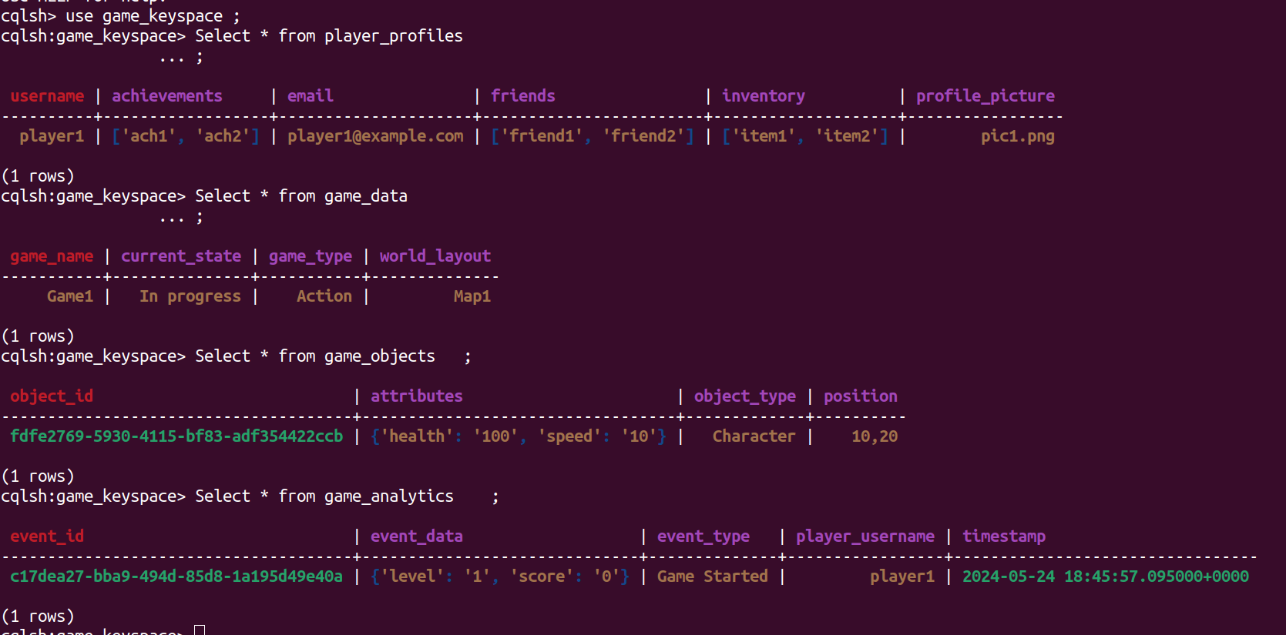

redis:
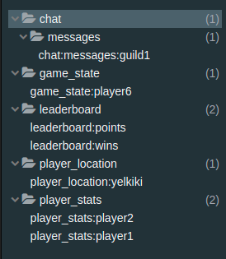

To be Viewed in detail during discussion

6. Conclusion
In conclusion, the data architecture implemented for The Gaming Platform effectively addresses the storage and retrieval needs of the gaming platform. The combination of Cassandra and Redis enables the project to achieve scalability, performance, and real-time processing capabilities required for delivering a dynamic and engaging gaming experience.

A Special Thanks to our beloved Dr and TAs

