**Q1) Pull any image from the docker hub, create its container, and execute it showing the output.**

Docker is a centralized platform to create, run, execute and deploy applications on server. Docker packages software into centralized unites called containers. Docker uses the kernel of the host operating system and we can pull and push images into server known as docker hub by using an intermediate known as docker daemon.

We can know the version of docker by using docker version command

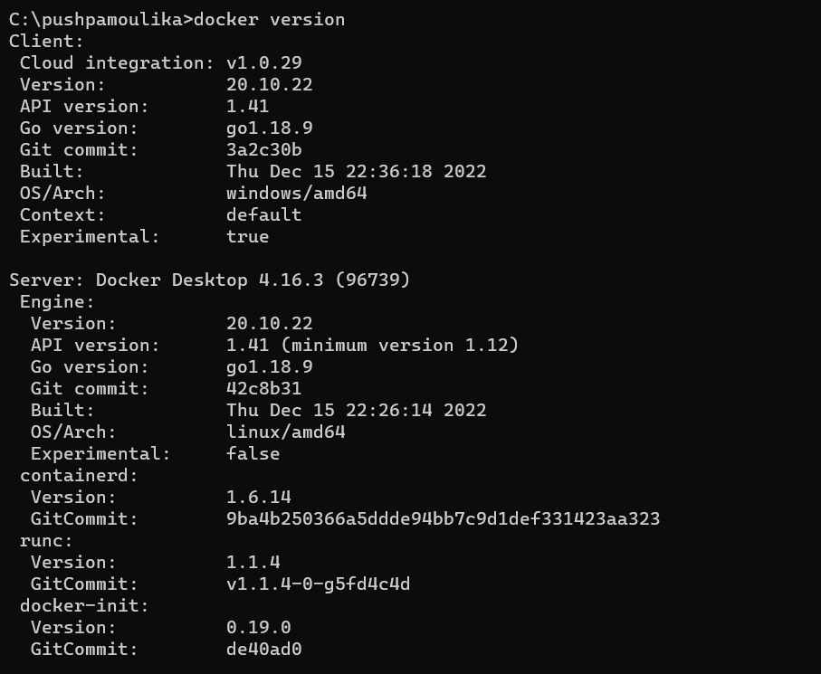

We can download a image by using docker pull <image name>. Docker pull downloads the image from docker hub but does not execute it.



Let’s download an image called nginx from the hub. After successful download of image, the terminal shoes the following lines.

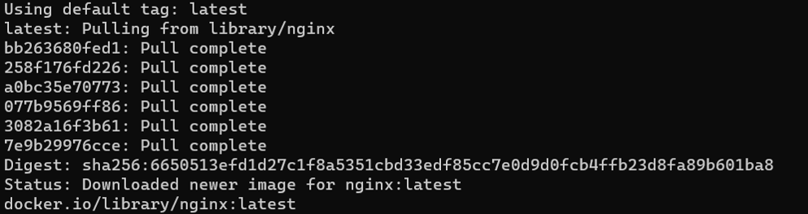

To create a container for an image and expose it to port 80 using docker run –name nginxcontainer -p 80:80 -d nginx



We can view the container by using the command docker ps -all



We can connect to the running container with following command

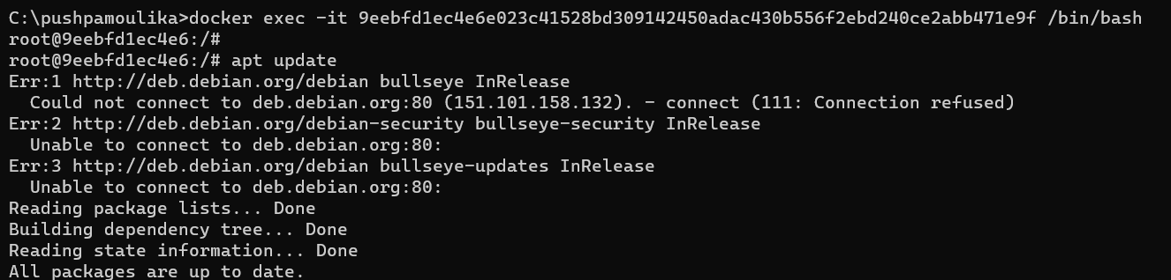

We can verify whether the container is running or not on docker desktop

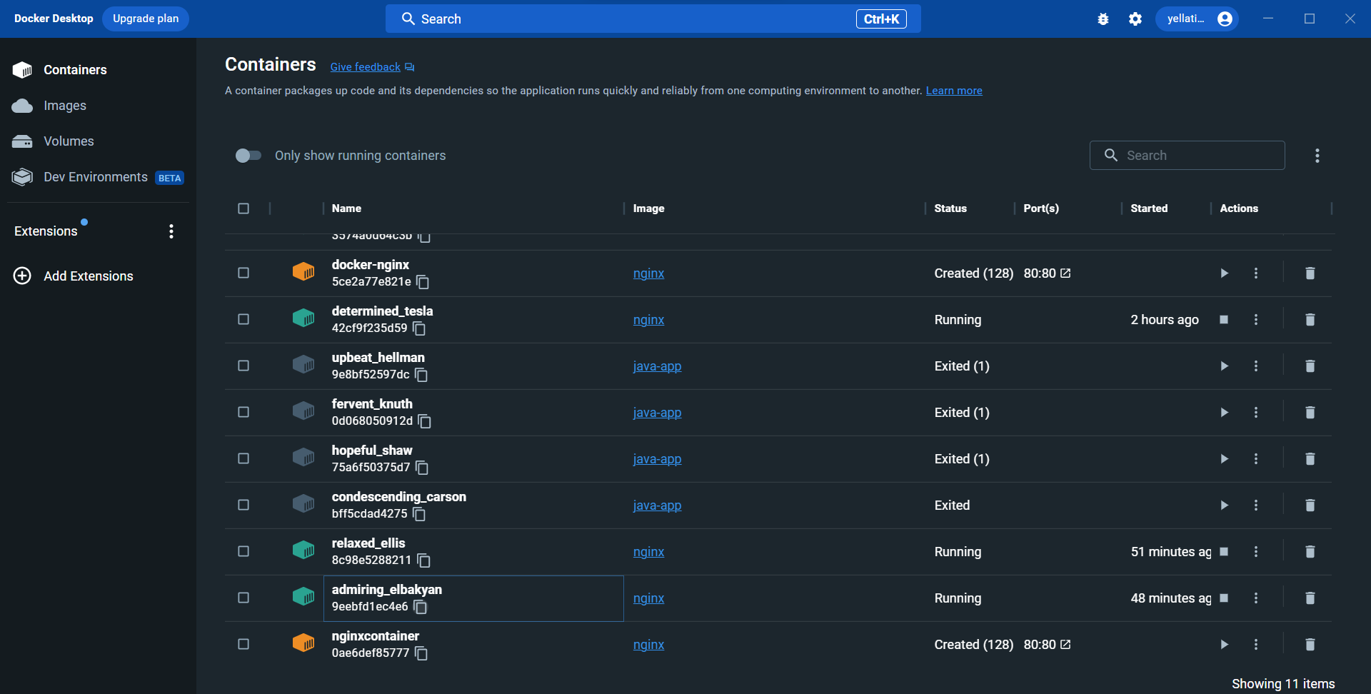

**Q2) Create the basic java application, generate its image with necessary files, and execute it with docker.**

Creating a java application on docker

Step1: create a directory.



Step2: go to the directory you have created

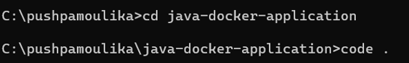

Step3: create a java file and save it as hello.java

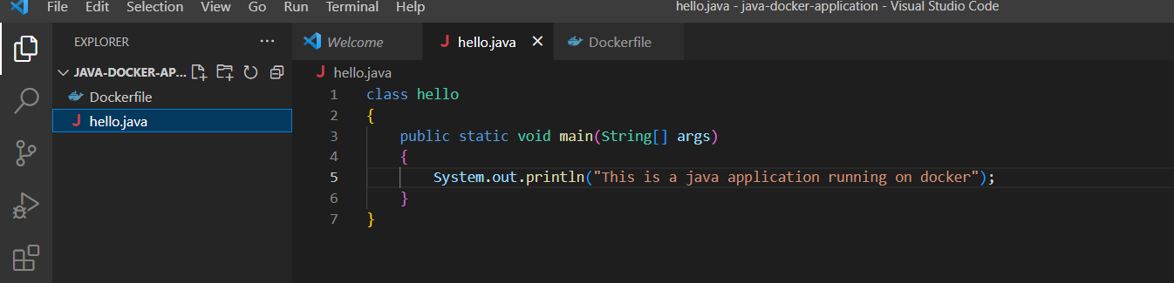

Step4: now create a docker file with commands

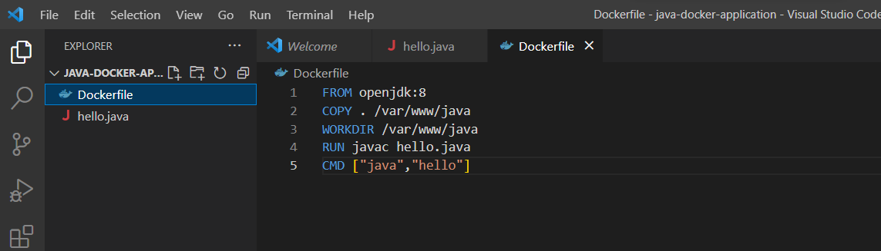

Step5: now build an image called java-app.

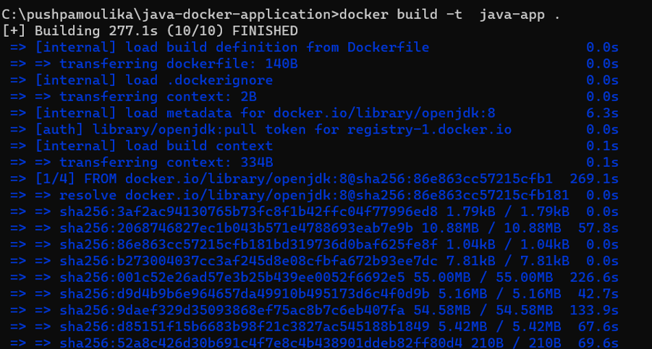

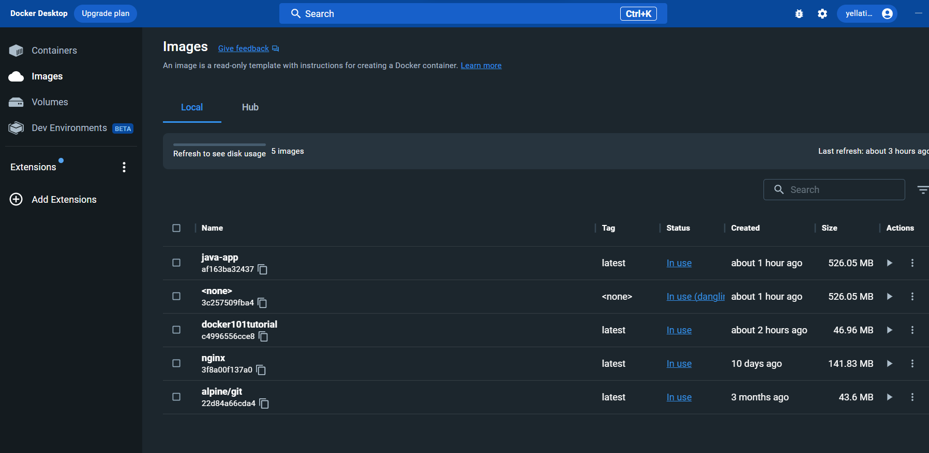

Step6: now run the java-app image by using command docker run <image name>



By opening docker desktop, we the java application running.

