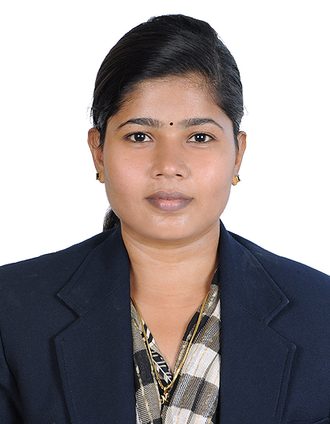 |  PERMANENT ADDRESS:  6/16A, North Street,  Kangayam patti(PO), Kottara Patti,  Thanjavur dist, Tamilnadu, INDIA  email: nevisevangeline@gmail.com  Phone: -- +919790593906
Date of Birth: 24th March, 1986
Marital Status: Not married
Religion: Christian (Catholic)
Passport No: H0080518 Validity:26-08-2018
R7406978 Validity:25-12-2027

Career Summary
- An experience primary teacher possessing excellent classroom management skills as well as dedication.
- Ability to devise and develop ways to encourage and challenge students to help them deepen their knowledge and understanding .
- Ability to develop and foster appropriate skills to enable the development of children.
Area of Expertise
- Classroom Management
- Behaviour Management
- Creative Questioning-
- Patient
- Student Focused
- Organised
- Hard Working
- Knowledgeable about all areas of teaching

Educational Qualifications     | DIPLOMA IN MONTESSORI TEACHING PRACTICE(IMTT)  International Montessori Teacher Training Institute,  Year 2014-2015  Trichy, Tamilnadu India  BACHELOR’S DEGREE IN ENGLISH Literature(B.A)  University of Bharathidasan– Graduation Year 2011-2014 Tamilnadu, India  DIPLOMA IN TEACHER EDUCATION (DTED)  ST.Mary’s Teacher Training Institution - Year 2009-2011  Trichy, Tamilnadu, India.
WORK EXPERIENCE
(In reverse chronological order)
Trinity Academy  Thillainagar, Trichy,  Tamilnadu, India | Designation: coaches candidates for IELTS,TOEFL and PTE examination and Tamilnadu public service commission examination.  Year: 2016- Present
Chellammal Vidyalaya School  (International CBSE)  Vengur, Kallanai,  Tamilnadu, India | Designation: Kindergarten Teacher  Subjects: KG classes/English/Math/Comp/EVS/Tamil  Year: 2015-2016
Sacred Heart school (CBSE)  Mathur, Pudhukottai District,  Tamilnadu, India | Designation: Primary Teacher  Subjects: Primary 1/ English/EVS/Math/ GK/Comp/Tamil  Year: 2012-2014
Daffodils Nursery and Primary School (CBSE) Mathur, Pudhukottai District,  Tamilnadu, India  Responsibilities  - Developing lesson plans as per the curriculum.  - Conducting tests for students on a montly and weekly basis to track their progress .  - Responsible to conduct extracurricular activities for the students.  - Helping and guiding the weak students in their curriculum.  - Conduct extra classes for weak students.  - Arrange parents teacher meeting.  - Maintain discipline in the classroom.  - Maintaining the attendance register of students.  - Maintaining up to date classrooms display.  - Help managing student behaviour.  Achievements  - Always got 100% results in all the subjects taught. | Designation: Primary Teacher  Subjects: Primary4  EVS/Math/English/Tamil  Year: 2007-2009 , 2011- 2012
Extra Curricular Activities   | 1) Singing/School level  2) Debate/College level  3) Athletics/School level  4)Drama/School level  5)Dancing
 Hobbies | Sports, Music, Socializing, Reading,  Television, Cooking & Gardening.
 Languages Known | English & Tamil
Work References:-  1. K.Tamilarasu  Director - Trinity Overseas Academy  29-A,(Upstairs) Trinity Building, 10th Cross,  Opp.Petrol Bunk, Thillai Nagar Main Road,  Trichy - 620 018 Tamil Nadu,  Phone: +91-431-4220204/+919345123873 | 2. Sr.Gracy,  Sacred Heart School,(CBSE),  Mathur,Pudukkottai District,  Taminadu, India  Phone;9786655983.

