B I O - D A T A

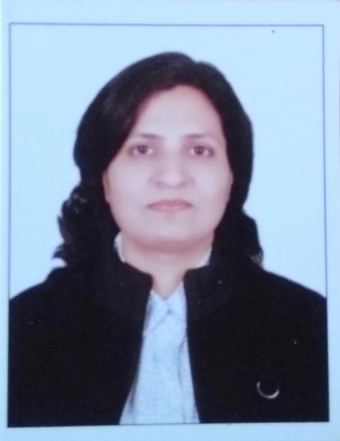

01.Name **:** REKHA SINGH

02. Date of Birth : 15th September – 1968

03. Contact No. : +91 – 7708030315

04. E – Mail :rekha2015ad@gmail.com,

singh7.rk@gmail.com

05. Nationality/Passport : Indian / Z4299595 Valid till 06.07.2027

06. Address : 1141, Tower 1, Prestige Ferns Residency

Harlur Main Road, Eastwood Township,

Harlur, Bengaluru, Karnataka, India

Karnataka 560102

#### 

**07. Educational Qualification:**

**A) MA (Hindi) from IGNOU, 2005.**

**B)** **B. Ed.** from Purvanchal University, Jaunpur, 1998.

**C) B. A.** from Allahabad University, Allahabad, 1990.

**D) Intermediate** from **Crosthwaite** Inter College Allahabad, 1986**.**

**E) High School** from MSS Inter College Allahabad, 1984.

### 08. Experience Profile:

* Since June - 2011 to Apr - 2013 as TGT Teacher with **Delhi Public School**, Nagpur.
* Since July - 2008 to Mar - 2009 as TGT Teacher with **Delhi Public School**, Gandhidham.
* Since Apr - 2007 to Sep - 2007 as PRT Teacher with Jindal Vijaynagar School, **JSW** Foundation, Toranagallu, Bellary.
* Since June - 2005 to Mar - 2007 as PRT Teacher with **DAV** Vidya Mandir, Bellary.
* Since June - 2004 to May - 2005 as PRT Teacher with Jindal Adarsh Vidyalaya, Bellary.
* Since July - 2002 to June - 2004 as PRT Teacher with TSS Jr. High School, Allahabad.
* Selected as TGT Hindi for Global International School Bangalore.
* Visiting faculty for the Indian Institute of Fashion Technology **(IIFT) Bangalore.**
* Obtained offer letter for TGT, **Indian School, Muscat, Oman**

### 09. Achievements:

* Appointed as Subject coordinator in DPS Nagpur.
* Performed the responsibility of House Master in DPS Nagpur.
* Organized enthusiastic classes for class 6th to Class 8th.
* Actively participated in School Annual day, Sports day and school functions.
* Organised educational tour of students to Bijapur, Karnataka.
* Organised educational tour of students to Nainital, Uttarekhand.
* Organised educational tour of students to Puri, Odisha.
* Conducted sports and cultural activities for students.
* Implementation of feedbacks from Parent teacher meetings and discussions with parent to improve the student’s performance.
* Writing Hindi poems and write-ups in Blogs.
* Published Hindi poems and articles in Newspapers / Magazines.

### 10. Skills and Training:

* Participated in Five day workshop on “Creative Teaching Techniques” Conducted by I - ACT Bangalore (A Division of Jain Group).
* Participated in Four day workshop on Clip program Conducted by INCERT Innovative programs, Chennai.
* Participated in one day Hindi seminar Conducted by Sankalp in Nagpur.
* Participated in District level Badminton tournaments.
* Keen interest in Quiz and current affairs.

**Place**: Bangalore