**RESUME**

**MUTHUKUMARAN** 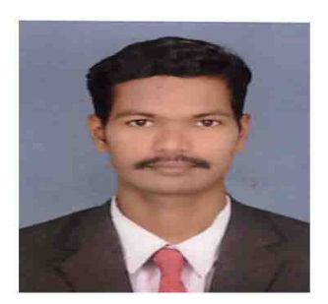

Mobile :+918610881796/+919543527326  
Email: [mkmuthuchem85@gamil.com](mailto:mkmuthuchem85@gamil.com)

**Objective**

Seek a position as **Chemistry / Science Teacher** where I can groom up the young generation with my knowledge and ability.

**Professional Experience**

**1.June 2018 to at present ,**

*GALAXYENGLISH MEDIUM SCHOOL, FUDAM , DIU, DAMAN AND DIU (U.T INDIA)*

**•Served as a trained graduate teacher**

**Responsibilities**

**• Teaching Chemistry &Physics to students between IX to X**

**• Exam coordinator**

**2. January 2014 to March 2017,**

**AMRITA VIDYALAYAM CBSE SENIOR SEC SCHOOL- NAGAPATTINAM**

* Served as a trained graduate teacher for 3 years.

**Responsibilities**

* Teaching Chemistry to students between IX to X.
* Teaching Science to students between VI to VIII
* Teaching EVS to students between IV to V
* NSO Coordinator

**3. December 2012 to December 2014,**

**AJC PUBLIC SCHOOL CBSE- NAGAPATTINAM**

* Served as a trained graduate teacher for one year.  
  **Responsibilities**
* Teaching Chemistry to students between class VI to IX.
* Teaching Physics to students between class VI to IX.
* Teaching English language to students GRADE IV
* Project guidance.
* Maintaining records

**Education**

* M.sc Chemistry, in progress- Manonmaniyam Sundhararanar university
* May -2010- NEWTON COLLEGE OF EDUCATION ,B.Ed.,
* November -2008 – M.R.G. Arts college , B.Sc. Chemistry
* March 2002 Higher secondary course certificate
* March 2000 Secondary school living certificate

**Skills and Competencies**

* Ability to teach the lessons in an interesting manner so that the students see the logic and retain the information.
* Participative style of teaching.
* Well versed with virtual teaching platforms.
* Utilizing computer resources including educational software and the internet, to promote interactive learning.

**Certificates**

* Certificate of Appreciation in 21st National Children’s science congress (NCSC-2013)

**Personal Details**

Father’s Name : THANGARASU. M

Date of Birth : 16.02.1985

Nationality : Indian

Religion : Hindu

Sex : Male

Marital state : Married

Spouse Name : ANITHA

Spouse’s Qualification : M.Sc., B.Ed,( in progress).

Languages Known : Tamil & English

Permanent Address : No. 4/1016, Carpenter Street,

PrathabaramPuram (Post),

Kilvelur (Taluk),

Nagapattinam (Dist)

Pin:611111

Declaration

I hereby declare that the above-mentioned information is correct up to my knowledge and I bear the responsibility for the correctness of the above-mentioned particulars.

Date : Yours faithfully,

Place :

(T.MUTHUKUMARAN)