初步分页工具

当我们的数据刚添加的时候，我们需要定义一个Page<T>的类，用于装我们的分页数据

package com.yellowcong.dao;

import java.util.List;

public class Page<T> {
/**
* pageindex 现在的页面
*/
private int pageIndex;
/**
* pageSize 页面的大小
*/
private int pageSize;
/**
* totalRecord 所有的记录
*/
private int totalRecord;
/**
* totalPage 所有的页面
*/
private int totalPage;
/**
* 获取的数据
*/
private List<T> datas;
/**
* @return the pageIndex
*/
public int getPageIndex() {
return pageIndex;
}
/**
* @param pageIndex the pageIndex to set
*/
public void setPageIndex(int pageIndex) {
this.pageIndex = pageIndex;
}
/**
* @return the pageSize
*/
public int getPageSize() {
return pageSize;
}
/**
* @param pageSize the pageSize to set
*/
public void setPageSize(int pageSize) {
this.pageSize = pageSize;
}
/**
* @return the totalRecord
*/
public int getTotalRecord() {
return totalRecord;
}
/**
* @param totalRecord the totalRecord to set
*/
public void setTotalRecord(int totalRecord) {
this.totalRecord = totalRecord;
}
/**
* @return the totalPage
*/
public int getTotalPage() {
return totalPage;
}
/**
* @param totalPage the totalPage to set
*/
public void setTotalPage(int totalPage) {
this.totalPage = totalPage;
}
/**
* @return the datas
*/
public List<T> getDatas() {
return datas;
}
/**
* @param datas the datas to set
*/
public void setDatas(List<T> datas) {
this.datas = datas;
}
}

简单的获取
@Override
public Page<User> list(String name,int pageSize,int pageNow) {
// TODO Auto-generated method stub
Connection conn = null;
PreparedStatement ps = null;
ResultSet rs = null;
Page<User> page = new Page<User>();
List<User> users = null;
try {
//解决胡乱添加page的问题
if(pageNow <=0) pageNow =0;

conn = SQLHelper.getConnection();
//获取count（*）
String sqlCount = "select count(*) from t_user ";

// 获取用户
String sql = "select * from t_user ";
//子要数据中有不满足的
if(name != null && !"".equals(name.trim())){
sql = sql+"where username like '%"+name+"%' or nickname like '%"+name+"%' ";
//其中sqlCount 和普通的获取方法是不一样的，通过这个Page 的方法，就实现了简单的分页
sqlCount =sqlCount+ "where username like '%"+name+"%' or nickname like '%"+name+"%' ";
}
sql = sql+ " limit ?,?";
System.out.println(sql);
System.out.println(sqlCount);
ps = conn.prepareStatement(sql);
//设定数据
ps.setInt(1, pageNow);
ps.setInt(2, pageSize);
rs = ps.executeQuery();
users = new ArrayList<User>();
while (rs.next()) {
User user = new User();
// 判断数据是否存在
user.setId(rs.getInt("id"));
user.setUsername(rs.getString("username"));
user.setNickname(rs.getString("nickname"));
user.setPassword(rs.getString("password"));
// 添加对象
users.add(user);
}
//获取Count
ps = conn.prepareStatement(sqlCount);
rs = ps.executeQuery();
//其中就一条数据
if(rs.next()){
int count = rs.getInt("count(*)");
//设定总的记录数
page.setTotalRecord(count);
//设定页面大小
page.setTotalPage((count-1)/pageSize +1);
}
page.setPageSize(pageSize);

//设定Pages中的数据
page.setDatas(users);
} catch (Exception e) {
// TODO: handle exception
e.printStackTrace();
// throw new UserException("用户获取失败！");
} finally {
SQLHelper.close(conn, ps, rs);
}
return page;
}

测试
@Test
public void testListByPage(){
Page<User> page = userDao.list("yellow",3,0);
//获取数据
List<User> users = page.getDatas();
//获取总的记录
int totalRecord = page.getTotalRecord();
//获取页面数
int pagecount = page.getTotalPage();
int pageNow = page.getPageIndex();

int pageSize = page.getPageSize();
System.out.println("页面大小："+pageSize+"\r\n"+

"页面数目"+pagecount+"\r\n"+
"现在所处页面"+pageNow+"\r\n"+
"所有记录"+totalRecord
);

//打印获取的数据
for(User user :users){
System.out.println(user.getId()+"|"+user.getUsername()+" | "+user.getPassword());
}
}

定义SystemContext 来传递数据
package com.yellowcong.dao;

public class SystemContext {
private static ThreadLocal<Integer> pageSize = new ThreadLocal<Integer>();
private static ThreadLocal<Integer> pageIndex = new ThreadLocal<Integer>();

public static void setPageSize(int _pageSize){
pageSize.set(_pageSize);
}

public static int getPageSize(){
return pageSize.get();
}
//删除数据
public static void removePageSize(){
pageSize.remove();
}

//设定页面
public static void setPageIndex(int _pageIndex){
pageIndex.set(_pageIndex);
}

public static int getPageIndex(){
return pageIndex.get();
}

public static void removePageIndex(){
pageIndex.remove();
}
}

定义PageFilter
来 设定我们所有数据的页码
package com.yellowcong.filter;

import java.io.IOException;

import javax.servlet.Filter;
import javax.servlet.FilterChain;
import javax.servlet.FilterConfig;
import javax.servlet.ServletException;
import javax.servlet.ServletRequest;
import javax.servlet.ServletResponse;

import com.yellowcong.dao.SystemContext;

/**
* Servlet Filter implementation class PageFilter
*/
public class PageFilter implements Filter {
private int pageSize;
private int pageIndex;
/**
* Default constructor.
*/
public PageFilter() {
// TODO Auto-generated constructor stub
}

/**
* @see Filter#destroy()
*/
public void destroy() {
// TODO Auto-generated method stub
}

/**
* @see Filter#doFilter(ServletRequest, ServletResponse, FilterChain)
*/
public void doFilter(ServletRequest request, ServletResponse response, FilterChain chain) throws IOException, ServletException {
// TODO Auto-generated method stub
// place your code here
try {
String page_index = request.getParameter("pageIndex");
if(page_index == null){
page_index = "1";
}
pageIndex = Integer.parseInt(page_index);
//设定数据的页面
SystemContext.setPageSize(pageSize);
SystemContext.setPageIndex(pageIndex);
chain.doFilter(request, response);
} catch (Exception e) {
// TODO: handle exception
}finally{
//清空数据
SystemContext.removePageIndex();
SystemContext.removePageSize();
}
}

/**
* @see Filter#init(FilterConfig)
*/
public void init(FilterConfig fConfig) throws ServletException {
// TODO Auto-generated method stub
String page_size = fConfig.getInitParameter("pageSize");
//解决数据为null的问题
if(page_size == null){
page_size = "10";
}
//设定pageSize
pageSize = Integer.parseInt(page_size);
}
}

web.xml 设定
<filter>
<display-name>PageFilter</display-name>
<filter-name>PageFilter</filter-name>
<filter-class>com.yellowcong.filter.PageFilter</filter-class>
<!-- 定义数据 -->
<init-param>
<param-name>pageSize</param-name>
<param-value>15</param-value>
</init-param>
</filter>
<filter-mapping>
<filter-name>PageFilter</filter-name>
<url-pattern>/</url-pattern>
</filter-mapping>

分页插件 JSPTAGS

搭建相应的环境
导入jar包


导入 page标签
<%@ page language="java" contentType="text/html; charset=UTF-8"
pageEncoding="UTF-8"%>
<%@ taglib uri="http://jsptags.com/tags/navigation/pager" prefix="pg"%>

案例
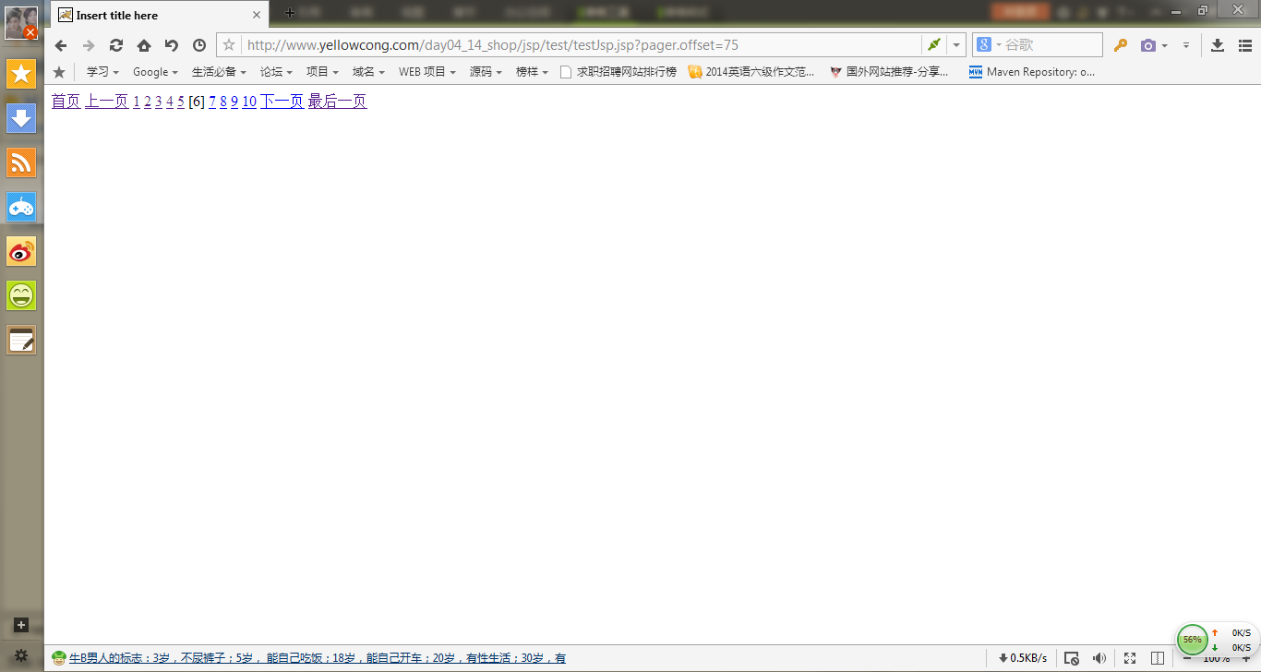

<%@ taglib uri="http://java.sun.com/jsp/jstl/core" prefix="c" %>
<!DOCTYPE html PUBLIC "-//W3C//DTD HTML 4.01 Transitional//EN" "http://www.w3.org/TR/html4/loose.dtd">
<html>
<head>
<meta http-equiv="Content-Type" content="text/html; charset=UTF-8">
<title>Insert title here</title>
</head>
<body>
<!-- 导入Page taglib后，需要设定数据
maxPageItems 默认是 10个
maxIndexPages 设定每一个角标是多少

导出数据用于比较对象，通过导入 用来设定当前页面的设计
-->
<pg:pager items="1000" maxIndexPages="10" maxPageItems="15" export="number">
<pg:first>
<a href="<%=pageUrl%>">首页</a>
</pg:first>
<pg:prev>
<a href="<%=pageUrl%>">上一页</a>
</pg:prev>
<!-- 这个是其余的数据 -->
<pg:pages>
<!-- 判断数据是否是当前数据 -->
<c:if test="${number == pageNumber}">
[${pageNumber }]
</c:if>
<c:if test="${number != pageNumber}">
<a href="<%=pageUrl %>"><%=pageNumber %></a>
</c:if>
</pg:pages>
<pg:next>
<a href="<%=pageUrl%>">下一页</a>
</pg:next>
<pg:last>
<a href="<%=pageUrl%>">最后一页</a>
</pg:last>
</pg:pager>
</body>
</html>

