简 单使用

环境搭建
将uplodify工具导入到 springmvc中的静态文件目录中 resources设定的目录

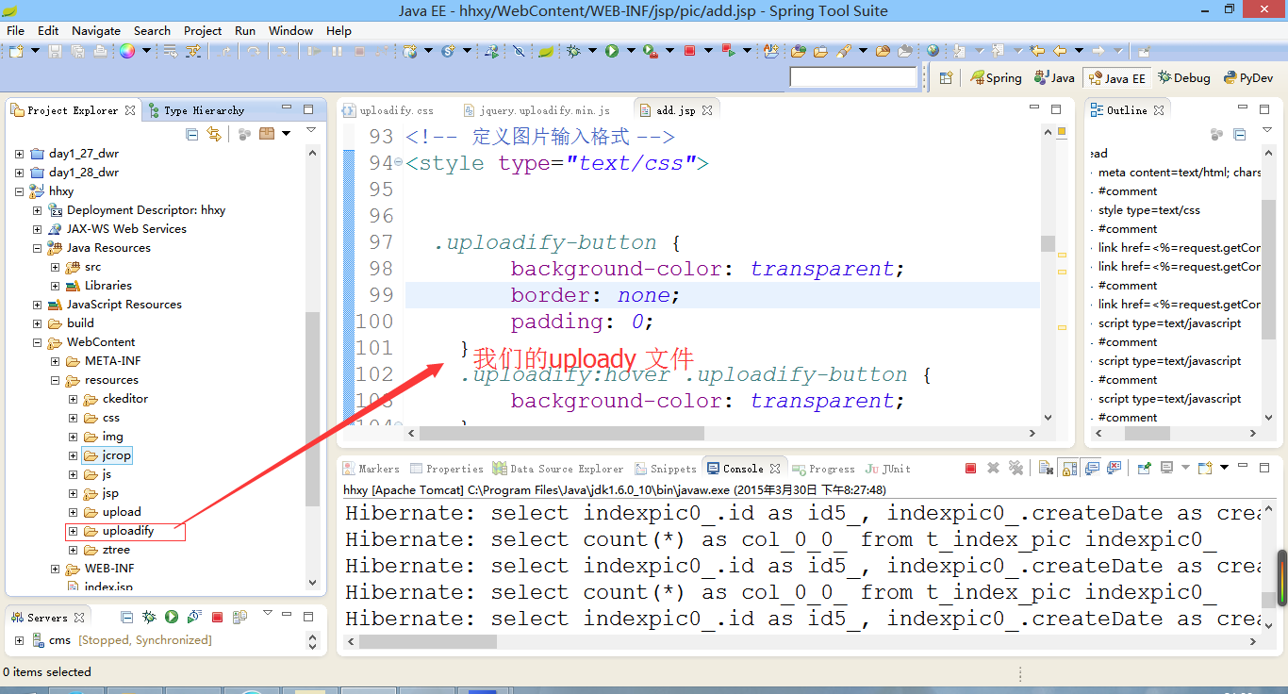

调用页面端
导入uplodify的样式和js文件，依赖于就jquery
<link href="<%=request.getContextPath()%>/resources/uploadify/uploadify.css"
rel="stylesheet" charset="utf-8" />
<script type="text/javascript" src="<%=request.getContextPath() %>/resources/js/jquery-1.7.1.min.js"></script>
<!-- 导入数据的上传 包 -->
<script type="text/javascript" src="<%=request.getContextPath() %>/resources/uploadify/jquery.uploadify.min.js"></script>

配置
<!-- 定义数据上传 -->
<script type="text/javascript">
$(function(){
$("#attach").uploadify({
//swf 控件
swf:$("#path").val()+"/resources/uploadify/uploadify.swf",
//上传的接收方法
uploader:'upload',
//action中接收的字段
fileObjName:'file',
//默认自动上传,关闭自动上传
auto:false,
//多个 上传 为false
multi:false,
//通过分号来隔开，添加我们需要的图片资源 ,还有一种位图 bmp
fileTypeExts:"*.jpg;*.png;*.gif;*.jpeg",
//fileTypeExts:"*.*", 表示所有数据
//设定回调数据
onUploadSuccess:function(file,data,response){
//其中data 就是返回来的json数据
//data {"result":1,"message":null,"obj":null}
//file是返回的数据名称， data是返回的json数据 response是返回数据
//alert("文件名"+file.name+"\t返回值"+response+"\tdata数据"+data);
//通过Jquerry 中的parseJson方法，将String类型的数据转换为 JSON 数据类型
var ao = $.parseJSON(data);
var attach = ao.attachment;
//获取到结果
alert(attach.newName);
}

});

$("input[value=添加]").click(function(){
//点击上传所有数据
$("#attach").uploadify("upload","*");
});
});
</script>

<input type="file" class="input-text" name="attach" id="attach"/>
</td>

结果
这个是我们原始的 上传按钮

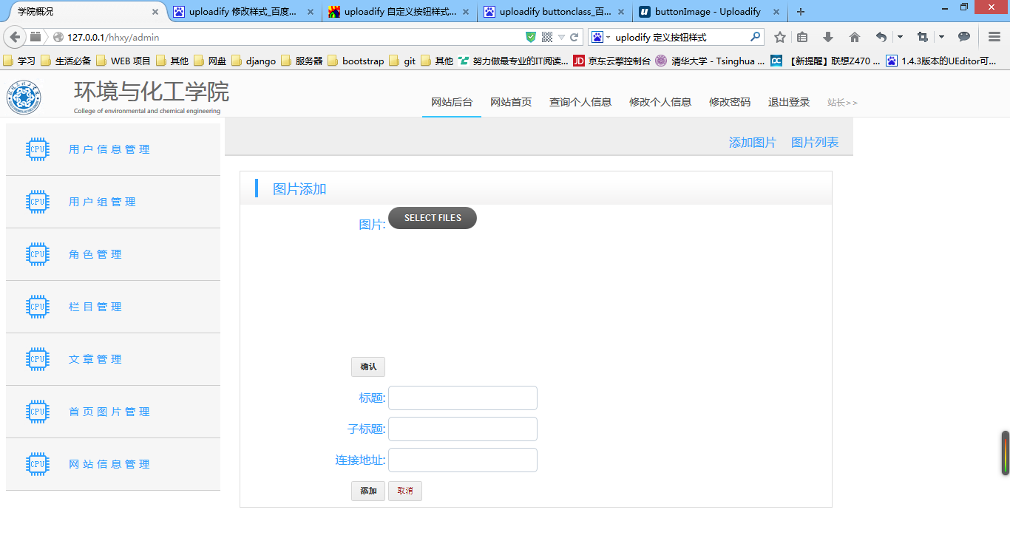

后端页面
我们的Action 提交到了pic这个Aciton中的'upload'方法中了，我没需要的就是定义这个方法， 定义的接受字段是 file

定义Action 中的 upload 方法
@RequestMapping(value="/upload",method=RequestMethod.POST)
public void upload(MultipartFile file,HttpServletResponse resp){
try {
String filename = file.getOriginalFilename();
String fileType = FilenameUtils.getExtension(filename);
//建立一个Attachment 对象
Attachment attach = new Attachment();
//初始化日期和下载次数
attach.setCreateDate(new Date());
attach.setDownloads(0);

if(AttachmentServiceImpl.imgs.contains(fileType)){
//对于缩略图 ，不算是附件
attach.setIsAttach(0);
attach.setIsImage(1);
}else{
attach.setIsImage(0);
attach.setIsAttach(1);
}
attach.setOldName(filename);
attach.setNewName(UUID.randomUUID().toString()+"."+fileType);
attach.setPassage(null);
attach.setSize(file.getSize());
attach.setType(fileType);

//通过Service 来处理数据
this.attService.add(attach, file.getInputStream());

//先添加到数据库中，然后写入到磁盘中
resp.setContentType("text/plain;charset=UTF-8");
//设定一个
AjaxObj obj = new AjaxObj(1);
//将我们获取的数据写回去
obj.setObj(attach);
//通过resp的方法，将数据写回到客户段
resp.getWriter().write(JsonUtils.object2Json(obj));
} catch (Exception e) {
// TODO: handle exception
}
}

上传Session丢失问题

显示图片样式修改
这个是 我们修改后的配置
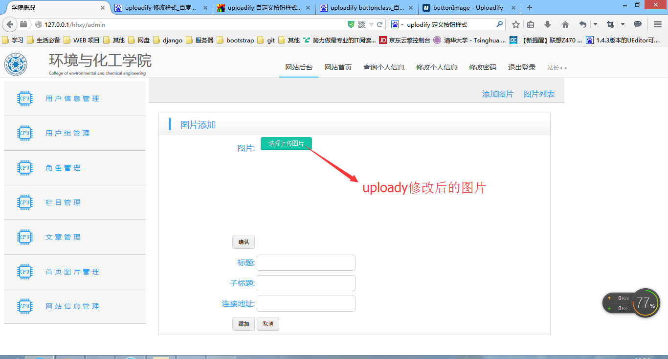

官方的api
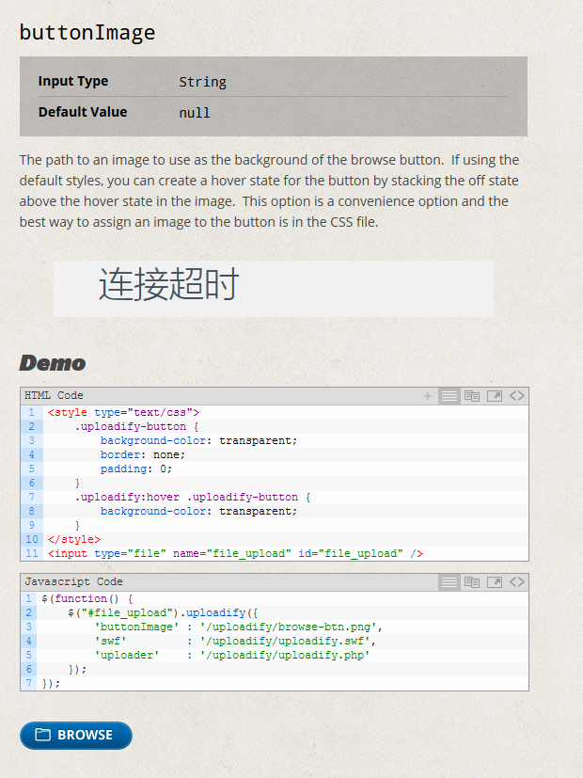

方法

定一个图片按钮
这个按钮，我们可以通过ps简单的实现

配置css样式
这个样式大家，直接复制就可以了，我们不需要 修改操作
<style type="text/css">
.uploadify-button {
background-color: transparent;
border: none;
padding: 0;
}
.uploadify:hover .uploadify-button {
background-color: transparent;
}
</style>

调试uplodify

通过在uplodify中添加
debug：true 就可以 解决问题

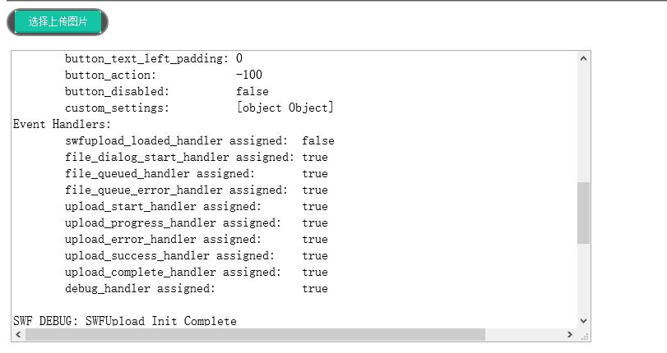

java
---SWFUpload Instance Info---
Version: 2.2.0 2009-03-25
Movie Name: SWFUpload_0
Settings:
upload_url: /ROOT/pic/uploadIndexImage
flash_url: /ROOT/resources/uploadify/uploadify.swf?preventswfcaching=1429657009848
use_query_string: false
requeue_on_error: false
http_success:
assume_success_timeout: 30
file_post_name: file
post_params: [object Object]
file_types: *.jpg;*.png;*.gif;*.jpeg
file_types_description: All Files
file_size_limit: 0
file_upload_limit: 0
file_queue_limit: 999
debug: true
prevent_swf_caching: true
button_placeholder_id: attach
button_placeholder: Not Set
button_image_url: /ROOT/pic/
button_width: 120
button_height: 30
button_text:
button_text_style: color: #000000; font-size: 16pt;
button_text_top_padding: 0
button_text_left_padding: 0
button_action: -100
button_disabled: false
custom_settings: [object Object]
Event Handlers:
swfupload_loaded_handler assigned: false
file_dialog_start_handler assigned: true
file_queued_handler assigned: true
file_queue_error_handler assigned: true
upload_start_handler assigned: true
upload_progress_handler assigned: true
upload_error_handler assigned: true
upload_success_handler assigned: true
upload_complete_handler assigned: true
debug_handler assigned: true

SWF DEBUG: SWFUpload Init Complete
SWF DEBUG:
SWF DEBUG: ----- SWF DEBUG OUTPUT ----
SWF DEBUG: Build Number: SWFUPLOAD 2.2.0
SWF DEBUG: movieName: SWFUpload_0
SWF DEBUG: Upload URL: /ROOT/pic/uploadIndexImage
SWF DEBUG: File Types String: *.jpg;*.png;*.gif;*.jpeg
SWF DEBUG: Parsed File Types: jpg,png,gif,jpeg
SWF DEBUG: HTTP Success: 0
SWF DEBUG: File Types Description: All Files (*.jpg;*.png;*.gif;*.jpeg)
SWF DEBUG: File Size Limit: 0 bytes
SWF DEBUG: File Upload Limit: 0
SWF DEBUG: File Queue Limit: 999
SWF DEBUG: Post Params:
SWF DEBUG: session_id=534EB240BA4FEE8FE6B904E2272F4143
SWF DEBUG: ----- END SWF DEBUG OUTPUT ----
SWF DEBUG:

python
---SWFUpload Instance Info---
Version: 2.2.0 2009-03-25
Movie Name: SWFUpload_0
Settings:
upload_url: /pic/upload/uploadImage
flash_url: /static/uploadify/uploadify.swf?preventswfcaching=1429656485062
use_query_string: false
requeue_on_error: false
http_success:
assume_success_timeout: 30
file_post_name: file
post_params: [object Object]
file_types: *.jpg;*.png;*.gif;*.jpeg
file_types_description: All Files
file_size_limit: 0
file_upload_limit: 0
file_queue_limit: 999
debug: true
prevent_swf_caching: true
button_placeholder_id: attachFile
button_placeholder: Not Set
button_image_url: /pic/upload/
button_width: 120
button_height: 30
button_text:
button_text_style: color: #000000; font-size: 16pt;
button_text_top_padding: 0
button_text_left_padding: 0
button_action: -100
button_disabled: false
custom_settings: [object Object]
Event Handlers:
swfupload_loaded_handler assigned: false
file_dialog_start_handler assigned: true
file_queued_handler assigned: true
file_queue_error_handler assigned: true
upload_start_handler assigned: true
upload_progress_handler assigned: true
upload_error_handler assigned: true
upload_success_handler assigned: true
upload_complete_handler assigned: true
debug_handler assigned: true

SWF DEBUG: SWFUpload Init Complete
SWF DEBUG:
SWF DEBUG: ----- SWF DEBUG OUTPUT ----
SWF DEBUG: Build Number: SWFUPLOAD 2.2.0
SWF DEBUG: movieName: SWFUpload_0
SWF DEBUG: Upload URL: /pic/upload/uploadImage
SWF DEBUG: File Types String: *.jpg;*.png;*.gif;*.jpeg
SWF DEBUG: Parsed File Types: jpg,png,gif,jpeg
SWF DEBUG: HTTP Success: 0
SWF DEBUG: File Types Description: All Files (*.jpg;*.png;*.gif;*.jpeg)
SWF DEBUG: File Size Limit: 0 bytes
SWF DEBUG: File Upload Limit: 0
SWF DEBUG: File Queue Limit: 999
SWF DEBUG: Post Params:
SWF DEBUG: ----- END SWF DEBUG OUTPUT ----
SWF DEBUG:

