# 编译安装php

## 没有C编译器

|  |
| --- |
| configure: error: no acceptable C compiler found in $PATH |

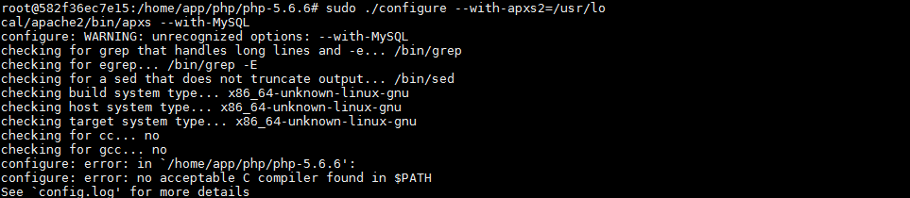

## 不能创建执行

|  |
| --- |
| configure: error: C compiler cannot create executables |