Morse Code Documentation

\*video submit file was too large

Sending (---)

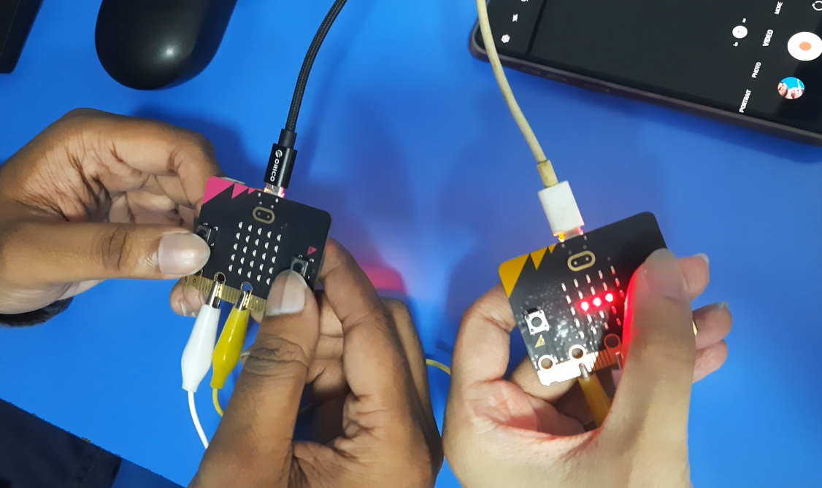

Receiving Corresponding Alphabet (O)

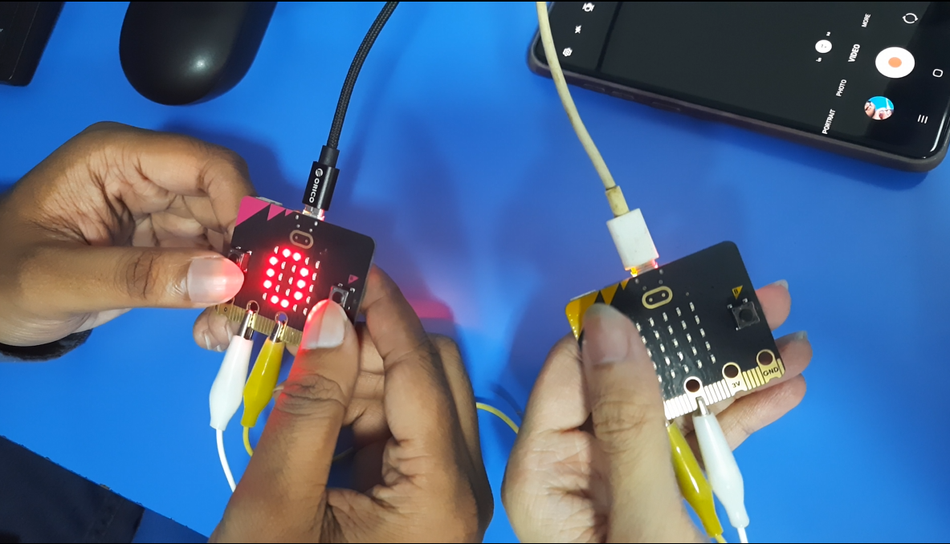

Shake to Scroll full message

