ML8010 GPRS Modem User’s Manual

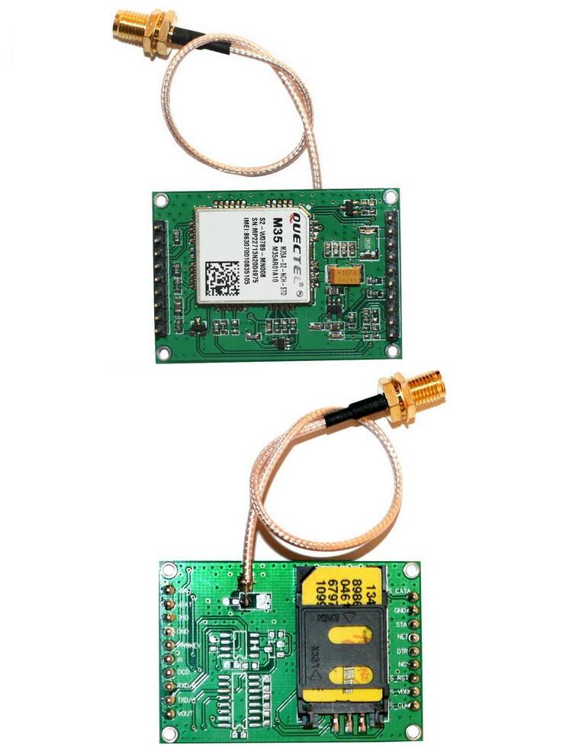

Shenzhen Mellow Technology Co., Limited

Add: 218,2nd floor, 4 Building, Zhuguang Second Industrial Zone, Xili Town, Nanshan District, Shenzhen China
Tel: +86-755-86507059 Skype ID: mellowsales
E-mail: sales@szmellow.com Website:www.szmellow.com
Contents

1 Introduction 2
2 Product concept 2
3 Application interface 2
3.1Pin description 2
3.2 Operating modes 2
3.3 Power supply (VBAT) 2
3.4 Power up and power down scenarios 2
3.4.1 Power On 2
3.4.2 Power down module using the PWRKEY pin 2
3.4.3 Power down module using AT command 2
3.4.4 Over-voltage or under-voltage automatic shutdown 2
3.4.5 Restart module using the PWRKEY pin 2
3.5 Power saving 2
3.5.1 Minimum functionality mode 2
3.5.2 SLEEP mode (slow clock mode) 2
3.5.3 Wake up module from SLEEP mode 2
3.6 Summary of state transitions 2
3.7 Serial interfaces 2
3.8 Network status indication 2
4 Mechanical dimension 2

1 Introduction
This document defines the ML8010 module series and describes the hardware interface of the
ML8010 module that connects to the customer application and the air interface.
This document can help customer quickly understand module interface specifications, electrical
and mechanical details. With the help of this document, associated application notes and user
guide, customer can use ML8010 module to design and set up mobile applications quickly.

2 Product concept
The ML8010 is a Quad-band GSM/GPRS engine that works at frequencies GSM850MHz,
GSM900MHz, DCS1800MHz and PCS1900MHz. The ML8010 features GPRS multi-slot class 12
and supports the GPRS coding schemes CS-1, CS-2, CS-3 and CS-4.
The ML8010 is integrated with Internet service protocols, which are TCP/UDP, FTP and HTTP.
Extended AT commands have been developed for customer to use these Internet service protocols
easily.
The modules are fully RoHS compliant to EU regulation.
Table 1 Module key features
Feature | Implementation
Power supply | Single supply voltage 3.3V – 4.6V,Normal 4.0V
Frequency bands | ● Quad-band: GSM850, GSM900, DCS1800, PCS1900.  ● The module can search these frequency bands automatically  ● The frequency bands can be set by AT command.  ● Compliant to GSM Phase 2/2+
Transmitting power | ● Class 4 (2W) at GSM850 and GSM900  ● Class 1 (1W) at DCS1800 and PCS1900
GPRS connectivity | ● GPRS multi-slot class 12 (default)  ● GPRS multi-slot class 1~12 (configurable)  ● GPRS mobile station class B
Temperature range | ● Normal operation: -35°C ~ +80°C  ● Restricted operation: -45°C ~ -35°C and +80°C ~ +85°C ¹⁾  ● Storage temperature: -45°C ~ +90°C
DATA GPRS:  CSD: | ● GPRS data downlink transfer: max. 85.6 kbps  ● GPRS data uplink transfer: max. 85.6 kbps  ● Coding scheme: CS-1, CS-2, CS-3 and CS-4  ● Support the protocols PAP (Password Authentication Protocol)  usually used for PPP connections  ● Internet service protocols TCP/UDP/FTP/HTTP/MMS  ● Support Packet Switched Broadcast Control Channel (PBCCH)  ● CSD transmission rates: 2.4, 4.8, 9.6, 14.4 kbps non-transparent  ● Unstructured Supplementary Services Data (USSD) support
SMS | ● MT, MO, CB, Text and PDU mode  ● SMS storage: SIM card
FAX | Group 3 Class 1 and Class 2
SIM interface | Port SIM card: 1.8V, 3V, Protected against ESD with a TVS diode array.
Serial interface | ● Support from 4800 bps to 115200 bps  ● Support RS232,RS485,TTL(3.3V,customized 5V)  ● Embed standard AT command（GSM07.05 and 07.07）
Phonebook management | Support phonebook types: SM, FD, LD, RC, ON, MC
SIM Application Toolkit | Support SAT class 3, GSM 11.14 Release 99
Physical characteristics | 49*34*12mm
1) When the module works in this temperature range, the deviations from the GSM specification
might occur. For example, the frequency error or the phase error could increase.
Table 2 Coding schemes and maximum net data rates over air interface
Coding scheme | 1 Timeslot | 2 Timeslot | 4 Timeslot
CS-1: | 9.05kbps | 18.1kbps | 36.2kbps
CS-2: | 13.4kbps | 26.8kbps | 53.6kbps
CS-3: | 15.6kbps | 31.2kbps | 62.4kbps
CS-4: | 21.4kbps | 42.8kbps | 85.6kbps

3 Application interface

3.1Pin description
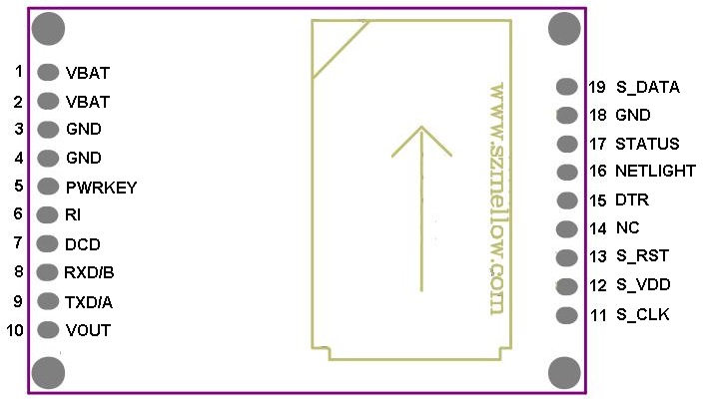
Figure 1 Pin distribution
Table 3 Pin description
PIN NAME | PIN | I/O | DESCRIPTION | DC CHARATERISTICS | COMMENT
VBAT | 1,2 | I | Module main power supply. The power supply of module has to be a single voltage source of VBAT = 3.3V~4.6V,it must be able to provide sufficient current in a transmitting burst which typically rises to 2A | Vmax = 4.6V  Vmin = 3.3V  Vnormal = 4.0V | Recommend to used MIC29302/SP29302 High-Current Low-Dropout Regulators
VOUT | 10 | O | Supply 3.3V voltage for external circuit | Vmax = 3.4V  Vmin = 3.2V  Vnormal = 3.3V  Imax = 150mA | 1.If unused, keep this pin open.  2.Recommend to added a 2.2~4.7uF bypass capacitor when using this pin to power supply.
GND | 3,4,18 | I | Power and digital ground
PWRKEY | 5 | I | Power on/off control input, PWRKEY should be pulled up for a moment to turn on or turn off the module. | TTL (3.3V) level, it can be connected to the MCU/ARM I/O port indirectly.
STATUS | 17 | O | Used to indicate the module operating status. High level indicates module power on and low level indicates power off. | TTL (3.3V) level, it can be connected to the MCU/ARM I/O port indirectly. | If unused, keep this pin open.
NETLIGHT | 16 | O | Network status  indication. |  | If unused, keep this pin open.
TXD/A | 9 | O | TTL/RS232:  Transmitting data.  RS485:  Difference Bus A | TTL:  logicL:0V±0.3V;  logicH:3.3V±0.3V.  RS232:  LogicL:+3.0V～+15.0V;  LogicH:-3.0V～-15.0V.  RS485:Difference Bus
RXD/B | 8 | I | TTL/RS232:  receiving data.  RS485:  Difference Bus B
DTR | 15 | I | Data terminal ready | TTL (3.3V) level, it can be connected to the MCU/ARM I/O port indirectly. | If unused, keep these pin open.
DCD | 7 | O | Data carrier detection |  | If unused, keep these pin open.
RI | 6 | O | Ring indicator |  | If unused, keep these pin open.
S_VDD | 12 | O | Voltage supply for SIM card | The voltage can be selected by software automatically. Either 1.8V or 3.0V | If using the module SIM card socket, keep these pin open.  All signals of SIM interface has be protected against ESD with a TVS diode array in the module.
S_DATA | 19 | I/O | SIM data
S_CLK | 11 | O | SIM clock
S_RST | 13 | O | SIM reset
NC | 14 |  |  | Unconnected any signal | Keep it open

3.2 Operating modes
The table below briefly summarizes the various operating modes referred to in the following
chapters.
Table 4 Overview of operating modes
Mode | Function
Normal operation | GSM/GPRS  SLEEP | The module will automatically go into SLEEP mode if DTR is set to high level and there is no interrupt (such as GPIO interrupt or data on serial port).  In this case, the current consumption of module will reduce to the minimal level.  During SLEEP mode, the module can still receive paging  message and SMS from the system normally.
Normal operation | GSM IDLE | Software is active. The module has registered to the GSM  network, and the module is ready to send and receive.
Normal operation | GSM TALK | GSM connection is going. In this mode, the power  consumption is decided by the configuration of Power  Control Level (PCL), dynamic DTX control and the working  RF band.
Normal operation | GPRS IDLE | The module is not registered to GPRS network. The module is not reachable through GPRS channel.
Normal operation | GPRS  STANDBY | The module is registered to GPRS network, but no GPRS  PDP context is active. The SGSN knows the Routing Area where the module is located at.
Normal operation | GPRS  READY | The PDP context is active, but no data transfer is going on. The module is ready to receive or send GPRS data. The  SGSN knows the cell where the module is located at.
Normal operation | GPRS DATA | There is GPRS data in transfer. In this mode, power  consumption is decided by the PCL, working RF band and GPRS multi-slot configuration.
POWER DOWN | Normal shutdown by sending the “AT+QPOWD=1” command, using the  PWRKEY pin. The power management ASIC disconnects the power supply from the base band part of the module, and only the power supply for the RTC is remained. Software is not active. The serial interfaces are not accessible. Operating voltage (connected to VBAT) remains applied.
Minimum  functionality  mode (without  removing power  supply) | Use the “AT+CFUN” command can set the module to a minimum  functionality mode without removing the power supply. In this case, the RF  part of the module will not work or the SIM card will not be accessible, or  both RF part and SIM card will be closed all, but the serial port is still  accessible. The power consumption in this case is very low.

3.3 Power supply (VBAT)
The power supply of the module is from a single voltage source of VBAT= 3.3V...4.6V. The GSM
transmitting burst can cause obvious voltage drop at the supply voltage thus the power supply
must be carefully designed and is capable of providing sufficient current up to 2.0A.
The circuit design of the power supply for the module largely depends on the power source. Figure 2 shows a reference design of +5V input power source. The designed output for the power supply is 4.0V, thus a linear regulator can be used. If there’s a big voltage difference between the input source and the desired output (VBAT), a switching converter power supply would be preferable for its better efficiency especially with the 2.0A peak current in burst mode of the module.
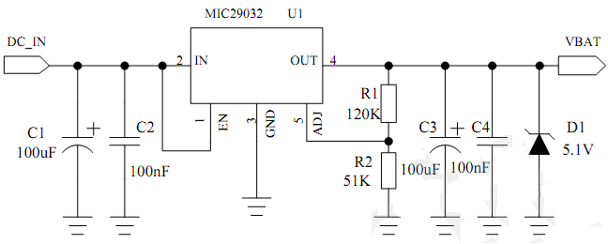
Figure 2 recommend Power supply

3.4 Power up and power down scenarios

3.4.1 Power On
Customer’s application can turn on the module by driving the pin PWRKEY to a high level voltage and after STATUS pin outputs a high level, PWRKEY pin can be released. Customer may monitor the level of the STATUS pin to judge whether the module is power-on or not. If the STATUS pin is ignored, pull the PWRKEY pin to high level for more than 2 seconds to turn on the
module. The power on timing is illustrated as following figure 3.
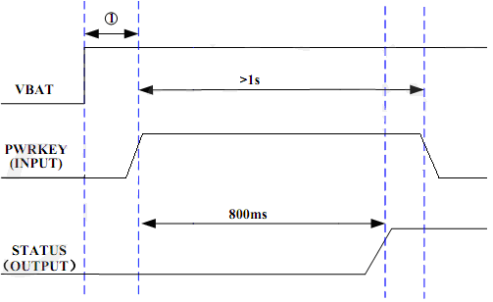
Figure 3 Timing of turn on the module
①Ensure the VBAT voltage stability before driving the pin PWRKEY to a high level voltage. Recommend at least time intervals of 30 ms.

3.4.2 Power down module using the PWRKEY pin
Customer’s application can turn off the module by driving the PWRKEY to a high level voltage for certain time. The power-down scenario is illustrated as in Figure 4.
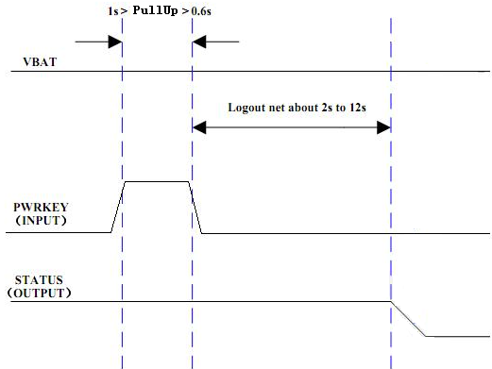
Figure 4 Timing of turn off the module
The power-down procedure causes the module to log off from the network and allows the software
to save important data before completely disconnecting the power supply, thus it is a safe way. Before the completion of the power-down procedure the module sends out the result code shown
below:
NORMAL POWER DOWN
After this moment, no further AT command can be executed. And then the module enters the
POWER DOWN mode, The POWER DOWN mode can also be indicated by STATUS pin, which is a low level voltage in this mode.

3.4.3 Power down module using AT command
Customer’s application can use an AT command “AT+QPOWD=1” to turn off the module. This
command will let the module to log off from the network and allow the software to save important
data before completely disconnecting the power supply, thus it is a safe way.
Before the completion of the power-down procedure the module sends out the result code shown
below:
NORMAL POWER DOWN
After this moment, no further AT command can be executed. And then the module enters the
POWER DOWN mode, The POWER DOWN mode can also be indicated by STATUS pin, which is a low level voltage in this mode.

3.4.4 Over-voltage or under-voltage automatic shutdown
The module will constantly monitor the voltage applied on the VBAT, if the voltage ≤ 3.5V, the
following URC will be presented:
UNDER_VOLTAGE WARNNING
If the voltage ≥ 4.5V, the following URC will be presented:
OVER_VOLTAGE WARNNING
The uncritical voltage range is 3.3V to 4.6V. If the voltage > 4.6V or <3.3V, the module would
automatically shutdown itself.
If the voltage <3.3V, the following URC will be presented:
UNDER_VOLTAGE POWER DOWN
If the voltage >4.6V, the following URC will be presented:
OVER_VOLTAGE POWER DOWN
After this moment, no further AT command can be executed. The module logoff from network
and enters POWER DOWN mode, The POWER DOWN mode can also be indicated by the pin STATUS, which is a low level voltage in this mode.

3.4.5 Restart module using the PWRKEY pin
Customer’s application can restart the module by driving the PWRKEY to a high level voltage for
certain time, which is similar to the way to turn on module. Before restarting the module, at least
500ms should be delayed after detecting the low level of STATUS. The restart scenario is illustrated as the following figure 5
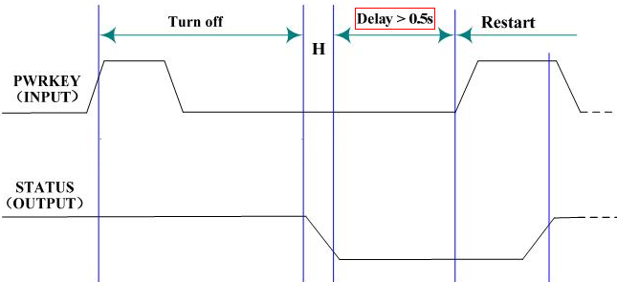Figure 5 Timing of restart system

3.5 Power saving
Upon system requirement, there are several actions to drive the module to enter low current
consumption status. For example, “AT+CFUN” can be used to set module into minimum
functionality mode and DTR hardware interface signal can be used to lead system to SLEEP
mode.

3.5.1 Minimum functionality mode
Minimum functionality mode reduces the functionality of the module to minimum level, thus
minimizes the current consumption when the slow clocking mode is activated at the same time.
This mode is set with the “AT+CFUN” command which provides the choice of the functionality
levels <fun>=0,1,4.
● 0: minimum functionality;
● 1: full functionality (default);
● 4: disable both transmitting and receiving of RF part;

If the module is set to minimum functionality by “AT+CFUN=0”, the RF function and SIM card
function would be closed. In this case, the serial port is still accessible, but all AT commands
correlative with RF function or SIM card function will not be accessible.
If the module has been set by “AT+CFUN=4”, the RF function will be closed, the serial port is
still active. In this case, all AT commands correlative with RF function will not be accessible.
After the module is set by “AT+CFUN=0” or “AT+CFUN=4”, it can return to full functionality
by “AT+CFUN=1”.
For detailed information about “AT+CFUN”, please refer to AT command manual.

3.5.2 SLEEP mode (slow clock mode)
The SLEEP mode is disabled in default software configuration. Customer’s application can enable
this mode by “AT+QSCLK=1”. On the other hand, the default setting is “AT+QSCLK=0” and in
this mode, the module can’t enter SLEEP mode.
When “AT+QSCLK=1” is set to the module, customer’s application can control the module to
enter or exit from the SLEEP mode through pin DTR. When DTR is set to high level, and there is
no on-air or hardware interrupt such as GPIO interrupt or data on serial port, the module will enter
SLEEP mode automatically. In this mode, the module can still receive voice, SMS or GPRS paging from network but the serial port is not accessible.

3.5.3 Wake up module from SLEEP mode
When the module is in the SLEEP mode, the following methods can wake up the module.
● If the DTR Pin is pulled down to a low level, it would wake up the module from the SLEEP
mode. The serial port will be active about 20ms after DTR changed to low level.
● Receiving a voice or data call from network to wake up module.
● Receiving an SMS from network to wake up module.
Note: DTR pin should be held low level during communicating between the module and Customer’s application.

3.6 Summary of state transitions
Table 5 Summary of state transition
Current mode | Next mode
 | Power Down | Normal Mode | Sleep Mode
Power Down |  | Use PWRKEY pin
Normal mode | AT+QPOWD or use PWRKEY pin, |  | Set AT+QSCLK=1 and pull up the DTR pin to high level
Sleep Mode | Use PWRKEY pin | Pull down DTR pin to low level, Receiving a voice or data call from network, Receiving an SMS from network

3.7 Serial interfaces
There are three interface optional, included RS232/RS485/TTL(3.3V),the connect between ML8010 and MCU/ARM shown in figure 6. dotted line: optional connection.

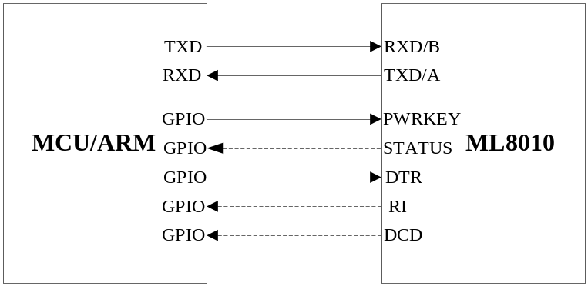
Figure 6 connect to MCU/ARM

3.8 Network status indication
The NETLIGHT signal can be used to driver a network status indication LED. The Working state of this pin is list in the table 6.
Table 6 Working state of the NETLIGHT
state | Module Function
Off | The module is not running
64ms On/800ms Off | The module is not synchronized with network
64ms On/2000ms Off | The module is synchronized with network
64ms On/600ms Off | GPRS data transfer is ongoing.
A reference circuit is shown in Figure 7
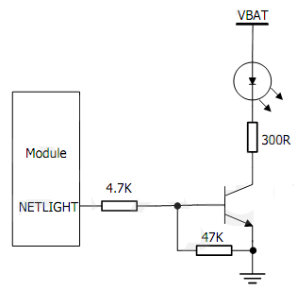
Figure 7 reference circuit of the NETLIGHT

4 Mechanical dimension
