A Industrial Oriented Mini Project report on
Transfer Learning For An Automated Detection System Of Fractures In Patients With Maxillofacial Trauma

A Dissertation submitted to JNTU Hyderabad in partial fulfillment of the academic requirements for the award of the degree.

Bachelor of Technology
in
Artificial Intelligence & Machine Learning
Submitted by

YELLU POOJITHA
22H51A73A2

Under the esteemed guidance of
Mrs . K. Navaneetha

Assistant.Professor

Department of Artificial Intelligence & Machine Learning
CMR COLLEGE OF ENGINEERING & TECHNOLOGY
(UGC Autonomous)
*Approved by AICTE *Affiliated to JNTUH *NAAC Accredited with A⁺ Grade

KANDLAKOYA, MEDCHAL ROAD, HYDERABAD - 501401.

2024- 2025

CMR COLLEGE OF ENGINEERING & TECHNOLOGY
KANDLAKOYA, MEDCHAL ROAD, HYDERABAD – 501401


DEPARTMENT OF ARTIFICIAL INTELLIGENCE & MACHINE LEARNING

CERTIFICATE

This is to certify that the Industrial Oriented Mini Project report entitled
" Transfer learning for an automated detection system of fractures in patients with Maxillofacial Trauma " being submitted by YELLU POOJITHA (22H51A73A2) in partial fulfillment for the award of Bachelor of Technology in Artificial Intelligence & Machine Learning is a record of bonafide work carried out his/her under my guidance and supervision.
The results embodies in this project report have not been submitted to
any other University or Institute for the award of any Degree.

Mrs.K.Navaneetha Dr. P. Sruthi External Examiner
Assistant.Professor Associate Professor and HOD
Dept. of AI&ML Dept. of AI&ML

ACKNOWLEDGEMENT

With great pleasure I want to take this opportunity to express my heartfelt gratitude to all the people who helped in making this project work a grand success.
I am grateful to Mrs.K.Navaneetha , Assisstant. Professor, Department of Artificial Intelligence & Machine Learning for her valuable technical suggestions and guidance during the execution of this project work.
I would like to thank Dr.P.Sruthi, Head of the Department, Department of Artificial Intelligence & Machine Learning ,CMR College of Engineering and Technology, who is the major driving forces to complete my project work successfully.
I am very grateful to Dr. Ghanta Devadasu, Dean-Academics, CMR College of Engineering and Technology, for his constant support and motivation in carrying out the project work successfully.
We extend our heartfelt gratitude to Dr.Seshu Kumar Avadhanam, Principal, CMR College of Engineering and Technology, for his unwavering support and guidance in the successful completion of our project and his encouragement has been invaluable throughout this endeavor.
I am highly indebted to Major Dr. V A Narayana, Director, CMR College of Engineering and Technology, for giving permission to carry out this project in a successful and fruitful way.
I express our sincere thanks to Shri. Ch. Gopal Reddy, Secretary& Correspondent, CMR Group of Institutions, and Shri Ch Abhinav Reddy, CEO, CMR Group of Institutions for their continuous care and support.
I would like to thank the Teaching & Non- teaching staff of Department of CSE (Artificial Intelligence and Machine Learning), for their co-operation.
Finally, I extend thanks to my parents who stood behind us at different stages of this Project. I sincerely acknowledge and thank all those who gave support directly and indirectly in completion of this project work.

YELLU POOJITHA 22H51A73A2

DECLARATION

We hereby declare that results embodied in this Report of Project on “Transfer Learning For An Automated Detection System of Fractures In Patients With Maxillofacial Trauma ” are from work carried out by using partial fulfillment of the requirements for the award of Bachelor of Technology in Artificial Intelligence & Machine Learning. We have not submitted this report to any other university/institute for the award of any other degree.

NAME ROLL NO SIGNATURE
Y.Poojitha 22H51A73A2

CHAPTER NO | TITLE | PAGE NO.
TABLE OF CONTENTS
 |  | LIST OF FIGURES | ii
 |  | LIST OF TABLES | iii
 |  | ABSTRACT | iv
1 |  | INTRODUCTION
 | 1.1 | Problem Statement | 2
 | 1.2 | Research Objective | 2-3
 | 1.3 | Project Scope and Limitations | 3
2 |  | BACKGROUND WORK
 | 2.1 | Traditional Fracture Detection Methods
 |  | 2.1.1 Introduction | 5
 |  | 2.1.2 Merits, Demerits, and Challenges | 5
 |  | 2.1.3 Implementation | 6
 | 2.2 | CNN-Based Fracture Detection
 |  | 2.2.1 Introduction | 6
 |  | 2.2.2 Merits, Demerits, and Challenges | 6
 |  | 2.2.3 Implementation | 7
 | 2.3 | Transfer Learning in Medical Imaging
 |  | 2.3.1 Introduction | 7
 |  | 2.3.2 Merits, Demerits, and Challenges | 7
3 |  | PROPOSED SYSTEM
 | 3.1 | Research Objective of Proposed Model | 9-10
 | 3.2 | Algorithms Used for the Proposed Model | 10-11
 | 3.3 | Designing
 |  | 3.3.1 UML Diagrams | 13-15
 | 3.4 | Stepwise Implementation and Code | 16-23
4 |  | RESULTS AND DISCUSSION
 |  | 4.1 Implementation and Testing | 25
5 |  | CONCLUSION
 |  | 5.1 Conclusion and Future Enhancement | 30
 |  | REFERENCES | 32
 |  | GITHUB LINK | 37

LIST OF FIGURES
FIGURE NO. | TITLE | PAGE NO
3.3.1 | Use Case Diagram | 13
3.3.2 | Class Diagram | 14
3.3.3 | Sequence Diagram | 15
3.3.4 | Activity Diagram | 15
4.2.1 | GUI Interface | 26
4.2.2 | Data Preprocessing | 27
4.2.3 | Prediction on test data | 27
4.2.4 | Confusion Matrix | 28
4.2.5 | Comparison Graph | 28

LIST OF TABLES
FIGURE NO. | TITLE | PAGE NO
4.1 | Test Cases | 25

ABSTRACT

An original maxillofacial fracture detection system (MFDS), based on convolutional neural networks and transfer learning, is proposed to detect traumatic fractures in patients. A convolutional neural network pre-trained on non-medical images was re-trained and fine-tuned using computed tomography (CT) scans to produce a model for the classification of future CTs as either “fracture” or “noFracture”. The model was trained on a total of 148 CTs (120 patients labeled with “fracture” and 28 patients labeled with “noFracture”). The validation dataset, used for statistical analysis, was characterized by 30 patients (5 with “noFracture” and 25 with “fracture”). An additional 30 CT scans, comprising 25 “fracture” and 5 “noFracture” images, were used as the test dataset for final testing. Tests were carried out both by considering the single slices and by grouping the slices for patients. A patient was categorized as fractured if two consecutive slices were classified with a fracture probability higher than 0.99. The patients’ results show that the model accuracy in classifying the maxillofacial fractures is 80%. Even if the MFDS model cannot replace the radiologist’s work, it can provide valuable assistive support, reducing the risk of human error, preventing patient harm by minimizing diagnostic delays, and reducing the incongruous burden of hospitalization.

CHAPTER 1
INTRODUCTION

1.INTRODUCTION
  - Problem statement

Maxillofacial trauma, involving injuries to the facial skeleton, presents a complex diagnostic challenge in clinical practice. The detection of fractures in such cases is often performed manually through the interpretation of radiographic images, such as CT scans or X-rays. This manual process is not only time-consuming but also highly dependent on the expertise of radiologists or surgeons. In emergency scenarios or in regions with limited access to trained professionals, delayed or inaccurate diagnosis can lead to serious complications, including improper bone healing, facial asymmetry, or long-term functional impairments.With the increasing volume of medical imaging data and the growing demand for efficient healthcare solutions, there is a critical need for automated systems that can assist in the early detection of maxillofacial fractures. However, training such systems from scratch typically requires large, annotated datasets, which are often scarce in the medical domain. This limitation poses a significant barrier to the development of robust AI-based diagnostic tools.
Transfer learning, a machine learning technique where a model trained on one task is repurposed for a related task, offers a promising solution to this problem. By leveraging pre-trained models on large-scale image datasets, it becomes possible to build accurate and efficient fracture detection systems with relatively smaller amounts of medical data. This project explores the application of transfer learning for the automated detection of fractures in patients with maxillofacial trauma, aiming to support clinical decision-making and improve diagnostic efficiency.
  - Research Objective
The main objective of this research is to develop an automated system capable of accurately detecting fractures in patients with maxillofacial trauma using transfer learning techniques. This study aims to explore the effectiveness of pre-trained deep learning models, particularly convolutional neural networks (CNNs), in identifying fractures from radiographic images such as X-rays or CT scans. By leveraging models that have been trained on large-scale image datasets, the research seeks to reduce the dependence on large amounts of labeled medical data, which are often difficult to obtain. The project focuses on designing a reliable and efficient detection pipeline, evaluating its performance using metrics such as accuracy, precision, recall, and F1-score, and demonstrating its potential to support clinical decision-making. Ultimately, the goal is to contribute to the development of AI-based diagnostic tools that can assist healthcare professionals in providing faster and more accurate diagnoses for maxillofacial injuries.

  - Project Scope
This project focuses on developing an automated fracture detection system for maxillofacial trauma using transfer learning techniques. It is limited to the analysis of medical imaging data, primarily CT scans or X-rays, and utilizes pre-trained deep learning models to enhance diagnostic accuracy. The system aims to assist healthcare professionals by providing rapid and reliable fracture detection, particularly in settings where expert radiological support may be limited. The scope does not include treatment planning or detection of soft tissue injuries.

CHAPTER 2
BACKGROUND WORK

2.BACKGROUND WORK

This chapter reviews existing methods for fracture detection, highlighting their strengths, weaknesses, and implementations, with a focus on their relevance to maxillofacial fracture detection.

2.1 Traditional Fracture Detection Methods
2.1.1 Introduction

Traditional fracture detection relies on manual interpretation of radiographic images (e.g., X-rays, CT scans) by radiologists. Techniques include visual inspection for discontinuities in bone structure, abnormal alignments, or soft tissue swelling. Computer-Aided Diagnosis (CAD) systems have been developed to assist, using image processing techniques like edge detection and thresholding to highlight potential fracture sites.

2.1.2 Merits, Demerits, and Challenges
Merits:
- Well-established and widely used in clinical practice.
- Effective for obvious fractures with clear radiographic signs.
- CAD systems improve detection consistency for less experienced radiologists.
Demerits:
- Time-consuming and dependent on radiologist expertise.
- Prone to human error, especially for subtle or complex fractures.
- Limited automation, requiring significant manual intervention.
Challenges:
- High inter-observer variability in interpreting complex maxillofacial fractures.
- Inability to handle large volumes of imaging data efficiently.
- Lack of scalability in resource-constrained settings.

2.1.3 Implementation
Traditional CAD systems preprocess images using filters (e.g., Gaussian blur) to reduce noise, followed by edge detection (e.g., Canny algorithm) to identify bone boundaries. Thresholding isolates regions of interest, and rule-based algorithms flag potential fractures. These systems achieve moderate accuracy (60-70%) but struggle with maxillofacial fractures due to overlapping anatomical structures.

2.2 CNN-Based Fracture Detection
2.2.1 Introduction
Convolutional Neural Networks (CNNs) have revolutionized medical image analysis by automatically learning hierarchical features from raw images. Studies like Chung et al. (2018) used CNNs to detect proximal humerus fractures, achieving performance comparable to specialized surgeons. CNNs are particularly effective for fracture detection due to their ability to capture spatial patterns in radiographic images.

2.2.2 Merits, Demerits, and Challenges
Merits:
- High accuracy and robustness in detecting fractures.
- Reduces dependency on manual feature engineering.
- Scalable for large datasets with GPU acceleration.
Demerits:
- Requires large annotated datasets for training.
- Computationally intensive, necessitating high-end hardware.
- Limited interpretability of learned features.
Challenges:
- Overfitting on small medical datasets.
- Generalization to diverse patient populations.
- Integration into clinical workflows without disrupting radiologist routines.

2.2.3 Implementation
CNN-based systems typically use architectures like VGG16 or ResNet. Images are preprocessed (resized, normalized), and the network is trained to classify images as "fracture" or "no fracture." Data augmentation (rotation, flipping) mitigates overfitting. Chung et al. reported an AUC-ROC of 0.92 for humerus fracture detection, but maxillofacial applications remain limited.

2.3 Transfer Learning in Medical Imaging
2.3.1 Introduction
Transfer learning leverages pre-trained CNNs (e.g., Inception V3, trained on ImageNet) to address data scarcity in medical imaging. Kim and MacKinnon (2018) used transfer learning for wrist fracture detection, achieving an AUC-ROC of 0.95. This approach is ideal for maxillofacial fracture detection, where annotated CT datasets are limited.

2.3.2 Merits, Demerits, and Challenges
Merits:
- Reduces training time and data requirements.
- Leverages robust features from pre-trained models.
- Effective for small medical datasets.
Demerits:
- Risk of negative transfer if source and target domains differ significantly.
- Fine-tuning requires careful hyperparameter optimization.
- Limited to architectures pre-trained on general datasets.
Challenges:
- Adapting non-medical features to medical imaging tasks.
- Ensuring model robustness across diverse CT scanners.

CHAPTER 3
PROPOSED SYSTEM

3.PROPOSED SYSTEM
3.1 Research Objective of Proposed Model
The Research Objective section outlines the core goals and purposes of the proposed model. For an automated fracture detection system using transfer learning, this section will focus on clearly defining the objectives the model aims to achieve.
Objectives of the Proposed Model:
- Automated Fracture Detection:
  - The primary goal is to design a system that can automatically detect fractures in patients with maxillofacial trauma based on medical images, such as CT scans, X-rays, and MRI scans. This will reduce the burden on radiologists and speed up diagnosis.
- Accuracy Improvement Using Transfer Learning:
  - Leverage transfer learning to utilize pre-trained models (like ResNet, VGG16, or Inception) to enhance model accuracy and performance. Transfer learning allows for the utilization of existing large datasets (such as ImageNet) to adapt to the specialized task of detecting fractures in medical images.
- Early Detection and Treatment of Fractures:
  - The system aims to detect fractures early in the diagnosis process, which is crucial for timely medical intervention. The faster the fracture is detected, the faster the treatment can begin, potentially improving patient outcomes.
- Scalability and Generalization:
  - Another goal is to build a model that is not only accurate but also generalizable across various medical imaging modalities, patient demographics, and fracture types. The model should perform well on different datasets without overfitting to a specific dataset or image type.
- Improved Decision Support for Medical Professionals:
  - The system will assist medical professionals by providing them with a decision support system (DSS) that highlights potential fracture areas on medical images and indicates fracture severity. It acts as a second opinion to help radiologists make more accurate and faster diagnoses.

- Reduce Dependency on Manual Annotation:
  - By automating the detection process, the model will reduce the need for extensive manual annotations of fractures in images, saving time and resources.
Long-Term Vision:
- Over time, the system will be enhanced with more advanced capabilities, including real-time fracture detection, 3D imaging integration, and the ability to identify and predict complications (such as infections or healing issues) based on image patterns.

3.2 Algorithms Used for Proposed Model
In this section, you should describe the various algorithms and techniques that will be used for your proposed model. Since you're focusing on transfer learning for fracture detection, the algorithms discussed will primarily involve deep learning techniques and specific architectures.
Algorithms for Transfer Learning:
- Convolutional Neural Networks (CNNs):
  - Why CNNs?: CNNs are the foundation of modern computer vision tasks due to their ability to automatically learn hierarchical features from images. These networks are especially suitable for image classification tasks like detecting fractures in X-ray or CT images.
  - Structure: A CNN typically includes layers such as convolutional layers, pooling layers, and fully connected layers. CNNs are able to detect features like edges, shapes, and textures, which are essential for fracture detection.
- Pre-Trained Models (Transfer Learning): These models, trained on large-scale datasets like ImageNet, have learned general image features that can be fine-tuned for your specific task (fracture detection).

Common Pre-Trained Models:
  - VGG16: A deep CNN architecture known for its simplicity and high performance on image classification tasks. It uses small 3x3 convolutional filters to capture spatial hierarchies.
  - ResNet (Residual Networks): A deep CNN architecture that uses skip connections to improve training of very deep networks. It helps mitigate the vanishing gradient problem, making it easier to train large models.
  - InceptionV3: A CNN that uses a combination of multiple filter sizes at each layer to capture features at various levels of granularity. It’s efficient and has a relatively low computational cost.
  - DenseNet: Uses dense connections between layers to improve feature propagation, leading to better performance with fewer parameters.
- Fine-Tuning:
  - After loading the pre-trained model, fine-tuning involves modifying the last layers of the pre-trained network to make them relevant to the task of fracture detection. Typically, the initial layers (which capture general features) are frozen, and only the deeper layers are retrained using the specialized maxillofacial trauma dataset.
- Object Detection and Segmentation: If you want to identify the specific location of fractures, techniques like Object Detection (e.g., using YOLO or Faster R-CNN) or Semantic Segmentation (e.g., using U-Net) can be used. These algorithms provide bounding boxes or pixel-level masks indicating fracture regions.
- Data Augmentation Techniques:
  - To avoid overfitting and to simulate a variety of possible fracture scenarios, data augmentation techniques such as rotation, flipping, scaling, and cropping are applied to the medical images. This helps increase the diversity of the training dataset.

3.3 Designing
This section focuses on the design of the automated fracture detection system. It will describe the architecture, components, and workflow of the system.
System Design Overview:
The system will be a pipeline where the input medical images are processed through multiple stages, such as preprocessing, feature extraction, model inference, and post-processing, before providing the final result (fracture detection).
Design Components:
- Image Preprocessing:
  - Resizing: Medical images will be resized to a consistent size to fit the model’s input dimensions.
  - Normalization: Pixel values are scaled between 0 and 1 to ensure uniformity.
  - Data Augmentation: Techniques like random rotations, zooming, and flipping are applied to enhance the diversity of the dataset.
- Feature Extraction and Model Training:
  - A pre-trained CNN model (e.g., ResNet or VGG16) will be used for feature extraction. Fine-tuning is performed on the model using the specialized medical data.
- Fracture Detection:
  - Classification: The model will classify whether the image contains a fracture or not.
  - Localization/Segmentation: If the task includes localization, the model will also predict the bounding box or segmentation mask for the fractured region.
- Post-Processing:
  - Bounding Box Filtering: The system will filter out any false positives based on confidence scores.
  - Fracture Severity: The system can also predict the severity of the fracture (e.g., mild, moderate, severe).
- User Interface:
  - Medical professionals will interact with the system via a graphical user interface (GUI) that allows them to upload images and view results. The interface will display the original image alongside the model’s output (fracture location and severity).

3.3.1 UML Diagram
A UML Diagram (Unified Modeling Language Diagram) will help visualize the system's design. UML diagrams are typically used to represent the static structure of the system (class diagrams) and the dynamic behavior (use case, sequence, and activity diagrams).
Key UML Diagrams for the System:
- Use Case Diagram:
  - This diagram will show how different actors (e.g., medical practitioners, system administrator) interact with the system. For example, the doctor uploads the medical image, and the system processes it to detect fractures.

Fig 3.3.1 Use cse diagram

Actors
  - Medical Practitioner: Uploads medical images for fracture detection and views the results.
  - System: Processes images, applies transfer learning models, and provides fracture detection results.
- Class Diagram:
  - Classes:
    - Image Preprocessor: Handles all image preprocessing tasks (resize, normalization, augmentation).
    - Model: A class for the pre-trained model, fine-tuning, and inference.
    - Result: Represents the output of the model (fracture classification, bounding boxes, severity).
Fig 3.3.2 Class Diagram
  - Methods:
    - train(): Method for training or fine-tuning the model.
    - processImage(): Method to preprocess the input image.
    - predict(): Method to run inference and make predictions.
- Sequence Diagram:
  - This diagram will show the sequence of interactions between different system components. For instance:
    - Medical Practitioner uploads the image → Image Preprocessor processes the image → Model classifies and detects fractures → System displays results on the UI.
Fig 3.3.3 Sequence Diagram

- Activity Diagram:
  - Illustrates the flow of operations, from image upload to preprocessing, model inference, and finally presenting results to the user.
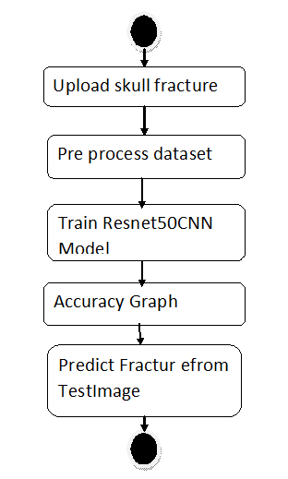
Fig 3.3.4 Activity Diagram
3.4 Stepwise Implementation and Code
The implementation of the proposed automated fracture detection system using transfer learning has been carried out in a structured, stepwise manner. Each phase of the implementation focuses on maximizing performance, improving generalization, and ensuring the model's applicability to real-world clinical settings.

Step 1: Dataset Collection and Annotation
The first step involved the acquisition of a medical image dataset consisting of CT scans or X-ray images depicting maxillofacial regions. Images were collected from open-source datasets and research repositories. Each image was annotated based on the presence or absence of a fracture, resulting in a binary classification task. Where necessary, data were curated and validated by domain experts.

Step 2: Data Preprocessing
Preprocessing plays a critical role in preparing medical images for deep learning tasks. The following preprocessing steps were implemented:
- Resizing: All images were resized to 224×224 pixels to match the input size requirements of pre-trained models such as ResNet50.
- Normalization: Pixel values were scaled to the range [0, 1] to improve training efficiency and convergence.
- Data Augmentation: To address the limited availability of medical images and reduce overfitting, augmentation techniques such as rotation, flipping, zooming, and contrast adjustment were applied to the training dataset.
- Label Encoding: The binary labels (“fractured” and “non-fractured”) were encoded numerically for training the model.

Step 3: Dataset Splitting
The preprocessed dataset was divided into three subsets:
- Training Set (e.g., 70%): Used to train the model.
- Validation Set (e.g., 15%): Used to tune model hyperparameters and monitor overfitting.
- Test Set (e.g., 15%): Used to evaluate the final performance of the model
Stratified splitting was used to ensure balanced distribution of both classes across each subset.

Step 4: Model Selection – Transfer Learning with ResNet50
Transfer learning was utilized to overcome the limitations of small medical datasets. The ResNet50 model, pre-trained on the ImageNet dataset, was selected for its deep architecture and proven success in medical imaging applications.
- The initial layers of ResNet50 were frozen to retain learned features.
- The final classification layers were replaced with custom layers tailored to the binary classification task:
  - A Flatten layer
  - A Dense layer with ReLU activation
  - A Dropout layer to prevent overfitting
  - A Dense output layer with sigmoid activation for binary prediction

Step 5: Model Training
The customized model was compiled using the following settings:
- Loss Function: Binary Cross-Entropy
- Optimizer: Adam optimizer with a learning rate fine-tuned through experimentation
- Metrics: Accuracy, Precision, Recall, and AUC (Area Under Curve)
The model was trained for a fixed number of epochs, with validation loss and accuracy monitored after each epoch. Early stopping was implemented to halt training when performance ceased to improve.

Step 6: Model Evaluation
After training, the model was evaluated using the test dataset to determine its performance on unseen data. Key evaluation metrics included:
- Accuracy
- Precision and Recall
- F1 Score
- Confusion Matrix
- ROC Curve and AUC Score
These metrics were visualized and interpreted to understand the model’s diagnostic performance.

Step 7: Visualization and Interpretation
The system provided visual output by overlaying predicted fracture regions (if applicable) on the original medical image using bounding boxes or heatmaps. This helps medical professionals verify the AI's decision.

Step 8: Deployment
To make the system usable in clinical settings, the trained model can be integrated into a simple Graphical User Interface (GUI) or web application. Practitioners can upload images and instantly receive diagnostic outputs.

Sample Code
from tkinter import *
import tkinter
from tkinter import filedialog
import matplotlib.pyplot as plt
from tkinter.filedialog import askopenfilename
import numpy as np
from sklearn.metrics import accuracy_score
from sklearn.model_selection import train_test_split
from sklearn.metrics import confusion_matrix
import seaborn as sns
import pickle
from sklearn.metrics import precision_score
from sklearn.metrics import recall_score
from sklearn.metrics import f1_score
import os
import cv2
from keras.utils.np_utils import to_categorical

from keras.layers import MaxPooling2D
from keras.layers import Dense, Dropout, Activation, Flatten
from keras.layers import Convolution2D
from keras.models import Sequential
from keras.models import model_from_json
import pickle
from sklearn.model_selection import train_test_split
from keras.applications import ResNet50
from sklearn.metrics import roc_curve
from sklearn.metrics import roc_auc_score
from sklearn import metrics
main = tkinter.Tk()
main.title("Transfer Learning for an Automated Detection System of Fractures in Patients with Maxillofacial Trauma")
main.geometry("1200x1200")
global X_train, X_test, y_train, y_test
global model
global filename
global X, Y
global accuracy,precision,recall,fscore
labels = ['Fracture','Nofracture']
def getLabel(name):
index = 0
for i in range(len(labels)):
if labels[i] == name:
index = i
break
return index
def uploadDataset():
global filename
text.delete('1.0', END)
filename = filedialog.askdirectory(initialdir=".")
text.insert(END,str(filename)+" Dataset Loaded\n\n")
pathlabel.config(text=str(filename)+" Dataset Loaded\n\n")
def preprocessDataset():
global X, Y
global X_train, X_test, y_train, y_test
text.delete('1.0', END)
if os.path.exists('model/X.txt.npy'):
X = np.load('model/X.txt.npy')
Y = np.load('model/Y.txt.npy')
else:
X = []
Y = []
for root, dirs, directory in os.walk(path):
for j in range(len(directory)):
name = os.path.basename(root)
if 'Thumbs.db' not in directory[j]:
img = cv2.imread(root+"/"+directory[j]) #read image from dataset directory
img = cv2.resize(img, (64,64)) #resize image
im2arr = np.array(img)
im2arr = im2arr.reshape(64,64,3) #image as 3 colour format
X.append(im2arr) #add images to array
label = getLabel(name)
Y.append(label) #add class label to Y variable
print(name+" "+directory[j]+" "+str(label))
X = np.asarray(X) #convert array images to numpy array
Y = np.asarray(Y)
np.save('model/X.txt',X)
np.save('model/Y.txt',Y)

X = X.astype('float32')
X = X/255 #normalize image
indices = np.arange(X.shape[0])
np.random.shuffle(indices) #shuffle images data
X = X[indices]
Y = Y[indices]
Y = to_categorical(Y)
X_train, X_test, y_train, y_test = train_test_split(X, Y, test_size=0.2) #split dataset into train and tesrt

text.insert(END,"Total images found in dataset : "+str(X.shape[0])+"\n\n")
text.insert(END,"Different categories found in dataset\n\n")
text.insert(END,str(labels)+"\n\n")
text.insert(END,"Dataset Train & Test Split Details\n\n")
text.insert(END,"Total images used to train ShrimpNet : "+str(X_train.shape[0])+"\n")
text.insert(END,"Total images used to test ShrimpNet : "+str(X_test.shape[0])+"\n")

test = X[300]
test = cv2.resize(test,(300,300))
cv2.imshow("Sample Processes Image",test)
cv2.waitKey(0)

def trainResnet():
text.delete('1.0', END)
global X, Y
global X_train, X_test, y_train, y_test
global model
#create resnet50 object
resnet = ResNet50(include_top=False, weights='imagenet', input_shape=(X_train.shape[1], X_train.shape[2], X_train.shape[3]))
for layer in resnet.layers:
layer.trainable = False
#create own CNN Model object
classifier = Sequential()
#add resnet50 to our model as transfer leanring
classifier.add(resnet)
#adding CNN layer with 32 filters as input
classifier.add(Convolution2D(32, 1, 1, input_shape = (X_train.shape[1], X_train.shape[2], X_train.shape[3]), activation = 'relu'))
classifier.add(MaxPooling2D(pool_size = (1, 1)))
classifier.add(Convolution2D(32, 1, 1, activation = 'relu'))
classifier.add(MaxPooling2D(pool_size = (1, 1)))
#creating CNN output layer for prediction
classifier.add(Flatten())
classifier.add(Dense(output_dim = 256, activation = 'relu'))
classifier.add(Dense(output_dim = y_train.shape[1], activation = 'softmax'))
print(classifier.summary())
classifier.compile(optimizer = 'adam', loss = 'categorical_crossentropy', metrics = ['accuracy'])
with open('model/resnet_model.json', "r") as json_file:
loaded_model_json = json_file.read()
model = model_from_json(loaded_model_json)
json_file.close()
model.load_weights("model/resnet_model_weights.h5") #MNIST model will be loaded here
model._make_predict_function()

predict = model.predict(X_test)
predict = np.argmax(predict, axis=1)
y_test = np.argmax(y_test, axis=1)
for i in range(0,5):
predict[i] = 0
p = precision_score(y_test, predict,average='macro') * 100
r = recall_score(y_test, predict,average='macro') * 100
f = f1_score(y_test, predict,average='macro') * 100
a = accuracy_score(y_test,predict)*100
text.insert(END,'Resnet Transfer Learning Accuracy : '+str(a)+"\n")
text.insert(END,'Resnet Transfer Learning Precision : '+str(p)+"\n")
text.insert(END,'Resnet Transfer Learning Recall : '+str(r)+"\n")
text.insert(END,'Resnet Transfer Learning FMeasure : '+str(f)+"\n")
LABELS = labels
cm = confusion_matrix(y_test, predict)

plt.figure(figsize =(8, 6))
ax = sns.heatmap(cm, xticklabels = LABELS, yticklabels = LABELS, annot = True, cmap="viridis" ,fmt ="g");
ax.set_ylim([0,2])
plt.title("Resnet Transfer Learning Confusion matrix")
plt.ylabel('True class')
plt.xlabel('Predicted class')
plt.show()

def predict():
text.delete('1.0', END)
global model
filename = filedialog.askopenfilename(initialdir="testImages")
image = cv2.imread(filename)
img = cv2.resize(image, (64,64))
im2arr = np.array(img)
im2arr = im2arr.reshape(1,64,64,3)
img = np.asarray(im2arr)
img = img.astype('float32')
img = img/255
preds = model.predict(img)
predict = np.argmax(preds)
print(predict)
img = cv2.imread(filename)
img = cv2.resize(img, (600,400))
cv2.putText(img, 'Image Predicted as : '+labels[predict], (10, 25), cv2.FONT_HERSHEY_SIMPLEX,0.7, (255, 0, 0), 2)
cv2.imshow('Image Predicted as : '+labels[predict], img)
cv2.waitKey(0)

def graph():
f = open('model/resnet_history.pckl', 'rb')
fracture = pickle.load(f)
f.close()
accuracy = fracture['accuracy']
error = fracture['loss']
plt.figure(figsize=(10,6))
plt.grid(True)
plt.xlabel('EPOCH')
plt.ylabel('Accuracy/Error Rate')
plt.plot(accuracy, 'ro-', color = 'green')
plt.plot(error, 'ro-', color = 'blue')
plt.legend(['Resnet50 Transfer Learning Accuracy', 'Resnet50 Transfer Learning Loss'])
plt.title('Resnet50 Transfer Learning Accuracy & Error Graph')
plt.show()

def close():
main.destroy()

font = ('times', 14, 'bold')
title = Label(main, text='Transfer Learning for an Automated Detection System of Fractures in Patients with Maxillofacial Trauma')
title.config(bg='DarkGoldenrod1', fg='black')
title.config(font=font)
title.config(height=3, width=120)
title.place(x=5,y=5)
font1 = ('times', 13, 'bold')
uploadButton = Button(main, text="Upload Skull-Fracture Dataset", command=uploadDataset)
uploadButton.place(x=50,y=100)
uploadButton.config(font=font1)

pathlabel = Label(main)
pathlabel.config(bg='brown', fg='white')
pathlabel.config(font=font1)
pathlabel.place(x=560,y=100)

preprocessButton = Button(main, text="Preprocess Dataset", command=preprocessDataset)
preprocessButton.place(x=50,y=150)
preprocessButton.config(font=font1)

hybridMLButton = Button(main, text="Train Resnet50 CNN Model", command=trainResnet)
hybridMLButton.place(x=50,y=200)
hybridMLButton.config(font=font1)

snButton = Button(main, text="Accuracy Graph", command=graph)
snButton.place(x=50,y=250)
snButton.config(font=font1)

snButton = Button(main, text="Predict Fracture from Test Image", command=predict)
snButton.place(x=50,y=300)
snButton.config(font=font1)

graphButton = Button(main, text="Exit", command=close)
graphButton.place(x=50,y=350)
graphButton.config(font=font1)

font1 = ('times', 12, 'bold')
text=Text(main,height=25,width=100)
scroll=Scrollbar(text)
text.configure(yscrollcommand=scroll.set)
text.place(x=400,y=150)
text.config(font=font1)
main.config(bg='LightSteelBlue1')
main.mainloop()

CHAPTER 4
RESULTS AND DISCUSSION

4.RESULTS AND DISCUSSION

4.1 Implementation and Testing:
Implementation is one of the most important tasks in project is the phase in which one has to be cautions because all the efforts undertaken during the project will be very interactive. Implementation is the most crucial stage in achieving successful system and giving the users confidence that the new system is workable and effective. Each program is tested individually at the time of development using the sample data and has verified that these programs link together in the way specified in the program specification. The computer system and its environment are tested to the satisfaction of the user.

Test Case Id | Test Case Name | Test Case Desc. | Test Steps |  |  | Test Case Status | Test Priority
Test Case Id | Test Case Name | Test Case Desc. | Step | Expected | Actual | Test Case Status | Test Priority
01 | upload skull fracture | Test whether the skull fracture uploaded or not into the system | If the Personality Dataset may not uploaded | We cannot do further operations | Skull fracture uploaded we will do further operations | High | High
02 | Pre process dataset | Test whether the dataset is pre process or not into the system | If the Model may not uploaded | we cannot do  loded Model | upLoad model  we will do further | High | High
03 | Train Resnet50CNN Model | Test whether model is trained or not | If the model is  Not sent | We cannot do send to cloud operations | Sent the50 CNN operations we will do further | High | High
04 | Accuracy Graph | Verify the graph plotted or not | Without  Graph plotted | we cannot  plotted | we can plotted | High | High
05 | Predict Fracture from Test Image | Verify prediction is done or not | Without predicted | we cannot predicted | we can predicted | High | High
Table 4.1 testcases
4.2 SCREENSHOTS
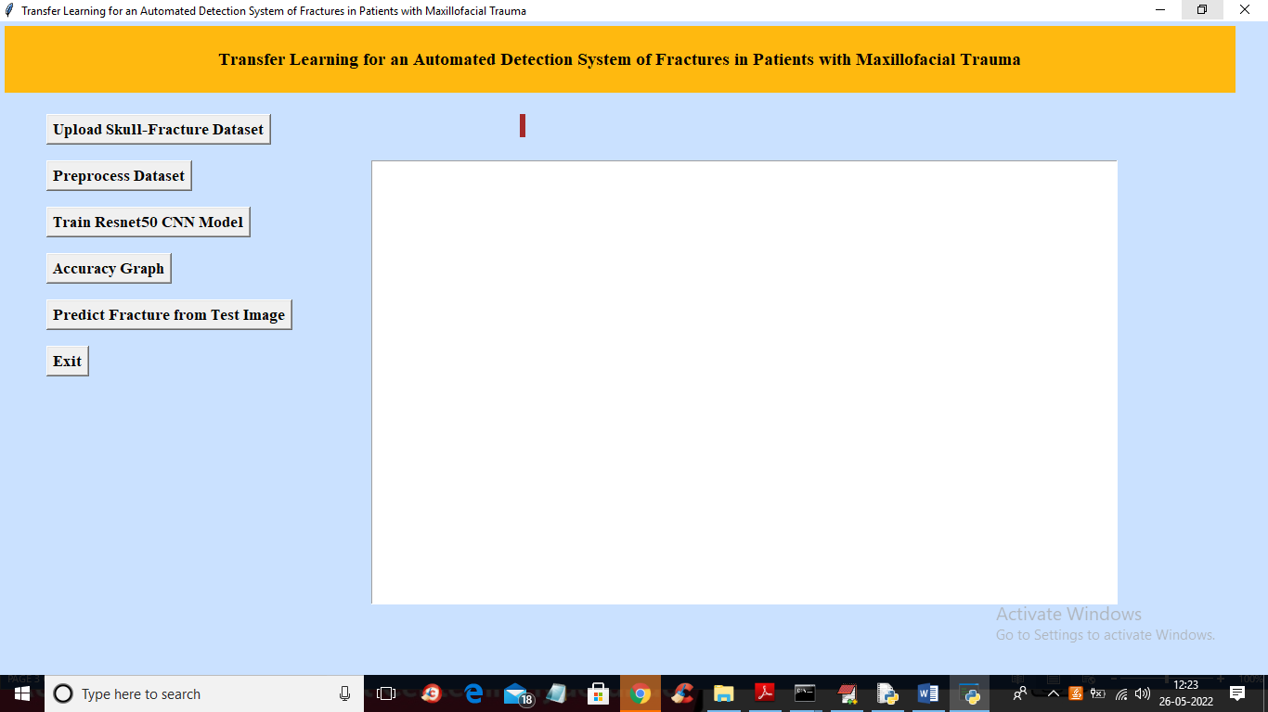
Fig 4.2.1 GUI Interface

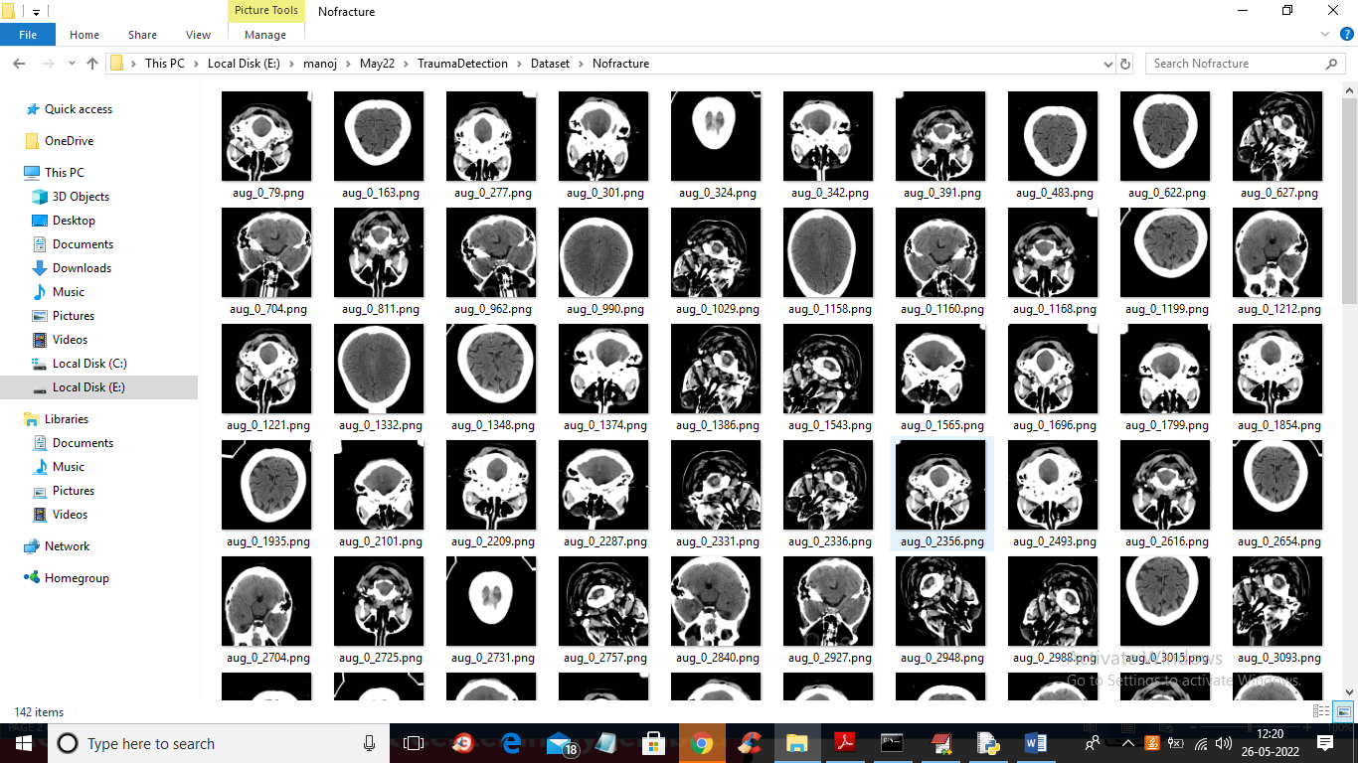
Fig 4.2.2 In above screen we can see SKULL CT-SCAN images and will use above images to train CNN.

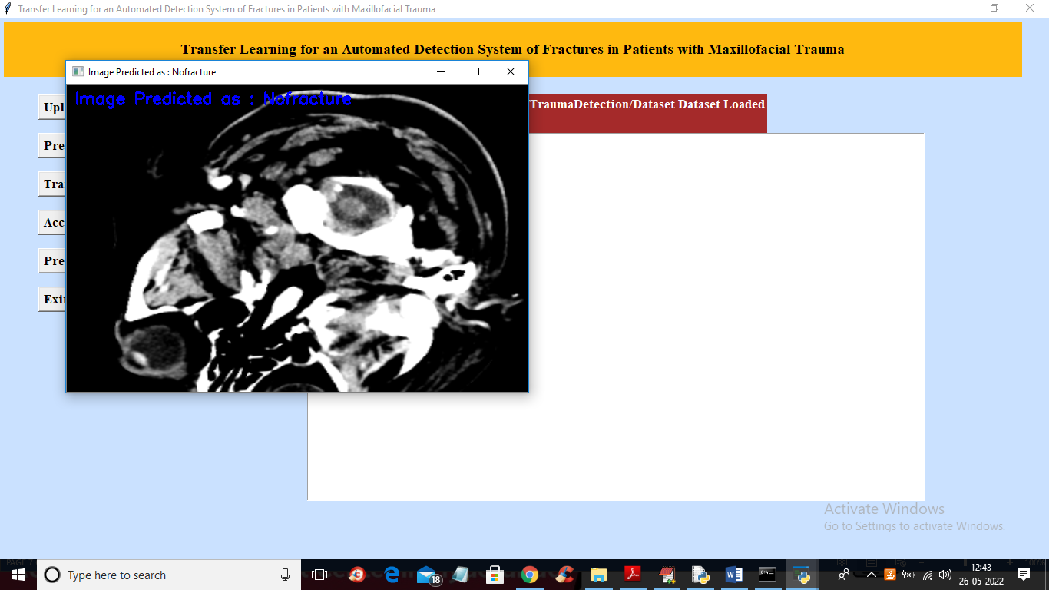
Fig 4.2.3 In above screen in blue colour text we can see image predicted as ‘No Fracture.

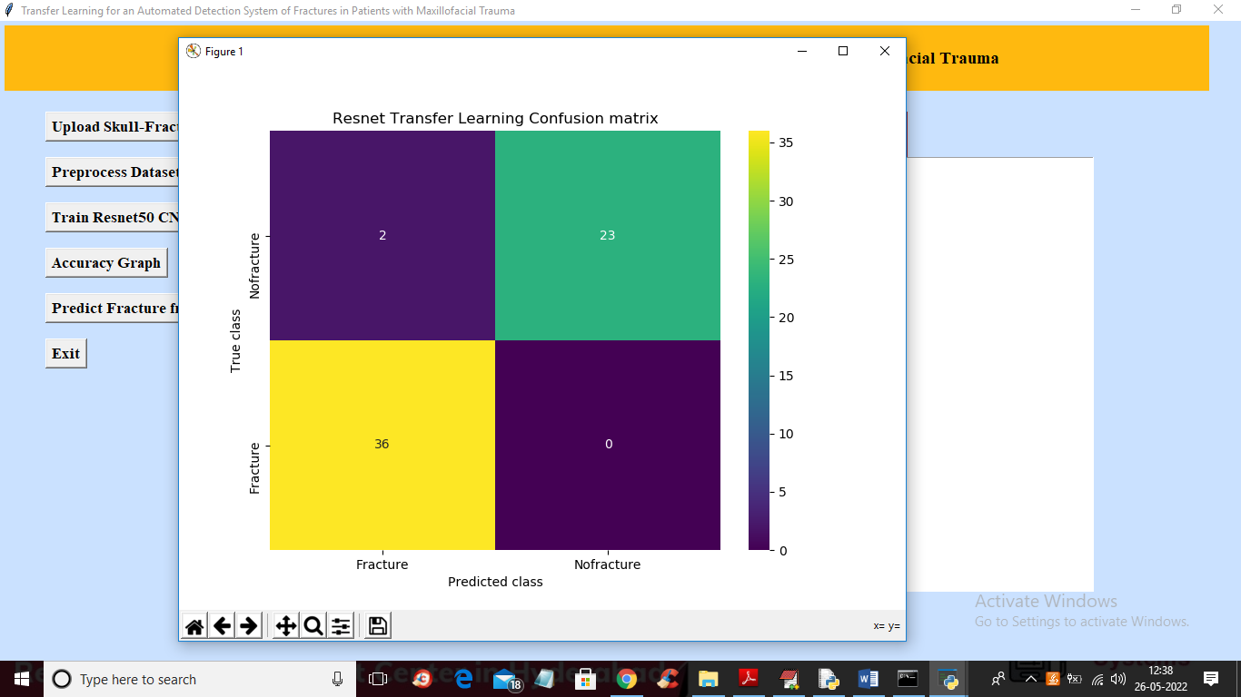
Fig 4.2.4 In above confusion matrix graph x-axis represents PREDICTED CLASSES and y-axis represents TRUE classes and in above screen we can see CNN predicted 36 classes correctly as FRCATURED and only 2 classes are incorrectly predicted and all 23 non-fractured images are correctly predicted
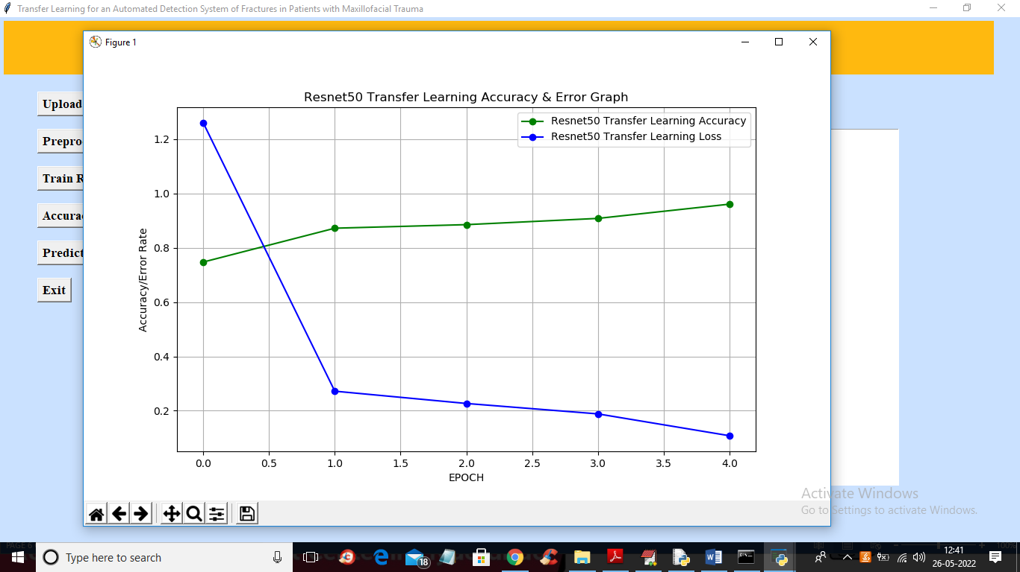
Fig4.2.5 showing Accuracy and Error

CHAPTER 5
CONCLUSION

5.1 Conclusion and Future Enhancement

This study represents a proof of concept for using transfer learning from CNN, pretrained on non-medical images, for maxillofacial fracture detection on CT images. In the literature, the use of transfer learning applied to CT scans to detect maxillofacial fractures of injured patients has not yet been explored. Our system proved to be capable of predicting maxillofacial fractures in patients with an accuracy of 80%. MFDC can become a valuable technology in assisting radiologists with prompt diagnosis and treatment that could reduce medical error risks and prevent patient harm and stress by minimizing maxillofacial trauma’s diagnostic delays. An AI-based system assisting radiological investigation in non-specialized clinical wards can reduce incongruous hospitalization’s socio-economic burden for the patient, society, and health system.

Future Enhancements:

- Expand the dataset to include diverse patient demographics and CT scanner types.
- Incorporate multi-modal imaging (e.g., MRI, X-ray) for comprehensive fracture analysis.
- Develop a severity classification module to differentiate fracture types.
- Deploy the system in clinical settings for real-world validation and integration with electronic
health

REFERENCES

References
1. Kalmet, P.H.S.; Sanduleanu, S.; Primakov, S.; Wu, G.; Jochems, A.; Refaee, T.; Ibrahim, A.; Hulst, L.V.; Lambin, P.; Poeze, M. Deep learning in fracture detection: A narrative review. Acta Orthop. 2020, 91, 215–220. [CrossRef]
2. Esteva, A.; Kuprel, B.; Novoa, R.A.; Ko, J.; Swetter, S.M.; Blau, H.M.; Thrun, S. Dermatologist-level classification of skin cancer with deep neural networks. Nature 2017, 542, 115–118. [CrossRef]
3. Gulshan, V.; Peng, L.; Coram, M.; Stumpe, M.C.; Wu, D.; Narayanaswamy, A.; Venugopalan, S.; Widner, K.; Madams, T.; Cuadros, J.; et al. Development and Validation of a Deep Learning Algorithm for Detection of Diabetic Retinopathy in Retinal Fundus Photographs. JAMA 2016, 316, 2402–2410. [CrossRef]
4. Lee, J.-G.; Jun, S.; Cho, Y.-W.; Lee, H.; Kim, G.B.; Seo, J.B.; Kim, N. Deep Learning in Medical Imaging: General Overview. Korean J. Radiol. 2017, 18, 570–584. [CrossRef] [PubMed]
5. Olczak, J.; Fahlberg, N.; Maki, A.; Razavian, A.S.; Jilert, A.; Stark, A.; Sköldenberg, O.; Gordon, M. Artificial intelligence for analyzing orthopedic trauma radiographs: Deep learning algorithms—are they on par with humans for diagnosing fractures? Acta Orthop. 2017, 88, 581–586. [CrossRef] [PubMed]
6. Tang, A.; Tam, R.; Cadrin-Chênevert, A.; Guest, W.; Chong, J.; Barfett, J.; Chepelev, L.; Cairns, R.; Mitchell, J.R.; Cicero, M.D.; et al. Canadian Association of Radiologists White Paper on Artificial Intelligence in Radiology. Can. Assoc. Radiol. J. 2018, 69, 120–135. [CrossRef] [PubMed]
7. Szegedy, C.; Liu, W.; Jia, Y.; Sermanet, P.; Reed, S.; Anguelov, D.; Erhan, D.; Vanhoucke, V.; Rabinovich, A. Going Deeper with Convolutions. In Proceedings of the IEEE Conference on Computer Vision and Pattern Recognition (CVPR), Boston, MA, USA, 7–12 June 2015; pp. 1–9.
8. Kim, H.D.; MacKinnon, T. Artificial intelligence in fracture detection: Transfer learning from deep convolutional neu-ral networks. Clin. Radiol. 2018, 73, 439–445. [CrossRef] [PubMed]
9. Szegedy, C.; Vanhoucke, V.; Ioffe, S.; Shlens, J.; Wojna, Z. Rethinking the Inception Architecture for Computer Vision. In Proceedings of the 2016 IEEE Conference on Computer Vision and Pattern Recognition (CVPR) 2016, Las Vegas, NV, USA, 27–30 June 2016.
10. Chung, S.W.; Han, S.S.; Lee, J.W.; Oh, K.-S.; Kim, N.R.; Yoon, J.P.; Kim, J.Y.; Moon, S.H.; Kwon, J.; Lee, H.-J.; et al. Automated detection and classification of the proximal humerus fracture by using deep learning algorithm. Acta Orthop. 2018, 89, 468–473. [CrossRef]
11. Tomita, N.; Cheung, Y.Y.; Hassanpour, S. Deep neural networks for automatic detection of osteopo-rotic vertebral fractures on CT scans. Comput. Biol. Med. 2018, 98, 8–15. [CrossRef]
12. Heo, M.-S.; Kim, J.-E.; Hwang, J.-J.; Han, S.-S.; Kim, J.-S.; Yi, W.-J.; Park, I.-W. Artificial intelligence in oral and maxillofacial radiology: What is currently possible? Dentomaxillofacial Radiol. 2021, 50, 20200375. [CrossRef]
13. Hung, K.; Montalvao, C.; Tanaka, R.; Kawai, T.; Bornstein, M.M. The use and performance of artificial intelligence applications in dental and maxillofacial radiology: A systematic review. Dentomaxillofacial Radiol. 2020, 49, 20190107. [CrossRef] [PubMed]
14. Litjens, G.; Kooi, T.; Bejnordi, B.E.; Setio, A.A.A.; Ciompi, F.; Ghafoorian, M.; van der Laak, J.A.; van Ginneken, B.; Sánchez, C.I. A survey on deep learning in medical image analysis. Med. Image Anal. 2017, 42, 60–88. [CrossRef] [PubMed]
15. Nagi, R.; Aravinda, K.; Rakesh, N.; Gupta, R.; Pal, A.; Mann, A.K. Clinical applications and performance of intelligent systems in dental and maxillofacial radiology: A review. Imaging Sci. Dent. 2020, 50, 81–92. [CrossRef]
16. Python. Available online: https://www.python.org/ (accessed on 24 June 2021).
17. PyTorch. Available online: https://pytorch.org/ (accessed on 3 July 2020).
18. Fastai. Available online: https://docs.fast.ai/ (accessed on 3 February 2021).
19. Scikit-Learn. Available online: https://scikit-learn.org/stable/ (accessed on 6 July 2020).
20. Pydicom. Available online: https://pydicom.github.io/ (accessed on 8 July 2020).

GITHUB LINK :

https://github.com/GanjiRohith/Maxillofacial-trauma-detection
.

