Launch the instance on AWS

Rename the instance or leave it as it is

JENKINS SETUP:

Connect to dev machine through git bash

Update the apt repository
sudo apt-get update

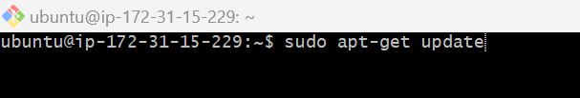

Download java

sudo apt-get install -y openjdk-21-jdk

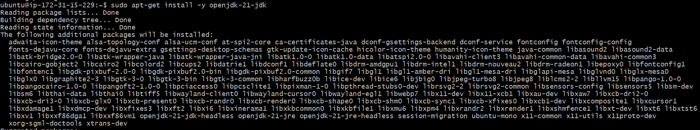

Open the bowser type jenkins.io in the URL --> click on the download
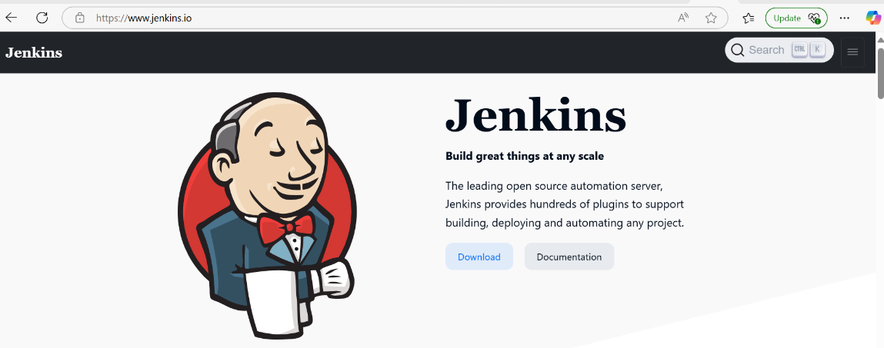
Right click on the generic java package --> copy the link

https://get.jenkins.io/war-stable/2.492.2/jenkins.war

Run the below command in the gitbash dev terminal

$wget https://get.jenkins.io/war-stable/2.492.2/jenkins.war

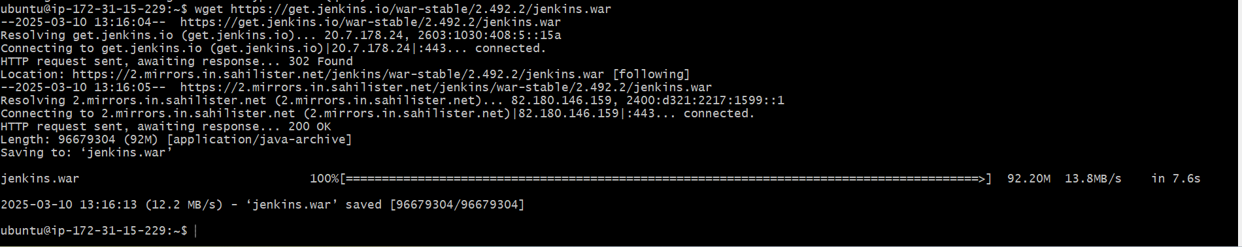

Start the jenkins

$java -jar jenkins.war

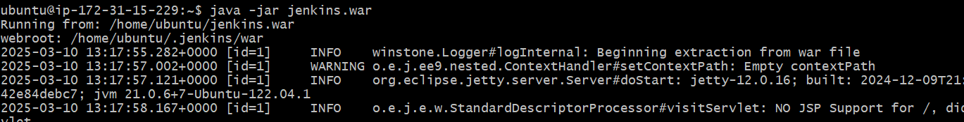

Administration password is available on the terminal

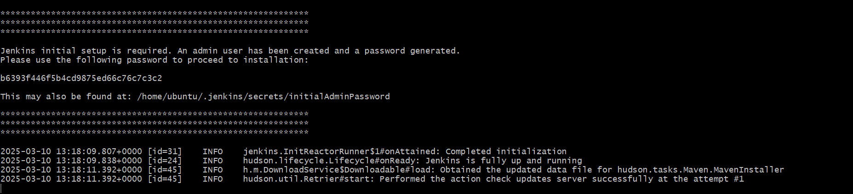

ACCESSING JENKINS:

Open the browser -->Take the public ip of devserver :8080

Copy paste the admin password
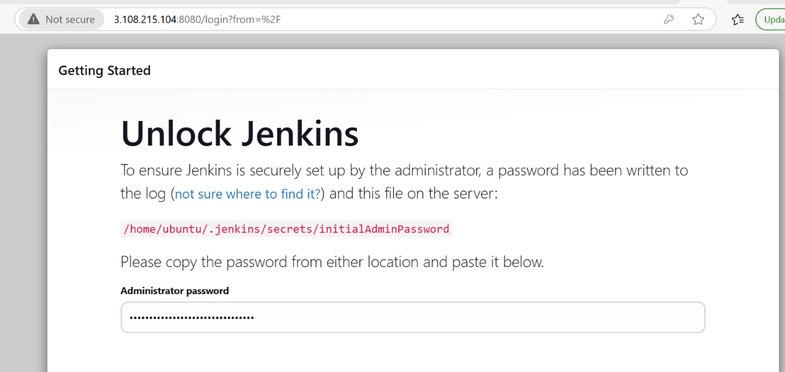

Click on install suggested plugin

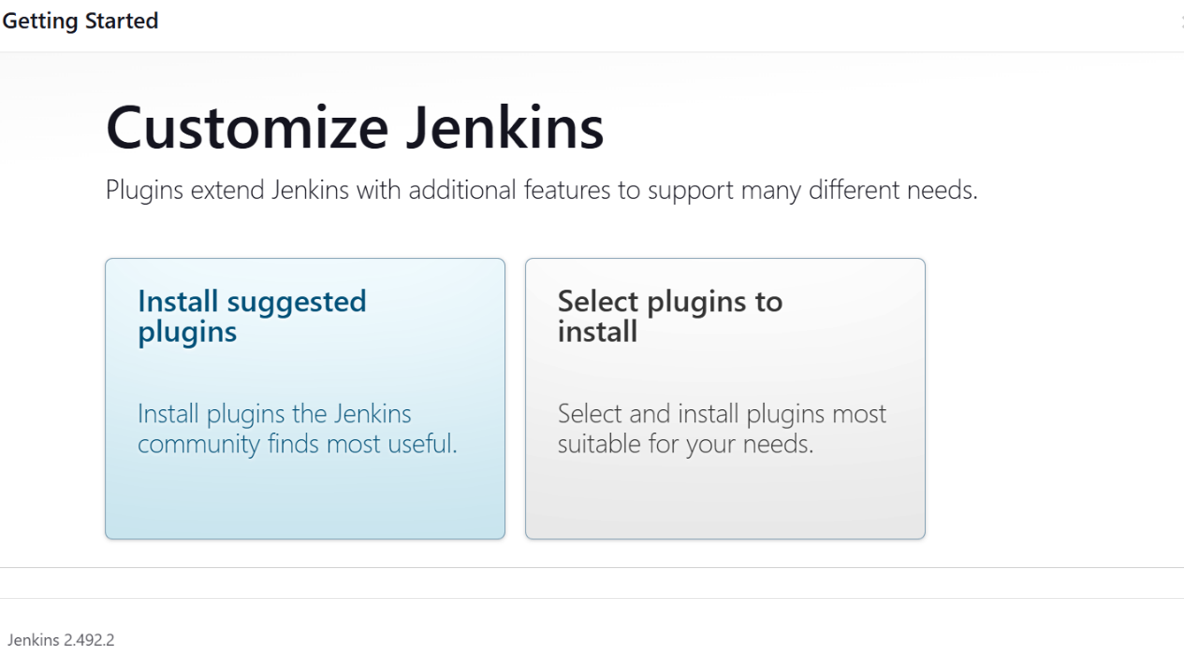

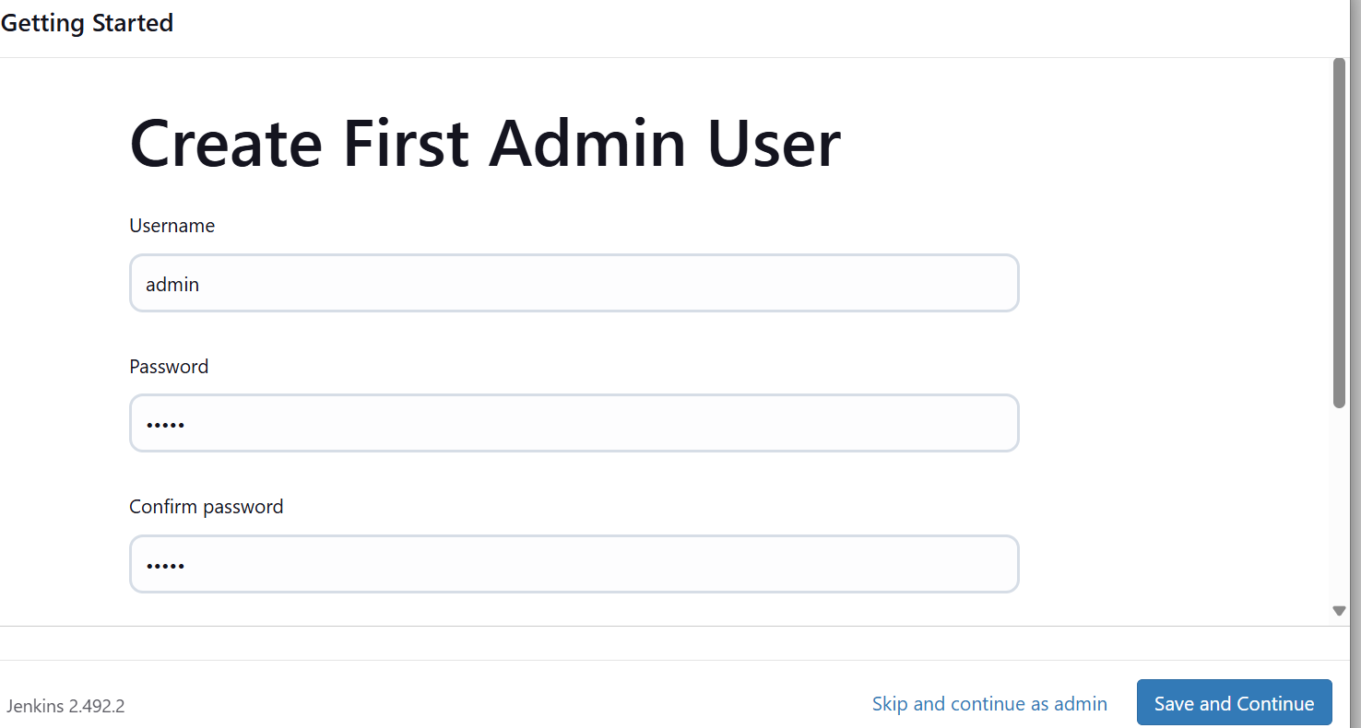

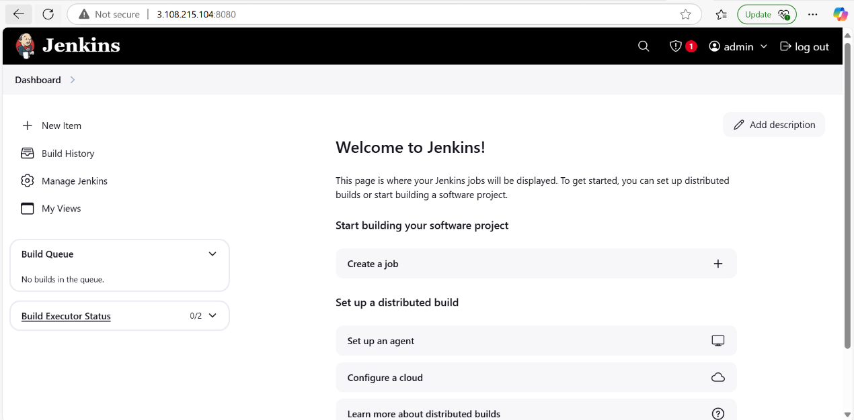
Build war file:

Connect dev terminal through git

Check java is install or not. If not install then install java

Check maven is install or nto . if not install then install maven

Check jenkins is install or not . if not install then install jenkins

Maven download:

Go to the root directory

sudo su -

cd /opt

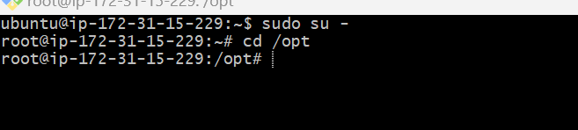

Open the browser type maven download

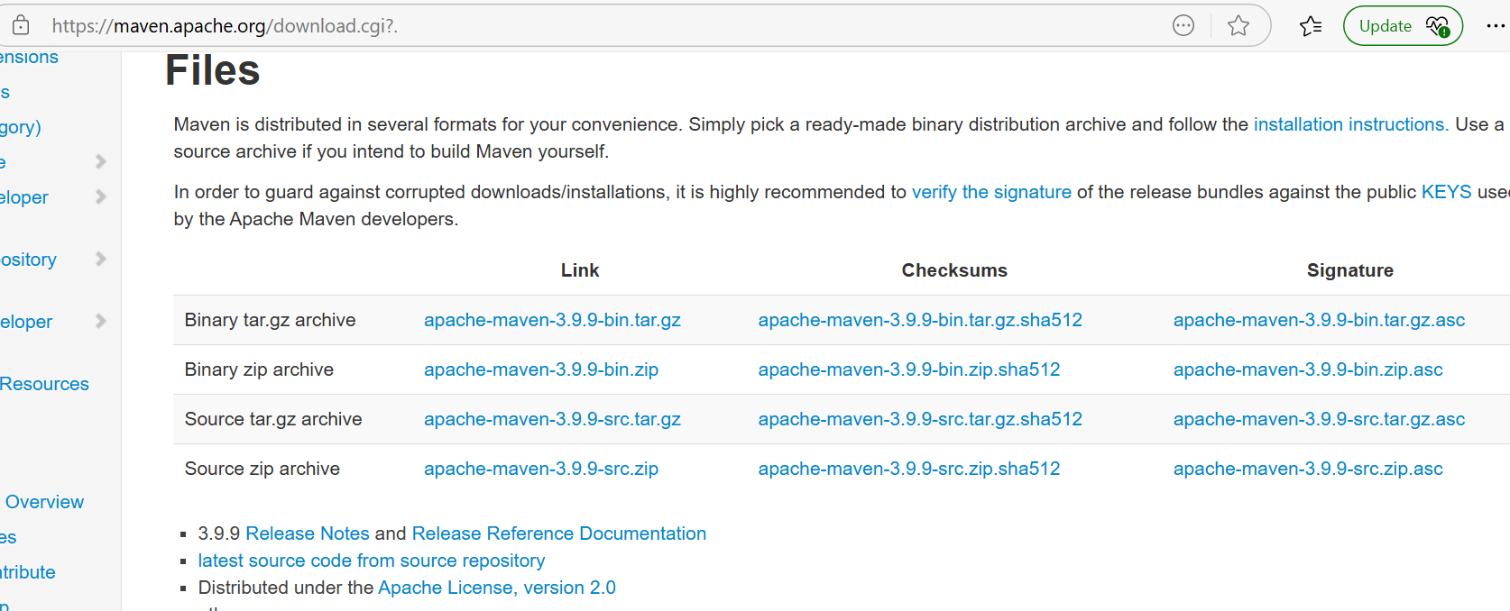

Right click on the apache-maven.3.9.12.bin.tar.gz -->copy the link

wget https://dlcdn.apache.org/maven/maven-3/3.9.12/binaries/apache-maven-3.9.12-bin.tar.gz

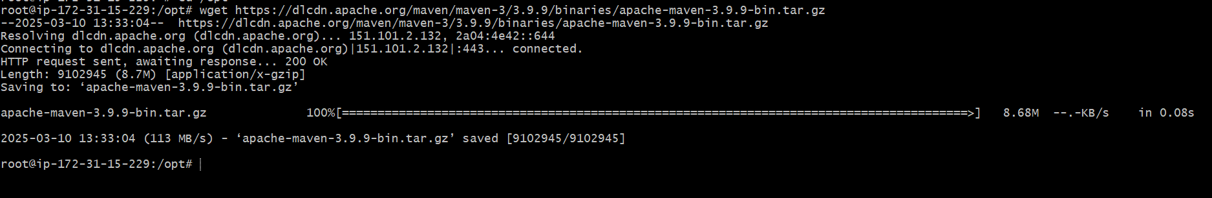

Unzip the maven zip file

tar -xvzf apache-maven-3.9.9-bin.tar.gz

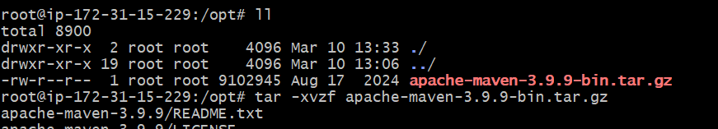

#ll

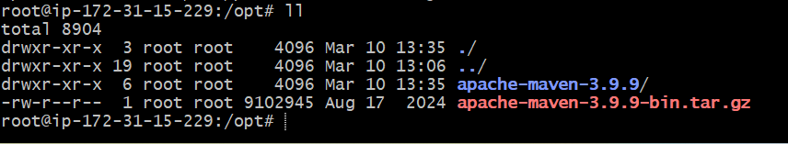

Rename apache-maven-3.9.9 to maven

mv apache-maven-3.9.12 maven

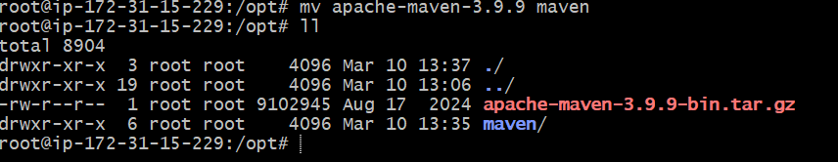

cd maven

#ll

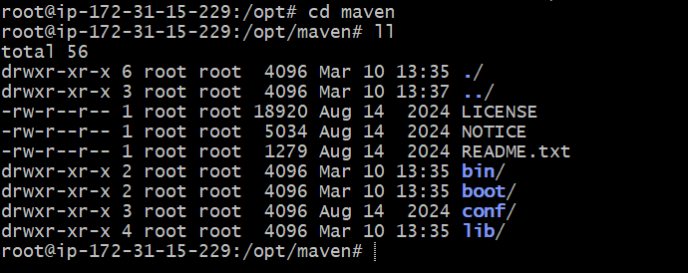

Note down the maven path
#pwd

/opt/maven

Move to cd bin

#ll

Note down the maven bin path (/opt/maven/bin)
#pwd
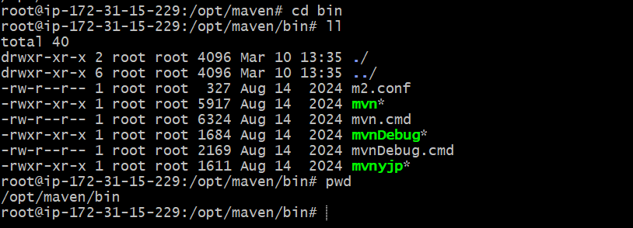

Now check the maven is install or not

mvn --version

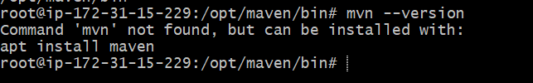

Try with the below command

./mvn --version

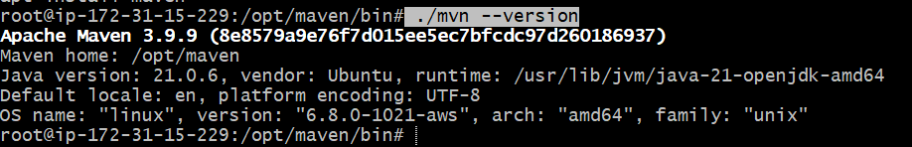

Now go back to the root directory --> cd /

Check the maven version --> mvn --version

It shows maven is not found.

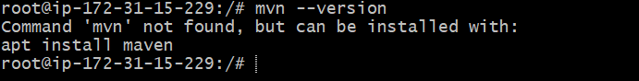

So we need to create environment variable

Go to root directory with below command

cd ~

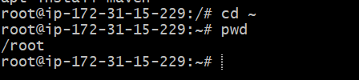

#ll

you can see the .profile file

Open the file with below command

sudo vim .profile

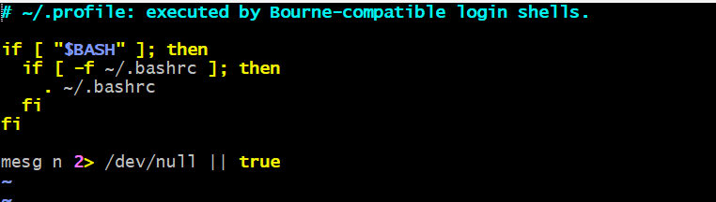

Go to the insert mode( click on I) and give the maven,java home and m2 paths here

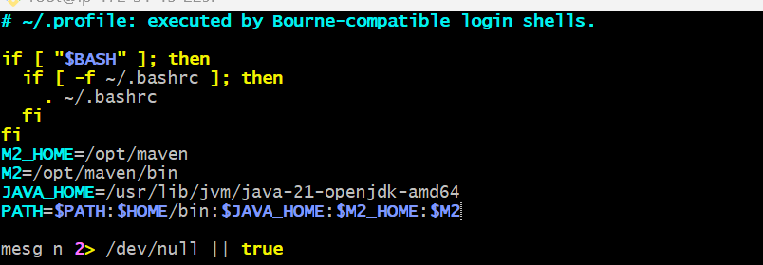

Esc->:wq->enter

To get the java_home path
#find / -name java-21* (/usr/lib/jvm/java-21-openjdk-amd64)

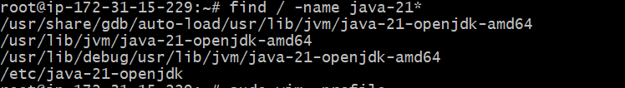

#echo $PATH

U CANT SEE THE JAVA AND MAVEN PATH ABOVE . SO WE NEED TO RESTART THE .PROFILE FILE with below command

#source .profile
#echo $PATH

Now u can see the java and maven paths

Now check the maven version

#mvn --version -->now u can able to see the maven

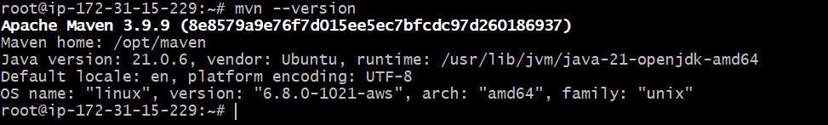

Now go to the jenkins dashboard u need to install one plugin (maven integration)
Click on new item, check whether maven project is available

Managejenkins-->plugins-->available plugins-->maven integration plugin

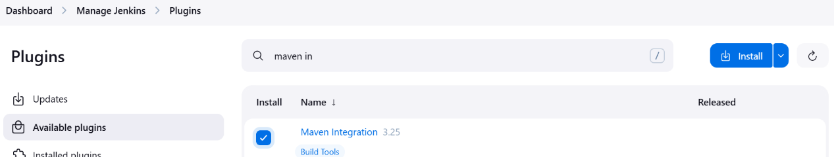

Without this plugin we can’t able to see the maven project

Once installed , click on the restart jenkins

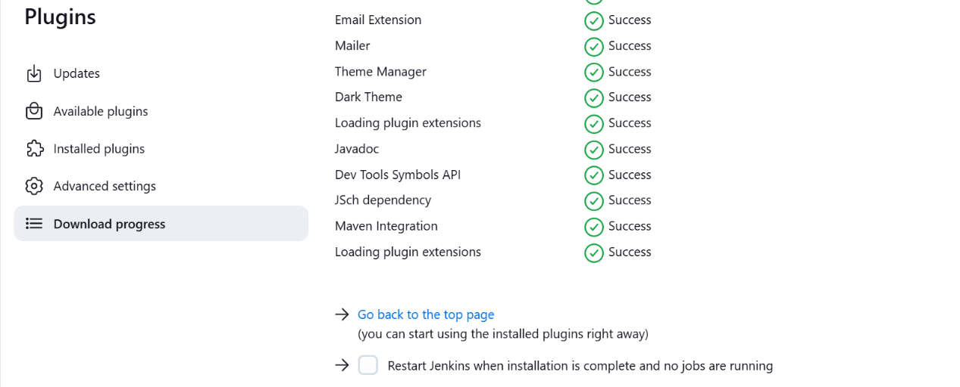

you need to add java and maven paths in the jenkins

Go to jenkins dashboard-->managejenkins-->tools

Add JDK and add MAVEN

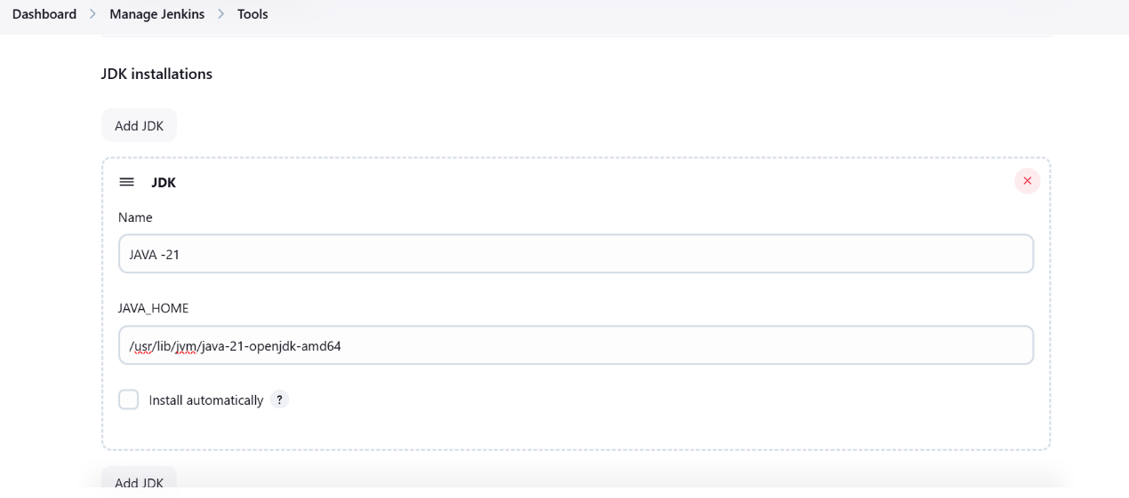

UNCHECK THE install automatically

Add maven

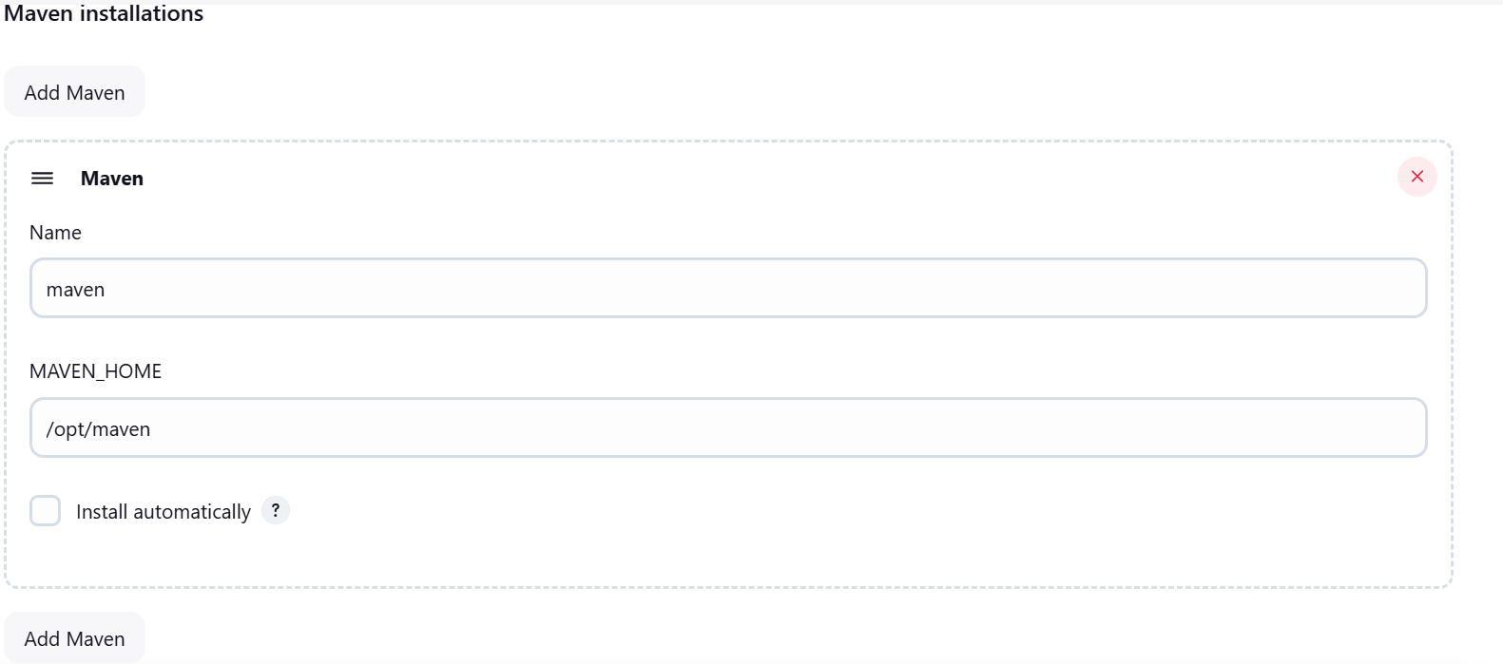

Click on apply and save it

Now we can create job for war file

Dashboard-->newitem-->war(give any name) select maven project click on ok

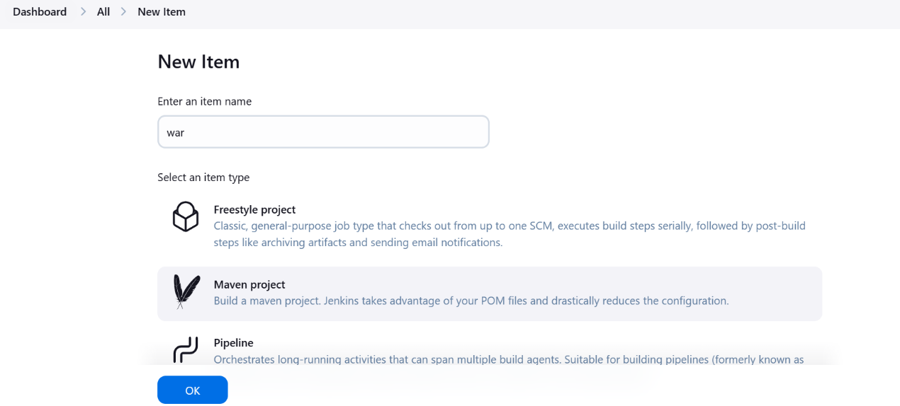

Open git and create a new repository or select any existing repository, copy the HTTPS repository URL

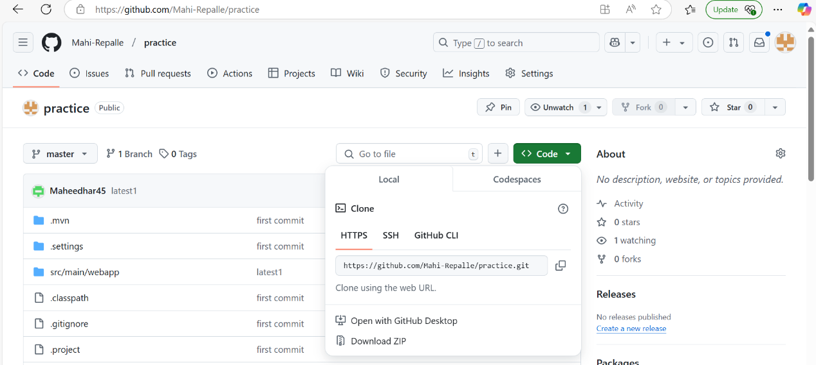

Go to Jenkins, select Source code management-->select git--> give the github url project path
Copied HTTPS path paste it in the jenkins repository url
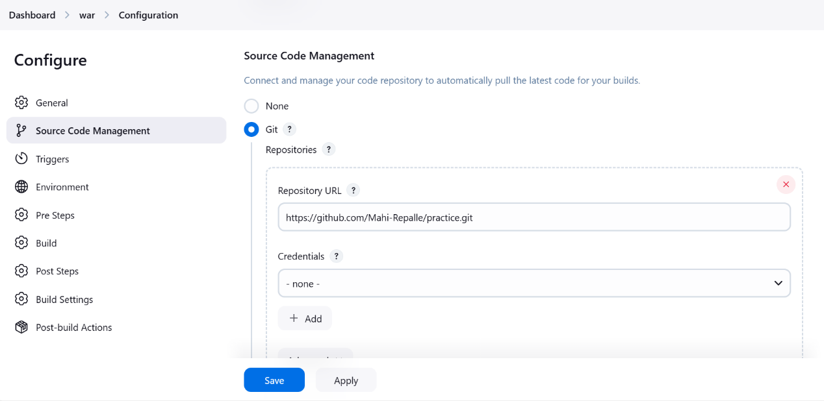

Select the build goal and options write the command clean install click on apply and save

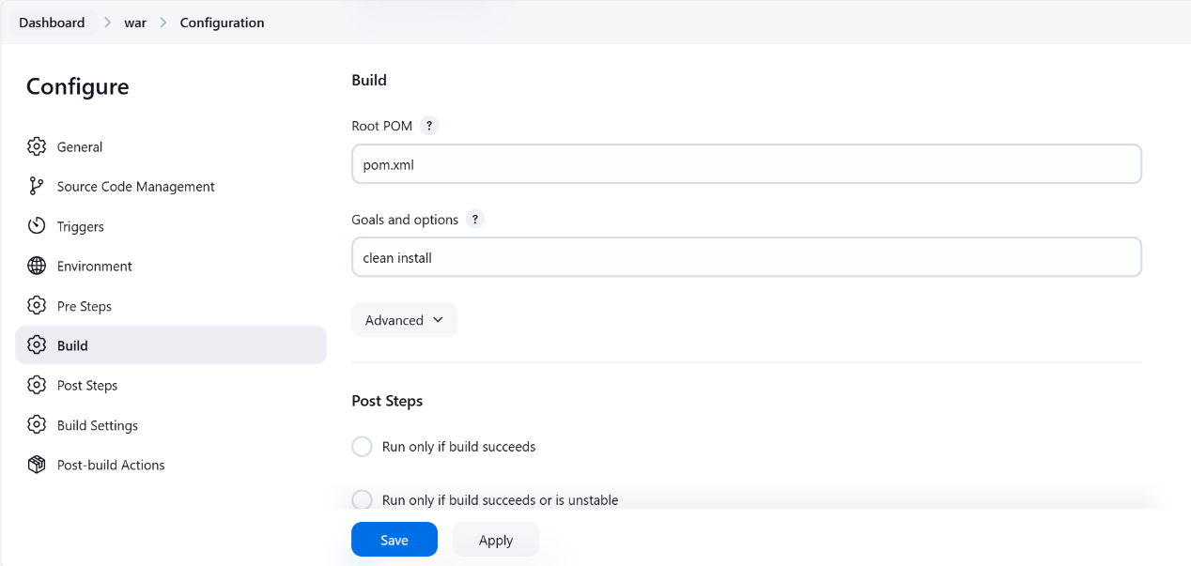

Click on build now

If job execution is taking lot of time
Then
logout the jenkins
Stop the dev instance
Restart the dev instance
Start the jenkins server
Run the job
Now your job will be executed

