**SLA monitor;**

SLA monitor function is used to accurately observe the runtime performance of cloud services to ensure that they are fulfilling the contractual QoS requirements that are published in SLAs. The data then collected by the monitor is processed by management system of SLA to SLA reporting metrics. Apparently, from the textbook figure 8.8 we can see how an SLA monitor functions and its importance. SLA monitor stops functioning when a firewall cluster has failed and all of the IT resources in data center becomes unavailable. SLA monitor polling agent then starts issuing PS-unreachable events after three successive PS-timeout events. Now from the figure 8.9 of the textbook we can clearly see that as soon after IT resources becomes operational the SLA monitor polling agent starts receiving responses from the physical servers and issues PS-reachable events. (Thomas Erl, 2014)

SLA monitor system is correctly used to over-serve the runtime performances of cloud services and to ensure that they fulfill the contractual requirements. As any organization is depended on this service provider and expect a timely services as contracted. Very crucial to have a detector like SLA monitor in cloud service to stand up to clients expectations. The data collected by monitor is entered in to SLA system which further is used to aggregate in to reporting metrics. Also to that system then repairs the failed of the cloud services when expectation cases occur. All in all we can say the SLA monitor role is more like of an electric generator uses when electricity runs off or an antivirus to protect our laptops and computers. (CloudPatterns, 2018).

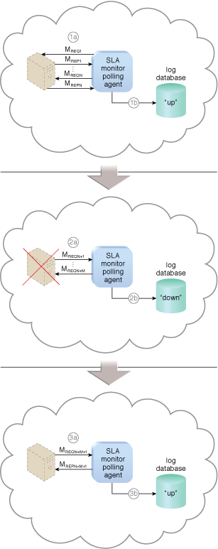

References

CloudPatterns. (2018, June 20th). SLA Management System. Retrieved from cloud paterns : http://cloudpatterns.org/mechanisms/sla_management_system

Thomas Erl, Z. M. (2014). Cloud Computing: Concepts, Technology & Architecture. New York: Pearson.