Exercise 1: | Data Visualization from CSV Using Python

Aim
To create a Python script that reads data from a CSV file containing social media post metrics and generates basic visualizations (bar chart, line chart, and pie chart) to analyze engagement across platforms and post types effectively.

Software Used
- Programming Language: Python 3.x
- Libraries:
  - Pandas (for data loading and manipulation)
  - Matplotlib (for creating visualizations)
- Environment: Jupyter Notebook.

Description
This exercise demonstrates how to visualize data from a CSV file using Python. The dataset contains information about social media posts, including platforms, post types, and engagement metrics (likes, shares, comments, views). The script:
- Loads and cleans the data (handles missing values and invalid entries).
- Aggregates metrics (e.g., average likes and views by platform).
- Generates three visualizations:
  - Bar chart: Compares average likes across platforms.
  - Line chart: Shows trends in average views across platforms.
  - Pie chart: Displays the percentage distribution of post types. These visualizations help analyze engagement patterns and distribution in the dataset.

Dataset Details
- File Name: social_media_data.csv
- Location: Place the file in the same directory as the script/notebook.

Columns:
  - date: Date of the post (format: YYYY-MM-DD).

  - platform: Social media platform (e.g., Twitter, Instagram, Facebook; includes some invalid entries like "NonExistingPlatform").
  - post_type: Type of post (text, image, video).
  - likes: Number of likes (may contain NaN/null).
  - shares: Number of shares (may contain NaN/null).
  - comments: Number of comments (may contain NaN/null).
  - views: Number of views (may contain NaN/null).
- Rows: Approximately 500+ entries.

List of Tasks
- Import necessary libraries (Pandas and Matplotlib).
import pandas as pd
import matplotlib.pyplot as plt
import seaborn as sns
%matplotlib inline

- Load the CSV file into a DataFrame.
df = pd.read_csv("social_media_data.csv")

df.head()
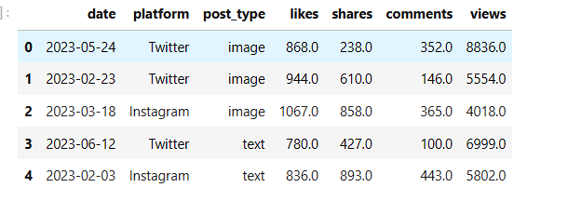

- Preview the data to verify loading.
print("dataset")
print(df)
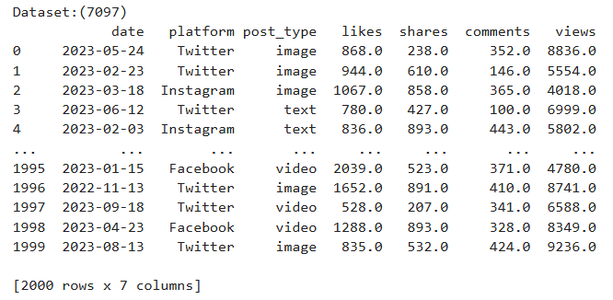
- Clean the data by filling missing values (NaN) with 0.
df.fillna(0, inplace=True)
- Filter out invalid platforms (keep only Twitter, Instagram, Facebook).
valid_platforms=["Twitter","Instagram","Facebook"]
data=df[df["platform"].isin(valid_platforms)]
- Aggregate average metrics (likes, shares, comments, views) by platform.
agg_data = df.groupby("platform").agg({
"likes": "mean",
"shares": "mean",
"comments": "mean",
"views": "mean"
}).reset_index()
print("\nAggregated data:")
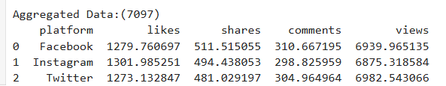
print(agg_data)

- Create a bar chart for average likes by platform.
plt.figure(figsize=(10, 6))
plt.bar(agg_data['platform'], agg_data['likes'], color='skyblue',edgecolor='black')
plt.title('Average Likes by Platform - 7071',fontsize=12,pad=15)
plt.xlabel('Platform',fontsize=12)
plt.ylabel('Average Likes',fontsize=12)
plt.xticks(rotation=45,ha='right')
plt.tight_layout()
plt.savefig("bar_chart_avg_likes.png", dpi=300)
plt.show()

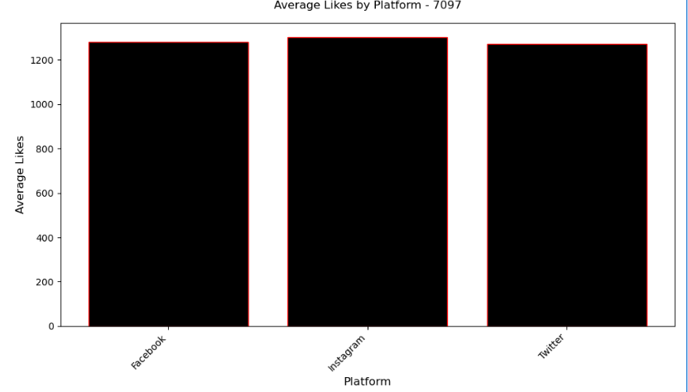

- Create a line chart for average views by platform.
plt.figure(figsize=(10, 6))
plt.plot(agg_data['platform'], agg_data['views'], marker='o', linestyle='--', color='green',linewidth=2)
plt.title('Average Views by Platform - 7071',fontsize='14',pad='15')

plt.xlabel('Platform',fontsize=12)
plt.ylabel('Average Views',fontsize=12)
plt.xticks(rotation=45,ha='right')
plt.grid(True, alpha=0.3)
plt.tight_layout()
plt.savefig('line_chart_avg_views.png', dpi=300)
plt.show()

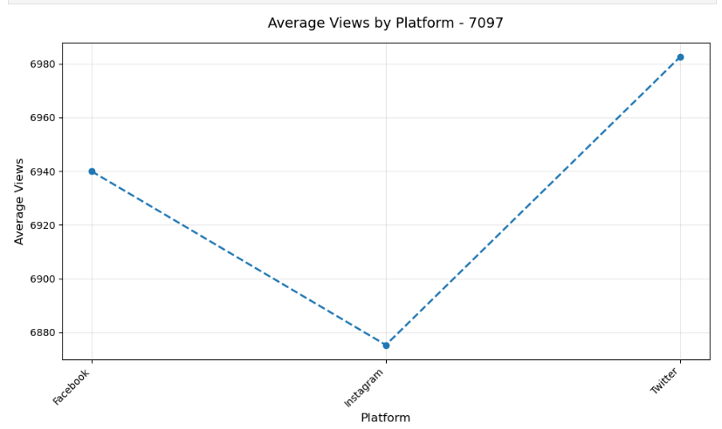

- Create a pie chart for the distribution of post types.
post_type_counts = data['post_type'].value_counts()
plt.figure(figsize=(6, 6))
plt.pie(post_type_counts,
labels=post_type_counts.index,
autopct='%1.1f%%',
startangle=140,
colors=plt.cm.Paired.colors,
textprops={'fontsize': 12})

plt.title('Distribution of Post Types - 7071',fontsize=14,pad=20)
plt.tight_layout()
plt.savefig('pie_chart_post_type.png', dpi=300)
plt.show()

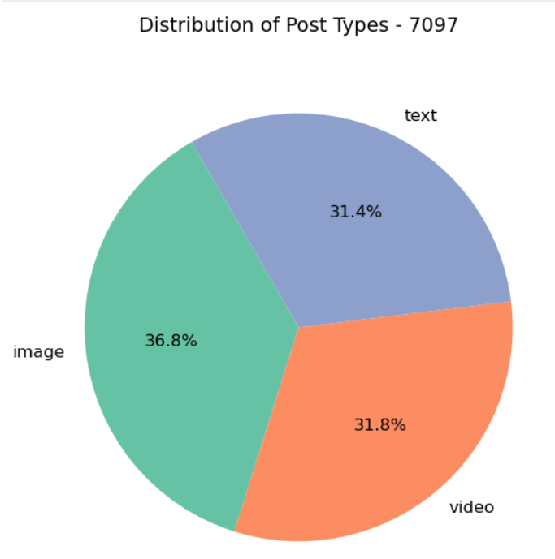

YOUTUBE VIDEO LINK:
https://youtu.be/wYoQAj0KL4U

Result:
The Python script successfully analyzed social media data from a CSV file and generated bar, line, and pie charts that clearly illustrated engagement patterns across platforms and post types.

