1. Running “node bamazonCustomer.js”

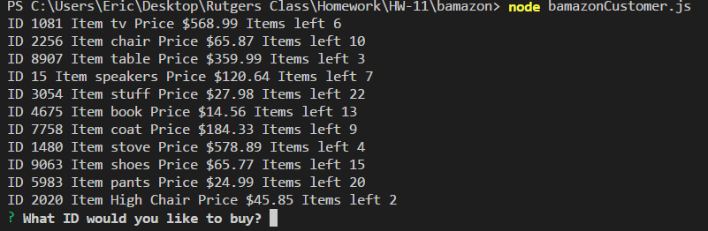

1. Let’s pick more than what is available



1. Let’s pick less this time

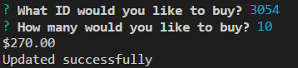

1. Let’s now view to see if the inventor updated

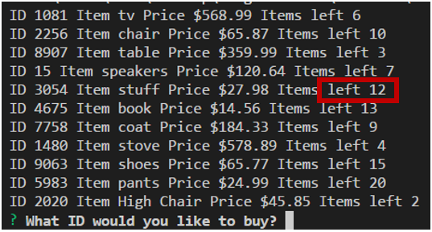

1. Now let’s look at the managers view “node bamazonManager.js”

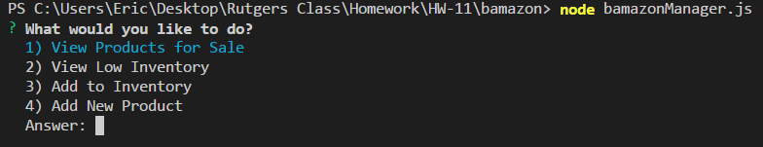

1. Type “1” to view Products

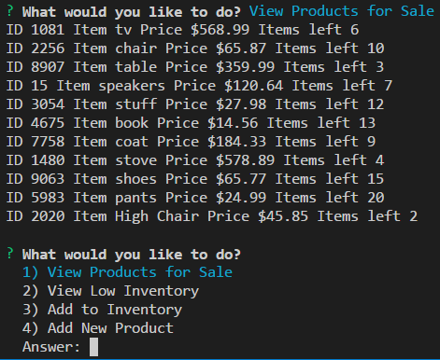

1. Now let’s take a look to see when we type “2”

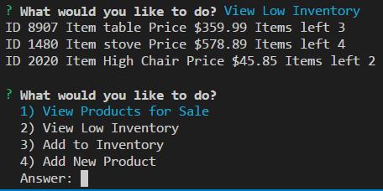

1. Now let’s see what happens when we type “3”

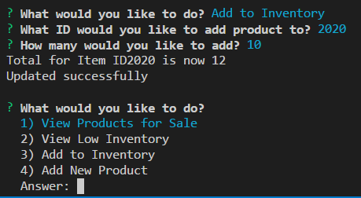

1. Let’s take a look again at the Products for Sale to see if the change really did happen

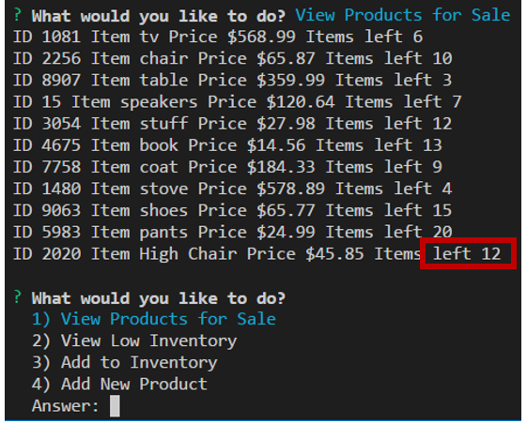

1. Great! Now let’s add a New Product by typing “4” and answer a few questions

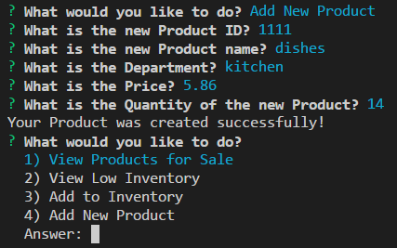

1. Let’s view our products by typing “1” again

