TECHNICAL DESIGN DOCUMENT
Enterprise CI/CD, Runtime Configuration & Semantic Versioning Framework

Project | Intervention Management Platform (IMP)
Component | React 18 Frontend UI
Target Platform | Azure DevOps Pipelines + Azure App Service (Windows / Slots)
Security Posture | Regulated Utility Customer Environment
Document Version | 2.0 — Reviewed & Improved
Date | 21 August 2026
Author | DevOps Architecture Team (Reviewed)
Status | Approved — Implementation Ready
Review Cycle | Quarterly

Document Purpose
This Technical Design Document defines the enterprise CI/CD architecture, runtime configuration strategy, and semantic versioning framework for the IMP React 18 Frontend UI. It incorporates a deep independent review of the original design, corrects critical branch/artifact mismatches, enforces independent branch-based deployments, and provides production-ready Azure DevOps pipeline templates.
CONFIDENTIAL — For Internal Use Only

Table of Contents

1. Executive Summary
The reviewed design is directionally strong: it separates CI from CD, uses a single React build artifact, injects environment configuration at deployment time, uses Azure DevOps Variable Groups, and records release metadata. However, the original YAML contained several design and correctness problems that could produce skipped stages, missing artifacts, or an apparent “successful” pipeline that did not deploy the intended environment.
This revised design retains the required operating model while correcting all identified defects:
- Branches are promoted independently: dev → DEV, uat → UAT, preprod → PREPROD, main → PROD.
- A deployment does not require an earlier environment stage to have run in the same CD execution.
- CI builds only the branch commit that triggered it and publishes one environment-neutral react-ui.zip artifact.
- CD is triggered by the exact CI pipeline run and deploys the artifact from that run to the matching environment.
- Environment-specific API URL, environment name, version and deployment timestamp are injected through public/config.js at deployment time.
- PREPROD in the production resource group is mapped to the preprod branch (not main), because it remains a pre-production deployment.
- PROD is the only stage that creates the annotated Git tag vX.Y.Z.

Key Architecture Decision: The operating model is independent branch deployment, not true artifact promotion. Each environment branch produces its own CI artifact. This matches the team’s PR/merge process. Strict binary promotion can be added later if mandated.

2. Detailed Review Findings — Original Design
The independent review identified the following issues ranked by priority. All Critical and High findings have been corrected in the recommended implementation.
Priority | Finding | Why it Matters | Recommended Correction
Critical | PREPROD (Prod RG) CD stage configured for main but consumes a preprod artifact. | Main CI publishes react-ui; preprod publishes a different name. Main-triggered CD cannot reliably find the artifact. | Use branchName: preprod and artifactName: react-ui for the single environment-neutral artifact.
Critical | CD stages depend on previous environment stages even though deployments are independent. | A UAT-only CD run has DeployDEV skipped. Dependency creates unnecessary graph coupling and confusing skipped behaviour. | Set each independent CD stage dependsOn: [] . Use Azure DevOps Environment approvals for gates.
High | CI variable groups are environment-specific even though CI does not inject runtime configuration. | Couples an environment-neutral build to environment settings and increases accidental cross-environment dependency. | Remove environment Variable Groups from CI. Keep them in CD only.
High | Design says ‘Build Once, Deploy Anywhere’ but CI rebuilds on every branch merge. | A dev artifact and later uat artifact are separate builds. They share lineage but are not the same binary. | Call the model ‘Build Once per branch commit, Deploy Exactly That Artifact’ unless true promotion is adopted.
High | Runtime config is rewritten inside a deployed artifact and then re-zipped. | The original immutable CI artifact is modified before deployment. | Copy artifact to a staging directory, inject config there, deploy the resulting package; retain original CI artifact unchanged.
High | Git tag uses the CI run name as the production version. | If run-name formatting changes, tag semantics can drift. | Compute release version explicitly from package.json and pass as output variable; tag only the exact source commit.
Medium | Azure App Service configuration values and client-side config are conflated. | Anything in React runtime config is visible to the browser and must not contain secrets. | Only non-secret values (API base URL, environment, version, timestamp) belong in config.js.
Medium | web.config rewrite excludes /api based on REQUEST_URI. | Exclusion is only useful if the same host intentionally serves API routes. | Keep exclusion only if required; otherwise simplify the SPA rule.
Medium | Manual/local YAML validation is not part of the repository workflow. | YAML template/compile-time errors can still reach Azure DevOps. | Add local yamllint / Python YAML parsing and a repository pre-validation script.

3. Target Architecture & Deployment Model
The target architecture intentionally separates three concerns:
- CI — source validation, dependency installation, TypeScript compilation, Vite build, SemVer calculation, artifact creation and publication.
- CD — exact artifact download, environment-specific runtime configuration injection, App Service deployment, smoke checks and release tagging.
- Runtime — browser loads config.js before the React bundle, allowing the same compiled JavaScript bundle to run against different APIs.

3.1 Architecture Diagram — Reviewed Target
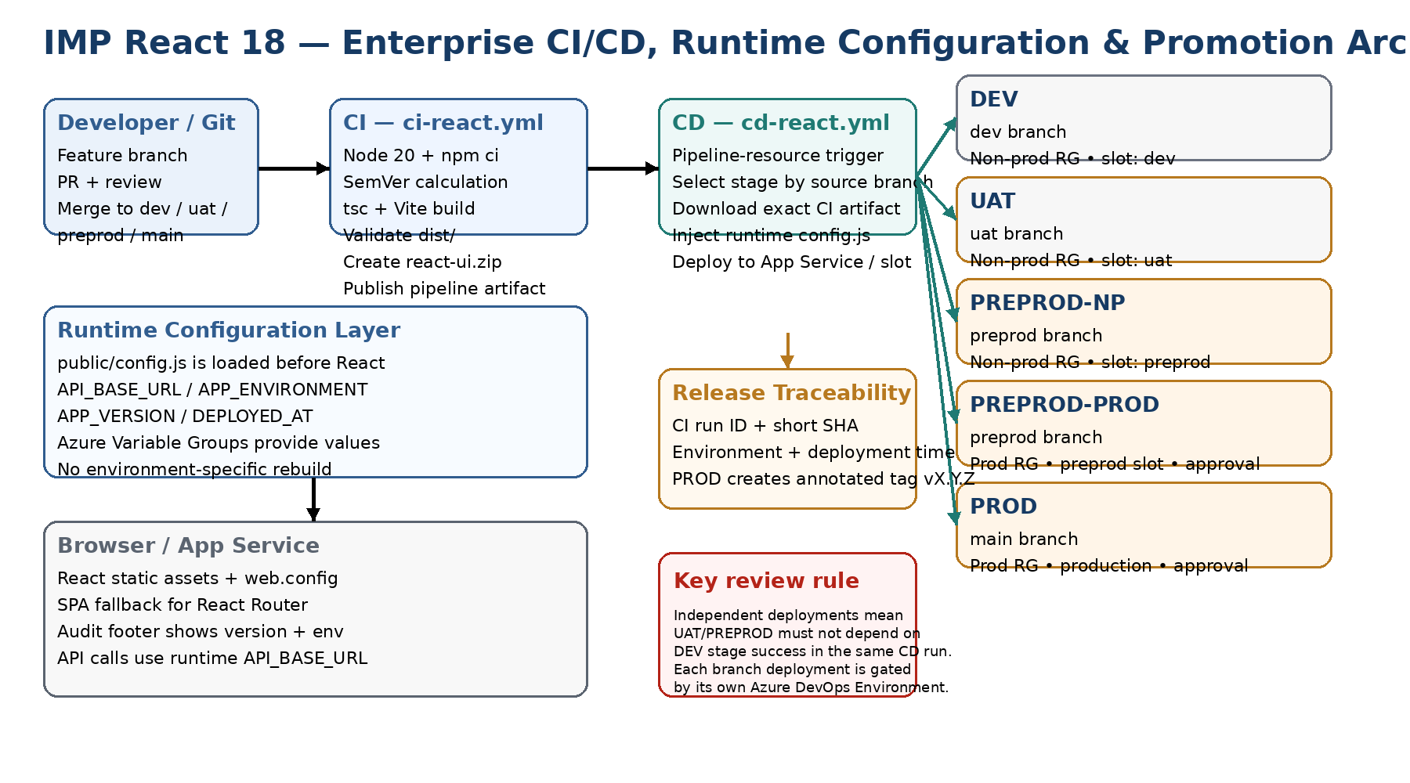
Figure 1 — Reviewed target architecture for independent branch-based deployments

3.2 Promotion Flow Diagram
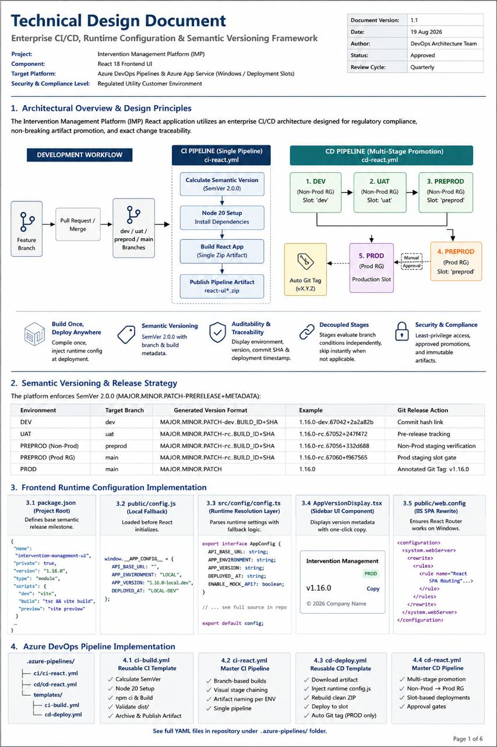
Figure 2 — IMP React 18 Enterprise CI/CD, Runtime Configuration & Promotion Architecture

3.3 Branch-to-Environment Contract
Source Branch | CI | CD Target | Resource Group | Slot | Approval
dev | Build + publish react-ui | DEV | Non-prod | dev | No / optional
uat | Build + publish react-ui | UAT | Non-prod | uat | No / optional
preprod | Build + publish react-ui | PREPROD (Non-prod) | Non-prod | preprod | Optional
preprod | Same CI artifact | PREPROD (Prod RG) | Prod | preprod | Required
main | Build + publish react-ui | PROD | Prod | Production | Required

Important: The two PREPROD deployments intentionally use the same source branch. If the organisation does not require a PREPROD slot in the production RG, remove that stage rather than mapping it to main.

4. Semantic Versioning Strategy
package.json remains the source of the base MAJOR.MINOR.PATCH version. The pipeline adds branch/build metadata for traceability.
Environment | Branch | Displayed CI Version | Production Git Tag
DEV | dev | 1.16.0-dev.<BuildId>+<SHA> | None
UAT | uat | 1.16.0-rc.<BuildId>+<SHA> | None
PREPROD | preprod | 1.16.0-rc.<BuildId>+<SHA> | None
PROD | main | 1.16.0 | v1.16.0

Review note: SemVer build metadata may contain a short SHA, but the build identifier should be treated as traceability metadata, not as a release approval mechanism. The immutable source commit and CI run are the authoritative traceability points.

5. Runtime Configuration Design
The React bundle must not contain environment-specific API URLs at compile time if the goal is a single deployable artifact. The browser loads /config.js before the application bundle.

5.1 package.json (Source of Truth)
The version field in package.json is the single source of the base MAJOR.MINOR.PATCH value. Example:
{ "name": "intervention-management-ui", "version": "1.16.0", "type": "module", ... }

5.2 public/config.js (Runtime Injection Target)
This file is overwritten at deployment time with environment-specific values. It must never contain secrets.
window.__APP_CONFIG__ = { API_BASE_URL: "", APP_ENVIRONMENT: "LOCAL", APP_VERSION: "1.16.0-local", DEPLOYED_AT: "LOCAL-DEV", ENABLE_MOCK_API: false };

5.3 src/config/config.ts (Resolution Layer)
The TypeScript module resolves runtime values first, falling back to Vite environment variables for local development. It exposes getConfig() and getApiBaseUrl() helpers used throughout the application.

5.4 index.html Loading Order
The <script src="/config.js"> tag must appear in <head> before the React entry-point module so that window.__APP_CONFIG__ is available when the application initialises.

5.5 public/web.config (IIS SPA Fallback)
A simplified SPA rewrite rule is recommended. The rule rewrites all non-file/non-directory requests to /. An explicit /api exclusion is retained only if the same App Service host intentionally serves API routes.
Runtime rule: Do not put client secrets, certificates, connection strings, tokens or credentials in config.js. It is downloaded by every browser user.

6. Recommended Repository Structure
InterventionManagement-UI/
├── public/
│ ├── config.js
│ └── web.config
├── src/
│ ├── config/
│ │ └── config.ts
│ └── components/layout/AppVersionDisplay.tsx
├── package.json / package-lock.json / tsconfig.json / vite.config.ts
└── .azure-pipelines/
├── ci/ci-react.yml
├── cd/cd-react.yml
└── templates/ci-build.yml & cd-deploy.yml

7. Azure DevOps CI/CD Implementation

7.1 Design Principles Applied
- Single environment-neutral CI pipeline (ci-react.yml) triggered by dev, uat, preprod and main.
- Reusable CI template (ci-build.yml) performs Node setup, SemVer calculation, typecheck, build, validation and artifact publish.
- CD pipeline (cd-react.yml) is resource-triggered by the CI pipeline; each stage evaluates the source branch and runs independently (dependsOn: []).
- Reusable CD template (cd-deploy.yml) downloads the exact CI artifact, injects runtime config into a staging directory, deploys, runs smoke tests and (for PROD only) creates an annotated Git tag.
- Approvals are enforced by Azure DevOps Environments, not by YAML pauses.

7.2 Why a Single CI Build?
Because the build is environment-neutral. The branch itself determines the version metadata, while CD determines the runtime environment. This avoids maintaining four nearly identical CI build definitions and guarantees that the same source commit produces a consistent artifact for its branch.

7.3 CD Stage Independence (Critical Correction)
Every CD stage is configured with dependsOn: []. Consequently a UAT-only run does not leave a skipped DeployDEV stage in a dependent state, and a PREPROD or PROD deployment never waits for earlier environments. Governance is provided exclusively by Azure DevOps Environment Approvals & Checks on the PREPROD-PROD and PROD environments.

8. Azure DevOps Variable Groups
Variable Group | API_BASE_URL | APP_ENV | Resource Group | Web App
VG-IMP-UI-DEV-NONPROD-RG | https://api-dev.utility.co.uk | DEV | rg-imp-nonprod-uksouth | app-imp-ui-dev
VG-IMP-UI-UAT-NONPROD-RG | https://api-uat.utility.co.uk | UAT | rg-imp-nonprod-uksouth | app-imp-ui-uat
VG-IMP-UI-PREPROD-NONPROD-RG | https://api-preprod-np.utility.co.uk | PREPROD | rg-imp-nonprod-uksouth | app-imp-ui-preprod
VG-IMP-UI-PREPROD-PROD-RG | https://api-preprod.utility.co.uk | PREPROD | rg-imp-prod-uksouth | app-imp-ui-prod
VG-IMP-UI-PROD-PROD-RG | https://api.utility.co.uk | PROD | rg-imp-prod-uksouth | app-imp-ui-prod

- Keep Variable Groups out of CI unless the value is genuinely required to build/test the application.
- Grant pipeline access only to the required Variable Groups.
- For client-side values use ordinary variables; never store secrets in config.js.
- Use Environment-level approvals/checks for PREPROD-PROD and PROD.

9. Security, Compliance & Traceability
- Build artifact is immutable after CI publication; CD works from a copied runtime staging directory.
- The original CI artifact remains available for audit and comparison.
- Deployment records include CI run, source branch, source commit and deployment timestamp.
- Production Git tag is created only after successful PROD deployment.
- Azure DevOps service connections use least privilege and are scoped to the required subscription/resource group.
- System.AccessToken is used only in the tagging step and is never printed.
- Azure DevOps Environment approvals/checks provide a governance boundary outside the YAML itself.
- React runtime configuration is public; no secrets are allowed.

10. Local Validation Before Push
YAML failures that reach Azure DevOps as informational runs are exactly the type of issue that should be caught before pushing. Three validation layers are recommended.

10.1 YAML Syntax Validation
Install once: python -m pip install yamllint pyyaml
Then parse each file with a generic YAML loader and run yamllint. Note that a generic parser validates syntax but does not understand Azure DevOps template expressions; local parsing is necessary but not sufficient.

10.2 Application Validation
npm ci && npm run typecheck && npm run build && npm run preview

10.3 Azure DevOps Validation
- Use the pipeline editor’s YAML validation before queueing.
- Confirm pipeline resource name/source matches the actual CI pipeline name.
- Confirm Variable Group names exactly match Library entries.
- Confirm service connection names exactly match the service connections.
- Verify Azure DevOps Environment names exist and contain the intended approvals/checks.

11. Troubleshooting Runbook
Symptom | Likely Cause | Resolution
Informational run / YAML error | Invalid YAML or Azure template expression before the pipeline can evaluate triggers. | Run local YAML parse + yamllint, then Azure DevOps YAML validation.
UAT stage skipped when UAT branch triggered | UAT stage depends on DEV stage from the same CD run. | Use dependsOn: [] for independent branch deployments.
PREPROD Prod-RG artifact not found | CD stage expects preprod artifact but is mapped to main. | Map PREPROD Prod-RG to preprod branch and use react-ui artifact.
Variable not found | Variable Group not linked or variable name differs. | Check Library name, pipeline authorisation and exact variable spelling.
Azure service connection not found | Service connection passed as a runtime variable or name is incorrect. | Pass service connection as a compile-time template parameter.
React route returns 404 after refresh | IIS does not rewrite unknown SPA paths to index.html. | Ensure web.config is in public/ and therefore copied to dist/.
UI calls wrong API | Runtime config.js missing, not loaded before React, or overwritten incorrectly. | Open /config.js in browser and verify network request order.
PROD tag fails | Build Service lacks tag/contribute permissions or OAuth token access. | Enable script access to OAuth token and grant minimum repository permissions.

12. Architecture Decision — Independent Branch Deployment vs True Artifact Promotion
The current operating model is independent branch deployment. When code is merged into UAT several days after DEV, the UAT branch commit is the source of the UAT CI artifact. This is consistent with the stated workflow, but it is not the same as promoting the exact DEV artifact.
Model | What Moves Between Environments | Fits Current Workflow? | Audit Characteristic
Independent branch deployment | A new build from each environment branch | Yes | Trace each environment to its own CI run/commit
True artifact promotion | The exact same immutable ZIP from DEV → UAT → PREPROD → PROD | No, not without changing workflow | Strongest ‘build once, deploy anywhere’ guarantee

Recommendation: For the immediate IMP deployment model, keep independent branch deployment because it matches the team’s PR/merge process. If the customer later mandates strict binary promotion, create a release/artifact-promotion pipeline and stop rebuilding the UI for each environment.

13. Implementation Checklist
- Create public/config.js and ensure index.html loads it before the React entry point.
- Keep web.config under public/ so Vite copies it into dist/.
- Add src/config/config.ts and update API calls to use getApiBaseUrl().
- Add npm run typecheck and confirm npm ci + npm run build succeed locally.
- Add the four Azure pipeline YAML files exactly under .azure-pipelines/.
- Create the five Variable Groups and authorise only the required pipelines.
- Create Azure DevOps Environments for DEV, UAT, PREPROD-NONPROD, PREPROD-PROD and PROD.
- Configure approval/check policies on PREPROD-PROD and PROD.
- Verify service connections and resource group/web app names.
- Grant repository tag permissions to the build identity only if automated PROD tagging is required.
- Run local YAML parsing and yamllint before every pipeline YAML change.
- Run CI from dev and verify the artifact is react-ui.zip.
- Run UAT deployment from uat and verify it uses the uat CI run artifact.
- Run preprod deployment from preprod and verify both preprod targets if both are required.
- Merge to main only through the approved PR process, then deploy PROD and verify the vX.Y.Z tag.

Appendix A — Review Scope & Methodology
The supplied design document was retained as the source basis for terminology, environment names, variable-group naming convention, runtime configuration approach, SemVer intent, Azure App Service target and deployment flow. The revised implementation corrects the branch/artifact mismatch for PREPROD in the production RG, removes unnecessary CI environment coupling, makes independent CD stages genuinely independent, and clarifies the distinction between branch-based deployment and strict artifact promotion.
All Critical and High findings identified in the independent review have been addressed in the recommended YAML templates and operational guidance contained in this document. The resulting design is implementation-ready for a regulated utility customer environment.
— End of Technical Design Document —
Document Version 2.0 • 21 August 2026 • Approved for Implementation

