

Connect4

ARTIFICIAL INTELLEGENCE

7427 | 7806 | 7861

**Introduction:**

**Connect Four is a two-player board game where the objective is to be the first to form a horizontal, vertical, or diagonal line of four pieces of the same color on a grid. In this report we present the implementation of a Connect Four game using two different algorithms: Minimax with Alpha-Beta Pruning , without pruning and Heuristic Pruning.**

**In this game the player is the opponent(minimizer) while the AI is the maximizer.**

**We divided our code into GUI and engine connected together through agent function, also we implemented several helping functions like is_terminal to check if it is a draw game and get_valid_location to check if the tile is valid to put the piece in it.**

**Implemented Algorithms:**

1. **Minimax with Alpha-Beta Pruning:**

* Minimax is a decision-making algorithm commonly used in two-player turn-based games.
* It explores the game tree recursively, alternating between maximizing and minimizing players, to determine the optimal move.
* Alpha-Beta Pruning is applied to improve the efficiency of the Minimax algorithm by pruning branches of the tree that are guaranteed to be worse than previously explored branches.

1. **Heuristic Pruning:**

* Heuristic Pruning is an enhancement to the traditional Minimax algorithm.
* Instead of exploring the entire game tree to a certain depth, it uses a heuristic function to evaluate the game state at each depth and decides which branches to prune based on the heuristic score.
* This approach aims to reduce the number of nodes expanded while still making reasonably good decisions.

1. **Without Pruning:**

* In this approach, the game tree is explored to the specified depth without any pruning techniques.
* It serves as a baseline comparison to assess the effectiveness of pruning techniques in reducing the search space.

**Data Structures Used:**

1. **Grid Representation:**

* The game board is represented as a 6x7 grid where each cell can contain one of three values: empty (0), player 1 piece (1), or player 2 piece (2).
* The grid is stored as a 2D list in Python.

1. **Tree Structure:**

* For the Minimax and Heuristic Pruning algorithms, a tree structure is used to represent the game tree.
* Each node in the tree corresponds to a game state, and child nodes represent possible future game states resulting from different moves.
* The tree is implemented as a nested dictionary, where each node contains information such as depth, value, and child nodes.

**Comparison:**

* Minimax without Alpha-Beta Pruning:

| K Value | Time Taken (seconds) (avg of 21 iterations) | Nodes Expanded |
| --- | --- | --- |
| 3 | 0.03613494691394624 | 399 |
| 4 | 0.3159065700712658 | 2800 |

* ExpectedMinimax:

| K Value | Time Taken (seconds) | Nodes Expanded |
| --- | --- | --- |
| 3 | 0.04941530454726446 | 399 |
| 4 | 0.347070478257678 | 2800 |
|  |  |  |

* Heuristic Pruning:

| K Value | Time Taken (seconds) | Nodes Expanded |
| --- | --- | --- |
| 3 | 0.051667576744442896 | 171 |
| 4 | 0.1568800381251744 | 1422 |
|  |  |  |

**Sampe runs:**

**Home page:**

**Expected minimax:  
**

**Start of the game with difficulty 4  
from the game :  
**

**The tree :  
**

**End of the game :  
**

**Minimax :  
start of the game without pruning with difficulty 4:**

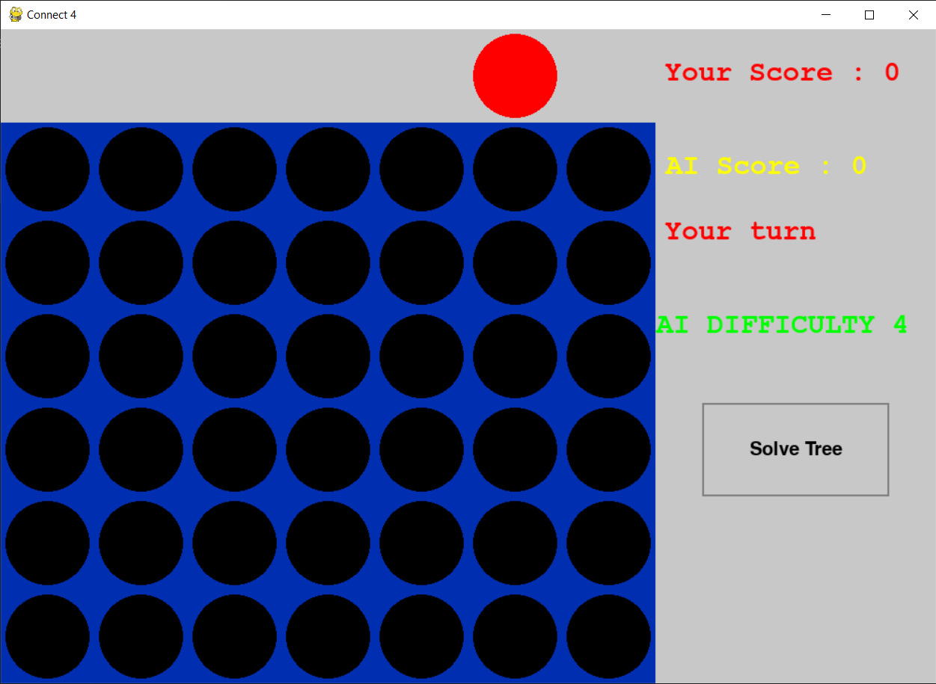

**From the game :  
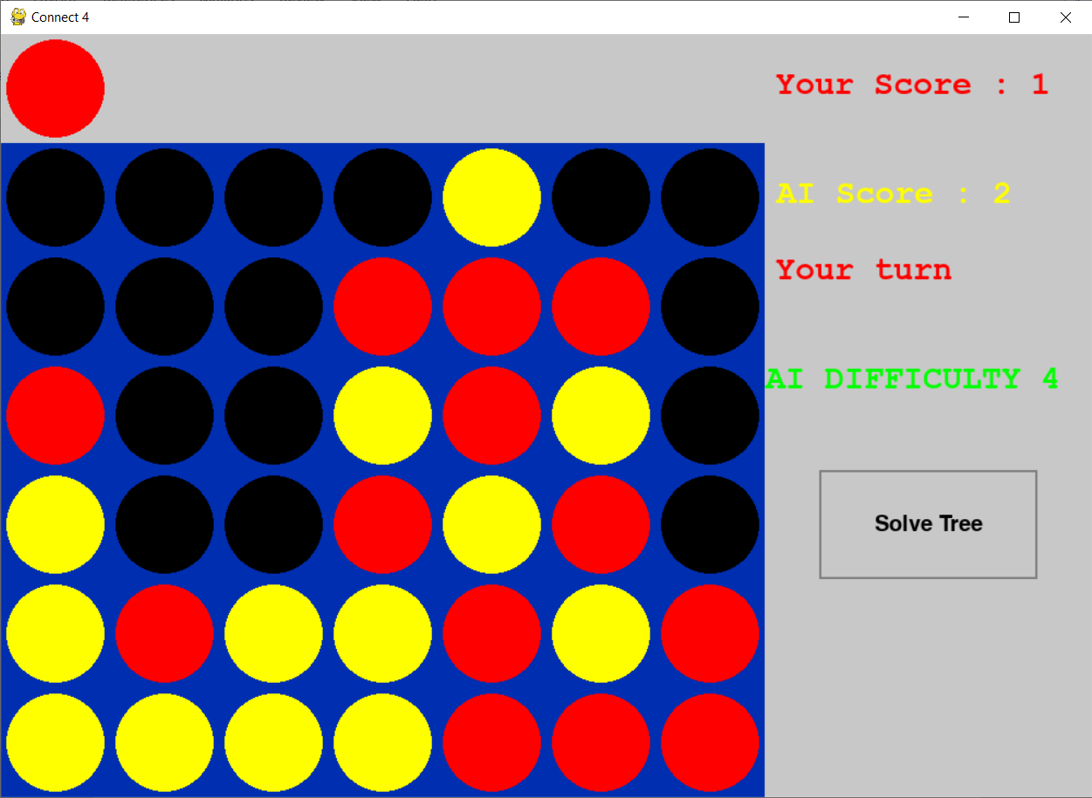**

**The tree:  
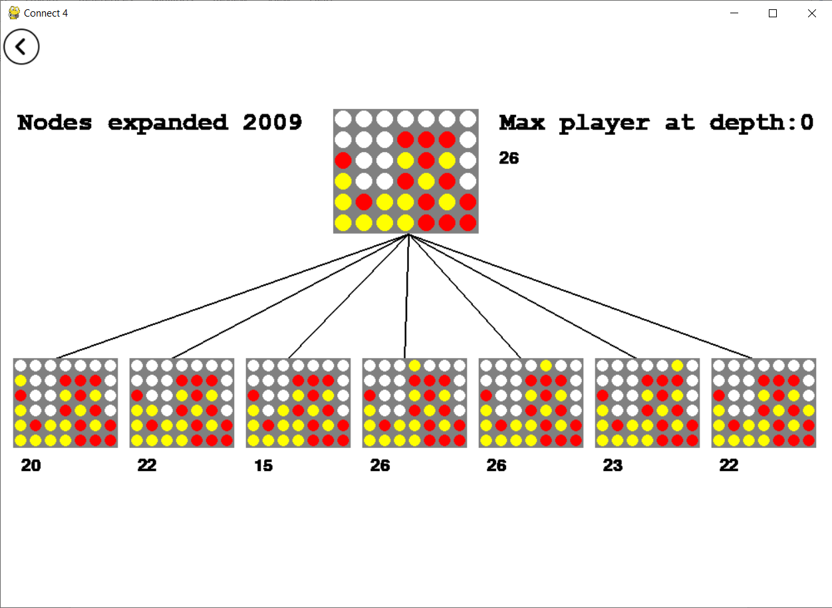  
end of the game :  
**

**Game minimax with pruning and difficulty 5:  
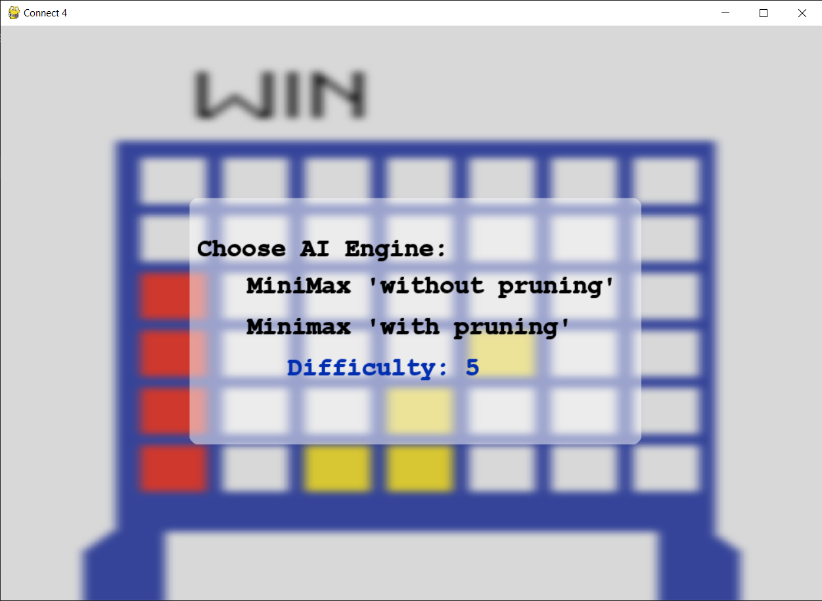  
start of the game :  
**

**From the game :  
**

**The tree :  
**

**End of the game :  
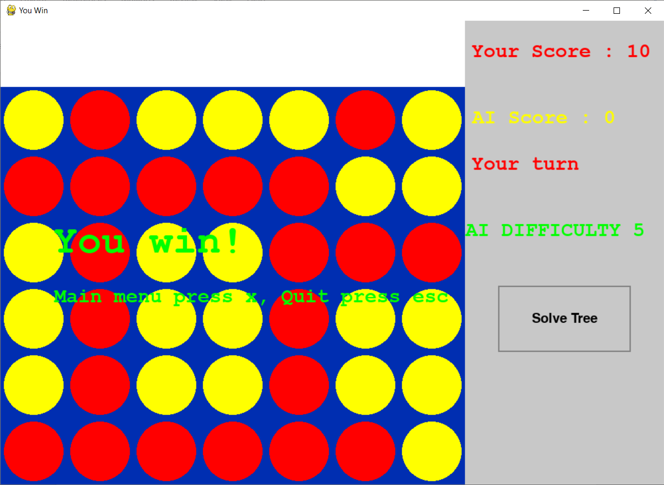**

1. **Minimax Algorithm**: This classic algorithm is used for decision-making in two-player games. It explores the game tree recursively, considering all possible future moves up to a certain depth. The agent aims to maximize its score while assuming that the opponent also plays optimally.
2. **Minimax Algorithm with Alpha-Beta Pruning**: This variant of the minimax algorithm enhances efficiency by pruning branches of the game tree that cannot possibly influence the final decision. Alpha-Beta pruning significantly reduces the number of nodes evaluated by the minimax algorithm.
3. **Expected Minimax Algorithm**: This algorithm extends the minimax approach by introducing probability distributions over possible moves. It calculates the expected value of each move considering the probabilities of different outcomes.

#### **Data Structures Used**

1. **Dictionary**: Dictionaries are extensively used to represent game states, game trees, and associated values. Each game state is mapped to a dictionary containing metadata and child states.
2. **Lists**: Lists are used to store valid locations for dropping pieces and for various computations within the algorithms.
3. **Numpy Arrays**: Numpy arrays are employed for efficient manipulation of game grids during score calculation.

**heuristic function:  
The heuristic function in the Connect Four AI evaluates game states to guide decision-making. It scores potential moves based on key factors:**

**Winning Conditions: Assigns a high score for configurations with four consecutive pieces, indicating an imminent victory.**

**Strong Winning Opportunities: Recognizes configurations with three pieces and one free slot as high-scoring moves.**

**Potential Winning Connections: Awards moderate scores for configurations with two pieces and two free slots nearby, suggesting potential winning connections.**

**Defensive Measures: Prioritizes blocking opponent's winning configurations by assigning high scores to defensive moves.**

**Counteracting Opponent's Moves: Penalizes configurations indicating the opponent's imminent victory to prioritize defensive actions.**

**Defense Against Two-In-A-Row Configurations: Penalizes configurations where the opponent has two consecutive pieces with two free slots nearby to prevent immediate defeat.**

**This heuristic function enables the AI to balance offensive and defensive strategies effectively, contributing to its competitive performance.**