Methodology
The project follows the Waterfall (System Development Life Cycle - SDLC) methodology. The project is divided into four sequential phases, and each phase must be completed and approved before the next one starts. This matches the time estimation of the project (15% / 20% / 35% / 30%).
Phase | Main activities | Deliverables
1. Planning | Project identification, system request, feasibility study, time estimation, task identification, PERT and Gantt charts | Project plan
2. Analysis | Interviews, questionnaire, DFDs, data dictionary, process specification, normalization, ERD, UML diagrams | Project proposal (requirements)
3. Design | Architecture design, data storage design, program design, interface design | Project specification
4. Implementation | Coding, testing, deployment, user training and maintenance | New system

Why Waterfall was chosen
- The requirements of a journal peer-review process are clear and stable (submit, assign, review, decide), so they can be defined completely at the beginning.
- The course and the deadline (1 January) require clear phases and documents (plan, proposal, specification) at the end of each phase.
- The team is small and works on a fixed schedule, so a simple and well-documented process is easier to manage.
Comparison with other methodologies
Methodology | Advantages | Disadvantages | Decision
Waterfall | Simple; clear phases and documents; easy to manage and track | Hard to change requirements after a phase is finished | Selected
Agile (Scrum) | Flexible; frequent delivery; fast feedback | Needs continuous user involvement; less documentation | Not selected
Prototyping | Users see the interface early; fewer misunderstandings | Can take more time; risk of unclear scope | Used only for the interface prototypes

Time Estimation
 | Planning | Analysis | Design | Implementation
Standard percentages | 15% | 20% | 35% | 30%
Estimated time based on planning time | Actual: 11 days | 15 days | 26 days | 22 days

Total project duration: 74 days (11 October 2026 - 23 December 2026), ready before the 1 January deadline.
Tasks Identification
Name of Task | System Request
Start Date | 11/10/2026
End Date | 14/10/2026
Person assigned to task | Member 1, Member 2
Priority | High
Resources Needed | Microsoft Word
Estimated Time | 6 hours
Actual Time | 5 hours

Name of Task | Feasibility Study
Start Date | 15/10/2026
End Date | 18/10/2026
Person assigned to task | Member 3
Priority | High
Resources Needed | Microsoft Word, Excel
Estimated Time | 8 hours
Actual Time | 7 hours

Name of Task | PERT Chart, Gantt Chart
Start Date | 19/10/2026
End Date | 21/10/2026
Person assigned to task | Member 4
Priority | High
Resources Needed | MS Project
Estimated Time | 9 hours
Actual Time | 8 hours

Name of Task | Interview
Start Date | 22/10/2026
End Date | 26/10/2026
Person assigned to task | Member 1, Member 2
Priority | Medium
Resources Needed | Microsoft Word
Estimated Time | 12 hours
Actual Time | 10 hours

Name of Task | Questionnaire
Start Date | 22/10/2026
End Date | 25/10/2026
Person assigned to task | Member 5
Priority | Medium
Resources Needed | Google Forms
Estimated Time | 5 hours
Actual Time | 4 hours

Name of Task | Data Flow Diagram
Start Date | 27/10/2026
End Date | 31/10/2026
Person assigned to task | Member 3, Member 4
Priority | High
Resources Needed | Draw.io / Internet
Estimated Time | 2 days
Actual Time | 14 hours

Name of Task | Data Store / Data Dictionary
Start Date | 1/11/2026
End Date | 3/11/2026
Person assigned to task | Member 3
Priority | High
Resources Needed | Microsoft Word
Estimated Time | 1 day
Actual Time | 8 hours

Name of Task | Process Specification
Start Date | 1/11/2026
End Date | 5/11/2026
Person assigned to task | Member 1
Priority | High
Resources Needed | Microsoft Word
Estimated Time | 2 days
Actual Time | 14 hours

Name of Task | Entity Relationship & Normalization
Start Date | 2/11/2026
End Date | 5/11/2026
Person assigned to task | Member 2
Priority | High
Resources Needed | StarUML, MySQL Workbench
Estimated Time | 2 days
Actual Time | 12 hours

Name of Task | UML (Use Case, Class, Sequence)
Start Date | 2/11/2026
End Date | 5/11/2026
Person assigned to task | Member 5
Priority | High
Resources Needed | StarUML
Estimated Time | 2 days
Actual Time | 13 hours

Name of Task | Architecture Design
Start Date | 6/11/2026
End Date | 11/11/2026
Person assigned to task | Member 4
Priority | High
Resources Needed | Microsoft Word
Estimated Time | 3 days
Actual Time | 2 days

Name of Task | Data Storage Design
Start Date | 12/11/2026
End Date | 16/11/2026
Person assigned to task | Member 2
Priority | High
Resources Needed | MySQL Workbench
Estimated Time | 3 days
Actual Time | 2 days

Name of Task | Program Design
Start Date | 17/11/2026
End Date | 22/11/2026
Person assigned to task | Member 3
Priority | High
Resources Needed | Draw.io
Estimated Time | 3 days
Actual Time | 2 days

Name of Task | Interface Design
Start Date | 23/11/2026
End Date | 1/12/2026
Person assigned to task | Member 4, Member 5
Priority | High
Resources Needed | Figma / Balsamiq
Estimated Time | 6 days
Actual Time | 5 days

Name of Task | Implementation (Coding)
Start Date | 2/12/2026
End Date | 15/12/2026
Person assigned to task | All members
Priority | High
Resources Needed | Visual Studio Code, MySQL
Estimated Time | 10 days
Actual Time | 9 days

Name of Task | Testing
Start Date | 16/12/2026
End Date | 20/12/2026
Person assigned to task | Member 1, Member 3
Priority | High
Resources Needed | Browser, Postman
Estimated Time | 4 days
Actual Time | 3 days

Name of Task | Deployment & Documentation
Start Date | 21/12/2026
End Date | 23/12/2026
Person assigned to task | Member 2, Member 5
Priority | Medium
Resources Needed | Web hosting
Estimated Time | 2 days
Actual Time | 2 days

Pert Chart (MS-Project)
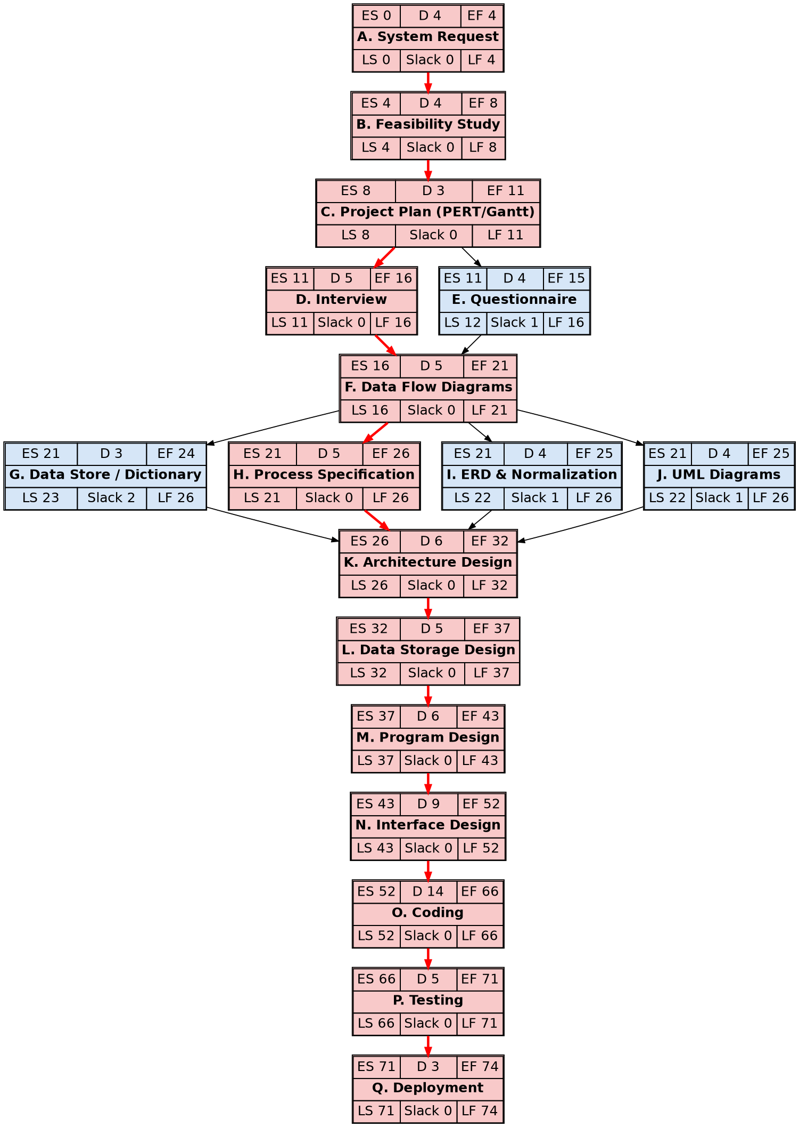
Critical path: A - B - C - D - F - H - K - L - M - N - O - P - Q (74 days). Red boxes are critical activities (slack = 0); blue boxes have slack (E = 1, G = 2, I = 1, J = 1).

Gantt chart (MS-Project)
