**::::::::::::::::::::::::::::::::::::::::::::::::::::::::::::::::::::::::::::::::::::::::::::::::::::::::::::::::::::::::TC_Amazon_Verify_Account_List_HyperLinks::::::::::::::::::::::::::::::::::::::::::::::::::::::::::::::::::::::::::::::::::::::::::::::::::::::::::::::::::::::::**

**--------------------------------------------------------------------------------------------Amazon Launched--------------------------------------------------------------------------------------------**

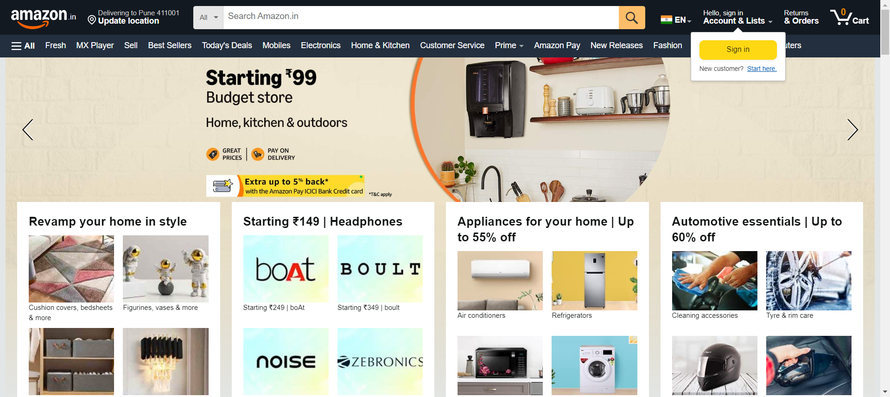

**--------------------------------------------------------------------------------------------Home_Store__Buy_Home_&_Kitchen_products_online_at_best_prices_in_India_-_Amazon_in--------------------------------------------------------------------------------------------**

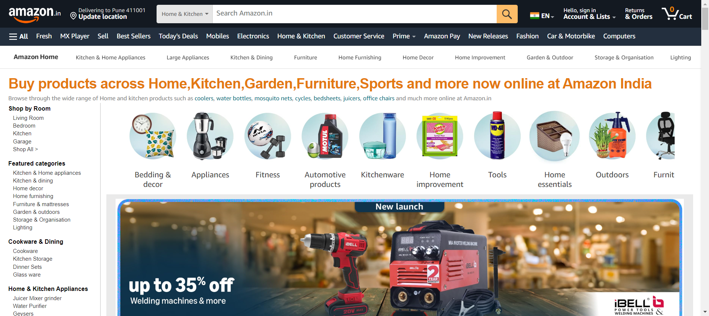

**--------------------------------------------------------------------------------------------Discover_your_style___Amazon_in--------------------------------------------------------------------------------------------**

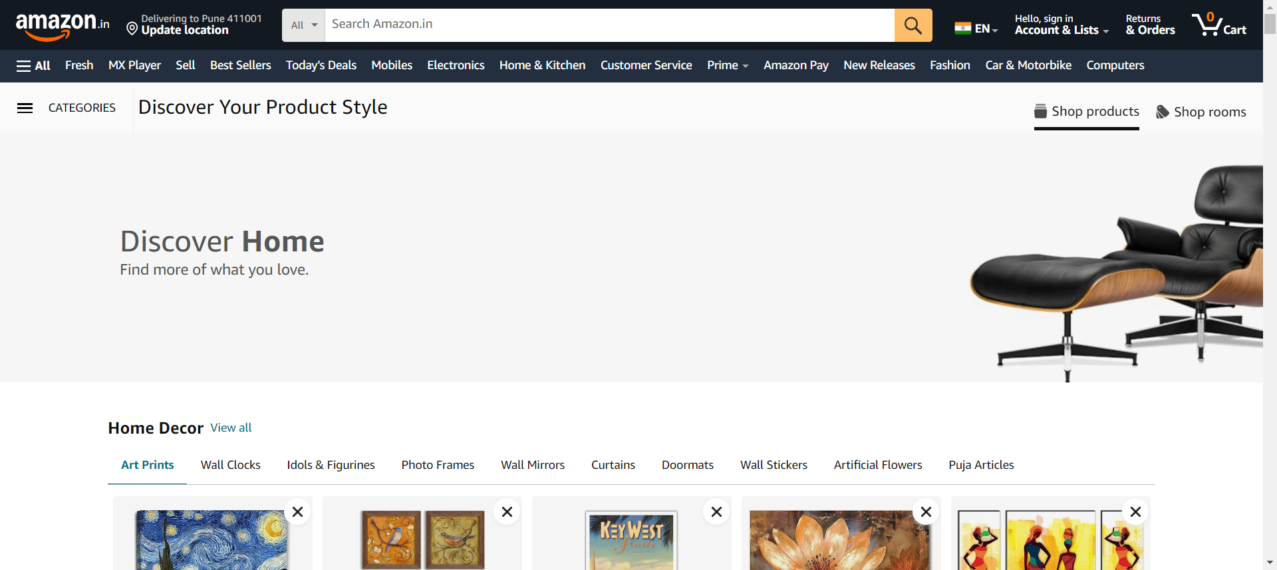

**----------------------------------------------------------------------------------------------------------------------------------------------------------------------------------------**

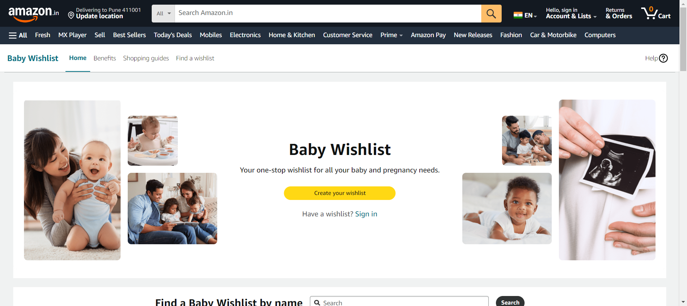

**--------------------------------------------------------------------------------------------Wish_List--------------------------------------------------------------------------------------------**

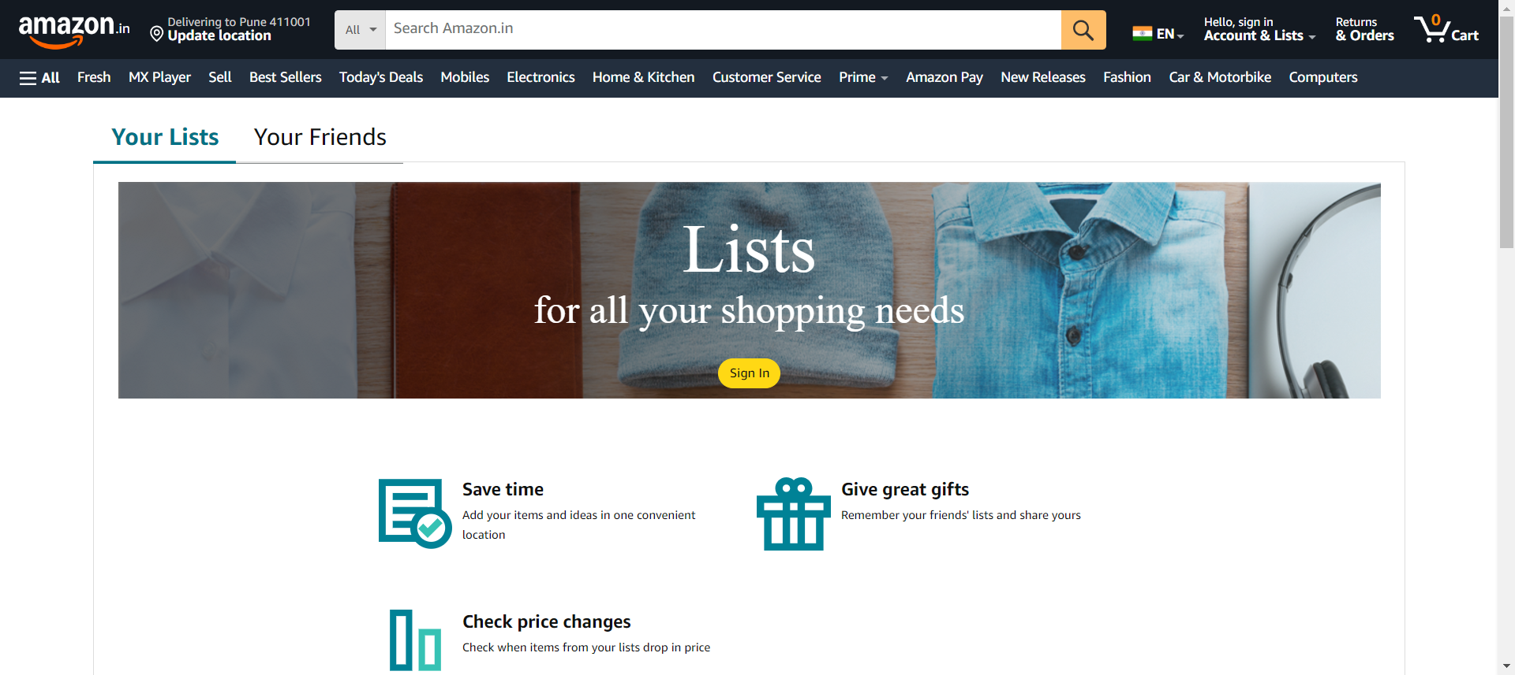

**--------------------------------------------------------------------------------------------Wish_List--------------------------------------------------------------------------------------------**

