Zhastay Yeltay

HBASE PRACTICE

***Note: The requirements for the practical task are just texts or scripts/codes are in bold, the other simple italic and yellowed text and screenshots are my answers.***

# CONTENTS

1. Notes regarding the practice ..................................................................................................................................................... 2
2. Connect to the the HBase environment ..................................................................................................................................... 2
3. General Details (10)................................................................................................................................................................... 3
4. Table and Data Creation (30) .................................................................................................................................................... 4
5. Qurey Data (60) ......................................................................................................................................................................... 5
6. Delete Table (10) ....................................................................................................................................................................... 6

* When you see the dollar sign in a command you need to execute, note this is just a command prompt indication. You do not need to actually write the “$”, as it is not part of the command. o For all practices below – write all the commands you have used in a “Practice answers document”.

|  |  |
| --- | --- |
| 1. | NOTES REGARDING THE PRACTICE |

When you are complete, you can submit this document for review.

|  |  |
| --- | --- |
| 2. | CONNECT TO THE THE HBASE ENVIRONMENT |

* Verify the “hbase” environment is up and running: **docker ps -a**
* Open a BASH session to the practice environment **docker exec -it hbase /bin/bash**

|  |  |
| --- | --- |
| 3. | GENERAL DETAILS (10) |

* View the HBase related scripts in the HBase “Bin” directory
  + Hint: The location of the base directory should be in “/opt”
  + You should see ~25 scripts

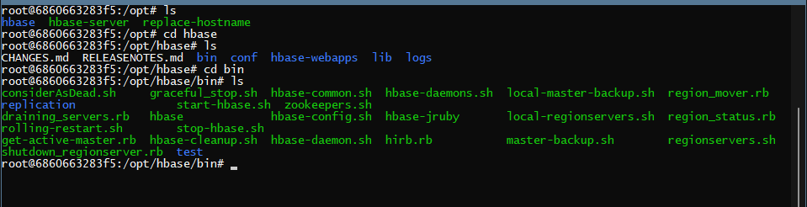

* Enter HBase Shell

* Get the HBase status in different levels
  + Retrieve base status, simple status, and detailed status

$status

$status ‘simple’

$status ‘detailed’

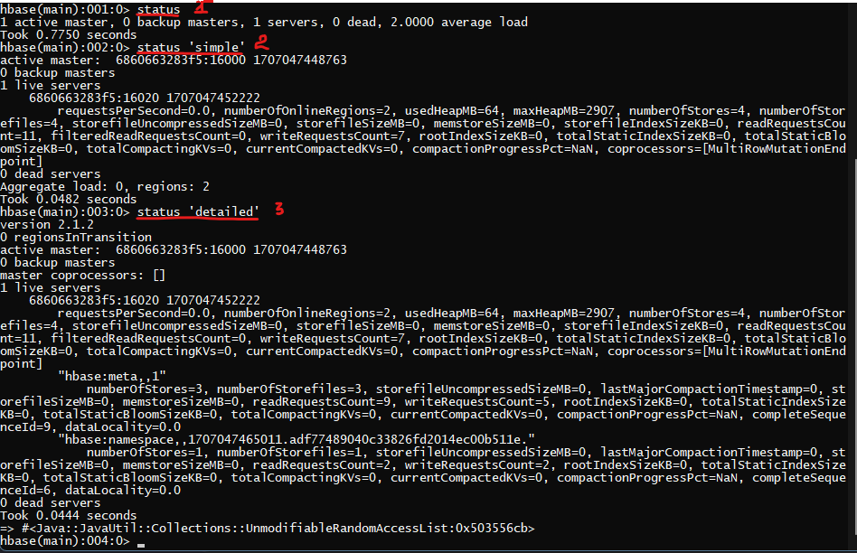

* List all filters

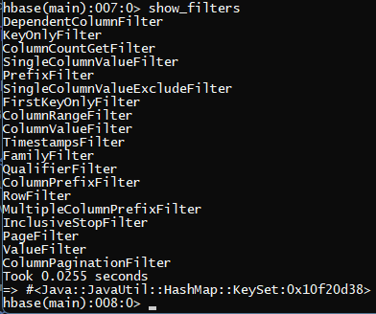

* List all tables

|  |  |
| --- | --- |
| 4. | TABLE AND DATA CREATION (30) |

* Create a table with the name: “employees” with the following column families
  + personal_data

• Store 2 versions for this column

* + professional_data

• Store 4 versions for this column

create 'employees', {NAME => 'personal_data', VERSIONS => 2}, {NAME => 'professional_data', VERSIONS => 4}



* List all tables

* Insert data for ten employees
  + The id of each employee must be a unique value
    - Insert employee’s id to be 1 - 10

▪ Fill the following data

* + - personal_data
    - first_name
    - surname
    - age

▪ professional_data

* + - role
    - expertise

put 'employees', '1', 'personal_data:first_name', 'Albert'

put 'employees', '1', 'personal_data:surname', 'Einstein'

put 'employees', '1', 'personal_data:age', '23'

put 'employees', '1', 'professional_data:role', 'Junior Developer'

put 'employees', '1', 'professional_data:expertise', 'Data Engineer'

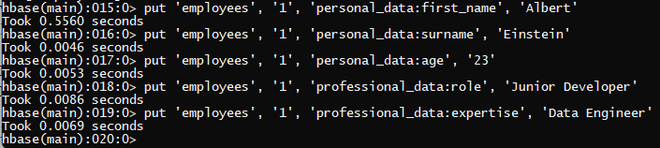

* Scan employee table to print all rows

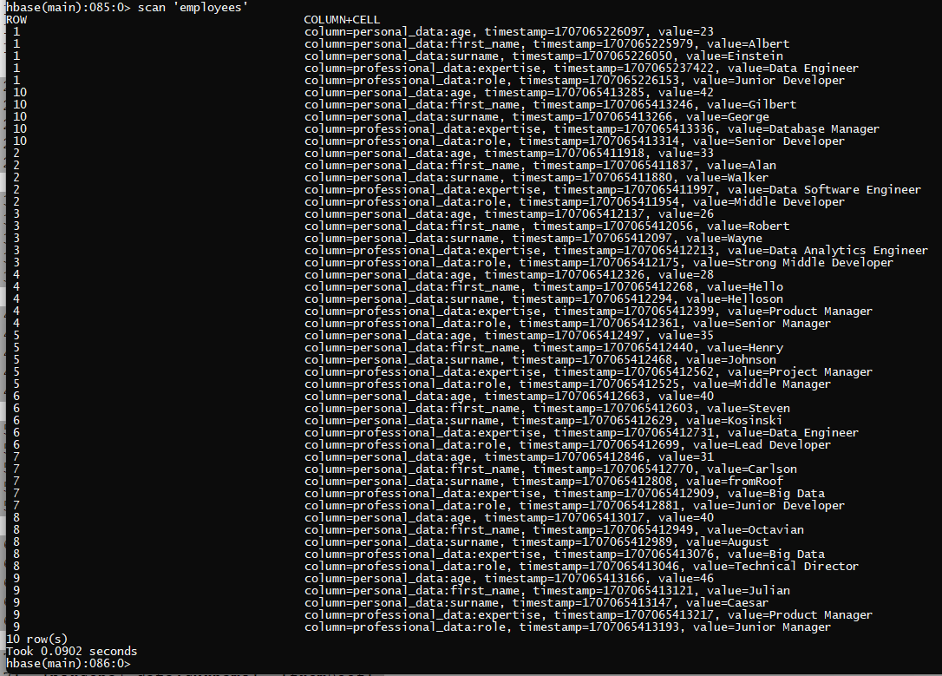

* Get all data of employee with id 7

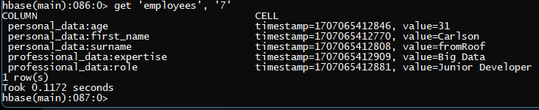

* Update age and role of employee number 3

put 'employees', '3', 'personal_data:age', '55'

put 'employees', '3', 'professional_data:role', 'Senior HR'

* Get all data of employee with id 3 and make sure updates applied

|  |  |
| --- | --- |
| 5. | QUREY DATA (60) |

* Query all record in employees table

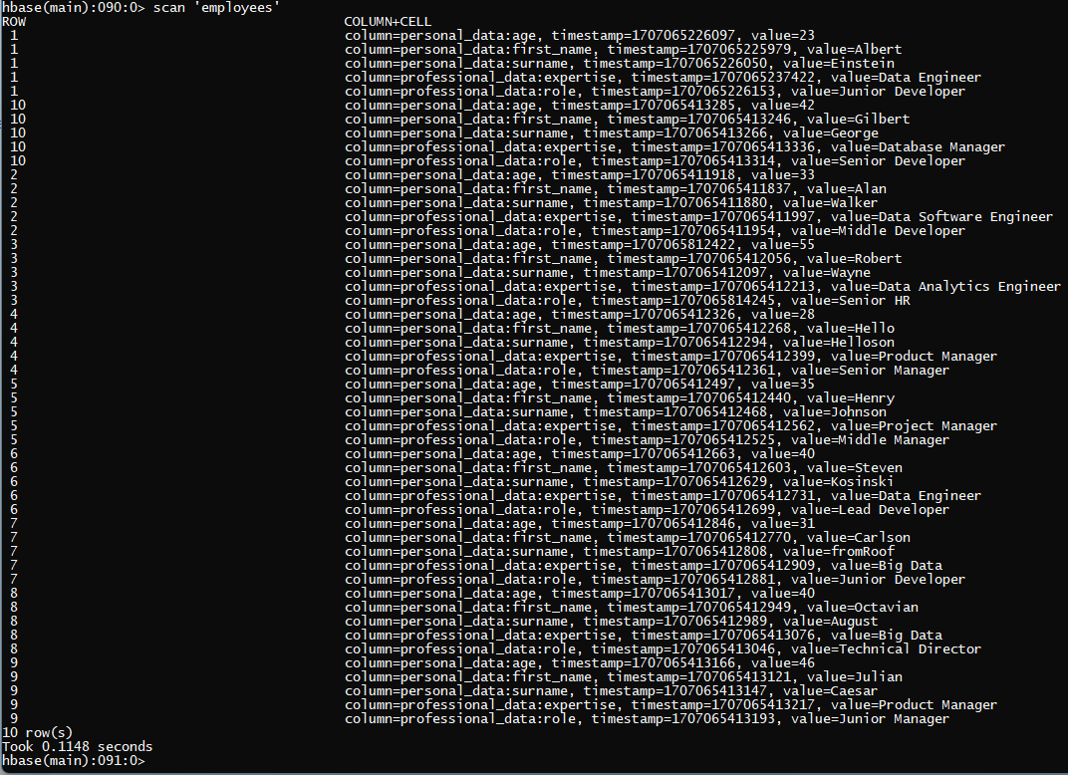

* Get all data of employee with id 3 and the 3 last versions of his column families: personal_data, professional_data

get 'employees', '3', {COLUMNS => ['personal_data', 'professional_data'], VERSIONS => 3}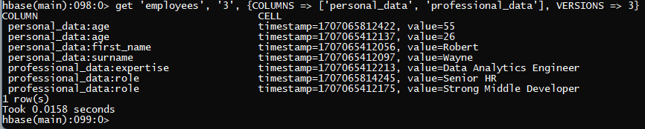

OR

scan 'employees', {FILTER => "RowFilter(=,'binary:3')", VERSIONS => 3}

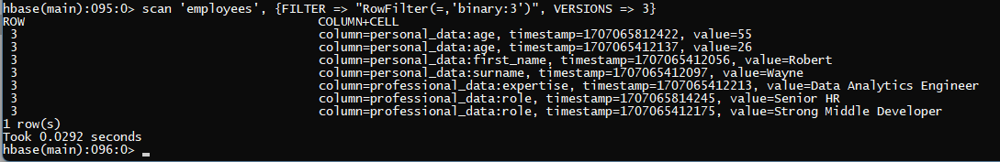

* Get all data of employees with age bigger or equals to 40

scan 'employees', { FILTER => "SingleColumnValueFilter('personal_data', 'age', >=, 'binary:40')" }

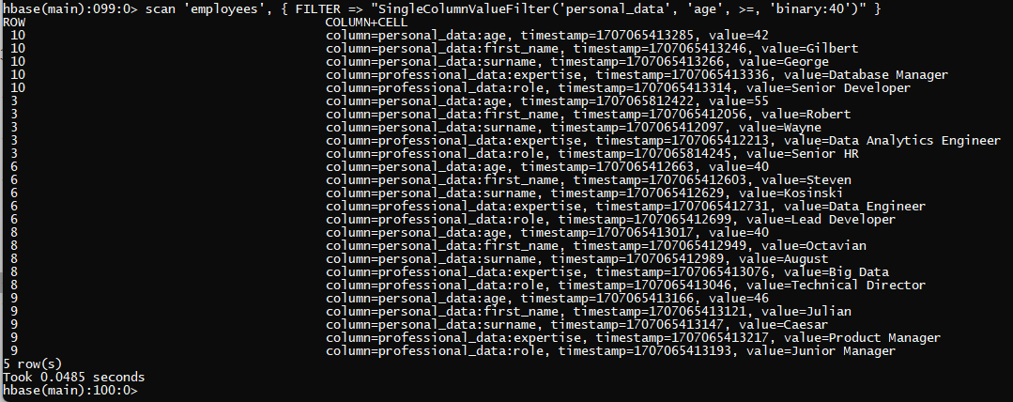

* Get only role value of all employees with age bigger than 35

scan 'employees', { FILTER => "SingleColumnValueFilter('personal_data', 'age', >, 'binary:35') AND MultipleColumnPrefixFilter('professional_data', 'role')" }

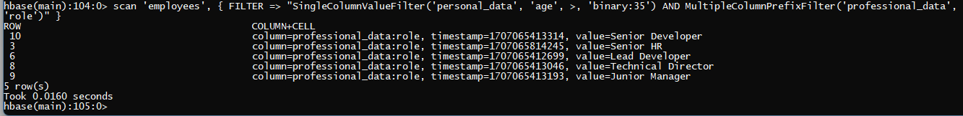

* Count the number of all employees

count 'employees'

* Count the number of employees with age less than 40

count 'employees', { FILTER => "SingleColumnValueFilter('personal_data', 'age', <, 'binary:40')" }



* Delete the newer age (that updated in topic 4) for employee with id 3

delete 'employees', '3', 'personal_data:age'



* Get the data of employee with id 3 and validate his age reverted to first value

get 'employees', '3', {COLUMN => 'personal_data:age', VERSIONS => 3}

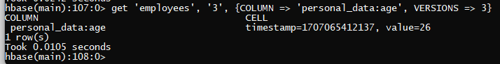

|  |  |
| --- | --- |
| 6. | DELETE TABLE (10) |

* Delete table employees

disable 'employees'

drop 'employees'

exists 'employees'

