***Zhastay Yeltay***

MONGODB PRACTICE

***Note: The requirements for the practical task are just texts or scripts/codes are in bold, the other simple italic and yellowed text and screenshots are my answers.***

# CONTENTS

1. Notes regarding the practice ..................................................................................................................................................... 2
2. Connect to the the MongoDB environment................................................................................................................................ 2
3. General Details and practice preparation (5) ............................................................................................................................ 3
4. Import products data into MongoDB (15) .................................................................................................................................. 3
5. Verify the loaded data in MongoDB (20) .................................................................................................................................... 3
6. CRUD operations in MongoDB collections (40) ......................................................................................................................... 4
7. Using indexes (5) ....................................................................................................................................................................... 5
8. Architecture and monitoring (15) ............................................................................................................................................... 5

|  |  |
| --- | --- |
| 1. | NOTES REGARDING THE PRACTICE |

* When you see the dollar sign in a command you need to execute, note this is just a command prompt indication. You do not need to actually write the “$”, as it is not part of the command. o For all practices below – write all the commands you have used in a “Practice answers document”.

When you are complete, you can submit this document for review.

|  |  |
| --- | --- |
| 2. | CONNECT TO THE THE MONGODB ENVIRONMENT |

* Verify the “MongoDB” environment is up and running: **docker ps -a**
* Open a BASH session to the practice environment **docker exec -it Mongo /bin/bash**

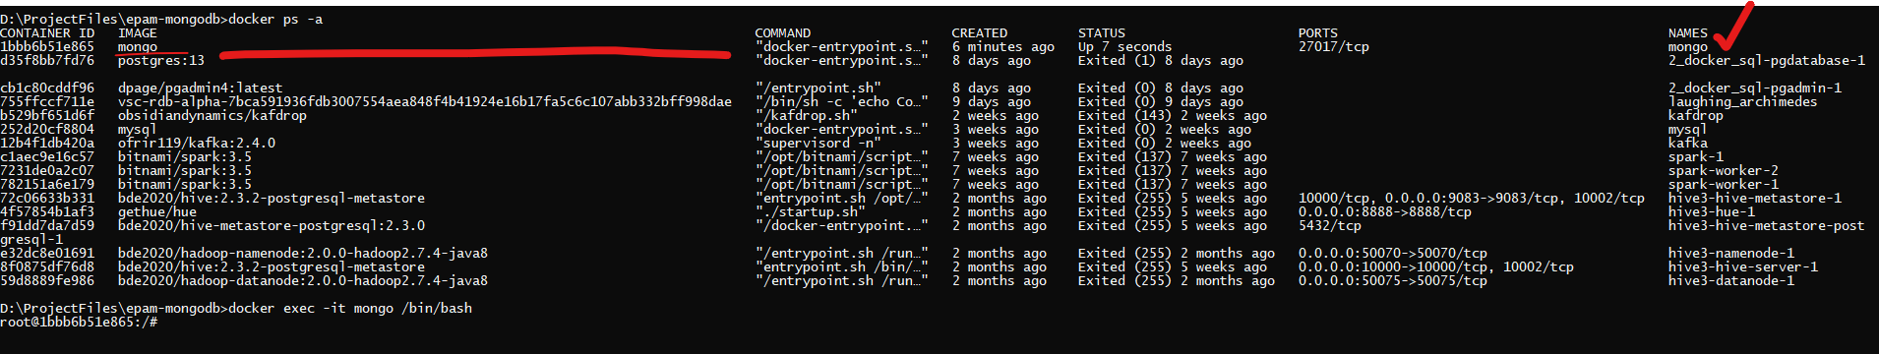

|  |  |
| --- | --- |
| 3. | GENERAL DETAILS AND PRACTICE PREPARATION (5) |

* Download the “[products.json”](https://drive.google.com/file/d/1sm-zko1LNJyZeD5Few2TcWXol-wUbpYc/view?usp=sharing) file to your computer (for example, to “c:\temp”) and copy it to “/data/products.json” in the Docker container.
  + See the Guidelines documents if you require assistance on this.

I downloaded the file and moved it into project directory. After that send it to docker mongodb location using cmd-bash.

1bbb6b51e865 – this is my mongodb’s id.

docker cp products.json 1bbb6b51e865:./data/products.json

|  |  |
| --- | --- |
| 4. | IMPORT PRODUCTS DATA INTO MONGODB (15) |

* Import the products information from the JSON file you have loaded into MongoDB.
  + Import into a collection named “products” and a database name “epam”
  + Specify the default MongoDB port in the relevant parameter
  + Specify an option so that the collection will be dropped if it exists before loading the new data
    - View the relevant command options using “--help" to find the relevant option ▪ See the Guidelines documents if you require assistance on this.

mongoimport --host localhost --port 27017 -d epam -c products ./data/products.json



|  |  |
| --- | --- |
| 5. | VERIFY THE LOADED DATA IN MONGODB (20) |

* Login to MongoDB
  + Do we have to specify the hostname and port number? Why?
  + What is the MongoDB version?

I used just mongosh command for new version of mongodb.

Also you can specify –host and –port or other parameters if it needs. In my case I can connect to mongodb just using mongosh command with default parameters localhost:27017.

root@1bbb6b51e865:/# ***mongosh***

Current Mongosh Log ID: 65b6ca82d95f5468ff57db1a

Connecting to: mongodb://127.0.0.1:27017/?directConnection=true&serverSelectionTimeoutMS=2000&appName=mongosh+2.1.1

Using MongoDB: 7.0.5

Using Mongosh: 2.1.1

For mongosh info see: https://docs.mongodb.com/mongodb-shell/

To help improve our products, anonymous usage data is collected and sent to MongoDB periodically (https://www.mongodb.com/legal/privacy-policy).

You can opt-out by running the disableTelemetry() command.

------

The server generated these startup warnings when booting

2024-01-28T21:14:49.312+00:00: Using the XFS filesystem is strongly recommended with the WiredTiger storage engine. See http://dochub.mongodb.org/core/prodnotes-filesystem

2024-01-28T21:14:50.208+00:00: Access control is not enabled for the database. Read and write access to data and configuration is unrestricted

2024-01-28T21:14:50.208+00:00: /sys/kernel/mm/transparent_hugepage/enabled is 'always'. We suggest setting it to 'never'

2024-01-28T21:14:50.208+00:00: vm.max_map_count is too low

------

test>



***Version is 7.0.5***

* Check – what options are available in MongoDB for the following:
  + Databases

Db.help()

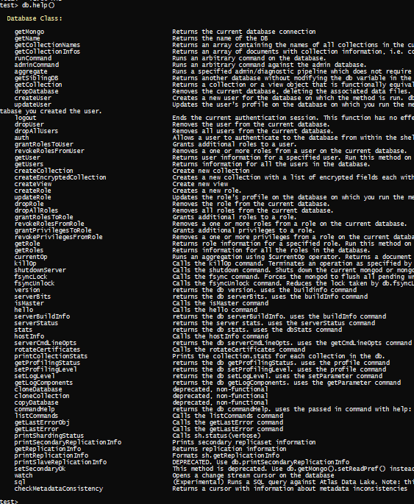

* + Collection

db.collection.help()

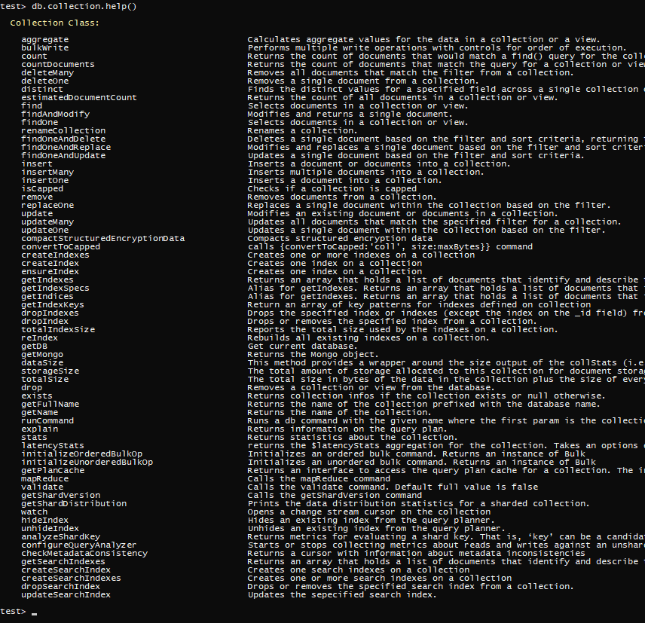

* + Find options in collections

db.collection.find().help()

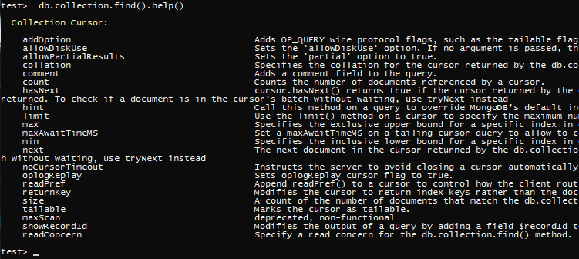

* + See the Guidelines documents if you require assistance on this.
* Check – Which databases currently exist in this MongoDB instance?

db.getName()



* Switch to use the database named “epam” o Check – Which collections currently exist in the database “epam”?

***use epam***



***db.getCollectionNames()***



* List all data in the collection “products” o Check – How many documents currently exist in this collection?

***db.products.find(), db.products.countDocuments()***

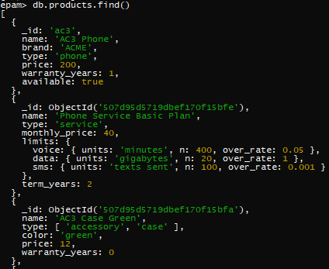



|  |  |
| --- | --- |
| 6. | CRUD OPERATIONS IN MONGODB COLLECTIONS (40) |

* Insert the following new document to the “products” collection with the following attributes:
  + Product id: “ac9”
  + Product name: “AC9 Phone”
  + Product brand: “ACME”
  + Product type: “phone”
  + Product price: 333
  + Product Warranty (in years): 0.25
  + Product availability: true

***db.products.insertOne({***

***_id: "ac9",***

***name: "AC9 Phone",***

***brand: "ACME",***

***type: "phone",***

***price: 333,***

***warranty_years: 0.25,***

***available: true***

***})***

* Perform queries to display products according to the following requirements:
  + Query 1:
    - Skip the first 2 products and display the next 10 products in the collection.
    - Make the output in an easy to read JSON format. (Each field and its value should appear in a separate row)

***db.products.find().skip(2).limit(10)***

***for (const myDoc of db.products.find().skip(2).limit(10) ) {***

***for (var key in myDoc) {***

***print(key + ": " + JSON.stringify(myDoc[key]));***

***}***

***print("\n");***

***}***

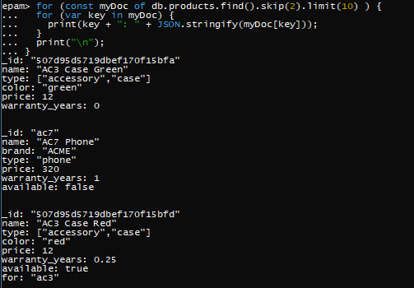

* + Query 2:
    - Display only the “name” and “brand” fields for each product.

***db.products.find({}, {"name": 1, "brand": 1, "_id": 0})***

* + Query 3:
    - Display only the “id” and “limits” fields for the first 10 products
    - Collect the results into a single array, in which each element is both “id” and “limits” of a specific product.
    - Examine the result you have received:

Did all “id” values had a matching “limits” value? Why so?

***db.products.find({}, {"_id": 1, "limits": 1}).limit(10)***

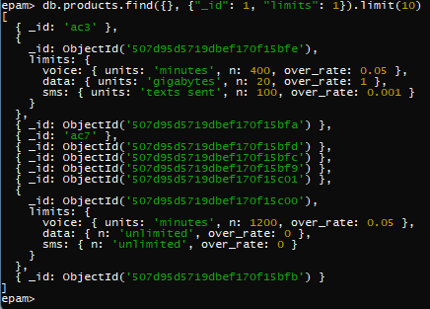

I will say that it shows if this key exists. In other cases as we can see it does not.

* + Query 4:
    - Display the IDs, names and prices of all products of which prices are greater or equal to 200.

***db.products.find({"price": {"$gte": 200}}, {"_id": 1, "name": 1, "price": 1})***

* + Query 5:
    - Display the IDs, names and prices of all products.
    - Sort the result according to price in descending order and name in ascending order (secondary sort)

***db.products.find({}, {"_id": 1, "name": 1, "price": 1}).sort({"price": -1, "name": 1})***

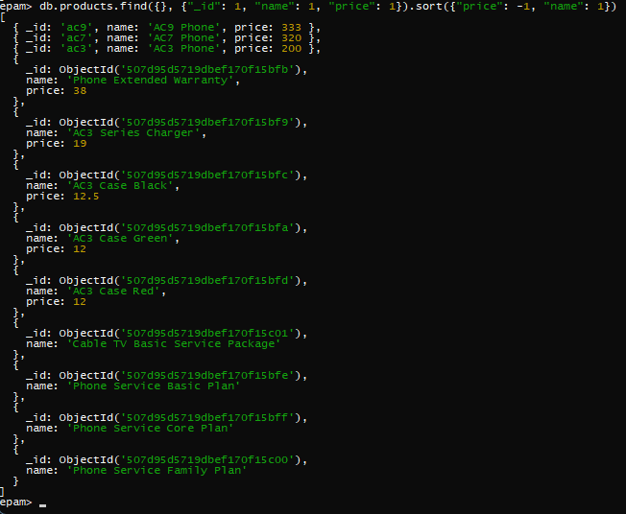

* + Query 6:
    - Write a query that displays how many products we have of type “service”. (Check the field which is named “type”)

***db.products.countDocuments({"type": "service"})***



* Updating records
  + General questions
    - Can we update the “_id” field? Why so?

***I tried to change as same value, it performed without errors and but no modifications. Also I tried to change it different value, it doesn’t work.***

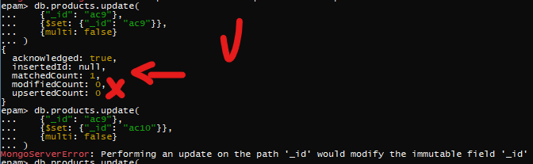

***No, you can not change _id value. You will get error like that:***

***MongoServerError: Performing an update on the path '_id' would modify the immutable field '_id'.***

* + - When should we use the “*set*” keyword? What happens if we omit it?

***It works like set in sql. The $set operator replaces the value of a field with the specified value. We change specific values using this keyword.***

***We can not do that. We will get this error:***

***MongoInvalidArgumentError: Update document requires atomic operators***

* + - When should use the “*multi*” keyword?

***It updates all data which are meet criteria. And it works as options.***

* + Please perform a query after each of the following updates to verify you have updates the documents as expected.
  + Update 1:
    - * Update product with ID “ac3”, so that he will now have only the following field values:
      * company: “EPAM”
      * item: “MongoDB”

***db.products.update(***

***{"_id": "ac3"},***

***{$set: {"company": "EPAM", "item": "MongoDB"}},***

***{multi: false}***

***)***

Update 2:

* + - * Update all products which have “ac3” somewhere in their name, and add a new field to their document – “subtype” with the value “AC3”.

Note that the “ac3” string in the name can be either lower or upper case.

***db.products.update(***

***{"name": /ac3/i},***

***{$set: {"subtype": "AC3"}},***

***{multi: true}***

***)***

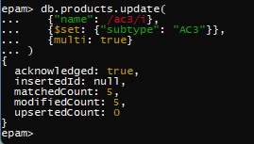

* Deleting records
  + Remove all records of type “service”.





|  |  |
| --- | --- |
| 7. | USING INDEXES (5) |

* Create an index for the “price” field

***db.products.createIndex({"price": 1})***



* Create a compound index for “type” and “subtype” fields

***db.products.createIndex({"type": 1, "subtype": 1 })***



* Create a text index for the “name” field.

***db.products.createIndex({"name": "text"})***

* + What is the benefit of a text index over a regular index?

***Text indexes have an advantage over a index because of its specialized support for full-text search features like relevance rating, word matches, and language-specific features.***

|  |  |
| --- | --- |
| 8. | ARCHITECTURE AND MONITORING (15) |

* Consult the guidelines document if required for assistance on the following requirements.
* Run a command which describes the current MongoDB node.

***db.isMaster() or db.hello()***

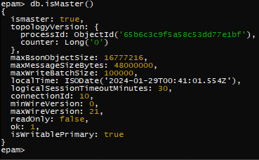

* + Change the command to display only the local time of the current instance.

***db.hello().localTime***



* Run a command which describes the current state of the database, with all its metrics and stats.

***db.serverStatus()***

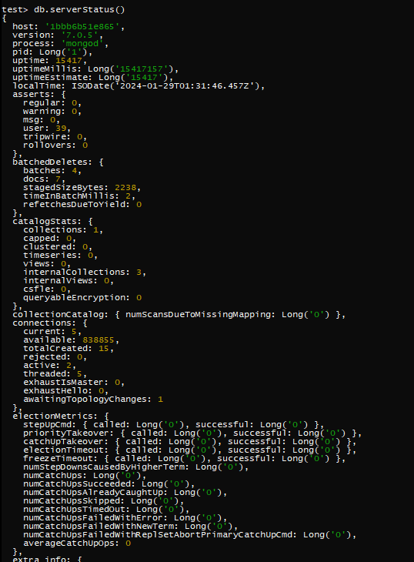

* Display information about all currently running operations in the database instance.

***db.currentOp()***

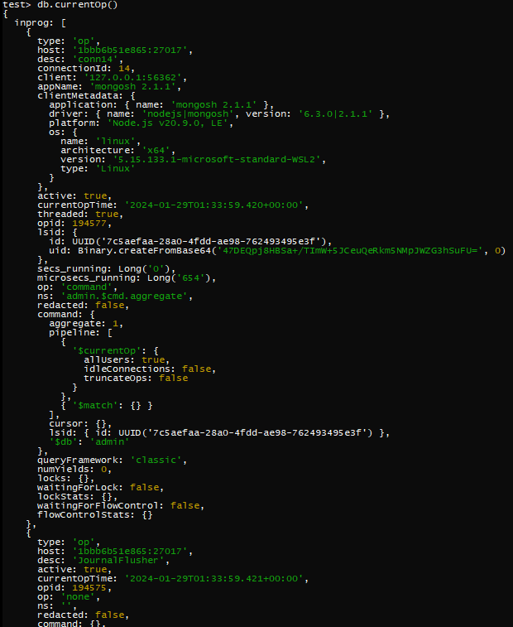

* Check – are replication sets currently enabled?

***rs.status()***

***No, replication sets are not.***

