**Statistics applied on three semesters of data**

1=worked examples

2=PS/WE/Randomly decided

3=FWE

4=ALL PS/WE/FWE

5=PS

7=PS/WE/Student decided

8=FWE/Student decided  
  
**First cleaned all the data: total time>0 and pre <1**

Total number of students in all three semesters = 545

Students in Fall2014: 179

After cleaning: 159

Students in Spring2015: 154

After cleaning: 154

Students in Fall2015: 212

After cleaning: 201

Total Time:

totalData<-subset(totalData,totalData$Total_time>0 & totalData$pre<1)

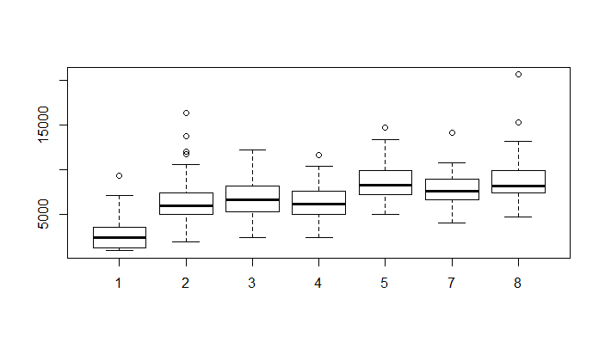

Cond Vs TotalTime (For all sems)

analysis<-lm(totalData$Total_time~as.factor(totalData$Cond))

> anova(analysis)

Analysis of Variance Table

Response: totalData$Total_time

Df Sum Sq Mean Sq F value Pr(>F)

as.factor(totalData$Cond) 6 797184882 132864147 30.178 < **2.2e-16** ***

Residuals 507 2232173834 4402710

---

Signif. codes: 0 ‘***’ 0.001 ‘**’ 0.01 ‘*’ 0.05 ‘.’ 0.1 ‘ ’ 1

**Fall 2014 data:**

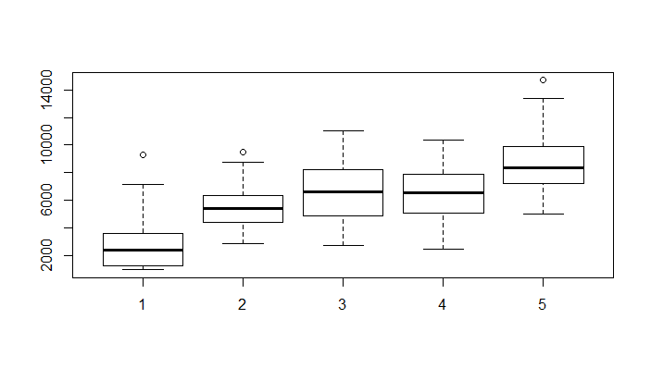

Cond vs TotalTime (Fall '14)

Time:

analysis<-lm(fall2014Data$Total_time~as.factor(fall2014Data$Cond))

> anova(analysis)

Analysis of Variance Table

Response: fall2014Data$Total_time

Df Sum Sq Mean Sq F value Pr(>F)

as.factor(fall2014Data$Cond) 4 464924331 116231083 28.254 < **2.2e-16** ***

Residuals 154 633516215 4113742

---

Signif. codes: 0 ‘***’ 0.001 ‘**’ 0.01 ‘*’ 0.05 ‘.’ 0.1 ‘ ’ 1

**T-test on condition 1 and 2:**

with(fall2014Data, t.test(Total_time[Cond==1],Total_time[Cond==2]))

Welch Two Sample t-test

data: Total_time[Cond == 1] and Total_time[Cond == 2]

t = -5.1191, df = 31.515, p-value = **1.462e-05**

alternative hypothesis: true difference in means is not equal to 0

95 percent confidence interval:

-3775.995 -1625.421

sample estimates:

mean of x mean of y

2798.476 5499.184

**T-test on condition 1 and 3:**

with(fall2014Data, t.test(Total_time[Cond==1],Total_time[Cond==3]))

Welch Two Sample t-test

data: Total_time[Cond == 1] and Total_time[Cond == 3]

t = -6.5604, df = 43.203, p-value = **5.477e-08**

alternative hypothesis: true difference in means is not equal to 0

95 percent confidence interval:

-5083.99 -2693.49

sample estimates:

mean of x mean of y

2798.476 6687.216

**Scores:**

**Pre and iso-post: (Pair-wise t-tests)**

> t.test(pre_10, iso_10, paired = T)

Paired t-test

data: pre_10 and iso_10

t = -9.2274, df = 158, p-value < **2.2e-16**

alternative hypothesis: true difference in means is not equal to 0

95 percent confidence interval:

-0.1647131 -0.1066328

sample estimates:

mean of the differences

-0.135673

**Pre and post:**

> t.test(pre, post,paired = T)

Paired t-test

data: pre and post

t = 0.41185, df = 158, p-value = **0.681**

alternative hypothesis: true difference in means is not equal to 0

95 percent confidence interval:

-0.01848236 0.02822091

sample estimates:

mean of the differences

0.004869272

**Repeated measures ANOVA:**

> score_anova(fall2014Data)

$`(Intercept)`

Terms:

<empty>

Sum of Squares 0

Deg. of Freedom 0

$userID

Terms:

Cond Residuals

Sum of Squares 0.322739 9.239408

Deg. of Freedom 4 154

Residual standard error: 0.2449411

4 out of 8 effects not estimable

Estimated effects may be unbalanced

$Within

Terms:

test Cond:test Residuals

Sum of Squares 1.4633685 0.0958876 2.6196019

Deg. of Freedom 1 4 154

Residual standard error: 0.1304239

Estimated effects may be unbalanced

$`Error: userID`

Df Sum Sq Mean Sq F value Pr(>F)

Cond 4 0.323 0.08068 1.345 0.256

Residuals 154 9.239 0.06000

$`Error: Within`

Df Sum Sq Mean Sq F value Pr(>F)

test 1 1.4634 1.463 86.028 <2e-16 ***

Cond:test 4 0.0959 0.024 1.409 0.233

Residuals 154 2.6196 0.017

---

Signif. codes: 0 ‘***’ 0.001 ‘**’ 0.01 ‘*’ 0.05 ‘.’ 0.1 ‘ ’ 1

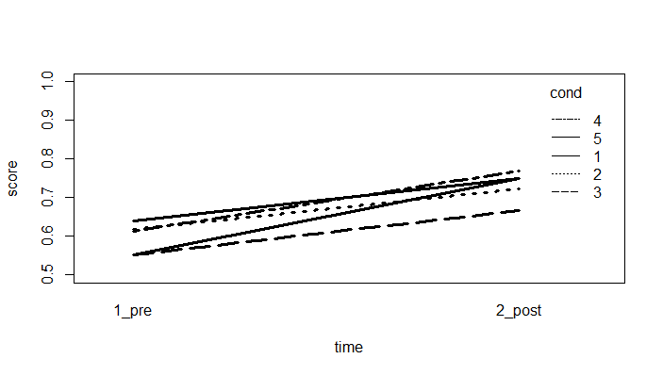

**Spring 2015:**

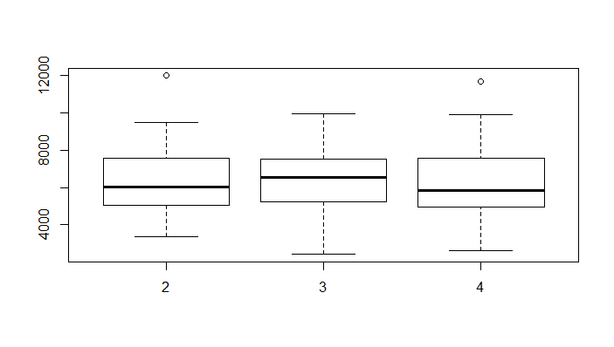

Cond vs TotalTime (Spr '15)

> analysis<-lm(spring2015Data$Total_time~as.factor(spring2015Data$Cond))

> anova(analysis)

Analysis of Variance Table

Response: spring2015Data$Total_time

Df Sum Sq Mean Sq F value Pr(>F)

as.factor(spring2015Data$Cond) 2 638010 319005 0.0999 **0.905**

Residuals 151 482141882 3192993

> t.test(pre_10, iso_10, paired = T)

Paired t-test

data: pre_10 and iso_10

t = -7.9215, df = 153, p-value = **4.489e-13**

alternative hypothesis: true difference in means is not equal to 0

95 percent confidence interval:

-0.16324095 -0.09807074

sample estimates:

mean of the differences

-0.1306558

t.test(pre, post,paired = T)

Paired t-test

data: pre and post

t = 0.69074, df = 153, p-value = **0.4908**

alternative hypothesis: true difference in means is not equal to 0

95 percent confidence interval:

-0.01624483 0.03371144

sample estimates:

mean of the differences

0.008733302

> score_anova(spring2015Data)

$`(Intercept)`

Terms:

<empty>

Sum of Squares 0

Deg. of Freedom 0

$userID

Terms:

Cond Residuals

Sum of Squares 0.649939 13.218766

Deg. of Freedom 2 151

Residual standard error: 0.2958741

2 out of 4 effects not estimable

Estimated effects may be unbalanced

$Within

Terms:

test Cond:test Residuals

Sum of Squares 1.314463 0.015220 3.189770

Deg. of Freedom 1 2 151

Residual standard error: 0.145342

Estimated effects may be unbalanced

$`Error: userID`

Df Sum Sq Mean Sq F value Pr(>F)

Cond 2 0.65 0.3250 3.712 0.0267 *

Residuals 151 13.22 0.0875

---

Signif. codes: 0 ‘***’ 0.001 ‘**’ 0.01 ‘*’ 0.05 ‘.’ 0.1 ‘ ’ 1

$`Error: Within`

Df Sum Sq Mean Sq F value Pr(>F)

test 1 1.314 1.3145 62.23 5.73e-13 ***

Cond:test 2 0.015 0.0076 0.36 0.698

Residuals 151 3.190 0.0211

---

Signif. codes: 0 ‘***’ 0.001 ‘**’ 0.01 ‘*’ 0.05 ‘.’ 0.1 ‘ ’ 1

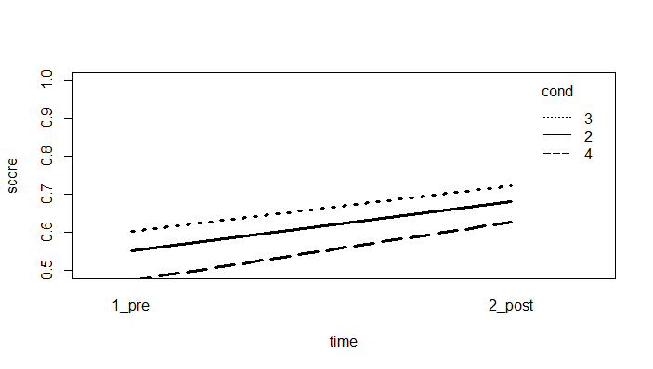

**Fall 2015:**

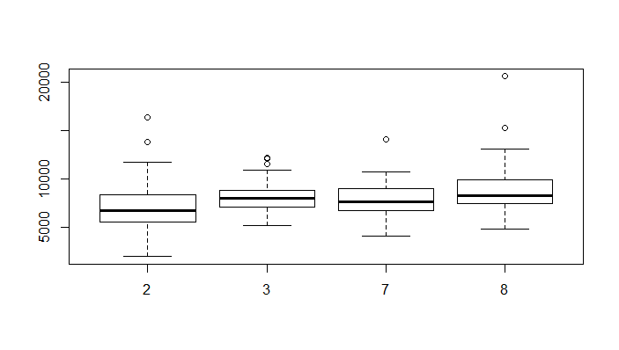

Cond vs TotalTime (Fall '15)

anova(analysis)

Analysis of Variance Table

Response: fall2015Data$Total_time

Df Sum Sq Mean Sq F value Pr(>F)

as.factor(fall2015Data$Cond) 3 69340505 23113502 4.6601 **0.003602** **

Residuals 197 977085884 4959827

---

Signif. codes: 0 ‘***’ 0.001 ‘**’ 0.01 ‘*’ 0.05 ‘.’ 0.1 ‘ ’ 1

> t.test(pre_10, iso_10, paired = T)

Paired t-test

data: pre_10 and iso_10

t = -12.581, df = 200, p-value < **2.2e-16**

alternative hypothesis: true difference in means is not equal to 0

95 percent confidence interval:

-0.1901590 -0.1386271

sample estimates:

mean of the differences

-0.164393

t.test(pre, post,paired = T)

Paired t-test

data: pre and post

t = -4.1569, df = 200, p-value = **4.781e-05**

alternative hypothesis: true difference in means is not equal to 0

95 percent confidence interval:

-0.06560385 -0.02338904

sample estimates:

mean of the differences

-0.04449645

> score_anova(fall2015Data)

$`(Intercept)`

Terms:

<empty>

Sum of Squares 0

Deg. of Freedom 0

$userID

Terms:

Cond Residuals

Sum of Squares 0.191736 8.345392

Deg. of Freedom 3 197

Residual standard error: 0.2058213

3 out of 6 effects not estimable

Estimated effects may be unbalanced

$Within

Terms:

test Cond:test Residuals

Sum of Squares 2.716020 0.152452 3.279342

Deg. of Freedom 1 3 197

Residual standard error: 0.1290209

Estimated effects may be unbalanced

$`Error: userID`

Df Sum Sq Mean Sq F value Pr(>F)

Cond 3 0.192 0.06391 1.509 0.214

Residuals 197 8.345 0.04236

$`Error: Within`

Df Sum Sq Mean Sq F value Pr(>F)

test 1 2.716 2.7160 163.160 <2e-16 ***

Cond:test 3 0.152 0.0508 3.053 0.0296 *

Residuals 197 3.279 0.0166

---

Signif. codes: 0 ‘***’ 0.001 ‘**’ 0.01 ‘*’ 0.05 ‘.’ 0.1 ‘ ’ 1

