|  |  |  |  |
| --- | --- | --- | --- |
| Django | 目安時間: The time usually taken : | 24 | 時間  hours |
| **Web Library System** | | | |
| **課題の目的 The aim of this assignment**  Learn with Django how to implement CRUD which is the fundamental function of Web application. | | | |
| **提出物 Required results**  Submit the following product:   1. Django project files | | | |
| **事前準備 Preparation**   1. Use PyCharm as develop environment. 2. Read coding convention  PEP 8 https://www.python.org/dev/peps/pep-0008/ | | | |

# How to proceed this assignment

Implement each functions according to the order of functions.xlsx.

Use python and Django for Implementation.

# Specifications of Web Library System

## Summary

### Book management

Web Library System manages “book data”. This “book data” has the following fields:

* id
* title
* author
* publisher
* summary
* release Date
* category

Web Library System will access to the DB which stores “book data”, and user can add, search, edit, delete, and change rental status through Web browser.

### User management

Web Library System manages also “User” information for authentication. (We will not use Django Group Management and so disable default Group Management in Django Admin)

### Other function

For other functions which should be implemented, refer “functions.xlsx”.

### Example

Web Library System will manage “book data” like the following example:

|  |  |  |  |  |  |  |  |
| --- | --- | --- | --- | --- | --- | --- | --- |
| **id** | **title** | **author** | **publisher** | **Summary** | **Release date** | **category** | |
|  | Python Programming for the Absolute Beginner | Michael Dawson | Cengage Learning Ptr; | The author teaches readers the basics of Python programming through simple game creation | 2010/01/12 | | Programming |
|  | Code Complete second edition | Steve McConnell | Microsoft Press | Widely considered one of the best practical guides to programming | 2004/06/19 | | Programming |
|  | Harry Potter and the Philosopher's Stone | J. K. Rowling | Bloomsbury Children’s Books | One of the great famous novel for children, and read all over the world. | 1999/09/01 | | Novel |

## System Image

Here is the system image of Web Library System.

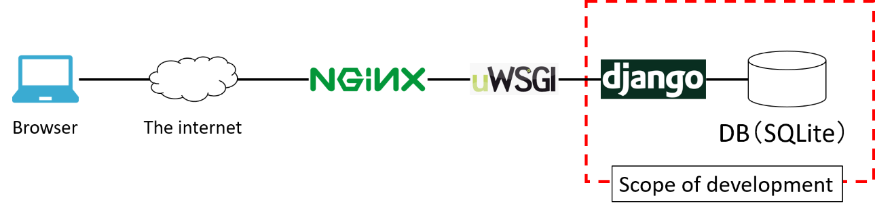

## Screens

Here is the screen list of Web Library System.

| **No.** | **Screen** | **Admin** | **User** | **Description** |
| --- | --- | --- | --- | --- |
|  | Login | ○ | ○ | After authentication succeed, Home screen will be shown. |
|  | Home | ○ | ○ | Show dashboard. |
|  | User List | ○ | × | Screen to show and search user. |
|  | Add User |  | × | Screen to add user newly. |
|  | Edit／Delete User | ○ | × | Screen to edit or delete the selected group, but, authentication information (id, password) and group cannot be changed. |
|  | Book List | ○ | ○ | Screen to show and search book, but, user can see only books of his/her group. |
|  | Add Book | ○ | ○ | Screen to add book newly. |
|  | Edit／Delete Book | ○ | ○ | Screen to edit or delete the selected book, but the book with status “on loan” cannot be edited or deleted.  And for editing, each field except id can be edited. |
|  | Borrow Book | ○ | ○ | Screen to change the status of book to “on loan” and add borrower. |
|  | Return Book |  |  | Change the status of book to “available” |

* The column “Admin”, “User” represents that each screen can be seen by Administrator or User.

* Refer “Screen_Image.pptx” for screen layout.

## Screen Transitions

The diagram below shows screen transitions.

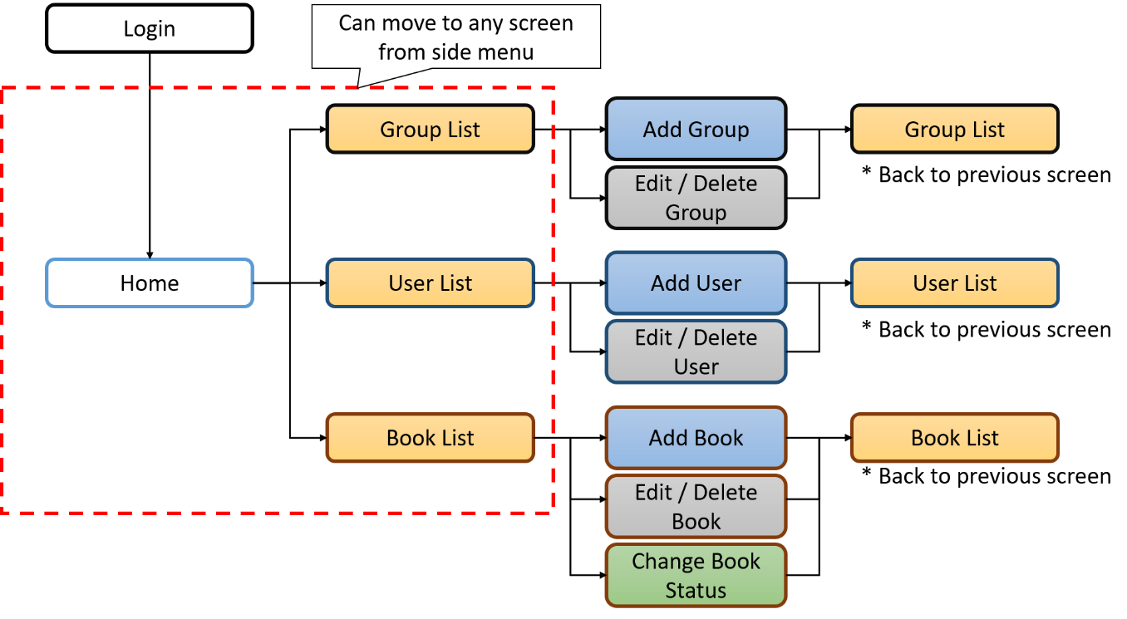

## Implementation rule

To implement this system, follow these points.

1. Implement each screens based on the screen images of “ScreenImage.pptx”. But, you can arrange look & feel of each screen, for example, the position, shape, or color of each element.
2. Use django-admin-bootstrap as a design template of admin screen.　(eg. Urls that start with <http://localhost:8000/admin>[/](http://localhost:8000/admin/) )  
   https://github.com/douglasmiranda/django-admin-bootstrap
3. Implement validation of input value by using Django standard function in server side.

**End of assignment**