1,UnixBench

========================================================================
BYTE UNIX Benchmarks (Version 5.1.3)

System: localhost.example: GNU/Linux
OS: GNU/Linux -- 2.6.32-431.el6.x86_64 -- #1 SMP Fri Nov 22 03:15:09 UTC 2013
Machine: x86_64 (x86_64)
Language: en_US.utf8 (charmap="UTF-8", collate="UTF-8")
CPU 0: Intel(R) Xeon(R) CPU E5-2690 v3 @ 2.60GHz (5200.0 bogomips)
x86-64, MMX, Physical Address Ext, SYSENTER/SYSEXIT, SYSCALL/SYSRET
CPU 1: Intel(R) Xeon(R) CPU E5-2690 v3 @ 2.60GHz (5200.0 bogomips)
x86-64, MMX, Physical Address Ext, SYSENTER/SYSEXIT, SYSCALL/SYSRET
CPU 2: Intel(R) Xeon(R) CPU E5-2690 v3 @ 2.60GHz (5200.0 bogomips)
x86-64, MMX, Physical Address Ext, SYSENTER/SYSEXIT, SYSCALL/SYSRET
CPU 3: Intel(R) Xeon(R) CPU E5-2690 v3 @ 2.60GHz (5200.0 bogomips)
x86-64, MMX, Physical Address Ext, SYSENTER/SYSEXIT, SYSCALL/SYSRET
CPU 4: Intel(R) Xeon(R) CPU E5-2690 v3 @ 2.60GHz (5200.0 bogomips)
x86-64, MMX, Physical Address Ext, SYSENTER/SYSEXIT, SYSCALL/SYSRET
CPU 5: Intel(R) Xeon(R) CPU E5-2690 v3 @ 2.60GHz (5200.0 bogomips)
x86-64, MMX, Physical Address Ext, SYSENTER/SYSEXIT, SYSCALL/SYSRET
CPU 6: Intel(R) Xeon(R) CPU E5-2690 v3 @ 2.60GHz (5200.0 bogomips)
x86-64, MMX, Physical Address Ext, SYSENTER/SYSEXIT, SYSCALL/SYSRET
CPU 7: Intel(R) Xeon(R) CPU E5-2690 v3 @ 2.60GHz (5200.0 bogomips)
x86-64, MMX, Physical Address Ext, SYSENTER/SYSEXIT, SYSCALL/SYSRET
15:00:53 up 3 min, 1 user, load average: 0.02, 0.04, 0.01; runlevel 3

------------------------------------------------------------------------
Benchmark Run: Tue Feb 28 2017 15:00:53 - 15:28:57
8 CPUs in system; running 1 parallel copy of tests

Dhrystone 2 using register variables 36272535.6 lps (10.0 s, 7 samples)
Double-Precision Whetstone 3886.2 MWIPS (9.9 s, 7 samples)
Execl Throughput 2261.4 lps (30.0 s, 2 samples)
File Copy 1024 bufsize 2000 maxblocks 1100992.1 KBps (30.0 s, 2 samples)
File Copy 256 bufsize 500 maxblocks 304771.6 KBps (30.0 s, 2 samples)
File Copy 4096 bufsize 8000 maxblocks 3124352.2 KBps (30.0 s, 2 samples)
Pipe Throughput 2121021.6 lps (10.0 s, 7 samples)
Pipe-based Context Switching 239292.4 lps (10.0 s, 7 samples)
Process Creation 11756.8 lps (30.0 s, 2 samples)
Shell Scripts (1 concurrent) 6547.9 lpm (60.0 s, 2 samples)
Shell Scripts (8 concurrent) 3562.2 lpm (60.0 s, 2 samples)
System Call Overhead 4264013.6 lps (10.0 s, 7 samples)

System Benchmarks Index Values BASELINE RESULT INDEX
Dhrystone 2 using register variables 116700.0 36272535.6 3108.2
Double-Precision Whetstone 55.0 3886.2 706.6
Execl Throughput 43.0 2261.4 525.9
File Copy 1024 bufsize 2000 maxblocks 3960.0 1100992.1 2780.3
File Copy 256 bufsize 500 maxblocks 1655.0 304771.6 1841.5
File Copy 4096 bufsize 8000 maxblocks 5800.0 3124352.2 5386.8
Pipe Throughput 12440.0 2121021.6 1705.0
Pipe-based Context Switching 4000.0 239292.4 598.2
Process Creation 126.0 11756.8 933.1
Shell Scripts (1 concurrent) 42.4 6547.9 1544.3
Shell Scripts (8 concurrent) 6.0 3562.2 5937.0
System Call Overhead 15000.0 4264013.6 2842.7
========
System Benchmarks Index Score 1743.7

------------------------------------------------------------------------
Benchmark Run: Tue Feb 28 2017 15:28:57 - 15:57:09
8 CPUs in system; running 8 parallel copies of tests

Dhrystone 2 using register variables 289405386.8 lps (10.0 s, 7 samples)
Double-Precision Whetstone 31038.8 MWIPS (9.9 s, 7 samples)
Execl Throughput 20430.6 lps (30.0 s, 2 samples)
File Copy 1024 bufsize 2000 maxblocks 891337.7 KBps (30.0 s, 2 samples)
File Copy 256 bufsize 500 maxblocks 232063.5 KBps (30.0 s, 2 samples)
File Copy 4096 bufsize 8000 maxblocks 2948140.9 KBps (30.0 s, 2 samples)
Pipe Throughput 16856680.3 lps (10.0 s, 7 samples)
Pipe-based Context Switching 1880429.7 lps (10.0 s, 7 samples)
Process Creation 106498.8 lps (30.0 s, 2 samples)
Shell Scripts (1 concurrent) 39599.2 lpm (60.0 s, 2 samples)
Shell Scripts (8 concurrent) 5382.3 lpm (60.0 s, 2 samples)
System Call Overhead 8233888.0 lps (10.0 s, 7 samples)

System Benchmarks Index Values BASELINE RESULT INDEX
Dhrystone 2 using register variables 116700.0 289405386.8 24799.1
Double-Precision Whetstone 55.0 31038.8 5643.4
Execl Throughput 43.0 20430.6 4751.3
File Copy 1024 bufsize 2000 maxblocks 3960.0 891337.7 2250.9
File Copy 256 bufsize 500 maxblocks 1655.0 232063.5 1402.2
File Copy 4096 bufsize 8000 maxblocks 5800.0 2948140.9 5083.0
Pipe Throughput 12440.0 16856680.3 13550.4
Pipe-based Context Switching 4000.0 1880429.7 4701.1
Process Creation 126.0 106498.8 8452.3
Shell Scripts (1 concurrent) 42.4 39599.2 9339.4
Shell Scripts (8 concurrent) 6.0 5382.3 8970.6
System Call Overhead 15000.0 8233888.0 5489.3
========
System Benchmarks Index Score 6097.5

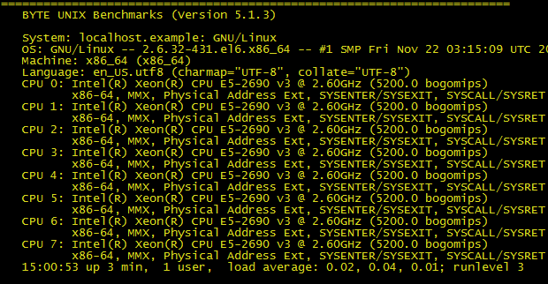
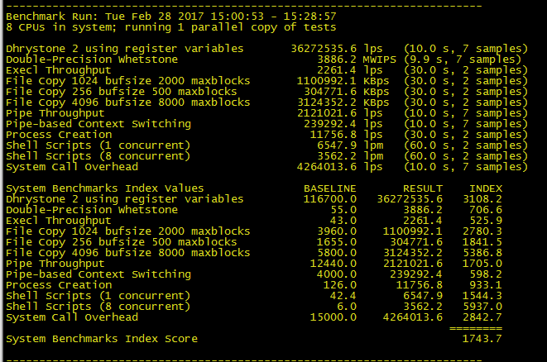
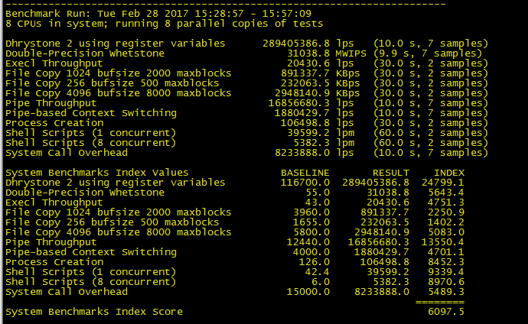
2,圆周率
real 0m19.448s
user 0m19.437s
sys 0m0.001s
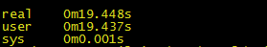

3，内存性能
[root@localhost mbw]# mbw 4
Long uses 8 bytes. Allocating 2*524288 elements = 8388608 bytes of memory.
Using 262144 bytes as blocks for memcpy block copy test.
Getting down to business... Doing 10 runs per test.
0 Method: MEMCPY Elapsed: 0.00115 MiB: 4.00000 Copy: 3469.211 MiB/s
1 Method: MEMCPY Elapsed: 0.00118 MiB: 4.00000 Copy: 3401.361 MiB/s
2 Method: MEMCPY Elapsed: 0.00116 MiB: 4.00000 Copy: 3439.381 MiB/s
3 Method: MEMCPY Elapsed: 0.00116 MiB: 4.00000 Copy: 3454.231 MiB/s
4 Method: MEMCPY Elapsed: 0.00115 MiB: 4.00000 Copy: 3487.358 MiB/s
5 Method: MEMCPY Elapsed: 0.00116 MiB: 4.00000 Copy: 3460.208 MiB/s
6 Method: MEMCPY Elapsed: 0.00114 MiB: 4.00000 Copy: 3496.503 MiB/s
7 Method: MEMCPY Elapsed: 0.00115 MiB: 4.00000 Copy: 3466.205 MiB/s
8 Method: MEMCPY Elapsed: 0.00114 MiB: 4.00000 Copy: 3518.030 MiB/s
9 Method: MEMCPY Elapsed: 0.00114 MiB: 4.00000 Copy: 3514.938 MiB/s
AVG Method: MEMCPY Elapsed: 0.00115 MiB: 4.00000 Copy: 3470.415 MiB/s
0 Method: DUMB Elapsed: 0.00034 MiB: 4.00000 Copy: 11904.762 MiB/s
1 Method: DUMB Elapsed: 0.00031 MiB: 4.00000 Copy: 12820.513 MiB/s
2 Method: DUMB Elapsed: 0.00031 MiB: 4.00000 Copy: 12779.553 MiB/s
3 Method: DUMB Elapsed: 0.00033 MiB: 4.00000 Copy: 12012.012 MiB/s
4 Method: DUMB Elapsed: 0.00031 MiB: 4.00000 Copy: 12820.513 MiB/s
5 Method: DUMB Elapsed: 0.00031 MiB: 4.00000 Copy: 12820.513 MiB/s
6 Method: DUMB Elapsed: 0.00033 MiB: 4.00000 Copy: 11976.048 MiB/s
7 Method: DUMB Elapsed: 0.00031 MiB: 4.00000 Copy: 12820.513 MiB/s
8 Method: DUMB Elapsed: 0.00032 MiB: 4.00000 Copy: 12658.228 MiB/s
9 Method: DUMB Elapsed: 0.00031 MiB: 4.00000 Copy: 12820.513 MiB/s
AVG Method: DUMB Elapsed: 0.00032 MiB: 4.00000 Copy: 12531.328 MiB/s
0 Method: MCBLOCK Elapsed: 0.00034 MiB: 4.00000 Copy: 11904.762 MiB/s
1 Method: MCBLOCK Elapsed: 0.00031 MiB: 4.00000 Copy: 12738.854 MiB/s
2 Method: MCBLOCK Elapsed: 0.00031 MiB: 4.00000 Copy: 12738.854 MiB/s
3 Method: MCBLOCK Elapsed: 0.00033 MiB: 4.00000 Copy: 11976.048 MiB/s
4 Method: MCBLOCK Elapsed: 0.00031 MiB: 4.00000 Copy: 12738.854 MiB/s
5 Method: MCBLOCK Elapsed: 0.00031 MiB: 4.00000 Copy: 12820.513 MiB/s
6 Method: MCBLOCK Elapsed: 0.00033 MiB: 4.00000 Copy: 12048.193 MiB/s
7 Method: MCBLOCK Elapsed: 0.00032 MiB: 4.00000 Copy: 12698.413 MiB/s
8 Method: MCBLOCK Elapsed: 0.00031 MiB: 4.00000 Copy: 12861.736 MiB/s
9 Method: MCBLOCK Elapsed: 0.00033 MiB: 4.00000 Copy: 12012.012 MiB/s
AVG Method: MCBLOCK Elapsed: 0.00032 MiB: 4.00000 Copy: 12441.680 MiB/s
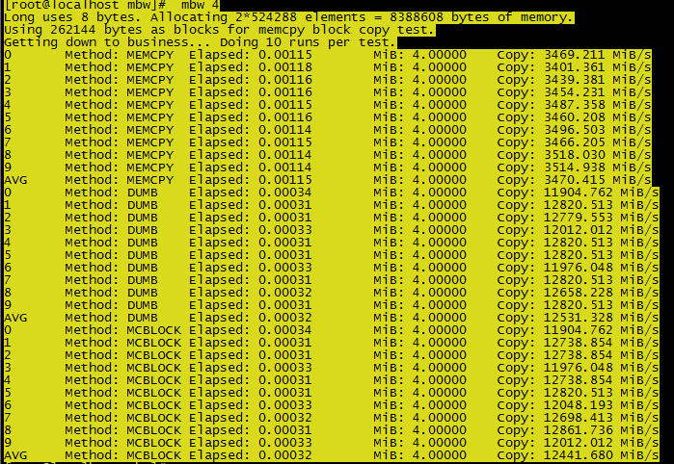
Io
4k
随机读
[root@localhost /]# fio -filename=/dev/sda -direct=1 -iodepth 1 -thread -rw=randread -ioengine=psync -bs=4k -size=50M -numjobs=30 -runtime=60 -group_reporting -name=mytest

顺序写

随机写
混合随机读写

