Secondary Data Analysis of the Multicenter AIDS Cohort Study
Introduction
Multicenter AIDS Cohort Study (MACS) is an ongoing prospective cohort study of the natural and treated histories of HIV-1 infection in homosexual and bisexual men in 4 major cities in the United States. MACS data was provided for secondary analysis, it comprised 3935 observations representing up to 8 years of longitudinal laboratory and quality of life measures on 715 unique men, who were infected with HIV, after beginning highly active antiretroviral treatment (HAART) which is the standard treatment for HIV infected patients. Analysis will be focused on the 2 timepoints of interest, baseline (year 0) and year 2 follow-up.
There are 4 measures of treatment response (outcomes) that are of interest in this analysis, they include standardized viral load (in copies/ml), CD4+ T-cell count (in cells), aggregate physical and mental quality of life score (QoL, both ranging from 0 to 100). For each of these outcomes, it is of interest to test the following hypotheses, whether: (a) the outcome at 2 years after HAART differs by hard drug use status at baseline, and (b) this difference is explained by adherence (to medications taken since last visit) status at year 2.
Methods
Mean and standard deviation estimates were reported for continuous variables, and frequency and proportion for categorical variables. These estimates were tabulated and stratified by baseline hard drug use, inference (i.e., p-value) from appropriate statistical tests (e.g. Wilcoxon rank sum, Fisher’s or Chi-Square test) in the frequentist framework were obtained and reported. The decision to provide inference for the comparison of these characteristics was because MACS was an observational, not a randomized study. Boxplots, stratified by baseline hard drug use status, were used for visual assessment of the distribution of continuous variables at timepoints of interest.
Study participants with both baseline and year 2 follow-up data were considered for inclusion as the final analysis dataset. Treatment adherence, measured on an ordinal scale, was categorized as a new binary variable due to small cell counts. Race/ethnicity combination, smoking status, and highest level of education at baseline, were all also individually categorized as new binary variables due to small cell counts. Implausible, negative, and unknown body mass index (BMI) variables were re-coded to missing. The final analysis dataset comprised observations without missing value for any of the treatment response (outcome) or demographic variables that are of interest in this analysis at baseline and follow-up (year 2).
Standardized viral load was positively skewed and a log₁₀ transformation was applied to obtain a more bell-shaped distribution for analysis. Otherwise, none of the other three outcome variables were transformed. Investigator-provided covariates that were adjusted for, for face validity include age, BMI (kg/m²), smoking status, highest level of education and race/ethnicity. The status of treatment adherence, as a mediator variable, was assessed for each of the 4 outcomes.
A Bayesian linear regression model with a normal distribution likelihood was fitted for each of the 4 outcomes. Non-informative priors were specified for each of the regression coefficients and the residual variance. The mean and variance of the priors for the coefficients and intercept term, for the QoL and CD4+ T-cell count outcome models, were drawn from a normal distribution with mean of 0 and variance of 100², while for the standardized viral load model, a mean of 1 with the same variance was specified because of the log₁₀ transformation. For all 4 models, a half normal non-informative prior with mean of 0 and variance 100² was specified. The model was fitted using Stan, implemented with the cmdstanr package in R Statistical Software v4.5.2. Stan simulates the posterior distribution of the model estimates with Hamiltonian Monte Carlo using the No U-Turn Sampler. Four (4) chains were run each with 5000 iterations of warm-up and 20000 iterations each, and with a seed value for reproducibility. Such high iterations for warm-up and keeping were drawn so as to improve converge characteristics. Autocorrelation plots, trace plots, posterior density of chains, and R-hat were used for model diagnostics and checking convergence. Model comparison was based on the Widely Applicable Information Criterion (WAIC) statistics (where a lower score is better).
Three different models were fitted for each (year 2) outcome variable, a univariable, crude, and adjusted model. The univariable model has hard drug use as the only predictor. The crude model includes all the pre-specified covariates plus the respective baseline outcome measure, the rationale (for including baseline measure) was to adjust for between-subject differences at baseline which also serve as a precision variable. The adjusted model adds the treatment adherence mediator variable to the crude model, the rationale for adding it was to see how much the coefficient for the key predictor, hard drug use, changed. To test the first hypothesis, for each treatment response, the posterior mean with 95% highest posterior density interval (HPDI) were reported and assessed whether it includes the null value of 0. For the second hypothesis, an informal mediation analysis for treatment adherence was performed. The posterior mean with 95% HPDI of the indirect effect of mediation was estimated from the difference in posterior draws between the crude and adjusted models for hard drug use at baseline variable. Details of the mediation analysis, hypothesis test criteria, as well as the final model presented for each outcome, are provided in the Supplementary Section below. In addition, the posterior probability of a clinically meaningful change between hard drug user and non-user at baseline was estimated and tabulated for each treatment response. Clinically meaningful change, provided by the investigator, were 0.5 for log₁₀ standardized viral load, 50 cells/ml for CD4+ T-cells, and 2 points each for mental and physical QoL. All 4 outcomes were considered equally important and there was no ranking among them, also there was no adjustment for multiple comparisons with respect to either hypothesis for any of the outcomes.
This analysis was repeated in a frequentist framework by fitting separate linear regression models for each outcome, however, findings from this frequentist analysis was not the primary focus on this report.
Results
The provided dataset included repeated observations across up to 8 years for 715 unique subjects at baseline. Only 506 (71%) of these 715 subjects have data available in year 2. Supplementary Table 1 shows the distribution and comparison of treatment response and demographic variables at baseline and year 2 follow-up for the 715 and 506 subjects respectively, stratified by hard drug use status at baseline. Among patients that reported using hard drugs at baseline, 41% were lost to follow-up by year 2 compared to 28% among those who did not report using hard drugs (p=0.029). In total, 43 unique subjects were excluded from the final analysis dataset due to missing or implausible values for several demographic and/or outcome variables including BMI. The final analysis dataset comprised 463 unique observations.
Table 1 shows the distribution of subject demographic characteristics at baseline, and outcome variables at baseline and year 2 follow-up stratified by hard drug use status at baseline, including inference (p-value) for the comparison of these characteristics between hard drug users and non-users. Using a 5% significance level in a frequentist framework, there is significant difference in BMI, highest level of education, smoking status, physical QoL at baseline & year 2, and CD4+ T-cell count at year 2 between subjects that reported using hard drugs at baseline compared to those that did not. Figure 1 is a boxplot of the distribution of all treatment response measures stratified by time (baseline and year 2) and hard drug use status. The Bayesian MCMC diagnostic assessments showed convergence, good overlay of posterior draws chains, quick diminishing of autocorrelation, and a pattern of random noise in the trace plot.
From Table 2, based on the crude model, the posterior mean (95% HPDI) of the difference in physical and mental QoL between hard drug users at baseline and non-users is -3.34 (-5.61, -1.06) and -0.28 (-3.18, 2.63) respectively. Compared to non-hard drug users, hard drug users have a lower CD4+ T-cell count with a posterior mean (95% HPDI) of -163.60 (-215.76, -111.58). Finally, the posterior mean of the difference in log10 viral load (copies/mL) between hard drug users and non-users is -0.06 (-0.39, 0.27). There is a 95% probability that hard drug users compared to non-users have a lower aggregate physical QoL score and lower CD4+ T-cell count. Therefore, there is a high level of confidence e(probability) that hard drug use is associated with these responses. The HPDI for aggregate mental QoL score and log10 viral load includes the null value of 0. Therefore, there is a low level of confidence that these response variables are associated with hard drug use. The respective MCMC models converged (R-Hat = 1) and generally, the adjusted model was not better than the crude model, except for log10 viral load based on WAIC criteria.
In mediation analysis (Table 3), the indirect effect of hard drugs on treatment response via treatment adherence was not clinically meaningful based on the comparison of the difference in posterior mean between the crude and adjusted models. For this reason, the conclusion was that treatment adherence is not a meaningful mediator of the relationship between hard drug use and any of the treatment responses in this study. Estimates from both Bayesian and frequentist analysis frameworks are similar.
The posterior probability of the indicated clinically meaningful effect for physical and mental QoL is 83.4% and 26.3% respectively (Table 4), while it is 99.98% for CD4+ T-cell count and 23.8% for log10 viral load. There is a comparatively lower probability of a clinically meaningful effect for mental QoL and log10 viral load agrees with the findings in Table 2 indicating that there is limited evidence that there is a clinically meaningful difference between hard drug users and non-users.
The Supplementary Section includes additional relevant results, including frequentist model details, correlation plots and Bayesian MCMC convergence and diagnostics.
Conclusion
With a high level of confidence, it can be concluded that aggregate physical QoL score and CD4+ T-cells differ by baseline hard drug use status, and hard drug users had significantly lower estimates compared to non-users. The posterior probability of a clinically meaningful effect was high (83.4% and 99.98% respectively). The same conclusion cannot be reached based on aggregate mental QoL and log10 viral load. The association between hard drug use and any of these treatment response variables is not mediated by treatment adherence based on the indicated criteria.
A major study limitation is the subject dropout (lost to follow-up), 29% of subjects were lost between baseline and year 2, and a higher proportion of dropout happened among the hard drug users at baseline. Also, there is evidence of a slight difference in the characteristics of the subjects that remained in study compared to those that started the study. Missing data analysis, and perhaps causal inference methods including weighting (for differences in baseline characteristics) and censoring (to control for loss to follow-up) should be attempted in further studies to understand the impact of missingness on study conclusions.

Table 1: Subject demographic and behavioral characteristics at baseline, and treatment response variables at baseline and year 2, stratified by baseline hard drug use status.
 | Hard Drug use at Baseline?
Subject Characteristics | No N = 427¹ | Yes N = 36¹ | p-value² | Overall N = 463¹
Age at visit (years) | 43.1 (8.7) | 43.9 (9.5) | 0.621 | 43.2 (8.7)
Body Mass Index (kg/m^2) | 25.3 (4.4) | 23.6 (3.4) | 0.013 | 25.2 (4.3)
Race/ethnicity |  |  | 0.147
Other | 150 (35%) | 17 (47%) |  | 167 (36%)
White, non-Hispanic | 277 (65%) | 19 (53%) |  | 296 (64%)
Highest level of education |  |  | 0.049
Below four years college | 236 (55%) | 26 (72%) |  | 262 (57%)
Four years of college or higher | 191 (45%) | 10 (28%) |  | 201 (43%)
Smoking status |  |  | <0.001
Former/never smoker | 278 (65%) | 9 (25%) |  | 287 (62%)
Current smoker | 149 (35%) | 27 (75%) |  | 176 (38%)
Baseline: Aggregate physical QoL score | 51.4 (9.0) | 49.2 (7.1) | 0.032 | 51.2 (8.9)
Baseline: Aggregate mental QoL score | 45.2 (13.8) | 42.0 (11.6) | 0.068 | 44.9 (13.6)
Baseline: CD4+ T cell count | 374.5 (202.3) | 360.0 (200.8) | 0.918 | 373.3 (202.0)
Baseline: Log10 viral Load (HIV copies per mL of blood) | 4.5 (0.9) | 4.6 (0.9) | 0.879 | 4.5 (0.9)
Year 2: Aggregate physical QoL score | 50.0 (9.9) | 44.4 (12.0) | 0.001 | 49.6 (10.2)
Year 2: Aggregate mental QoL score | 47.6 (11.8) | 45.9 (14.1) | 0.858 | 47.4 (12.0)
Year 2: CD4+ T cell count | 556.1 (264.1) | 371.2 (248.8) | <0.001 | 541.7 (267.3)
Year 2: Log10 viral Load (HIV copies per mL of blood) | 1.8 (1.2) | 1.9 (1.5) | 0.798 | 1.8 (1.2)
Year 2: Adherence to meds taken since last visit |  |  | 0.239
<95% | 45 (11%) | 1 (3%) |  | 46 (10%)
>=95% | 382 (89%) | 35 (97%) |  | 417 (90%)
¹Mean (SD); n (%)
²Wilcoxon rank sum test; Pearson's Chi-squared test; Fisher's exact test

Table 2: Bayesian analysis, posterior distribution and model convergence estimates for each treatment response
Treatment Response | Model Type | Posterior  Mean | Standard  Deviation | Lower  95% HPDI | Upper  95% HPDI | R-Hat | WAIC | **Change  in WAIC
Physical QoL | Univariate | -5.65 | 1.77 | -8.56 | -2.79 | 1 | 3460.29 | NA
 | Crude | -3.34 | 1.39 | -5.61 | -1.06 | 1 | 3223.63 | -236.66
 | Adjusted | -3.56 | 1.40 | -5.87 | -1.26 | 1 | 3222.19 | -1.44
 | *Adjusted (adherence) | 2.19 | 1.22 | 0.19 | 4.21 | 1
Mental QoL | Univariate | -1.67 | 2.09 | -5.10 | 1.76 | 1 | 3616.36 | NA
 | Crude | -0.28 | 1.76 | -3.18 | 2.63 | 1 | 3444.05 | -172.31
 | Adjusted | -0.53 | 1.77 | -3.42 | 2.39 | 1 | 3443.90 | -0.15
 | *Adjusted (adherence) | 2.31 | 1.55 | -0.27 | 4.86 | 1
CD4+ T-cells | Univariate | -184.35 | 45.75 | -259.20 | -109.35 | 1 | 6478.04 | NA
 | Crude | -163.60 | 31.71 | -215.76 | -111.58 | 1 | 6124.82 | -353.22
 | Adjusted | -169.34 | 31.84 | -221.78 | -117.16 | 1 | 6122.65 | -2.17
 | *Adjusted (adherence) | 55.35 | 27.98 | 9.40 | 101.47 | 1
Log10 Viral Load | Univariate | 0.06 | 0.21 | -0.29 | 0.41 | 1 | 1511.73 | NA
 | Crude | -0.06 | 0.20 | -0.39 | 0.27 | 1 | 1440.23 | -71.50
 | Adjusted | -0.01 | 0.20 | -0.35 | 0.32 | 1 | 1436.21 | -4.02
 | *Adjusted (adherence) | -0.44 | 0.18 | -0.73 | -0.15 | 1
*Estimates from the posterior distribution of treatment adherence covariate
**A reduction in WAIC of 3 points or more is considered meaningful

Table 3: Mediation analysis, indirect effect of hard drug on treatment response via treatment adherence
Treatment Response | Bayesian Framework |  |  |  | Frequentist Framework
 | Posterior  Mean | Standard  Deviation | Lower  95% HPDI | Upper  95% HPDI | Point  Estimate | Percent  Mediation
Physical QoL | 0.226 | 1.968 | -3.626 | 4.074 | 0.231 | -6.924%
Mental QoL | 0.247 | 2.503 | -4.706 | 5.143 | 0.242 | -83.958%
CD4+ T-cells | 5.734 | 44.822 | -82.296 | 93.232 | 5.803 | -3.541%
Log10 Viral Load | -0.046 | 0.287 | -0.595 | 0.529 | -0.047 | 78.603%

Table 4: Posterior probabilities of a clinically meaningful effect
Treatment Response | Clinical  Meaningful Effect | Posterior Probability
Physical QoL | 2 points | 83.39%
Mental QoL | “ | 26.34%
CD4+ T-cell count | 50 | 99.98%
Log₁₀ Viral Load (in copies per mL of blood) | 0.5 | 23.78%

Figure 1: Boxplots of treatment response variables stratified by baseline hard drug use status and period (baseline and year 2)
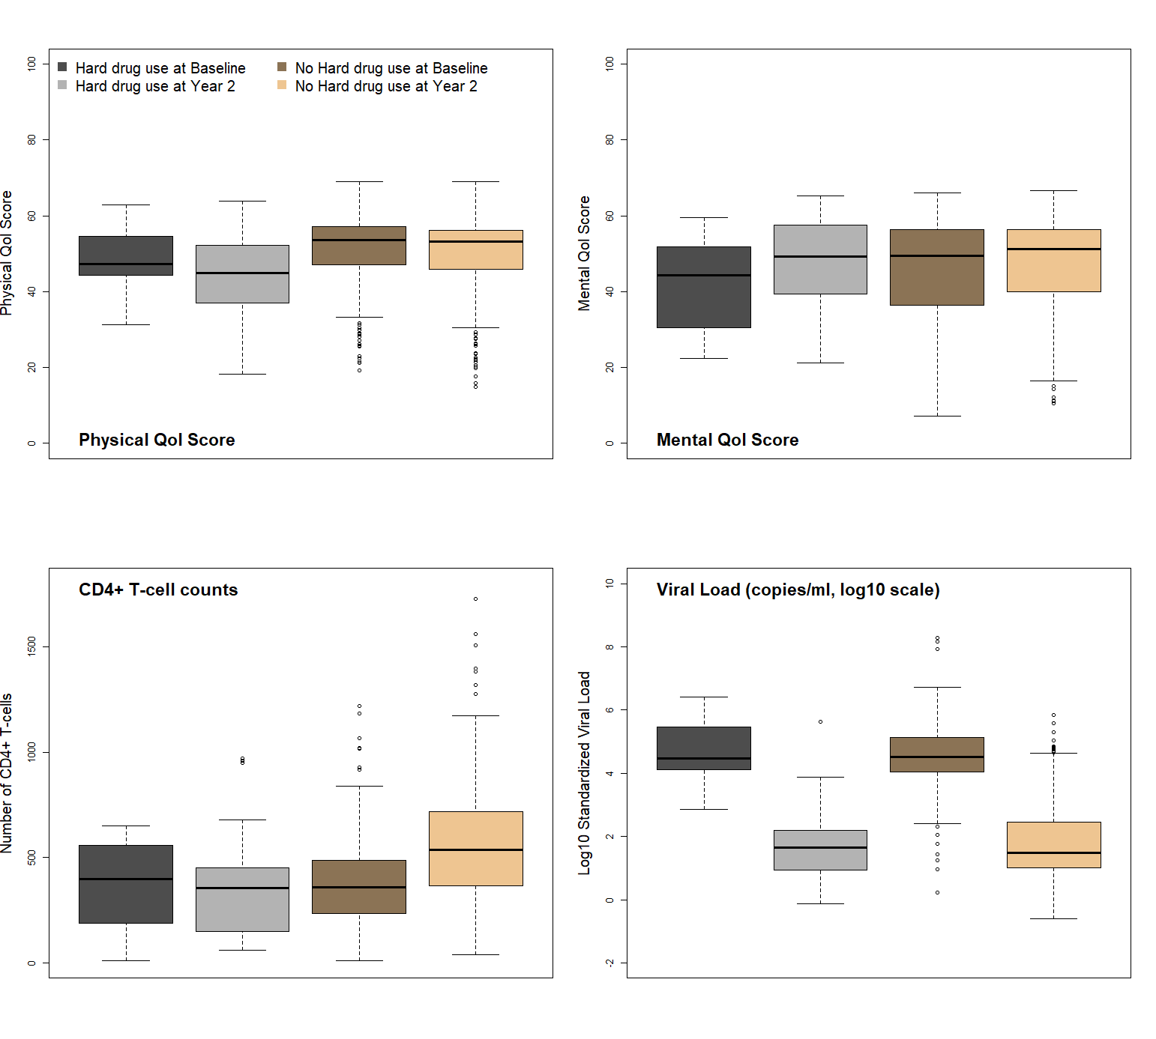

Reproducible Research Information
- GitHub repository for Project 1: https://github.com/yemiaj/BIOS6624/tree/main/Project1
- Raw data file (from Canvas) location: “C:/Users/Owner/Documents/cuclasses/spring26/bios_6624/BIOS6624/Project1/DataRaw/hiv_6624_final.csv”
- Processed and clean final analysis file location: “C:/Users/Owner/Documents/cuclasses/spring26/bios_6624/BIOS6624/Project1/DataProcessed/hiv_6624_clean.csv”
- Other .gitignore hidden files used by Stan:
  - “C:/Users/Owner/Documents/cuclasses/spring26/bios_6624/BIOS6624/Project1/Code/linear_regression_half_normal.exe”
  - “C:/Users/Owner/Documents/cuclasses/spring26/bios_6624/BIOS6624/Project1/Code/linear_regression_half_normal.stan”
- Code files layout:
  - “/Code/P1_clean_and_analyses.R” was used to import and clean the raw data from Canvas. Then a clean .csv file was saved into the “/DataProcessed/” folder for final analysis. This program should be run first if reproducibility is to be attempted.
  - “C:/Users/Owner/Documents/cuclasses/spring26/bios_6624/BIOS6624/Project1/Reports/project1_report_YemiJegede.Rmd” contains organized (into Markdown code chunks with titles) code used to generate all tables, figures, and Bayesian analysis.
- README files in the main and sub-directories were updated with comments to make them more informative.

Supplementary Section
Table of Contents
Mediation analysis ………………………………………………………………page 13
Supplementary Table 1: Distribution and comparison of treatment response and demographic variables at baseline and year 2 follow-up, stratified by hard drug use status at baseline …………………………………………………………………………page 15
Supplementary Table 2: Posterior mean, HPDI, and diagnostics for the crude model by treatment response…………………………………………………………………page 17
Supplementary Table 3: Frequentist analysis coefficient estimate, standard error, confidence interval, and performance measures…………………………………page 18
Supplementary Figure 1: Correlation matrix plot showing scatter plot (in the lower diagonal), histogram (on the diagonal), and Pearson correlation coefficient among variable pairs in the final, clean data………………………………………………page 20
Supplementary Figure 2: Autocorrelation, trace, and chains overlay plot for the Physical QoL model is presented below……………………………………………………page 21
Supplementary Figure 3: Autocorrelation, trace, and chains overlay plot for the Mental QoL crude model…………………………………………………………………page 24
Supplementary Figure 4: Autocorrelation, trace, and chains overlay plot for the CD4+ T-cell crude model…………………………………………………………………page 27
Supplementary Figure 5: Autocorrelation, trace, and chains overlay plot for the CD4+ T-cell crude model…………………………………………………………………page 30

Mediation Analysis
Treatment adherence at year 2 was assessed as a mediator variable of the association between baseline hard drug use and each treatment response outcome. It is noteworthy that treatment adherence does not meet the criteria for a confounder because of its lack of association with hard drug use (p=0.239, see Table 1 and Supplementary Table 1). The rationale (hypothetical causal framework) for adherence being a mediator is as follows “hard drug use could impact adherence to HAART and inadequate adherence to HAART could in turn impact the effectiveness of HAART on any of the treatment response variables.” To be a mediator, a plausible causal framework is needed (already specified above) and two additional criteria. Firstly, it is required that the mediator variable is associated with the key predictor which as noted above treatment adherence is not associated with hard drug use. This association was not formally assessed however, it requires regressing hard drug on the pre-specified covariates on treatment adherence status by fitting a logit model. The small cell counts shown in Table 1 may make fitting cumbersome. The second criterion for mediation is that the coefficient for the key predictor changes when the mediator variable is included in the model compared to the coefficient when mediator variable is excluded.
Contextually, mediation analysis involves separating the effect of HAART on outcome into direct and indirect effects. Direct effect is the effect of HAART on outcome and indirect effect is the effect on HAART on outcome via treatment adherence. The direct effect was assessed in the crude model and indirect effect in the adjusted model. The difference in the coefficient quantifies the magnitude of mediation, and the ratio of this magnitude relative to the coefficient in the crude model is the fraction of mediation. Assessment of mediation for treatment adherence was considered informal because the first criterion was not formally assessed and mediation was only based on the second criterion.
In the Bayesian framework, the posterior distribution of the indirect effect of treatment adherence (TAie) was obtained by taking the difference between the posterior distribution draws (PDd) for the key predictor (hard drug use, HDU) in the crude and adjusted model, that is PD TAie = PD HDU Crude – PD HDU Adjusted. The posterior mean of PD TAie and 95% HPDI was reported as the estimate and credible interval of the indirect effect mediation by treatment adherence. If the absolute value of the posterior mean of PD TAie is greater than the investigator-specified clinically meaningful difference (provided in the main Methods section above) for any of the outcomes, then it is concluded that treatment adherence mediates the association between the outcome and hard drug use.
If mediation is concluded based on the criteria above, then estimates from the adjusted model will be reported for final analysis, if not, then estimates from the crude model will be reported.

Supplementary Table 1: Distribution and comparison of treatment response and demographic variables at baseline and year 2 follow-up, stratified by hard drug use status at baseline.
 | Baseline |  |  |  | Follow-up (Year 2)
 | Hard Drug Use at Baseline? |  |  |  | Hard Drug Use at Baseline?
Subject Characteristics | No N = 649¹ | Yes N = 66¹ | p-value² | Overall N = 715¹ | No N = 467¹ | Yes N = 39¹ | p-value² | Overall N = 506¹
Aggregate Mental Quality of Life Score | 45.6 (13.4) | 43.4 (12.4) | 0.090 | 45.4 (13.3) | 47.6 (11.8) | 45.9 (13.5) | 0.643 | 47.5 (11.9)
NA (missing) | 2 (0.3%) | 0 (0%) |  | 2 (0.3%) | 6 (1.3%) | 0 (0%) |  | 6 (1.2%)
Aggregate Physical Quality of Life Score | 50.7 (9.4) | 44.8 (9.6) | <0.001 | 50.1 (9.5) | 49.9 (10.0) | 43.8 (11.6) | <0.001 | 49.4 (10.2)
NA (missing) | 2 (0.3%) | 0 (0%) |  | 2 (0.3%) | 6 (1.3%) | 0 (0%) |  | 6 (1.2%)
CD4+ T cell count | 385.0 (211.3) | 335.1 (187.0) | 0.103 | 380.3 (209.5) | 559.5 (265.0) | 365.6 (239.7) | <0.001 | 544.0 (268.0)
NA (missing) | 24 (3.7%) | 0 (0%) |  | 24 (3.4%) | 19 (4.1%) | 0 (0%) |  | 19 (3.8%)
Standardized Viral Load (HIV copies per mL of blood) | 823,035.3 (10,222,100.4) | 265,041.6 (609,095.8) | 0.371 | 770,801.1 (9,734,267.3) | 6,216.4 (40,801.6) | 32,946.8 (114,453.0) | 0.819 | 8,357.0 (51,070.2)
NA (missing) | 39 (6.0%) | 3 (4.5%) |  | 42 (5.9%) | 19 (4.1%) | 0 (0%) |  | 19 (3.8%)
Log10 Standardized Viral Load (HIV copies per mL of blood) | 4.5 (0.9) | 4.7 (0.8) | 0.371 | 4.5 (0.9) | 1.8 (1.2) | 1.8 (1.4) | 0.819 | 1.8 (1.2)
NA (missing) | 39 (6.0%) | 3 (4.5%) |  | 42 (5.9%) | 19 (4.1%) | 0 (0%) |  | 19 (3.8%)
Body Mass Index (kg/m^2) | 36.1 (99.2) | 22.4 (6.8) | <0.001 | 34.8 (94.4) | 39.6 (116.3) | 25.0 (3.9) | 0.311 | 38.3 (111.4)
NA (missing) | 27 (4.2%) | 0 (0%) |  | 27 (3.8%) | 51 (11%) | 1 (2.6%) |  | 52 (10%)
Age at visit (years) | 42.4 (9.4) | 43.7 (9.9) | 0.323 | 42.6 (9.4) | 45.2 (8.7) | 46.6 (9.5) | 0.303 | 45.3 (8.8)
Race, Ethinicity Category |  |  | 0.040 |  |  |  | 0.123
White, non-Hispanic | 390 (60%) | 32 (48%) |  | 422 (59%) | 301 (64%) | 19 (49%) |  | 320 (63%)
White, Hispanic | 29 (4%) | 0 (0%) |  | 29 (4%) | 19 (4%) | 0 (0%) |  | 19 (4%)
Black, non-Hispanic | 180 (28%) | 28 (42%) |  | 208 (29%) | 120 (26%) | 17 (44%) |  | 137 (27%)
Black, Hispanic | 9 (1%) | 0 (0%) |  | 9 (1%) | 3 (1%) | 0 (0%) |  | 3 (1%)
Other | 8 (1%) | 0 (0%) |  | 8 (1%) | 5 (1%) | 0 (0%) |  | 5 (1%)
Other Hispanic | 33 (5%) | 6 (9%) |  | 39 (5%) | 19 (4%) | 3 (8%) |  | 22 (4%)
Highest Level of Education |  |  | <0.001 |  |  |  | <0.001
8th grade or less | 5 (1%) | 0 (0%) |  | 5 (1%) | 4 (1%) | 0 (0%) |  | 4 (1%)
9th to 11th grade | 30 (5%) | 20 (30%) |  | 50 (7%) | 20 (4%) | 13 (33%) |  | 33 (7%)
12th grade | 112 (17%) | 13 (20%) |  | 125 (17%) | 71 (15%) | 3 (8%) |  | 74 (15%)
1+ year college (but no degree) | 235 (36%) | 19 (29%) |  | 254 (36%) | 167 (36%) | 13 (33%) |  | 180 (36%)
Four years college | 136 (21%) | 4 (6%) |  | 140 (20%) | 105 (22%) | 1 (3%) |  | 106 (21%)
Some graduate work | 50 (8%) | 0 (0%) |  | 50 (7%) | 38 (8%) | 0 (0%) |  | 38 (8%)
Post-graduate degree | 81 (12%) | 10 (15%) |  | 91 (13%) | 62 (13%) | 9 (23%) |  | 71 (14%)
Lost to follow-up (between Year 0 and 2) |  |  | 0.029
No | 467 (72%) | 39 (59%) |  | 506 (71%)
Yes | 182 (28%) | 27 (41%) |  | 209 (29%)
Smoking Status |  |  | <0.001 |  |  |  | <0.001
Never smoked | 187 (29%) | 1 (2%) |  | 188 (26%) | 136 (29%) | 0 (0%) |  | 136 (27%)
Former smoker | 211 (33%) | 12 (18%) |  | 223 (31%) | 166 (36%) | 12 (31%) |  | 178 (35%)
Current smoker | 251 (39%) | 53 (80%) |  | 304 (43%) | 164 (35%) | 27 (69%) |  | 191 (38%)
NA (missing) |  |  |  |  | 1 (0.2%) | 0 (0%) |  | 1 (0.2%)
Adherence to meds taken since last visit |  |  |  |  |  |  | 0.354
100% |  |  |  |  | 190 (41%) | 21 (54%) |  | 211 (42%)
95 - 99% |  |  |  |  | 226 (48%) | 17 (44%) |  | 243 (48%)
75 - 94% |  |  |  |  | 38 (8%) | 1 (3%) |  | 39 (8%)
<75% |  |  |  |  | 13 (3%) | 0 (0%) |  | 13 (3%)
¹Mean (SD); n (%)
²Wilcoxon rank sum test; Fisher's Exact Test for Count Data with simulated p-value (based on 2000 replicates); Pearson's Chi-squared test

Supplementary Table 2: Posterior mean, HPDI, and diagnostics for the crude model by treatment response
Treatment Response | Predictor | Posterior Mean | Standard Deviation | Lower 95% HPDI | Upper 95% HPDI | R-Hat | ESS Bulk | ESS Tail
Physical QoL | Reference subject | 17.64 | 3.61 | 11.71 | 23.58 | 1 | 55906.10 | 54414.09
 | Used hard drug at baseline | -3.34 | 1.39 | -5.61 | -1.06 | 1 | 91097.03 | 57933.11
 | Baseline physical QoL score | 0.69 | 0.04 | 0.62 | 0.77 | 1 | 71465.18 | 58260.79
 | BMI (kg/m^2) | 0.07 | 0.09 | -0.07 | 0.22 | 1 | 79181.02 | 57583.05
 | Age (in years) | -0.10 | 0.04 | -0.17 | -0.03 | 1 | 75231.54 | 58453.96
 | White non-Hispanic | -0.38 | 0.80 | -1.70 | 0.95 | 1 | 93525.18 | 59690.79
 | College or higher educated | -0.15 | 0.78 | -1.44 | 1.15 | 1 | 95117.27 | 58348.86
 | Current smoker | -1.66 | 0.80 | -2.97 | -0.34 | 1 | 87961.74 | 60004.71
Mental QoL | Reference subject | 19.62 | 3.66 | 13.61 | 25.63 | 1 | 51555.92 | 52308.89
 | Used hard drug at baseline | -0.28 | 1.76 | -3.18 | 2.63 | 1 | 79669.76 | 58951.80
 | Baseline mental QoL score | 0.48 | 0.03 | 0.42 | 0.54 | 1 | 72769.30 | 57444.69
 | BMI (kg/m^2) | 0.03 | 0.11 | -0.15 | 0.21 | 1 | 61479.97 | 54126.07
 | Age (in years) | 0.09 | 0.05 | 0.00 | 0.18 | 1 | 70561.14 | 56092.26
 | White non-Hispanic | 0.08 | 1.02 | -1.60 | 1.75 | 1 | 75315.01 | 59319.36
 | College or higher educated | 2.66 | 0.99 | 1.02 | 4.29 | 1 | 76247.82 | 58056.19
 | Current smoker | 1.39 | 1.01 | -0.28 | 3.05 | 1 | 73347.42 | 58193.03
CD4+ T-cells | Reference subject | 154.91 | 64.91 | 48.39 | 261.85 | 1 | 47762.95 | 48726.08
 | Used hard drug at baseline | -163.60 | 31.71 | -215.76 | -111.58 | 1 | 78085.92 | 54653.32
 | Baseline CD4+ T-cell count | 0.95 | 0.04 | 0.88 | 1.02 | 1 | 74838.45 | 56484.57
 | BMI (kg/m^2) | 2.85 | 2.00 | -0.45 | 6.12 | 1 | 54870.57 | 54597.60
 | Age (in years) | -0.78 | 0.96 | -2.37 | 0.81 | 1 | 65628.89 | 56195.17
 | White non-Hispanic | 7.23 | 18.22 | -22.66 | 37.33 | 1 | 73860.71 | 58960.50
 | College or higher educated | 5.59 | 17.83 | -23.72 | 34.78 | 1 | 71041.24 | 58876.26
 | Current smoker | -0.04 | 18.29 | -30.14 | 30.10 | 1 | 70411.83 | 60444.76
Log10 Viral Load | Reference subject | 0.58 | 0.52 | -0.28 | 1.45 | 1 | 50999.53 | 52888.70
 | Used hard drug at baseline | -0.06 | 0.20 | -0.39 | 0.27 | 1 | 101861.06 | 56715.76
 | Baseline log10 viral load (copies/ml) | 0.48 | 0.06 | 0.39 | 0.58 | 1 | 68270.14 | 59419.87
 | BMI (kg/m^2) | -0.02 | 0.01 | -0.05 | 0.00 | 1 | 72105.89 | 58319.20
 | Age (in years) | 0.00 | 0.01 | -0.01 | 0.01 | 1 | 83266.05 | 57759.21
 | White non-Hispanic | -0.24 | 0.12 | -0.43 | -0.04 | 1 | 94024.37 | 58391.82
 | College or higher educated | -0.13 | 0.11 | -0.31 | 0.06 | 1 | 91131.01 | 60322.80
 | Current smoker | 0.02 | 0.12 | -0.17 | 0.22 | 1 | 88842.33 | 58111.86

Supplementary Table 3: Frequentist analysis coefficient estimate, standard error, confidence interval, and performance measures
Treatment Response | Predictor | Coefficient | Standard Error | P-value | Lower  95% CI | Upper  95% CI | Residual variance | Adjusted R-Squared | Variance Inflation Factor
Physical QoL | Reference subject | 17.64 | 3.59 | 0.00 | 10.59 | 24.69 | 7.76 | 0.42 | 0.00
 | Used hard drug at baseline | -3.34 | 1.39 | 0.02 | -6.06 | -0.61 | 7.76 | 0.42 | 1.06
 | Baseline physical QoL score | 0.70 | 0.04 | 0.00 | 0.61 | 0.78 | 7.76 | 0.42 | 1.13
 | BMI (kg/m^2) | 0.07 | 0.09 | 0.40 | -0.10 | 0.24 | 7.76 | 0.42 | 1.07
 | Age (in years) | -0.10 | 0.04 | 0.02 | -0.18 | -0.01 | 7.76 | 0.42 | 1.09
 | White non-Hispanic | -0.38 | 0.81 | 0.64 | -1.96 | 1.20 | 7.76 | 0.42 | 1.15
 | College or higher educated | -0.15 | 0.78 | 0.84 | -1.68 | 1.38 | 7.76 | 0.42 | 1.14
 | Current smoker | -1.66 | 0.80 | 0.04 | -3.22 | -0.09 | 7.76 | 0.42 | 1.15
Mental QoL | Reference subject | 19.60 | 3.66 | 0.00 | 12.40 | 26.81 | 9.85 | 0.32 | 0.00
 | Used hard drug at baseline | -0.29 | 1.76 | 0.87 | -3.75 | 3.17 | 9.85 | 0.32 | 1.06
 | Baseline mental QoL score | 0.48 | 0.03 | 0.00 | 0.41 | 0.55 | 9.85 | 0.32 | 1.04
 | BMI (kg/m^2) | 0.03 | 0.11 | 0.80 | -0.19 | 0.24 | 9.85 | 0.32 | 1.06
 | Age (in years) | 0.09 | 0.05 | 0.10 | -0.02 | 0.20 | 9.85 | 0.32 | 1.06
 | White non-Hispanic | 0.09 | 1.01 | 0.93 | -1.89 | 2.07 | 9.85 | 0.32 | 1.12
 | College or higher educated | 2.66 | 0.98 | 0.01 | 0.72 | 4.59 | 9.85 | 0.32 | 1.14
 | Current smoker | 1.39 | 1.01 | 0.17 | -0.59 | 3.38 | 9.85 | 0.32 | 1.14
CD4+ T-cells | Reference subject | 155.82 | 64.19 | 0.02 | 29.68 | 281.96 | 177.86 | 0.56 | 0.00
 | Used hard drug at baseline | -163.88 | 31.79 | 0.00 | -226.35 | -101.41 | 177.86 | 0.56 | 1.06
 | Baseline CD4+ T-cell count | 0.95 | 0.04 | 0.00 | 0.87 | 1.03 | 177.86 | 0.56 | 1.04
 | BMI (kg/m^2) | 2.83 | 1.99 | 0.15 | -1.07 | 6.73 | 177.86 | 0.56 | 1.09
 | Age (in years) | -0.78 | 0.96 | 0.42 | -2.67 | 1.11 | 177.86 | 0.56 | 1.03
 | White non-Hispanic | 7.05 | 18.17 | 0.70 | -28.65 | 42.76 | 177.86 | 0.56 | 1.11
 | College or higher educated | 5.54 | 17.83 | 0.76 | -29.49 | 40.57 | 177.86 | 0.56 | 1.14
 | Current smoker | -0.10 | 18.20 | 1.00 | -35.87 | 35.66 | 177.86 | 0.56 | 1.14
Log10 Viral Load | Reference subject | 0.59 | 0.52 | 0.26 | -0.44 | 1.61 | 1.13 | 0.15 | 0.00
 | Used hard drug at baseline | -0.06 | 0.20 | 0.77 | -0.46 | 0.34 | 1.13 | 0.15 | 1.06
 | Baseline log10 viral load (copies/ml) | 0.48 | 0.06 | 0.00 | 0.37 | 0.60 | 1.13 | 0.15 | 1.05
 | BMI (kg/m^2) | -0.02 | 0.01 | 0.05 | -0.05 | 0.00 | 1.13 | 0.15 | 1.08
 | Age (in years) | 0.00 | 0.01 | 0.53 | -0.02 | 0.01 | 1.13 | 0.15 | 1.04
 | White non-Hispanic | -0.24 | 0.12 | 0.04 | -0.47 | -0.01 | 1.13 | 0.15 | 1.13
 | College or higher educated | -0.13 | 0.11 | 0.27 | -0.35 | 0.10 | 1.13 | 0.15 | 1.15
 | Current smoker | 0.02 | 0.12 | 0.84 | -0.20 | 0.25 | 1.13 | 0.15 | 1.14

Supplementary Figure 1: Correlation matrix plot showing scatter plot (in the lower diagonal), histogram (on the diagonal), and Pearson correlation coefficient among variable pairs in the final, clean data
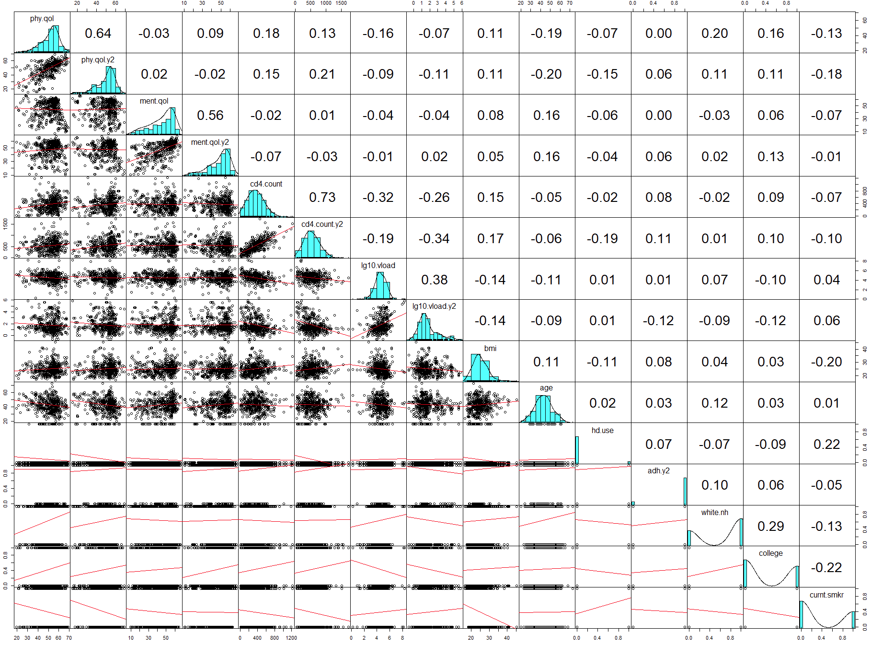
Supplementary Figure 2: Autocorrelation, trace, and chains overlay plot for the Physical QoL model is presented below
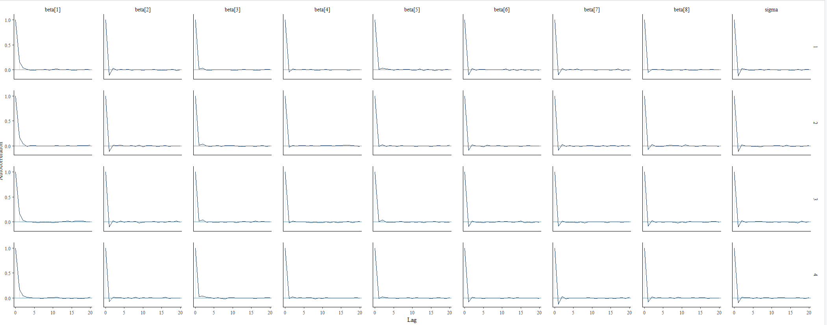
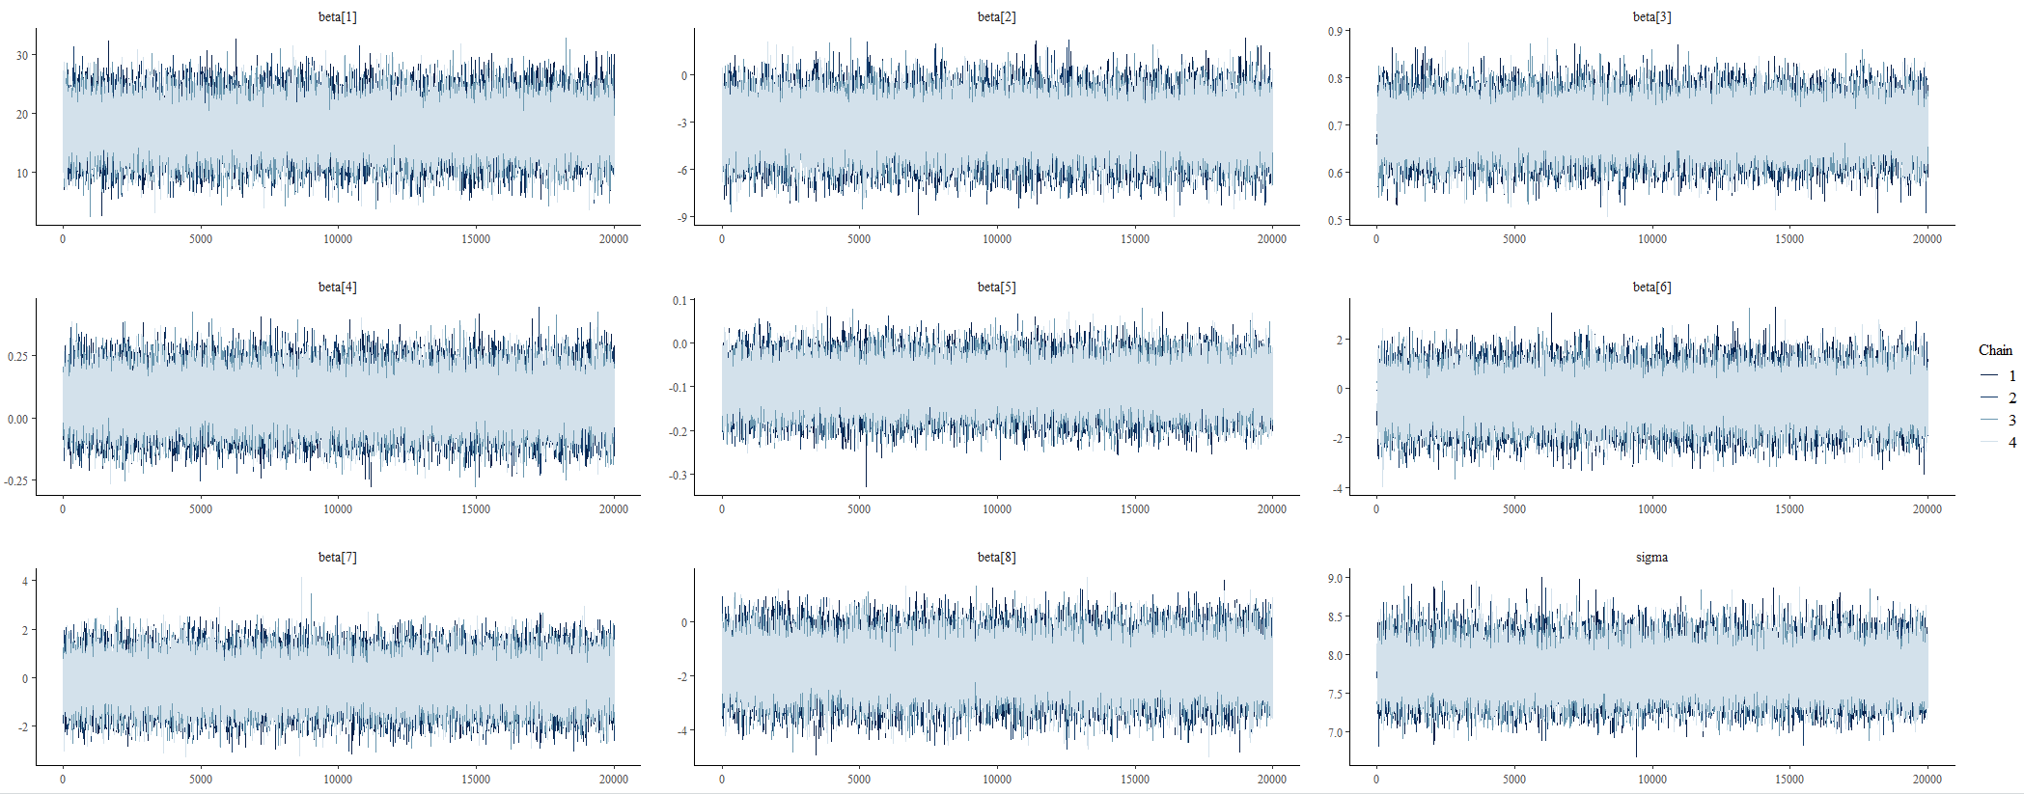
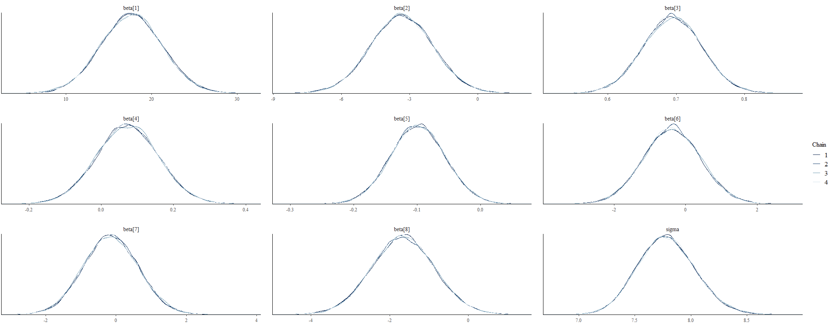

Supplementary Figure 3: Autocorrelation, trace, and chains overlay plot for the Mental QoL crude model
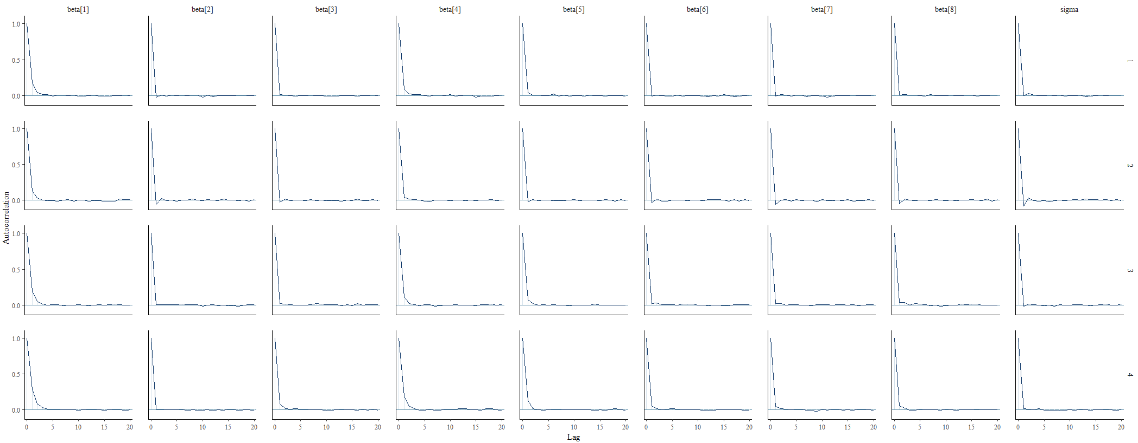
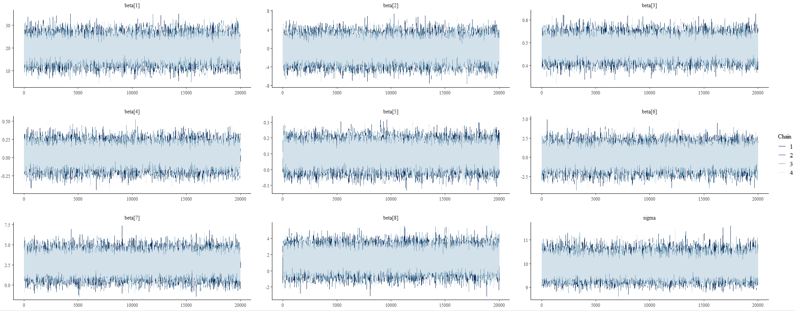

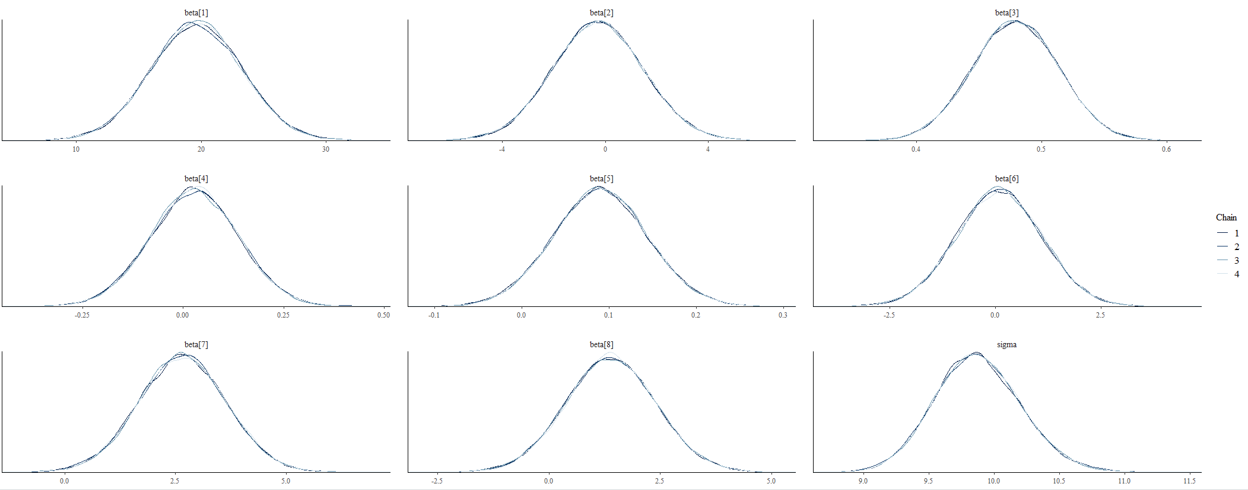

Supplementary Figure 4: Autocorrelation, trace, and chains overlay plot for the CD4+ T-cell crude model
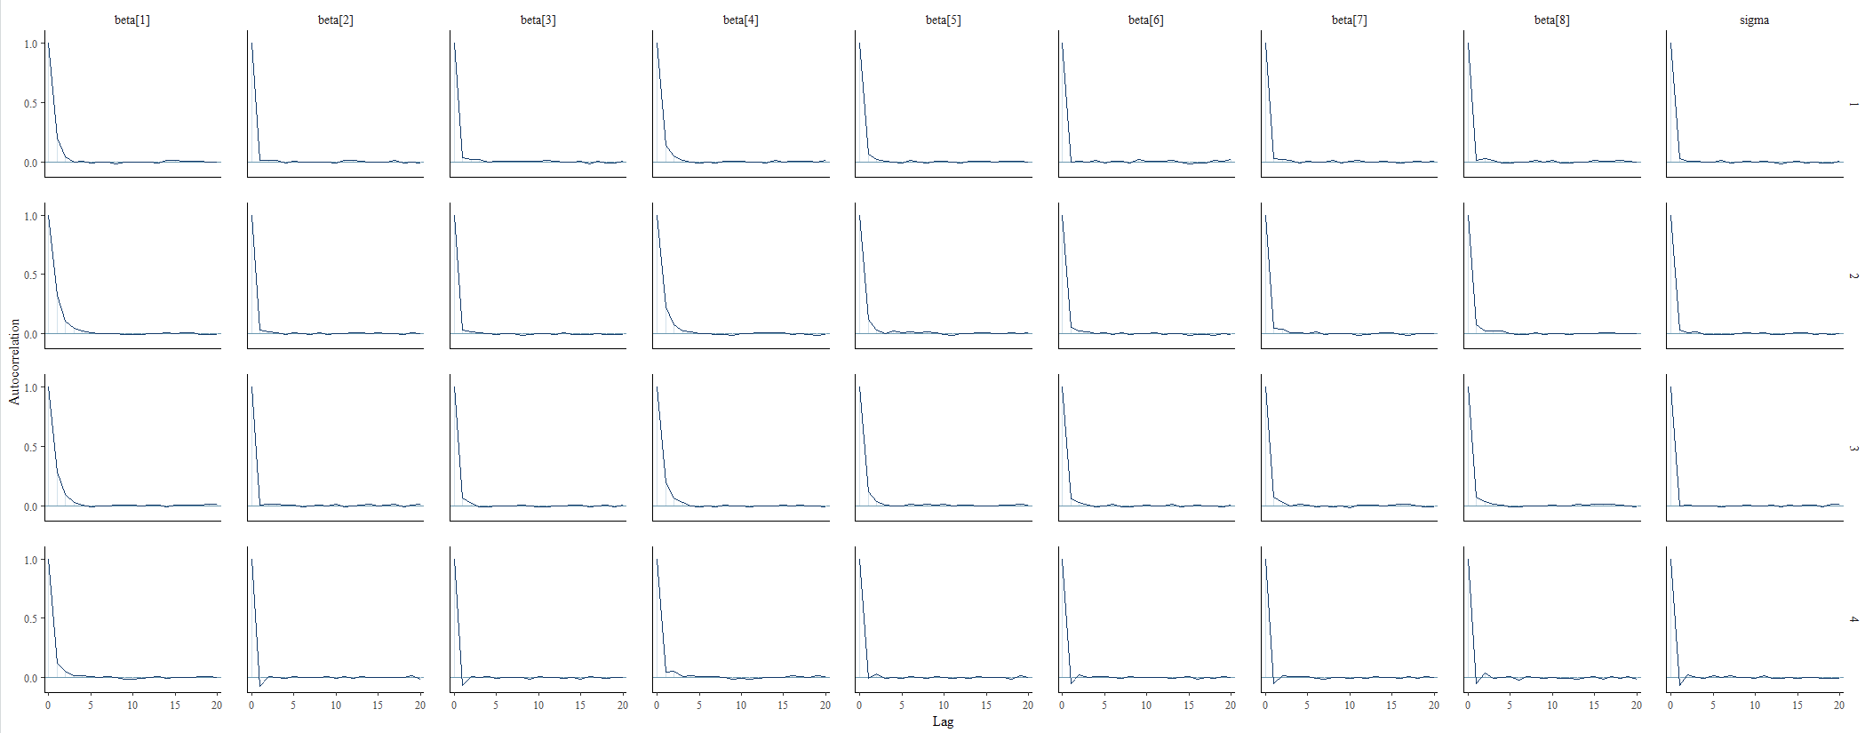
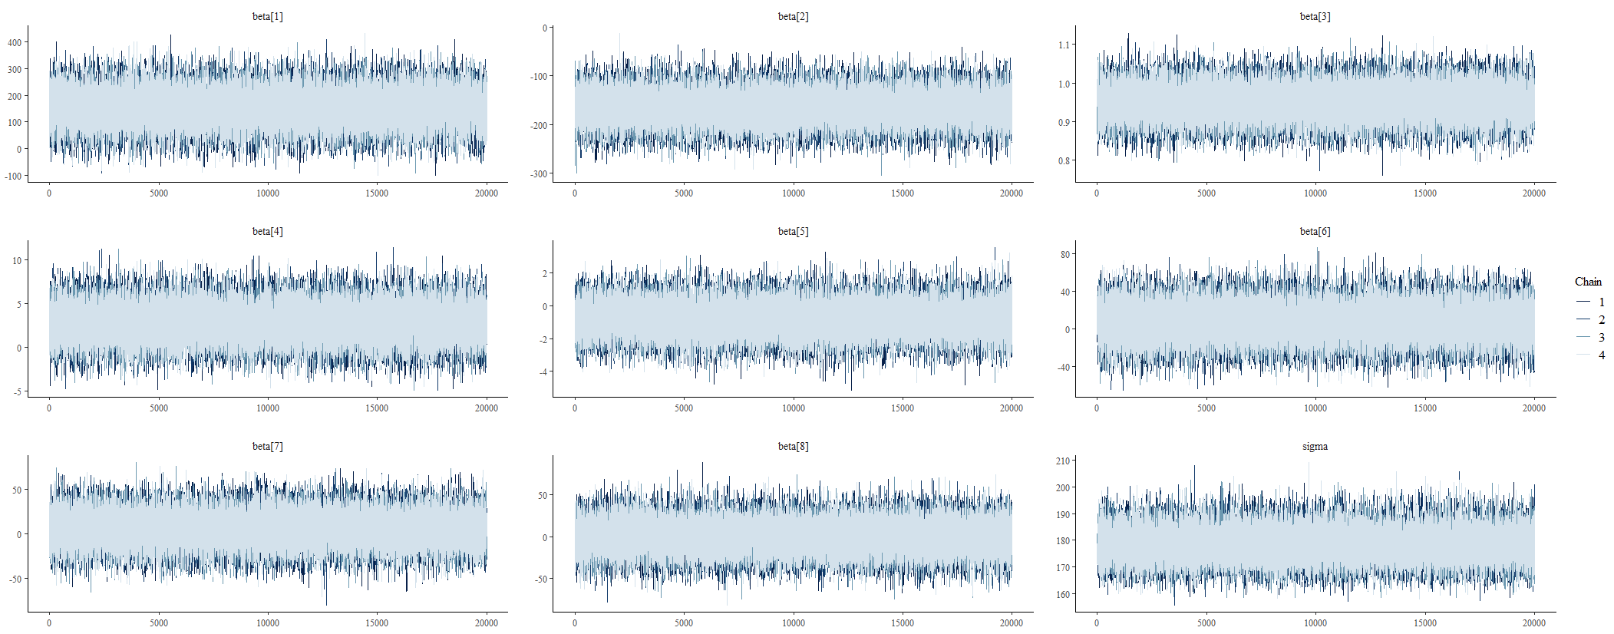
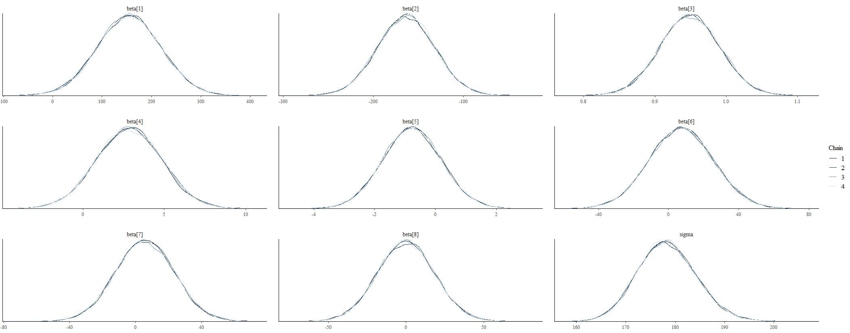

Supplementary Figure 5: Autocorrelation, trace, and chains overlay plot for the CD4+ T-cell crude model
