Aim 1 Analytical Plan: Variable Description & Notation: Predictor and outcome variables will be measured at baseline and one-year follow-up visit; covariates will be measured at baseline (Table 1). InfMrk_{j} is shorthand for the inflammation markers variable category which comprises 4 variables (Table 1) and is indexed by j = 1 to 4. BL-InfMrk_{j}, Yr1-InfMrk_{j}, and ∆InfMrk_{j} are InfMrk j measured at baseline (BL), one-year follow-up (Yr1), and difference (change) between Yr1 and BL respectively. This is applicable to CogMeas_{m}, and CortThck_{n} variable categories, indexed by m (1 to 5), and n (1) respectively. Descriptive analyses: Mean and standard deviation (SD) [frequency and proportion] estimates will be tabulated for continuous [categorical] variables. The table will be stratified by follow-up period (baseline vs one-year). Variable assessment will include tabulating subject characteristics by enrollment site to check for differences; using graphical methods to check for skewness and functional form; and checking for batch, ceiling, and floor effects in measured markers. Missingness in marker/demographic variables is expected to be minimal. Also, projected attrition is minimal (~10% expected) and already accounted for in the accrual goal. Subjects with baseline and 1-year follow-up data will be included in final analysis; to maintain target accrual goal, outliers in inflammation markers will be replaced after further review. Primary analysis: A multivariable linear regression (MLR) model will be fitted for each pairwise combination (j, m, n indices) of predictor and outcome variables as indicated in Table 2. For each model, the assumptions of a MLR will be checked, and multicollinearity will be assessed using variance inflation factor. Continuous variables with skewed distributions may be transformed (e.g., log, square root) or the appropriate functional form modelled (e.g. adding a quadratic term); categorical covariates may be collapsed. Covariate selection: Given the expected sample size (N=175) and the models specified in Table 2, only few covariates can be included in the model. The relationship between covariate pairs, and covariates and outcomes pairs will be assessed using appropriate statistical methods (e.g., Pearson correlation coefficient (rho, ρ), difference in means (mean diff.), and tests of independence for continuous (cont.), cont./categorical (cat.), and cat./cat. pairs respectively). For example, if the absolute value of ρ, |ρ|, is >0.7 (corresponding to an explained variation, R² >49% (0.7²)) only one of the variables in the pair will be included in the MLR. An equivalent threshold for selection will be implemented for cont./cat. and cat./cat. pairs. Attention will be paid to relationships between variable pairs that represent confounder or precision variables. We anticipate the inclusion of no more than 5 ‘Covariates’ to the model (Table 2). Alternatively, if there is a strong dependence among the covariates, then a dimension reduction approach such as principal component analysis (PCA) will be used and the first 5 PCs, at most, will be used as covariates. The choice of covariates will be decided and finalized before doing any hypothesis test, and each MLR will use the same set of covariates for consistency. Hypothesis tests: Hypotheses for Aim 1a and 1b corresponds to testing whether the reduced vs the full models (in Table 2) provides a better fit to the data for each predictor and outcome pairs (indexed by j, m, n). A MLR model will be fitted, and each hypothesis will be tested using a partial F-test. There is a total of 48 partial F-tests for Aim 1a and 1b (Table 2). Hommel’s procedure¹ will be used to control the family-wise error rate (FWER) at 5%, and a hypothesis test with adjusted p-value ≤ 0.05 (see Power Analysis details below) will be deemed statistically significant. Compared to other FWER control procedures, Hommel’s procedure is more powerful and makes no assumption about dependency among tests despite a possibly positive dependency of tests indexed by j and m. Results summary: For each fitted MLR, beta, standard error (SE), 95% confidence interval (CI), change in adjusted R², and adjusted p-value will be tabulated, and visualized using a forest plot (beta, SE, 95% CI). All analysis will be performed using R statistical software. Aim 2 Analytical Plan: The notation, descriptive and primary analyses plan, covariate selection, results summary, and hypothesis testing approach specified for Aim 1 also applies to Aim 2. However, there are a total of 24 hypotheses tests for Aim 2 (Table 2). Aim 2 models are considered different from Aim 1 due to the presence of BL-AmyDep. The same procedure will be used to control the FWER at 5% and the statistical signifcance criteria is the same.
Power Analysis and Additional Statistical Considerations: Preliminary data: |ρ| between ∆CVLT, a cognitive measure, [CortThck] and IL-6 & MCP-1, is 0.26 and 0.32 [0.60 and 0.69] respectively. This corresponds to R² of 0.07, 0.10, 0.36, and 0.48 respectively. Aim 1a & 1b: With a sample size of 175, and across the range of likely (see Supplementary Data) R² in the reduced model (Table 2), the statistical power² to detect a given effect size for BL-InfMrk or ∆InfMrk using a partial F-test with a 5% alpha is plotted in Figure 1 (LHS). For example, estimated power is 95% (blue + symbol) to detect a 6% increase in R² from 15% to 21% (15% + 6% = 21%) using a partial F-test with 5% alpha. Aim 2: With the same sample size and partial F-test, assuming a low correlation for ρ_{AmyDep} (0.1 approximately) between AmyDep & either outcome (CogMeas and CortThck), and AmyDep & InfMrk (main effect), Figure 1 (RHS) shows estimated statistical power³ to detect a given interaction term effect size across a range of correlations between inflammation (main effect) and outcome. Note that power increases with increasing ρ_{AmyDep}. For example, power is 92% to detect an interaction effect of 0.25 if ρ_{InfMrk x CortThck} is 0.25 (blue + symbol). Adjusted p-value: Aim 1 and Aim2 hypothesis tests will be performed separately. Adjusted p-values using Hommel’s approach will be obtained in R with the command p.adjust(p, method = “hommel”), where p is the vector of hypothesis test p-values for Aim 1 (p=48) and Aim 2 (p=24).
References
- Hommel, G. (1988). A stagewise rejective multiple test procedure based on a modified Bonferroni test. Biometrika, 75, 383–386. doi:10.2307/2336190.
- Crespi C, Liu Z (2025). powertools: Power and Sample Size Tools. doi:10.32614/CRAN.package.powertools <https://doi.org/10.32614/CRAN.package.powertools>, R package version 1.0.0, https://CRAN.R-project.org/package=powertools.
- Baranger DAA, Finsaas MC, Goldstein BL, Vize CE, Lynam DR, Olino TM (2023). “Tutorial: Power analyses for interaction effects in cross-sectional regressions.” Advances in Methods and Practices in Psychological Science, *6*(3). doi:10.1177/25152459231187531 <https://doi.org/10.1177/25152459231187531>.
- Xu Y, Qiao M, Gunasekaran TI, et al. Evaluating polygenic risk score prediction performance for Alzheimer's disease in a population-based Hispanic cohort using single- and multi-ancestry models. Lancet Reg Health Am. 2025;49:101198. Published 2025 Jul 25. doi:10.1016/j.lana.2025.101198
- Liu, Jiaxuan et al. “DNA methylation in the APOE genomic region is associated with cognitive function in African Americans.” BMC medical genomics vol. 11,1 43. 8 May. 2018, doi:10.1186/s12920-018-0363-9

Supplementary Data (APOE and other risk factors literature review)
Eliciting background explained variation: APOE is associated with AD and cognition, with an R² ranging between 1.4 to 2.1% in a specific demographic cohort.⁴ Polygenic risk score analysis in a larger cohort had a R² of between 1.6 to 3.9%.⁴ DNA methylation analysis study in a specific demographic cohort identified a signature with an additional R² of up to 8.7%.⁵ after controlling for demographics and APOE status. These studies adjusted for covariates similar to those that will be adjusted for in this study and also used genetic markers that may have the same or stronger effect that the covariates being considered in the current study. It is expected that the background/baseline R² attainable by any of the reduced models in this study will be similar to these studies and therefore ranges between 1.4 to 14.7%.
Rationale for inclusion of a Supplementary Data section
While the inclusion of this section exceeds the page allocation for this report, the information included here would have otherwise been elicited from the study principal investigator such that there would not be need to include this supplementary section in the grant document to be submitted.

Table 1: Type, category, and list of variables that will be measured in this study
*Variable Type  (measurement scale) | Variable category  [shorthand] | Variables details | Applies to
Predictor  (continuous) | Inflammation markers  [InfMrk] | (1) IL-6, (2) TNF-alpha, (3) MCP-1, (4) Eotaxin-1 | Aim 1 & 2
Predictor  (continuous) | Amyloid deposition  (AmyDep) | (1) Global uptake based on mean SUVR (AmyDep) | Aim 2
Outcome  (continuous) | Cognitive measures  [CogMeas] | (1) 20’ Delay, Total Correct, (2) Recognition, D-Prime,  (3) 15’ Delay, Total Correct, (4) Proportion Correct,  (5) 1-Week Delay, Total Correct | Aim 1 & 2
Outcome  (continuous) | Brain structure  (CortThck) | (1) Grey matter cortical thickness (CortThck) | Aim 1 & 2
Covariates  (continuous and categorical) | Demographics | Age, sex | Aim 1 & 2
 | Cardiovascular markers,  immune & health history,  health measures, genetics | Severity level (CDR scale),  Inflammation markers and immune-related conditions,  cardiovascular disease risk,  BMI, history of hypercholesterolemia,  NSAID use, APOE genotype, etc.
*Predictor and Outcome variables will be measured at both baseline and one year follow-up visit
SUVR: standard uptake value ratios; CDR: clinical dementia rating; BMI: body mass index

Table 2: Study aims and statistical models to test study hypotheses
Study Aim | Outcome | Statistical Models | No. of tests
1a | Cognitive  measure | Full: ∆CogMeas_{m} = BL-InfMrk_{j} + BL-CogMeas + Age + Sex + Covariates  Reduced: ∆CogMeas_{m} = BL-CogMeas + Age + Sex + Covariates | m x j =  5 x 4 = 20
1a | Cortical  thickness | Full: ∆CortThck_{n} = BL-InfMrk_{j} + BL-CortThck + Age + Sex + Covariates  Reduced: ∆CortThck_{n} = BL-CortThck + Age + Sex + Covariates | n x j =  1 x 4 = 4
1b | Cognitive  measure | Full: ∆CogMeas_{m} = ∆InfMrk_{j} + BL-CogMeas + Age + Sex + Covariates  Reduced: ∆CogMeas_{m} = BL-CogMeas + Age + Sex + Covariates | m x j =  5 x 4 = 20
1b | Cortical  thickness | Full: ∆CortThck_{n} = ∆InfMrk_{j} + BL-CortThck + Age + Sex + Covariates  Reduced: ∆CortThck_{n} = BL-CortThck + Age + Sex + Covariates | n x j =  1 x 4 = 4
2 | Cognitive  measure | Full: ∆CogMeas_{m} = ∆InfMrk_{j} + BL-AmyDep + (∆InfMrk_{j} * BL-AmyDep) + BL-CogMeas + Age + Sex + Covariates  Reduced: ∆CogMeas_{m} = ∆InfMrk_{j} + BL-AmyDep + BL-CogMeas + Age + Sex + Covariates | m x j =  5 x 4 = 20
2 | Cortical  thickness | Full: ∆CortThck_{n} = ∆InfMrk_{j} + BL-AmyDep + (∆InfMrk_{j} * BL-AmyDep) + BL- CortThck + Age + Sex + Covariates  Reduced: ∆CortThck_{n} = ∆InfMrk_{j} + BL-AmyDep + BL- CortThck + Age + Sex + Covariates | n x j =  1 x 4 = 4

Figure 1: Statistical power to detect a range of effect sizes (Aim 1a, 1b, and 2)
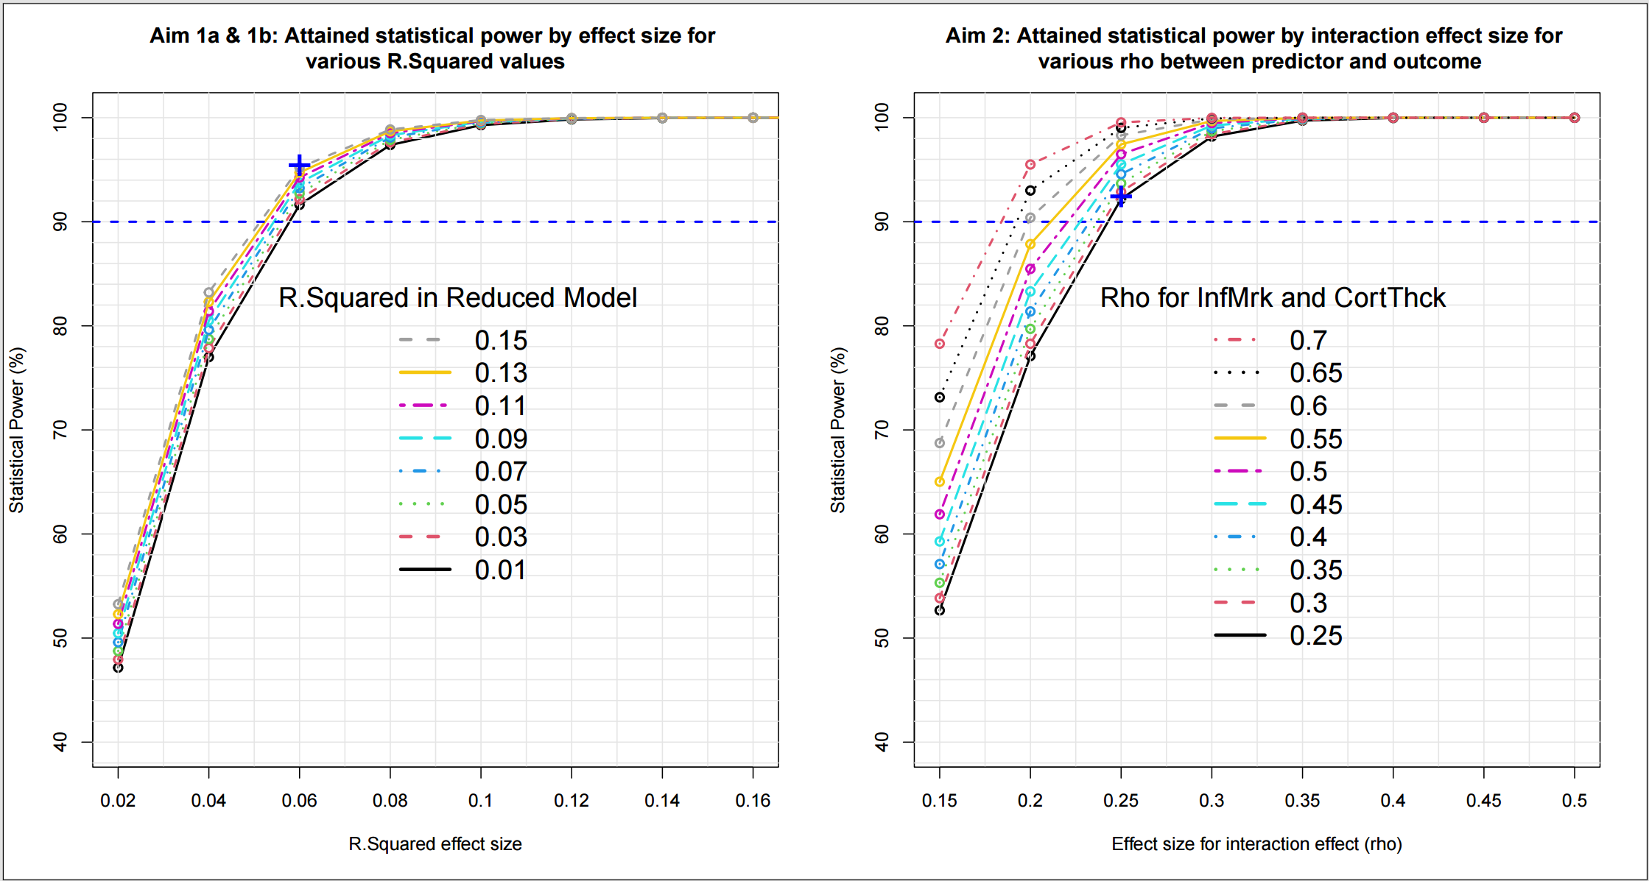

Reproducible Research Information
- GitHub repository for Project 2: https://github.com/yemiaj/BIOS6624/tree/main/Project2
- Raw data file (from Canvas) location: “C:/Users/Owner/Documents/cuclasses/spring26/bios_6624/BIOS6624/Project2/DataRaw/ PrelimData.csv”
- Processed and clean final analysis file location: Not applicable for the current project
- Code files layout:
  - “/Code/P2_design.R” contains the program used for power calculation and the creation of Figure 1.
  - “C:/Users/Owner/Documents/cuclasses/spring26/bios_6624/BIOS6624/Project2/Reports/ Jegede_Project2_GrantApplication_Analysis_&_SampleSizeCalculation.pdf” is the final study report.
- README files in the main and sub-directories were updated with comments to make them more informative.

