**Chapter 1:** **Introduction to Entrepreneurship**

**Chapter Objectives**

* Explain entrepreneurship and discuss its importance.
* Describe corporate entrepreneurship and its use in established firms.
* Discuss three main reasons people decide to become entrepreneurs.
* Identify four main characteristics of successful entrepreneurs.
* Explain five common myths regarding entrepreneurship.
* Discuss the impact of entrepreneurial firms on economies and societies.
* Identify ways in which large firms benefit from the presence of smaller entrepreneurial firms.
* Explain the entrepreneurial process.
  1. **What is Entrepreneurship?**

The word entrepreneur derives from the French words entre, meaning “between,” and prendre, meaning “to take.” The word was originally used to describe people who “take on the risk” between buyers and sellers or who “undertake” a task such as starting a new venture. Inventors and entrepreneurs differ from each other. An inventor creates something new. An entrepreneur assembles and then integrates all the resources needed—the money, the people, the business model, the strategy, and the risk-bearing ability—to transform the invention into a viable business.

**Definition:** There is lack of agreement on fundamental definition of entrepreneur from time to time, from country to country and from field of study to field of study

* Academic Definition (Stevenson & Jarillo)
  + Entrepreneurship is the process by which individuals pursue opportunities without regard to resources they currently control.
* Venture Capitalist (Fred Wilson)
  + Entrepreneurship is the art of turning an idea into a business.
* Explanation of What Entrepreneurs Do

Entrepreneurs assemble and then integrate all the resources needed –the money, the people, the business model, the strategy—needed to transform an invention or an idea into a viable business.

**An entrepreneur can be defined as follows:**

* One who brings resource, labor, materials, and other assets into combination that makes their value greater than before and also one who introduces changes innovations. **( Economist)**
* A person typically driven by certain forces need to obtain or attain something, to experiment, to accomplish or perhaps to escape the authority of others. **(Psychologist)**
* One who creates wealth for others as well, who finds better way to utilize resources and reduce waste and who produce job others are glad to get.

(**Capitalist philosopher)**

* is introducing something new in the economy, if it is in the advanced economy and he/she is one who starts an industry (old or new), undertake risks, uncertainties & also performs managerial functions, if it is in the developing economy **(Schumpeter)**
* is “an energetic single minded” person having mission and a clear vision

**(David silver)**

* shifting economic resources out of an area of lower in to an area of higher productivity **(Peter Druker)**

**Corporate Entrepreneurship**

* + Is the conceptualization of entrepreneurship at the firm level.
  + All firms fall along a conceptual continuum that ranges from highly conservative to highly entrepreneurial.
  + The position of a firm on this continuum is referred to as its entrepreneurial intensity.

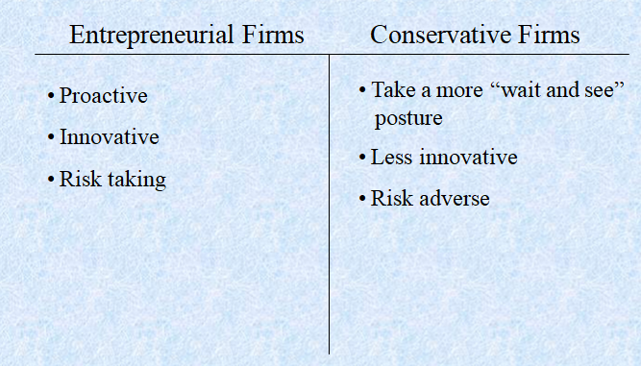

* 1. **Why Become an Entrepreneur?**

The three primary reasons that people become entrepreneurs and start their own firms

* **Desire to be their own boss**

This doesn’t mean, however, that entrepreneurs are difficult to work with or that they have trouble accepting authority. Instead, many entrepreneurs want to be their own boss because either they have had a longtime ambition to own their own firm or because they have become frustrated working in traditional jobs

* **Desire to pursue their own ideas**

Some people are naturally alert, and when they recognize ideas for new products or services, they have a desire to see those ideas realized.

For example, some people, through a hobby, leisure activity, or just everyday life, recognize the need for a product or service that is not available in the marketplace. If the idea is viable enough to support a business, they commit tremendous time and energy to convert the idea into a part-time or full-time firm.

* **Financial rewards**

Making a profit and increasing the value of a company is a solidifying goal that people can rally around. But money is rarely the primary motivation behind the launch of an entrepreneurial firm.

* **Job security-**over the past 10 years, large companies have eliminate more jobs than they have created.
* **Quality of life**: - starting a business gives the founder some choice over when, where and how to work.
  1. **Characteristics of Successful Entrepreneurs**

**Four Primary Characteristics**

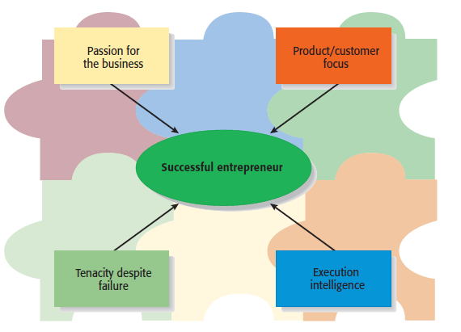**\**

* **Passion for the Business**
  + The number one characteristic shared by successful entrepreneurs is a passion for the business.
  + This passion typically stems from the entrepreneur’s belief that the business will positively influence people’s lives.
* **Product/Customer Focus**
  + A second defining characteristic of successful entrepreneurs is a product/customer focus.
  + An entrepreneur’s keen focus on products and customers typically stems from the fact that most entrepreneurs are, at heart, craftspeople.
* **Tenacity Despite Failure**
  + Because entrepreneurs are typically trying something new, the failure rate is naturally high.
  + A defining characteristic for successful entrepreneurs’ is their ability to persevere through setbacks and failures.
* Execution Intelligence

The ability to fashion a solid business idea into a viable business is a key characteristic of successful entrepreneurs.

* 1. **Common Myths About Entrepreneurs**
* **Myth 1: Entrepreneurs Are Born Not Made**
  + This myth is based on the mistaken belief that some people are genetically predisposed to be entrepreneurs.
  + The consensus of many studies is that no one is “born” to be an entrepreneur; everyone has the potential to become one.
  + Whether someone does or doesn’t become an entrepreneur, is a function of the environment, life experiences, and personal choices.

Although no one is “born” to be an entrepreneur, there are common traits and characteristics of successful entrepreneurs

**Common traits and characteristics of Entrepreneur**

|  |  |
| --- | --- |
| * A moderate risk taker | * Optimistic disposition |
| * A networker | * Persuasive |
| * Achievement motivated | * Promoter |
| * Alert to opportunities | * Resource assembler/leverager |
| * Creative | * Self-confident |
| * Decisive | * Self-starter |
| * Energetic | * Tenacious |
| * A strong work ethic | * Tolerant of ambiguity |
| * Lengthy attention span | * Visionary |

* **Myth 2: Entrepreneurs Are Gamblers**
  + Most entrepreneurs are moderate risk takers.
  + The idea that entrepreneurs are gamblers originates from two sources:
    - Entrepreneurs typically have jobs that are less structured, and so they face a more uncertain set of possibilities than people in traditional jobs.
    - Many entrepreneurs have a strong need to achieve and set challenging goals, a behavior that is often equated with risk taking.
* **Myth 3: Entrepreneurs Are Motivated Primarily by Money.**
  + While it is naïve to think that entrepreneurs don’t seek financial rewards, money is rarely the reason entrepreneurs start new firms.
  + In fact, some entrepreneurs warn that the pursuit of money can be distracting.
* **Myth 4: Entrepreneurs Should Be Young and Energetic.**
  + The most active age for business ownership is 35 to 45 years old.
  + While it is important to be energetic, investors often cite the strength of the entrepreneur as their most important criteria in making investment decisions.
    - What makes an entrepreneur “strong” in the eyes of an investor is experience, maturity, a solid reputation, and a track record of success.
    - These criteria favor older rather than younger entrepreneurs.
  1. **Entrepreneurship Importance**

1. **Economic Impact of Entrepreneurial Firms**

* Innovation
  + Is the process of creating something new, which is central to the entrepreneurial process.
  + Small firms are twice as innovative per employee as large firms.
* Job Creation

In the past two decades, economic activity has moved in the direction of smaller entrepreneurial firms, which may be due to their unique ability to innovate and focus on specialized tasks.

1. **Entrepreneurial Firms’ Impact on Society** 
   * The innovations of entrepreneurial firms have a dramatic impact on society.
   * Think of all the new products and services that make our lives easier, enhance our productivity at work, improve our health, and entertain us in new ways.
2. **Entrepreneurial Firms’ Impact on Larger Firms**

Many entrepreneurial firms have built their entire business models around producing products and services that help larger firms become more efficient and effective.

* 1. **The Entrepreneurial Process**

The Entrepreneurial Process Consists of Four Steps

**Step 1: Deciding to become an entrepreneur.**

Usually, a triggering event prompts an individual to become an entrepreneur.

For example; an individual may lose her job and decide that the time is right to start her own business. Or a person might receive an inheritance and for the first time in his life have the money to start his own company

**Step 2: Developing successful business ideas**

A business plan is a written document that describes all the aspects of a business venture in a concise manner. It is usually necessary to have a written business plan to raise money and attract high-quality business partners. Some entrepreneurs are impatient and don’t want to spend the time it takes to write a business plan

**Step 3: Moving from an idea to an entrepreneurial firm.**

The first step in turning an idea into reality is to prepare a proper ethical and legal foundation for a firm, including selecting an appropriate form of business ownership

**Step 4: Managing and growing the entrepreneurial firm.**

Given today’s competitive environment, all firms must be managed and grown properly to ensure their ongoing success. This is the final stage of the entrepreneurial process

**Chapter 2: Recognizing Opportunities and Generating Ideas**

**Chapter Objectives**

* Explain why it’s important to start a new firm when its “window of opportunity” is open.
* Explain the difference between an opportunity and an idea.
* Describe the three general approaches entrepreneurs use to identify opportunities.
* Identify the four environmental trends that are most instrumental in creating business opportunities.
* List the personal characteristics that make some people better at recognizing business opportunities than others.
* Identify the five steps in the creative process.
* Describe the purpose of brainstorming and its use as an idea generator.
* Describe how to use library and Internet research to generate new business ideas.
* Explain the purpose of maintaining an idea bank.
* Describe three steps for protecting ideas from being lost or stolen.

**2.1. Identifying & recognizing Opportunities**

**What is An Opportunity?**

Opportunity Defined: an opportunity a favorable set of circumstances that creates a need for a new product, service or business.

**An opportunity has four essential qualities**

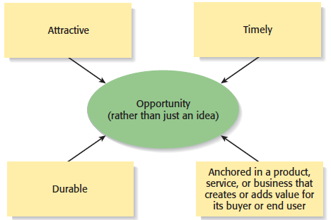

**Three Ways to Identify an Opportunity**

First Approach: Observing Trends

* Observing Trends
  + Trends create opportunities for entrepreneurs to pursue.
  + The most important trends are:
    - Economic forces.
    - Social forces.
    - Technological advances.
    - Political action and regulatory change.
  + It’s important to be aware of changes in these areas.
* Environmental Trends Suggesting Business or Product Opportunity Gaps

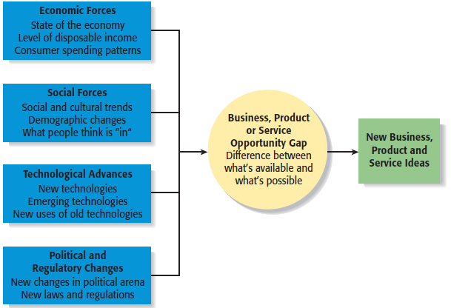

**Trend 1: Economic Forces**

Economic trends help determine areas that are ripe for new startups and areas that startups should avoid.

Example of Economic Trend Creating a Favorable Opportunity

* A weak economy favors startups that help consumers save money.
* An example is GasBuddy.com, a company started to help consumers save money on gas.

**Trend 2: Social Forces**

Social trends alter how people and businesses behave and set their priorities. These trends provide opportunities for new businesses to accommodate the changes.

**Examples of Social Trends**

* Retirement of baby boomers.
* The increasing diversity of the workplace.
* Increasing interest in health, fitness, and wellness.
* Emphasis on alternative forms of energy.
* New forms of music and other types of entertainment.

**Trend 3: Technological Advances**

Once a technology is created, products often emerge to advance it

Example: H20Audio

An example is H20Audio, a company started by four former San Diego State University students that makes waterproof housings for the Apple iPod.

**Trend 4: Political Action and Regulatory Changes**

Political action and regulatory changes also provide the basis for opportunities.

**General Example**

Laws to protect the environment have created opportunities for entrepreneurs to start firms that help other firms comply with environmental laws and regulations.

Company created to help other companies comply with a specific law.

**Specific Example**

The No Child Left Behind Act of 2002 requires states to develop criterion-based assessments in basic skills to be periodically given to students in certain grades. Kim and Jay Kleeman, two high school teachers, started Shakespeare Squared, a company that helps high schools comply with the act.

**Second Approach: Solving a Problem**

* **Solving a Problem**
  + Sometimes identifying opportunities simply involves noticing a problem and finding a way to solve it.
  + These problems can be pinpointed through observing trends and through more simple means, such as intuition, serendipity, or change.
* A problem facing the U.S. and other countries is finding alternatives to fossil fuels.
* A large number of entrepreneurial firms, like this wind farm, are being launched to solve this problem



**Third Approach: Finding Gaps in the Marketplace**

**2.2. Finding Gaps in the Marketplace**

* Gaps in the Marketplace
  + A third approach to identifying opportunities is to find a gap in the marketplace
  + A gap in the marketplace is often created when a product or service is needed by a specific group of people but doesn’t represent a large enough market to be of interest to mainstream retailers or manufacturers.
* Product gaps in the marketplace represent potentially viable business opportunities.

**Specific Example**

In 2000 Tish Cirovolv realized there were no guitars on the market made specifically for women. To fill this gap, she started Daisy Rock Guitars, a company that makes guitars just for women.

**2.3. Personal Characteristics of the Entrepreneur**

Characteristics that tend to make some people better at recognizing opportunities than others

**Prior Experience**

* **Prior Industry Experience**
  + Several studies have shown that prior experience in an industry helps an entrepreneur recognize business opportunities.
    - By working in an industry, an individual may spot a market niche that is underserved.
    - It is also possible that by working in an industry, an individual builds a network of social contacts who provide insights that lead to recognizing new opportunities.
* **Cognitive Factors**
  + Studies have shown that opportunity recognition may be an innate skill or cognitive process.
  + Some people believe that entrepreneurs have a “sixth sense” that allows them to see opportunities that others miss.
  + This “sixth sense” is called entrepreneurial alertness, which is formally defined as the ability to notice things without engaging in deliberate search.
* **Social Networks**
  + The extent and depth of an individual’s social network affects opportunity recognition.
  + People who build a substantial network of social and professional contacts will be exposed to more opportunities and ideas than people with sparse networks.
  + In one survey of 65 start-ups, half the founders reported that they got their business idea through social contacts.
* Strong Tie Vs. Weak Tie Relationships

All of us have relationships with other people that are called “ties.” (See next slide.)

* Nature of Strong-Tie Vs. Weak Tie Relationships
  + Strong-tie relationship are characterized by frequent interaction and form between coworkers, friends, and spouses.
  + Weak-tie relationships are characterized by infrequent interaction and form between casual acquaintances.
* Result
  + It is more likely that an entrepreneur will get new business ideas through weak-tie rather than strong-tie relationships. (See next slide.)
* Why weak-tie relationships lead to more new business ideas than strong-tie relationships

|  |  |
| --- | --- |
| Strong-Tie Relationships | Weak-Tie Relationships |
| These relationships, which typically form between likeminded individuals, tend to reinforce insights and ideas that people already have. | These relationships, which form between casual acquaintances, are not as apt to be between like-minded individuals, so one person may say something to another that sparks a completely new idea. |

* **Creativity**
  + Creativity is the process of generating a novel or useful idea.
  + Opportunity recognition may be, at least in part, a creative process.
  + For an individual, the creative process can be broken down into five stages, as shown on the next slide.
* Five-Steps to Generating Creative Ideas

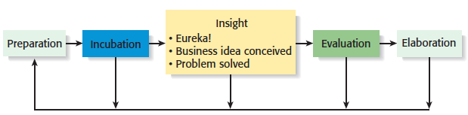

**Incubation**

* The stage during which a person considers an idea or thinks about a problem; it is the “mulling things over” phase.
* Sometimes incubation is a conscious activity, and sometimes it is unconscious and occurs while a person is engaged in another activity.
* One writer characterized this phenomenon by saying that “ideas churn around below the threshold of consciousness

**Insight**

* The flash of recognition—when the solution to a problem is seen or an idea is born. It is sometimes called the “eureka” experience.
* In a business context, this is the moment an entrepreneur recognizes an opportunity. Sometimes this experience pushes the process forward, and sometimes it prompts an individual to return to the preparation stage.

For example, an entrepreneur may recognize the potential for an opportunity but may feel that more knowledge and thought is required before pursuing it

**Evaluation**

* The stage of the creative process during which an idea is subjected to scrutiny and analyzed for its viability.
* Many entrepreneurs mistakenly skip this step and try to implement an idea before they’ve made sure it is viable.
* A particularly challenging stage of the creative process because it requires an entrepreneur to take a candid look at the viability of an idea.

**Elaboration**

* The stage during which the creative idea is put into a final form
* The details are worked out and the idea is transformed into something of value, such as a new product, service, or business concept.
* In the case of a new business, this is the point at which a business plan is written

**Full View of the Opportunity Recognition Process**

Depicts the connection between an awareness of emerging trends and the personal characteristics of the entrepreneur



**2.4. Techniques for Generating Ideas**

* **Brainstorming**
  + Is a technique used to generate a large number of ideas and solutions to problems quickly.
  + A brainstorming “session” typically involves a group of people, and should be targeted to a specific topic.
  + Rules for a brainstorming session:
    - No criticism.
    - Freewheeling is encouraged.
    - The session should move quickly.
    - Leap-frogging is encouraged.
* **Focus Group**
  + A focus group is a gathering of five to ten people, who have been selected based on their common characteristics relative to the issues being discussed.
  + These groups are led by a trained moderator, who uses the internal dynamics of the group environment to gain insight into why people feel they way they do about a particular issue.
  + Although focus groups are used for a variety of purposes, they can be used to help generate new business ideas.
* **Library Research**
  + Libraries are an often underutilized source of information for generating new business ideas.
  + The best approach is to talk to a reference librarian, who can point out useful resources, such as industry-specific magazines, trade journals, and industry reports.
  + Simply browsing through several issues of a trade journal or an industry report on a topic can spark new ideas.

Large public and university libraries typically have access to search engines and industry reports that would cost thousands of dollars to access on your own.

Examples of Useful Search Engines and Industry Reports

* Lexis-Nexis Academic
* ProQuest
* IBISWorld
* Mintel
* Standard & Poor’s Net

Advantage

* **Internet Research**
  + If you are starting from scratch, simply typing “new business ideas” into a search engine will produce links to newspapers and magazine articles about the “hottest” new business ideas.
  + If you have a specific topic in mind, setting up Google or Yahoo! e-mail alerts will provide you to links to a constant stream of newspaper articles, blog posts, and news releases about the topic.
  + Targeted searches are also useful.

**Other Techniques**

* **Customer Advisory Boards**
  + Some companies set up customer advisory boards that meet regularly to discuss needs, wants, and problems that may lead to new ideas.
* **Day-In-The-Life Research**
* A type of anthropological research, where the employees of a company spend a day with a customer.

**2.5. Encouraging and Protecting Ideas**

**Encouraging New Ideas**

* **Establishing a Focal Point for Ideas**
  + Some firms meet the challenge of encouraging, collecting, and evaluating ideas by designating a specific person to screen and track them—for if its everybody’s job, it may be no one’s responsibility.
  + Another approach is to establish an idea bank (or vault), which is a physical or digital repository for storing ideas.
* **Encouraging Creativity at the Firm Level**

Creativity is the raw material that goes into innovation and should be encouraged at the organizational and individual supervisory level**.**

**Protecting Ideas from Being Lost or Stolen**

Step 1

* + The idea should be put in a tangible form such as entered into a physical idea logbook or saved on a computer disk, and the date the idea was first thought of should be entered.

Step 2

* + The idea should be secured. This may seem like an obvious step, but is often overlooked.

Step 3

Avoid making an inadvertent or voluntary disclosure of an idea, in a manner that forfeits the right to claim exclusive rights to it.

**Chapter 3**: **Feasibility Analysis**

**Chapter Objectives**

* Explain what a feasibility analysis is and why it’s important.
* Discuss the proper time to complete a feasibility analysis when developing an entrepreneurial venture.
* Describe the purpose of a product/service feasibility analysis and the two primary issues that a proposed business should consider in this area.
* Explain a concept statement and its components.
  + Describe the purpose of a buying intentions survey and how it’s administered
* Explain the importance of library, Internet, and gumshoe research.
* Describe the purpose of industry/market feasibility analysis and the two primary issues to consider in this area.
* Discuss the characteristics of an attractive industry.
* Describe the purpose of organizational feasibility analysis and list the two primary issues to consider in this area.
* Explain the importance of financial feasibility analysis and list the most critical issues to consider in this area.
  1. **What Is Feasibility Analysis?**

**Feasibility Analysis**

* Feasibility analysis is the process of determining whether a business idea is viable.
* It is the preliminary evaluation of a business idea, conducted for the purpose of determining whether the idea is worth pursuing.

**When to Conduct a Feasibility Analysis**

* Timing of Feasibility Analysis
  + The proper time to conduct a feasibility analysis is early in thinking through the prospects for a new business.
  + The thought is to screen ideas before a lot of resources are spent on them
* Components of a Properly Conducted Feasibility Analysis
* A properly conducted feasibility analysis includes four separate components, as discussed in the following slides.
  1. **Role of feasibility analysis in developing successful business ideas**

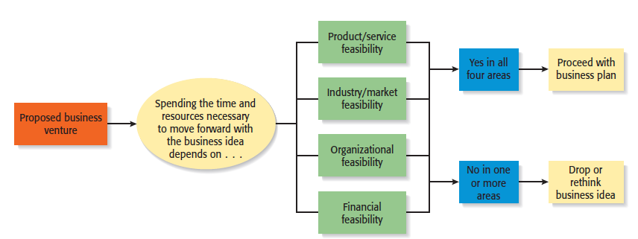

**Forms of Feasibility Analysis**

* 1. **Product/Service Feasibility Analysis**
* Is an assessment of the overall appeal of the product or service being proposed.
* Before a prospective firm rushes a new product or service into development, it should be sure that the product or service is what prospective customers want.

**Components of product/service feasibility analysis**

* Product/Service Desirability
* Product/Service Demand

**Product/Service Desirability**

First, ask the following questions to determine the basic appeal of the product or service.

* Does it make sense? Is it reasonable? Is it something consumers will get excited about?
* Does it take advantage of an environmental trend, solve a problem, or take advantage of a gap in the marketplace?
* Is this a good time to introduce the product or service to the market?
* Are there any fatal flaws in the product or service’s basic design or concept?

**Product/Service Desirability**

* Second, Administer a Concept Test
  + A concept statement should be developed.
  + A concept statement is a one page description of a business that is distributed to people who are asked to provide feedback on the potential of the business idea.
  + The feedback will hopefully provide the entrepreneur
    - A sense of the viability or the product or service idea.
    - Suggestions for how the idea can be strengthened or “tweaked” before proceeding further.

**Product/Service Demand**

* Product/Service Demand
  + There are two steps to assessing product/service demand.
  + Step 1: Administer a Buying Intentions Survey
  + Step 2: Conduct library, Internet, and Gumshoe research
* Buying Intentions Survey
  + Is an instrument that is used to gauge customer interest in a product or service.
  + It consists of a concept statement or a similar description of a product or survey with a short survey attached to gauge customer interest.
  + Internet sites like Survey Monkey make administering a buying intentions survey easy and affordable.

**Buying intentions survey**

Distributed to a different group of people than those who completed the initial concept statement test

How likely would you be to buy the product or service described above, if we make it?

_________Definitely would buy

_________Probably would buy

_________ Might or might not buy

_________ probably would not buy

_________Definitely would not buy

Additional questions that is sometimes included in the survey:

How much would you be willing to pay for the product or service?

Where would you expect to find this product or service for sale?

* **Library, Internet, and Gumshoe Research**
  + The second way to assess the demand for a product or service is by conducting library, Internet, and gumshoe research.
  + Reference librarians can often point you towards resources to help you investigate a business idea, such as industry-specific trade journal and industry reports.
  + Internet searches can often yield important information about the potentially viability of a product or service idea.

**Gumshoe Research**

* A gumshoe is a detective or an investigator that scrounges around for information or clues wherever they can be found.
* Be a gumshoe. Ask people what they think about your product or service idea. If your idea is to sell educational toys, spend a week volunteering at a day care center and watch how children interact with toys.
* One of the most effective things an entrepreneur can do to conduct a thorough product/service feasibility analysis is to hit the streets and talk to potential customers.
  1. **Industry/Target Market Feasibility Analysis**
* Is an assessment of the overall appeal of the industry and the target market for the proposed business.
* An industry is a group of firms producing a similar product or service.
* A firm’s target market is the limited portion of the industry it plans to go after.

**Components of industry/target market feasibility analysis**

* Industry Attractiveness
* Target Market Attractiveness
* **Industry Attractiveness**
  + Industries vary in terms of their overall attractiveness.
  + In general, the most attractive industries have the characteristics depicted on the next slide.
  + Particularly important—the degree to which environmental and business trends are moving in favor rather than against the industry.

**Characteristics of Attractive Industries**

* Are young rather than old
* Are early rather than late in their life cycle
* Are fragmented rather than concentrated
* Are growing rather than shrinking
* Sell products or services that customers “must have” rather “want to have “
* Are not crowded
* Have high rather than low operating margins
* Are not highly dependent on the historically low price of a key low raw material, like gasoline or flour, to remain profitable.
* **Target Market Attractiveness**
  + The challenge in identifying an attractive target market is to find a market that’s large enough for the proposed business but is yet small enough to avoid attracting larger competitors.
  + Assessing the attractiveness of a target market is tougher than an entire industry.
  + Often, considerably ingenuity must be employed to finding information to assess the attractiveness of a specific target market.
  1. **Organizational Feasibility Analysis**
* Is conducted to determine whether a proposed business has sufficient management expertise, organizational competence, and resources to successfully launch a business.
* Focuses on non-financial resources.

**Components of organizational feasibility analysis**

* + - Management Prowess
    - Resource Sufficiency
* **Management Prowess**
  + A firm should candidly evaluate the prowess, or ability, of its management team to satisfy itself that management has the requisite passion and expertise to launch the venture.
  + Two of the most important factors in this area are:
    - The passion that the solo entrepreneur or the founding team has for the business idea.
    - The extent to which sole entrepreneur or the founding team understands the markets in which the firm will participate.
* An indication of passion is the willingness of a new venture team to complete a comprehensive feasibility analysis
* **Resource Sufficiency**
  + This topic pertains to an assessment of whether an entrepreneur has sufficient resources to launch the proposed venture.
  + To test resource sufficiency, a firm should list the 6 to 12 most critical nonfinancial resources that will be needed to move the business idea forward successfully.
    - If critical resources are not available in certain areas, it may be impractical to proceed with the business idea.

Examples of nonfinancial resources that may be critical to the successful launch of a new business

* Availability of affordable office or lab space.
* Likelihood of local and state government support of the business.
* Quality of the labor pool available.
* Proximity to key suppliers and customers.
* Willingness of high quality employees to join the firm.
* Likelihood of establishing favorable strategic partnerships.
* Proximity to similar firms for the purpose of sharing knowledge.
* Possibility of obtaining intellectual property protection in key areas
  1. **Financial Feasibility Analysis**
* Is the final component of a comprehensive feasibility analysis
* A preliminary financial assessment is sufficient.

**Components of financial feasibility analysis**

* Total Start-Up Cash Needed
* Financial Performance of Similar Businesses
* Overall Financial Attractiveness of the Proposed Venture

**Total Start-Up Cash Needed**

* + The first issues refer to the total cash needed to prepare the business to make its first sale.
  + An actual budget should be prepared that lists all the anticipated capital purchases and operating expenses needed to generate the first $1 in revenues.
  + The point of this exercise is to determine if the proposed venture is realistic given the total start-up cash needed.

**Financial Performance of Similar Businesses**

* + Estimate the proposed start-up’s financial performance by comparing it to similar, already established businesses.
  + There are several ways to doing this, all of which involve a little ethical detective work.
    - First, there are many reports available, some for free and some that require a fee, offering detailed industry trend analysis and reports on thousands of individual firms.
    - Second, simple observational research may be needed.

For example, the owners of New Venture Fitness Drinks could estimate their sales by tracking the number of people who patronize similar restaurants and estimating the average amount each customer spends.

**Overall Financial Attractiveness of the Proposed Investment**

* + A number of other financial factors are associated with promising business startups.
  + In the feasibility analysis stage, the extent to which a business opportunity is positive relative to each factor is based on an estimate rather than actual performance.
  + The table on the next slide lists the factors that pertain to the overall attractiveness of the financial feasibility of the business idea.

**Financial Factors Associated With Promising Business Opportunities**

* Steady and rapid growth in sales during the first 5 to 7 years in a clearly defined market niche.
* High percentage of recurring revenue—meaning that once a firm wins a client, the client will provide recurring sources of revenue.
* Ability to forecast income and expenses with a reasonable degree of certainty.
* Internally generated funds to finance and sustain growth.
* Availability of an exit opportunity for investors to convert equity to cash.

**Chapter 4: Writing a Business Plan**

**Chapter Objectives**

* Explain the purpose of a business plan.
* Discuss the two primary reasons for writing a business plan.
* Describe who reads a business plan and what they’re looking for.
* Explain the difference between a summary business plan, a full business plan, and an operational business plan.
* Explain why the executive summary may be the most important section of a business plan.
* Describe a milestone and how milestones are used in business plans.
* Explain why its important to include separate sections on a firm’s industry and its target market in a business plan.
* Explain why the “Management Team and Company Structure” section of a business plan is particularly important.
* Describe the purposes of a “sources and uses of funds” statement and an “assumptions sheet.”
* Detail the parts of an oral presentation of a business plan.

**4.1. What Is a Business Plan?**

* Business Plan
  + A business plan is a written narrative, typically 25 to 35 pages long, that describes what a new business plans to accomplish.
* Dual-Use Document

For most new ventures, the business plan is a dual-purpose document used both inside and outside the firm.

**4.2. Why a Business Plan**

**There are two primary audiences for a firm’s business plan**

|  |  |
| --- | --- |
| **Audience** | **What They are Looking For** |
| A Firm’s Employees | A clearly written business plan helps the employees of a firm operate in sync and move forward in a consistent and purposeful manner. |
| Investors and other external stakeholders | A firm’s business plan must make the case that the firm is a good use of an investor’s funds or the attention of others. |

**Guidelines for Writing a Business Plan**

* Structure of the Business Plan
  + To make the best impression a business plan should follow a conventional structure, such as the outline for the business plan shown in the chapter.
  + Although some entrepreneurs want to demonstrate creativity, departing from the basic structure of the conventional business plan is usually a mistake.
  + Typically, investors are busy people and want a plan where they can easily find critical information.
  + Software Packages
    - There are many software packages available that employ an interactive, menu-driven approach to assist in the writing of a business plan.
    - Some of these programs are very helpful. However, entrepreneurs should avoid a boilerplate plan that looks as though it came from a “canned” source.
  + Sense of Excitement
    - Along with facts and figures, a business plan needs to project a sense of anticipation and excitement about the possibilities that surround a new venture.
* **Content of the Business Plan**
  + The business plan should give clear and concise information on all the important aspects of the proposed venture.
  + It must be long enough to provide sufficient information yet short enough to maintain reader interest.
  + For most plans, 25 to 35 pages is sufficient.
* **Types of Business Plans**

There are three types of business plans, which are shown on the next slide.

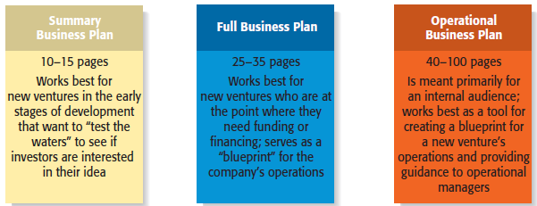

* Recognizing the Elements of the Plan May Change
  + It’s important to recognize that the plan will usually change while written.
  + New insights invariably emerge when an entrepreneur or a team of entrepreneurs immerse themselves in writing the plan and start getting feedback from others.

**4.3. Outline of Business Plan**

* Outline of Business Plan
  + A suggested outline of a business plan is shown on the next several slides.
  + Most business plans do not include all the elements introduced in the sample plan; we include them here for the purpose of completeness.
  + Each entrepreneur must decide which elements to include in his or her plan.

**Section 1: Executive Summary**

**Section 2: Company Description**

**Section 3: Industry Analysis  
Section 4: Market Analysis**

**Section 4: Marketing Plan**

**Section 5: Management Team and Company Structure**

**Section 6: Operations Plan**

**Section 7: Product (or Service) Design and Development Plan**

**Section 8: Financial Projections**

**Section 1: Executive Summary**

* + The executive summary is a short overview of the entire business plan
  + It provides a busy reader with everything that needs to be known about the new venture’s distinctive nature.
  + An executive summary shouldn’t exceed two single-space pages.
* In many instances an investor will ask for a copy of a firm’s executive summary and will ask for a copy of the entire plan only if the executive summary is sufficiently convincing.
* The executive summary, then, is arguably the most important section of a business plan.

**Section 2: Company Description**

* Company Description
  + The main body of the business plan beings with a general description of the company.
  + Items to include in this section:
    - Company description.
    - Company history.
    - Mission statement.
    - Products and services.
    - Current status.
    - Legal status and ownership.
* Key partnerships (if any).
* While at first glance this section may seem less important than the others, it is extremely important.
* It demonstrates to your reader that you know how to translate an idea into a business.

**Section 3: Industry Analysis**

* Industry Analysis
  + This section should being by describing the industry the business will enter in terms of its size, growth rate, and sales projections.
  + Items to include in this section:
    - Industry size, growth rate, and sales projections.
    - Industry structure.
    - Nature of participants.
    - Key success factors.
    - Industry trends.
    - Long-term prospects.
* Before a business selects a target market it should have a good grasp of its industry—including where it’s promising areas are and where its points of vulnerability are.
* The industry that a company participates in largely defines the playing field that a firm will participate in.

**Section 4: Market Analysis**

* Market Analysis
  + The market analysis breaks the industry into segments and zeros in on the specific segment (or target market) to which the firm will try to appeal.
  + Items to include in this section:
    - Market segmentation and target market selection.
    - Buyer behavior.
    - Competitor analysis.
* Most startups do not service their entire industry. Instead, they focus on servicing a specific (target) market within the industry.
* It’s important to include a section in the market analysis that deals with the behavior of the consumers in the market. The more a startup knows about the consumers in its target market, the more it can tailor its products or service appropriately.

**Section 4: Marketing Plan**

* Marketing Plan
  + The marketing plan focuses on how the business will market and sell its product or service.
  + Items to include in this section:
    - Overall marketing strategy.
    - Product, price, promotions, and distribution.
* The best way to describe a startup’s marketing plan is to start by articulating its marketing strategy, positioning, and points of differentiation, and then talk about

how these overall aspects of the plan will be supported by price, promotional mix, and distribution strategy.

**Section 5: Management Team and Company Structure**

* Management Team and Company Structure
  + The management team of a new venture typically consists of the founder or founders and a handful of key management personnel.
  + Items to include in this section:
    - Management team.
    - Board of directors.
    - Board of advisers.
    - Company structure.
* This is a critical section of a business plan.
* Many investors and others who read the business plan look first at the executive summary and then go directly to the management team section to assess the strength of the people starting the firm

**Section 6: Operations Plan**

* Operations Plan
  + Outlines how your business will be run and how your product or service will be produced.
  + A useful way to illustrate how your business will be run is to describe it in terms of “back stage” (unseen to the customer) and “front stage” (seen by the customer) activities.
  + Items to include in this section:
    - General approach to operations.
    - Business location.
    - Facilities and equipment.
* Your have to strike a careful balance between adequately describing this topic and providing too much detail.
* As a result, it is best to keep this section short and crisp.

**Section 7: Product (or Service) Design and Development Plan**

* Product (or Service) Design and Development Plan
  + If you’re developing a completely new product or service, you need to include a section that focuses on the status of your development efforts.
  + Items to include in this section:
    - Development status and tasks.
    - Challenges and risks.
    - Intellectual property.
* Many seemingly promising startups never get off the ground because their product development efforts stall or turn out to be more difficult than expected.
* It’s important to convince the reader of your plan that this won’t happen to you.

**Section 8: Financial Projections**

* Financial Projections
  + The final section of a business plan presents a firm’s pro forma (or projected) financial projections.
  + Items to include in this section:
    - Sources and uses of funds statement.
    - Assumptions sheet.
    - Pro forma income statements.
    - Pro forma balance sheets.
    - Pro forma cash flows.
    - Ratio analysis.
* Having completed the earlier sections of the plan, its easy to see why the financial projections come last.
* They take the plans you’ve developed and express them in financial terms.

**4.4. Presenting the Business Plan to Investors**

* The Oral Presentation
  + The first rule in making an oral presentation is to follow directions. If you’re told you have 15 minutes, don’t talk for more than the allotted time.
  + The presentation should be smooth and well-rehearsed.
  + The slides should be sharp and not cluttered.
* Questions and Feedback to Expect from Investors
* The smart entrepreneur has a good idea of the questions that will be asked, and will be prepared for those queries.

Twelve PowerPoint Slides to Include in an Investor Presentation

|  |  |
| --- | --- |
| * Title Slide * Problem * Solution * Opportunity and target market * Technology * Competition | * Marketing and sales * Management team * Financial projections * Current status * Financing sought * Summary |

**Chapter 5: Industry and Competitor Analysis**

**Chapter Objectives**

* Explain the purpose of an industry analysis.
* Identify the five competitive forces that determine industry profitability.
* Explain the role of “barriers to entry” in creating disincentives for firms to enter an industry.
* Identify the nontraditional barriers to entry that are especially associated with entrepreneurial firms.
* List the four industry-related questions to ask before pursuing the idea for a firm.
* Identify the five primary industry types and the opportunities they offer.
* Explain the purpose of a competitor analysis.
* Identify the three groups of competitors a new firm will face.
* Describe ways a firm can ethically obtain information about its competitors.
* Describe the reasons for completing a competitive analysis grid.

**What is Industry Analysis?**

* Industry
  + An industry is a group of firms producing a similar product or service, such as airlines, fitness drinks, furniture, or electronic games.
* Industry Analysis

Is business research that focuses on the potential of an industry.

**What is Industry Analysis Important?**

Importance

* Once it is determined that a new venture is feasible in regard to the industry and market in which it will compete, a more in-depth analysis is needed to learn the ins and outs of the industry.
* The analysis helps a firm determine if the niche market it identified during feasibility analysis is favorable for a new firm.
* When studying an industry, an entrepreneur must answer three questions before pursuing the idea of starting a firm.

**Question 1:** Is the industry accessible—in other words, is it is realistic place for a new venture to enter?

**Question 2**: Does the industry contain markets that are ripe for innovation or are underserved?

**Question 3:** Are there positions in the industry that avoid some of the negative attributes of the industry as a whole?

**How Industry and Firm-Level Factors Affect Performance**

* **Firm Level Factors**
  + Include a firm’s assets, products, culture, teamwork among its employees, reputation, and other resources.
* **Industry Level Factors**
  + Include threat of new entrants, rivalry among existing firms, bargaining power of buyers, and related factors.
* **Conclusion**

In various studies, researchers have found that from 8% to 30% of the variation in firm profitability is directly attributable to the industry in which a firm competes.

**Techniques Available to Assess Industry Attractiveness**

**Assessing Industry Attractiveness**

* Study Environmental and Business Trends
* The Five Competitive Forces Model

**Studying Industry Trends**

* **Environmental Trends**
  + dInclude economic trends, social trends, technological advances, and political and regulatory changes.
  + For example, industries that sell products to seniors are benefiting by the aging of the population.
* **Business Trends**
  + Other trends that impact an industry.

For example, are profit margins in the industry increasing or falling? Is innovation accelerating or waning? Are input costs going up or down**?**

**The Five Competitive Forces Model**

* **Explanation of the Five Forces Model**
  + The five competitive forces model is a framework for understanding the structure of an industry.
  + The model is composed of the forces that determine industry profitability.
  + They help determine the average rate of return for the firms in an industry**.**
  + Each of the five-forces impacts the average rate of return for the firms in an industry by applying pressure on industry profitability.
* Well managed firms try to position their firms in a way that avoids or diminishes these forces—in an attempt to beat the average rate of return of the industry.

**The Five Competitive Forces Model**

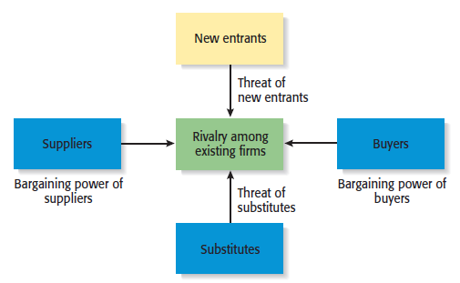

**Threat of Substitutes**

* + The price that consumers are willing to pay for a product depends in part on the availability of substitute products.
  + For example, there are few if any substitutes for prescription medicines, which is one of the reasons the pharmaceutical industry is so profitable.
* In contrast, when close substitutes for a product exist, industry profitability is suppressed, because consumers will opt out if the price gets too high.
  + The extent to which substitutes suppress the profitability of an industry depends on the propensity for buyers to substitute between alternatives.
* This is why firms in an industry often offer their customers amenities to reduce the likelihood that they will switch to a substitute product, even in light of a price increase.
* A customer could easily get a cup of coffee cheaper at one of Starbuck’s competitors.
* To decrease the likelihood of this, Starbucks offers high- quality fresh coffee, good service, and a pleasant atmosphere.
* Starbucks has therefore reduced the threat of substitutes.

**Threat of New Entrants**

* + If the firms in an industry are highly profitable, the industry becomes a magnet to new entrants.
  + Unless something is done to stop this, the competition in the industry will increase, and average industry profitability will decline.
  + Firms in an industry try to keep the number of new entrants low by erecting barriers to entry.
* A barrier to entry is a condition that creates a disincentive for a new firm to enter an industry.

**Barriers to Entry**

|  |  |
| --- | --- |
| Barrier to Entry | Explanation |
| Economies of Scale | Industries that are characterized by large economies of scale are difficult for new firms to enter, unless they are willing to accept a cost disadvantage. |
| Product differentiation | Industries such as the soft drink industry that are characterized by firms with strong brands are difficult to break into without spending heavily on advertising. |
| Capital requirements | The need to invest large amounts of money to gain entrance to an industry is another barrier to entry. |
| Cost advantages independent of size | Existing firm may have cost advantages not related to size. For example, the existing firms in an industry may have purchased land when it was less expensive than it is today. |
| Access to distribution channels | Distribution channels are often hard to crack. This is particularly true in crowded markets, such as the convenience store market. |
| Government and legal barriers | Some industries, such as broadcasting, require the granting of a license by a public authority to compete. |

* **Non Traditional Barriers to Entry**
  + It is difficult for start-ups to execute barriers to entry that are expensive, such as economies of scale, because money is usually tight.

Start-ups have to rely on nontraditional barriers to entry to discourage new entrants, such as assembling a world-class management team that would be difficult for another company to replicate.

**Nontraditional Barriers to Entry**

|  |  |
| --- | --- |
| Barrier to Entry | Explanation |
| Strength of management team | If a start-up puts together a world-class management team, it may give potential rivals pause in taking on the start-up in its chosen industry. |
| First-mover advantage | If a start-up pioneers an industry or a new concept within an industry, the name recognition the start-up establishes may create a barrier to entry. |
| Passion of the management team and employees | If the employees of a start-up are motivated by the unique culture of a start-up, and anticipate large financial reward, this is a combination that cannot be replicated by larger firms. |
| Unique Business Model | If a start-up is able to construct a unique business model and establish a network of relationships that makes the business model work, this set of advantages creates a barrier to entry. |
| Internet Domain Name | Some Internet domain names are so “spot-on” that they give a start-up a meaningful leg up in terms of e-commerce opportunities. |
| Inventing a new approach to an industry | If a start-up invents a new approach to an industry and executes it in an exemplary fashion, these factors create a barrier to entry for potential imitators. |

**Rivalry among Existing Firms**

* **Rivalry Among Existing Firms**
  + In most industries, the major determinant of industry profitability is the level of competition among existing firms.
  + Some industries are fiercely competitive, to the point where prices are pushed below the level of costs, and industry-wide losses occur.
  + In other industries, competition is much less intense and price competition is subdued.
* Factors that determine the intensity of the rivalry among existing firms in an industry.
* **Number and balance of competitors**
* The more competitors there are, the more likely it is that one or more will try to gain customers by cutting its price.
* **Degree of difference between products**
* The degree to which products differ from one product to another affects industry rivalry.
* **Growth rate of an industry**
* The competition among firms in a slow-growth industry is stronger than among those in fast-growth industries.
* **Level of fixed costs**
* Firms that have high fixed costs must sell a higher volume of their product to reach the break-even point than firms with low fixed costs.

**Bargaining Power of Suppliers**

* **Bargaining Power of Suppliers**
  + Suppliers can suppress the profitability of the industries to which they sell by raising prices or reducing the quality of the components they provide.
  + If a supplier reduces the quality of the components it supplies, the quality of the finished product will suffer, and the manufacturer will eventually have to lower its price.
  + If the suppliers are powerful relative to the firms in the industry to which they sell, industry profitability can suffer.
* **Factors that have an impact on the ability of suppliers to exert pressure on buyers**
* **Supplier concentration**
* When they are only a few suppliers that supply a critical product to a large number of buyers, the supplier has an advantage.
* **Switching costs**
* Switching costs are the fixed costs that buyers encounter when switching or changing from one supplier to another. If switching costs are high, a buyer will be less likely to switch suppliers.
* **Attractiveness of substitutes**
* Supplier power is enhanced if there are no attractive substitutes for the product or services the supplier offers.
* **Threat of forward integration**
* The power of a supplier is enhanced if there is a credible possibility that the supplier might enter the buyer’s industry.

**Bargaining Power of Buyers**

* Bargaining Power of Buyers
  + Buyers can suppress the profitability of the industries from which they purchase by demanding price concessions or increases in quality.

For example, the automobile industry is dominated by a handful of large companies that buy products from thousands of suppliers in different industries. This allows the automakers to suppress the profitability of the industries from which they buy by demanding price reductions.

Factors that have an impact on the ability of suppliers to exert pressure on buyers

* **Buyer group concentration**
* If there are only a few large buyers, and they buy from a large number of suppliers, they can pressure the suppliers to lower costs and thus affect the profitability of the industries from which they buy.
* **Buyer’s costs**
* The greater the importance of an item is to a buyer, the more sensitive the buyer will be to the price it pays.
* **Degree of standardization of supplier’s products**
* The degree to which a supplier’s product differs from its competitors affect the buyer’s bargaining power.
* **Threat of backward integration**
* The power of buyers is enhanced if there is a credible threat that the buyer might enter the supplier’s industry.

**First Application of the Five Forces Model**

* First Application of the Model
  + The five forces model can be used to assess the attractiveness of an industry by determining the level of threat to industry profitability for each of the forces.
  + If a firm fills out the form shown on the next slide and several of the threats to industry profitability are high, the firm may want to reconsider entering the industry or think carefully about the position it would occupy.
* **Second Application of the Five Forces Model  
  Second Application of the Model**
  + The second way a new firm can apply the five forces model to help determine whether it should enter an industry is by using the model to answer several key questions.
  + The questions are shown in the figure on the next slide, and help a firm project the potential success of a new venture in a particular industry.

**Industry Types and the Opportunities They Offer**

* Emerging Industries
  + Industries in which standard operating procedures have yet to be developed.
    - Opportunity: First-mover advantage.
* Fragmented Industries
  + Industries that are characterized by a large number of firms of approximately equal size.
* Opportunity: Consolidation.
* Mature Industries
  + Industries that are experiencing slow or no increase in demand.
    - Opportunities: Process innovation and after-sale service innovation.
* Declining Industries
  + Industries that are experiencing a reduction in demand.
* Opportunities: Leadership, establishing a niche market, and pursuing a cost reduction strategy.
* Global Industries
  + Industries that are experiencing significant international sales.
    - Opportunities: Multi domestic and global strategies.

**Competitor Analysis**

* What is a Competitor Analysis?
  + A competitor analysis is a detailed analysis of a firm’s competition.
  + It helps a firm understand the positions of its major competitors and the opportunities that are available.
  + A competitive analysis grid is a tool for organizing the information a firm collects about its competitors.

**Identifying Competitors**

**Types of Competitors New Ventures Face**

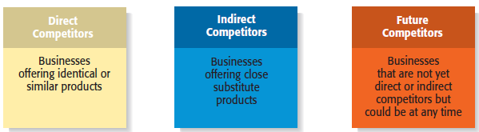

**Sources of Competitive Intelligence**

* Collecting Competitive Intelligence
  + To complete a competitive analysis grid, a firm must first understand the strategies and behaviors of its competitors.
  + The information that is gathered by a firm to learn about its competitors is referred to as competitive intelligence.
  + A new venture should take care that it collects competitive intelligence in a professional and ethical manner.
* Many companies attend trade shows to not only display their products, but to see what their competitors are up to.

**Completing a Competitive Analysis Grid**

* Competitive Analysis Grid
  + A tool for organizing the information a firm collects about its competitors
  + A competitive analysis grid can help a firm see how it stakes up against its competitors, provide ideas for markets to pursue, and identify its primary sources of competitive advantage.

**Chapter 6: Developing an Effective Business Model**

**Chapter Objectives**

* Describe a business model.
* Explain business model innovation.
* Discuss the importance of having a clearly articulated business model.
* Discuss the concept of the value chain.
* Identify a business model’s two potential fatal flaws.
* Identify a business model’s four major components.
* Explain the meaning of the term business concept blind spot.
* Define the term core competency and describe its importance.
* Explain the concept of supply chain management.
* Explain the concept of fulfillment and support.

**6.1. What is a Business Model?**

* **Model**
  + A model is a plan or diagram that’s used to make or describe something.
* **Business Model**
  + A firm’s business model is its plan or diagram for how it competes, uses its resources, structures its relationships, interfaces with customers, and creates value to sustain itself on the basis of the profits it generates.
* The term “business model” is used to include all the activities that define how a firm competes in the marketplace.

**6.2. The Importance of Business Models**

Having a clearly articulated business model is important because it does the following:

* Serves as an ongoing extension of feasibility analysis. A business model continually asks the question, “Does this business make sense?”
* Focuses attention on how all the elements of a business fit together and constitute a working whole.
* Describes why the network of participants needed to make a business idea viable is willing to work together.
* Articulates a company’s core logic to all stakeholders, including all employees.

**Diversity or Variety in Business Models**

* There is no standard business model for an industry or for a target market within an industry.
* However, over time, the most successful business models in an industry predominate.
* There are always opportunities for business model innovation.

**How Business Models Emerge**

* **The Value Chain**
  + The value chain is the string of activities that moves a product from the raw material stage, through manufacturing and distribution, and ultimately to the end user.
  + By studying a product’s or service’s value chain, an organization can identify ways to create additional value and assess whether it has the means to do so.
  + Value chain analysis is also helpful in identifying opportunities for new businesses and in understanding how business models emerge.
  + Entrepreneurs look at the value chain of a product or a service to pinpoint where the value chain can be made more effective or to spot where additional “value” can be added.
  + This type of analysis may focus on:
  + A single primary activity such as marketing and sales.
  + The interface between one stage of the value chain and another, such as the interface between operations and outgoing logistics.
  + One of the support activities, such as human resource management

**The Value Chain**

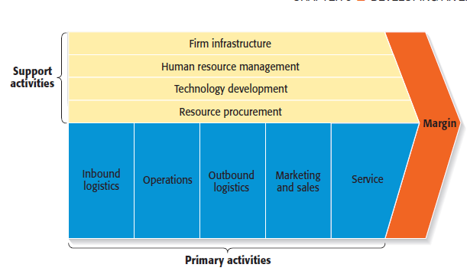

**Potential Fatal Flaws in Business Models**

* **Fatal Flaws**
  + Two fatal flaws can render a business model untenable from the beginning:
    - A complete misread of the customer.
    - Utterly unsound economics.

**6.3. Components of a Business Model**

**Four Components of a Business Model**

* + **Core Strategy**
  + **Strategic Resources**
  + **Partnership Network**
  + **Customer Interface**
  + **Core Strategy**
  + The first component of a business model is the core strategy, which describes how a firm competes relative to its competitors.
* Primary Elements of Core Strategy
  + Mission statement.
  + Product/market scope.
* Basis for differentiation.

**Mission Statement**

* A firm’s mission, or mission statement, describes why it exists and what its business model is suppose to accomplish

**Product/Market Scope**

* A company’s product/market scope defines the products and markets on which it will concentrate.

**Basis of Differentiation**

It is important that a new venture differentiate itself from its competitors in some way that is important to its customers. If a new firm’s products or services aren’t different from those of its competitors, why should anyone try them?

* **Strategic Resources**
* Strategic Resources
  + A firm is not able to implement a strategy without resources, so the resources a firm has affects its business model substantially.
    - For a new venture, its strategic resources may initially be limited to the competencies of its founders, the opportunity they have identified, and the unique way they plan to serve their market.
  + The two most important strategic resources are:
    - A firm’s core competencies.
    - Strategic assets.

**Primary Elements of Strategic Resources**

* **Core Competencies**

A core competency is a resource or capability that serves as a source of a firm’s competitive advantage. Examples include Sony’s competence in miniaturization and Dell’s competence in supply chain management.

* **Strategic Assets**

Strategic assets are anything rare and valuable that a firm owns. They include plant and equipment, location, brands, patents, customer data, a highly qualified staff, and distinctive partnerships.

* **Partnership Network**
* Partnership Network
  + A firm’s partnership network is the third component of a business model. New ventures, in particular, typically do not have the resources to perform key roles.
  + In most cases, a business does not want to do everything itself because the majority of tasks needed to build a product or deliver a service are not core to a company’s competitive advantage.
  + A firm’s partnership network includes:
    - Suppliers.
    - Other key relationships.

**Primary Elements of Partnership Network**

* **Suppliers**
* A supplier is a company that provides parts or services to another company. Intel is Dell’s primary supplier for computer chips, for example
* **Other Key Relationships**
* Firms partner with other companies to make their business models work. An entrepreneur’s ability to launch a firm that achieves a competitive advantage may hinge as much on the skills of the partners as on the skills within the firm itself.

**The Most Common Types of Business Partnerships**

1. **Joint Venture:** An entity created by two or more firms pooling a portion of their **resources** to create a separate, jointly owned organization.
2. **Network:** A hub-and –wheel configuration with a local firm at the hub organizing the interdependencies of a complex array of firms.
3. **Consortia:** A group of organizations with similar needs that band together to create a new entity to address those needs.
4. **Strategic Alliance:** An arrangement between two or more firms that establishes an exchange relationship but has no joint ownership involved.
5. **Trade Associations:** Organizations( typically nonprofit) that are formed by firms in the same industry to collect and disseminate trade information, offer legal and technical advice, furnish industry related training, and provide a platform for collecting lobbying.

* **Customer Interface**
  + The way a firm interacts with its customer hinges on how it chooses to compete.
    - For example, Amazon.com sells books over the Internet while Barnes & Noble sells through its traditional bookstores and online.
  + The three elements of a company’s customer interface are:
    - Target customer.
    - Fulfillment and support.
    - Pricing model.

**Primary Elements of Customer Interface**

* **Target Market**
* A firm’s target market is the limited group of individuals or businesses that it goes after or tries to appeal to.
* **Fulfillment and Support**
* Fulfillment and support describes the way a firm’s product or service reaches it customers. It also refers to the channels a company uses and what level of customer support it provides.
* **Pricing Structure**
* The third element of a company’s customer interface is its pricing structure. Pricing models vary, depending on a firm’s target market and its pricing philosophy.

**Chapter 7: Building a New-Venture Team**

**Chapter Objectives**

* Identify the primary elements of a new venture team.
* Explain the term liabilities of newness.
* Discuss the difference between heterogeneous and homogenous founding teams.
* Identify the personal attributes that strengthen a founder's chances of successfully launching an entrepreneurial venture.
* Describe how to construct a “skills profile,” and explain how it helps a start-up identify gaps in its new-venture team.
* Describe a board of directors and explain the difference between inside directors and outside directors.
* Identify the two primary ways in which the nonemployee members of a start-up’s new-venture team help the firm.
* Describe the concept of signaling and explain why it’s important.
* Discuss the purpose of forming an advisory board.
* Explain why new venture firms use consultants for help and advice.

**New Venture Team**

* + Is the group of founders, key employees, and advisers that move a new venture from an idea to a fully functioning firm.
  + Usually, the team doesn’t come together all at once. Instead, it is built as the new firm can afford to hire additional personnel.
  + The team also involves more than paid employees.
    - Many firms have boards of directors, boards of advisers, and professionals on whom they rely for direction and advice.

**Liabilities of Newness**

* New ventures have a high propensity to fail.
* The high failure rate is due in part to liabilities of newness, which refers to the

fact that new companies often falter because the people involved can’t adjust

fast enough to their new roles and because the firm lacks a track record of success.

* Assembling a talented and experienced management team is one path that firms

can take to overcome these limitations.

**Separate Elements of a New Venture Team**

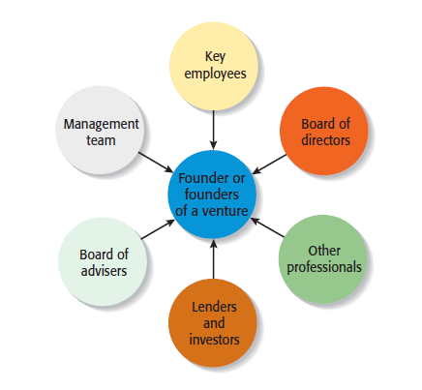

**Founder or Founders**

* + The characteristics of the founder or founders of a firm and their early decisions have a significant impact on the manner in which the new venture team takes shape.

**Size of the Founding Team**

* + Studies have shown that 50% to 70% of all new ventures are started by more than one individual.
* It is believed that new ventures that are started by a team rather than a single individual have an advantage.

**Qualities of Founders**

Factors That May Contribute to a Founders’ Success

* Firm started by a team
* Higher education
* Prior entrepreneurial experience
* Relevant industry experience
* The ability to “network” effectively

**Factors that Contribute to a Founder or Founders’ Success**

* **Firm Started by a Team**
  + Start-ups started by a team can provide greater resources, a broader diversity of viewpoints, and a broader array of other positive attributes than ventures started by individuals.
* **Higher Education**
* Entrepreneurial skills are enhanced through higher education.
* **Prior Entrepreneurial Experience**
  + Founders familiar with the entrepreneurial process are more likely to avoid costly mistakes than founders without similar experience.
* **Relevant Industry Experience**
  + Founders with relevant industry experience are more likely to have:
    - Better established professional networks.
    - More applicable marketing and management skills.
* **Broad Social and Professional Network**
  + Founders with broad social and professional networks have potential access to additional know-how, capital, and customer referrals.

**Recruiting and Selecting Key Employees**

* Recruiting Key Employees
  + Startups vary in terms of how quickly they need to add personnel.
  + In some instances, the founders will work alone for a period of time. In other instances, employees are hired immediately.
* A skills profile is a chart that depicts the most important skills that are needed and where skills gaps exist in a new firm.

**The Roles of the Board of the Directors**

* **Board of Directors**
  + If a new venture organizes as a corporation, it is legally required to have a board of directors.
  + A board of directors is a panel of individuals who are elected by a corporation’s shareholders to oversee the management of the firm.
  + A board is typically made up of both inside directors and outside directors.
    - An inside director is a person who is also an officer of the firm.
    - An outside director is someone who is not employed by the firm.
* **Formal Responsibility of the Board**
  + A board of directors has three formal responsibilities.
    - Appoint the officers of the firm.
    - Declare dividends.
    - Oversee the affairs of the corporation.
* **Frequency of Meetings and Compensation**
  + Most board of directors meets three to four times a year.
* New ventures are more likely to pay their board members in company stock or ask them to service on a voluntary basis rather than pay a cash honorarium**.**

**Chapter 8: Getting Financing or Funding**

**Chapter Objectives**

* Explain why most entrepreneurial ventures need to raise money during their early life.
* Identify the three sources of personal financing available to entrepreneurs.
* Provide examples of how entrepreneurs bootstrap to raise money or cut costs.
* Identify the three steps involved in properly preparing to raise debt or equity financing.
* Discuss the difference between equity funding and debt financing.
* Explain the role of an elevator speech in attracting financing for an entrepreneurial venture.
* Describe the difference between a business angel and a venture capitalist.
* Explain why an initial public offering (IPO) is an important milestone in an entrepreneurial venture.
* Discuss the SBA Guaranteed Loan Program.
* Explain the advantages of leasing for an entrepreneurial venture.

**The Importance of Getting Financing or Funding**

* The Nature of the Funding and Financing Process
  + Few people deal with the process of raising investment capital until they need to raise capital for their own firm.
    - As a result, many entrepreneurs go about the task of raising capital haphazardly because they lack experience in this area.
* Why Most New Ventures Need Funding
  + There are three reasons most new ventures need to raise money during their early life.
    - The three reasons are shown on the following slide.

**Why Most New Ventures Need Financing or Funding**

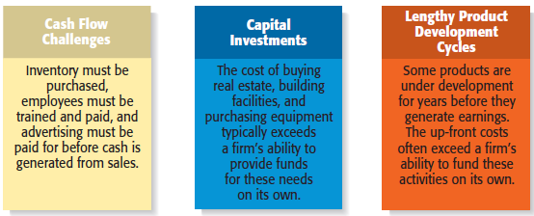

**Alternatives for Raising Money for a New Venture**

* **Personal Funds**
  + The vast majority of founders contribute personal funds, along with sweat equity, to their ventures.
    - Sweat equity represents the value of the time and effort that a founder puts into a new venture.
* **Friends and Family**

Friends and family are the second source of funds for many new ventures.

* **Bootstrapping**
  + A third source of seed money for a new venture is referred to as bootstrapping.
  + Bootstrapping is finding ways to avoid the need for external financing or funding through creativity, ingenuity, thriftiness, cost-cutting, or any means necessary.
  + Many entrepreneurs bootstrap out of necessity.

**Examples of Bootstrapping Methods**

* Buying used instead of new equipment.
* Coordinate purchases with other businesses
* Leasing equipment instead of buying.
* Obtaining payments in advance from customers.
* Minimizing personal expenses.
* Avoiding unnecessary Expenses.
* Buying items cheaply but prudently via options such as eBay.
* Sharing office space or employees with other Businesses.
* Hiring interns

**Preparing to Raise Debt or Equity Financing**

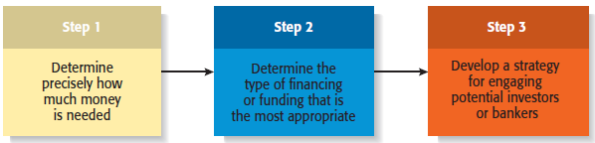

**Sources of Equity Funding**

* **Business Angels**
  + Are individuals who invest their personal capital directly in start-ups.
  + The prototypical business angel is about 50 years old, has high income and wealth, is well educated, has succeeded as an entrepreneur, and is interested in the startup process.
  + The number of angel investors in the U.S. has increased dramatically over the past decade.
  + Business angels are valuable because of their willingness to make relatively small investments.
  + Business angels are difficult to find.
* **Venture Capital**
  + Is money that is invested by venture-capital firms in start-ups and small businesses with exceptional growth potential.
* Venture-capital firms are limited partnerships of money managers who raise money in “funds” to invest in start-ups and growing firms.
* The funds, or pool of money, are raised from wealthy individuals, pension plans, university endowments, foreign investors, and similar sources.
  + Venture capital firms fund very few entrepreneurial firms in comparison to business angels.
    - Many entrepreneurs get discouraged when they are repeatedly rejected for venture capital funding, even though they may have an excellent business plan.
    - Venture capitalists are looking for the “home run” and so reject the majority of the proposals they consider.
    - Still, for the firms that qualify, venture capital is a viable alternative for equity funding.
  + An important part of obtaining venture-capital funding is going through the due diligence process:
  + Venture capitalists invest money in start-ups in “stages,” meaning that not all the money that is invested is disbursed at the same time.
  + Some venture capitalists also specialize in certain “stages” of funding.
* **Initial Public Offering**
  + An initial public offering (IPO) is a company’s first sale of stock to the public. When a company goes public, its stock is traded on one of the major stock exchanges.
  + An IPO is an important milestone for a firm. Typically, a firm is not able to go public until it has demonstrated that it is viable and has a bright future.

**Reasons that Motivate Firms to Go Public**

* Is a way to raise equity capital to fund current and future operations.
* Raises a firm’s public profile, making it easier to attract high-quality customers and business partners.
* Is a liquidity event that provides a means for a company’s investors to recoup their investments.
* Creates a form of currency that can be used to grow the company via acquisitions

**8.3. Sources of Debt Financing**

* **Commercial Banks**
* **Banks**
  + Historically, commercial banks have not been viewed as a practical sources of financing for start-up firms.
  + This sentiment is not a knock against banks; it is just that banks are risk adverse, and financing start-ups is a risky business.
    - Banks are interested in firms that have a strong cash flow, low leverage, audited financials, good management, and a healthy balance sheet.
* **Other Sources of Debt Financing**
* **Vendor credit**

(also known as trade credit) is when a vendor extends credit to a business in order to allow the business to buy its products and/or services up front but defer payment until later.

* **Factoring**

is a financial transaction whereby a business sells its accounts receivable to a third party, called a factor, at a discount in exchange for cash

* **Peer-to-peer lending**

is a financial transaction that occurs directly between individuals or “peers.” Prosper, which is the best known peer-to-peer lending network, is a Web site where individuals can buy loans and request to borrow money. Prosper evaluates the credit risk of individuals requesting loans, and then lists the loans for others to consider taking on. For the matches that are made, Prosper manages the loan repayment. The loans are unsecured loans that are fully amortized over a period of one, three, or five years.

* **Crowd funding**

is the modern-day version of “passing the hat.” Crowd funding sites allow entrepreneurs to create a profile, list their fund-raising goals, and provide an explanation of how the funds will be used.

**Creative Sources of Financing or Funding**

* **Leasing**
  + A lease is a written agreement in which the owner of a piece of property allows an individual or business to use the property for a specified period of time in exchange for payments.
  + The major advantage of leasing is that it enables a company to acquire the use of assets with very little or no down payment.
  + Most leases involve a modest down payment and monthly payments during the duration of the lease.
  + At the end of an equipment lease, the new venture typically has the option to stop using the equipment, purchase it for fair market value, or renew the lease.
  + Leasing is almost always more expensive than paying cash for an item, so most entrepreneurs think of leasing as an alternative to equity or debt financing.
* **Small Business Innovation Research Grants**
  + The Small Business Innovation Research (SBIR) and the Small Business Technology Transfer (STTR) programs are two important sources of early-stage funding for technology firms.
  + These programs provide cash grants to entrepreneurs who are working on projects in specific areas.
    - The main difference between the SBIR and the STTR programs is that the STTR program requires the participation of researchers working at universities or other research institutions.
  + The SBIR Program is a competitive grant program that provides over $1 billion per year to small businesses in early-stage and development projects.
  + Each year, 11 federal departments and agencies are required by the SBIR to reserve a portion of their R&D funds for awards to small businesses.
  + Guidelines for how to apply for the grants are provided on each agency’s Web site.
  + The SBIR is a three phase program, meaning that firms that qualify have the potential to receive more than one grant to fund a particular proposal.
  + Historically, less than 15% of all phase I proposals are funded. The payoff for successful proposals, however, is high.
    - The money is essentially free. It is a grant, meaning that it doesn’t have to be paid back and no equity in the firm is at stake.

The small business receiving the grant also retains the rights to any intellectual property generated as the result of the grant initiative.

* **Other Grant Programs**
* Private Grants
  + There are a limited number of grants programs available.
  + Getting grants takes a little detective work.
  + Granting agencies are low key, and must be sought out.
* Other Government Grants
  + The federal government has grant programs beyond the SBIR and STTR programs.
  + The full spectrum of grants available is listed at [www.grants.gov](http://www.grants.gov/).
* Be careful of grant-related scams.
* **Strategic Partners**
  + Strategic partners are another source of capital for new ventures.
  + Many partnerships are formed to share the costs of product or service development, to gain access to particular resources, or to facilitate speed to market.
  + Older established firms benefit by partnering with young entrepreneurial firms by gaining access to their creative ideas and entrepreneurial spirit.
* Biotech firm often partner with large drug companies to conduct clinical trials and bring new products to market.
* The biotech firms benefit by obtaining funding from their partners, and the partners benefit by having additional products to sell.

**Chapter 9: Unique Marketing Issues**

**Chapter Objectives**

* Explain the purpose of market segmentation.
* Describe the importance of selecting a target market.
* Explain why it’s important for a start-up to establish a unique position in its target market.
* Describe the importance of the ability to position a company’s products on benefits rather than features.
* Illustrate the two major ways in which a company builds a brand.
* Identify the four components of the marketing mix.
* Explain the difference between a core product and an actual product.
* Contrast cost-based pricing and value-based pricing.
* Explain the differences between advertising and public relations.
* Weigh the advantages and disadvantages of selling direct versus selling through intermediaries.

**9.1. Selecting a Market and Establishing a Position in the Market**

* Important Questions That All Startups Must Ask
  + In order to succeed, a new firm must address this important issue: Who are our customers are how will we appeal to them?
  + A well-managed start-up approaches this query by following a three-step process:
    - Segmenting the market.
    - Selecting a target market.
    - Establishing a unique position in the target market

**The Process of Selecting a Target Market and Positioning Strategy**

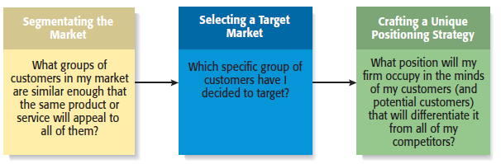

**Segmenting the Market**

* Involves studying a firm’s industry and determining the different target markets in that

industry.

* Markets can be segmented in a number of different ways, including

- Product type

- Price point

- Customers served

**Selecting a Target Market**

**Target Market**

* Once a firm has segmented the market, a target market must be chosen.
* The market must be sufficiently attractive and the firm must have the capability to serve it.
* The Net book segment of the computer industry is new, and is being targeted by startups like Eee PC.

**Establishing a Unique Position**

**Positioning**

* After selecting a target market, the firm’s next step is to establish a “position” within the market that differentiates it from its rivals.
* A “position” is the part of a market that the firm is claiming as its own.
* A firm establishing a unique position in its customers’ minds by drawing attention to two or three of the product’s attributes
* Firms often develop a “tagline” to reinforce the position they have staked out in their market, or a phrase that is used consistently in a company’s literature and thus becomes associated with the company.
* An example is Nike’s familiar tagline, “Just do it.”

**Selling Benefits Rather Than Features**

* Selling Benefits Rather Than Features
  + Many entrepreneurs make the mistake of positioning their company’s products or services on features rather than benefits.
  + A positioning or marketing strategy that focuses on the features of a product, such as its technical merits, is usually much less effective than a campaign focusing on what the merits of the product can do.
  + Consider the example of the following slide.

**Two difference approaches to promoting a cell phone**

|  |  |
| --- | --- |
| Approach | Illustration |
| Selling Features | “Our cell phones are equipped with sufficient memory to store 1,000 phone numbers.” |
| Selling Benefits | “Our cell phones let you store up to 1,000 phone numbers, providing you access to the phone numbers of your family, friends, and business acquaintances instantly. |
| Conclusion | The first statement tells a prospect how many phone numbers the cell phone will hold but doesn’t say why that’s important. The second statement tells a prospect how buying the product will enhance his or her life or business. |

**Establishing a Brand**

* **Establishing a Brand**
  + A brand is the set of attributes—positive or negative—that people associated with a company.
    - These attributes can be positive, such as trustworthy, dependable, or easy to deal with.
    - Or they can be negative, such as cheap, unreliable, or difficult to deal with.
  + The customer loyalty a company creates through its brand is one of its most valuable assets.
* **Brand Management**
* Some companies monitor the integrity of their brands through a program called “brand management.”

**Different Ways of Thinking about the Meaning of a Brand**

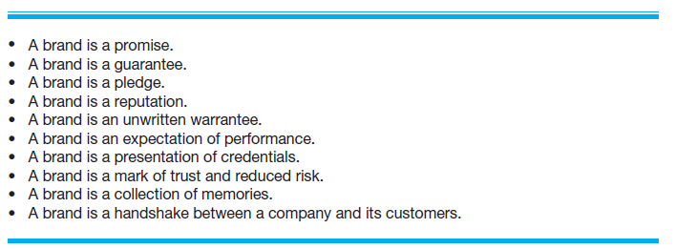

* Establishing a Brand
  + So how does a firm establish a brand?
    - On a philosophical level, a firm must have meaning in its customer’s lives. It must create value—something for which customers are willing to pay.
    - On a more practical level, brands are built through a number of techniques, including advertising, public relations, sponsorships, support of social causes, and good performance.
    - A firm’s name, logo, Web site design, and even its letterhead are part of its brand.
* Power of a Strong Brand
  + Ultimately, a strong brand can be a very powerful asset for a firm.
* Cobranding
  + A technique that companies use to strengthen their brands is to enter into a cobranding arrangements with other firms.
* Cobranding refers to a relationship between two or more firms where the firm’s brands promote each another.

**The Four Ps of Marketing for New Ventures**

* **Product**
  + Is the good or service a firm offers to its target market.
  + The initial rollout is one of the most critical times in the marketing of a new product.
  + All firms face the challenge that they are unknown and that it takes a leap of faith for the first customers to buy their products.
    - Some startups meet this challenge by using reference accounts.
* **Price**
  + Price is the amount of money consumers pay to buy a product.
  + The price a company charges for its products sends an important message to its target market.
    - For example, Oakley positions its sunglasses as innovative, state-of-the-art products that are both high quality and visually appealing.
    - This position in the market suggests a premium price that Oakley charges.
  + Most entrepreneurs use one of two methods to set the price for their products, as shown on the next slide.
* **Promotion**
  + Refers to the activities the firm takes to communicate the merits of its product to its target market.
  + There are several common activities that entrepreneurs use to promote their products and services.
* Advertising
* Advertising is making people aware of a product or service in hopes of persuading them to buy it.

**Place (or Distribution)**

* + Encompasses all the activities that move a firm’s product from its place of origin to the consumer.
  + The first choice a firm has to make regarding distribution is whether to sell its products directly to consumers or through intermediaries (such as wholesalers and retailers).
  + Within most industries, both choices are available, so the decision typically depends on how a firm believes its target market wants to buy its product.

**Chapter 10 Preparing the Proper Ethical and Legal Foundation**

**Chapter Objectives**

* Describe how to create a strong ethical culture in an entrepreneurial venture.
* Explain the importance of “leading by example” in terms of establishing a strong ethical culture in a firm.
* Explain the importance of having a code of conduct and an ethics training program.
* Explain the criteria important to selecting an attorney for a new firm.
* Discuss the importance of a founder’s agreement.
* Provide several suggestions for how entrepreneurial firms can avoid litigation.
* Discuss the importance of nondisclosure and noncompete agreements.
* Provide an overview of the business licenses and business permits that a start-up must obtain before it starts conducting business.
* Discuss the differences among sole proprietorships, partnerships, corporations, and limited liability companies.
* Explain why most fast-growth entrepreneurial ventures organize as corporations or limited liability companies rather than sole proprietorships or partnerships.

**10.1. Initial Ethical and Legal Issues Facing a New Firm**

* Establishing a strong ethical culture
* Lead By Example
  + The most important thing that any entrepreneur, or team of entrepreneurs, can do to build a strong ethical culture in their organization is to lead by example.
* Establish a Code of Conduct
  + A code of conduct (or code of ethics) is a formal statement of an organization’s values on certain ethical and social issues.
* Implement an Ethics Training Program
  + Ethics training programs teach business ethics to help employees deal with ethical dilemmas and improve their overall ethical conduct.
  + An ethical dilemma is a situation that involves doing something that is beneficial to oneself or the organization, but may be unethical.

**Potential Payoffs for Establishing a Strong Ethical Culture**

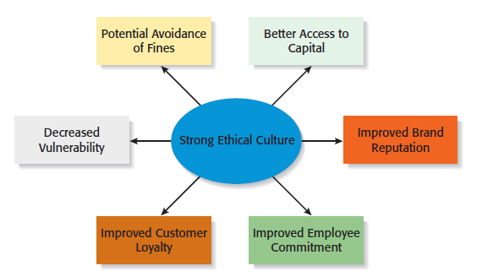

* Choosing an attorney
* Select an Attorney Early
  + It is important for an entrepreneur to select an attorney as early as possible when developing a business venture.
  + It is critically important that the attorney be familiar with startup issues.
* Intellectual Property
* For issues dealing with intellectual property (patents, trademarks, copyrights, and trade secrets) it is essential to use an attorney who specializes in this field.

**How to Select an Attorney**

* Contact the local bar association and ask for a list of attorneys who specialize in start-ups in your area.
* Interview several attorneys.
* Select an attorney who is familiar with the start-up process.
* Select an attorney who can assist you in raising money for your new venture.
* Make sure your attorney has a track record of completing his or her work on time.
* Talk about fees.
* Select an attorney that you think understands your business.
* Learn as much about the process of starting a business yourself as possible.
* **Drafting a founder’s agreement**
  + A founder’s agreement (or shareholders’ agreement) is a written document that deals with issues such as the relative split of the equity among the founders of the firm, how individual founders will be compensated for the cash or the “sweat equity” they put into the firm, and how long the founders will have to remain with the firm for their shares to fully vest.
  + The items to include in the founders agreement are shown on the following slide.

Items to Include in a Founders’ Agreement

* Nature of the prospective business.
* A brief business plan.
* Identity and proposed titles of the founders.
* Legal form of business ownership.
* Apportionment of stock.
* Consideration paid for stock or ownership share of each of the founders.
* Identification of any intellectual property signed over to the business.
* Description of the initial operating capital.
* Buyback clause.
* **Avoiding legal disputes**
  + Most legal disputes are the result of misunderstandings, sloppiness, or a simple lack of knowledge of the law. Getting bogged down in legal disputes is something an entrepreneur should work hard to avoid.
  + There are several steps that an entrepreneur can take to avoid legal disputes:
    - Meet all contractual obligations.
    - Avoid undercapitalization.
    - Get everything in writing.
    - Set standards.
* **Obtaining business licenses and permits**
  + In most communities, a business needs a license to operate.
  + If the business will be run out of the founder’s home, a separate home occupation business license is often required.
  + If a business has employees, or is a corporation, limited liability company, or limited partnership, it will usually need a state business license in addition to its local one.
  + A narrow group of companies are required to have a federal business license, including investment advising, drug manufacturing, and interstate trucking.
  + Along with obtaining the appropriate licenses, some businesses may need to obtain one or more permits.
  + The need to obtain a permit depends on the nature and location of the business.
    - If you plan to sell food, you’ll need a city or county health permit.
    - If your business is open to the public, you may need a fire permit.
    - Some communities require businesses to obtain a license to put up a sign.
    - All businesses that plan to use a fictitious name need a fictitious business name permit.
* Choosing a form of business organization

**When a business is launched, a form of legal entity must be chosen. The most common legal entities are…**

* **Sole Proprietorship** 
  + The simplest form of business entity is the sole proprietorship.
  + A sole proprietorship is a form of business organization involving one person, and the person and the business are essentially the same.
  + A sole proprietorship is not a separate legal entity. The sole proprietor is responsible for all the liabilities of the business, and this is a significant drawback.

**Advantages of a Sole Proprietorship**

* Creating one is easy and inexpensive.
* The owner maintains complete control of the business and retains all of the profits.
* Business losses can be deducted against the sole proprietors other sources of income.
* It is not subject to double taxation (explained later).
* The business is easy to dissolve.

**Disadvantages of a Sole Proprietorship**

* Liability on the owners’ part is unlimited.
* The business relies on the skills and abilities of a single owner to be successful.

Of course, the owner can hire employees who have additional skills and abilities.

* Raising capital can be difficult.
* The business ends at the owner’s death or loss of interest in the business.
* The liquidity of the owner’s investment is low.
* **Partnerships** 
  + If two or more people start a business, they must organize as a partnership, corporation, or limited liability company.
  + Partnerships are organized as either general or limited liability partnerships.

**General Partnership**

* A form of business organization where two or more people pool their skills, abilities, and resources to run a business. The primary disadvantage is that all partners are liable for all the partnership’s debts and obligations.

**Limited Partnership**

* A modified form of general partnership.
* The major difference between the two is that a limited partnership includes two classes of owners: general partners and limited partners.
* The general partners are liable for the debts and obligations of the partnership, but the limited partners are only liable up to the amount of their investment.

Advantages of a General Partnership

* Creating one is relatively easy and inexpensive compared to a corporation or

limited liability company.

* The skills and abilities of more than one individual are available to the firm.
* Having more than one owner may make it easier to raise funds.
* Business losses can be deducted against the partners’ other sources of income.
* It is not subject to double taxation (explained later).

Disadvantages of a Partnership

* Liability on the part of each general partner is unlimited.
* The business relies on the skills and abilities of a fixed number of partners. Of

course, the owners can hire employees who have additional skills and abilities.

* Raising capital can be difficult.
* Because decision making among the partners is shared, disagreements can occur.
* The business ends with the death or withdrawal of one partner unless otherwise

stated in the partnership agreement.

* The liquidity of each partner’s investment is low.
* **Corporations**
  + A corporation is a separate legal entity organized under the authority of a state.
  + Corporations are organized as either C corporations or subchapter S corporations.
* C corporations are what most people think of when they hear the word “corporation.”
* Is a separate legal entity that, in the eyes of the law, is separate from its owners.
* In most cases a corporation shields its owners, who are called shareholders, from personal liability for the debts of the corporation.
* A corporation is governed by a board of directors, which is elected by the shareholders.
* A corporation is formed by filing articles of incorporation.
* A corporation is taxed as a separate legal entity.
* A disadvantage of a C corporation is that it is subject to double taxation.

This means that a corporation is taxed on its net income, and when the same income is distributed to shareholders in the form of dividends, the income is taxed again on the shareholders’ personal tax returns.

**Advantages of a C Corporation**

* Owners are liable only for the debts and obligations of the corporation up the

amount of their investment.

* The mechanics of raising capital is easier.
* No restrictions exist on the number of shareholders, which differs from

subchapter S corporations.

* Stock is liquid if traded on a major stock exchange.
* The ability to share stock with employees through stock options or other

incentive plans can be a powerful form of employee motivation.

* **Limited Liability Company**
* Is a form of business ownership that is rapidly gaining popularity in the

U.S.

* Along with the Subchapter S, it is a popular choice for start-up firms.
* The limited liability company combines the limited liability advantage of the

corporation with the tax advantages of a partnership.

* A limited liability company does not pay taxes. Profits and losses are passed through to the tax returns of the owners.

Advantages of a Limited Liability Company

* Members are liable for the debts and obligations of the business only up to the

amount of their investment.

* The number of shareholders is unlimited.
* An LLC can elect to be taxed as a sole proprietor, partnership, S corporation,

or corporation, providing much flexibility.

* Because profits are taxed only at the shareholder level, there is no double

taxation.

**Disadvantages of a Limited Liability Company**

* Setting up and maintaining one is more difficult and expensive.
* Tax accounting can be complicated.
* Some of the regulations governing LLCs vary by state.
* Because LLCs are a relatively new type of business entity, there is not as much legal precedent available for owners to anticipate how legal disputes might affect their business.
* Some states levy a franchise tax on LLCs—which is essentially a fee the LLC pays the state for the benefit of limited liability.

**Chapter 11: Strategies for Firm Growth**

**Chapter Objectives**

* Explain the difference between internal growth strategies and external growth strategies.
* Identify the keys to effective new product development.
* Explain the common reasons new products fail.
* Discuss a market penetration strategy.
* Explain “international new venture” and describe its importance to entrepreneurial firms.
* Discuss the objectives a company can achieve by acquiring another business.
* Identify a promising acquisition candidate’s characteristics.
* Explain “licensing” and how it can be used as a growth strategy.
* Explain “strategic alliances” and describe the difference between technological alliances and marketing alliances.
* Explain “joint ventures,” and describe the difference between a scale joint venture and a link joint venture.

**Internal and External Growth Strategies**

|  |  |
| --- | --- |
| **Internal Growth Strategies** | **External Growth Strategies** |
| Involve efforts taken within the firm itself, such as new product development, other product related strategies, and international expansion. | Rely on establishing relationships with third parties, such as mergers, acquisitions, strategic alliances, joint ventures, licensing, and franchising. |

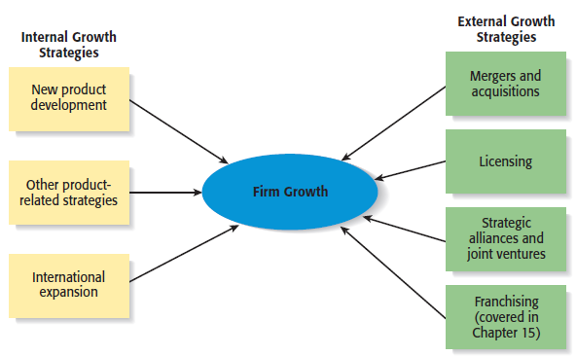

**11.1. Internal Growth Strategies**

* New product development
* Other product-related strategies
* International expansion

**Advantages and Disadvantages of Internal Growth Strategies**

|  |  |
| --- | --- |
| **Advantages**   * Incremental, even-paced growth. * Provides maximum control. * Preserves organizational culture. * Encourages internal entrepreneurship. * Allows firms to promote from within**.** | **Disadvantages**   * Slow form of growth. * Need to develop new resources. * Investment in a failed internal growth * Strategy can be difficult to recoup. * Adds to industry capacity. |

* **New Product Development**
  + Involves the creation and sale of new products (or services) as a means of increasing firm revenues.
  + In many fast-paced industries, new product development is a competitive necessity.
    - For example, the average product life cycle in the computer software industry is 14 to 16 months.

**Keys to Effective New Product and Service Development**

* Find a niche and fill it.
* Develop products that add value.
* Get quality right and pricing right.
* Focus on a specific target market.
* Conduct ongoing feasibility analysis.

**Common Reasons That New Products Fail**

* Inadequate feasibility analysis.
* Overestimation of market potential.
* Bad timing.
* Inadequate advertising and promotions.
* Poor service.
* **Other Product Related Strategies**

|  |  |
| --- | --- |
| **Product Strategy** | **Description** |
| Improving an Existing Product or Service | Often a business can increase its revenues by simply increasing the quality of an existing product or service. |
| Increasing Market Penetration | Increasing the sales of a product or service through greater marketing efforts or through increased production capacity. |
| Extending Product Lines | Making additional variations of a product so it will appeal to a broader range of clientele. |
| Geographic Expansion | Growth via expanding to additional geographic locations |

* **International Expansion**
  + Another common form of growth for entrepreneurial firms.
  + International new ventures are businesses that, from their inception, seek to derive significant competitive advantage by using their resources to sell products or services in multiple countries.
  + Although there is vast potential associated with selling overseas, it is a fairly complex form of growth.
* **Foreign-Market Entry Strategies**
  + **Exporting**
    - Producing a product at home and shipping it to a foreign market.
  + **Licensing**
    - An arrangement whereby a firm with the proprietary rights to a product grants permission to another firm to manufacture that product for specified royalties or other payments.
  + **Joint Ventures**
    - Involves the establishment of a firm that is jointly owned by two or more otherwise independent firms.
      * Fuji-Xerox is a joint venture between an American and a Japanese company.
  + **Franchising**
    - An agreement between a franchisor (a company like McDonald’s Inc., that has an established business method and brand) and a franchisee (the owner of one or more McDonald’s restaurants).
  + **Turnkey Project**
    - A contractor from one country builds a facility in another country, trains the personnel that will operate the facility, and turns over the keys to the project when it is completed and ready to operate.
  + **Wholly Owned Subsidiary**
    - A company that has made the decision to manufacture a product in a foreign country and establish a permanent presence.

**11.2. External Growth Strategies**

* **Mergers and Acquisitions**
* **Licensing**
* **Strategic Alliances and Joint Ventures**
* **Franchising**

**Advantages and Disadvantages of External Growth Strategies**

**Advantages**

* Reducing competition.
* Access to proprietary products.
* Gaining access to new products.
* Gaining access to new markets.
* Access to technical expertise.
* Access to an established brand name.
* Economies of scale.
* Diversification of business risk.

**Disadvantages**

* Incompatibility of top management.
* Clash of corporate cultures.
* Operational problems.
* Increased business complexity.
* Loss of organizational flexibility.
* Antitrust implications.
* **Mergers and Acquisitions**
  + An acquisition is the outright purchase of one firm by another .
  + A merger is the pooling of interests to combine two or more firms into one.
* Purpose of Acquisitions
  + Acquiring another business can fulfill several of a company’s needs, such as:
    - Expanding its product line.
    - Gaining access to distribution channels.
    - Achieving competitive economies of scale.
* **Licensing**
  + The granting of permission by one company to another company to use a specific form of its intellectual property under clearly defined conditions.
  + Virtually any intellectual property a company owns that is protected by a patent, trademark, or copyright can be licensed to a third party.
* Licensing Agreement
  + The terms of a license are spelled out by a licensing agreement.

**Type of Licensing**

1. **Technology Licensing**: The licensing of proprietary technology that the licensor typically controls by virtue of a utility patent
2. **Merchandise and Character Licensing:** The licensing of a recognized trademark or brand that the licensor typically controls through a trademark or copyright.

**Strategic Alliances**

* + A strategic alliance is a partnership between two or more firms developed to achieve a specific goal.
  + Strategic alliances tend to be informal and do not involve the creation of a new entity.
  + Participating in strategic alliances can boost a firm’s rate of product innovation and foreign sales.

**Type of Alliance**

1. **Technological Alliances:** Feature cooperation in R&D, engineering, and manufacturing.
2. **Marketing Alliances:** Typically match a company with excess distribution capacity with a company that has a product to sell.

* **Joint Ventures**
  + A joint venture is an entity created when two or more firms pool a portion of their resources to create a separate, jointly owned organization.
  + A common reason to form a joint venture is to gain access to a foreign market. In these cases, the joint venture typically consists of the firm trying to reach a foreign market and one or more local partners.

**Type of Joint Venture**

1. **Scale Joint Venture:** Partners collaborate at a single point in the value chain to gain economies of scale in production or distribution.
2. **Link Joint Venture:** Positions of the partners are not symmetrical, and the partners help each other access adjacent links in the value chain.

**Advantages and Disadvantages of Participating in Strategic Alliances and Joint Ventures**

|  |  |
| --- | --- |
| **Advantages** | **Disadvantages** |
| * Gain access to a specific resource. * Economies of scale. * Risk and cost sharing. * Gain access to a foreign market. * Learning. * Speed to market. * Neutralizing competitors. * Blocking competitors. | * Loss of proprietary information. * Management complexities. * Financial and organizational risks. * Risk becoming depending on a partner. * Partial loss of decision autonomy. * Partners’ cultures may clash. * Loss of organizational flexibility. |