**GTICKET SCHEDULING**

**by**

**Yusuf Emirhan Şahin**

**Mehmethan Turan**

**Rıdvan Batuhan Arkan**

**CSE 331 Operating Systems Design**

**Term Project Report**

**Yeditepe University**

**Faculty of Engineering**

**Department of Computer Engineering**

**Spring 2020**

**ABSTRACT**

With multiprogramming and multithreading come to computer world scheduling become very significant part of operating system. Computer’s perform rely on mostly scheduling algorithm that decide which process or thread execute or wait. This paper we are going to analyze computer performance with different scheduling algorithm and compare their performance.

**TABLE OF CONTENTS**

**INTRODUCTION**4

**DESIGN and IMPLEMENTATION**6

**TESTS and RESULTS**9

**CONCLUSION**10

**REFERENCES**11

# INTRODUCTION

In this project our group will change our normal scheduling policy in Linux Kernel 2.4.20 to the GTicket scheduling policy. We used Linux Kernel 2.4.20 since its ease of understanding and implementation of our scheduling policy. The scheduler is the part of an operating system that governs the process queue, which determines what to run next. By deciding what process can run, the scheduler is responsible for best utilizing the system and giving the impression that multiple processes are simultaneously executing.

GTicket scheduling is a type of a process scheduling that runs quite different from native Linux scheduler. In the native scheduler, the scheduler governs processes fairly. In our scheduler we take a different look at our fairness, and instead of running processes fairly, we give our user groups a fair way of schedule policy. For our team, each process starts with 8 tickets. Each process can hold minimum of 1 ticket and maximum of 15 tickets. When the scheduler selects the next process what it does is first gets the maximum ticket count of the processes, and after taking the maximum value, it selects a random value between 1 to maximum ticket value. After all of that we finally select the next process by selecting a process in line that has bigger value of tickets than our random value.

The kernel stores the list of processes in a circular doubly linked list called the task_list. Each element in the task list is a process descriptor of the struct task_struct, which is defined in <linux/sched.h>. The task structure contains all the information about a specific process. We want to change to linux scheduling policy into lottery scheduling policy we need to create ticket number integer variable in task_struct and initialize it 8 when process instantly created, in fork.c.

We don’t want to delete the native scheduling policy, because we want to compare it to GTicket and get to a conclusion. We created a system call named pteamt and initialized a value named gticket_policy in it to switch between the scheduler policies.

# DESIGN and IMPLEMENTATION

* 1. **Changes in <sched.h>**

In sched.h we need to declare all the variables that we are going to use in our scheduler. Because in our scheduling policy, we give every process a ticket, unlike the native scheduler. That’s why we initialize our ticket number as nr_tickets. After that we also declare the last_reached and group_flag variables. We’ll talk about group_flag in detail at 2.3 of our report.

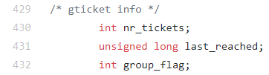

The reason why we declare our last_reached variable is that we use jiffies in our scheduler, which has the type unsigned long.

* 1. **Changes in <fork.c>**

In fork.c we need to add few variables in order to use our scheduler policy. Fork.c initiates all the important variables for us. When a new process is created, we define the number of tickets that it has as 8. We also define the last_reached variable as jiffies. And at last we declare the group_flag as 0.

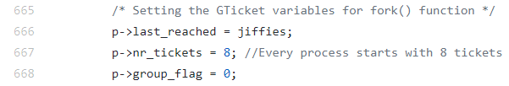

The reason why we set numbers in the pointer p is that the fork.c declares our task_struct as p in our do_fork() function. We are also going to use task_struct in sched.c, because all processes does contain task_struct.

* 1. **Changes in <sched.c>**

After we design and implement what we did on 2.1 and 2.2 we started to alter our standard scheduler. First of all, we need to add a flag to choose which scheduler to work, so we declare our flag variable in line 43 and check it on line 610.



C:\Users\Yusuf\AppData\Local\Microsoft\Windows\INetCache\Content.Word\Ek Açıklama 2020-05-20 041623.png

If gticket_policy is 0, we’ll use the standard schedule policy, and if it’s 1 we’ll use GTicket schedule policy.

After we switch to GTicket scheduler, what we do first is that we update our ticket values.

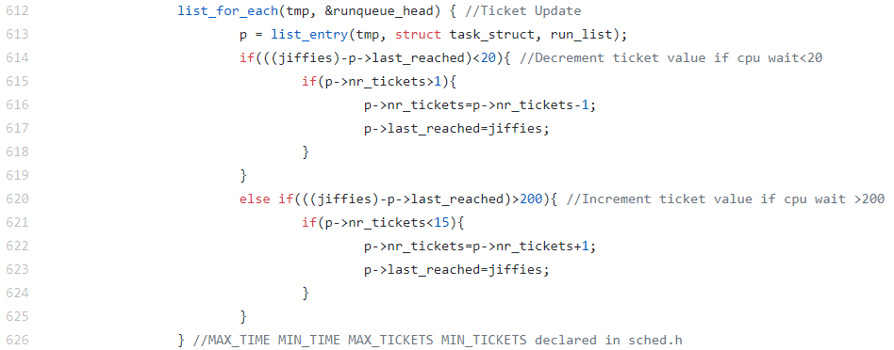

In 612 we say to the scheduler that we want to do a loop in our run_list and look at every processes last_reached value. If the process were to be wait less than 20 ms and has more than 1 ticket, we decrement a ticket from it. If the process were to be wait more than 200 ms and has less than 15 ticket we increment a ticket from it. We also reset the last_reached value after setting the ticket values.

In 628 we declare our maxticketvalue as 1 and gflagsum as 0. It’ll be useful on the next parts of our scheduler design.

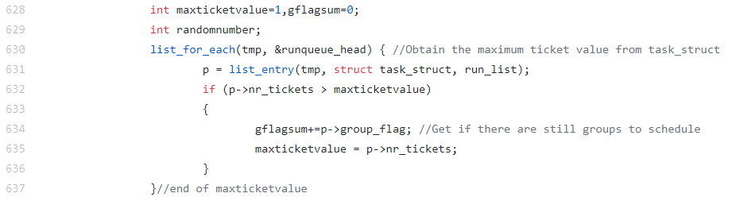

If the number of tickets in a specific process is more than maxticketvalue, we will assign the value of it to maxticketvalue.

Whilst we are looping in the run_list, we also sum all of the group_flag variables in gflagsum because of the next part of our code:

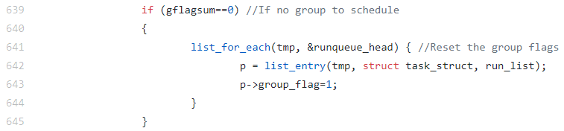

After we get the summation of all the group flags we’ll check if it’s equal to zero. We do this because if there is no group to schedule next, we won’t be able to run our processes. If all of the group flags are 0, we’ll set them 1 on all of them in lines 641 to 644.

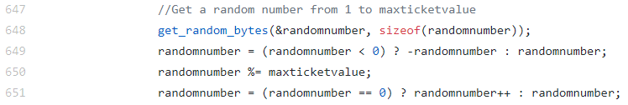

In line 647 we start to get a random value. Using get_random_bytes() function in line 648 we assign a random number in our variable randomvariable. In line 649, we check if it’s negative or not, we don’t want a number that’s negative. We also use modulus to get a number from 0 to our maxticketvalue number. Because a random number can be anything. And at last in line 651 we check if our randomnumber is 0 or not, we also don’t want a random variable that equals to 0.

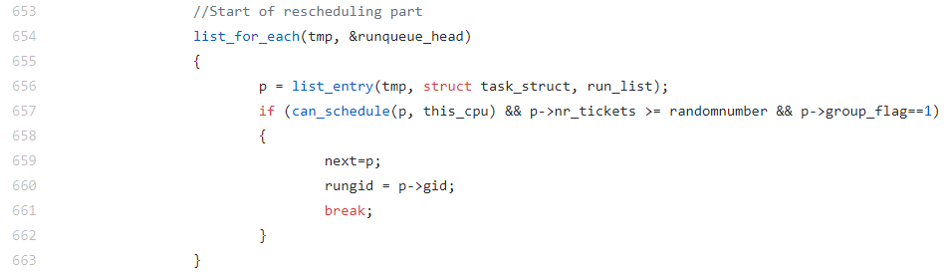

At line 654 we come to our rescheduling part of the code. This is the most important part of our scheduler. We check if a process is in the ready queue, the number of tickets of it are bigger than our random value and also check if the group flag of our contestant process is 1 at line 657. If a process can meet all of these criteria, we declare the next process as it in line 659. We also get the user group id of this process in line 660, and break from our loop.

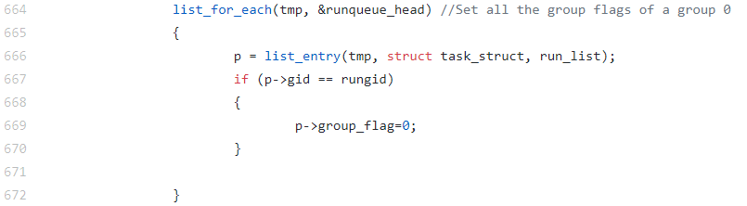

In this last part we just set all of the processes that has the same user group id with the process that we selected to 0. The line 664 to 672 shows the process



Our variable rungid is declared in line 558 of sched.c. It has the type gid_t because in the task_struct of every process we contain them with the same variable type.

# TESTS and RESULTS

# CONCLUSION

# REFERENCES