**The Vikings**

**Team Project Sprint 2 (TP-3.2)**

**Hotel Checking System (HCS)**

**Team members:**

**Biniam G Haile**

**Darius O. Nyaundi**

**Elvis A. Ndenge**

**Patrice A. Yemmene**

**Eyad Shesli**

# Vision Documents

Hotel Checking system (HCS) dated April 14, 2018.

## Introduction

We envision a Hotel Checking system (HCS) that Hotel employees will use to facilitate the check-in process of their guests, with membership-based priority. This system will be flexible to support varying business rules, a few user interface mechanisms (Front Desk, Housekeeping and In Room Dinning) and integration with third party systems (for example an online system that guests may use to book their room).

## Stakeholder Descriptions

* The patron wants fast check-in and membership consideration.
* The FrontDesk wants easier access to information on room status in order to provide customer satisfaction.
* HouseKeeping will like easier communication in notifying FrontDesk on room cleanliness and vacancy.
* InRoom-Dinning will also like easier communication when notifying FrontDesk on MiniBar status in a room.

## Market Demographics

This system is targeted at small, generally family owned Hotel businesses. Many of these may not have the financial power needed to buy systems that big players in the market can afford. Therefore, they will find the HCS convenient, reliable and affordable.

## Stakeholder (Non-User) summary

Mr. John and his family started a hotel business a few years ago, initially using their vacation town house. However, over the years, this has grown to be the largest Hotel in their small town, with 120 rooms located in five buildings, on 3,200 acres. Yet, check-in process has been manual. The motivation for the Hotel Checking System is to develop a web-based application (WebApp) that helps Mr. John and his family manage more efficiently and accurately the checking process of guests into their hotel. These non-user stakeholders of this system are members of the John family, who will see more efficiency in the management of the operations of their hotel business, and a greater return of their investments.

## Key High-Level Goals

* We need priority status for members.
* We need system manager for fast easy processing of room status.
* We need a solid interface for interaction between users.
* We need to identify status of members in system manager.
* We need quote time to room status updates (if possible) in system manager.
* We need Guest profiles within system.
* We need Mini bar and Room update entries connected to room status in system manager.

|  |  |  |  |
| --- | --- | --- | --- |
| High-level Goals | Priority | Problems and Concerns | Current Solution |
| Efficient and fast  management of  hotel staff and  equipment | High | Reduction of speed on  System data access due to increasingly large database. | Fast search algorithm and memory caching provides a solution. |
| Accurate Patron’s  Bookings | High | Inaccurate room availability search due to miscommunication. | Most rooms are available once the current patron is checked out in timely manner; however, rooms can be occupied for extended amount of time due to timely system update. This problem can be addressed by updating room status right after patron evacuates and cleaned. |
| Recognition of membership status | High | Rooms may not be assigned due to priority of membership. | Manage the membership (Gold, Silver and nonmember) and make sure rooms are assigned to top members first and bottom members last. |
| Easy access to room status. | High | Status of rooms need to be made in order for priority of members are checked in the quickest. | HouseKeeping is able to update status or room (VC, VD, OC). |
| Easy access to MiniBar status. | High | Status of MiniBar need to be made in order for priority of members are checked in the quickest | InRoom-Dinning will be able to update minibar status (MBNR, MBR). |

## User-Level Goals

**Front desk** – check in patron and checks system for room updates.

**Housekeeping** – updates check-in system on vacancy and cleanliness or room status.

**Patron** – checks in with front desk.

**RoomService** – updates check in system on restocking of minibar.

**System Manager** – manages update statuses of room availability.

**Check-in system**- has patron profile and patron status update for check in.

## Summary of System Features

The purpose of the project is to build a check in system for hotel operations. Guests will be checked in by the FrontDesk (worker) who will coordinate with housekeeping (worker) to insure the rooms are clean and ready for occupancy through the system. RoomService will check minibar in room and enters minibar status in system as well. Once rooms are clean and minibar restocked, FrontDesk will check each Guest club-status (gold, silver or none- member) and assign rooms by priority. If the room is not clean the Guest will have to wait based on priority status. There will be interactions between the <<Patrons>> <<FrontDesk>> <<RoomService>>and <<housekeeping>>. We will also incorporate an interface so that each of the users <<Patron>> <<FrontDesk>> <<RoomService>>and <<housekeeping>> may interact with each other the system as well. This system will assume that the Guest would have made a prior booking registration via an online system. In other words, this system may not manage walk-ins.

The user interface will be a graphical one, permitting complete navigation using keyboard , mouse combination.

## Glossary

|  |  |  |  |  |  |  |
| --- | --- | --- | --- | --- | --- | --- |
| Term | Description | Format | Range of Values | Validation Rules | Relationship to other elements | Aliases |
| FD | A hotel front desk agent represents the first point of contact with guests and handles all stages of a guest's stay. |  |  |  | Patron, FrontDesk, In-Room dinning, HouseKeeping, System | Front Desk |
| Patron | a customer of the hotel and a occupier of the Rooms |  |  |  | FrontDesk, Silver, Gold, None Member, Rooms |  |
| HK | are responsible for making sure all assigned areas of the room are clean, neat, and tidy. |  |  |  | Room, FrontDesk | HouseKeeping |
| MB | a refrigerator in a hotel room containing a selection of refreshments that are charged for on the bill if used by the occupant |  |  |  | In-Room Dinning | MiniBar |
| Manager | responsible for planning, directing and overseeing the operations |  |  |  | System |  |
| Gold | First Priority highest level of membership. |  |  |  | Patron |  |
| Silver | Second Priority second highest level of membership. |  |  |  | Patron |  |
| NM | Lowest of Priority not a in membership status. |  |  |  | Patron | None-Member |
| Transaction | an exchange or [transfer](https://www.merriam-webster.com/dictionary/transfer) of services |  |  |  | FrontDesk |  |
| Room | Space that can be occupied by Patrons. |  |  |  | HouseKeeping, Patron |  |
| VC | Status of the Room is empty and clean. |  |  |  | Room, Housekeeping, FrontDesk | Vacant-Clean |
| VD | Status of the Room is empty and Dirty. |  |  |  | Room, Housekeeping, FrontDesk | Vacant-Dirty |
| MBR | The MiniBar items are all restocked in MiniBar. |  |  |  | In-Room Dinning, FrontDesk | MiniBar-Restocked |
| MBNR | The MiniBar items are not all restocked in MiniBar. |  |  |  | In-Room Dinning, FrontDesk | MiniBar- Not Restocked |
| Interface | Allow for interaction between another system, person, organization, etc.. |  |  |  | All-CLasses |  |
| IRD | Takes care of all hotel food items in the Room. |  |  |  | MiniBar, FrontDesk | In-Room Dinning |
| System | a set of connected things or parts forming a complex whole, in particular. |  |  |  | FrontDesk, HouseKeeping, In-Room Dinning |  |
| RN | Gives the number of the room. |  |  |  | FrontDesk and HouseKeeping. | RoomNumber |
| ER | If a guest booked prior to stay. |  |  |  | FrontDesk, Manager, system. | ExistingReservations |
| CN | The number a guest receives once booked the room to identify that they are the ones who booked the room. |  |  |  | System, FrontDesk, Patron, System, Manager. | ConformationNunber |
| AN | Number of rooms available. |  |  |  | Manager, Rooms, FronDesk, System. | AvailabilityNumber |
| OC | Once room has a booking already on it or once someone is checked into room. |  |  |  | Rooms | Occupied |
| PR | Contains name and conformation of patron |  |  |  | FrontDesk, System. | PatronRecord |

## CLASS DOMAIN LIST FINAL

|  |  |
| --- | --- |
| Patron | Customer of the hotel and the occupier of the <<Room>>. |
| HouseKeeping | Checking of <<Room>> status and reporting status to <<FrontDesk>>. |
| InRoomDinning | Checking of <<Minibar>> and reports status to <<FrontDesk>>. |
| FrontDesk | **<<**ConformationNumber>> holder and <<Room>> status holder. Holds PatronRecord as well. |
| Rooms | identifies what status room is in VC, VD, AN. |
| MiniBar | Holds records ofMBNR, MBR |
| HCSApp | Containsinterface/ management/ system. |
| PatronRecord | Holds Name, membership status and ConformationNumber of patron. |
| Confirmation | Holds Patron details, as well as confirmation number |

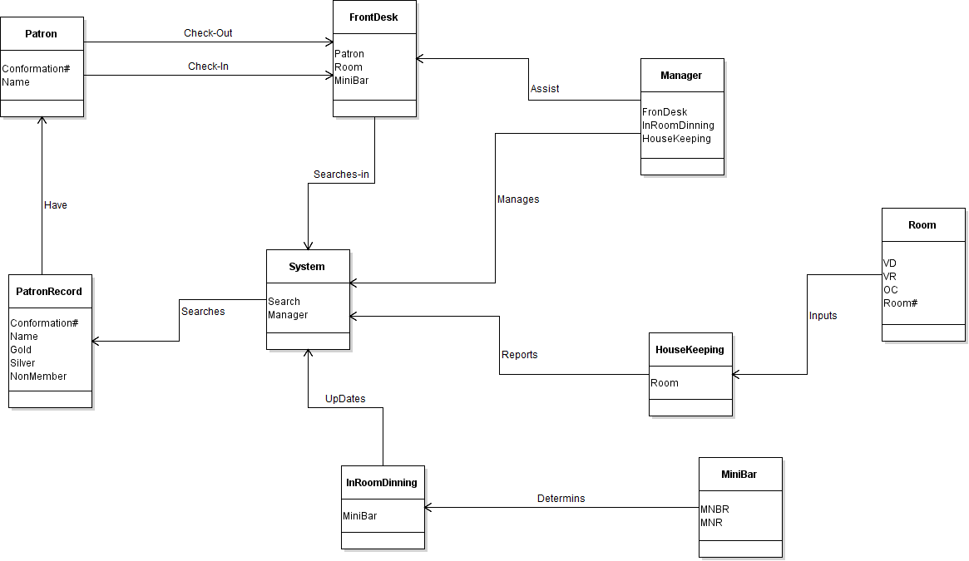

Patron  
- FirstName  
- LastName  
- Adress  
- Tel:  
- BookedDate  
-PatronId

Confirmation class  
- Status  
- patronFisrtName  
- patronLastName  
- confirmationDate  
- confirmationId

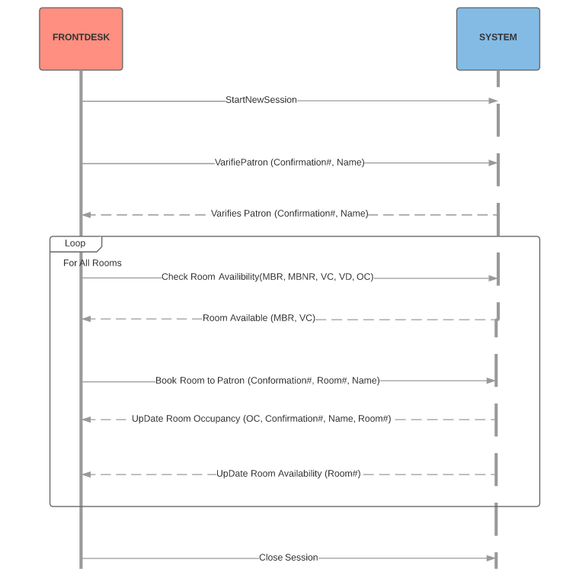

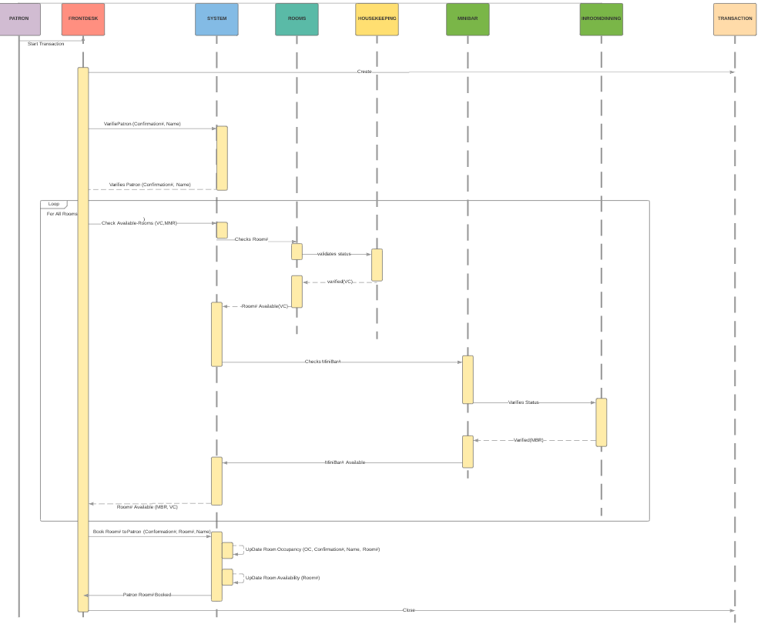

System Architecture Design