# The Problem

My friend Pino Bacinelo is the President and Managing Broker of Pacific M&A and Business Brokers Ltd. A business broker is the professional advisor/intermediary who helps business owners sell their business. If anyone reading this report is thinking of selling his business in British Columbia, Pino and his team are **the** go-to professionals.

For Business Brokers, Restaurants are perhaps the most vibrant sector. Thus, knowing where Restaurants are located and if there are areas of Restaurant concentration is very important information when searching for new clients.

Although Pino is a seasoned Professional and I am pretty sure that he knows the Vancouver landscape inside out, the information of Restaurants' locations will definitely be very important in the training and onboarding of new brokers.

***Pino my friend this is for you!!!***

# The Data

[Foursquare](https://foursquare.com/) is the most trusted, independent location data platform for understanding how people move through the real world.

From Foursquare we will get all the Restaurants in Vancouver and their coordinates, so that we can show their location on a map of the area. Showing every single Restaurant on the map will defeat the purpose. Instead, we will group them by neighborhoods and show which neighborhoods have the biggest concentration. We use postcodes to define neighborhoods.

The data for Postcodes, neighborhood names and coordinates were downloaded from the [GeoNames](https://www.geonames.org/) Postal Code Dataset.

We combined the information to obtain a count of Restaurants in each Vancouver Postal Code, and then grouped the neighborhoods into 4 groups,  
according to the Number of Restaurants.

# Methodology

Since the question is “where are restaurants concentrated” there was no need to invoke statistical inferencing or machine learning. A simple count and grouping were all that was needed.

Restaurants were grouped into 4 quartiles, instead of arbitrarily deciding the cut-off number for each category.

I did not include all “eating and drinking” places in the analysis. I tried to stay as close as possible to Full-Service Restaurants, so I included all venues with venue category that included the word “Restaurant” and added to them Pizza “places”, Burger and Fired Chicken “joints”, as well as Diners. From now on I refer to them as “Restaurants” (i.e., Restaurants within quotation marks)

I did not cross reference the Number of “Restaurants” with other data, e.g. frequency of visits or income per capita of each neighborhood. When we are looking for new listings and it is more than likely that we will be doing on-site cold calls, the number of establishments per inhabitant, or the income bracket of the neighborhood becomes irrelevant. We simply want to in the area where most Restaurants are located.

# Results

Overall, 30 Neighborhoods included venues that fitted my definition of “Restaurants”. The top 5 Neighborhoods were:

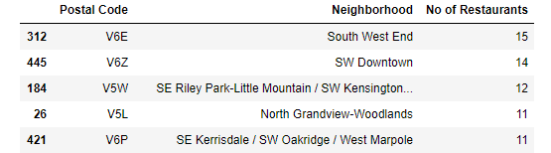

I grouped the neighborhoods into 4 Groups, according to the total Number of “Restaurants”, and color coded the groups. Superimposing the color-coded neighborhoods on the map of Vancouver, with the bigger marker representing a bigger number of “Restaurants”, gives a visualization of “Restaurant” concentration in Vancouver.

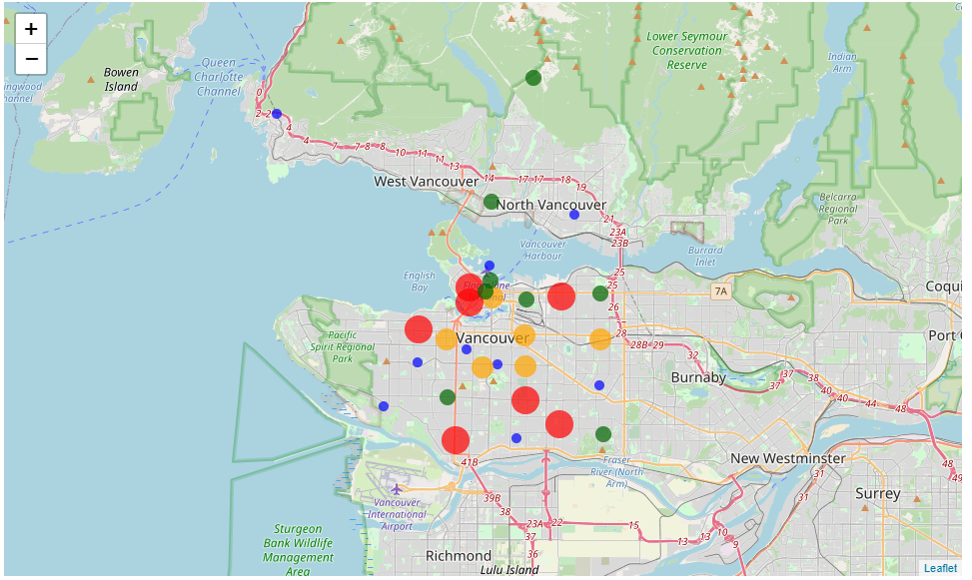

Two areas of concentration are readily notable from the map: the biggest one is close to the Harbour, and then the other one is further South with 3 Red bubbles surrounding a small blue dot. Going North of the Harbor to find “Restaurants” does not seem to be worth the trouble.

# Discussion

What if my definition of “Restaurants” is too restrictive? After all I have excluded bagels, donut stores, sandwiches and delis and a lot of other vibrant categories for business brokers. Well, that’s the beauty of Python, we can very easily change the definition of Restaurants and re-run the whole analysis!

In the entire Vancouver area, there are a total of 167 “Restaurants” (as defined for the purposes of this report), categorized by Foursquare in 36 different categories. Only 26 of those categories have more than one “Restaurant”. The Top 5 Restaurant types in Vancouver:

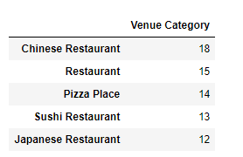

More Greek Restaurants in Vancouver than Italian? I would not have guessed!

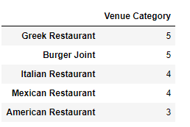

# Conclusion

For a business broker looking to get new clients from “Restaurants” the total game consists of 167 Restaurants. Good news is that they are mainly concentrated in 2 areas and this is where I would start from. But then again, my friend, you know much better.

To see the Number of “Restaurants” for all Vancouver Neighborhoods, the Number of Restaurants in Vancouver per type (and all the coding to get them) and a clickable map, click [HERE](https://nbviewer.jupyter.org/github/yempe/Capstone/blob/3e3e0d72b5782317306051f63bcc1cc1df32affd/capstone%20copy%201.ipynb).