

Lab 1: Create a Virtual machine in the portal

At the end of each lab, any resources you created in your account will be preserved. Some Azure resources, such as VM instances, may be automatically shut down, while other resources, such as storage services will be left running. Keep in mind that some Azure features cannot be stopped and can still incur charges (i.e. Azure Bastion). To minimize your costs, delete all resources and recreate them as needed to test your work during a session.

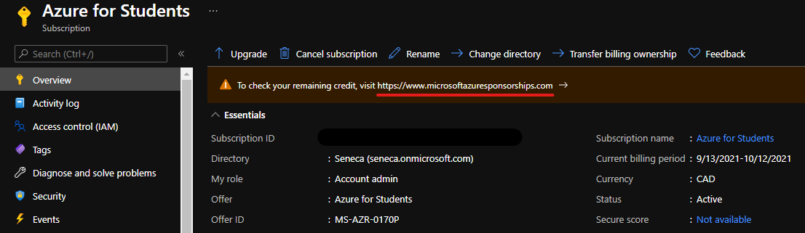

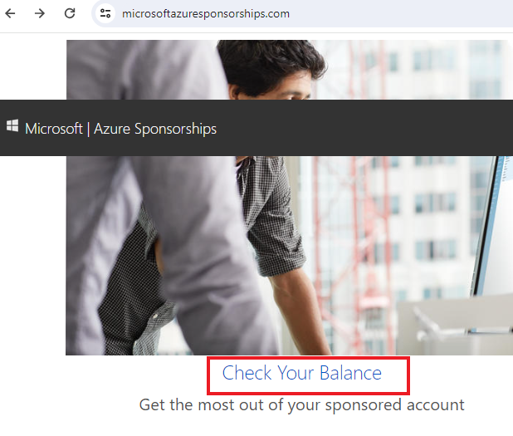

**Reference**: AZ-900T0X-MICROSOFTAZUREFUNDAMENTALS

# 01 - Create a virtual machine in the portal

In this walkthrough, we will create a virtual machine in the Azure portal, connect to the virtual machine, install the web server role and test.

**Note**: Take time during this walk-through to click and read the Informational icons.

# Task 1: Create the virtual machine (10 min)

In this task, we will create a Windows Server 2019 Datacenter – Gen1 vm virtual machine.

1. Sign in to the [Azure portal (https://portal.azure.com)](https://portal.azure.com/?azure-portal=true) with your **odl_user_xxx** azure account
2. From the **All services** blade, search for and select **Virtual machines**, and then click **+ Create and select Azure virtual machine**. On the **Basics** tab, fill in the following information (leave the defaults for everything else):

| Settings | Values |
| --- | --- |
| Subscription | **Choose your subscription (you should see “Seneca College : <course name>”)** |
| Resource group | **myRGVM** (create new) |
| Virtual machine name | **myVm** |
| Location | **(US) East US** |
| Availability options | **No Infrastucture redundancy required** |
| Security type | **Standard** |
| Image | **Windows Server 2019 Datacenter – x64 Gen2** |
| Size | Standard D2s v3 (Note: You may need to click in “See all sizes” |
| Administrator account username | **azureuser** |
| Administrator account password | **Pa$$w0rd1234** |
| Select inbound port | **RDP (3389)** and **HTTP (80)** |
|  |  |

1. Switch to the **Disk tab**, and look for the **OS disk type**:

| Settings | Values |
| --- | --- |
| OS disk type | **Standard HDD** (locally-redundant storage) |

1. Switch to the **Networking tab,** and look for the **Select inbound ports**:

| Settings | Values |
| --- | --- |
| Select inbound ports | **HTTP (80), RDP (3389)** |
|  |  |

1. **Note** - Verify that both port 80 and 3389 are selected
2. Switch to the **Monitoring** tab section, select the following setting:

| Settings | Values |
| --- | --- |
| Boot diagnostics | **Disable** |
|  |  |

1. Leave the remaining defaults and then click the **Review + create** button at the bottom of the page.
2. Once Validation is passed click the **Create** button. It can take anywhere from five to seven minutes to deploy the virtual machine.
3. You will receive updates on the deployment page and via the **Notifications** area (the bell icon in the top menu).

* **Verify Port 80 and 3389 were opened**

# Task 2: Connect to the virtual machine

In this task, we will connect to our new virtual machine using RDP.

1. Search for **myVM** and select your new virtual machine.

**Note**: You could also use the **Go to resource** link on the deployment page or the link to the resource in the **Notification** area.

1. On the virtual machine **Overview** blade, click the **Connect** button and choose **Download** **RDP file**. A **myVM.rdp** file should have been downloaded.

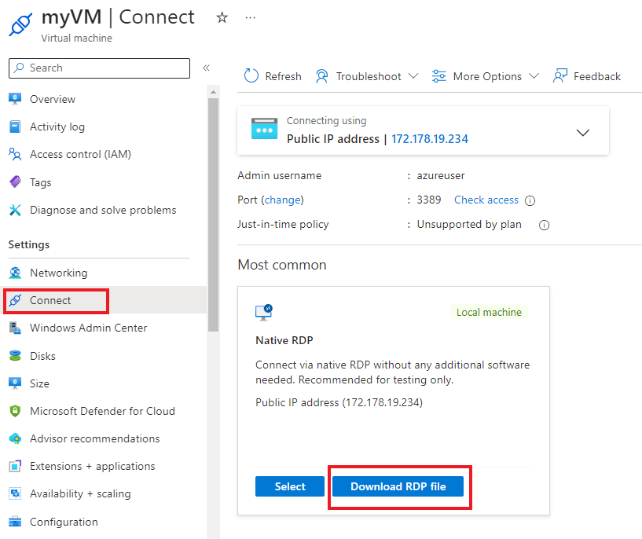

**Note**: The following directions tell you how to connect to your VM from a Windows computer. On a Mac, you need an RDP client such as this Remote Desktop Client from the Mac App Store and on a Linux computer you can use an open source RDP client.

1. **Open** the downloaded RDP file and click **Connect** when prompted (keep the default options to connect with the public IP address over port 3389).

[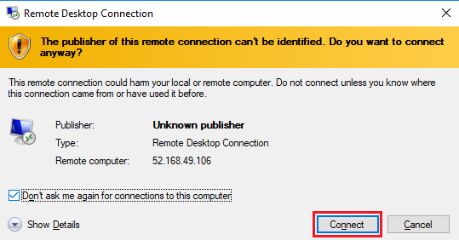](https://microsoftlearning.github.io/AZ-900T0x-MicrosoftAzureFundamentals/Instructions/images/0102.png)

1. In the **Windows Security** window, make sure that your user ID is **azureuser**. Use the password that selected during the configuration on Task 1 ( **Pa$$w0rd1234** ). Click **OK** to connect.

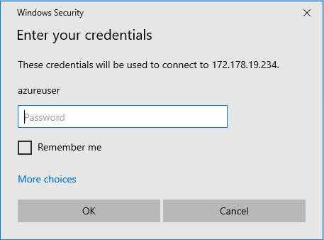

1. You may receive a certificate warning during the sign-in process. Click **Yes** or to create the connection and connect to your deployed VM. You should connect successfully.

[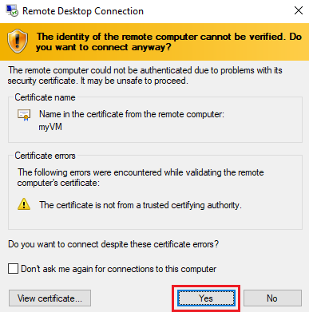](https://microsoftlearning.github.io/AZ-900T0x-MicrosoftAzureFundamentals/Instructions/images/0104.png)

Congratulations! You have deployed and connected to a Windows Server virtual machine in Azure

# Task 3: Install the web server role and test

In this task, install the Web Server role on the server and ensure the default IIS welcome page can be displayed.

1. Open up a PowerShell command prompt on the virtual machine, by clicking the **Start** button, typing **PowerShell**, right clicking **Windows PowerShell**, and selecting **Run as administrator** in the right-click menu.

[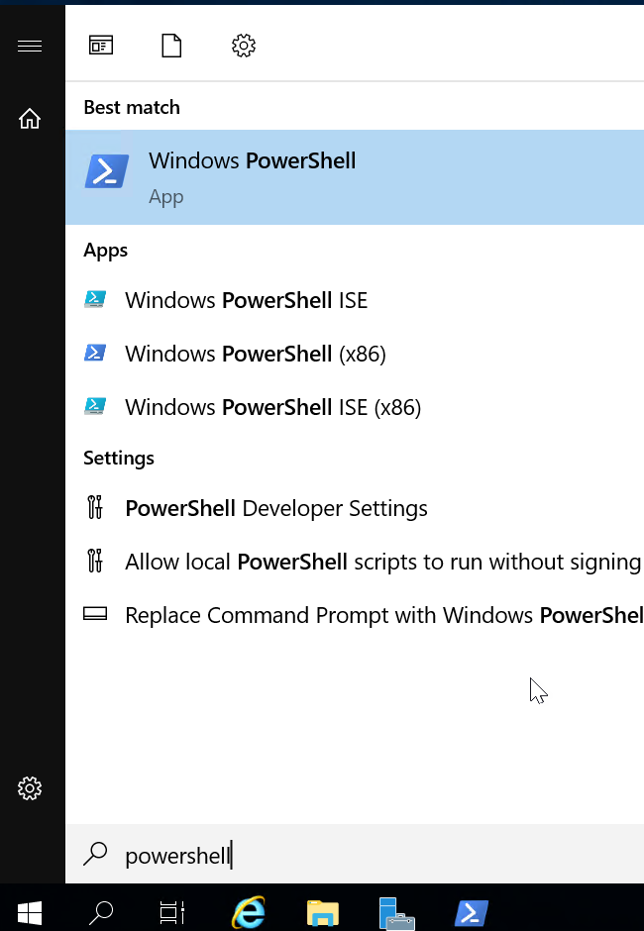](https://microsoftlearning.github.io/AZ-900T0x-MicrosoftAzureFundamentals/Instructions/images/0105.png)

1. Install the **Web-Server** feature in the virtual machine by running the following command in the PowerShell command prompt. You can copy and paste this command.

CodeCopy

Install-WindowsFeature -name Web-Server -IncludeManagementTools

1. When completed there will be a prompt stating **Success** with a value **True**. You do not need to restart the virtual machine to complete the installation. Close the RDP connection to the VM.

[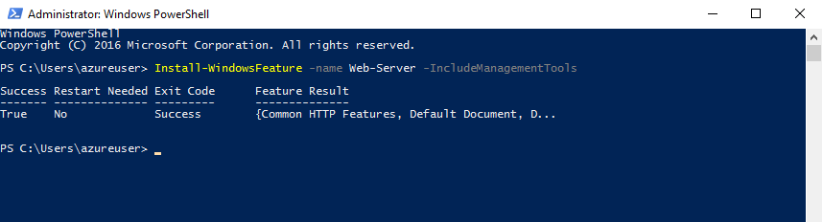](https://microsoftlearning.github.io/AZ-900T0x-MicrosoftAzureFundamentals/Instructions/images/0106.png)

1. Back in the portal, navigate back to the **Overview** blade of myVM and, use the **Click to clipboard** button to copy the public IP address of myVM, open a new browser tab, paste the public IP address into the URL text box, and press the **Enter** key to browse to it.

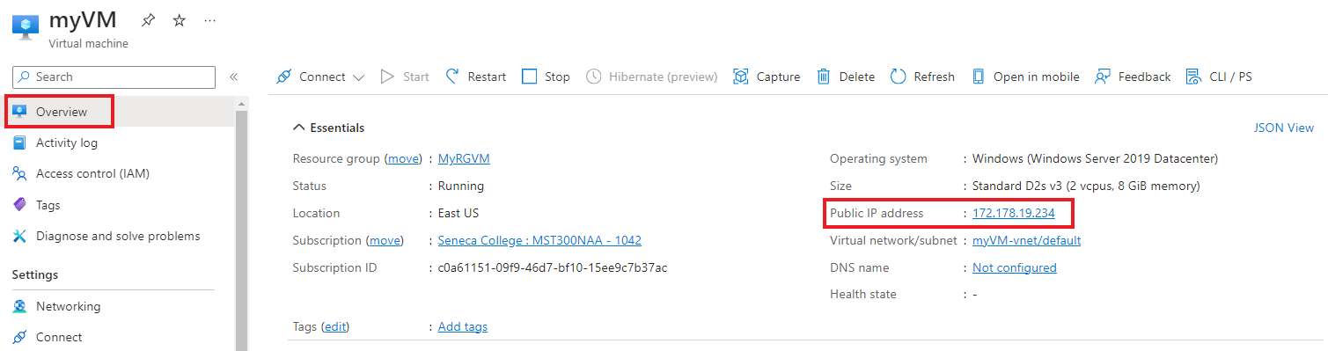

1. The default IIS Web Server welcome page will open.

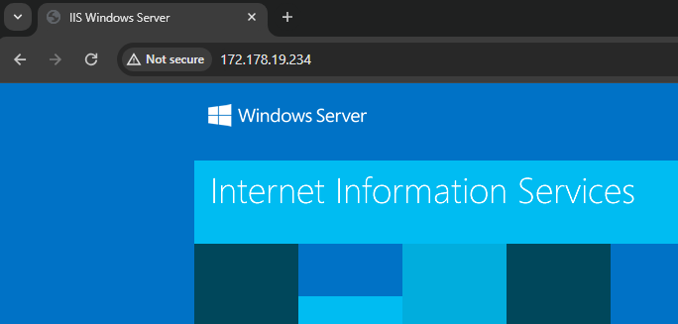

Modify the default website title to your student ID (i.e. dtrinh1) instead of “IIS Windows Server”.

Congratulations! You have created a web server that is accessible via its public IP address. If you had a web application to host, you could deploy application files to the virtual machine and host them for public access on the deployed virtual machine.

**Note**: To avoid additional costs, you must remove the resources within the resource group that you created for this lab ( **myRGVM** ) . Do not delete the default resource group that was provided with your **CloudLab** Account.

# Submission Requirements

Submit the following 3 screenshots with the required information:

**Screenshot #1:**

* Access to your webpage using an external IP address
* Webpage with the title modified to your student ID
* The Azure Portal with your **CloudLab Account** [requires another browser window]
  + **Note**: underline the above items as described in the below picture

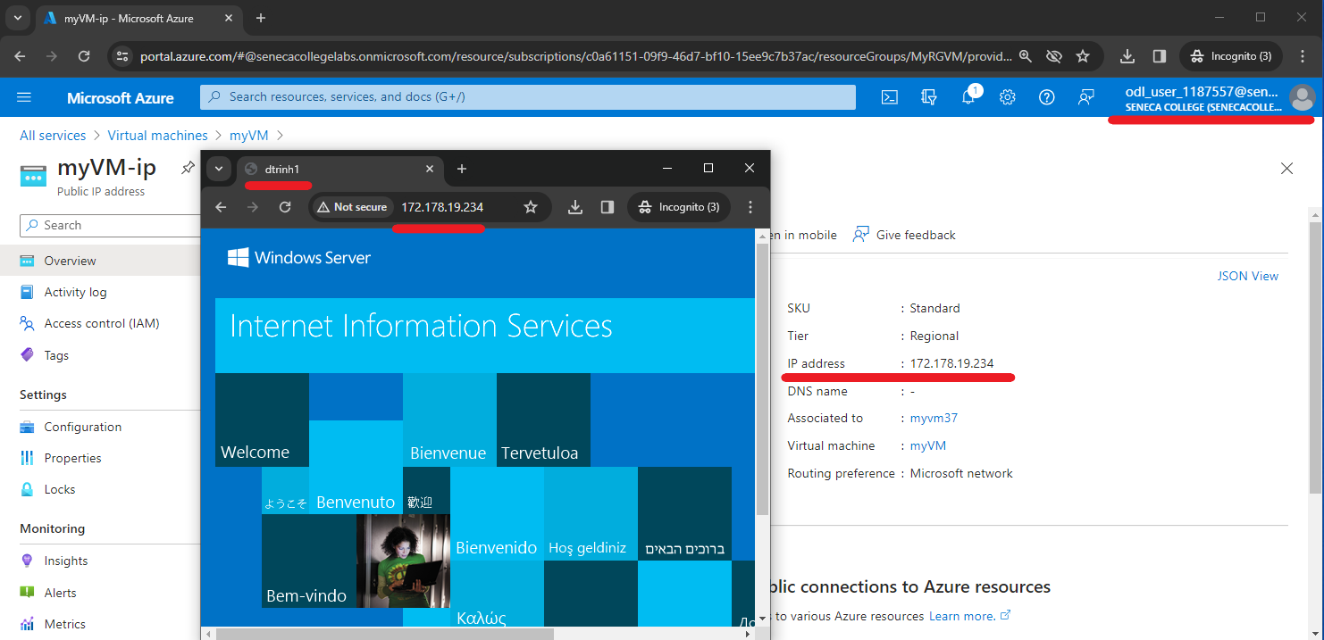

**Screenshot #2:**

* Successful deletion of all resources within resource group. **DO NOT DELETE YOUR RESOURCE GROUP!**
  + To delete all resources with a resource group, go to “**Resource Group**”, select “**MyRGVM**”, select all resources within the resource group, and select “**Delete**”

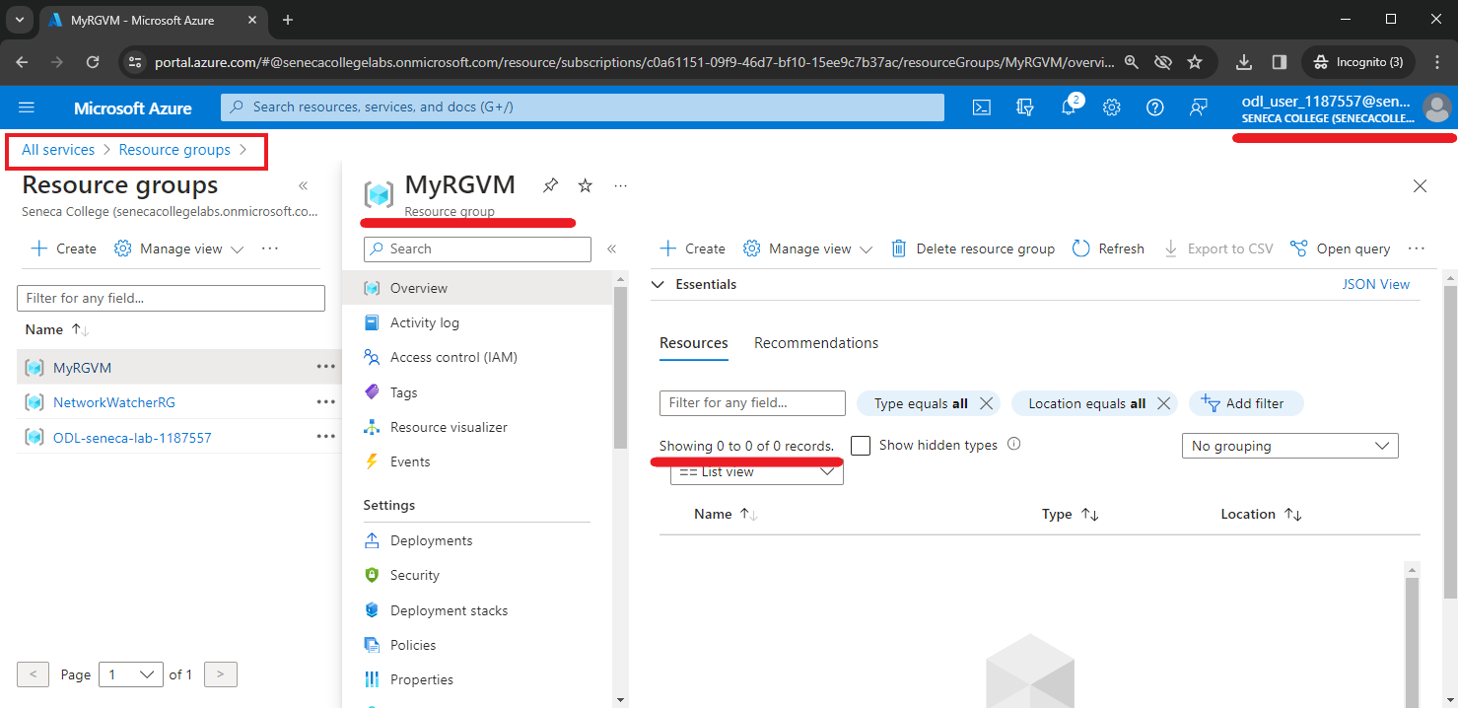

**Screenshot #3**

Configure a Budget and an Alert in your subscription. You should get an Alert everytime that you consume $10 of your Subcription.

* Guide (Video): <https://web.microsoftstream.com/video/2825299f-c521-46b5-872e-a48fefb6a1e2>
* Cost Analysis: <https://learn.microsoft.com/en-us/azure/cost-management-billing/costs/quick-acm-cost-analysis>
* Create a Budget: <https://learn.microsoft.com/en-us/azure/cost-management-billing/costs/tutorial-acm-create-budgets>

