

Lab 2: Create a Web App

At the end of each lab, any resources you created in your account will be preserved. Some Azure resources, such as VM instances, may be automatically shut down, while other resources, such as storage services will be left running. Keep in mind that some Azure features cannot be stopped and can still incur charges (i.e. Azure Bastion). To minimize your costs, delete all resources and recreate them as needed to test your work during a session.



Reference: AZ-900T0X-MICROSOFTAZUREFUNDAMENTALS

02 - Create a Web App

In this walkthrough, we will create a new web app that runs a Docker container. The container displays a Welcome message.

# Task 1: Create a Web App (10 min)

**Azure** **App Service** is actually a collection of four services, all of which are built to help you host and run web applications. The four services (Web Apps, Mobile Apps, API Apps, and Logic Apps) look different, but in the end they all operate in very similar ways. Web Apps are the most commonly used of the four services, and this is the service that we will be using in this lab.

In this task, you will create an **Azure App Service Web App**.

1. Sign-in to the [Azure portal](http://portal.azure.com/) with your **odl_user_xxx** azure account
2. From the **All services** blade, search for and select **App Services**, and click **+ Create and select Web App**
3. On the **Basics** tab of the **Web App** blade, specify the following settings (replace **xxxx** in the name of the web app with letters and digits such that the name is globally unique). Leave the defaults for everything else, including the App Service Plan.

| Setting | Value |
| --- | --- |
| Subscription | **Choose your subscription (you should see “Seneca College : <course name>”)** |
| Resource Group | **myRGWebApp1** (create new) |
| Name | **studentIDWebAppxxxx (example: dtrinh1WebApp1234)** |
| Publish | **Docker Container** |
| Operating System | **Linux** |
| Region | **East US** (ignore any service plan availability warnings) |
|  |  |

1. **Note** - Remember to change the **xxxx** so that it makes a unique **Name**
2. Go to the **Docker** tab and configure the container information. The startup command is optional and not needed in this exercise.

**Note:** This is same container that was used in the Container Instances walkthrough to display a hello world message.

| Setting | Value |
| --- | --- |
| Options | **Single container** |
| Image Source | **Docker Hub** |
| Access Type | **Public** |
| Image and tag | **mcr.microsoft.com/azuredocs/aci-helloworld** |
|  |  |

1. Click **Review + create**, and then click **Create**.

# Task 2: Test the Web App

In this task, we will test the web app.

1. Wait for the Web App to deploy.
2. From **Notifications** click **Go to resource**.
3. On the **Overview** blade, locate the **URL** entry.

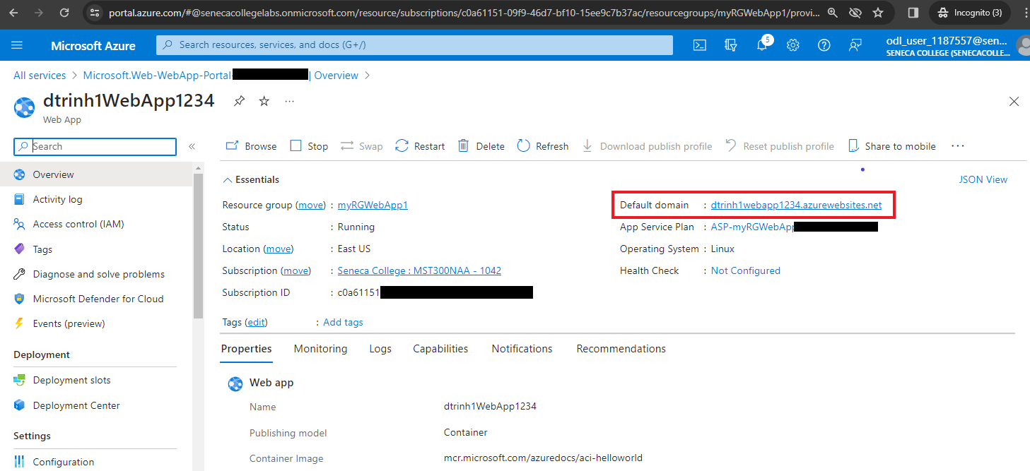

1. Click on the **URL** to open the new browser tab and display the Welcome to Azure Container Instances page.

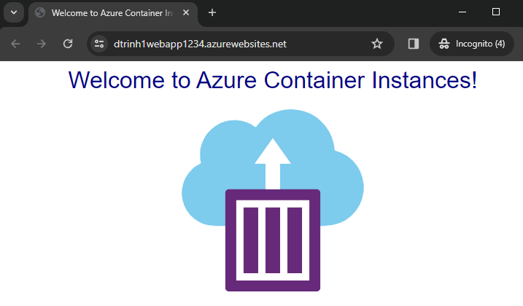

1. Switch back to the **Overview** blade of your web app and note that it includes several charts. If you repeat step 4 a few times, you should be able to see correspoding telemetry being displayed in the charts. This includes number of requests and average response time.

**Note**: To avoid additional costs, you can remove all **resources** in the resource group. Search for resource groups, click your resource group, and then delete the resources within the resource group. **DO NOT DELETE YOUR RESOURCE GROUP.**

# Submission Requirements

Submit a screenshot with the following information:

**Screenshot #1:**

* Name of your WebApp
* Requests chart showing an increase in HTTP requests
* The Azure Portal with your **Cloud Lab Account**
  + **Note**: underline the above items as described in the below picture

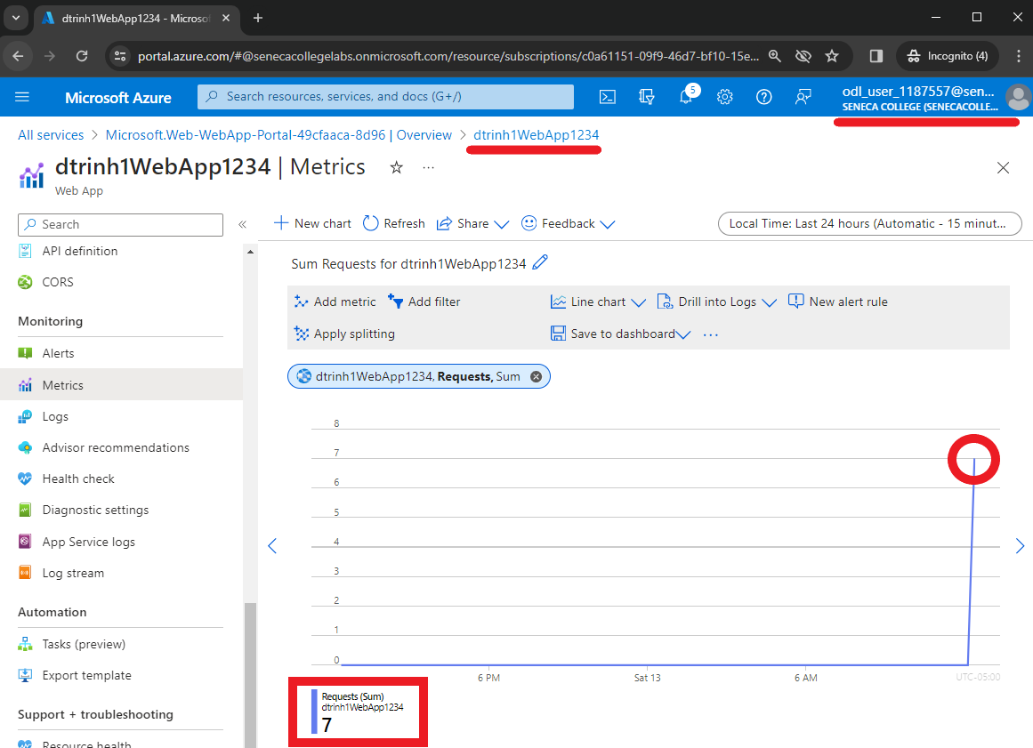

**Screenshot #2:**

* Successful deletion of all resources within resource group. **DO NOT DELETE YOUR RESOURCE GROUP!**
  + To delete all resources with a resource group, go to “**Resource Group**”, select “**MyRGWebApp1**”, select all resources within the resource group, and select “**Delete**”

