

Lab 3: Deploy Azure Container Instances

At the end of each lab, any resources you created in your account will be preserved. Some Azure resources, such as VM instances, may be automatically shut down, while other resources, such as storage services will be left running. Keep in mind that some Azure features cannot be stopped and can still incur charges (i.e. Azure Bastion). To minimize your costs, delete all resources and recreate them as needed to test your work during a session.



Reference: AZ-900T0X-MICROSOFTAZUREFUNDAMENTALS

# 03 - Deploy Azure Container Instances

In this walkthrough we create, configure, and deploy a Docker container by using Azure Container Instances (ACI) in the Azure Portal. The container is a Welcome to ACI web application that displays a static HTML page.

# Task 1: Create a container instance (10 min)

In this task, we will create a new container instance for the web application.

1. Sign in to the [Azure portal](https://portal.azure.com/) with your **odl_user_xxx** azure account
2. From the **All services** blade, search for and select **Container instances** and then click **+ Create**.
3. Provide the following Basic details for the new container instance (leave the defaults for everything else)):

| Setting | Value |
| --- | --- |
| Subscription | **Choose your subscription (you should see “Seneca College : <course name>”)** |
| Resource group | **myRGContainer** (create new) |
| Container name | **mycontainer** |
| Region | **(US) East US** |
| Availability Zones | **None** |
| SKU | **Standard** |
| Image source | **Other registry** |
| Image type | **Public** |
| Image | **mcr.microsoft.com/azuredocs/aci-helloworld** |
| OS type | **Linux** |
| Size | **Leave at the default** |
|  |  |

1. Configure the **Networking tab** (replace **xxxx** with letters and digits such that the name is globally unique). Leave all other settings at their default values .

| Setting | Value |
| --- | --- |
| DNS name label | **<studentID>containerdnsxxxx (example: dtrinh1containerdns1234)** |
|  |  |

1. **Note**: Your container will be publicly reachable at dns-name-label.region.azurecontainer.io. If you receive a **DNS name label not available** error message following the deployment, specify a different DNS name label (don’t use xxxx) and re-deploy.

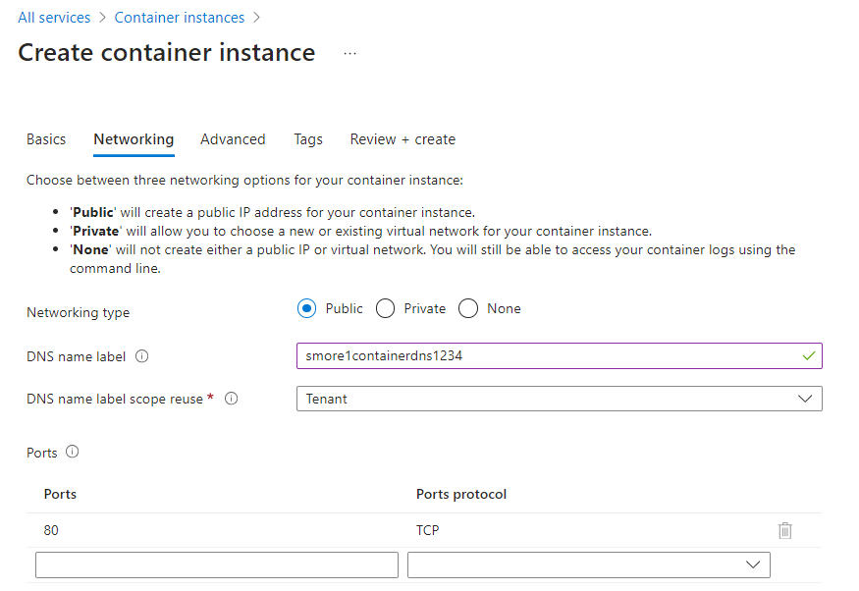

1. Click **Review + Create** to start the automatic validation process.
2. Click **Create** to create the container instance.
3. Monitor the deployment page and the **Notifications** page.
4. While you wait you may be interested in viewing the [sample code behind this simple application](https://github.com/Azure-Samples/aci-helloworld). Browse the \app folder.

# Task 2: Verify deployment of the container instance

In this task, we verify that the container instance is running by ensuring that the welcome page displays.

1. After the deployment is complete, click the **Go to resource** link the deployment blade or the link to the resource in the Notification area.
2. On the **Overview** blade of **mycontainer**, ensure your container **Status** is **Running**.
3. Locate the Fully Qualified Domain Name (FQDN).

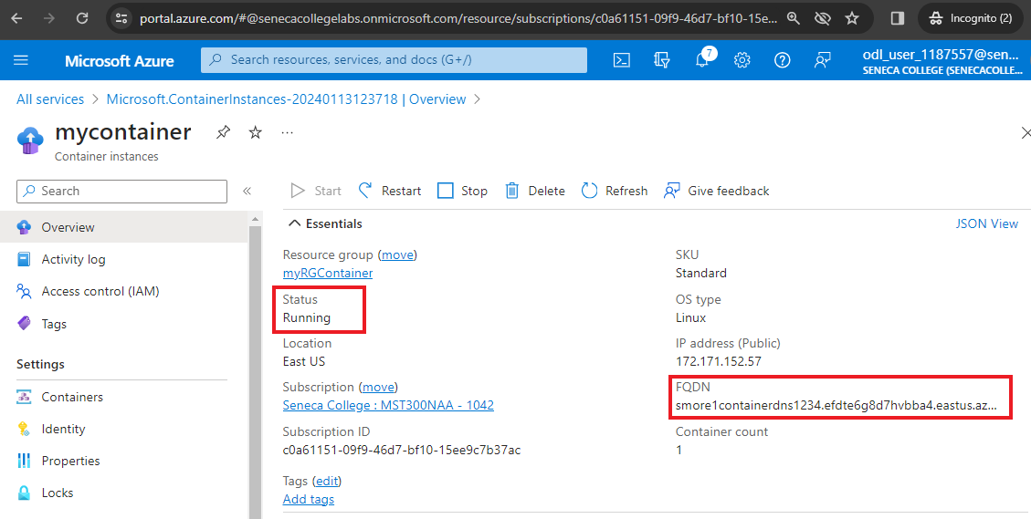

1. Copy the container’s FQDN into the URL text box web browser and press **Enter**. The Welcome page should display.

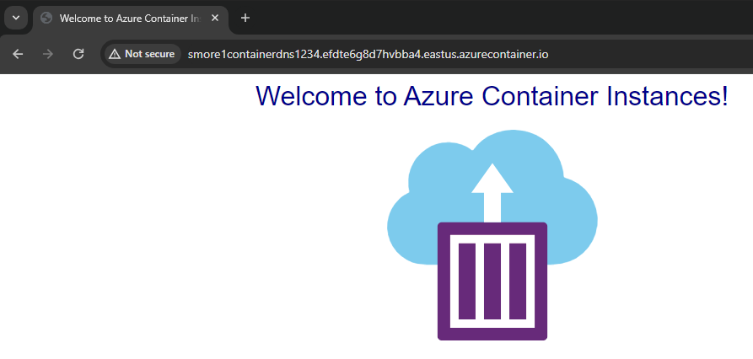

**Note**: You could also use the container IP address in your browser.

Congratulations! You have used Azure Portal to successfully deploy an application to a container in Azure Container Instance.

**Note**: To avoid additional costs, you can remove all resources in the resource group. Search for resource groups, click your resource group, and then delete the resources within the resource group. **DO NOT DELETE YOUR RESOURCE GROUP.**

# Submission Requirements

Submit a screenshot with the following information:

**Screenshot #1:**

* Access to your Azure Container Instance using its FQDN
* The Azure Portal with your **Cloud Lab Account** [requires another browser window]
  + **Note**: underline the above items as described in the below picture

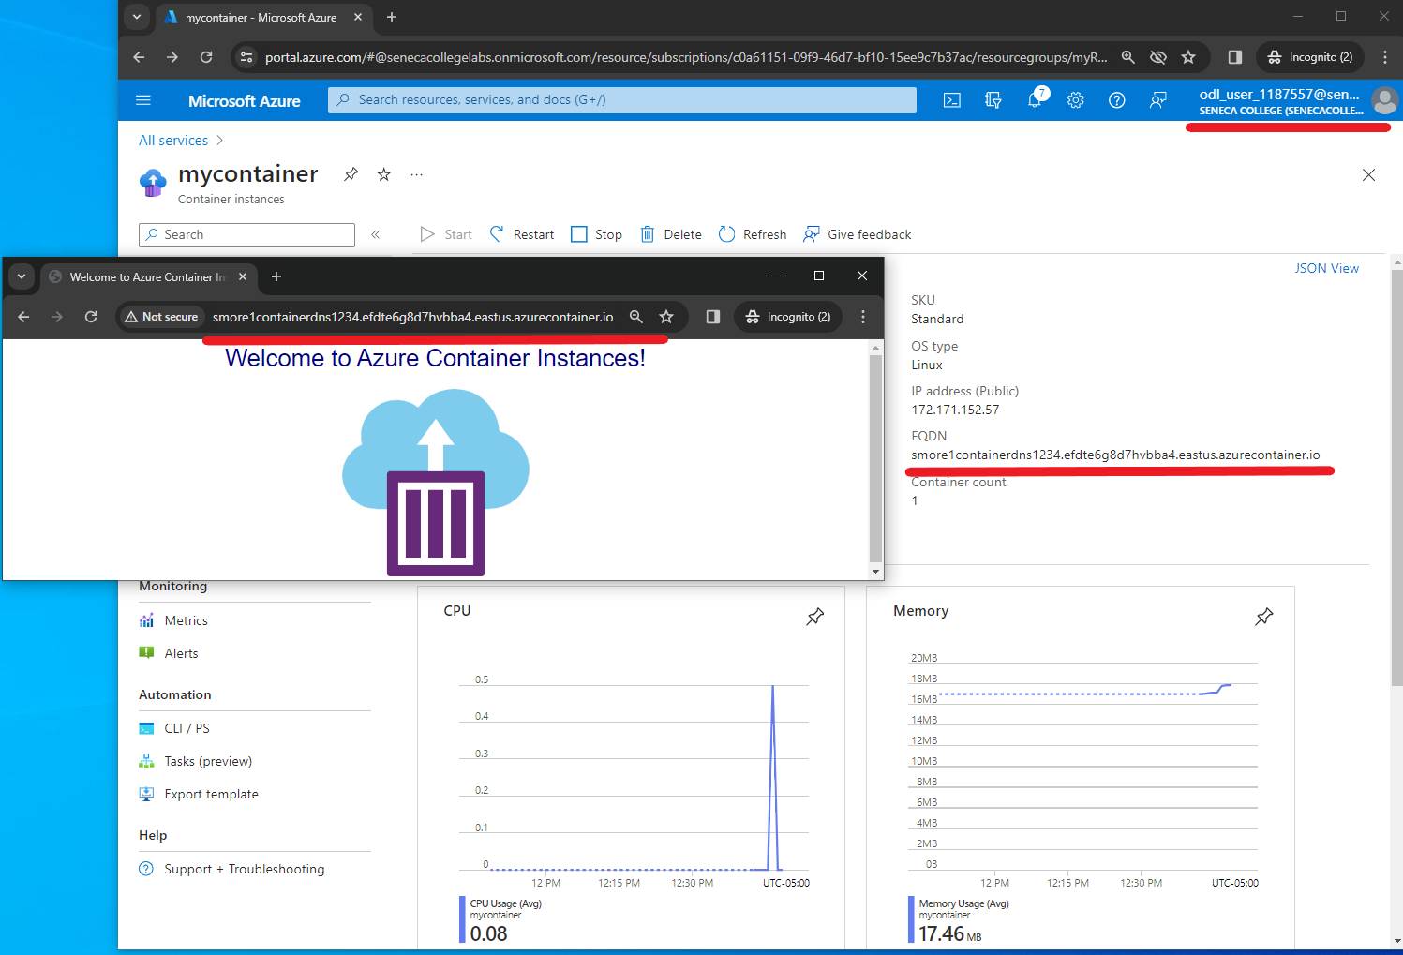

**Screenshot #2:**

* Successful deletion of all resources within resource group. **DO NOT DELETE YOUR RESOURCE GROUP!**
  + To delete all resources with a resource group, go to “**Resource Group**”, select “**MyRGContainer**”, select all resources within the resource group, and select “**Delete**”

