

Lab 8a: Implement Azure Logic Apps

At the end of each lab, any resources you created in your account will be preserved. Some Azure resources, such as VM instances, may be automatically shut down, while other resources, such as storage services will be left running. Keep in mind that some Azure features cannot be stopped and can still incur charges (i.e. Azure Bastion). To minimize your costs, delete all resources and recreate them as needed to test your work during a session.

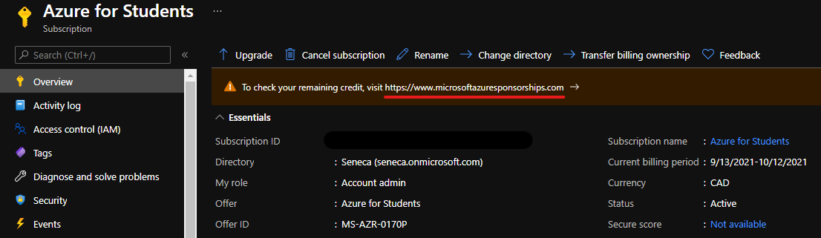

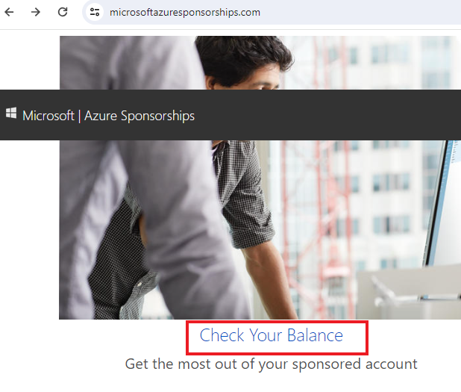

**Reference**: AZ-900T0X-MICROSOFTAZUREFUNDAMENTALS

Lab: Create an example Consumption workflow in multi-tenant Azure Logic Apps with the Azure portal

Applies to: **Azure Logic Apps (Consumption)**

This lab shows how to create an example automated workflow that integrates two services, an RSS feed for a website and an email account. More specifically, you'll create a [Consumption logic app workflow that runs in multi-tenant Azure Logic Apps](https://learn.microsoft.com/en-us/azure/logic-apps/logic-apps-overview#resource-environment-differences).

**Note**

This example workflow uses the RSS connector and the Office 365 Outlook connector. The RSS connector provides a trigger that checks an RSS feed, based on the specified schedule. The Office 365 Outlook connector provides an action that sends an email for each new item. The connectors in this example are only two connectors among [hundreds of connectors](https://learn.microsoft.com/en-us/connectors/connector-reference/connector-reference-logicapps-connectors) that you can use in a workflow. While this example is cloud-based, Azure Logic Apps supports workflows that connect apps, data, services, and systems across cloud, on-premises, and hybrid environments.

The following screenshot shows the high-level example workflow:



As you progress through this lab, you'll learn the following basic steps:

* Create a Consumption logic app resource that's hosted in multi-tenant Azure Logic Apps.
* Select the blank logic app workflow template.
* Add a trigger that specifies when to run the workflow.
* Add an action that performs a task after the trigger fires.
* Run your workflow.

Task1 - Create a Consumption logic app resource

1. Sign in to the [Azure portal](https://portal.azure.com/) with your <CloudLab account>
2. In the Azure search box, enter **logic apps**, and select **Logic apps**.

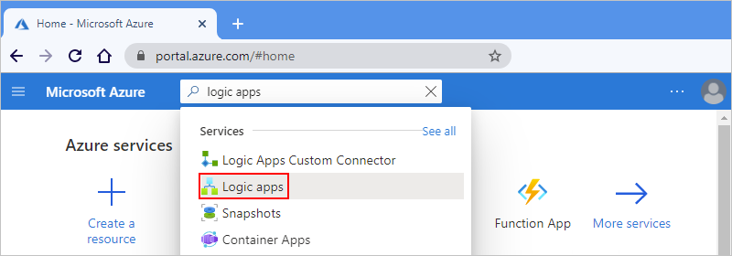

1. On the **Logic apps** page and toolbar, select **Add**.
2. On the **Create Logic App** pane, choose your logic app resource's plan type first. That way, only the options for that plan type appear.
   1. Find the **Plan** section.
   2. For **Plan type**, select **Consumption**.
3. Provide the following information for your logic app resource:

| **Settings** | **Value** |
| --- | --- |
| Subscription | **Choose your subscription (you should see “Seneca College : <course name>”)** |
| Resource Group | **MyRGLogicApp** |
| Logic App name | **MyLogicApp<studentID> (**For example: **MyLogicApp-smore1)** |
| Publish | **Workflow** |
| Region | **East US** |
| Plan | **Consumption** |
| Enable log analytics | **No** |

**Note**

1. When you're done, your settings look similar to the following example:

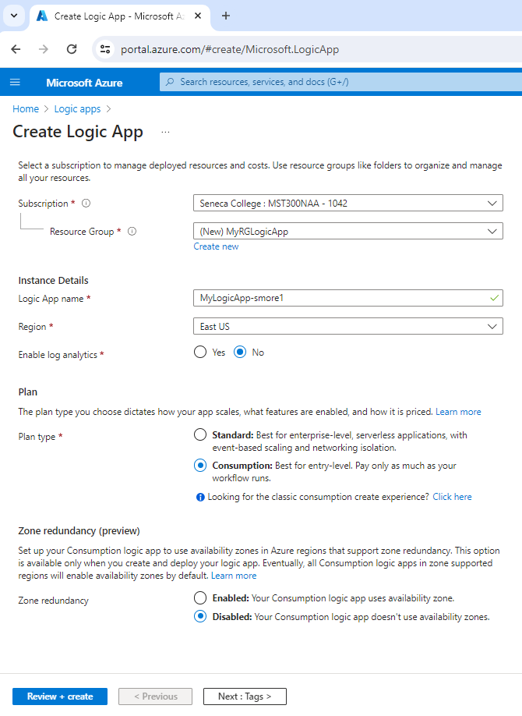

1. When you're ready, select **Review + Create**.
2. On the validation page that appears, confirm all the information that you provided, and select **Create**.

Task 2 - Select the blank template

1. After Azure successfully deploys your logic app resource, select **Go to resource**. Or, find and select your logic app resource by typing the name in the Azure search box.

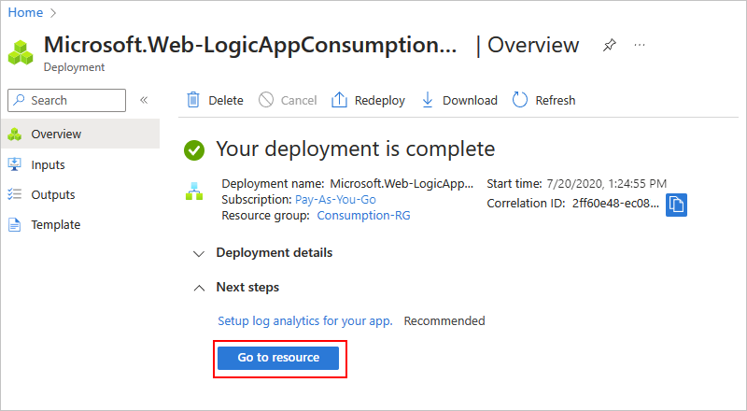

1. In the left menu, under “Development Tools” select **Logic App Designer**
2. Scroll down past the video and the section named **Start with a common trigger**.
3. Under **Templates**, select **Blank Logic App**.
4. After you select the template, the designer shows an empty workflow.

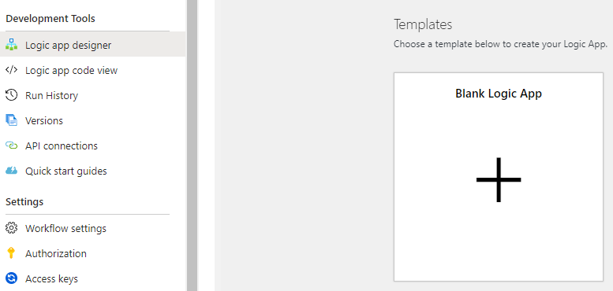

Task 3 - Add the trigger

A workflow always starts with a single [trigger](https://learn.microsoft.com/en-us/azure/logic-apps/logic-apps-overview#logic-app-concepts), which specifies the condition to meet before running any subsequent actions in the workflow. Each time the trigger fires, Azure Logic Apps creates and runs a workflow instance. If the trigger doesn't fire, no workflow instance is created or run. Azure Logic Apps includes hundreds of connectors with triggers that you can use to start your workflow.

This example uses an **RSS trigger** that checks an RSS feed, based on the specified schedule. If a new item exists in the feed, the trigger fires, and a new workflow instance is created and run. If multiple new items exist between checks, the trigger fires for each item, and a separate new workflow instance runs for each item. By default, workflow instances created at the same time also run at the same time, or concurrently.

1. In the designer, under the search box, select **All**. In the search box, enter **rss**.
2. From the **Triggers** list, select the RSS trigger named **When a feed item is published**.

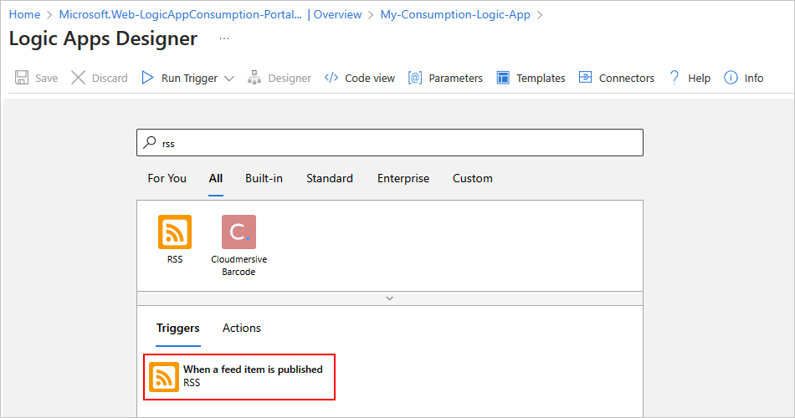

1. In the trigger, provide the following information:

| **Property** | **Required** | **Value** | **Description** |
| --- | --- | --- | --- |
| **The RSS feed URL** | Yes | **https://feeds.a.dj.com/rss/RSSMarketsMain.xml** | The RSS feed URL to monitor.  This example uses the Wall Street Journal's RSS feed at [**https://feeds.a.dj.com/rss/RSSMarketsMain.xml**](https://feeds.a.dj.com/rss/RSSMarketsMain.xml). However, you can use any RSS feed that doesn't require HTTP authorization. |
| **Chosen property will be used to determine** | No | **PublishDate** | The property that determines which items are new. |
| **Interval** | Yes | **1** | The number of intervals to wait between feed checks.  This example uses **1** as the interval. |
| **Frequency** | Yes | **Minute** | The unit of frequency to use for every interval.  This example uses **Minute** as the frequency. |

**Note**: If you don’t get the required emails, change the Frequency from 1 Minute to 1 hour

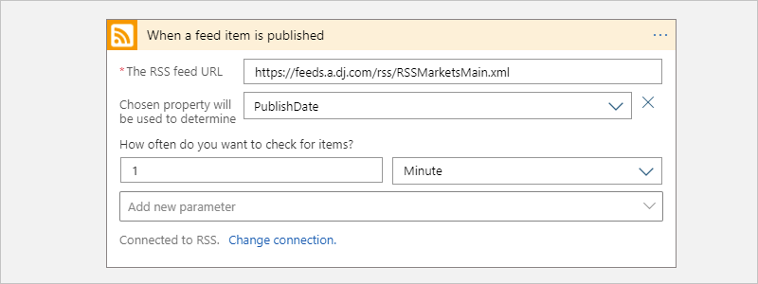

1. Hide the trigger's information for now by selecting inside the title bar to collapse the details window.

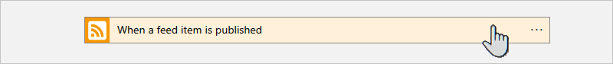

1. Save your workflow. On the designer toolbar, select **Save**.

This step instantly publishes your logic app workflow live in the Azure portal. However, the trigger only checks the RSS feed without taking any other actions. So, you need to add an action to specify what you want to happen when the trigger fires.

Task 4 - Add an action

Following a trigger, an [action](https://learn.microsoft.com/en-us/azure/logic-apps/logic-apps-overview#logic-app-concepts) is any subsequent step that runs some operation in the workflow. Any action can use the outputs from the previous step, which can be the trigger or another action. You can choose from many different actions, include multiple actions up to the [limit per workflow](https://learn.microsoft.com/en-us/azure/logic-apps/logic-apps-limits-and-config#definition-limits), and even create different action paths.

This example uses an Office 365 Outlook action that sends an email each time that the trigger fires for a new RSS feed item. If multiple new items exist between checks, you receive multiple emails.

1. Under the **When a feed item is published** trigger, select **New step**.

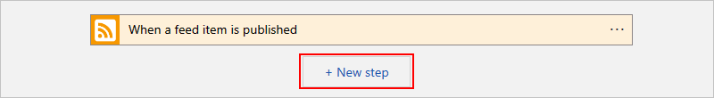

1. Under the **Choose an operation** search box, select **All**.
2. In the search box, enter **send an email**. To filter the **Actions** list to a specific app or service, select the icon for that app or service first.

For example, if you have a Microsoft work or school account and want to use Office 365 Outlook, select **Office 365 Outlook**. Or, if you have a personal Microsoft account, select **Outlook.com**. This example continues with Office 365 Outlook.

**Note**

If you use a different supported email service in your workflow, the user interface might look slightly different. However, the basic concepts for connecting to another email service remain the same.

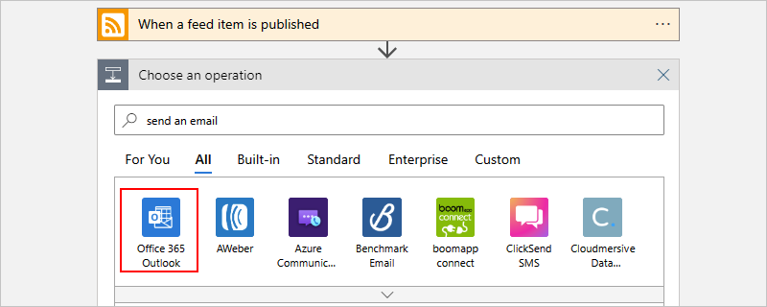

You can now more easily find and select the action that you want, for example, **Send an email**:

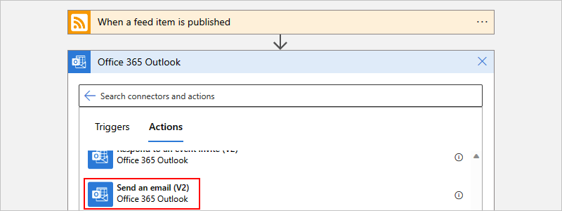

1. If your selected email service prompts you to **sign in** and authenticate your identity. Use your Seneca email address.

In the **Send an email** action, specify the following information to include in the email.

* + In the **To** box, enter the receiver's email address. For this example, use your Seneca email address.
  + In the **Subject** box, enter the email subject. For this example, enter the following text with a trailing blank space: **New RSS item:**

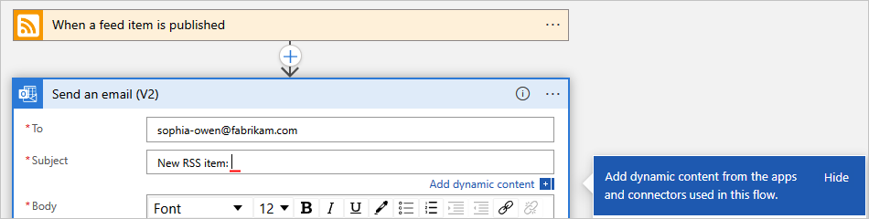

* + From the **Add dynamic content** list, under **When a feed item is published**, select **Feed title**.

The feed title is a trigger output that references the title for the RSS item. Your email uses this output to show the RSS item's title.

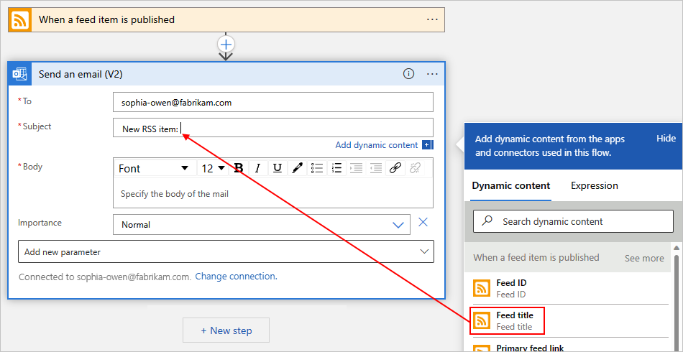

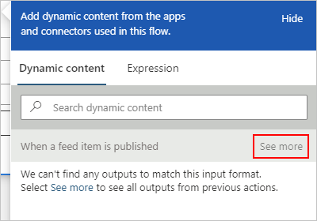

When you're done, the email subject looks like the following example:

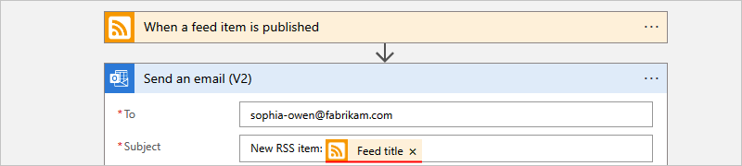

* + In the **Body** box, enter email body content.

For this example, the body includes the following properties, preceded by descriptive text for each property. To add blank lines in an edit box, press Shift + Enter.

| **Descriptive text** | **Property** | **Description** |
| --- | --- | --- |
| Title: | **Feed title** | The item's title |
| Date published: | **Feed published on** | The item's publishing date and time |
| Link: | **Primary feed link** | The URL for the item |

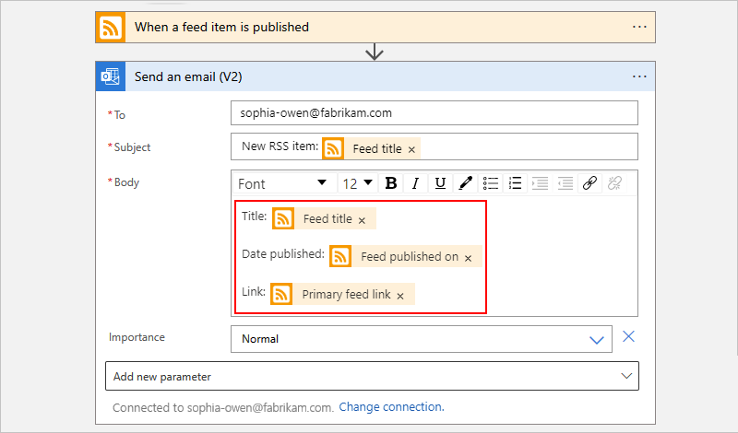

1. Save your workflow. On the designer toolbar, select **Save**.

Task 5 - Run your workflow

To check that the workflow runs correctly, you can wait for the trigger to check the RSS feed based on the specified schedule. Or, you can manually run the workflow from the designer toolbar.

* From the **Run Trigger** menu, select **Run**.

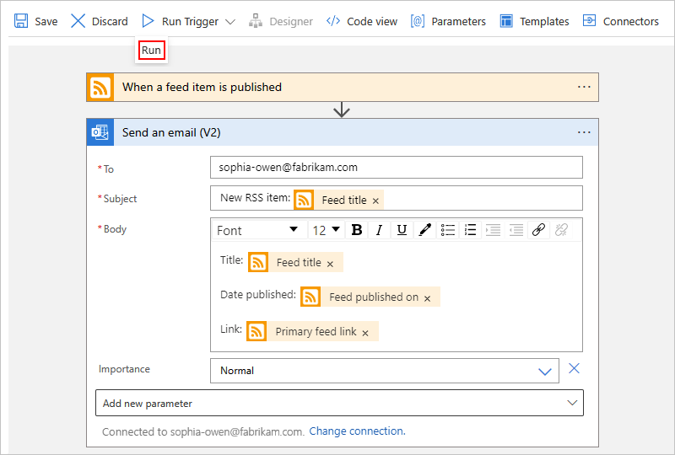

If the RSS feed has new items, your workflow sends an email for each new item. Otherwise, your workflow waits until the next interval to check the RSS feed again.

The following screenshot shows a sample email that's sent by the example workflow. The email includes the details from each trigger output that you selected plus the descriptive text that you included for each item.

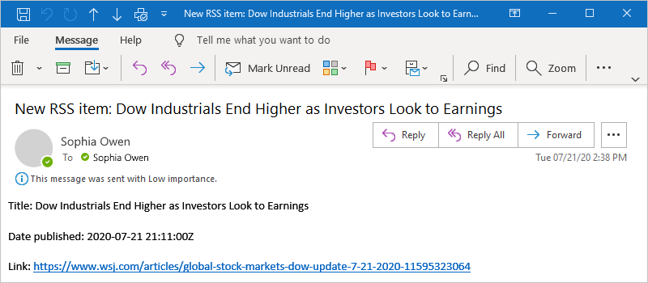

**Troubleshoot problems**

If you don't receive emails from the workflow as expected:

* Check your email account's junk or spam folder, in case the message was incorrectly filtered.
* Make sure the RSS feed you're using has published items since the last scheduled or manual check.
* Try different web browsers. Chrome tends to have issues
* Try to change the Frequency to 1 hour (instead of 1 minute)

# Submission Requirements

Submit the following 3 screenshots with the required information:

**Screenshot #1:**

* Logic App flow/connectors
* The Azure Portal with your **CloudLab Account** [requires another browser window]

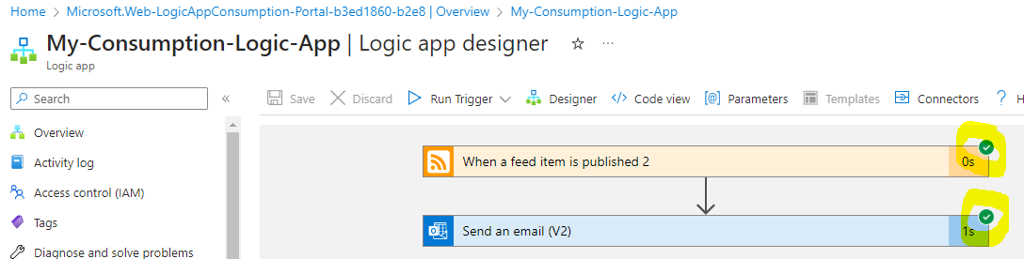

**Screenshot #2:**

* The email that was sent by the logic app

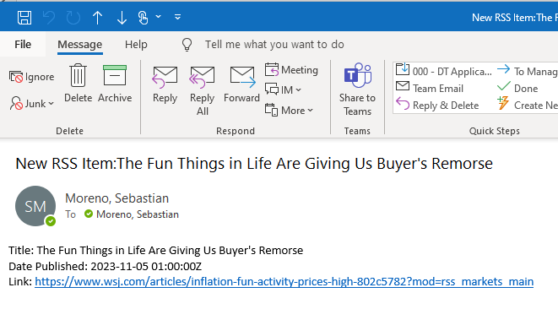

**Screenshot #3:**

* Successful deletion of all resources within resource group. **DO NOT DELETE YOUR RESOURCE GROUP!**
  + To delete all resources with a resource group, go to “**Resource Group**”, select “**MyLogicApp**, select all resources within the resource group, and select “**Delete**”

