

Lab 9: Create a VM with a Template

At the end of each lab, any resources you created in your account will be preserved. Some Azure resources, such as VM instances, may be automatically shut down, while other resources, such as storage services will be left running. Keep in mind that some Azure features cannot be stopped and can still incur charges (i.e. Azure Bastion). To minimize your costs, delete all resources and recreate them as needed to test your work during a session.



Reference: AZ-900T0X-MICROSOFTAZUREFUNDAMENTALS

# 09 - Create a VM with a Template

In this walkthrough, we will deploy a virtual machine with a QuickStart template and examine monitoring capabilities.

# Task 1: Explore the gallery and locate a template (10 min)

In this task, we will browse the Azure QuickStart gallery and deploy a template that creates a virtual machine.

1. In a browser, access the [Azure Quickstart Templates gallery](https://azure.microsoft.com/resources/templates?azure-portal=true). In the gallery you will find a number of popular and recently updated templates. These templates automate deployment of Azure resources, including installation of popular software packages.
2. Browse through the many different types of templates that are available.

**Note**: Are there are any templates that are of interest to you?

1. Search for or directly access the [Deploy a Virtual Machine](https://learn.microsoft.com/en-us/samples/azure/azure-quickstart-templates/vm-trustedlaunch-windows/) template. (We will deploy a Windows Virual Machine using a secure framework)

**Note**: The **Deploy to Azure** button enables you to deploy the template via the Azure portal. During such deployment, you will be prompted only for small set of configuration parameters.

1. Click the **Deploy to Azure** button. Your browser session will be automatically redirected to the [Azure portal](http://portal.azure.com/).
2. If prompted, sign in to the Azure subscription you want to use in this lab (Note: Make sure to login with your CloudLab account).
3. Click **Edit template**. The Resource Manager template format uses the JSON format. Review the parameters and variables. Then locate the parameter for virtual machine name and update them accordingly, pls see below.
4. On the **Basic** blade configure the parameters required by the template

| Setting | Value |
| --- | --- |
| Subscription | **Choose your subscription (you should see “Seneca College : <course name>”)** |
| Resource group | **myRGTemplate** **(you should see “Seneca College : <course name>”)** |
| Region | **(US) East US** |
| Vm Name | **<studentID>-vm (for example: smore1-vm)** |
| Admin username | **azureuser** |
| Admin password | **Pa$$w0rd1234** |
| Location | **eastus** |
| DNS label prefix | **<studentID>-vm (for example: smore1-vm)** |
| Windows OS version | **2019-Datacenter** |
|  |  |

1. ** Note: There is no cost associated with this template.
2. Click **Review + Create**.
3. Click **Create**
4. Monitor your deployment.

# Task 2: Verify and monitor your virtual machine deployment

In this task, we will verify the virtual machine deployed correctly.

1. From the **All services** blade, search for and select **Virtual machines**.
2. Ensure your new virtual machine was created.

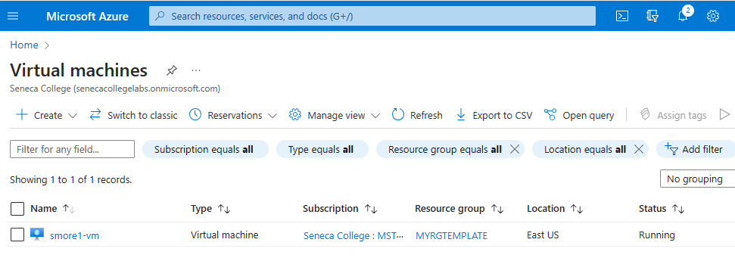

1. Select your virtual machine and on the **Overview** pane scroll down and select **Monitoring**.
2. 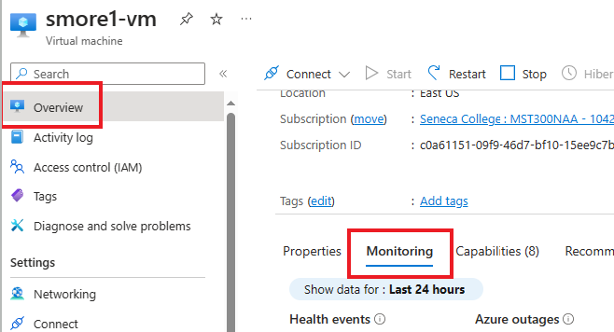

**Note**: The monitoring timeframe can be adjusted from one hour to 30 days.

1. Review different charts that are provided including **CPU (average)**, **Network (total)**, and **Disk bytes (total)**.
2. Click on any chart. Note that you can **Add metric** and change the chart type.
3. Return to the **Overview** blade.
4. Click on the **Activity log** (left pane). Activity logs record such events as creation or modification of resources.
5. Click **Add filter**, and experiment with searching for different event types and operations.

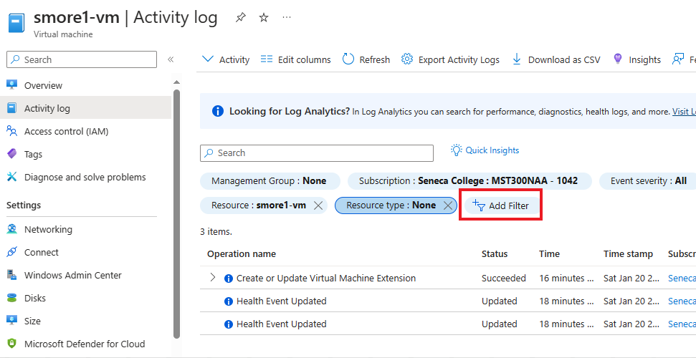

# Submission Requirements

Submit a screenshot with the following information:

**Screenshot #1:**

* Overview properties of the virtual machine created using a template
* The Azure Portal with your **CloudLab Account** [requires another browser window]
  + **Note**: underline the above items as described in the below picture

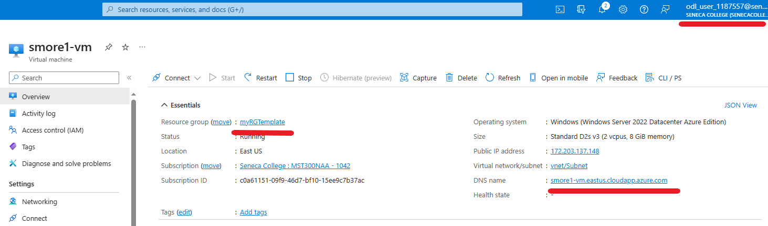

**Screenshot #2:**

* Successful deletion of all resources within resource group. **DO NOT DELETE YOUR RESOURCE GROUP!**
  + To delete all resources with a resource group, go to “**Resource Group**”, select “**myRGTemplate**”, select all resources within the resource group, and select “**Delete**”

