Misalignment-Induced Load Redistribution in Gear Meshes: A Compliance-Ratio Analysis of Published Face-Width and Planetary Load-Sharing Experiments
Yunus Emre Karabacak*
Department of Mechanical Engineering, Karadeniz Technical University, 61080 Trabzon, Türkiye
*Corresponding author. E-mail: karabacak@ktu.edu.tr; ORCID: 0000-0002-0268-3656

Abstract
Shaft misalignment and carrier pinhole position errors redistribute load across the face width of a gear mesh and among the planets of a planetary gear set, yet rating standards describe the two cases with separate factors. This study examined whether both depend on misalignment through one dimensionless compliance ratio, the geometric mismatch divided by the effective elastic deflection of the loaded path. Measurements from six experimental studies (helical, hypoid, spur and planetary gears; three laboratories) were split, before fitting, into calibration and validation sets. For a helical pair, the face-width redistribution slope was linear in the ratio with a coefficient of 0.90 (95% confidence interval 0.80–1.05; R² = 0.975) when the pair-specific mesh deflection was used, and ISO 6336-1 Method C matched or exceeded the measured root-strain ratios once an effective residual misalignment was included. For planetary sets with a floating sun, a one-parameter path model based on the same ratio reproduced measured six-planet load shares with a root-mean-square error of 1.6 percentage points, as accurately as a multibody contact model. The effective planet-centre deflection was about 8.6 times the mesh-only value from ISO 6336-1 and grew sub-linearly with load, so the mesh load factor decreased with torque with a pooled exponent of 0.73 (95% confidence interval 0.64–0.83). Without recalibration, the model reduced the per-pin error on an industrial six-planet gearbox by 24% in one of two data sets. No published transmission-error study reports both misalignment magnitude and mesh deflection, so a transmission-error relation could not be tested.
Keywords Gear misalignment; Face load factor; Planet load sharing; Carrier pinhole position error; Compliance ratio; Transmission error

1 Introduction
Misalignment between mating gears cannot be eliminated in practice; it arises from manufacturing and assembly tolerances of bearing seats and carrier pinholes and from shaft, bearing and housing deflection. Its first effect is geometric: the flanks are no longer parallel, so load concentrates towards one end of the face width in a parallel-axis pair, or on one planet in a planetary gear set. Its second effect is elastic: teeth, shafts, bearings and rims deflect and partly restore contact. The balance between the two governs the peak tooth stress, the contact pattern and the mesh excitation, and hence the tolerances that a precision gearbox must hold.
Rating standards treat the two cases separately: the face load factor K_{Hβ} describes the distribution across the face width [1, 2], and the mesh load factor K_{γ} the distribution among the planets [3]. ISO 6336-1 Method C already compares the effective equivalent misalignment with the mean mesh deflection [1], whereas planetary design practice specifies K_{γ} mainly as a function of the number of planets, not of torque [3]. If redistribution in both settings were governed by the same ratio of geometric mismatch to elastic path deflection, K_{γ} would vary with torque, and one dimensionless coordinate could organise face-width, planet-to-planet and possibly transmission-error data.
Detailed load distribution models exist for both settings (Section 2), but whether one dimensionless ratio governs both has not been tested against independent experiments with a data partition fixed in advance. This study carried out such a test with published measurements. A compliance ratio Π was defined, a slice model of the face width and a translational path model of the planetary set were formulated in terms of Π, and both were compared with ISO 6336-1 Method C, a multibody contact model, a constant design value of K_{γ} and equal load sharing. Regime boundaries and failures of transfer were treated as admissible outcomes.
The contributions are (1) a test, on measurements from two laboratories, of whether face-width and planet-to-planet redistribution share one controlling ratio while all load paths remain in contact; (2) a quantification of the effective path compliance and load exponent that this ratio requires in planetary sets, which implies that K_{γ} decreases sub-linearly with torque; and (3) a statement of the current limits, namely the incomplete transfer to an industrial gearbox and the absence of experiments that would allow a misalignment–transmission-error relation to be tested.

2 Literature Review

2.1 Face-Width Load Distribution Under Misalignment
Root-strain experiments have shown that controlled shaft misalignment shifts the load towards one end of a helical face width [4] and between toe and heel of a hypoid pair [5]. Unloaded contact-pattern measurements quantified the loss of contact area under axial, radial and angular misalignment [6]. Finite-element loaded tooth contact analysis showed that misalignment in the plane of action changes contact and root stresses, load sharing and transmission error, whereas misalignment normal to that plane has little effect [7, 8]. Misalignment also reduces the time-varying mesh stiffness [9] and changes the contact pattern and contact fatigue life of profile-shifted helical gears [10], and lead modification can move the load from the face ends towards the centre [11]. A recent finite-element assessment found that the ISO 6336 methods overestimate the face load factor of helical gears in most of the cases examined [12]. These models predict the distribution of a given gear pair but do not reduce it to a dimensionless parameter that is comparable across gear pairs, loads and architectures.

2.2 Planet Load Sharing Under Carrier Errors
Planet load sharing has been modelled with discrete [13–15], system-level and deformable-body [16, 17] and three-dimensional formulations that include manufacturing errors and tooth modifications [18–20]. The translational analogy of [15] represents each planet by its sun and ring mesh springs in parallel, in series with the planet bearing, and gives closed-form planet loads while all planets remain loaded. Multi-mesh models show that planet tilting loads opposite face ends of the sun–planet and ring–planet meshes [19], and slice-based models with three-dimensional pinhole errors were validated on wind-turbine stages [20]. A system-level model of an industrial gearbox reproduced its measured load shares within 10% [21], and the system configuration has been studied parametrically [22]. Experimentally, a single carrier pinhole error can almost unload a planet [17, 23], and measurements on the same industrial gearbox quantified the effect of measured pinhole errors under static and rotating conditions [24, 25]. No single governing ratio has been identified, and the torque dependence of K_{γ} has not been compared across laboratories with the scaling implied by linear path stiffness.

2.3 Transmission Error Under Misalignment
Transmission error is a principal excitation of gear noise and is linearly related to the dynamic stress factor of spur gears [26, 27]. Encoder-based measurement has made it accessible on industrial gearboxes [28], and planetary models have been validated jointly for transmission error, mesh stiffness and load sharing [29]. Experimental evidence on misalignment is scarce: one study reported that misalignment raises the low-order transmission-error harmonics of a crowned spur pair at light load, without reporting its magnitude [30], and a gearbox study described misalignment effects through vibration and inspection [31]. Neither reports the mesh deflection.

2.4 Research Gap
Table 1 shows that misalignment magnitude and load distribution are reported in several studies, but mesh deflection only for one helical pair (as a calculated value) and transmission error only once, without a misalignment magnitude. Whether face-width and planet-to-planet redistribution collapse onto one deflection-normalised ratio has therefore not been tested on independent measurements, and the data for an equivalent test on transmission error do not yet exist. This study addresses the first gap and specifies the experiment needed for the second.
Table 1 Quantities reported in experimental studies on gear misalignment. Y = quantitative; P = partial or qualitative; – = not reported; n.a. = not applicable; TE = transmission error; C_{β} = lead crown height; h = misalignment slope; V, H, G, γ = hypoid pinion offset, pinion mounting distance, gear mounting distance and shaft angle errors; n = number of planets
Study | Architecture | Misalignment magnitude | Mesh deflection or stiffness | Load distribution | Torque sweep | TE
Hotait and Kahraman [4] | Helical; C_{β} = 0, 12, 25 µm | Y (h = 0, ±1, ±2 × 10⁻³ m/m) | Y (calculated: 17 µm at 200 N·m) | Y (5 root gauges) | P (data at 200 N·m) | –
Hotait et al. [5] | Hypoid, face-hobbed | Y (V, H, G, γ) | – | Y (5 root gauges) | P (300 N·m shown) | –
Ligata et al. [23]; Singh et al. [17] | Planetary, n = 3–6 | Y (0, ±35, ±70 µm) | P (bearing stiffness) | Y (ring root strain) | Y (600–1000 N·m) | –
Kim et al. [24] | Industrial planetary, n = 6 | Y (measured pinholes) | – | Y (pin strain) | Y (25–100%) | –
Kim et al. [25] | Industrial planetary, n = 6 | Y (measured pinholes) | – | Y (pin strain) | Y (25–125%) | –
Dong et al. [20] | Wind-turbine helical planetary, n = 3, 4 | Y (measured 3D pinhole errors) | – | Y (ring root strain across the face width) | Y (25–100%) | –
Kumar et al. [6] | Spur, unloaded | Y (axial, radial, angular) | n.a. | P (contact area) | – | –
Xiong and Chen [30] | Spur, crowned | P (eccentric sleeve; value not given) | – | – | P (0 and 30 N·m) | Y

3 Methodology

3.1 Compliance Ratio
The descriptor compares the geometric mismatch that misalignment imposes on a load path with the elastic deflection of that path under its mean load:
$Π=\frac{e_{eff}}{δ_{eff}}, δ_{eff}=\frac{w_{m}}{c_{eff}}$ (1)
where e_{eff} (µm) is the mismatch at the end of the path (the lead mismatch across the face width, or the tangential pinhole position error of a planet), δ_{eff} (µm) is the effective elastic deflection under the mean load w_{m} (per unit face width for a mesh, per planet for a planetary set), and c_{eff} is the effective path stiffness. For c_{eff} equal to the mesh stiffness c_{γβ}, Π is the ratio used in ISO 6336-1 Method C [1]. The hypothesis is that redistribution depends on misalignment mainly through Π, and that c_{eff} is a property of the whole load path, including shafts, bearings, pins and rims, rather than of the mesh alone.

3.2 Face-Width Redistribution Model
For a parallel-axis pair, the load intensity along the face width is represented by the slice (Winkler) model
$w\left(ζ\right)=c_{eff}\left\langle δ_{0}−g\left(ζ\right)\right\rangle , g\left(ζ\right)=−\left(h+h_{0}\right)bζ+C_{β}{\left(2ζ\right)}^{2}$ (2)
where ζ = z/b − 1/2 is the normalised face-width coordinate, z the position from the reference edge, b the face width, ⟨·⟩ the positive part (the contact carries no tension), δ₀ the rigid-body approach fixed by the load balance, g(ζ) the unloaded separation, h the imposed misalignment slope (m/m), h₀ an effective residual misalignment of the rig and C_{β} the lead crown height at the face ends. Models of this type underlie ISO 6336-1 Annex E [1] and slice-based load distribution models [20]. For an uncrowned pair in full contact, Eq. (2) gives a linear distribution with the normalised slope
$S=\frac{d\left(w/w_{m}\right)}{dζ}=κΠ, Π=\frac{\left(h+h_{0}\right)b}{δ_{m}}$ (3)
where δ_{m} is the mean mesh deflection, so that Π follows from Eq. (1) with e_{eff} = (h + h₀)b expressed in micrometres, and κ is an empirical transfer coefficient; slice theory gives κ = 1 while |Π| ≤ 2, i.e. while the whole face width is in contact. The ISO 6336-1 Method C baseline uses the same ratio [1]:
$K_{Hβ}=\left\{\begin{aligned}1+\frac{\left|Π\right|}{2}, \left|Π\right|≤2 \\ \sqrt{2\left|Π\right|}, \left|Π\right|>2\end{aligned}\right., K_{Fβ}=K_{Hβ}^{N_{F}}$ (4)
where Π is taken from Eq. (3) with κ = 1, application and dynamic factors of 1 and no running-in allowance; K_{Hβ} and K_{Fβ} are the face load factors for contact and root stress, N_{F} = (b/h_{t})²/[1 + b/h_{t} + (b/h_{t})²], and h_{t} is the tooth depth. The change of branch at |Π| = 2 marks the loss of contact at one face end. Measured root strain was used as a proxy for the local load intensity; because root strain spreads over a finite length of the face width, the proxy smooths the distribution near the face ends.

3.3 Planet-to-Planet Redistribution Model
Each sun–planet–ring path of an n-planet set is represented by a unilateral spring of stiffness k_{p}. The sun floats, and planet i at angle ψ_{i} has a tangential pinhole position error e_{i}, positive when it advances the planet into mesh. The path loads follow
$\begin{aligned}F_{i}=k_{p}\left\langle u+e_{i}−x\sin{ψ_{i}}+y\cos{ψ_{i}}\right\rangle \\ \sum_{i}{F_{i}}=F_{t}, \sum_{i}{F_{i}\sin{ψ_{i}}}=\sum_{i}{F_{i}\cos{ψ_{i}}}=0\end{aligned}$ (5)
where F_{i} is the tangential load on path i, u the common tangential approach, x and y the sun translations and F_{t} the total tangential load at the pin circle (F_{t} = 2T_{s}/r_{s} for a fixed ring, with sun torque T_{s} and sun pitch radius r_{s} [15]). Mesh forces act tangentially (the pressure-angle component of the sun translation is neglected), and the planets are equally spaced. Equation (5) is the translational analogy of [15]; here it was solved by minimising the elastic energy subject to the unilateral constraint, so that a planet may lose contact. With δ_{eff} = F_{t}/(nk_{p}), the mean tangential displacement of the planet centres, the solution depends only on Π_{i} = e_{i}/δ_{eff}. To allow for Hertzian, bearing and rim nonlinearity, the effective deflection was allowed to grow with load:
$δ_{eff}\left(T\right)=δ_{ref}{\left(\frac{T}{T_{ref}}\right)}^{m}, δ_{ref}=\frac{δ_{ISO}}{η}$ (6)
where T is the transmitted torque, T_{ref} a reference torque, δ_{ref} the effective deflection at T_{ref}, m the load exponent (m = 1 for linear springs), δ_{ISO} the planet-centre displacement at T_{ref} produced by the sun–planet and planet–ring meshes, which act in parallel on the planet [15], with the ISO 6336-1 mesh stiffness [1], and η = δ_{ISO}/δ_{ref} the ratio of the effective path stiffness to the mesh-only stiffness. The planetary response is summarised by
$K_{γ}=n\max_{i}{L_{i}}, L_{i}=\frac{F_{i}}{F_{t}}, K_{γ}−1∝Π∝T^{−m}$ (7)
where L_{i} is the load fraction of planet i; the proportionality holds only while all planets are loaded. For a single tangential error e₁ > 0, the closed-form solution of [15] gives the constant explicitly:
$K_{γ}=1+c_{n}Π_{1}$ (8)
where Π₁ = e₁/δ_{eff} and c_{n} = 1/4, 2/5 and 1/2 for n = 4, 5 and 6. For six planets, Eq. (8) has the same form as the first branch of Eq. (4). The design baseline treats K_{γ} as a constant, 1.44 for six planets [3, 25].

3.4 Experimental Data Sources and Selection Criteria
Experiments were selected if they reported a controlled or measured misalignment and a quantitative load-distribution or transmission-error response, with the full text available and an extractable uncertainty. Six studies met these criteria for load redistribution [4–6, 23–25], with tabulated values for [23] in [17]; the only transmission-error study [30] lacks the misalignment magnitude and was used as directional evidence (Table 2). The qualitative gearbox study [31], numerical and system-level simulations [7, 8, 10, 21], an encoder study without a misalignment sweep [28] and a trade-journal report [32] of [4] were not used for validation, and the combined load distribution coefficient of [20] was used only qualitatively (Section 5.1). At least three independent sources from at least two laboratories were required before a relation was tested; this was met for load redistribution (The Ohio State University [4, 5, 23]; an industrial gearbox in Korea [24, 25]) but not for transmission error.
Table 2 Experimental sources and their role in the analysis. n.r. = not reported; ẽ_{c1} = tangential pinhole position error of planet 1; T_{s} = sun torque; CW/CCW = clockwise/counter-clockwise; CMM = coordinate measuring machine; other symbols as in Table 1
Source | Configuration and geometry | Material; operating conditions | Measured output; uncertainty | Role
Hotait and Kahraman [4] | Helical, 62/62 teeth, normal module 2.04 mm, normal pressure angle 16°, β = 32.5°, b = 20 mm; C_{β} = 0, 12, 25 µm; h = 0, ±1, ±2 × 10⁻³ m/m; gauges 2.7–16.5 mm from one face end | Steel, E = 207 GPa; 200 min⁻¹; 100–500 N·m | Peak root strain at 5 gauges; ±25 µε (digitised); calculated mesh deflection 17 µm at 200 N·m | Calibration (C_{β} = 0); internal validation (C_{β} = 25 µm)
Hotait et al. [5] | Hypoid, face-hobbed, 10/41 teeth, gear face width 31 mm; V, H = 0, ±0.1, ±0.2 mm; G = −0.05 to 0.3 mm; γ = ±0.1, ±0.2° | n.r.; ≤ 15 min⁻¹; up to 500 N·m | Peak-to-peak root stress at 5 gauges; ±10 MPa (digitised) | Linearity test in a non-parallel architecture
Ligata et al. [23] | Helical planetary, 73/26/125 teeth (sun/planet/ring), normal module 1.81 mm, β = 13.12° [15], b = 25 mm, n = 3–6; ẽ_{c1} = 0, ±35, ±70 µm on one pinhole | n.r. (ground gears); 500 min⁻¹; T_{s} = 200–1000 N·m (600–1000 N·m used); floating sun | Planet load fraction from ring root strain; ±0.01 (digitised) | Calibration (n = 6); internal validation (n = 4, 5)
Singh et al. [17] | Same rig and gear sets as [23] | As [23]; 1000 N·m | Tabulated load percentages, n = 6 | Calibration (n = 6)
Kim et al. [24] | Two-stage planetary; stage 1: 50/31/112 teeth, module 3.5 mm, n = 6; measured pinhole errors −79 to 82 µm (front/rear mean) | n.r.; static, output fixed; 25–100% of 9119 N·m (same test analysed in [21]) | Load share per pin (tabulated) | External validation
Kim et al. [25] | Same gearbox type; stage-1 face width 72 mm; measured pinhole errors −16 to 49 µm | n.r.; 85.9 min⁻¹; 25–125% of 7295 N·m; CW and CCW | Mesh load factor per pin (tabulated) | External validation
Kumar et al. [6] | Spur, 40/40 teeth, module 3 mm, b = 20 mm; axial 6 mm, radial 1–2 mm, angular 2.64–4.67° | EN 31; unloaded paste impression | Contact area by CMM (tabulated) | Zero-load limit
Xiong and Chen [30] | Spur, 61/61 teeth, module 4 mm, b = 40 mm; C_{β} = 26, 53, 88 µm; eccentric sleeve on output shaft | n.r.; 50–1200 min⁻¹; 0 and 30 N·m | Dynamic TE harmonics by encoders; misalignment n.r. | Directional TE evidence

3.5 Data Extraction and Harmonisation
Tabulated values were used where available [6, 17, 24, 25]. Other curves were digitised at 200 dpi by locating the axis frames from pixel rows and columns and extracting colour-thresholded marker centroids at the known gauge or abscissa positions, with overlapping markers resolved manually. The digitisation uncertainty was taken as ±25 µε for helical root strain, ±10 MPa for hypoid root stress and ±0.01 for planet load fraction; the digitised six-planet load fractions at 1000 N·m [23] differed from the tabulated values [17] by at most 0.005.
For face-width redistribution, the peak root strain at each gauge was divided by the five-gauge mean, and the normalised slope S was obtained by linear regression on ζ. For planetary sets, the load fraction L_{i} was converted to a per-planet factor nL_{i} (K_{γ,i} for the industrial gearbox), whose maximum is K_{γ}; K_{max} and K_{min} are the largest and smallest values of nL_{i} in a test condition. Torque was normalised by 1000 N·m sun torque for [23] and by the rated torque for [24, 25]. Unreported mesh deflections were computed from the reported face width and torque with the ISO 6336-1 mean mesh stiffness c_{γ} = 20 N/(mm·µm), a typical value for solid steel spur and helical gears [1]; for planetary sets, they were expressed as the planet-centre displacement produced by the two meshes acting in parallel [15].

3.6 Data Partition
The partition (Table 2) was fixed before the final models were fitted. The calibration and internal validation sets come from the same rig (helical pair: uncrowned and crowned gears; planetary sets: six planets and four or five planets), whereas the industrial gearbox data [24, 25] from a different laboratory form the external validation set. The hypoid [5], unloaded contact-area [6] and transmission-error [30] data were used to test linearity in a non-parallel architecture, the zero-load limit and the placement of transmission error on the same coordinate. No validation data were used to choose functional forms, exponents or parameters, except in one labelled recalibration test (Section 4.5).

3.7 Hypotheses and Statistical Analysis
The hypotheses and falsification criteria (Table 3) were set before the final fits. Accuracy was measured by the root-mean-square error (RMSE) of the normalised response, and complexity was accounted for with the Akaike information criterion, AIC = N ln(RSS/N) + 2k, where N is the number of observations, RSS the residual sum of squares and k the number of fitted parameters. Parameter uncertainty was expressed as 95% confidence intervals (CI) from a bootstrap in which gauge positions were resampled and Gaussian digitisation noise at the levels of Section 3.5 was added (4000 replicates for the helical pair, 150 for the planetary sets). The torque exponent of each series with all planets loaded was obtained by a straight-line fit of ln(K_{γ} − 1) against ln(T/T_{ref}), and the pooled exponent was compared with 1 by a one-sample t-test and, without distributional assumptions, by a two-sided sign test.
Table 3 Hypotheses, falsification criteria and outcomes
No. | Hypothesis | Test and falsification criterion | Outcome
H1 | The face-width redistribution slope is linear in Π with κ = 1 | S versus Π; 95% CI of κ includes 1; R² > 0.9 | Supported: κ = 0.90 (0.80–1.05), R² = 0.975
H2 | The helical calibration transfers to a crowned pair | RMSE for C_{β} = 25 µm below that of the nominal model | Partly supported: 0.148 versus 0.189; systematic residuals at the face ends
H3 | Redistribution is linear in the misalignment in a non-parallel architecture | Hypoid toe–heel slope versus V; R² > 0.95 | Supported at 300 N·m: R² = 0.993
H4 | A one-parameter model reproduces planet loads as well as a multibody model | Six-planet load-share RMSE not above that of [17] | Supported: 1.63 versus 1.68 percentage points
H5 | K_{γ} − 1 decreases with torque as T⁻¹ (linear path compliance) | 95% CI of the pooled torque exponent includes 1 | Rejected: 0.73 (0.64–0.83); t-test and sign test p < 0.001; 14 of 15 series below 1
H6 | η and m transfer to an independent industrial gearbox | Per-pin RMSE below equal sharing in both external sets; peak K_{γ} better than 1.44 | Not supported (one of two data sets; peak K_{γ} worse)
H7 | Transmission error can be placed on the Π coordinate | At least three sources with misalignment magnitude and mesh deflection | Not testable: one source, misalignment not quantified

4 Results

4.1 Face-Width Redistribution in a Helical Pair
Figure 1 shows the normalised peak root strains of the helical pair [4] with the slice model of Eq. (2). For the uncrowned pair, the distributions are nearly linear and change sign with h. With δ_{m} = 17 µm, the average mesh deflection along the plane of action calculated in [4] for this pair at 200 N·m from an average mesh stiffness of 169 N/µm, the regression S = κΠ + S₀ on the nominal ratio (h₀ = 0; Fig. 2a) gave κ = 0.90 (95% CI 0.80–1.05), S₀ = −0.44 and R² = 0.975. The interval includes the slice-theory value κ = 1, so H1 is supported.
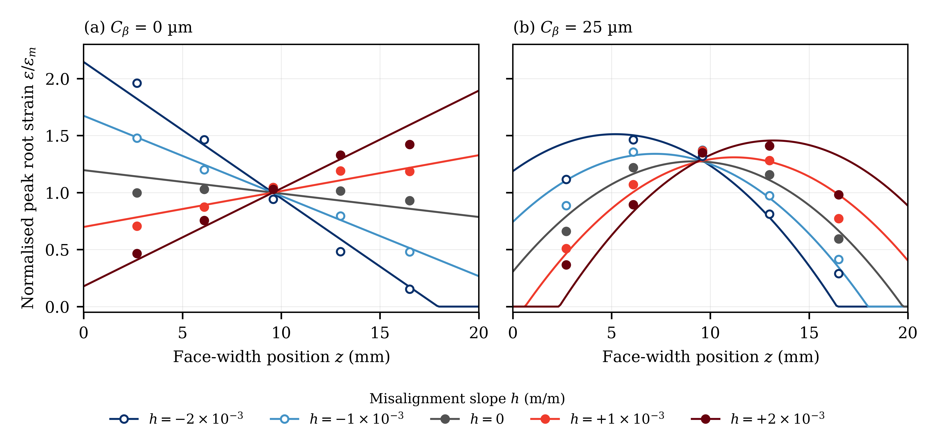
Fig. 1 Normalised peak root strain along the face width of the helical pair of [4] at T = 200 N·m. Symbols: experimental data (digitised; open symbols for h < 0). Lines: slice model, Eq. (2), with κ = 0.88 and h₀ = −0.4 × 10⁻³ m/m calibrated on (a) and applied unchanged to (b). (a) Uncrowned pair, calibration set. (b) Pair with 25 µm lead crown, internal validation set
The intercept reflects a sign asymmetry: at |h| = 2 × 10⁻³ m/m, S was −2.82 for h < 0 but 1.40 for h > 0 (Fig. 2a), and the distributions cross about 8 mm rather than 10 mm from the reference edge, which [4] attributed to unavoidable shaft misalignment within the test-machine tolerances. In the slice model, this corresponds to an effective residual misalignment h₀ = −0.4 × 10⁻³ m/m (about 8 µm across the face width). Fitting κ, h₀ and a gauge-spreading width to the uncrowned data gave κ = 0.88, h₀ = −0.4 × 10⁻³ m/m and zero spreading, with an RMSE of 0.073 against 0.144 for the nominal model (κ = 1, h₀ = 0); the AIC fell from −96.9 to −125.1 despite three added parameters. Because the distribution measured at h = 0 is nearly uniform (S = −0.09), h₀ is an effective parameter for the sign asymmetry rather than a measured rig error. For h = −2 × 10⁻³ m/m, κ|Π| ≈ 2.5, just beyond the contact-loss boundary, but the predicted loss of contact lies beyond the outermost gauge (Fig. 1a), so the five-gauge slope remains usable.
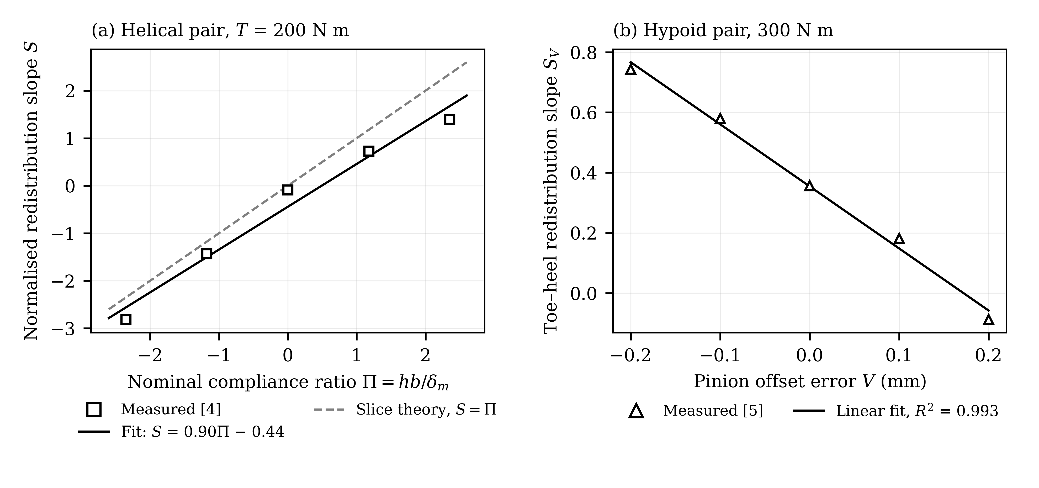
Fig. 2 (a) Normalised redistribution slope of the helical pair [4] against the nominal compliance ratio Π of Eq. (3) (h₀ = 0); the dashed line is the full-contact slice-theory result S = Π. (b) Normalised toe–heel slope of the peak-to-peak root stress of the hypoid pair [5] against the pinion offset error V at 300 N·m
For the crowned pair (Fig. 1b), the same parameters with C_{β} = 25 µm predicted the change to a convex distribution and the shift of the peak from gauge C2 to gauge C4 (numbered from the reference edge) as h changed sign. The RMSE was 0.148 against 0.189 for the nominal model, so H2 is partly supported. The residuals are systematic: at |h| = 2 × 10⁻³ m/m, the model unloads the face ends, whereas the outermost gauges still carried 29–37% of the mean strain. A crown of 12.5 µm instead of 25 µm per end raised the RMSE to 0.223, so the crown definition is not the cause; a plausible cause is load spreading in the root fillet between neighbouring slices, which the slice model neglects.
Table 4 compares the Method C factors of Eq. (4) with the ratio of maximum to mean gauge strain. With nominal misalignment, Method C gives the same factor for +h and −h, whereas the measured ratios differ by up to 38% between signs. With h₀, the predicted K_{Fβ} equals the measured ratio in the most severe case (1.96) and exceeds it by 0.08–0.26 otherwise. Because the outermost gauges lie 2.7 and 3.5 mm inside the face ends [4], the measured ratio is a lower bound for the true factor, so Method C is conservative by a small margin once the residual misalignment is known.
Table 4 ISO 6336-1 Method C face load factors and measured gauge-strain ratios for the uncrowned helical pair at 200 N·m (N_{F} = 0.78; δ_{m} = 17 µm)
h (10⁻³ m/m) | |Π|, nominal | K_{Fβ}, nominal | |Π|, with h₀ | K_{Fβ}, with h₀ | Measured ε_{max}/ε_{m}
−2 | 2.35 | 1.83 | 2.82 | 1.96 | 1.96
−1 | 1.18 | 1.43 | 1.65 | 1.60 | 1.48
+1 | 1.18 | 1.43 | 0.71 | 1.27 | 1.19
+2 | 2.35 | 1.83 | 1.88 | 1.68 | 1.42

4.2 Linear Redistribution in a Hypoid Pair
The mesh deflection of the hypoid pair [5] was not reported, so only linearity could be tested. The normalised toe–heel slope S_{V} of the peak-to-peak root stress decreased linearly with the pinion offset error V (Fig. 2b): dS_{V}/dV = −2.06 mm⁻¹ with R² = 0.993, and a quadratic term (−1.17 mm⁻²) changed S_{V} by less than 0.05 over the tested range. The intercept S_{V} = 0.35 reflects the inherent toe–heel asymmetry of the hypoid contact. H3 is therefore supported within ±0.2 mm at 300 N·m.

4.3 Planet Load Sharing: Calibration and Internal Validation
Fitting Eq. (5) to the tabulated six-planet load percentages at 1000 N·m for the cases in which planet 1 had a tangential pinhole position error ẽ_{c1} = e₁ = ±70 µm gave δ_{ref} = 42 µm (40–44 µm under the digitisation-noise bootstrap). With this single parameter, the model reproduced the full six-planet data set (ẽ_{c1} = 0, ±35, ±70 µm) with an RMSE of 1.63 percentage points, against 1.68 for the multibody contact predictions of [17] and 5.89 for equal sharing (Fig. 3a); the ±35 µm cases, not used in the fit, gave 1.53. The model also reproduced the measured pattern: the planet with the error and the opposite planet gained load, the two neighbours lost load, and the remaining pair stayed near the nominal share. H4 is supported.
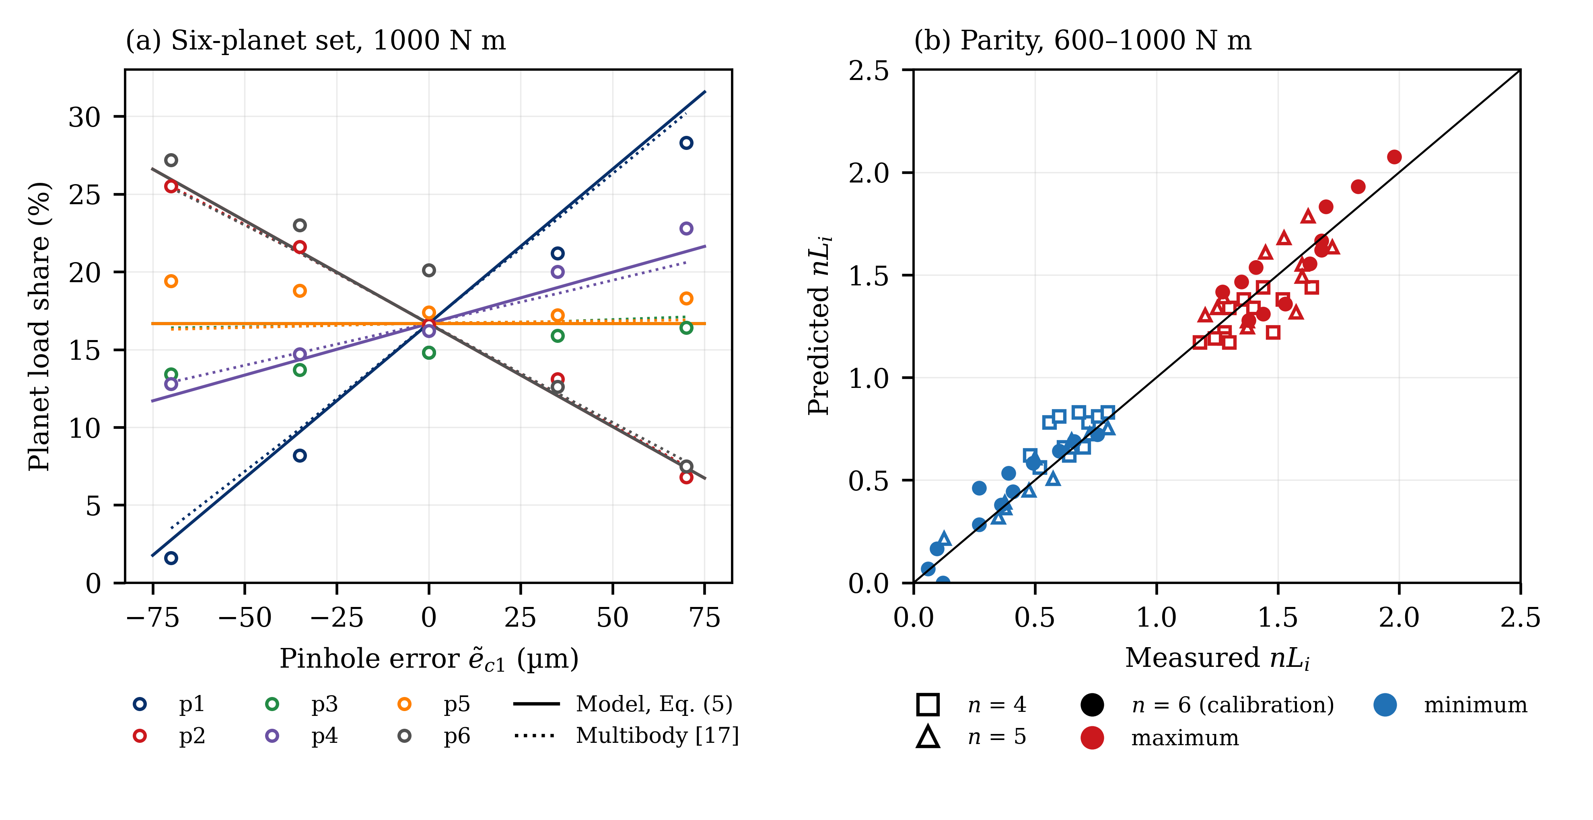
Fig. 3 Planet load sharing on the rig of [17, 23]. (a) Six-planet load shares at 1000 N·m against the tangential pinhole position error ẽ_{c1} of planet 1: symbols, tabulated measurements [17]; solid lines, one-parameter model, Eq. (5); dotted lines, multibody contact model of [17] (computational, for comparison). The model lines of planets 2 and 6, and of planets 3 and 5, coincide. (b) Predicted against measured maximum (red) and minimum (blue) per-planet factors nL_{i} for n = 4 and 5 (internal validation, open symbols) and n = 6 (calibration, filled symbols) at 600–1000 N·m
At 1000 N·m, the two meshes acting in parallel displace the planet centre by δ_{ISO} = 4.9 µm with the ISO stiffness (tangential mesh force 2.46 kN per planet), so η = 0.12: the effective path is about 8.6 times more compliant than the meshes alone. The planet needle bearing (2.0–2.5 × 10⁵ N/mm [15, 17]) adds about 20–25 µm under its 4.9 kN load; the remainder is attributed to the ring rim, its spline support and a mesh stiffness below the generic value. The calibrated deflection is consistent with the planet support stiffness of 9 × 10⁴ N/mm identified for this rig with a deformable-body model [15], which gives about 55 µm. Fitting δ_{ref} and m of Eq. (6) to all six-planet data (600–1000 N·m) gave m = 0.5 (bootstrap range 0.2–0.7). For the four- and five-planet data, whose slightly unequal planet spacing the model ignores, predictions with the same δ_{ref} and m and the per-planet load scaled by 6/n gave an RMSE of K_{max} and K_{min} of 0.109, against 0.119 for m = 1 and 0.447 for equal sharing (Fig. 3b). For K_{max} alone, the RMSE was 0.127, against 0.155 for the constant K_{γ} = 1.44 (Table 5).

4.4 Torque Dependence of the Mesh Load Factor
Equation (7) predicts K_{γ} − 1 ∝ T^{−m} while all planets carry load. Figure 4 shows K_{γ} − 1 against normalised torque for the twelve error cases of [23] and the four industrial series of [24, 25]. The fitted exponents were 0.75–0.97 for four planets, 0.38–0.87 for five and 0.65–0.79 for six, except for the six-planet case with ẽ_{c1} = −70 µm, in which planet 1 carried less than 2% of the load at every torque and the exponent fell to 0.14. The industrial series gave 0.52 and 0.70 [24], and 0.54 for counter-clockwise (CCW, 50–125%) and 1.16 for clockwise (CW) rotation [25]. Fourteen of the fifteen series with all planets loaded gave exponents below 1 (0.38–0.97; median 0.70, interquartile range 0.63–0.86). The pooled mean was 0.73 (95% CI 0.64–0.83), and both the t-test against 1 and the sign test (p < 0.001) reject H5 (m = 1). The four industrial series alone also average 0.73, so the pooled value is not driven by one laboratory; its excess over the m = 0.5 of the six-planet calibration set indicates a rig-dependent exponent of about 0.5–0.8. The exponent also differs from 0, the value implied by a torque-independent design factor: all fifteen exponents were positive (sign test, p < 0.001).
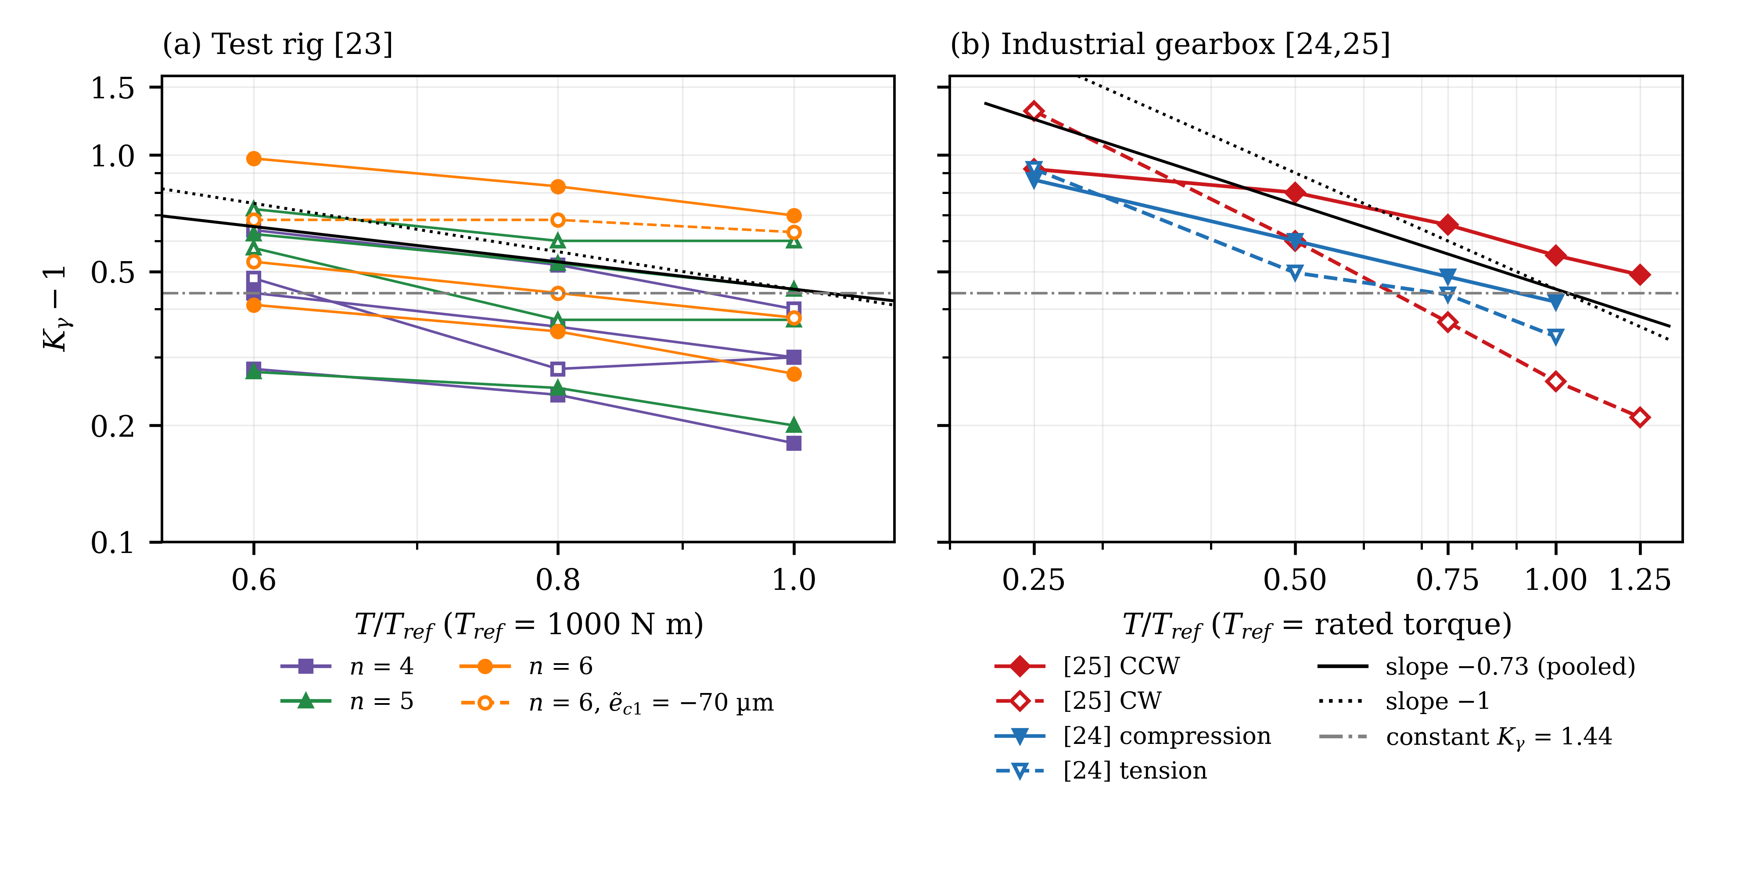
Fig. 4 Torque dependence of K_{γ} − 1 on logarithmic axes. (a) Test rig of [23]: twelve error cases for n = 4–6 (filled symbols: ẽ_{c1} > 0; open symbols: ẽ_{c1} < 0; dashed line: six-planet case with ẽ_{c1} = −70 µm, in which planet 1 is almost unloaded); T_{ref} = 1000 N·m sun torque. (b) Industrial gearbox of [24, 25]; T_{ref} = rated torque. Solid black line: pooled slope −0.73; dotted line: slope −1; dash-dot line: constant design value K_{γ} = 1.44
The six-planet case at −70 µm marks the regime boundary: once a planet is unloaded, a lower torque cannot redistribute its share, and K_{γ} saturates. This is the planetary counterpart of the loss of end contact at |Π| = 2 in Eq. (4).

4.5 External Validation on an Industrial Gearbox
The industrial gearbox [24, 25] was predicted from its measured pinhole errors with η = 0.12 and m = 0.5 from the calibration set and with the mesh deflection computed from the stage-1 geometry (b = 72 mm, ring pitch radius 196 mm). Because the sign convention of the errors relative to the direction of rotation is ambiguous in [25], both mappings were evaluated. With the floating-sun model and the better mapping, the per-pin RMSE for [25] was 0.321 against 0.424 for equal sharing, a 24% reduction (Fig. 5a); the opposite mapping gave 0.586, and a fixed-sun model 0.82–0.90. For [24], the model gave 0.407 against 0.391 for equal sharing (Fig. 5b): the transferred model did not explain the measured pattern. The peak factor was predicted with an RMSE of 0.408 [25] and 0.461 [24], worse than 0.358 and 0.238 for the constant 1.44, so H6 is not supported.
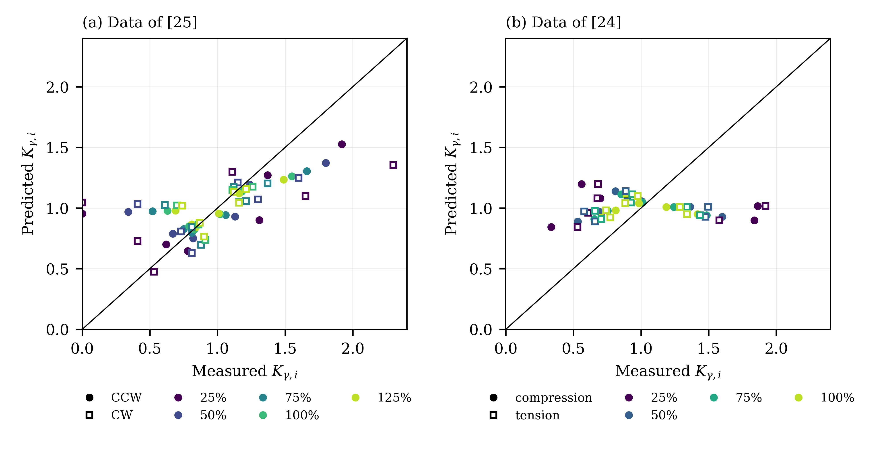
Fig. 5 External validation on the industrial six-planet gearbox. Per-pin mesh load factors K_{γ,i} predicted from the measured pinhole errors with η = 0.12 and m = 0.5 from the calibration set, against measurements. (a) Data of [25] (filled: CCW; open: CW). (b) Data of [24] (filled: compression gauges; open: tension gauges). Colour indicates the torque level as a percentage of the rated torque
In a separate recalibration test, δ_{ref} was fitted to the 100% torque data of each external set and the other torque levels were predicted. For [25], the per-pin RMSE was 0.341 against 0.456 for equal sharing on the same subset, and the peak-factor RMSE was 0.391 with m = 0.5 and 0.294 with m = 1, against 0.393 for the constant, in line with the CW exponent of 1.16 (Fig. 4b). For [24], the fit reverted to equal sharing (δ_{ref} at the upper search bound of 2000 µm). Yet for the 100% condition of the same test, the load shares computed with a system-level model [21] give an RMSE of nL_{i} of 0.07 against 0.23 for equal sharing, so the measured errors carry information that the single-spring model with transferred η does not capture.
Table 5 Comparison with baseline models: RMSE of the per-planet factor nL_{i} (planetary sets) or of the normalised strain (helical pair). Lower is better; AIC is given where parameter counts differ; pp = percentage points
Data set (role) | Compliance-ratio model | Linear, nominal or multibody model | Constant K_{γ} = 1.44 | Equal sharing or uniform
Helical, C_{β} = 0 (calibration) | 0.073 (k = 3; AIC −125.1) | 0.144 (k = 0; AIC −96.9) | – | –
Helical, C_{β} = 25 µm (internal validation) | 0.148 | 0.189 | – | –
Six-planet shares, 1000 N·m (calibration) | 1.63 pp (k = 1) | Multibody model [17]: 1.68 pp | – | 5.89 pp
Six-planet K_{max}, 600–1000 N·m (calibration) | 0.114 (m = 0.5) | 0.181 (m = 1) | 0.243 | –
Four- and five-planet K_{max}, K_{min} (internal validation) | 0.109 (AIC −209.1) | 0.119 (AIC −202.6) | – | 0.447 (AIC −77.2)
Four- and five-planet K_{max} (internal validation) | 0.127 | 0.139 | 0.155 | –
[25] per pin (external validation) | 0.321 | – | – | 0.424
[25] K_{max} (external validation) | 0.408 | – | 0.358 | –
[24] per pin (external validation) | 0.407 | – | – | 0.391
[24] K_{max} (external validation) | 0.461 | – | 0.238 | –

4.6 Zero-Load Limit and Transmission-Error Evidence
In the unloaded contact-pattern experiments of [6], the elastic deflection is negligible and Π is effectively infinite. The measured contact-area reductions for axial and radial offsets agreed with the geometric model of the same authors within 1.6 percentage points, and those for angular misalignments of 2.64° and 4.67° (23 and 41 times the largest slope in [4]) were about 6 percentage points smaller (Table 6). These data confirm the geometric limit but carry no information on the elastic redistribution described by Π.
For transmission error, misalignment introduced through an eccentric sleeve raised the first mesh harmonic of the dynamic transmission error of a spur pair with 53 µm lead crown at 30 N·m from about 0.6 × 10⁻⁵ to 1.9 × 10⁻⁵ rad at 50 min⁻¹ and from 0.2 × 10⁻⁵ to 1.5 × 10⁻⁵ rad at 1200 min⁻¹ [30] (values read from the published figures). The direction agrees with the loss of effective face width predicted by Eqs. (2)–(4), but the misalignment magnitude was not reported and the load was light, so tooth impacts across the backlash contribute strongly to the signal [30]. Finite-element results indicate that assembly errors increase transmission error without changing its waveform [7], but they cannot serve as validation. With one source and no quantified misalignment, H7 cannot be tested.
Table 6 Zero-load limit and transmission-error evidence. TE = transmission error; n.r. = not reported
Source | Misalignment | Measured response | Reference model | Use in this study
[6] | Axial 6 mm | Contact area −28.4% | Geometric: −30.0% | Zero-load limit
[6] | Radial 1 mm; 2 mm | −17.7%; −32.3% | −16.7%; −33.3% | Zero-load limit
[6] | Angular 2.64°; 4.67° | −14.0%; −37.5% | −20.3%; −43.5% | Zero-load limit
[30] | Eccentric sleeve, value n.r. | First TE harmonic ×3.2 (50 min⁻¹), ×7.5 (1200 min⁻¹), 30 N·m | None (experimental) | Direction only; not testable on Π

4.7 Uncertainty and Sensitivity
Table 7 summarises the parameter uncertainties and sensitivities. The helical result depends on the mesh deflection of 17 µm calculated in [4]: a 20% error changes κ by the same fraction and moves its CI to 0.64–0.84 or 0.96–1.26. The generic ISO 6336-1 mesh stiffness would give δ_{m} ≈ 6.7 µm for this pair at 200 N·m (133 N/mm of tangential load at the reference diameter of 150 mm) and κ ≈ 0.36. The stiffness calculated in [4] for this narrow, high-helix-angle pair, 169 N/µm or about 8.5 N/(mm·µm), is less than half the generic value, so Π must be formed with a pair-specific mesh stiffness. The exponent m is poorly constrained by three torque levels (0.2–0.7), but the rejection of m = 1 rests on the fifteen series of Fig. 4.
Table 7 Parameter uncertainty and sensitivity
Quantity | Estimate | Uncertainty or sensitivity | Effect on conclusion
κ (helical slope coefficient) | 0.90 | 95% CI 0.80–1.05 (bootstrap, ±25 µε noise) | H1 supported; conditional on δ_{m} = 17 µm
δ_{m} (helical mesh deflection) | 17 µm (calculated in [4]) | ±20%: CI of κ 0.64–0.84 or 0.96–1.26; generic ISO stiffness (6.7 µm): κ ≈ 0.36 | Π must be formed with a pair-specific mesh stiffness
h₀ (residual misalignment) | −0.4 × 10⁻³ m/m | Grid resolution 10⁻⁴ m/m; h = 0 case nearly uniform (S = −0.09) | Effective parameter for the sign asymmetry (Table 4)
Crown definition | C_{β} = 25 µm per end | C_{β} = 12.5 µm raises RMSE from 0.148 to 0.223 | Residuals not due to crown definition
δ_{ref} (six-planet, 1000 N·m) | 42 µm | Range 40–44 µm (±0.01 noise) | η = 0.11–0.12
Planet support stiffness of the rig [15] | 9 × 10⁴ N/mm | Planet-centre deflection about 55 µm at 1000 N·m, six planets | Same order as the calibrated 42 µm
m (load exponent) | 0.5 | Range 0.2–0.7 | Pooled exponent of Fig. 4: 0.73 (0.64–0.83)
Digitisation | – | Six-planet check against table: ≤ 0.005 | Negligible relative to model error
Direction mapping [25] | Better of two | Opposite mapping: RMSE 0.586 | External transfer not supported in either case
Sun support | Floating | Fixed sun: RMSE 0.82–1.16 (external data sets) | Floating-sun model retained

5 Discussion

5.1 Physical Interpretation and Comparison with the Literature
The results support a restricted form of the hypothesis: within one rig and while every load path remains in contact, redistribution depends on misalignment through the ratio of geometric mismatch to elastic deflection, both across the face width and among the planets. The settings differ in the deflection that enters the ratio. In the helical pair, it was the mesh deflection itself, provided that it was calculated for the specific pair; the generic ISO stiffness would have overstated Π by a factor of 2.5. In the planetary set, the planet-centre deflection was about 8.6 times the mesh-only value, about half of it from the planet bearing, and was consistent with the planet support stiffness identified independently for the same rig [15]. Support and component compliance therefore control planet-to-planet redistribution, as in models that include them [18, 19]. For six planets, the planetary relation, Eq. (8), and the linear branch of Method C, Eq. (4), have the same form.
Method C matched or exceeded the measured root-strain ratios once the residual misalignment was included, in agreement with the finite-element finding that the ISO 6336 methods overestimate the face load factor of helical gears in most cases [12]. The residuals of the crowned pair suggest that load spreading in the root, which slice models neglect, matters when lead modification moves the load towards the centre of the face width [11].
In planetary sets, the two modes coexist: planet tilting loads opposite face ends of the sun–planet and ring–planet meshes [19], and in a 2 MW wind-turbine stage with measured three-dimensional pinhole errors, the measured coefficient combining both distributions fell from about 2.0–2.25 at 25% to 1.45–1.6 at 100% of the rated torque for three and four planets [20]. Since a three-planet set with a floating member shares load equally regardless of tangential pinhole errors [15], this decrease must include face-width redistribution, which therefore also relaxes with load, as Π implies.
Two findings bear on design practice. First, K_{γ} was not constant. In linear discrete models, the deviation of each planet load from its nominal share is proportional to the pinhole errors and inversely proportional to T_{s} [15], i.e. m = 1 in Eq. (6); the measurements used here [23–25] instead gave exponents below 1 in fourteen of fifteen series from two laboratories (pooled 0.73). A constant factor such as 1.44 cannot represent this dependence: on the industrial gearbox, the measured peak factor ranged from 1.21 to 2.30 for the same hardware. Second, the path deflection was not proportional to load (m ≈ 0.5–0.8), as expected if the path stiffens with load. Possible sources are the nonlinearity of the effective planet stiffness noted in [15], the load-dependent mesh stiffness of modified teeth [19], Hertzian contact and the take-up of bearing clearance; the present data do not separate them. In both settings, the linear relation fails once one face end or one planet is unloaded: the face load factor then grows with the square root of Π, whereas K_{γ} saturates; system-level simulations of the industrial gearbox show the same saturation [21].
For tolerance allocation, pinhole position errors and lead mismatches should therefore be judged relative to the effective path deflection at the design load rather than to the mesh deflection alone; the same error produces less relative redistribution at high torque and in a compliant load path.

5.2 Transfer to an Industrial Gearbox
For the external data set in which the transferred model failed (Section 4.5), a system-level model with carrier, pin, bearing and housing flexibilities reproduced the 100% torque load shares within 10% from the same errors [21]. The pinhole errors therefore explain the load pattern, but one spring per planet with η transferred from a laboratory rig does not represent an industrial carrier, whose pinhole errors also differ between the front and rear plates by up to 33 µm [21], a three-dimensional error that affects load distribution [20]. η must be determined for each design, for example with system-level or three-dimensional models [18–21]; a coefficient that transfers across architectures is not supported.

5.3 Limitations and Future Work
Testing a misalignment–transmission-error relation requires experiments that report the misalignment magnitude, the mesh or path deflection and the transmission error together at more than one torque; the data reviewed here contain at most two of the three. A suitable experiment would combine controlled eccentric bearing caps as in [4], encoder-based measurement [28, 30] and a torque sweep, so that Π can be varied independently through the misalignment and through the load; planetary models validated for transmission error and load sharing [29] could support the interpretation of such data.
The calibration and internal validation sets of each analysis come from one laboratory, so internal validation tests transfer across gear sets, crown and planet count, but not across laboratories. Several data sets were digitised, the helical analysis relies on a deflection reported at one torque, and h₀ does not reproduce the nearly uniform distribution at h = 0. The planetary model represents each path by one spring and ignores sun-support stiffness, carrier deformation, planet tilting [19], three-dimensional pinhole errors [20] and dynamic effects; the industrial data were measured at rest and at 85.9 min⁻¹, where dynamic effects should be small. Simulation was used only to solve Eqs. (2) and (5), and no computational result was used for validation.

6 Conclusions
Measurements from six published experimental studies were used to test whether misalignment-induced load redistribution in gear meshes follows one dimensionless compliance ratio Π, the geometric mismatch divided by the effective elastic deflection of the loaded path. The main findings are as follows.
(1) For a helical pair, the normalised face-width redistribution slope was linear in Π with a coefficient of 0.90 (95% CI 0.80–1.05) when Π was formed with the mesh deflection calculated for the specific pair; the generic ISO 6336-1 mesh stiffness would overstate Π by a factor of about 2.5. With an effective residual misalignment of −0.4 × 10⁻³ m/m, ISO 6336-1 Method C matched or exceeded the measured root-strain ratios.
(2) For planetary sets with a floating sun, a one-parameter path model based on the same ratio reproduced measured six-planet load shares within 1.6 percentage points, comparable to a multibody contact model. For a single pinhole error and six planets, it has the same form as the linear branch of Method C.
(3) The effective planet-centre deflection was about 8.6 times the mesh-only value from ISO 6336-1, about half of it from the planet bearing, and grew sub-linearly with load. Consequently, K_{γ} decreased with torque, with exponents of 0.38–0.97 in fourteen of fifteen series from two laboratories (pooled 0.73, 95% CI 0.64–0.83), in contrast to the torque-independent value used in design practice.
(4) In both settings, the linear relation holds only while every load path remains in contact; beyond this boundary, the face load factor grows with the square root of Π and the planetary factor saturates.
(5) The laboratory calibration did not transfer to an industrial six-planet gearbox in absolute terms, because one spring per planet does not represent the system compliance of an industrial carrier, and the published experiments do not allow a misalignment–transmission-error relation to be tested.
These conclusions are limited to quasi-static conditions and to the gear types and error ranges listed in Table 2.

Declarations

Author Contributions
Yunus Emre Karabacak: Conceptualization, Methodology, Data curation, Formal analysis, Software, Visualization, Writing – original draft, Writing – review & editing.

Competing Interests
The author declares no known competing financial interests or personal relationships that could have appeared to influence the work reported in this paper.

Data Availability
All experimental values were extracted from the published sources listed in Table 2. The digitised data set, the extraction settings and the analysis scripts are available from the corresponding author on reasonable request.

References
- International Organization for Standardization. (2006). Calculation of load capacity of spur and helical gears — Part 1: Basic principles, introduction and general influence factors (ISO Standard No. 6336-1:2006, corrected version 2007-04-01). ISO.
- American Gear Manufacturers Association. (2004). Fundamental rating factors and calculation methods for involute spur and helical gear teeth (ANSI/AGMA 2001-D04). AGMA.
- American Gear Manufacturers Association. (2006). Design manual for enclosed epicyclic gear drives (ANSI/AGMA 6123-B06). AGMA.
- Hotait, M. A., & Kahraman, A. (2008). Experiments on root stresses of helical gears with lead crown and misalignments. Journal of Mechanical Design, 130(7), 074502. https://doi.org/10.1115/1.2931127
- Hotait, M. A., Kahraman, A., & Nishino, T. (2011). An investigation of root stresses of hypoid gears with misalignments. Journal of Mechanical Design, 133(7), 071006. https://doi.org/10.1115/1.4004224
- Kumar, P., Hirani, H., & Agrawal, A. K. (2019). Effect of gear misalignment on contact area: Theoretical and experimental studies. Measurement, 132, 359–368. https://doi.org/10.1016/j.measurement.2018.09.070
- Li, S. (2007). Effects of machining errors, assembly errors and tooth modifications on loading capacity, load-sharing ratio and transmission error of a pair of spur gears. Mechanism and Machine Theory, 42(6), 698–726.
- Li, S. (2015). Effects of misalignment error, tooth modifications and transmitted torque on tooth engagements of a pair of spur gears. Mechanism and Machine Theory, 83, 125–136. https://doi.org/10.1016/j.mechmachtheory.2014.09.011
- Saxena, A., Parey, A., & Chouksey, M. (2015). Effect of shaft misalignment and friction force on time varying mesh stiffness of spur gear pair. Engineering Failure Analysis, 49, 79–91. https://doi.org/10.1016/j.engfailanal.2014.12.020
- Qiu, F., Xie, D., Wang, B., Fu, Q., Ding, B., & Zhang, H. (2026). Meshing characteristics and fatigue life analysis of top drive gear transmission system under misalignment. Engineering Failure Analysis, 184, 110339. https://doi.org/10.1016/j.engfailanal.2025.110339
- Peng, Y., Zhao, N., Qiu, P., Zhang, M., Li, W., & Zhou, R. (2018). An efficient model of load distribution for helical gears with modification and misalignment. Mechanism and Machine Theory, 121, 151–168.
- Roda-Casanova, V., Funaru, T. G., & Patil, S. S. (2026). Analysis of the ISO 6336 face load factor and its application to helical gears. Proceedings of the Institution of Mechanical Engineers, Part C: Journal of Mechanical Engineering Science, 240(15), 5712–5729. https://doi.org/10.1177/09544062251347483
- Kahraman, A. (1994). Load sharing characteristics of planetary transmissions. Mechanism and Machine Theory, 29(8), 1151–1165.
- Bodas, A., & Kahraman, A. (2004). Influence of carrier and gear manufacturing errors on the static load sharing behavior of planetary gear sets. JSME International Journal Series C, 47(3), 908–915. https://doi.org/10.1299/jsmec.47.908
- Ligata, H., Kahraman, A., & Singh, A. (2009). A closed-form planet load sharing formulation for planetary gear sets using a translational analogy. Journal of Mechanical Design, 131(2), 021007. https://doi.org/10.1115/1.3042160
- Singh, A. (2005). Application of a system level model to study the planetary load sharing behavior. Journal of Mechanical Design, 127(3), 469–476. https://doi.org/10.1115/1.1864115
- Singh, A., Kahraman, A., & Ligata, H. (2008). Internal gear strains and load sharing in planetary transmissions: Model and experiments. Journal of Mechanical Design, 130(7), 072602. https://doi.org/10.1115/1.2890110
- Leque, N., & Kahraman, A. (2017). A three-dimensional load sharing model of planetary gear sets having manufacturing errors. Journal of Mechanical Design, 139(3), 033302.
- Hu, Y., Talbot, D., & Kahraman, A. (2018). A load distribution model for planetary gear sets. Journal of Mechanical Design, 140(5), 053302. https://doi.org/10.1115/1.4039337
- Dong, H., Zhang, C., Bai, S., & Wang, D. (2019). Modeling, analysis and testing of load distribution for planetary gear trains with 3D carrier pinhole position errors. International Journal of Precision Engineering and Manufacturing, 20(8), 1381–1394. https://doi.org/10.1007/s12541-019-00166-1
- Kim, J.-G., Park, Y.-J., Lee, S.-D., Oh, J.-Y., Kim, J.-H., & Lee, G.-H. (2018). Influence of the carrier pinhole position errors on the load sharing of a planetary gear train. International Journal of Precision Engineering and Manufacturing, 19(4), 537–543. https://doi.org/10.1007/s12541-018-0065-4
- Iglesias, M., Fernández del Rincón, A., de-Juan, A., García, P., Diez-Ibarbia, A., & Viadero, F. (2017). Planetary transmission load sharing: Manufacturing errors and system configuration study. Mechanism and Machine Theory, 111, 21–38. https://doi.org/10.1016/j.mechmachtheory.2016.12.010
- Ligata, H., Kahraman, A., & Singh, A. (2008). An experimental study of the influence of manufacturing errors on the planetary gear stresses and planet load sharing. Journal of Mechanical Design, 130(4), 041701. https://doi.org/10.1115/1.2885194
- Kim, J.-G., Park, Y.-J., Lee, G.-H., & Kim, J.-H. (2016). An experimental study on the effect of carrier pinhole position errors on planet gear load sharing. International Journal of Precision Engineering and Manufacturing, 17(10), 1305–1312. https://doi.org/10.1007/s12541-016-0155-0
- Kim, J.-G., Park, Y.-J., Lee, G.-H., Lee, S.-D., & Oh, J.-Y. (2018). Experimental study on the carrier pinhole position error affecting dynamic load sharing of planetary gearboxes. International Journal of Precision Engineering and Manufacturing, 19(6), 881–887. https://doi.org/10.1007/s12541-018-0104-1
- Tamminana, V. K., Kahraman, A., & Vijayakar, S. (2007). A study of the relationship between the dynamic factors and the dynamic transmission error of spur gear pairs. Journal of Mechanical Design, 129(1), 75–84.
- Hotait, M. A., & Kahraman, A. (2013). Experiments on the relationship between the dynamic transmission error and the dynamic stress factor of spur gear pairs. Mechanism and Machine Theory, 70, 116–128. https://doi.org/10.1016/j.mechmachtheory.2013.07.006
- Palermo, A., Britte, L., Janssens, K., Mundo, D., & Desmet, W. (2018). The measurement of gear transmission error as an NVH indicator: Theoretical discussion and industrial application via low-cost digital encoders to an all-electric vehicle gearbox. Mechanical Systems and Signal Processing, 110, 368–389.
- Pedrero, J. I., Sánchez-Espiga, J., Sánchez, M. B., Pleguezuelos, M., Fernández-del-Rincón, A., & Viadero, F. (2024). Simulation and validation of the transmission error, meshing stiffness, and load sharing of planetary spur gear transmissions. Mechanism and Machine Theory, 203, 105800. https://doi.org/10.1016/j.mechmachtheory.2024.105800
- Xiong, C., & Chen, S. (2020). Experimental study of the effect of assembly error on the lightly loaded transmission error of spur gear with crown modification. Journal of Low Frequency Noise, Vibration and Active Control, 39(4), 1039–1051. https://doi.org/10.1177/1461348419854833
- Kumar, P., & Hirani, H. (2021). Misalignment effect on gearbox failure: An experimental study. Measurement, 169, 108492.
- Hotait, M. A., Talbot, D., & Kahraman, A. (2008). An investigation of the influence of shaft misalignment on bending stresses of helical gears with lead crown. Gear Technology, November/December, 54–62.

