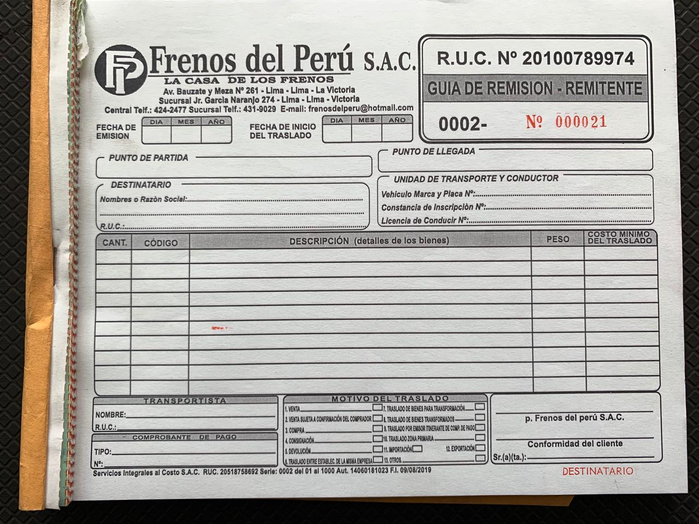

|  |  |  |
| --- | --- | --- |
| ${prod_c#1} | ${prod#1} | ${prod_um#1} |
| ${prod_c#2} | ${prod#2} | ${prod_um#2} |
| ${prod_c#3} | ${prod#3} | ${prod_um#3} |
| ${prod_c#4} | ${prod#4} | ${prod_um#4} |
| ${prod_c#5} | ${prod#5} | ${prod_um#5} |
| ${prod_c#6} | ${prod#6} | ${prod_um#6} |
|  |  |  |
|  |  |  |
|  |  |  |
|  |  |  |

${destinatario}

${ punto_partida}

${punto_llegada}