TACTICAL LIGHT VEHICLE — COMPARATIVE PROFILE
MILITARY UTILITY VEHICLES
Dongfeng EQ2050 Mengshi | AM General HMMWV M1114

VEHICLE PROFILE — 01 · PEOPLE'S REPUBLIC OF CHINA
Dongfeng EQ2050 “Mengshi”
猩士 · Multi-Role Tactical 4×4 Light Utility Vehicle · PLA Service 2001–Present

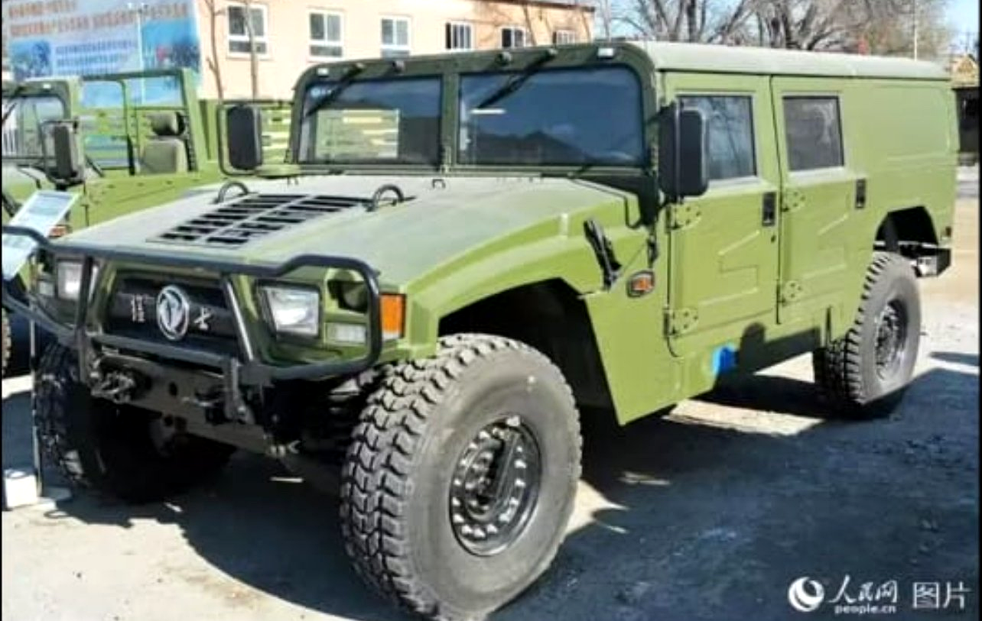
TECHNICAL SPECIFICATIONS

CURB WEIGHT  3,200 kg  Approx. 7,055 lbs |  | PAYLOAD CAPACITY  800–1,000 kg  Combat-loaded
CREW / SEATING  4–5 Crew  Mission-dependent |  | ENGINE  4BT/6BT Diesel  Cummins-derived, 110–175 hp
DRIVETRAIN  4×4 AWD  Portal axles, differential lock |  | GROUND CLEARANCE  400 mm  15.7 inches
MAX ROAD SPEED  ~130 km/h  On sealed surface |  | OPERATIONAL RANGE  ~500 km  Road conditions
FORDING DEPTH
800 mm
Without preparation

PLATFORM & OPERATIONAL FEATURES

PLATFORM & CONSTRUCTION  — High-strength steel ladder-frame chassis  — Independent front suspension with coil springs  — Leaf-spring live rear axle system  — Portal gear axles for extreme articulation  — Military-grade corrosion-resistant body panels  — Modular body (soft/hard top configurations)  — Integrated front push bar and winch mount |  | OPERATIONAL CAPABILITY  — Roof-mounted crew-served weapon station  — 60% gradient climb capability  — 800 mm trench-crossing (unprepared)  — CBRN-resistant sealed cabin option  — Slave-start and blackout driving modes  — Export variants for allied armed forces  — Ambulance, command and logistics sub-variants

MISSION ROLES General-purpose troop carrier · Command vehicle · Logistics support · Direct fire weapon platform · Border patrol · High-altitude / extreme terrain operations

VEHICLE PROFILE — 02 · UNITED STATES OF AMERICA
AM General HMMWV M1114
High Mobility Multipurpose Wheeled Vehicle — Up-Armoured Variant · U.S. Army / USMC · 1985–Present

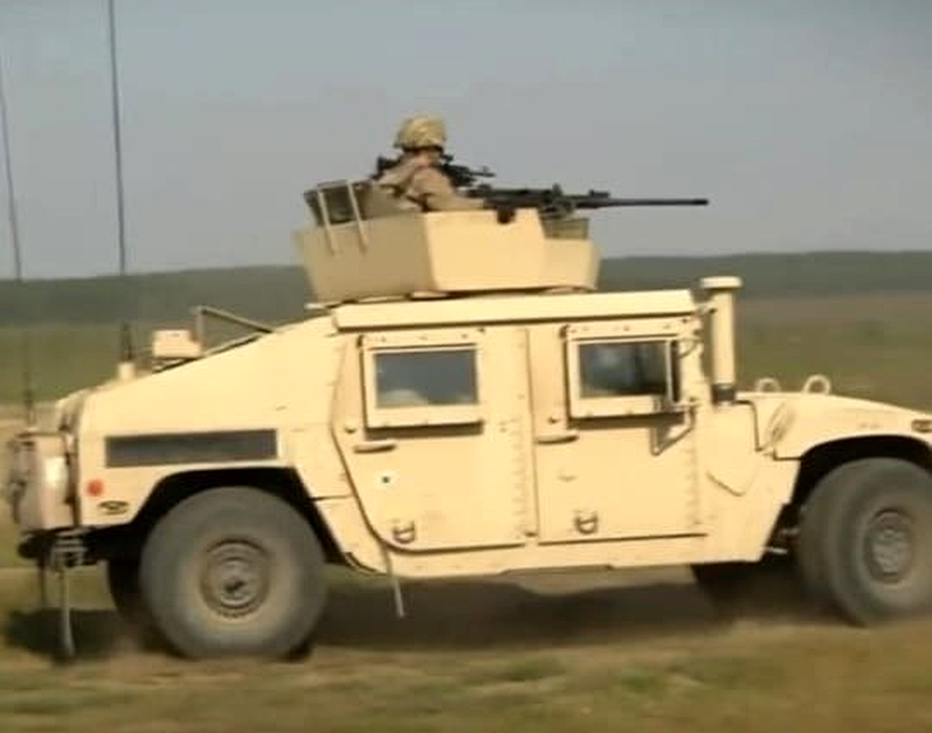
TECHNICAL SPECIFICATIONS

CURB WEIGHT  5,080 kg  Approx. 11,200 lbs (M1114) |  | PAYLOAD CAPACITY  1,134 kg  2,500 lbs operational
CREW / SEATING  2–5 Crew  Mission-dependent |  | ENGINE  6.5L V8 TD  GM Diesel, 160 hp / 520 Nm
DRIVETRAIN  4×4 AWD  Torsen CTIS / portal axles |  | GROUND CLEARANCE  406 mm  16 inches
MAX ROAD SPEED  113 km/h  70 mph on paved surface |  | OPERATIONAL RANGE  560 km  95 L standard fuel tank
FORDING DEPTH
760 mm
1,524 mm with deep-water kit

ARMOUR, WEAPONS & ELECTRONICS

ARMOUR & PROTECTION  — Factory-installed Level II B-kit armour (M1114)  — Armoured doors with ballistic glass windows  — Floor protection against IED and mine blast  — Central Tyre Inflation System (CTIS) standard  — Run-flat tyre capability  — NBC overpressure protection option  — Fire suppression in engine compartment |  | WEAPONS & ELECTRONICS  — OGPK / CROWS II armoured remote weapon station  — Compatible: M2HB .50 cal, MK19 AGL, M240, M249  — AN/VRC-92 SINCGARS communications integrated  — Blue Force Tracker (BFT) platform compatible  — TOW missile launcher variant (M1046)  — CASEVAC/MEDEVAC ambulance variant (M1035A2)  — EW/SIGINT antenna-ready roof structure

MISSION ROLES Infantry carrier · Direct-fire weapon platform · Command & control · CASEVAC/MEDEVAC · Scout/recce · Electronic warfare · Anti-tank missile carrier · Field logistics

SIDE-BY-SIDE SPECIFICATION COMPARISON
A direct technical and operational comparison of both tactical utility vehicles.
PARAMETER | DONGFENG EQ2050 | AM GENERAL M1114
Origin | China / Dongfeng Motor Corp | USA / AM General LLC
In Service | 2001 – Present (PLA) | 1985 – Present (US Armed Forces)
Base Concept | Inspired by HMMWV / Hummer H1 | Original HMMWV design
Combat Weight | ~3,200 – 3,800 kg | ~4,672 – 5,080 kg (M1114)
Engine Output | ~110 – 175 hp diesel | 160 hp / 520 Nm (6.5L V8 TD)
Factory Armour | Optional / variant-dependent | Standard on M1114 (Level B-kit)
Weapon Station | Roof pintle mount | OGPK armoured turret ring
Tyre System | Standard military tyres | CTIS / run-flat system
Ground Clearance | 400 mm | 406 mm
Max Speed | ~130 km/h | 113 km/h
Operational Range | ~500 km | ~560 km
Fording (unprepared) | 800 mm | 760 mm
Operators | China + exported allies | USA + 50+ allied nations
Est. Unit Cost | USD 40,000 – 80,000 | USD 130,000 – 220,000

For reference and brochure development purposes only. Data sourced from open military specifications and publicly available sources.

