

PSP [20ES104] COURSE PROJECT REPORT

On

MEDICAL BILLING SYSTEM

Developed By:

STUDENT NAME H.T.NO

Y.RAMYA 2203A52064

Under the Guidance of

Mr. Srinivas Aluvala, M.Tech. (Ph.D)
Assistant Professor

Submitted to
Department Computer Science and Artificial Intelligence SR University
Ananthasagar(V), Hasanparthy(M), Hanamkonda(Dist.) – 506371 www.sru.edu.in
June 2023
Department of Computer Science and Artificial Intelligence

CERTIFICATE

This is to certify that the PSP course project report entitled “ MEDICAL BILLING SYSTEM” is a record of bonafide work carried out by the student” Y. RAMYA” bearing roll number 2203A52064 of Computer Science and Artificial Intelligence department during the academic year 2022-23.

Supervisor

(Srinivas Aluvala)

Sl. No Title Page No.
- Problem statement 1
- Module-wise description 2
- Knowledge required to develop the project 3
- Source Code(.c.file code followed by .h file code) 4
- Result 9

PROBLEM STATEMENT:
Develop a C Application to store details of the medicines and to print the total bill and the details in terms of (Medical shop name, Tablet name, Quantity, Discount). Store the data in a dynamically in switch cases.
Provide the functionality for below mentioned:
Tablet names are displayed.

Select your medicine according to the prescription.

Enter no.of tablets.

Discount is given based on the quantity of the tablets.

Price is based on the discount given.

Loss is also given in details after the total cost.

This process continous untill you give the letter q.

MODULES:

In this application Two modules are used.
File Creation:
The code creates a file named "Ramyapsp.txt" to store the details of the medicine purchases and the total bill.

User Input:
The program prompts the user to enter the name of a medicine and the quantity they want to purchase. It uses the scanf function to read the user's input.

Cost Calculation:
The code calls the calculate_cost function to calculate the cost of the medicine based on its name and quantity.The function uses a switch statement to determine the medicine and applies the appropriate discount calculation.

File Writing:
After calculating the cost, the program opens the file in append mode and writes the details of the medicine purchase (medicine name, quantity, and cost) to the file using the fprintf function. It also updates the total bill by adding the cost Loop and Exit: The program continues to prompt the user for medicine names and quantities until the user enters "q" to quit. If the user enters an incorrect medicine name, the program displays an error message and continues to the next iteration of the loop.

Total Bill Calculation:
After the user finishes entering medicine purchases, the program writes the total bill to the file and displays it on the console.
KNOWLEDGE REQUIRED TO DEVELOP THIS APPLICATION
  - Control Statements (if, if-else, switch)

  - Loop Statements (while/do while, for)

  - Switch cases

  - Strings(strcmp)

  - Files

SOURCE CODE [.C FILE]:
/*
COURSE PROJECT TITLE:MEDICAL BILL
------------------------------------
DETAILS:
NAME:Y.RAMYA
HALL TICKET NUMBER:2203A52064
YEAR:1st
SEMISTER:2nd
SECTION:H1
Date:1/05/2023
--------------------------------------------
CREATING A PROGRAM BASED MEDICAL DETAILS
------Desktop--------------------------------------
*/
#include <stdio.h>
#include <stdlib.h>
#include <string.h>

float calculate_cost(char medicine_name[20], int quantity) {
float discount, price, cost;

switch (medicine_name[0]) {
case 'P':
printf(" Paracetamol Tablet");
printf("\nEnter the price: ");
scanf("%f", &price);
printf("Enter the discount: ");
scanf("%f", &discount);
cost = (price * discount * quantity) / 100.0;
printf("cost=%f", cost);
price = (price - cost);
printf("\nprice=%f", price);
break;
case 'A':
printf(" Aldoper Tablet");
printf("\nEnter the price: ");
scanf("%f", &price);
printf("Enter the discount: ");
scanf("%f", &discount);
cost = (price * discount * quantity) / 100.0;
printf("cost=%f", cost);
price = (price - cost);
printf("\nprice=%f", price);
break;
case 'C':
printf(" Chloroform Tablet");
printf("\nEnter the price: ");
scanf("%f", &price);
printf("Enter the discount: ");
scanf("%f", &discount);
cost = (price * discount * quantity) / 100.0;
printf("cost=%f", cost);
price = (price - cost);
printf("\nprice=%f", price);
break;
case 'D':
printf(" Diclofenac Tablet");
printf("\nEnter the price: ");
scanf("%f", &price);
printf("Enter the discount: ");
scanf("%f", &discount);
cost = (price * discount * quantity) / 100.0;
printf("cost=%f", cost);
price = (price - cost);
printf("\nprice=%f", price);
break;
case 'O':
printf(" Omee Tablet");
printf("\nEnter the price: ");
scanf("%f", &price);
printf("Enter the discount: ");
scanf("%f", &discount);
cost = (price * discount * quantity) / 100.0;
printf("cost=%f", cost);
price = (price - cost);
printf("\nprice=%f", price);
break;
case 'R':
printf(" Riboflavin Tablet");
printf("\nEnter the price: ");
scanf("%f", &price);
printf("Enter the discount: ");
scanf("%f", &discount);
cost = (price * discount * quantity) / 100.0;
printf("cost=%f", cost);
price = (price - cost);
printf("\nprice=%f", price);
break;
case 'F':
printf(" Fluconazole Tablet");
printf("\nEnter the price: ");
scanf("%f", &price);
printf("Enter the discount: ");
scanf("%f", &discount);
cost = (price * discount * quantity) / 100.0;
printf("cost=%f", cost);
price = (price - cost);
printf("\nprice=%f", price);
break;
case 'T':
printf(" Theophylline Tablet");
printf("\nEnter the price: ");
scanf("%f", &price);
printf("Enter the discount: ");
scanf("%f", &discount);
cost = (price * discount * quantity) / 100.0;
printf("cost=%f", cost);
price = (price - cost);
printf("\nprice=%f", price);
break;
default:
printf("Enter correct tablet name\n");
return -1.0;
}

return cost;
}

int main() {
char medicine_name[20];
int quantity;
float total_bill = 0.0, cost;

FILE *file = fopen("C:\\Users\\ramya\\Desktop\\Ramyapsp.txt", "w");
if (file == NULL) {
printf("Failed to open file.\n");
return 1;
}

fprintf(file, "************ Dr. Ravinder's Medical Store ************\n");
fprintf(file, "Located at: Mal: Chilpur, Dist: Ghunpur\n\n");

fprintf(file, "\nTABLET NAMES:");
fprintf(file, "\n1.Paracetamol Tablet");
fprintf(file, "\n2.Aldoper Tablet");
fprintf(file, "\n3.Chloroform Tablet");
fprintf(file, "\n4.Diclofenac Tablet");
fprintf(file, "\n5.Omee Tablet");
fprintf(file, "\n6.Riboflavin Tablet");
fprintf(file, "\n7.Fluconazole Tablet");
fprintf(file, "\n8.Theophylline Tablet");

fclose(file);

while (1) {
printf("\nEnter the medicine name (q to quit): ");
scanf("%s", medicine_name);
if (strcmp(medicine_name, "q") == 0) {
break;
}

printf("Enter the quantity: ");
scanf("%d", &quantity);

cost = calculate_cost(medicine_name, quantity);

if (cost == -1.0) {
continue;
}

total_bill += cost;
file = fopen("C:\\Users\\ramya\\Desktop\\Ramyapsp.txt", "a");
if (file == NULL) {
printf("Failed to open file.\n");
return 1;
}
fprintf(file, "\nMedicine: %s", medicine_name);
fprintf(file, "\nQuantity: %d", quantity);
fprintf(file, "\nCost: %.2f", cost);

fclose(file);
}

file = fopen("C:\\Users\\ramya\\Desktop\\Ramyapsp.txt", "a");
if (file == NULL) {

printf("Failed to open file.\n");

return 1;
}

fprintf(file, "\nTotal Bill: %.2f\n", total_bill);

fclose(file);

printf("\nTotal Bill: %.2f\n", total_bill);

return 0;

}

NORMAL CODE:
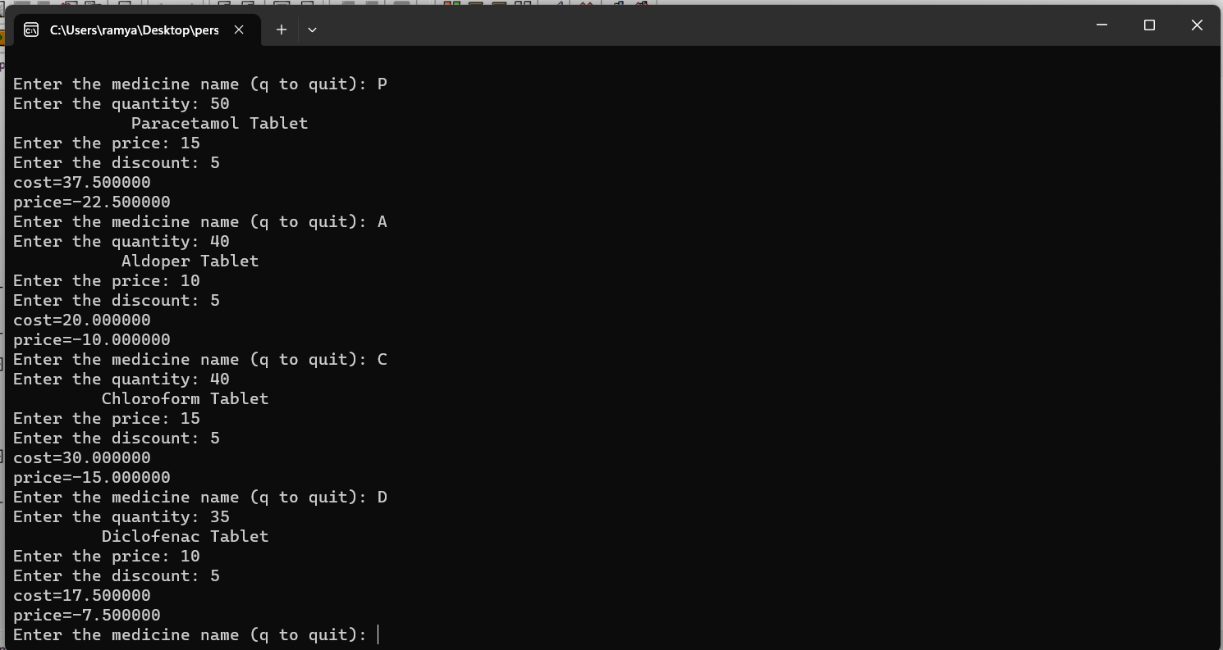

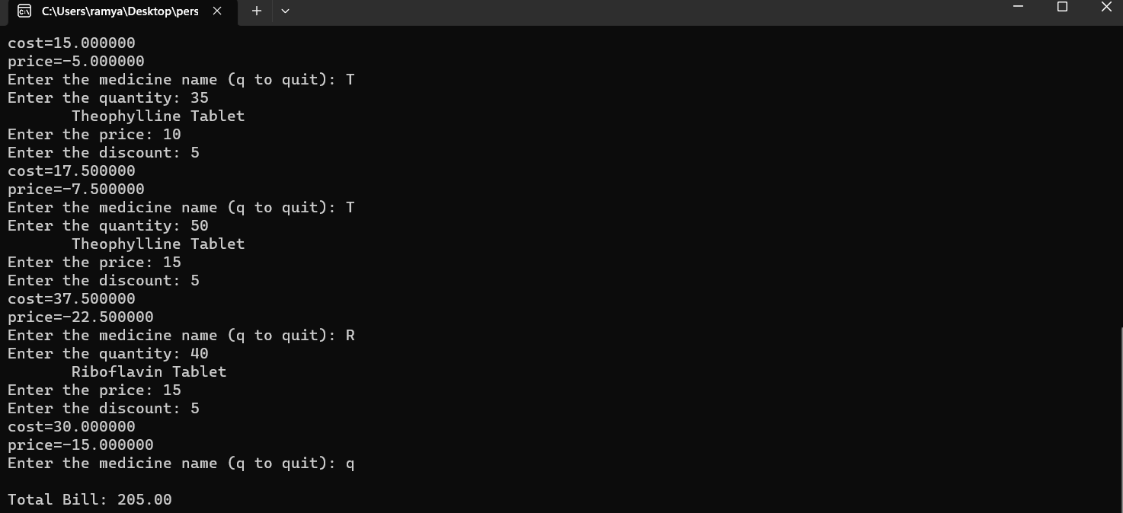

FILE CODE:
