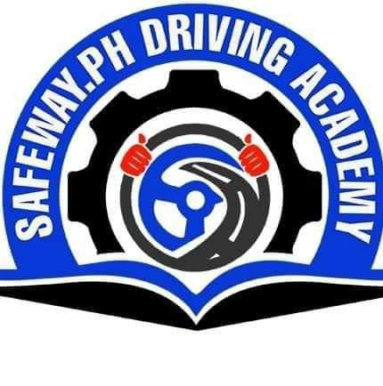

**SAFEWAY.PH DRIVING ACADEMY**  
**Grand Palace Bldg. Capitol Drive Butuan City**

**CERTIFICATE OF EMPLOYMENT**

*This is to certify that*

JOVELY D. LOR

*has been employed in*

**SAFEWAY.ph Driving Academy**

*as*

**Marketing Specialist**  
*from October 28, 2022 up to present*

This certification is being issued upon the request of the aforementioned name for whatever lawful purposes it may serve her best.

Given this **10th** day of **April 2024** at Butuan City.

**MARK RAYMUND B. PINTAC**

GENERAL MANAGER

**Office Tel. No:** 0910-123-4567 **Email Address:** safewayphbutuan@gmail.com **Mailing Address:** Grand Palace Bldg. Capitol Drive Butuan City, 8600