June 28, 2024

**ATTY. DIONEL O. ALBINA**

Chancellor

USTP-CDO

Dear Atty. Albina:

With reference to the approved Summary of Honoraria for the 1st Semester S.Y. 2023-2024 *(August 31, 2023 to January 24, 2024),* this is to respectfully request the Compensatory Time-Off (CTO)/Service Credits of the undersigned as shown in the table below:

|  |  |  |  |  |  |
| --- | --- | --- | --- | --- | --- |
| Name | Subject Handled | Equivalent Teaching Load | Actual Overload | Paid Overload | Number of Hours to Claim for CTO *(4.25x18wks)* |
| {{employee_name}} |  |  |  |  |  |
|  |  |
|  |  |
|  |  |

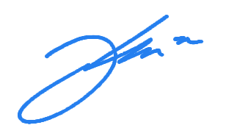

Respectfully yours,

**JUNAR A. LANDICHO, PhD**

Dean, CITC

Noted by:

JUDY ANN T. UGAY, RPm

Director, HRMO

Recommending Approval:

JOCELYN B. BARBOSA, PhD

VCAA, USTP-CDO

Approved:

ATTY. DIONEL O. ALBINA

Chancellor, USTP-CDO