Chat function
- UI
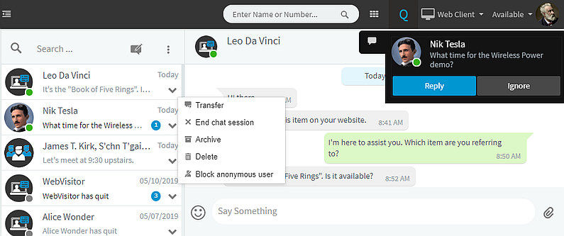
- Input fields
<<content>>
- Output & Navigate
<<content>>

