Login function
- UI
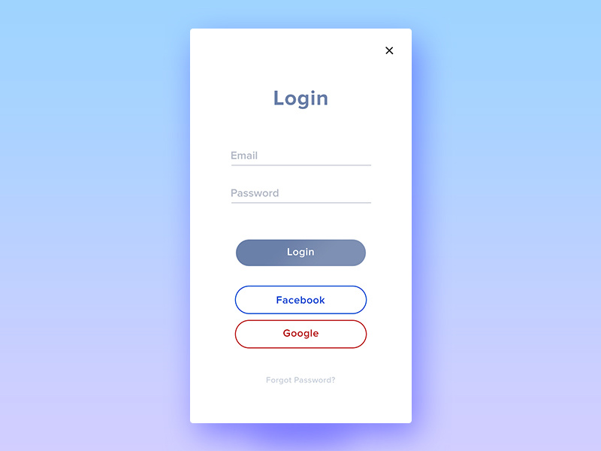
- Input fields
Name field | Type | Validation
Email | String | Required, email, max 191 character, unique
Password | String | Min: 6 character, max 191 character, required
- Output & Navigate
- Login button: Successfully -> Main screen of system
Fail -> Login screen
- Login with Facebook: Middleware to Facebook
- Login with Google: Middleware to Google
- Forgot Password?: -> “Forgot password” screen

