# DevsecOps Exercise:

So this this the task at broad level, there are a number of things here.. I am interested particularly in documenting what you do, even if you only do parts of this.. eg save shell history, web pages searched and read if any, what you do to address blockers if you hit any etc. also feel to play with the stuff and do something a bit different from what I am proposing if you get ideas..

1. Pick some sample python or java app/service demo and deploy it to kubernetes minikube locally on your own laptop.

For example can follow this tutorial (or anything similar just search on the web): <https://blog.apcelent.com/scaling-python-microservices-kubernetes.html>

If you get that to work,

1. could try wrap some of the commands to deploy services into a makefile, so that you can do something like:

make start -> start kubernetes in minikube

make deploy-redis

make deploy-flask

make run -> deploy/run app

make kill -> uninstall app and all dep. services

make stop -> stop minikube

1. Maybe Change the sample app to do something slightly different and
2. then redeploy it.

Assuming all the above is done, then

1. try to create helm templates and
2. use helm to do the deployment to kubernetes instead of plain yaml files,
3. possible allow for some params in help to control number of replicas or different version of the same service (Eg point to different docker image tag..)
4. to try deploy the same thing using the helm templates into IBM Cloud kubernetes service, eg this is a guide of how to deploy similar sample service to IBM Cloud but without helm: <https://developer.ibm.com/tutorials/scalable-python-app-with-kubernetes/#resources-and-references>
5. If you like add artifacts scripts logs screenshot .md docs etc. documenting the work into an IBM github repo under your account..

Contents

DevsecOps Exercise: 1

Sample python or java app/service demo and deploy it to kubernetes minikube locally. 4

Installing minikube in windows 10: 4

Installing Hyper – V on Windows 10: 4

Installing MiniKube on Windows 10: 4

Changes to Windows Hyper – V manager: 5

Start Minikube VM: 5

Stop Minikube: 6

Steps to verify on this to enable it back: 7

To reconfigure the service to start automatically using the Services desktop app 7

Start Minikube: 7

Confirm the installation with command 7

Trying a different Minukube seup on Windows 10: 8

Trouble shooting the error in Switch Management: 8

So tried Roll back as below: 8

Now Getting to see the Pods running on the system. 10

Launching Kubernetes dashboard to Visually from Browser: 10

Ssh and then Exit Minikube: 11

Get status of nodes: 12

From Linkedin > Running a Hello world app on Minikube 12

From Kubernetes Dashboard > Deployments: 12

Get replica sets: 13

Get pods: 13

Expose the deployment as NodePort: 13

Now Get services : 13

Launch the deployed service and **Access** it in **browser**: 14

Working on node.js app with minikube on Katacoda platform: 14

Create a deployment: 15

View the deployment: 15

View the Pod: 15

View Cluster events: 15

View Kubectl configuration: 16

Create a kubernetes service for the deployed node.js application: 16

View the Services created: 17

Make the Services accessible via minikube externally: 17

Access the exposed Services via browser from port 8080: 17

Unable to access the deployed and exposed node.js service : 17

Get addons list i.e set of supported addons of minikube : 17

Enable an addon Ex: **metrics-server**: 18

Verify the enabled addon: 18

Disable one of the enabled addons (metrics-server): 18

Now Clean-up of the Resources created in the cluster: 18

Stop minikube VM: 19

Rapid Development Cycle of a nginx Application in Minikube: 19

Deploy Hello-nginx 19

Check Deployments: 19

Expose hello-nginx as a NodePort service: 20

Launch and access deployed nginx on Browser: 20

Deploying Services with Makefile 20

Using Cygwin on Windows to use Makefiles. 21

So before that knowing a bit about makefiles: 21

Trying to run a makefile start minikube : 21

So now trying to stop minikube with **makefile** 22

Then trying to delete nginx deployment and service by makefile (still on Cygwin): 23

So trying the same delete kubectl commands from Command prompt: 23

**Task 1:**

## Sample python or java app/service demo and deploy it to kubernetes minikube locally.

* Intro to Kubernetes and Minikube (<https://www.youtube.com/watch?v=v4d2owCnZWc>)
* Save Shell history (on Windows ? ),
* Running MiniKube on Windows 10 with Hyper V (<https://medium.com/@JockDaRock/minikube-on-windows-10-with-hyper-v-6ef0f4dc158c> )
* Installing MiniKube : <https://kubernetes.io/docs/tasks/tools/install-minikube/>
* Kubernetes Local testing: <https://www.youtube.com/watch?v=BDrcUjOczsE>

## Installing minikube in windows 10:

* Install Windows package manager, Chocolatey. <https://chocolatey.org/install#installing-chocolatey>
* Installed Chocolatey with following command running as Admnistrator:
* @"%SystemRoot%\System32\WindowsPowerShell\v1.0\powershell.exe" -NoProfile -InputFormat None -ExecutionPolicy Bypass -Command "iex ((New-Object System.Net.WebClient).DownloadString('https://chocolatey.org/install.ps1'))" && SET "PATH=%PATH%;%ALLUSERSPROFILE%\chocolatey\bin"

## Installing Hyper – V on Windows 10:

* <https://docs.microsoft.com/en-us/virtualization/hyper-v-on-windows/quick-start/enable-hyper-v>
* Open a PowerShell console as Administrator.
* Run the following command:
* *Enable-WindowsOptionalFeature -Online -FeatureName Microsoft-Hyper-V -All*

## Installing MiniKube on Windows 10:

* Use the chocolatey package manager to install MiniKube. (from Cli)
* ***choco install minikube***

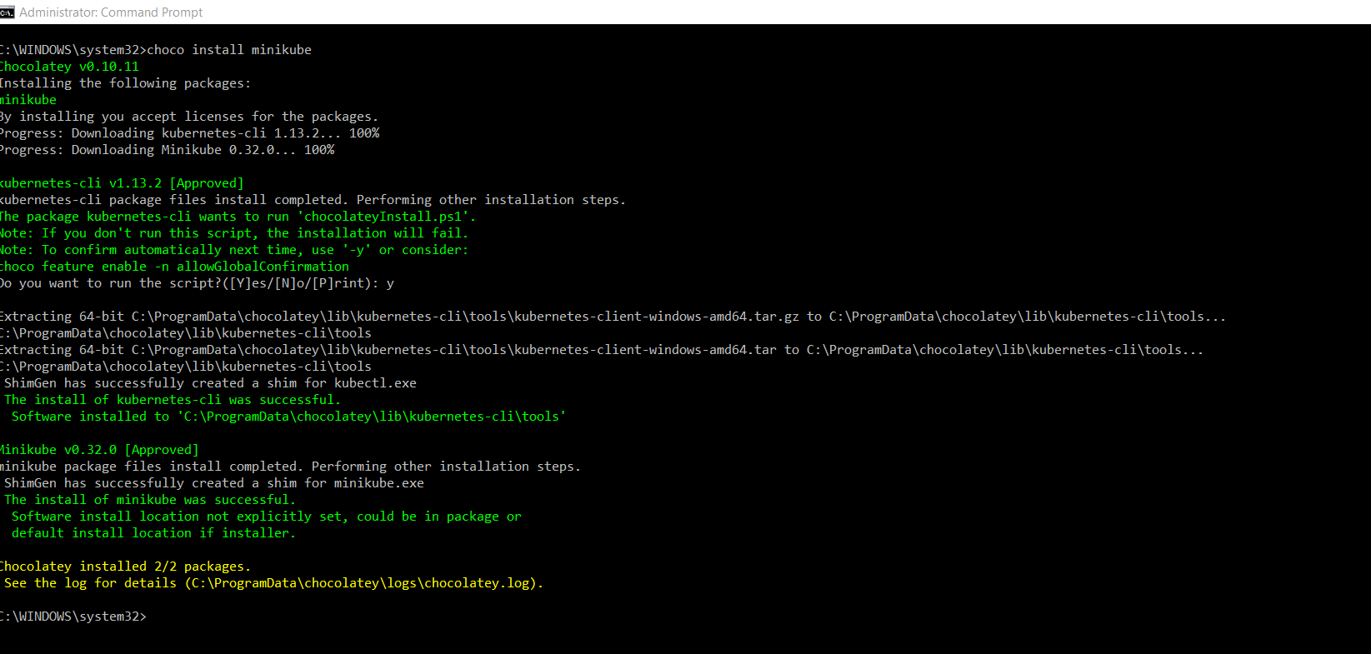

* That above command now installed both **Minikube** and **Kubernetes-cli** packages. (both)

## Changes to Windows Hyper – V manager:

* Launch Hyper – V manager from Windows
* Select the local Desktop machine
* Effectively following steps from Here: <https://medium.com/@JockDaRock/minikube-on-windows-10-with-hyper-v-6ef0f4dc158c>
* Enabling a Virtual Network Switch (external).

## Start Minikube VM:

* ***minikube start --vm-driver hyperv --hyperv-virtual-switch "Primary Virtual Switch"***

**Blocker ?...**

**The process seems not yet completed.**

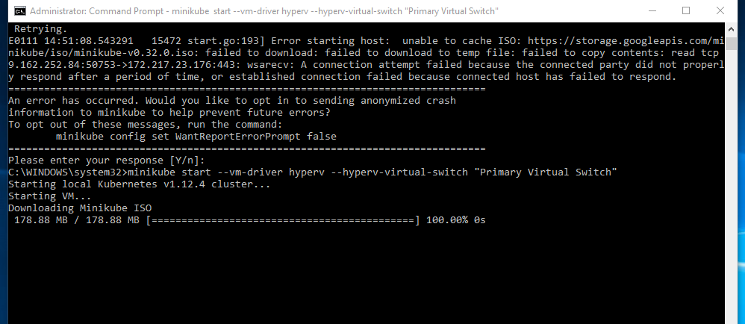

So tried by disabling IpV6 on the network adapter for the new Primary switch created.

[**https://medium.com/@JockDaRock/disabling-ipv6-on-network-adapter-windows-10-5fad010bca75**](https://medium.com/@JockDaRock/disabling-ipv6-on-network-adapter-windows-10-5fad010bca75)

And reran the below Switch command

minikube start --vm-driver hyperv --hyperv-virtual-switch "Primary Virtual Switch"

## Stop Minikube:

* ***Minikube stop***

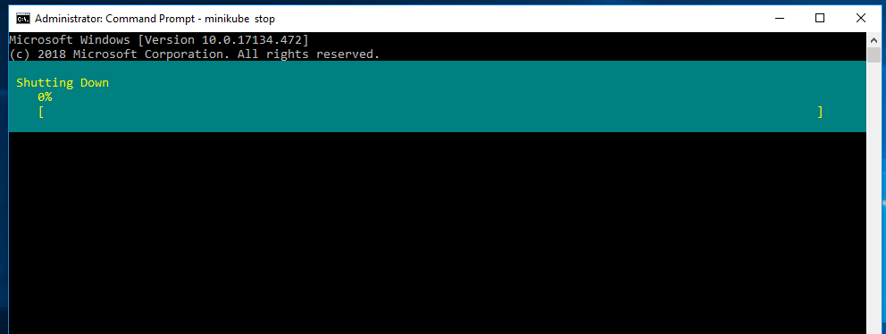

***Document Suggested to Disable the by default Enabled Dynamic memory.***

***But for me with current version it is greyed out.***

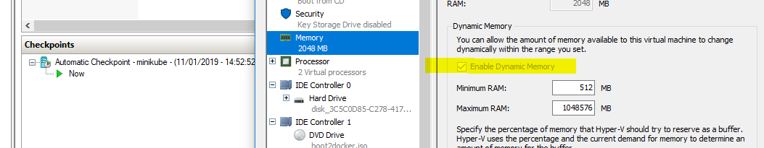

***Blocked as the Hyper V Windows VM service seems to have been stopped.***

### Steps to verify on this to enable it back:

### To reconfigure the service to start automatically using the Services desktop app

1. Open the Services desktop app. (Click **Start**, click in the **Start Search** box, type **services.msc**, and then press ENTER.)
2. In the details pane, right-click **Hyper-V Virtual Machine Management**, and then click **Properties**.
3. On the **General** tab, in **Startup** type, click **Automatic**.
4. To start the service, click **Start**.

## Start Minikube:

* ***>> minikube start***

## Confirm the installation with command

>>> ***kubectl get pods -n kube-system***

***But getting error:*** The error I received was:

*the server doesn't have a resource type "pods"*

## Trying a different Minukube seup on Windows 10:

***https://medium.com/jsonlovesyaml/12-step-tutorial-to-setup-kubernetes-on-your-windows-10-laptop-b7784b2253ce***

### Trouble shooting the error in Switch Management:

* Removed Primary Virtual Switch
* Added a new switch called ‘Test Virtual Switch’.
* Run the following command in command prompt with admin privileges to start the minikube VM and configure it to be used with kubectl
* >> minikube start --vm-driver hyperv --hyperv-virtual-switch "Test Virtual Switch"
* So removed minikube from Hyper V
* Added a new Switch called ‘raj minikube switch’
* Used same above switch command for new switch , but seeing below error
* **error starting host: error starting stopped host: exit status 1**
* 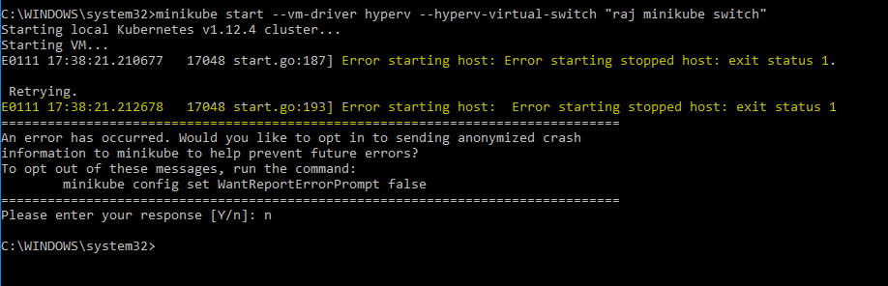

### So tried Roll back as below:

1. Stop and delete VM minikube in hyperv.
2. Delete .minikube directory
3. re-install --force minikube 0.27  
   (4. re-install --force kubectl.)

What worked for me was this. (similar to above steps).

I didn't manually create a .minikube directory at but installed minikube using chocolatey.

Make sure you have a Virtual Switch set up as mentioned here before and your command line runs as Administrator

1. Stop and delete Virtual Macine
2. run 'minikube delete' in command line (it exits with an error )
3. Since I ‘ve installed via chocolatey need to delete the .minikube folder from C:\Users\myUserName)
4. 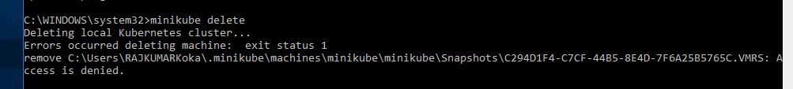
5. run 'minikube start --vm-driver="hyperv" --hyperv-virtual-switch="nameofyourswitch"'

after that. Give it time. It took 5 minutes to go through the complete process for me and get the ***Minikube*** tool ready to use Kubernetes locally.

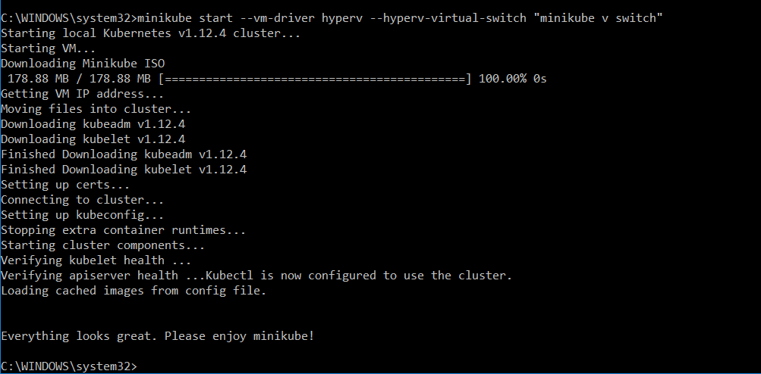

## Now Getting to see the Pods running on the system.

Run the command >> ***kubectl get pods -n kube-system***

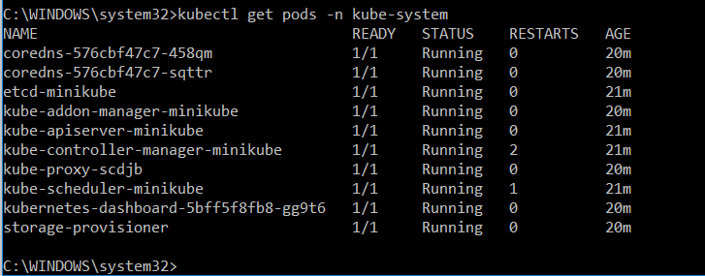

## Launching Kubernetes dashboard to Visually from Browser:

>>> minikube dashboard



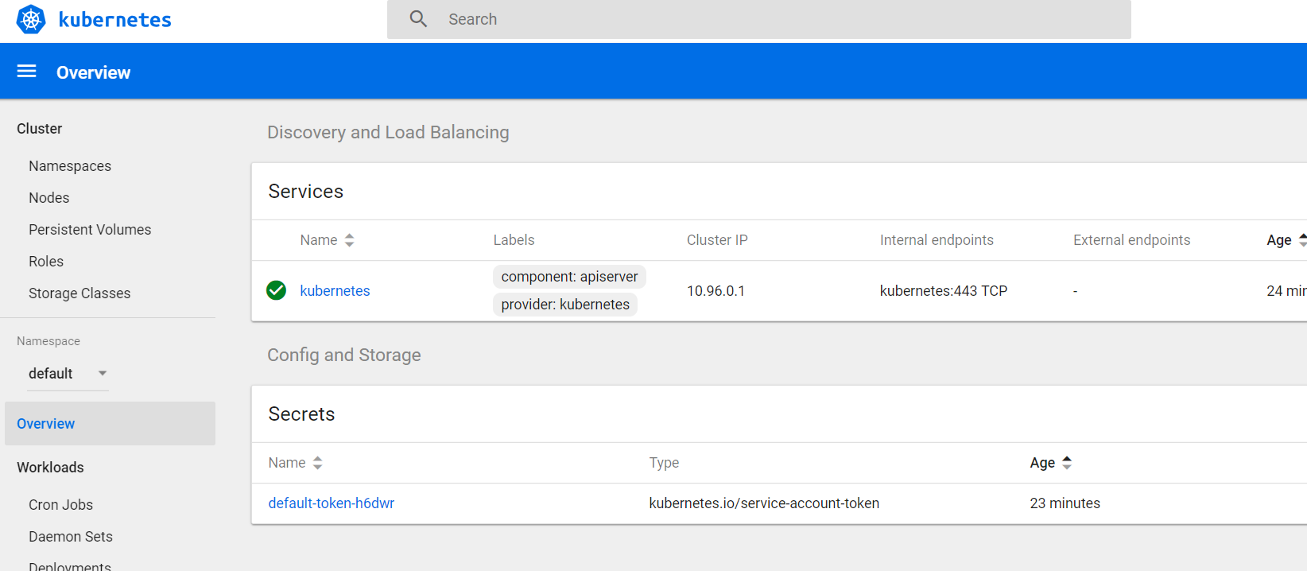

Check the Status of Minikube and IP of the VM instance with Minikube:

>>> ***Minikube status***

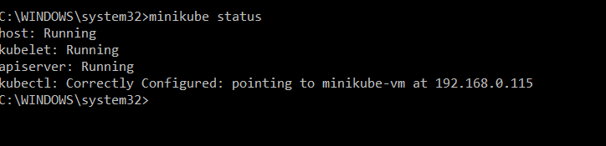

## Ssh and then Exit Minikube:

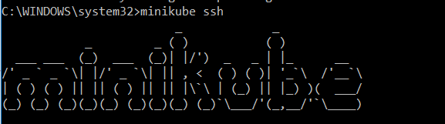

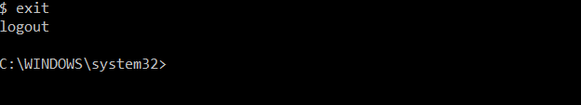

***Ip address of Minikube:***

***>> minikube ip***

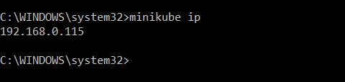

### Get status of nodes:

***>> kubectl get nodes***

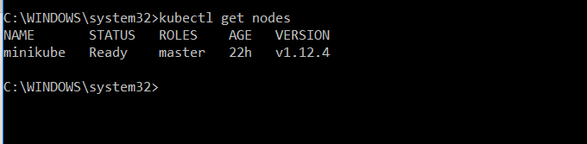

## From Linkedin > Running a Hello world app on Minikube

>> ***kubectl run hw --image=karthequian/helloworld --port=80***



***>> kubectl get deployments***

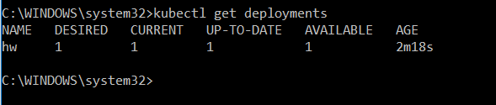

### From Kubernetes Dashboard > Deployments:

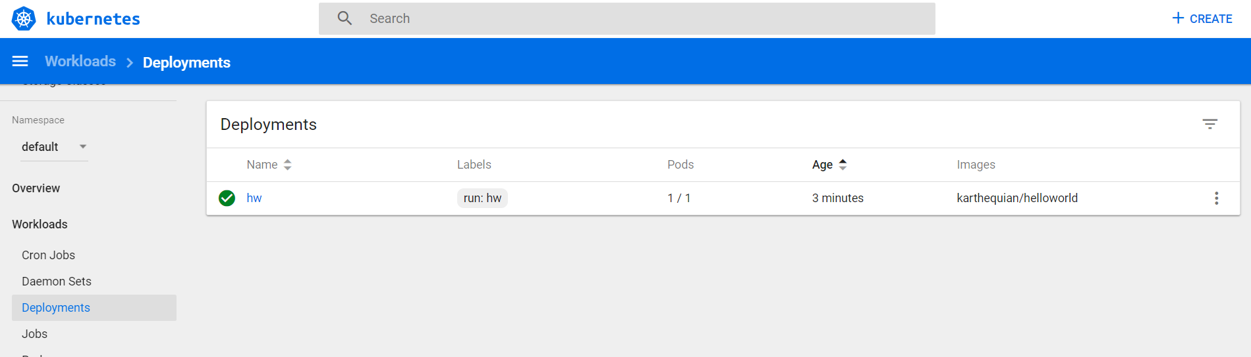

### Get replica sets:

***>> kubectl get rs***

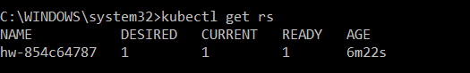

### Get pods:

***>> kubectl get pods***

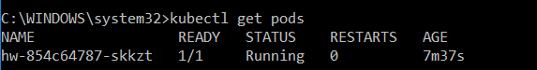

### Expose the deployment as NodePort:

***Kubectl expose deployment h –type=NodePort***

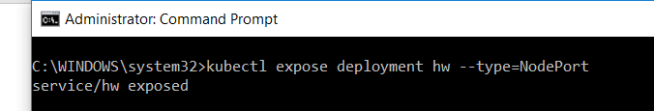

### Now Get services :

***>> kubectl get services***

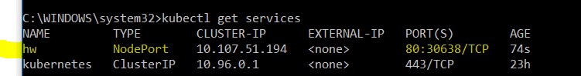

## Launch the deployed service and **Access** it in **browser**:

***>> minikube service hw***

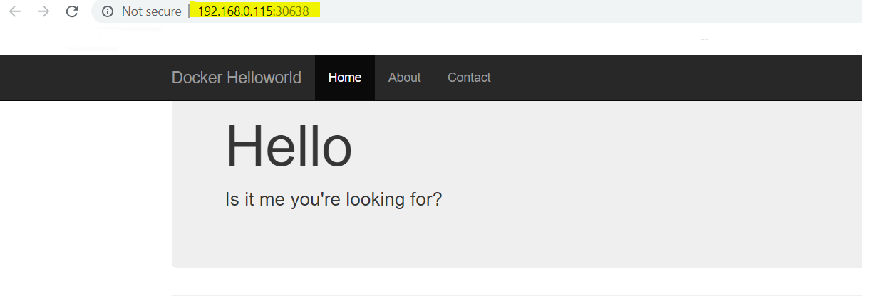

# Working on node.js app with minikube on Katacoda platform:

<https://kubernetes.io/docs/tutorials/hello-minikube/>

From Create a minikube cluster onwards:

>> minikube start

>> minikube dashboard

>> 

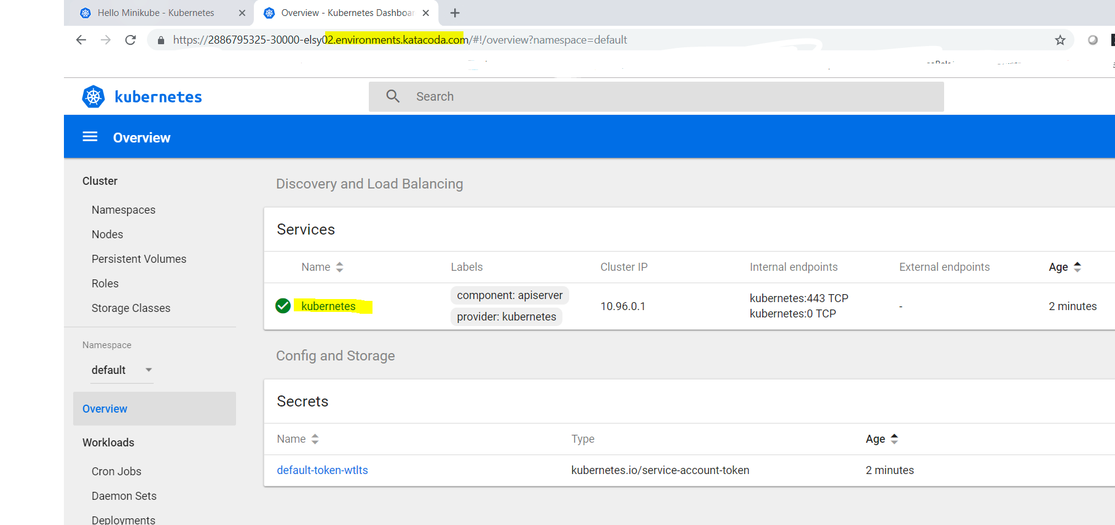

### Create a deployment:

**kubectl create deployment hello-node --image=gcr.io/hello-minikube-zero-install/hello-node**

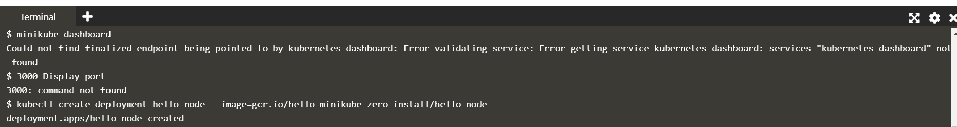

### View the deployment:

>> Kubectl get deployments

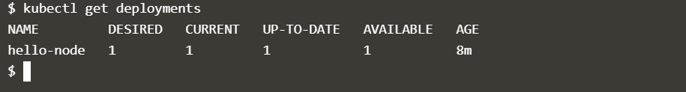

### View the Pod:

>> kubectl get pods

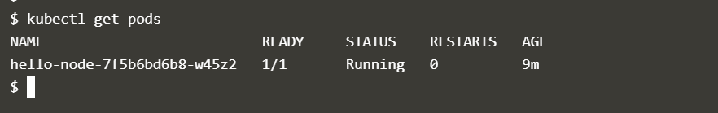

### View Cluster events:

>> kubectl get events

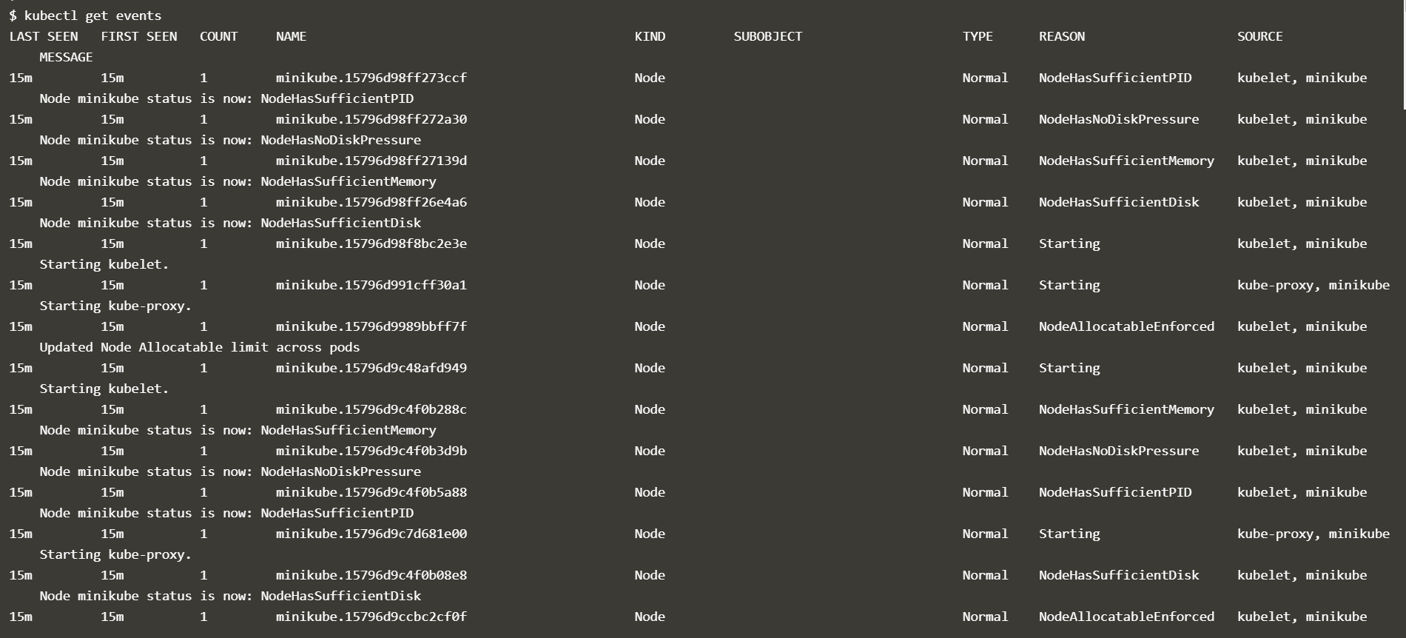

### View Kubectl configuration:

>> kubectl config view

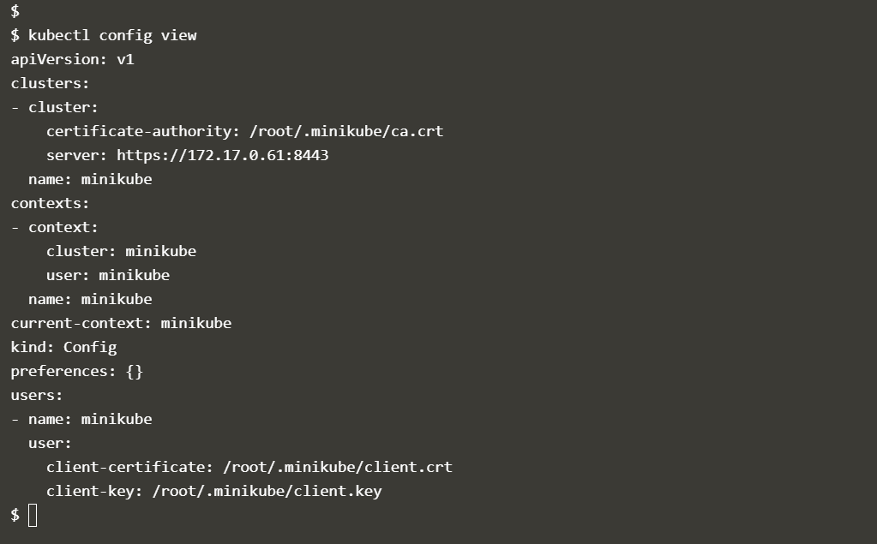

## Create a kubernetes service for the deployed node.js application:

**kubectl expose deployment hello-node --type=LoadBalancer --port=8080**

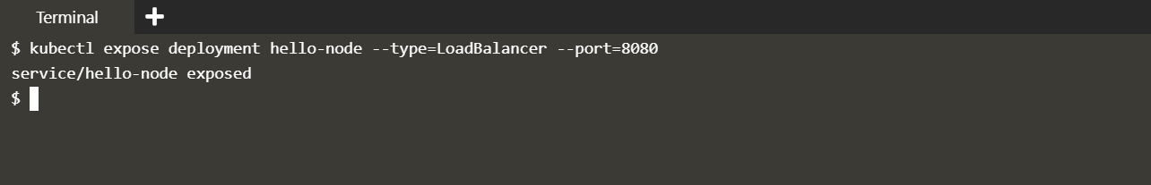

### View the Services created:

>> kubectl get services

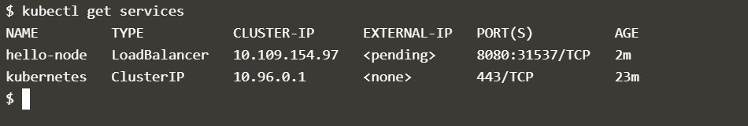

### Make the Services accessible via minikube externally:

>> minikube service hello-node

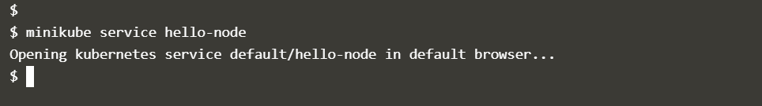

### Access the exposed Services via browser from port 8080:

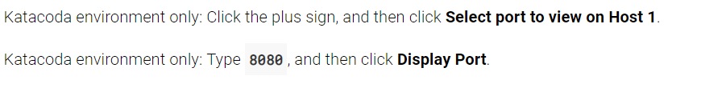

### Unable to access the deployed and exposed node.js service :



### Get addons list i.e set of supported addons of minikube :

>> minikube addons list

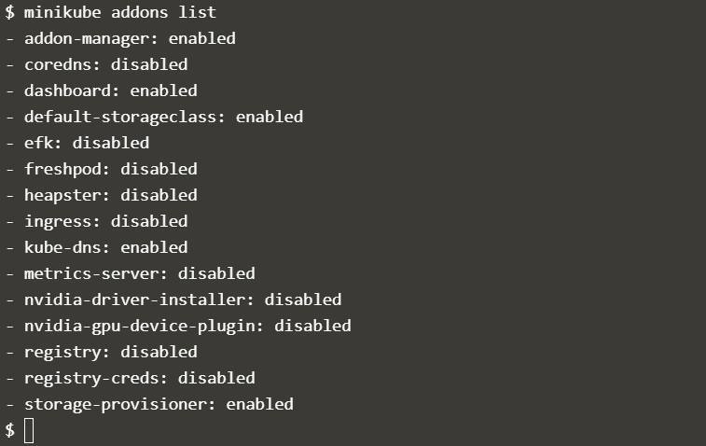

### Enable an addon Ex: **metrics-server**:

>> minikube addons enable metrics-server

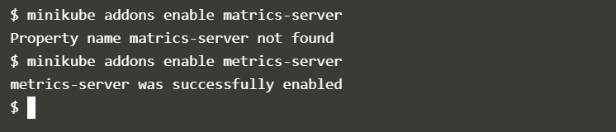

### Verify the enabled addon:

>> *minikube addons list*

### Disable one of the enabled addons (metrics-server):

>> *minikube addons disable metrics-server*

## Now Clean-up of the Resources created in the cluster:

>> ***Kubectl delete service hello-node***

>> ***kubectl delete deployment hello-node***

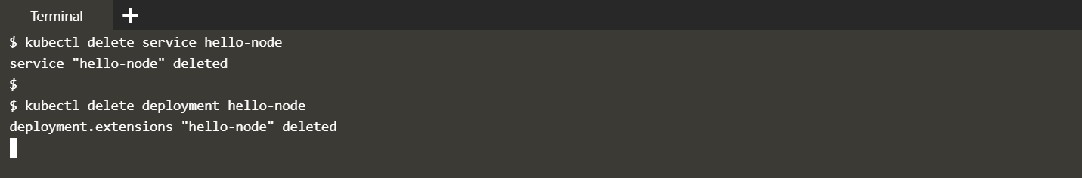

## Stop minikube VM:

>> ***minikube stop***

# Rapid Development Cycle of a nginx Application in Minikube:

Source: <https://rominirani.com/tutorial-getting-started-with-kubernetes-on-your-windows-laptop-with-minikube-3269b54a226>

### Deploy Hello-nginx

>> ***kubectl run hello-nginx --image=nginx --port=80***

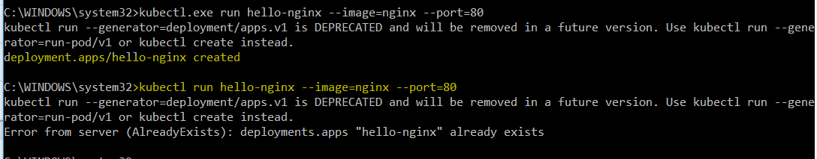

### Check Deployments:

***>> kubectl get deployments***

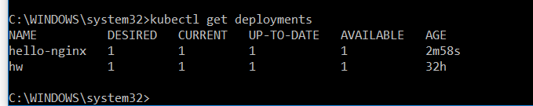

### Expose hello-nginx as a NodePort service:

>> ***kubectl expose deployment hello-nginx --type=NodePort***

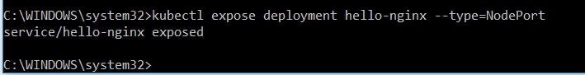

### Launch and access deployed nginx on Browser:

>> ***minikube service hello-nginx***



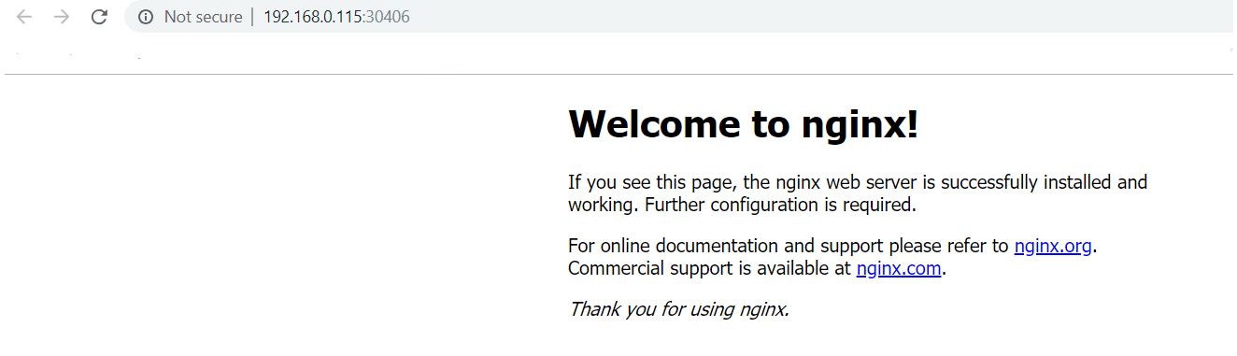

## Deploying Services with Makefile

Issue is mine is a Windows PC so to over come the limitation of Linux makefile I am trying to use Cygwin.

### Using Cygwin on Windows to use Makefiles.

### So before that knowing a bit about makefiles:

***https://swcarpentry.github.io/make-novice/02-makefiles/***

Got to know now that Make is available on the Cygwin version that I have installed currently but somehow it is not working:

* Ran into another issue make is unavailable in the installed version so searched and found the following solution which worked for me: (from Stackoverflow suggestions) @ <https://stackoverflow.com/questions/43166386/cygwin-doesnt-execute-make/43168228#43168228>
* Retry "Install from Local Directory" to make things faster. If not Uninstall only make
* Once uninstalled, re-run the setup again and check make, install the dependencies if needed.

Tested with make version 4.2.1-1 on my system, and got it working again.

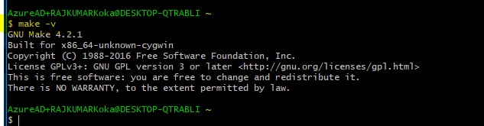

## Trying to run a makefile start minikube :

* Getting all sorts of **make** errors
* So Trying to write the makefile script which should start minikube service.

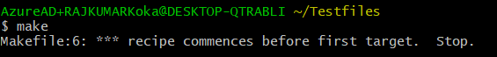

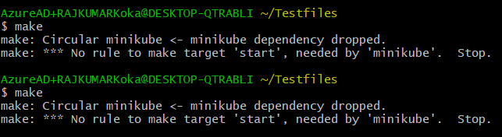

**Nothing worked so far**

{ Probably should try **Vagrant**? }

**Understood the Circular error above and trying to correct my Makefile.**

>> Got it corrected and now my makefile works when executed the make command on Cygwin

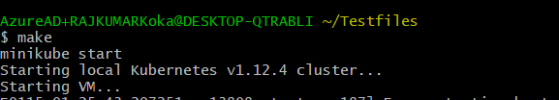

**But then now Cygwin asks for disabling Hyper-V hypervisor and says wont boot Virtual box.**

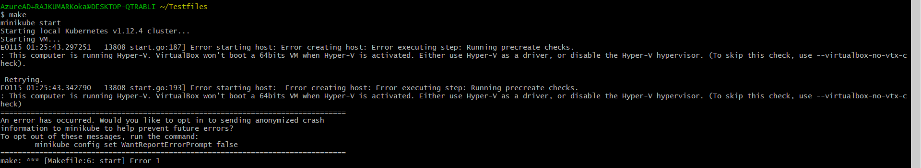

### So now trying to stop minikube with **makefile**

Again an error saying ‘Docker machine "minikube" does not exist.’.

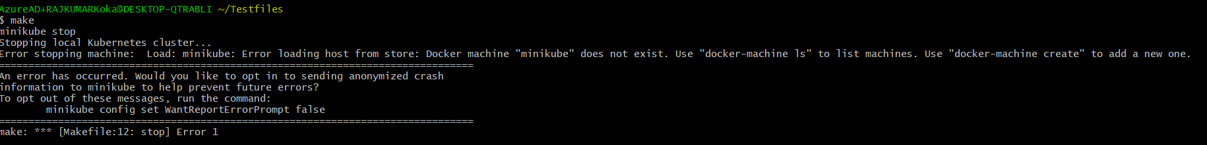

### Then trying to delete nginx deployment and service by makefile (still on Cygwin):



**The command is running but action fails to be executed on Cygwin terminal.**

### So trying the same delete kubectl commands from Command prompt:

After correcting the command syntax, could delete the deployment and Service from command prompt

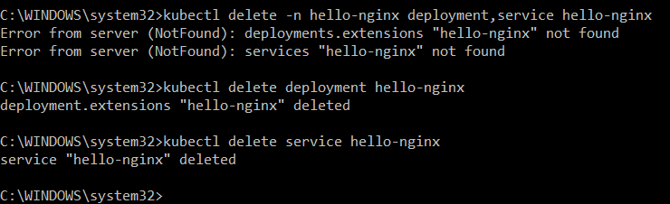

**but not from Cygwin terminal.**

