

Middle East Technical University

Electrical & Electronics Engineering Department

EE463 – Static Power Conversion I

Hardware Project

Final Report

Yasin Enes Çalışkan 2304319

Başak Koca 2232304

Mehmet Hakan Yel 2530699

# Table of Contents

**Table of Contents** **2**

**Introduction** **3**

**Problem Definition** **3**

**Possible Topologies for Solution** **3**

**1. Single Phase Thyristor Rectifier** **3**

**2. Three Phase Thyristor Rectifier** **5**

**3. Three Phase Diode Rectifier and Buck Converter** **6**

**4. Dimmer Circuit (with Thyristor)** **7**

**Topology Selection and Reasoning** **8**

**Theory of Dimmer** **8**

**Simulation Results** **10**

**Component Selection** **14**

**Thermal Analysis** **15**

**Cost Analysis** **16**

**Implementation** **17**

**Test Results** **18**

**No Load** **18**

**Full Load** **19**

**Conclusion** **19**

**References** **20**

# 

# Introduction

Converters and rectifiers are crucial for the motor drive system in the power electronics field. This project involves designing an AC/DC converter. The potential topologies discussed in this report. The topology is chosen in consideration of the benefits and drawbacks of the available options. It is explained why the preferred topology was changed while preparing the simulation report before. The theory, computation and simulations are provided for the chosen topology which is a Dimmer circuit with thyristor. The necessary components are selected utilizing the findings of studies following simulation and calculation analysis. Also, thermal analysis of the system is made. Then, the implementation process carried out in line with the preferred components was also explained and the data of the test results obtained were interpreted. Visuals and performance values of the final product are also included in the report.

# Problem Definition

Designing a controlled rectifier to drive a DC motor is a requirement for this project. The variable AC source is employed as the input. A kettle is wired to the AC motor which is coupled to the DC motor and used to boil water.

Input and output constraints:

* Input: Three phase or single-phase AC
* Output: DC Output, Vdcmax <180 V

Motor specifications:

* Armature Winding: 0.8 Ω, 12.5 mH
* Shunt Winding: 210 Ω, 23 H
* Interpoles Winding: 0.27 Ω, 12 mH

# Possible Topologies for Solution

## Single Phase Thyristor Rectifier

Regulated functioning is provided by the Single-Phase Thyristor Rectifier design. The topology contains four thyristors. The average output voltage of the rectifier can be varied by adjusting the firing angle of the thyristors. As a result, we can convert AC to variable DC using this architecture.

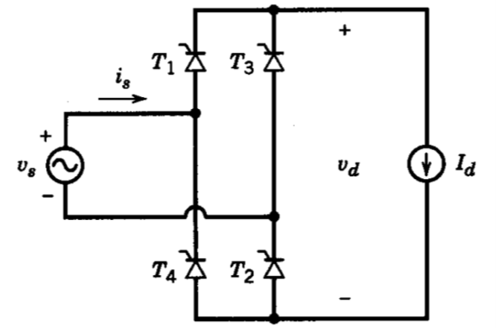

*Figure 1. Single phase thyristor rectifier schematic.*

The thyristors' ability to fire is controlled by sending a pulse signal to their gate terminals. To synchronize the timing of the thyristors' firing, it is necessary to recognize the zero crossings of the input ac waveform. The firing angles must have a 180-degree phase difference.

The single-phase thyristor rectifier has two operating modes. When in rectification mode, the average output voltage and current are positive. In this mode, power flows through the rectifier from the input side to the output side. On the other hand, in the inverter mode of operation, the average output voltage goes negative but the output current stays positive. Power flows from the input side to the output side. The rectifier thereby feeds electricity back into the grid. In equation 1, the average output voltage is displayed.

**Advantages**

* Due to the fewer thyristors needed, it is affordable and small.
* By coupling two Single Phase Thyristor Rectifier circuits, it may be operated in four quadrants. If there is an active source on the rectifier's output side when it is in inverter mode, it can send power back to the grid. A positive current can flow while the output voltage remains positive.

**Disadvantages**

* The output has a high voltage ripple.
* It causes large harmonics in current. It can be reduced by adding an inductor to the input, however that causes to increase in commutation time.
* It has low power factor.
* It is challenging to organize firing angles synchronously and extra circuits and sources are required to drive thyristors.
* A lower average output voltage than a three-phase thyristor rectifier.

## Three Phase Thyristor Rectifier

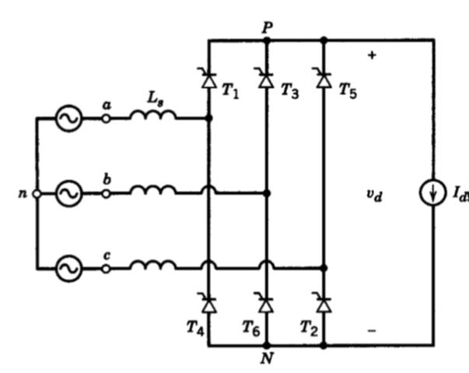

*Figure 2. Three phase thyristor rectifier schematic.*

Six thyristors are employed in the three phase thyristor rectifier. Thyristors are activated using gate signal generators to regulate output voltage. Theoretical output voltage calculation is as follows,

**Advantages**

* Without using an extra converter, the output voltage can be managed with a three phase thyristor rectifier.
* Output voltage ripple of this topology is lower than the single-phase thyristor rectifier topology.
* THD of this topology is lower. Since, the third harmonic of the input current is not observed.
* Back-to-back three phase thyristor rectifiers can be used to achieve four quadrant operation.

**Disadvantages**

* Thyristors are more expensive than regular diodes as components, and six thyristors make up this topology. This topology is therefore more expensive than other alternatives.
* Three phase thyristor rectifier topology requires the usage of six separate gate signals. In order to do this, gate drivers and additional components are needed. It raises the price and makes the structure more difficult.
* It is challenging to synchronize gate drivers. Since it should be taken into account, the zero-crossing issue.

## Three Phase Diode Rectifier and Buck Converter

There are two sections of this topology. Three phase AC grid voltage is rectified in the first section to low ripple DC voltage. In the second section, a buck converter is used to adjust the output voltage using the switch's duty cycle.

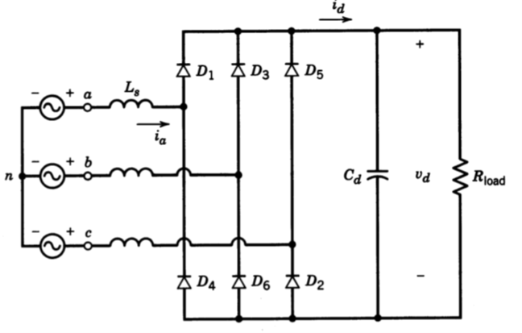

*Figure 3. Three phase diode rectifier schematic****.***

There is no control of average output voltage for three phase diode rectifiers. Calculation of the output voltage is as follows,

In order to control the output voltage, a buck converter must be used after the rectifier circuit.

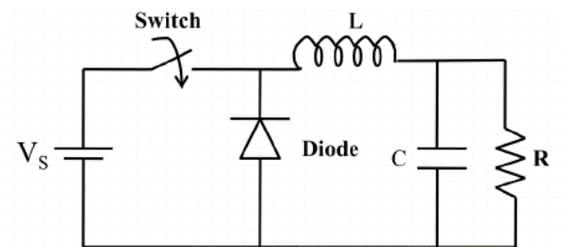

*Figure 4. Buck converter schematic****.***

The input dc voltage is step-down to the desired level by the buck converter. A MOSFET that is driven by a gate signal is used to regulate output voltage. Output voltage of a buck converter simply calculated as,

As the rectifier and the buck converter are connected together, the output voltage becomes,

**Advantages**

* This topology has low voltage ripple in output.
* Only one gate signal is needed for this topology, and it will be supplied to operate the buck converter. In comparison to other topologies, this system is hence simpler. Additionally, syncing the signals is not needed in this topology.
* The cost of this system is lower than that of thyristor rectifiers.

**Disadvantages**

* Four quadrant operation is not supported by this topology. There is no method to obtain four quadrants because a diode rectifier can only operate in one quadrant.
* As a result of using an external diode in the buck converter, the predicted efficiency is lower than topologies with thyristors.

## Dimmer Circuit (with Thyristor)

The dimmer circuit, which is also called analog AC Dimmer circuit, consists of only four components; triac, diac, capacitor and potentiometer. It works by regulating the source voltage with the help of a switch. Normally, triac is used for switching operation in AC dimmer circuit. By controlling the triac, AC current flows through the load connected in series to the circuit, and the amount of current on the load is adjusted by controlling it with different firing angles. However, in this case, since the AC output voltage is obtained, a DC motor can only be driven in series. However, since providing DC output voltage is among the project requirements, it is necessary to use thyristor instead of triac in the circuit. In the case of using the thyristor, when the input voltage is negative, current flow will not be allowed, so a high input voltage must be given in order to provide sufficient average voltage at the output.



*Figure 5. Schematic of dimmer circuit with thyristor.*

**Advantages**

* Low number of components required.
* The circuit is simple to set up and control.
* Size of the circuit is small.
* Because of the low number of components, the total cost is very low.
* Since the switching frequency is the same as the input voltage frequency, the amount of switching loss is low.

**Disadvantages**

* High input voltage is required for desired output voltage.
* This topology has high voltage ripple in output.

# Topology Selection and Reasoning

We gave information about 3 different alternative topologies that can be used within the scope of the project. We also listed the advantages and disadvantages of each topology. When we compared the advantages of each topology, we decided that dimmer circuit would be the most suitable topology for us.

Since the use of dimmer circuit topology was not among our alternatives during the simulation report phase, we preferred the three phase diode rectifier with buck converter topology because it is easier to control than the other two topologies. However, it was decided to use the dimmer circuit topology because it has the simplest circuit structure, it offers the cheapest solution, and its control can be provided in analog form with a single potentiometer.

# Theory of Dimmer

Circuit for this topology consists of only thyristor, diac, capacitor and resistor. A thyristor is a four-layer semiconductor device that uses P-type and N-type materials in alternate layers (PNPN). Anode, cathode, and gate, commonly referred to as a control electrode, are the three electrodes that typically make up a thyristor. The silicon-controlled rectifier is the most prevalent kind of thyristor (SCR). No current flows until a pulse is applied to the gate when the cathode is negatively charged in relation to the anode. As soon as this happens, the SCR starts to conduct current until the voltage between the cathode and anode is reversed or dropped below a certain threshold or holding value. A tiny triggering current or voltage can be used to switch or control massive amounts of electricity using this sort of thyristor.

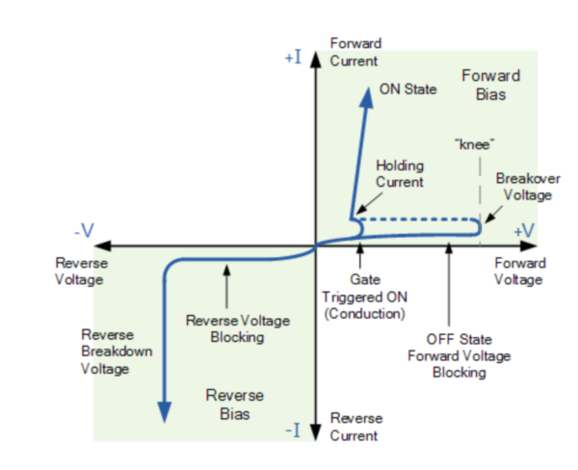

*Figure 6. I-V Characteristic of thyristor. [1]*

Two diodes connected back to back make up the component known as a diac. If the applied voltage is less than the breakover value, similar to a diode, the DAC shuts off the current flow. But there is also a negative break over voltage in a diac. When this occurs, the diac is open and unable to obstruct the flow of current since the applied voltage is less than the break over voltage (a negative number). 30 volts is typically considered to be the break over voltage.

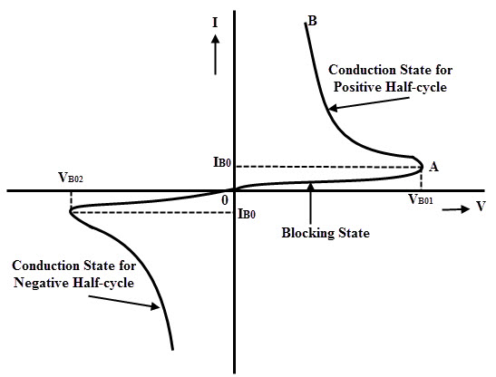

*Figure 7. I-V Characteristic of diac. [2]*

If the thyristor is off, current will flow to the branch that contains the capacitor and resistance. Our resistance levels are really high, nevertheless. As a result, relatively little current flows through the load. Additionally, the capacitor is charged in this situation. When the thyristor is open, the load is directly linked to the grid, and the only voltage drop that occurs is caused by the thyristor voltage. The branch that includes resistances and a capacitor is also short, which causes the capacitor to discharge.

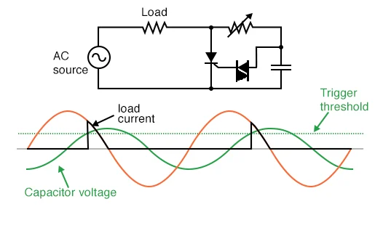

*Figure 8. Phase-shifted signal triggers SCR into conduction [3]*

The resistance-capacitive branch is employed to activate the thyristor. Additionally, the thyristor is also triggered by a diac. Capacitor is initially charged to positive or negative voltage. The diac opens and the thyristor is activated if the capacitor voltage equals +VBO, the diac's opening voltage. After that, the thyristor keeps conducting until either the anode to cathode voltage is negative or the thyristor current drops below the threshold current.

Potentiometers are also used to adjust the time constant. That is, it takes a long time to charge the capacitor while the potentiometer's resistance is at its highest level. As a result of input voltage sign changes, thyristor does not conduct. In other words, the capacitor voltage falls short of the VBO volts. The capacitor charges very quickly when the potentiometer's resistance is at its lowest value. As a result, the thyristor is opened to about 0 degrees.

# Simulation Results

In order to test our chosen topology, we first created a model in MATLAB Simulink and observed the input voltage and armature current amount for 180V output voltage. Then, we created our circuit on LTspice and tried to find the potentiometer resistance, where we reached the output voltage and the current on the load, which we observed in the Simulink. The motor is simulated by loading 2kW.

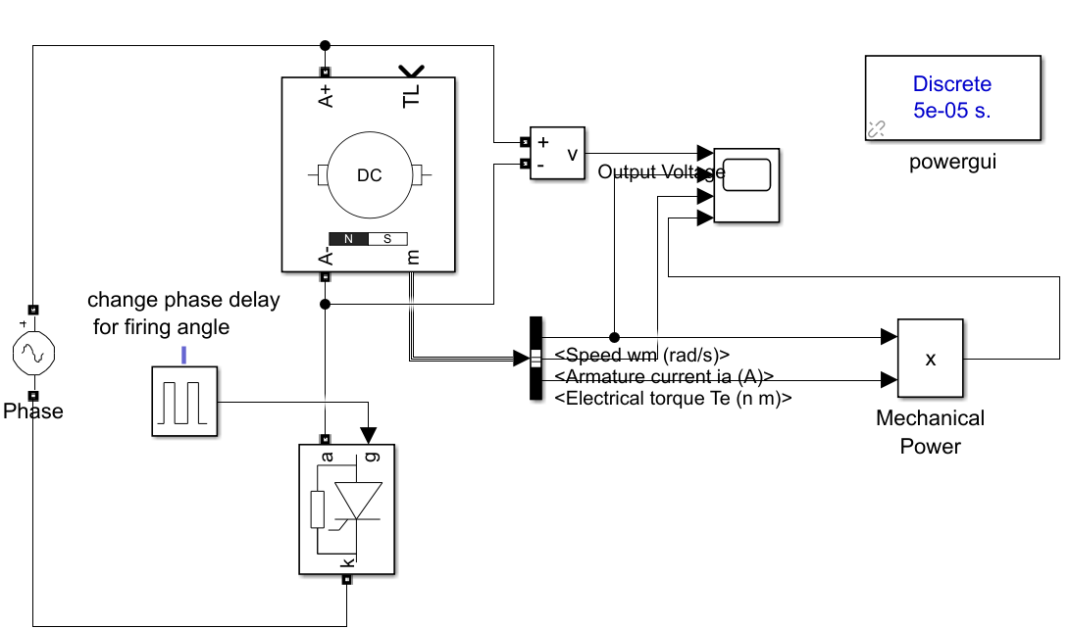

*Figure 10. Simulation model for dimmer circuit with DC motor in MATLAB Simulink.*

We started to observe the voltage formed on the DC motor by entering different values to the input voltage of the model and trying to trigger the thyristor with the minimum firing angle. When we applied a low input voltage, the output voltage did not reach 180V even if the thyristor was triggered with the minimum firing angle. For this reason, we determined the voltage to be 280Vrms, that is, 396V peak. While our input value is 280Vrms, even if the firing angle is not at the minimum, 180V can be observed in the output. The simulation data we obtained are included in figures 11 and 12.

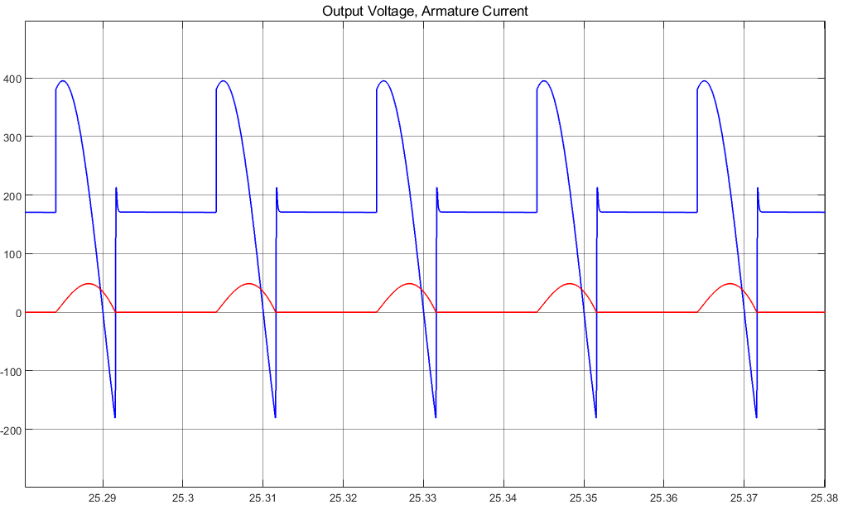

*Figure 11. Output voltage and armature current waveforms of the simulation model with 280Vrms input voltage*

*Figure 12. Armature current and output voltage data obtained from simulation model in MATLAB Simulink.*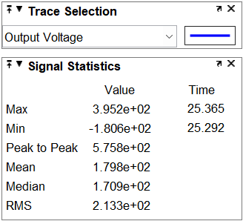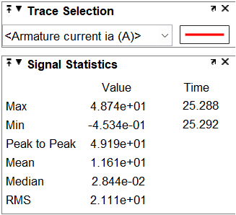

According to the data obtained, an average output voltage of 180V is obtained with an input voltage of 280 Vrms and a firing angle that has not yet been determined. The average armature current is 11.6A on average that satisfies the power requirement which is 2kW, as can be seen from figure 12.

In order to obtain the output characteristic observed in the Simulink model, the required POT resistance value was tried to be determined by using LTspice. While creating the circuit in LTspice, we modeled the DC motor using RL load and voltage source. The voltage source is used to model the back EMF that will occur in the DC motor. We tried to determine the required thyristor firing angle by changing the resistance value in the POT in order to obtain the output voltage of 180V on the motor.

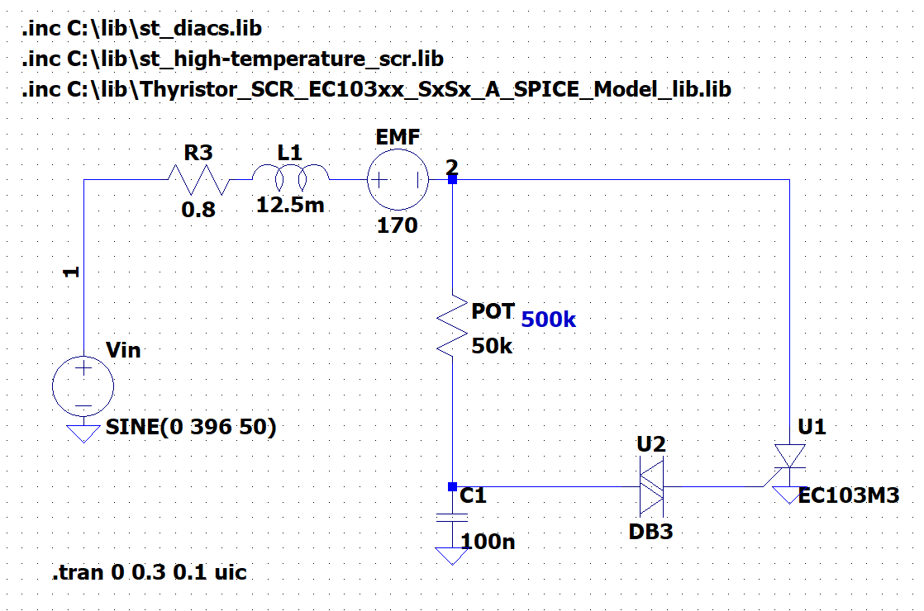

*Figure 13. Simulation model for dimmer circuit in LTspice.*

As can be seen in Figure 14, the output voltage value is zero because the thyristor cannot be triggered while our POT has the maximum resistance value.

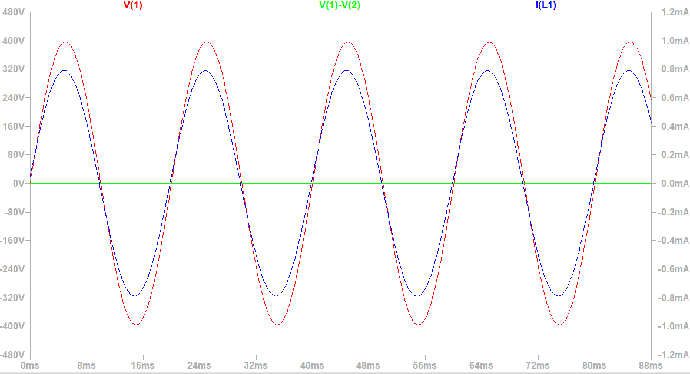

*Figure 14. Input voltage, output voltage and armature current waveforms obtained from simulation model with 500k Ohm POT resistance.*

When we reduce the POT resistance value to 350 Ohm, the thyristor starts to trigger and allows current to flow through the load.

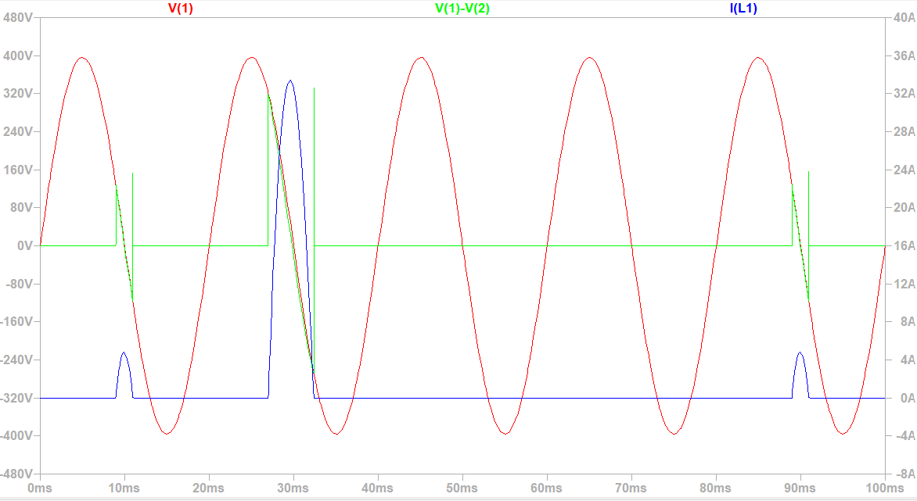

*Figure 15. Input voltage, output voltage and armature current waveforms obtained from simulation model with 350k Ohm POT resistance.*

When we reduced the resistance further, we were able to reach 180V output voltage at 50k Ohm.

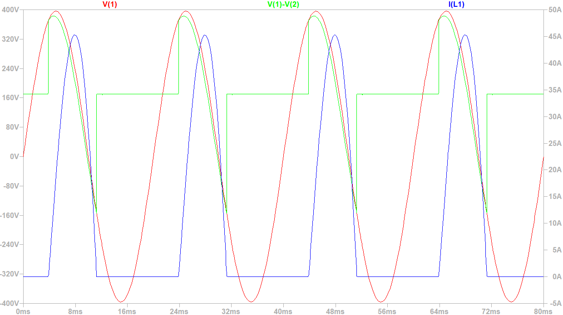

*Figure 15. Input voltage, output voltage and armature current waveforms obtained from simulation model with 50k Ohm POT resistance.*

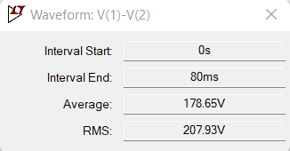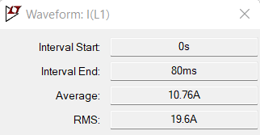

*Figure 16. Armature current and output voltage data obtained from simulation model in LTspice.*

When we look at the results we have obtained with the simulation models, we have seen that we can carry out the process that is driving a 2kW loaded motor. When the POT resistance value drops to 350 k ohm, our thyristor starts to trigger because the capacitor voltage reaches the opening voltage of the diac. When we lower the resistance value further, the firing angle decreases, allowing the amount of current passing through the thyristor load to increase.

# Component Selection

**TYN825RG THYRISTOR**

We made the decision to use a thyristor that can handle up to 25 Arms, 16 A average current. At rated voltage our average current was 11A. According to the findings of the simulation, the thyristor’s voltage rating must be more than 450V. TYN825RG’s breakover voltage is 800V peak, and a good choice for the design.

**DB3-DB3TG Diode for AC**

We have decided to use the diac. It has a 32V break-over voltage. It has a low break-over current of 100uA, which minimizes the loss on it.

**550k ohm Resistor with Potentiometer**

For rated voltage, at least a 350k ohm resistance is required. Thus, we have used a 550k ohm potentiometer. To trigger the thyristor, resistance is decreased from 550k ohm.

**50k ohm Stone Resistor**

As the potentiometer power losses are high at rated voltage, to reduce the dissipated heat we have used a 50k ohm resistor.

**100 nF 100 V Capacitor**

To enable the diac to conduct and give a gate signal to thyristor, we decided to use a 100 nF 100 V capacitor.

# Thermal Analysis

**THYRISTOR**

At an average current 2A, TYN825RG dissipates 1.7W power according to figure 16.

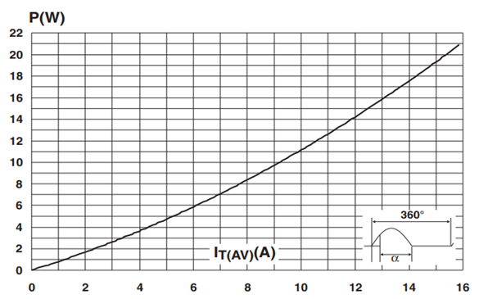

*Figure 16. Maximum average power dissipation versus average on-state current of TYN825RG [6]*

If there is no heatsink on thyristor, temperature of junction is:

TYN825RG’s operating temperature range is - 40 to + 125 °C. 98.50 °C is close to the upper temperature limit, and we should use a heatsink to reduce the temperature of the junction.

We have used a heatsink, which doesn’t have datasheet information. According to experimental results on thermal camera, Tj is 27.5 °C.

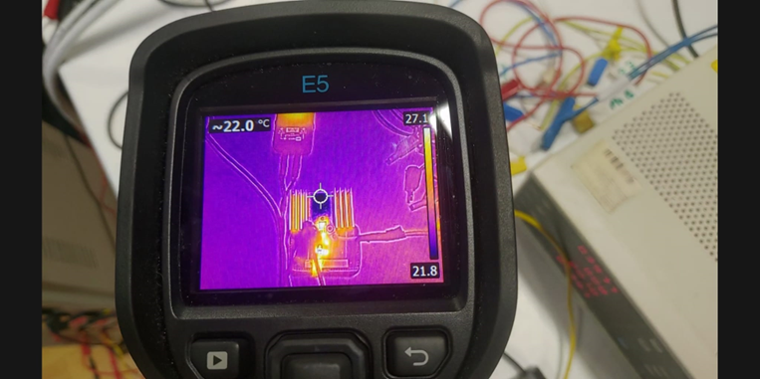

*Figure 17. Temperature of thyristor under no load*

# Cost Analysis

|  | **Cost (₺)** |
| --- | --- |
| TYN825RG THYRISTOR | 73.50 |
| DB3-DB3TG Diode for AC | 1.00 |
| 550k ohm Resistor with Potentiometer | 5.00 |
| 100k //100k = 50k ohm Stone Resistor | 15.50×2 |
| 100 nF 100 V Capacitor | 1.00 |
| Pertinax | 41.70 |
| Electronic Box | 30.00 |
| **Total Cost** | 183.20 |

*Table 1. Cost of components*

# Implementation

Our first prototype was implemented with BT152-600 13A 650V thyristor [4] attached to a heatsink of more than 20 K/W and the entire circuit was soldered to a stripboard. It was tested on a small R load and worked as expected with small current. When it was tested on the motor, thyristor failed due to overheating as the armature voltage reached around 130V. To prevent overheating, the heatsink was replaced with a bigger one of under 10 K/W. When it was tested on the motor again, the circuit successfully drove it at 180V under no load.

BT152-600 was not suitable to drive the motor under 2kW load. So, we replaced it with TYN825 16A 800V thyristor [5]. To decrease the size of the circuit, we pressed a PCB by ironing a copper plate. We then drilled holes through it with a bench drill. As seen, traces in which power flows are too thin for high currents. Therefore, we thickened these traces by applying solder to increase their current capacity. To protect the potentiometer against high current, we connected a 50k stone resistor in series.

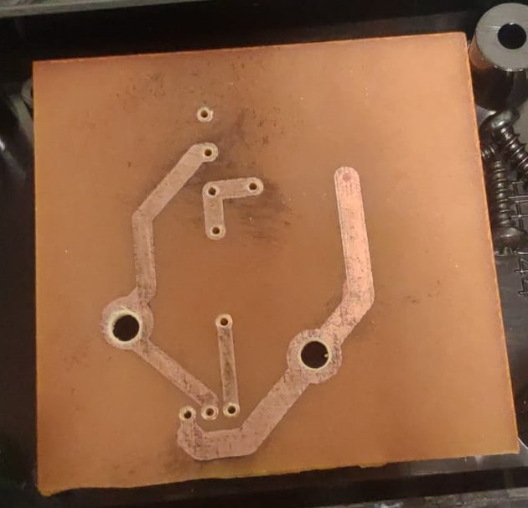

*Figure 18. Ironed PCB*

We soldered all components together and then chopped a project box into the shape to finalize the product as shown in Figure 18. The heatsink is outside of the box so as to facilitate convection. It has mechanical dimensions of 105x85x45 mm.



*Figure 19. Final Product*

# Test Results

## No Load

When the final product was tested on the motor with no load, it successfully started it up and drove it at rated voltage. At this state, the mean armature voltage was 180V and rotor speed was 1300rpm. The armature voltage and current waveforms are shown in Figure 20 where CH3 represents the armature voltage and CH4 represents current. During the startup, the peak current was observed to be under 20A. As seen, the motor draws around 2A at no load which means the driver supplies around 360W to the motor. At this condition, the driver is determined to operate with over 97% efficiency and the highest temperature of components is under 50°C.

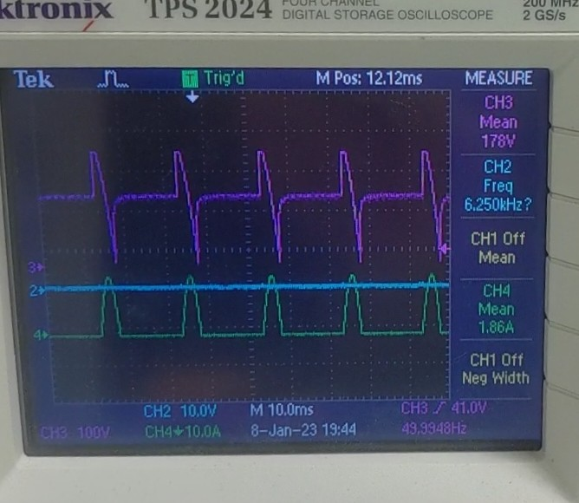

*Figure 20. Armature Voltage and Current*

## Full Load

When the motor was operating at rated voltage, the load turned on and armature voltage immediately dropped to around 160V which was expected. The voltage was attempted to be increased by further decreasing the resistance of the potentiometer. However, the motor was observed to suddenly slow down instead. After disconnecting the circuit and testing the potentiometer, its resistance was observed to be higher than before. The reason is that it burned when attempted to decrease its resistance.

The current through the potentiometer increases as its resistance decreases. This results in an increase in its dissipated heat. For example, when the resistance is decreased to 50k, the dissipated heat is around 1W. Potentiometers are not suitable for dissipating powers and considering this heat is concentrated in a very small slice, it is most likely to burn. To prevent this issue, 50k stone resistor is connected in series so that the heat is shared among them at low resistances. However even when the power was divided, it needed to be concentrated on a small portion of the potentiometer and consequently, burned again. In result, the driver could not be adjusted to operate at full load.

# Conclusion

Purpose of this project was to make a rectifier that drives a separately excited DC motor from standstill. It takes AC voltage input and outputs mean DC voltage between 0 and 180V. The motor is loaded by coupling it to a generator which supplies a kettle with 2kW power. To realize this driver, dimmer circuit was selected as topology among other possible alternatives. Simulations were done with this topology and accordingly, the components were selected. After experiments with the first prototype, heatsink and thyristor were selected according to the observations. In the end, this project cost ₺183.20 and the final product could successfully start the motor up to mean armature voltage of 180V. However, it failed to maintain that voltage when loaded due to the explained reason.

# References

[1] Sasmita, “V-I Characteristics of SCR Explained In Detail” electronicspot.com <https://electronicspost.com/draw-and-explain-the-v-i-characteristics-of-an-scr/> (Accessed Jan. 22 2023)

[2] “A Beginner’s Guide to DIAC | Symbol, Working, Applications” electronicshub.gov <https://www.electronicshub.org/diac/> (Accessed Jan. 23 2023)

[3] “The Silicon-Controlled Rectifier (SCR)” allaboutcircuit.com <https://www.allaboutcircuits.com/textbook/semiconductors/chpt-7/silicon-controlled-rectifier-scr/> (Accessed Jan. 24 2023)

[4] NXP Semiconductors. ”*BT152 series Thyristors*”, BT152, March 1997. Rev 1.200.

[5] STMicroelectronics. ”*Standard 25 A SCRs*”, TYN825, August 2014. Rev. 9.

[6] “Standard 25 a SCRS” pdf.utmel.com. (n.d.), https://pdf.utmel.com/r/datasheets/stmicroelectronics-tn2540800gtr-datasheets-4923.pdf