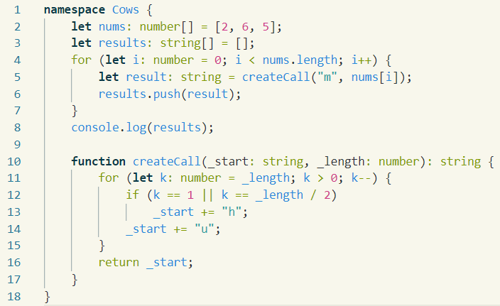L01: Recap & Foundation: „Cows“